INDOOR AIR QUALITY ASSESSMENT

Hobomock Elementary School
81 Learning Lane
Pembroke, MA

Prepared by:
Massachusetts Department of Public Health
Bureau of Environmental Health
Indoor Air Quality Program
November 2017

Background

Building: | Hobomock Elementary School (HES)
Address: | 81 Learning Lane, Pembroke, MA
Assessment Requested by: | Justin J. Domingos,  Director of Athletics/Facilities, Pembroke Public Schools
Reason for Request: | General indoor air quality (IAQ) assessment
Date of Assessment: | October 27, 2017
Massachusetts Department of Public Health/Bureau of Environmental Health (MDPH/BEH) Staff Conducting Assessment: | Ruth Alfasso, Environmental Engineer/Inspector, IAQ Program
Date of Building Construction: | Late 1972, with an addition and renovations in 1997
Building Description: | Brick and concrete single-story building with flat roof
Building Population: | Approximately 425 students in kindergarten through 6th grade with a staff of approximately 50
Windows: | Openable

IAQ Testing Results
Please refer to the IAQ Manual for methods, sampling procedures, and interpretation of results (MDPH, 2015). The following is a summary of indoor air testing results (Table 1).
- Carbon dioxide levels were below 800 parts per million (ppm) 47 of 54 areas tested, indicating adequate air exchange in most areas of building, however some areas were empty, which can reduce carbon dioxide levels.
- Temperature was within the recommended range of 70°F to 78°F in about half of areas tested the day of assessment and slightly below in the rest.
- Relative humidity was within or slightly below the recommended range of 40 to 60% in all areas the day of assessment.
- Carbon monoxide levels were non-detectable in all areas tested.
- Fine particulate matter (PM2.5) concentrations measured were below the NAAQS limit of 35 μg/m³ in all areas tested.

Ventilation
A heating, ventilating and air conditioning (HVAC) system has several functions. First it provides heating and, if equipped, cooling. Second, it is a source of fresh air. Finally, an HVAC system will dilute and remove normally occurring indoor environmental pollutants by not only introducing fresh air, but by filtering the airstream and ejecting stale air to the outdoors via exhaust ventilation. Even if an HVAC system is operating as designed, point sources of respiratory irritation may exist and cause symptoms in sensitive individuals.
Fresh air is provided air handling units (AHUs; Picture 1), which provide fresh air and heat to all areas of the school. One AHU also provides cooling. Air from the AHUs is filtered, heated or cooled as needed, and delivered to rooms via ducted supply vents on the ceiling. Air is exhausted from ceiling-mounted exhaust vents (Picture 2). In some cases these vents are located near classroom doors such that when classroom doors are open, exhaust vents will tend to pull hallway air into the classroom instead of removing stale air/pollutants from the room and out the building. Additional heat is provided by radiators in some areas.
To maximize air exchange, the MDPH recommends that both supply and exhaust ventilation operate continuously during periods of occupancy. In order to have proper ventilation with a mechanical supply and exhaust system, these systems must be balanced to provide an adequate amount of fresh air while removing stale air from a room. It is recommended that existing ventilation systems be re-balanced every five years to ensure adequate air systems function (SMACNA, 1994). It is unknown the last time these systems were balanced.

Microbial/Moisture Concerns
Water-damaged ceiling tiles were observed in a few areas (Picture 3; Table 1), which indicate leaks from the building envelope or plumbing system. These tiles should be replaced after the leak is found and repaired. It was reported that a new roof has been installed for the entire building, which has prevented leaks recently in most areas. A single area has still been reported to leak and an investigation to the source of this leak is ongoing.
Sinks were observed in most classrooms. Many of these sinks were leaking or difficult to turn off, which can be a source of water to moisten building materials (Picture 4). The backsplashes of some of the sinks had a gap which can allow the materials of the sink countertop to become damaged or lead to microbial growth (Picture 5). Some sinks also had porous materials (e.g., paper, boxes), carpeting, or large amounts of materials stored in the cabinets underneath them. Cabinets under sinks are a moist environment and items stored there may become water-damaged or colonized with mold.
The Large Instruction Room was equipped with two ductless air conditioner (AC) units, one of which was on during the visit (Picture 6). A slight musty or sour odor was observed in this room which seemed to be associated with the AC. Ductless AC units produce condensate that needs to be drained. If condensate becomes stagnant, odors can result.
Odors were reported in several other areas (Table 1) and these areas were examined for odor sources. Odors were described as “musty” and “like a litterbox”. No odor was detected in most of the areas of concern and only a slight musty odor was detected in classroom 140. Since previous water damage from roof leaks had been reported in these areas, the space above the ceiling tile system was examined. Above the ceiling tiles is a large open space with metal roof decking above and insulated ducts inside. Duct insulation was intact in areas examined, no other porous materials were found, and no signs of water damage, including stains or odors, were observed/detected. Any odors that occur in classrooms may originate in: sink drains and sink materials, indoor plants, or other classroom materials and activities. An outdoor source, such as a shrub or flowering plant, may account for odors, as many common trees and shrubs have odors sometimes described as “cat urine”. If odors continue to occur, a log of when they occur along with other information such as if the windows are opened, current/recent weather conditions, and classroom activities should be kept to assist in determining a cause.
Small refrigerators were observed in carpeted areas (Picture 7). Carpeting under refrigerators and water dispensing equipment can become moistened and soiled leading to odors and microbial growth.
Indoor plants were observed in a few areas (Picture 8; Table 1). Plants can be a source of pollen and mold, which can be respiratory irritants to some individuals. Plants should be properly maintained and equipped with drip pans and should be located away from air diffusers to prevent the aerosolization of dirt, pollen and mold.

Other IAQ Evaluations
Exposure to low levels of total VOCs (TVOCs) may produce eye, nose, throat, and/or respiratory irritation in some sensitive individuals. To determine if VOCs were present, BEH/IAQ staff examined rooms for products containing VOCs. BEH/IAQ staff noted hand sanitizers, cleaners/spray bottles, air fresheners, and dry erase materials in use within the building (Picture 9 -11; Table 1). All of these products have the potential to be irritants to the eyes, nose, throat, and respiratory system of sensitive individuals. Cleaners were observed to be of different types/manufacturers which may lead to product interactions with irritating or toxic byproducts. Cleaners used in classrooms should be supplied by the school or compatible. Cleaning products should also be clearly labeled and kept out of reach of children.
In a few areas, tennis balls had been sliced open and placed on chair footings to reduce noise (Picture 12). Tennis balls are made of a number of materials that are a source of respiratory irritants. Constant wearing of tennis balls can produce fibers and lead to off-gassing of VOCs. Tennis balls are made with a natural rubber latex bladder, which becomes abraded when used as a chair leg pad. Use of tennis balls in this manner may introduce latex dust into the school environment. Some individuals are highly allergic to latex (e.g., spina bifida patients) (SBAA, 2001). It is recommended that the use of materials containing latex be limited in buildings to reduce the likelihood of symptoms in sensitive individuals (NIOSH, 1997; NIOSH, 1998).
The AHUs are equipped with filters, one set of which were examined and found to be of the recommended pleated type and well-fitted into the AHU filter rack (Picture 13). It is recommended that AHUs be outfitted with pleated filters of a Minimum Efficiency Reporting Value (MERV) of 8 or higher, which are adequate in filtering out pollen and mold spores (ASHRAE, 2012). In addition, filters should be changed 2-4 times a year or in accordance with the manufacture’s recommendations. It is reported that filters are changed at least twice a year in these units.
Many classrooms had personal fans. Some of these had dusty blades (Picture 14; Table 1). Some supply diffusers, exhaust vents, and window AC units (Picture 15) were also observed to be dusty. This dust can be reaerosolized when the equipment is activated. Note that window AC units also have filters which need to be cleaned periodically in accordance with manufacturers’ instructions.
Some classrooms have a nook area in the back with an overhang and in many cases the ceiling and walls in this area were dusty. In some areas, items, including books, papers, toys and decorative items were observed on floors, windowsills, tabletops, counters, bookcases, and desks (Table 1), which can make it more difficult for custodial staff to clean. Pencil shavings/markings were observed on some counters (Picture 16); this debris can be a source of irritating dusts.
Many areas had carpeting. Carpeting should be cleaned annually or semi-annually in soiled high traffic areas as per the recommendations of the Institute of Inspection, Cleaning and Restoration Certification (IICRC, 2012). Carpeting is built in over the heaters in classrooms in some areas (Picture 17); this carpeting should be thoroughly cleaned regularly as it is both a place where students may sit and also will become heated during the winter, which may cause soil or dust in the carpet to produce odors. Many classrooms had area rugs, which should also be cleaned regularly and discarded when too worn out or soiled to be cleaned. Some of the area rugs were found to be frayed (Picture 18) and should be replaced to avoid both a tripping hazard and a source of irritating particles.
Note that the Environmental Protection Agency (EPA) conducted a National School Radon Survey in which it discovered nearly one in five schools had “…at least one frequently occupied ground contact room with short-term radon levels above 4 [picocuries per liter] pCi/L” (US EPA 1993). The BEH/IAQ Program therefore recommends that every school be tested for radon, and that this testing be conducted during the heating season while school is in session in a manner consistent with USEPA radon testing guidelines. Radon measurement specialists and other information can be found at www.nrsb.org and http://aarst-nrpp.com/wp, with additional information at: http://www.mass.gov/eohhs/gov/departments/dph/programs/environmental-health/exposure-topics/iaq/radon.

Conclusions/Recommendations
The following recommendations are made to assist in improving IAQ:
- Operate all supply and exhaust ventilation equipment continuously during occupied periods.
- Use openable windows to supplement fresh air during temperate weather. Ensure all windows are tightly closed at the end of the day.
- Check exhaust vents for draw periodically and repair any non-operating vents.
- Close classroom doors to facilitate exhaust function.
- Consider adopting a balancing schedule of every 5 years for all mechanical ventilation systems, as recommended by ventilation industrial standards (SMACNA, 1994).
- For buildings in New England, periods of low relative humidity during the winter are often unavoidable. Therefore, scrupulous cleaning practices should be adopted to minimize common indoor air contaminants whose irritant effects can be enhanced when the relative humidity is low. To control dusts, a high efficiency particulate arrestance (HEPA) filter equipped vacuum cleaner in conjunction with wet wiping of all surfaces is recommended. Avoid the use of feather dusters. Drinking water during the day can help ease some symptoms associated with a dry environment (throat and sinus irritations).
- Ensure roof and plumbing leaks are repaired and replace water-damaged ceiling tiles.
- Repair and maintain classroom sinks including fixing leaks and replacing gaskets to ensure they can be easily shut off. Repair sink backsplashes to seal gaps, or replace with a one-piece unit. Avoid storage of porous materials and large amounts of materials under sinks.
- Ensure that ductless AC condensate is draining properly and clean the units in the Large Instruction Room to prevent odors.
- Keep logs of any chronic odors in other areas including time, weather, and classroom activities to assist in determining the cause. Consider both indoor and outdoor sources when investigating odors.
- Avoid placing refrigerators and water dispensers on carpet; use a waterproof mat or place the appliances in tiled areas.
- Properly maintain plants, including drip pans, to prevent water damage to porous materials. Plants should also be located away from air diffusers to prevent the aerosolization of dirt, pollen, and mold.
- Reduce use of products and equipment that create VOCs and only use in well-ventilated areas. Minimize the use of air fresheners, deodorizers and scented products.
- Keep spray bottles/cleaning products out of the reach of children (e.g., in cabinets over sinks). Ensure that products are compatible with one another. It is suggested that only school-supplied products be used to avoid product interactions.
- Replace tennis balls on chair footings with latex-free glides.
- Continue to change filters for HVAC equipment 2-4 times a year. The MDPH recommends using pleated filters of Minimum Efficiency Reporting Value (MERV) of 8, which are adequate in filtering out pollen and mold spores (ASHRAE, 2012), if these can be used with current equipment.
- Regularly clean/vacuum supply/return vents and fans to avoid aerosolizing accumulated particulate matter.
- Clean window-mounted ACs including filters prior to the start of the cooling season and according to the manufacturer’s instructions.
- Consider reducing the amount of items stored in classrooms to make cleaning easier. Periodically move items to clean flat surfaces. Include the nook areas with overhang in periodic cleaning/dusting.
- Clean pencil sharpener debris regularly.
- Clean carpeting annually (or semi-annually in soiled high traffic areas) as per the recommendations of the Institute of Inspection, Cleaning and Restoration Certification (IICRC) including carpeting over heaters. Discard area rugs that are too worn or soiled to be effectively cleaned.
- The school should be tested for radon by a certified radon measurement specialist during the heating season when school is in session. Radon measurement specialists and other information can be found at: www.nrsb.org, and http://aarst-nrpp.com/wp.
- Consider adopting the US EPA (2000) document, “Tools for Schools”, as an instrument for maintaining a good IAQ environment in the building available at: http://www.epa.gov/iaq/schools/index.html.
- Refer to resource manual and other related IAQ documents located on the MDPH’s website for further building-wide evaluations and advice on maintaining public buildings. These documents are available at: http://mass.gov/dph/iaq.

References
ASHRAE. 2012. American Society of Heating, Refrigeration and Air Conditioning Engineers (ASHRAE) Standard 52.2-2012 -- Method of Testing General Ventilation Air-Cleaning Devices for Removal Efficiency by Particle Size (ANSI Approved).
IICRC. 2012. Institute of Inspection, Cleaning and Restoration Certification. Carpet Cleaning: FAQ. Retrieved from http://www.iicrc.org/consumers/care/carpet-cleaning.
MDPH. 2015. Massachusetts Department of Public Health. “Indoor Air Quality Manual: Chapters I-III”. Available at: http://www.mass.gov/eohhs/gov/departments/dph/programs/environmental-health/exposure-topics/iaq/iaq-manual/.
NIOSH. 1997. National Institute for Occupational Safety and Health. Alert Preventing Allergic Reactions to Natural Rubber latex in the Workplace. National Institute for Occupational Safety and Health, Atlanta, GA.
NIOSH. 1998. National Institute for Occupational Safety and Health. Latex Allergy A Prevention. National Institute for Occupational Safety and Health, Atlanta, GA.
SBAA. 2001. Latex In the Home And Community Updated Spring 2001. Spina Bifida Association of America, Washington, DC.
SMACNA. 1994. HVAC Systems Commissioning Manual. 1st ed. Sheet Metal and Air Conditioning Contractors’ National Association, Inc., Chantilly, VA.
US EPA. 1993. Radon Measurement in Schools, Revised Edition. Office of Air and Radiation, Office of Radiation and Indoor Air, Indoor Environments Division (6609J). EPA 402-R-92-014. https://www.epa.gov/sites/production/files/2014-08/documents/radon_measurement_in_schools.pdf
US EPA. 2000. Tools for Schools. Office of Air and Radiation, Office of Radiation and Indoor Air, Indoor Environments Division (6609J). EPA 402-K-95-001, Second Edition. http://www.epa.gov/iaq/schools/index.html.
Picture 1
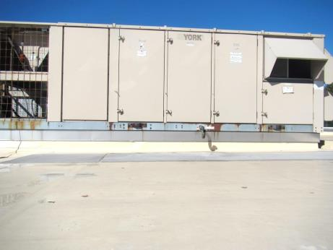
Rooftop air handling unit (AHU)
Picture 2
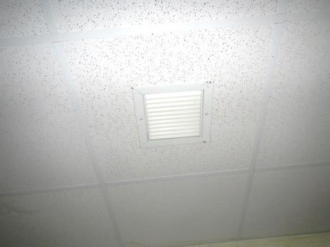
Ceiling-mounted exhaust vent
Picture 3
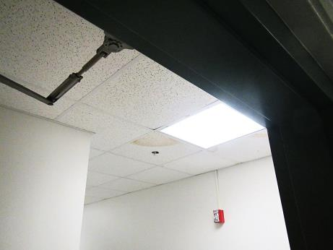
Water-damaged ceiling tile
Picture 4
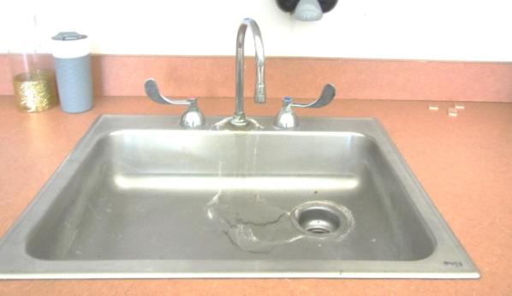
Leaking of sink faucet where it joins the sink basin
Picture 5
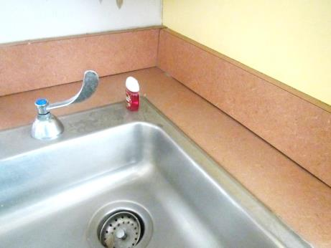
Gap between sink cabinet top and backsplash
Picture 6
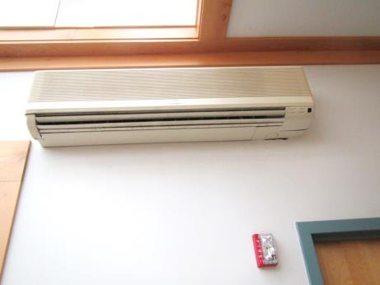
Ductless AC in the Large Instruction Room
Picture 7
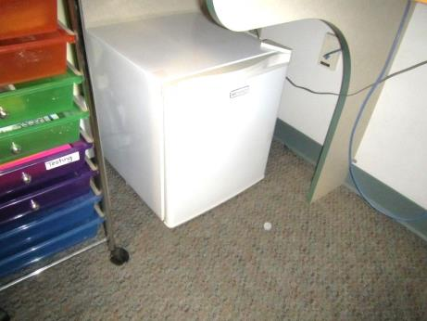
Small refrigerator on carpet
Picture 8
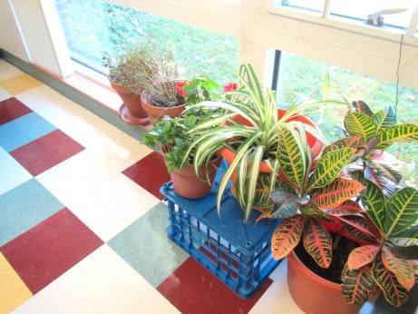
Plants
Picture 9
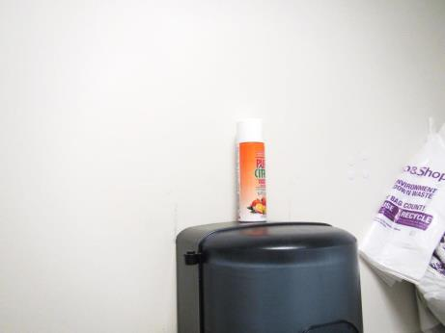
Air freshener spray
Picture 10
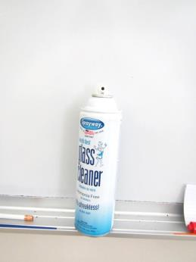
Glass cleaner in a classroom
Picture 11
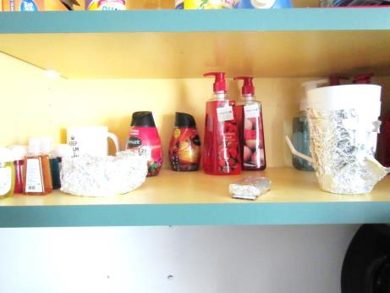
Air fresheners and scented hand sanitizers in classroom
Picture 12
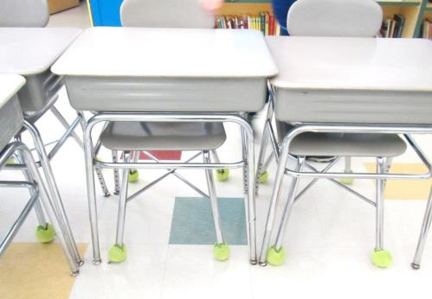
Tennis balls as chair glides
Picture 13
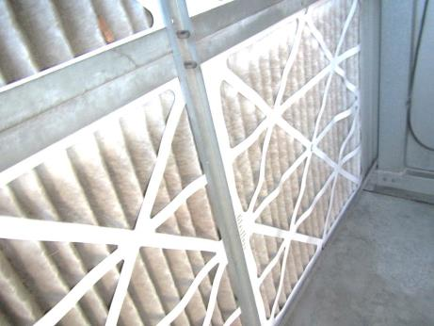
Filters in a rooftop AHU
Picture 14
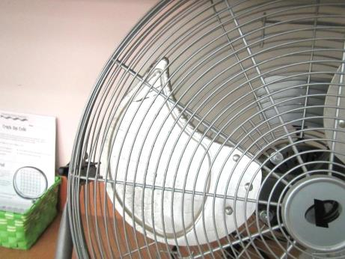
Dusty fan blade
Picture 15
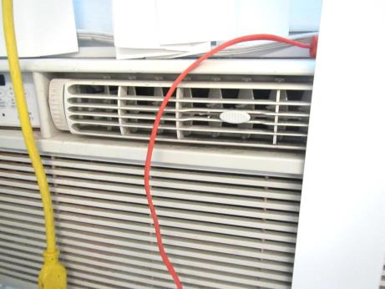
Dusty window air conditioner in classroom
Picture 16
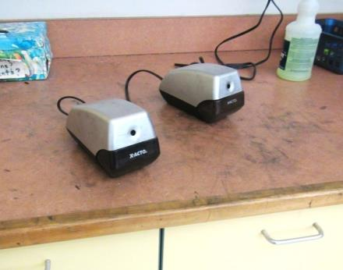
Pencil shavings/markings on table
Picture 17
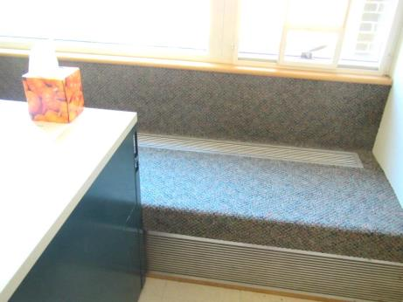
Carpeting/seat over heater
Picture 18
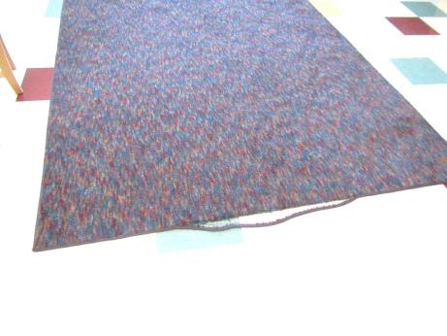
Frayed area rug
Location | Carbon  Dioxide  (ppm) | Carbon Monoxide  (ppm) | Temp  (°F) | Relative  Humidity  (%) | PM2.5  (µg/m³) | Occupants  in Room | Windows  Openable | Ventilation |  | Remarks
 |  |  |  |  |  |  |  | Supply | Exhaust
Background | 354 | 0.7 | 56 | 45 |  |  |  |  |  | Sunny
Special Ed classroom | 591 | ND | 68 | 55 | 2 | 0 | Y | Y | Y | Has 3 restrooms with exhausts, sink backsplash open, NC, items hanging from ceiling, porous items under sink
School psychologist | 700 | ND | 68 | 44 | 1 | 0 | N | Y | Y | Carpet, dusty fan
Large room | 453 | ND | 68 | 47 | 1 | 0 | N | Y | Y | 1 WD CT, DEM, ductless ACs, skylight, slight musty odor
Teacher’s workroom | 504 | ND | 71 | 39 | ND | 1 | N | Y | Y | Fridge on carpet, microwaves
Restroom in teacher’s workroom |  |  |  |  |  | 0 | N | Y | Y | WD CT, CP and air fresheners
Science room | 596 | ND | 71 | 40 | 4 | 0 | N | Y | Y | DEM, open backsplash, skylight
Computer lab | 700 | ND | 71 | 43 | 3 | 10 | N | Y | Y | 15 computers, carpeted, a few WD CT
Library | 675 | ND | 72 | 45 | ND | 12 | Y | Y | Y | Book fair ongoing, carpeted, a few WD CT
Librarian office | 674 | ND | 72 | 46 | 10 | 0 | Y | Y | Y | Carpeted
Library storage | 669 | ND | 71 | 46 | ND | 0 | N | Y | Y | Books, items, PF dusty
Teachers’ workroom | 671 | ND | 71 | 46 | 1 | 0 | N | Y | Y | NC
Nurse’s office | 610 | ND | 71 | 43 | ND | 1 | Y (in rear area) | Y | Y | NC, refrigerators
Teacher’s copy | 521 | ND | 70 | 35 | ND | 3 | N | Y | Y | AI
Music | 495 | ND | 69 | 39 | 2 | 1 | Y | Y | Y | Carpet, PF on, instruments
Ensemble | 440 | ND | 69 | 38 | 7 | 0 | N | Y | Y | DEM, water stains inside lights, carpet, missing/ajar tile
Gym | 440 | ND | 66 | 35 | 1 | 10 | N | Y | Y
Gym office |  |  |  |  |  |  |  |  |  | Items in totes
CAF | 564 | ND | 68 | 44 | 1 | ~50 | N | Y | Y | Door to outside
Custodian’s office | 449 | ND | 68 | 38 | 1 | 0 | N | Y | Y
Teacher’s lunch | 892 | ND | 68 | 55 | ND | 7 | Y | Y | Y | Window AC, fridge with broken gasket, microwaves
Kiln |  |  |  |  |  |  |  |  |  | Kiln is used once or twice a year, and has a vent
Vice Principal | 671 | ND | 70 | 42 | 1 | 1 | N | Y | Y | Carpet
Conference room | 590 | ND | 71 | 43 | ND | 0 | N | Y | Y | DEM
Reception | 620 | ND | 71 | 43 | ND | 2 | N | Y | Y | Carpet
Principal’s office | 699 | ND | 71 | 49 | 1 | 3 | Y | Y | Y
100 | 507 | ND | 69 | 40 | ND | 0 | Y | Y | Y | Sink drips, items under sink, CPs, DEM
105 | 475 | ND | 68 | 40 | 2 | 0 | Y | Y | Y | Area rug, paper under sink, plush toys
110 | 448 | ND | 69 | 38 | ND | 0 | Y | Y | Y | DEM, PF, area rug
115 | 425 | ND | 69 | 36 | ND | 1 | Y | Y | Y | Area rug, DEM, open backsplash
120 | 425 | ND | 69 | 37 | ND | 1 | Y | Y | Y | Area rug, plants, PF, DEM, CP, AI
125 | 448 | ND | 69 | 38 | 6 | 0 | Y | Y | Y | DEM, plants, CPs, area rug
130 | 551 | ND | 70 | 39 | ND | 10 | Y 2  Open | Y | Y | Area rug, plush items, sink backsplash open, reported odor, none detected
135 | 703 | ND | 70 | 37 | ND | 20 | Y 1  Open | Y | Y | TBs, area rug, plants, DEM
140 | 515 | ND | 70 | 37 | 1 | 0 | Y | Y | Y | Area rug, slight musty odor, reported odor
145 | 739 | ND | 70 | 36 | 1 | 16 | Y | Y | Y | CPs, HS, items under sink, DEM, area rug
150 | 648 | ND | 70 | 37 | ND | 18 | Y | Y | Y | PF on, AF, area rugs, window blocked by furniture, items under sink
155 | 745 | ND | 71 | 39 | ND | 21 | Y | Y | Y | DEM, area rug, sink backsplash has a gap
160 | 688 | ND | 70 | 37 | 1 | 18 | Y | Y | Y | Area rug, sink drips, backsplash gap, items under sink, DEM
165 | 526 | ND | 70 | 37 | ND | 1 | N | Y | Y | DEM, carpet, carpeted under sink
200 | 649 | ND | 71 | 43 | 1 | 7 | Y | Y | Y | DEM, sink backsplash gap, window AC, HS
205 | 593 | ND | 69 | 43 | ND | 18 | Y | Y | Y | Area rug, DEM, bouncy balls
210 | 498 | ND | 68 | 45 | ND | 18 | Y 2  Open | Y | Y | Area rug, TBs and TBs under sink
215 | 653 | ND | 70 | 43 | ND | 1 | Y | Y | Y | DEM, CPs, HS
220 | 931 | ND | 69 | 49 | ND | 21 | Y | Y | Y | Reported odor, not detected at time of visit
225 | 815 | ND | 68 | 48 | ND | 15 | Y | Y | Y | Area rug, DEM, microwave, sink, items under sink
230 | 815 | ND | 68 | 46 | ND | 21 | Y | Y | Y | Area rug, sink drips, HS
235 |  | ND | 67 | 46 | 15 | 17 | Y | Y | Y | NC, area rug, DEM, sink drips, CP/AFs, PF, dusty ceiling
240 | 547 | ND | 68 | 43 | ND | 0 | Y | Y | Y | DEM, sink, TBs
245 | 895 | ND | 69 | 46 | ND | 23 | Y | Y | Y | Aquarium, DEM, plant, area rug, dusty ceiling, fridge
250 | 1030 | ND | 68 | 47 | ND | 23 | Y 3 OPEN | Y | Y | NC and area rug, DEM, sink, PF, dusty vents
255 | 605 | ND | 67 | 46 | 1 | 0 | Y | Y | Y | Area rug frayed, sink leaks
Girls Restroom near 255 |  |  |  |  |  | 0 | N | Y | Y | DO
260 | 590 | ND | 70 | 42 | ND | 0 | Y | Y | Y | Carpet, DEM, sink drops, plush items and toys
261 | 566 | ND | 68 | 48 | ND | 3 | Y | Y | Y | 1 WD CT, window AC, area rug
264 ART | 747 | ND | 69 | 44 | ND | 0 | Y | Y | Y | Area rugs, DEM, art supplies, sink drips
265 office | 431 | ND | 68 | 43 | 1 | 0 | N | Y | Y | DEM
270 office | 810 | ND | 69 | 44 | 1 | 0 | N | Y | Y | Carpet, stand fan DEM
275 office | 543 | ND | 66 | 44 | ND | 0 | N | Y | Y | DEM, fridge on carpet
280 | 623 | ND | 68 | 43 | ND | 1 | N | Y | Y | Carpet, cushions, HS

