# BACKGROUND

**INDOOR AIR QUALITY**

**ASSESSMENT**

**Holbrook Public Safety Building**

**Holbrook Fire Department**

**300 South Franklin Street**

**Holbrook, MA**

Exterior view
Holbrook Public Safety Building
Holbrook Fire Department
300 South Franklin Street
Holbrook, MA


Prepared by:

Massachusetts Department of Public Health

Bureau of Climate Change and Environmental Health

Indoor Air Quality Program

September 2023

|  |  |
| --- | --- |
| Building: | Holbrook Public Safety Building (HPSB), Holbrook Fire Department (HFD) |
| Address: | 300 South Franklin Street, Holbrook, MA |
| Assessment Requested by: | HFD staff and coordinated through the Holbrook Board of Health and Fire Chief Luke McFadden |
| Reason for Request: | General indoor air quality (IAQ) assessment |
| Date of Assessment: | June 1, 2023 |
| Massachusetts Department of Public Health/Bureau of Climate and Environmental Health (MDPH/BCEH) Staff Conducting Assessment: | Mike Feeney, Director and Cory Holmes, Assistant Director, IAQ Program |
| Building Description: | The HPSB is made up of a two- and three-story building constructed in the early 2000’s and opened in 2005. It houses both the HFD and Holbrook Police Department (HPD). Portions of the building were built into a hill with two stories in the front and three in the rear. The building has several peaked roofs with asphalt shingles. Roofs and siding were replaced over the last few years. The space consists of suspended ceiling tiles, carpet squares, some wall-to-wall carpet, and gypsum wallboard. The Communications Center, which is located adjacent to the HPD, was completed in 2020. Please note, the HPD and Communications Center will be the subjects of separate reports. |
| Windows: | Openable |

# METHODS

Please refer to the IAQ Manual for methods, sampling procedures, and interpretation of results (MDPH, 2015).

**RESULTS and DISCUSSION**

The following is a summary of indoor air testing results (Table 1).

* ***Carbon dioxide*** levels were below the MDPH guideline of 800 parts per million (ppm) in all areas surveyed, indicating adequate air exchange.
* ***Temperature*** was within or close to the MDPH recommended range of 70°F to 78°F in areas tested.
* ***Relative humidity*** was within the MDPH recommended range of 40 to 60%.
* ***Carbon monoxide*** levels were non-detectable (ND) in all areas tested.
* ***Fine particulate matter (PM2.5)*** concentrations measured were below the National Ambient Air Quality Standard (NAAQS) limit of 35 μg/m3 in all areas tested.

## Ventilation

A heating, ventilating, and air conditioning (HVAC) system has several functions. First it provides heating and, if equipped, cooling. Second, it is a source of fresh air. Finally, an HVAC system will dilute and remove normally occurring indoor environmental pollutants by not only introducing fresh air, but by filtering the airstream and ejecting stale air to the outdoors via exhaust ventilation. Even if an HVAC system is operating as designed, point sources of respiratory irritation may exist and cause symptoms in sensitive individuals.

The HVAC system for HFD consists of air handling units (AHUs) located in mechanical rooms (Picture 1) or mounted on the ceiling (Picture 2), which draw in outside air and heat/cool it. Conditioned air is ducted to multi-directional, ceiling-mounted supply diffusers (Picture 3) and returned via ceiling vents (Picture 4) back to AHUs. The HVAC system is controlled by digital thermostats that feed into a computerized management system.

AHUs have filters, which should be changed 2-4 times a year or per the manufacturer’s recommendations. Filters should be at least a Minimum Efficiency Rating Value (MERV) of 8 *or higher*, if they fit and the equipment can handle the pressure reductions caused by more restrictive filters. Filters at HPSB were confirmed to be MERV 8 (Picture 5) and reported by Chief McFadden that they are changed twice a year under a preventative maintenance program.

In order to have proper ventilation with a mechanical ventilation system, the systems must be balanced after installation to provide an adequate amount of fresh air to the interior of a room while removing stale air from the room. It is recommended that HVAC systems be re-balanced every five years to ensure adequate air systems function (SMACNA, 1994).

Local exhaust ventilation exists in the kitchen, laundry room, turn-out gear rooms, restrooms, and showers. It is important to ensure proper function periodically and that they vent directly outdoors and do not mix with the general HVAC systems. The engine bay is equipped with a tailpipe exhaust collection system (Plymovent, Pictures 6 and 7). It is recommended that a regular preventative maintenance program be in place for systems of this type, which was confirmed by Chief McFadden.

## Microbial/Moisture Concerns

A few water-damaged ceiling tiles were observed (Table 1, Picture 8), which are evidence of building envelope and/or plumbing leaks. When a water leak is discovered and repaired, water-damaged tiles should be changed. One tile located in the hallway outside room 120, had dark stains, which may be mold growth (Picture 9).

The lower apparatus bay had severe corrosion on the underside of metal ceiling/decking (Picture 10), which corresponds to cracking of the upper apparatus bay floor (Picture 11). Staining on concrete walls was observed in a number of perimeter rooms in the lower area indicating either current or historical water infiltration (Picture 12).

Also, of note along the exterior of the building was a subterranean pit that provides make-up air for one of the AHUs. Although the drain was clear, there was noticeable plant debris accumulated in the pit (Picture 13). These pits should be cleared out on a regular basis to avoid being a source of mold, odors, or moisture being drawn into the AHU.

Visible mold growth was observed on the surface of ductwork and housing of the AHU located in the lower-level mechanical room off the apparatus bay (Pictures 14 through 16). This was likely the result of condensation from temperature differences with the HVAC equipment and elevated relative humidity in the apparatus bay.

## Other Concerns

Of particular importance is vehicle exhaust, which involves the process of combustion. Although the engine bays are equipped with a specialized system to remove exhaust during idling, pathways for vehicle exhaust and other pollutants to migrate into adjacent/occupied areas were identified. Doors separating the engine bays from occupied space are not tightly sealed, as noted by space observed beneath them (Pictures 17 and 18). These spaces should be sealed with weather-stripping to prevent the migration of products of combustion.

Most of the floors are covered with carpet squares, some areas have wall to wall carpeting. In general, it is not recommended for fire departments and other emergency response agencies to have carpeted floors due to the possible cross-contamination that may occur from footwear contact with automotive products, chemicals, or biological contamination. In addition, the Institute of Inspection, Cleaning and Restoration Certification (IICRC) discusses floor covering in its guideline, “Standard for Professional Cleaning of Textile Floor Coverings” (IICRC, 2015). Based on this standard, the IICRC recommends twice-daily vacuuming and/or pile-lifting cleaning for commercial carpeting in heavy traffic areas. This frequency of cleaning of the building as well as the use of vacuum cleaners equipped with high-efficiency particulate arrestance (HEPA) filters would remove respirable dust from the indoor air. Office areas were also mostly carpeted. Carpets in these areas should be cleaned annually (or semi-annually in soiled/high traffic areas) in accordance with Institute of Inspection, Cleaning and Restoration Certification (IICRC) recommendations (IICRC, 2012).

Finally, some supply, exhaust and return vents had accumulations of dust and debris (Table 1, Pictures 19 and 20). This dust/debris can be reaerosolized under certain conditions, and should be cleaned periodically (e.g., during regular filter changes). In follow-up correspondence with Chief McFadden he reported that at the request of HFD staff, the ductwork in the Fire Department living quarters was cleaned by a professional duct cleaning service on June 21st.

The US EPA recommendations (for homeowners but applicable to other situations) indicate that duct cleaning is often not necessary (US EPA, 2023). However, there are some situations where it should be considered. These include substantial mold growth on surfaces inside ducts and related components, the ducts have been infested by pests such as rodents, or ducts have become clogged with dust and debris (US EPA, 2023). Ducts that have been exposed to smoke or fire residues or uncontrolled construction pollutants may also be a candidate for cleaning. The US EPA document also recommends that if ducts are to be cleaned, that the contractor follow the standards set out by the National Air Duct Cleaners Association (NADCA). The NADCA standard “establishes minimum performance requirements for assessing new and existing HVAC systems, evaluating the cleanliness of HVAC system components, determining the need to clean and cleaning and restoring systems to a verifiable cleanliness level. The Standard also focuses on preventing job-related hazards, such as exposure to workers and occupants, and cross-contamination to the indoor environment (NADCA, 2021).

# CONCLUSIONS AND RECOMMENDATIONS

In view of the findings at the time of assessment, the following recommendations are made:

### **Ventilation recommendations**

1. Continue with preventative maintenance plans for general HVAC and Plymovent systems.
2. Continue to change filters for HVAC equipment 2-4 times a year using MERV 8 or the highest MERV rating the ventilation system can accommodate to improve air filtration as much as possible without significantly reducing airflow.
3. Clean the interior of AHUs and univents during regular filter changes using a HEPA-filtered vacuum cleaner with brush attachment or compressed air.
4. Periodically check local exhaust vents for turn out rooms, dryer, kitchen hood, and restrooms for proper operation and make adjustments/repairs as needed.
5. Have the HVAC system balanced every 5 years in accordance with SMACNA recommendations (SMACNA, 1994).

### **Water Damage recommendations**

1. Clean mold from exterior surface of AHU and ductwork using an antimicrobial in a manner consistent with the U.S. Environmental Protection Agency’s guidelines (US EPA, 2008) available at: <http://www.epa.gov/mold/mold-remediation-schools-and-commercial-buildings-guide>. Monitor for reoccurrence during hot/humid weather.
2. Ensure all leaks are repaired and replace water-damaged ceiling tiles.
3. Monitor lower level for water infiltration. If replacement of siding has remedied the situation, clean and refinish stained concrete walls. If water infiltration is ongoing, consult with a building envelope specialist.
4. Consult with a concrete flooring/architectural expert for long-term solutions to make repairs/prevent cracking of apparatus bay floors. In the interim, consider sealing as a temporary measure to prevent/reduce water infiltration.
5. Ensure subterranean air intake pits are cleaned of debris on a regular basis.
6. Inspect gutters and downspouts periodically for proper drainage, make repairs as necessary.

### **Other recommendations**

1. Clean supply, return, and exhaust vents regularly to remove accumulated dust/debris.
2. If ceiling tiles around dusty vents cannot be cleaned, replace.
3. Consideration should be given to replacing carpeting with a different type of floor covering that can be readily cleaned. Until that time, clean carpeting in accordance with IICRC recommendations (IICRC, 2012); annually (or semi-annually in soiled/high traffic areas).
4. For buildings in New England, periods of low relative humidity during the winter are often unavoidable. Therefore, scrupulous cleaning practices should be adopted to minimize common indoor air contaminants whose irritant effects can be enhanced when the relative humidity is low. To control for dusts, a high efficiency particulate arrestance (HEPA) filter equipped vacuum cleaner in conjunction with wet wiping of all surfaces is recommended. Avoid the use of feather dusters. Drinking water during the day can help ease some symptoms associated with a dry environment (throat and sinus irritations).
5. Refer to resource manual and other related IAQ documents located on the MDPH’s website for further building-wide evaluations and advice on maintaining public buildings. These documents are available at: <http://mass.gov/dph/iaq>.

**REFERENCES**

IICRC. 2012. Institute of Inspection, Cleaning and Restoration Certification. Carpet Cleaning: FAQ.

IICRC. 2015. Institute of Inspection, Cleaning and Restoration Certification. Commercial Carpet Cleaning: FAQ.

MDPH. 2015. Massachusetts Department of Public Health. “Indoor Air Quality Manual: Chapters I-III”. Available at: [Indoor air quality - manual and appendices | Mass.gov](https://www.mass.gov/lists/indoor-air-quality-manual-and-appendices)

NADCA. 2021. ACR: The NADCA Standard for Assessment, Cleaning, and Restoration of HVAC Systems, 2021 Edition. National Air Duct Cleaners Association. Mt. Laurel, New Jersey. 2021.

SMACNA. 1994. HVAC Systems Commissioning Manual. 1st ed. Sheet Metal and Air Conditioning Contractors’ National Association, Inc., Chantilly, VA.

US EPA. 2008. “Mold Remediation in Schools and Commercial Buildings”. Office of Air and Radiation, Indoor Environments Division, Washington, DC. EPA 402-K-01-001. September 2008. Available at: <http://www.epa.gov/mold/mold-remediation-schools-and-commercial-buildings-guide>.

US EPA. 2023. Should You Have the Air Ducts in Your Home Cleaned? United States Environmental Protection Agency. Last updated February 27, 2023. <https://www.epa.gov/indoor-air-quality-iaq/should-you-have-air-ducts-your-home-cleaned>

**Picture 1**

AHU in mechanical room



**AHU in mechanical room**

**Picture 2**

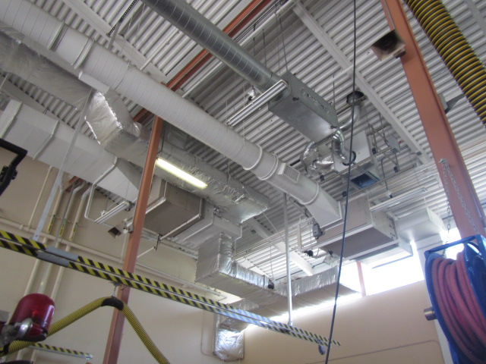

**Ceiling-mounted AHUs**

**Picture 3**

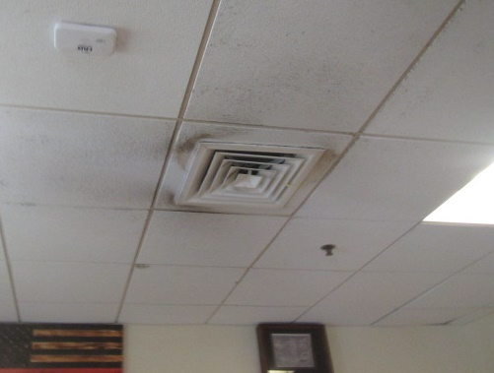

**Ceiling-mounted supply diffuser, note dust/debris on vent and surrounding ceiling tiles**

**Picture 4**

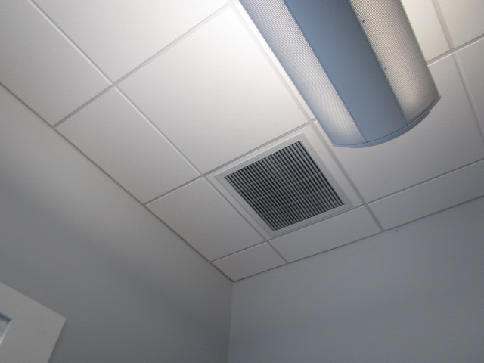

**Ceiling-mounted return vent**

**Picture 5**

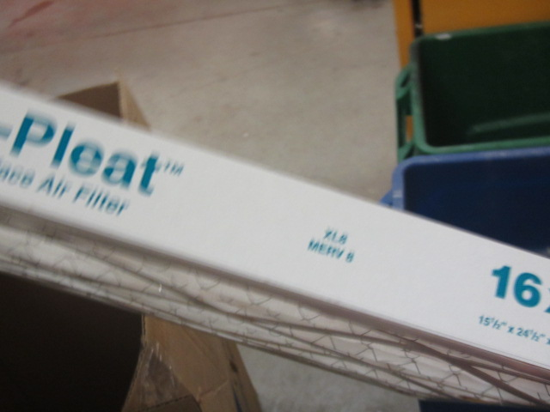

**Pleated MERV 8 filter**

**Picture 6**

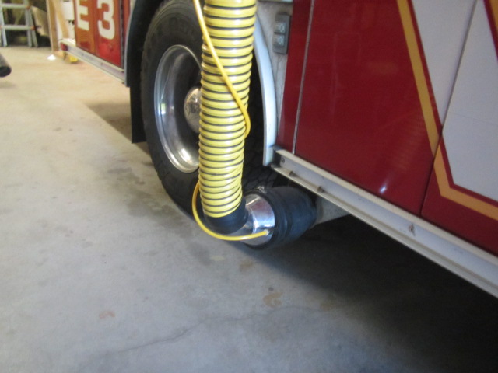

**Plymovent attached to tailpipe of fire apparatus**

**Picture 7**

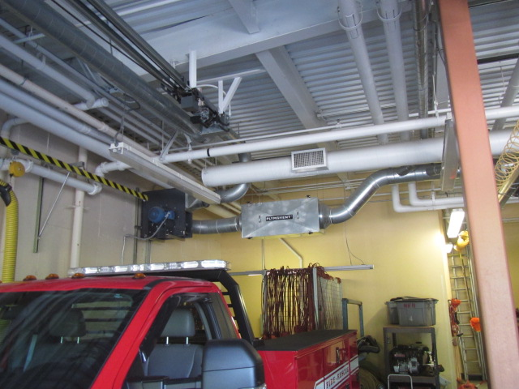

**Plymovent system (arrow)**

**Picture 8**

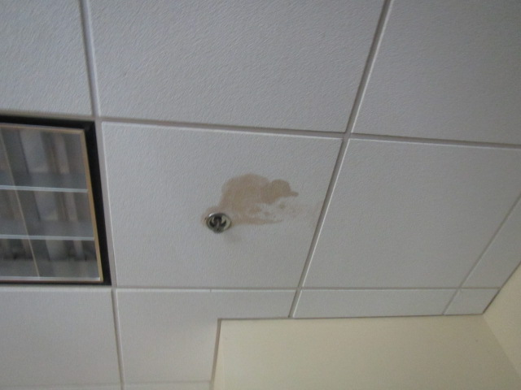

**Water-damaged ceiling tile**

**Picture 9**

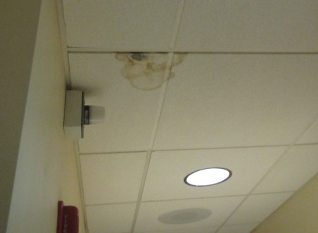

**Water-damaged ceiling tile in hallway outside room 120**

**Picture 10**

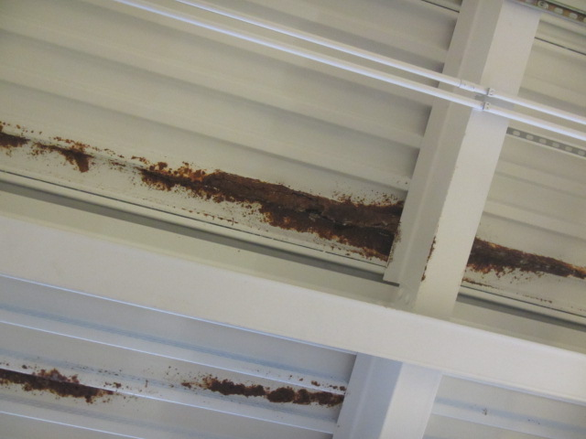

**Corrosion on the underside of the lower apparatus bay ceiling**

**Picture 11**

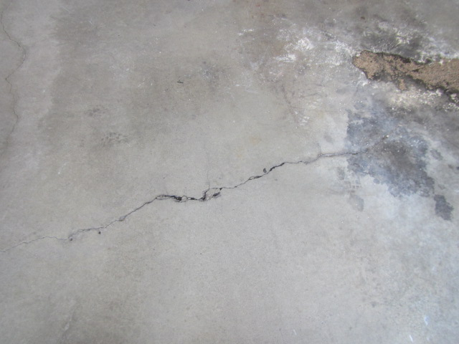

**Cracking in the upper apparatus bay concrete floor**

**Picture 12**

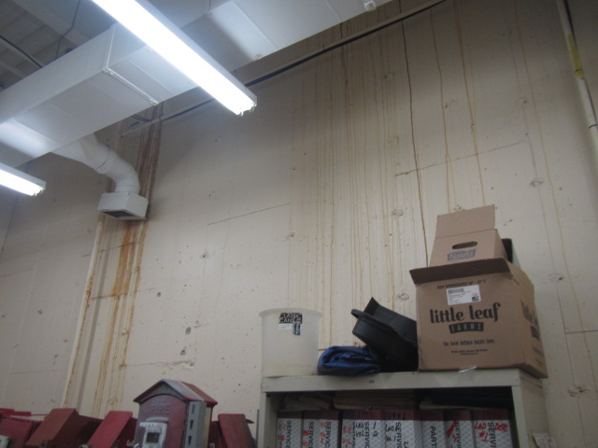

**Staining on walls indicating current/historic water infiltration**

**Picture 13**

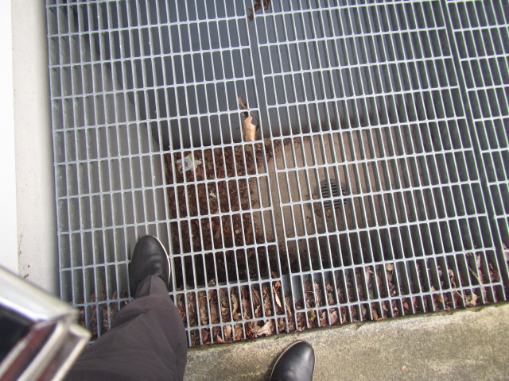

**Subterranean pit with air intake and floor drain, note leaf/debris accumulation**

**Picture 14**

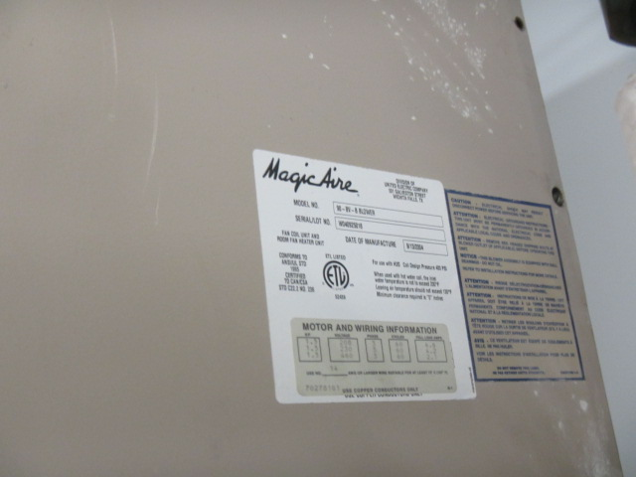

**White splotchy material on AHU housing indicating mold growth on surface**

**Picture 15**

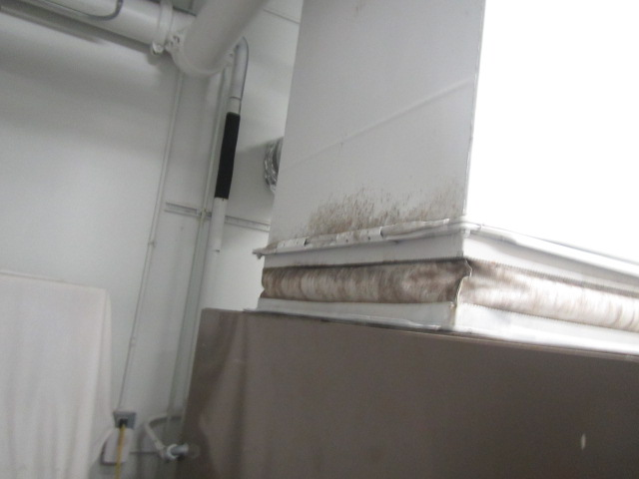

**Grey splotchy material on exterior of AHU ductwork indicating mold growth on surface**

**Picture 16**

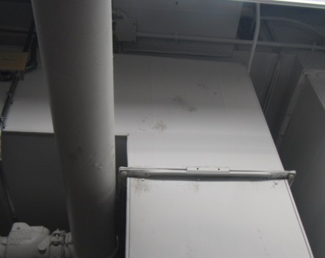

**Grey splotchy material on exterior of AHU ductwork indicating mold growth on surface**

**Picture 17**

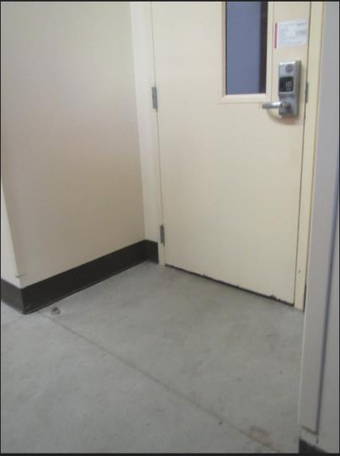

**Space beneath door to apparatus bay**

**Picture 18**

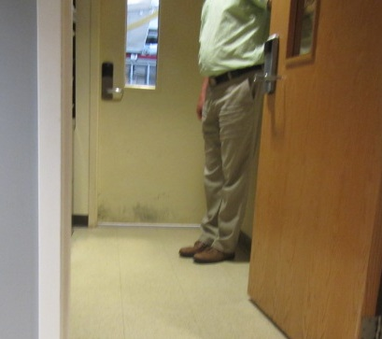

**Space beneath door to apparatus bay**

**Picture 19**

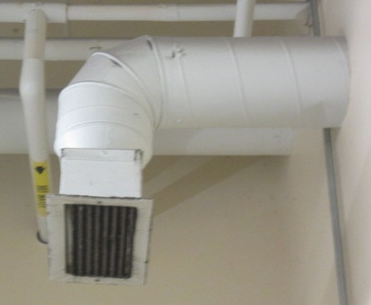

**Dust/debris accumulation on exhaust vent**

**Picture 20**

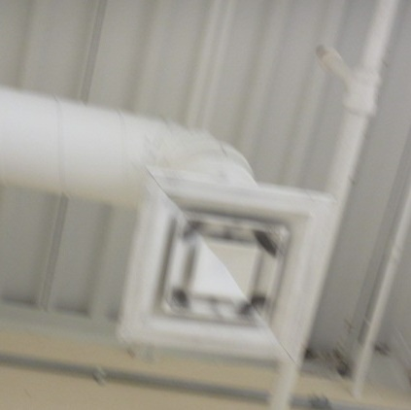

**Dust/debris accumulation on supply diffuser**

| Location | **Carbon**  **Dioxide**  **(ppm)** | **Carbon Monoxide**  **(ppm)** | **Temp**  **(°F)** | **Relative**  **Humidity**  **(%)** | **PM2.5**  **(µg/m3)** | **Occupants**  **in Room** | **Windows**  **Openable** | **Ventilation** | | **Remarks** |
| --- | --- | --- | --- | --- | --- | --- | --- | --- | --- | --- |
| **Supply** | **Exhaust** |
| Background | 349 | ND | 83 | 60 | 13 |  |  |  |  | Unseasonably warm and humid |
| 1st Fl Conference Room | 797 | ND | 71 | 53 | 12 | 4 | Y | Y | Y |  |
| 1st Fl Mechanical Room |  |  |  |  |  |  |  |  |  | Visible mold on ductwork and air handling unit surfaces |
| Laundry | 506 | ND | 73 | 54 | 20 | 0 | N | Y | Y | Dust/debris on vents |
| Turn Out Gear | 551 | ND | 73 | 51 | 20 | 0 | N | Y | Y | Dust/debris on vents, water infiltration/stains on rear wall |
| Lower Engine Bay | 550 | ND | 68 | 50 | 18 | 0 | N | Y | Y | Spaces under engine bay doors to occupied areas, severe corrosion metal ceiling due to water infiltration issues above, plymovents |
| Gym | 515 | ND | 73 | 50 | 9 | 0 | N | Y | Y |  |
| 203 | 554 | ND | 68 | 48 | 14 | 0 | Y | Y | Y | Dust/debris on vents, carpeting |
| 204 | 483 | ND | 67 | 50 | 15 | 0 | Y | Y | Y | Dust/debris on vents, carpeting |
| 205 | 474 | ND | 67 | 49 | 15 | 0 | Y | Y | Y | Dust/debris on vents, carpeting |
| 113 | 509 | ND | 69 | 60 | 12 | 0 | Y | Y | Y | Dust/debris on vents, carpeting |
| Turn Out Gear | 497 | ND | 80 | 45 | 15 | 0 | N |  | Y | Exhaust vent reactivated by Fire Chief on-site, door undercut |
| Day Room | 600 | ND | 75 | 54 | 13 | 1 | Y | Y | Y | Dust/debris on vents/ceiling tiles, gas stove-vented |
| 118 | 529 | ND | 72 | 55 | 12 | 0 | Y | Y | Y | Dust/debris on vents, carpeting |
| 119 | 504 | ND | 72 | 56 | 14 | 0 | Y | Y | Y | 2 WD CTs, carpeting |
| 120 | 566 | ND | 71 | 55 | 11 | 0 | Y | Y | Y | 3 WD CTs, carpeting |
| Hallway (outside 120) |  |  |  |  |  |  |  |  |  | WD CT-black stain (possible mold) |
| 121 | 495 | ND | 72 | 56 | 13 | 0 | Y  Open | Y | Y | WD CT |
| Upper Engine Bay | 448 | ND | 68 | 48 | 16 | 0 | N | Y | Y | Floor cracks in concrete – water infiltration issues near engine bay doors, plymovents |