INDOOR AIR QUALITY ASSESSMENT

Holbrook Junior/Senior High School
245 South Franklin Street
Holbrook, MA 02343

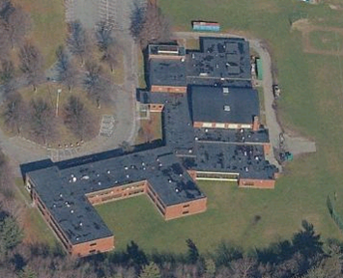

Prepared by:
Massachusetts Department of Public Health
Bureau of Environmental Health
Indoor Air Quality Program
March 2008

Background/Introduction
At the request of the Holbrook Board of Selectmen and the Holbrook Board of Health (HBOH), the Massachusetts Department of Public Health (MDPH), Bureau of Environmental Health (BEH) provided assistance and consultation regarding indoor air quality concerns at Holbrook Junior/Senior High School (HJSHS), 245 South Franklin Street, Holbrook, Massachusetts. Complaints of poor sanitary conditions and deteriorating conditions of the school prompted the request. On January 8, 2007, a visit was made to HJSHS by Cory Holmes, Sharon Lee, Susan Koszalka and James Tobin, Environmental Analysts in BEH’s Indoor Air Quality (IAQ) Program, to conduct an assessment. BEH staff were accompanied by Kathy Moriarty, Public Health Agent, HBOH; and for portions of the assessment, Edward Dunn, High School Principal and Don Quimby, Facilities Manager, Holbrook Public Schools.
The school was constructed in 1956 combining a U-shaped classroom wing attached to a gym and auditorium wing. The school contains 30 full-sized classrooms, 8 smaller educational classrooms for specialized instruction, science classrooms, a computer room, a gymnasium, locker rooms, kitchen/cafeteria, library, auditorium and music/band rooms. The majority of building components are original; however several areas have undergone improvements since its construction. Noted improvements include:
- a new single ply roof around 1990; a science lab renovation in 1995;
- total floor refinishing of the gymnasium in 2005;
- a replacement of the school’s window systems (in the early 1990s); and
- replacement of mechanical ventilation components (in the early 1990s).

Methods
Air tests for carbon monoxide, carbon dioxide, temperature and relative humidity were conducted with the TSI, Q-Trak, IAQ Monitor, Model 8551. Air tests for airborne particle matter with a diameter less than 2.5 micrometers were taken with the TSI, DUSTTRAK™ Aerosol Monitor Model 8520. MDPH staff also performed visual inspection of building materials for water damage and/or microbial growth.

Results
The school houses approximately 517 junior and high school students in grades 7 to 12 with approximately 75 staff members. Tests were taken during normal operations at the school and results appear in Table 1.

Discussion
Ventilation
It can be seen from Table 1 that carbon dioxide levels were above 800 parts per million (ppm) in 44 of 53 areas during the assessment, with several rooms at or close to 2,000 ppm. These elevated levels of carbon dioxide indicate poor air exchange in the majority of the areas surveyed, mainly due to deactivated/non-functional mechanical ventilation equipment. It is also important to note that several classrooms had open windows and/or were empty/sparsely populated, which typically can greatly reduce carbon dioxide levels. Carbon dioxide levels would be expected to be higher with full occupancy and with windows closed.
Fresh air is supplied to classrooms by unit ventilator (univent) systems (Pictures 1 and 2). A univent draws air from the outdoors through a fresh air intake located on the exterior wall of the building (Picture 3) or rooftop (Picture 4) and returns air through an air intake located at the base of the unit (Figure 1). Fresh and return air are mixed, filtered, heated and provided to classrooms through an air diffuser located in the top of the unit. Univents have control settings of off, low or high (Picture 5). Univents were found deactivated in many areas; therefore there was no means to provide mechanical ventilation to classrooms at the time of the assessment. Univents were also found obstructed by various items or had missing panels, exposing the interior of the units. In one instance (Room 112), the univent air diffuser was sealed with sheet metal (Picture 6). In order for univents to provide fresh air as designed, intakes/returns must remain free of obstructions. Importantly, these units must remain “on” and be allowed to operate while rooms are occupied.
Exhaust ventilation in classrooms is provided by wall or ceiling vents ducted to rooftop motors (Pictures 7 and 8). Many exhaust vents were deactivated at the time of the assessment. As with univents, in order to function properly, exhaust vents must be activated and allowed to operate while rooms are occupied. Without adequate supply and exhaust ventilation, excess heat and environmental pollutants can build up and lead to indoor air/comfort complaints.
Mechanical ventilation in common areas (e.g., gym, locker rooms, auditorium and cafeteria) is provided by rooftop or ceiling-mounted air-handling units (AHUs). Fresh air is distributed via ceiling-mounted air diffusers and ducted back to AHUs via return vents at the base of the units (Pictures 9 and 10). These units were deactivated at the time of the assessment; therefore, there were no means of mechanical air exchange which was evidenced by the elevated carbon dioxide levels in the gym (952 ppm).
To maximize air exchange, the MDPH recommends that both supply and exhaust ventilation operate continuously during periods of school occupancy. In order to have proper ventilation with a mechanical supply and exhaust system, the systems must be balanced to provide an adequate amount of fresh air to the interior of a room while removing stale air from the room. It is recommended that HVAC systems be re-balanced every five years to ensure adequate air systems function (SMACNA, 1994). The last balancing of these systems was likely at the time of the installation, approximately 15 years ago.
The Massachusetts Building Code requires a minimum ventilation rate of 15 cubic feet per minute (cfm) per occupant of fresh outside air or have openable windows in each room (SBBRS, 1997; BOCA, 1993). The ventilation must be on at all times that the room is occupied. Providing adequate fresh air ventilation with open windows and maintaining the temperature in the comfort range during the cold weather season is impractical. Mechanical ventilation is usually required to provide adequate fresh air ventilation.
Carbon dioxide is not a problem in and of itself. It is used as an indicator of the adequacy of the fresh air ventilation. As carbon dioxide levels rise, it indicates that the ventilating system is malfunctioning or the design occupancy of the room is being exceeded. When this happens, a buildup of common indoor air pollutants can occur, leading to discomfort or health complaints. The Occupational Safety and Health Administration (OSHA) standard for carbon dioxide is 5,000 parts per million parts of air (ppm). Workers may be exposed to this level for 40 hours/week, based on a time-weighted average (OSHA, 1997).
The MDPH uses a guideline of 800 ppm for publicly occupied buildings. A guideline of 600 ppm or less is preferred in schools due to the fact that the majority of occupants are young and considered to be a more sensitive population in the evaluation of environmental health status. Inadequate ventilation and/or elevated temperatures are major causes of complaints such as respiratory, eye, nose and throat irritation, lethargy and headaches. For more information concerning carbon dioxide, consult Appendix A.
Temperature measurements ranged from 69º F to 75º F, which were within the MDPH recommended comfort range in the majority of areas surveyed. The MDPH recommends that indoor air temperatures be maintained in a range of 70º F to 78º F in order to provide for the comfort of building occupants. In many cases concerning indoor air quality, fluctuations of temperature in occupied spaces are typically experienced, even in a building with an adequate fresh air supply. In addition, it is difficult to control temperature and maintain comfort without operating the ventilation equipment as designed (e.g., univents/exhaust vents deactivated/obstructed). Missing radiator grates were observed in classroom 112 (Picture 11), which can create uneven heating and/or a safety hazard.
The relative humidity measured in the building ranged from 29 to 49 percent, which were within or close to the MDPH recommended comfort range in the majority of areas surveyed (Table 1). The MDPH recommends a comfort range of 40 to 60 percent for indoor air relative humidity. Relative humidity levels in the building would be expected to drop during the winter months due to heating. The sensation of dryness and irritation is common in a low relative humidity environment. Low relative humidity is a very common problem during the heating season in the northeast part of the United States.

Microbial/Moisture Concerns
Several potential sources of water damage and mold growth were observed. Numerous areas had water-damaged/missing ceiling tiles which can indicate leaks from either the roof or plumbing system (Pictures 12 and 13/Table 1). Active leaks were reported along windows in room 112. In many areas, ceiling tiles have been completely removed or are loose/hanging creating physical hazards (Pictures 13 through 15). Water-damaged ceiling tiles can provide a source of mold and should be replaced after a water leak is discovered and repaired.
The US Environmental Protection Agency (US EPA) and the American Conference of Governmental Industrial Hygienists (ACGIH) recommend that porous materials be dried with fans and heating within 24 to 48 hours of becoming wet (US EPA, 2001; ACGIH, 1989). If not dried within this time frame, mold growth may occur. Once mold has colonized porous materials, they are difficult to clean and should be removed/discarded.
Open seams between sink countertops and walls were observed in several rooms (Picture 16/Table 1). If not watertight, moisture can penetrate through the seam, causing water damage. Improper drainage or sink overflow can lead to water penetration into the countertop, cabinet interior and areas behind cabinets. Water penetration and chronic exposure of porous and wood-based materials can cause these materials to swell and show signs of water damage.
Plants were observed growing in close proximity to a univent fresh air intake along the exterior (Picture 17). Shrubbery and flowering plants can be sources of mold and pollen and should be located away from fresh air intakes to prevent entrainment.
Also noted on the exterior of the building were missing panels (Picture 18), damaged brickwork and missing/damaged mortar around masonry (Pictures 19 and 20). Freezing/thawing action during winter months can further weaken bricks and mortar. Over time, this process can undermine the integrity of the building envelope, providing a means of water entry into the building via capillary action through foundation concrete and masonry (Lstiburek & Brennan, 2001).

Other IAQ Evaluations
Indoor air quality can be negatively influenced by the presence of respiratory irritants, such as products of combustion. The process of combustion produces a number of pollutants. Common combustion emissions include carbon monoxide, carbon dioxide, water vapor and smoke (fine airborne particle material). Of these materials, exposure to carbon monoxide and particulate matter with a diameter of 2.5 micrometers (μm) or less (PM2.5) can produce immediate, acute health effects upon exposure. To determine whether combustion products were present in the school environment, BEH staff obtained measurements for carbon monoxide and PM2.5.
Carbon monoxide is a by-product of incomplete combustion of organic matter (e.g., gasoline, wood and tobacco). Exposure to carbon monoxide can produce immediate and acute health affects. Several air quality standards have been established to address carbon monoxide and prevent symptoms from exposure to these substances. The MDPH established a corrective action level concerning carbon monoxide in ice skating rinks that use fossil-fueled ice resurfacing equipment. If an operator of an indoor ice rink measures a carbon monoxide level over 30 ppm, taken 20 minutes after resurfacing within a rink, that operator must take actions to reduce carbon monoxide levels (MDPH, 1997).
The American Society of Heating Refrigeration and Air-Conditioning Engineers (ASHRAE) has adopted the National Ambient Air Quality Standards (NAAQS) as one set of criteria for assessing indoor air quality and monitoring of fresh air introduced by HVAC systems (ASHRAE, 1989). The NAAQS are standards established by the US EPA to protect the public health from six criteria pollutants, including carbon monoxide and particulate matter (US EPA, 2006). As recommended by ASHRAE, pollutant levels of fresh air introduced to a building should not exceed the NAAQS levels (ASHRAE, 1989). The NAAQS were adopted by reference in the Building Officials & Code Administrators (BOCA) National Mechanical Code of 1993 (BOCA, 1993), which is now an HVAC standard included in the Massachusetts State Building Code (SBBRS, 1997). According to the NAAQS, carbon monoxide levels in outdoor air should not exceed 9 ppm in an eight-hour average (US EPA, 2006).
Carbon monoxide should not be present in a typical, indoor environment. If it is present, indoor carbon monoxide levels should be less than or equal to outdoor levels. On the day of assessment, outdoor carbon monoxide concentrations were non-detect (ND) (Table 1). Carbon monoxide levels measured in the school were also ND.
The US EPA has established NAAQS limits for exposure to particulate matter. Particulate matter is airborne solids that can be irritating to the eyes, nose and throat. The NAAQS originally established exposure limits to particulate matter with a diameter of 10 μm or less (PM10). According to the NAAQS, PM10 levels should not exceed 150 microgram per cubic meter (μg/m³) in a 24-hour average (US EPA, 2006). These standards were adopted by both ASHRAE and BOCA. Since the issuance of the ASHRAE standard and BOCA Code, US EPA established a more protective standard for fine airborne particles. This more stringent PM2.5 standard requires outdoor air particle levels be maintained below 35 μg/m³ over a 24-hour average (US EPA, 2006). Although both the ASHRAE standard and BOCA Code adopted the PM10 standard for evaluating air quality, MDPH uses the more protective PM2.5 standard for evaluating airborne particulate matter concentrations in the indoor environment.
Outdoor PM2.5 concentrations were measured at 47 μg/m³ (Table 1). This level exceeds the NAAQS PM2.5 level of 35 μg/m³; however, these outdoor PM2.5 levels were predicted (50-100 μg/m³) for the day of the assessment (AIRNow, 2008). The U.S. Environmental Protection Agency, National Oceanic and Atmospheric Agency, National Park Services, tribal, state, and local agencies developed the AIRNow Web site to provide the public with easy access to national air quality information. PM2.5 levels measured in the school ranged between 17 to 49 μg/m³ (Table 1). The large majority of PM2.5 measurements were below the NAAQS PM2.5 level of 35 μg/m³; however, PM2.5 measurements in a few locations were above the NAAQS standard the day of the assessment (Table 1), most likely due to a combination of elevated outdoor levels and deactivated mechanical ventilation equipment.
Frequently, indoor air levels of particulates (including PM2.5) can be at higher levels than those measured outdoors. A number of mechanical devices and/or activities that occur in schools can generate particulates during normal operations. Sources of indoor airborne particulates may include but are not limited to particles generated during the operation of fan belts in the HVAC system, cooking in the cafeteria stoves and microwave ovens; use of photocopiers, fax machines and computer printing devices; operation of an ordinary vacuum cleaner and heavy foot traffic indoors.
Indoor air quality can also be negatively influenced by the presence of materials containing volatile organic compounds (VOCs). VOCs are carbon-containing substances that have the ability to evaporate at room temperature. Frequently, exposure to low levels of total VOCs (TVOCs) may produce eye, nose, throat and/or respiratory irritation in some sensitive individuals. For example, chemicals evaporating from a paint can stored at room temperature would most likely contain VOCs. In an effort to determine whether VOCs were present in the building, air monitoring for TVOCs was conducted. An outdoor air sample was taken for comparison. Outdoor TVOC concentrations were ND (Table 1). Indoor TVOC concentrations were also ND (Table 1).
Chemistry classrooms were equipped with fume hoods. The efficacy of the draw of air through this equipment could not be determined. In addition, no record of the last date of calibration/inspection of the hoods was readily apparent. Chemical hoods should be recalibrated on an annual basis or as recommended by the manufacturer to ensure proper function.
The copy room contains two photocopiers. This area is not equipped with local exhaust ventilation to help reduce excess heat and odors. VOCs and ozone can be produced by photocopiers, particularly if the equipment is older and in frequent use. Ozone is a respiratory irritant (Schmidt Etkin, 1992).
Air fresheners and other scented materials (i.e., fragrant candles) were observed in some areas (Pictures 21 and 23). Air fresheners and candles can contain chemicals that can be irritating to the eyes, nose and throat of sensitive individuals. Furthermore, deodorizing agents do not remove materials causing odors, but rather mask odors that may be present in the area.
Other conditions that can affect indoor air quality were observed during the assessment. In several classrooms, items were observed on the floor, windowsills, tabletops, counters, bookcases and desks (Pictures 23 through 25). The large number of items stored in classrooms provides a source for dusts to accumulate. These items (e.g., papers, folders, boxes) make it difficult for custodial staff to clean. Items should be relocated and/or be cleaned periodically to avoid excessive dust build up. In addition, these materials can accumulate on flat surfaces (e.g., desktops, shelving and carpets) in occupied areas and subsequently be re-aerosolized causing further irritation.
A number of exhaust/return vents, univent supply vents and personal fans (Picture 26 and 27) were observed to have accumulated dust. If exhaust vents are not functioning, backdrafting can occur, which can re-aerosolize accumulated dust particles. Re-activated univents and fans can also aerosolize dust accumulated on vents/fan blades.
An accumulation of chalk dust, pencil shavings and dry erase particulate was observed in some classrooms (Picture 28). When windows are opened or univents are operating, these materials can become airborne. Once aerosolized, they can act as irritants to eyes and the respiratory system.
Open utility holes and missing ceiling tiles were observed in the library (Picture 29) and other areas (Table 1), which can provide pathways for drafts, dust and particulates to migrate into occupied areas. Exposed fiberglass insulation was observed around the univent in classroom 207. Fiberglass insulation can provide a source of eye, skin and respiratory irritation.
A number of aquariums and terrariums were located in the classrooms. Murky water was observed in one aquarium. Aquariums should be properly maintained to prevent microbial/algal growth, which can emit unpleasant odors. Similarly, terrariums should be properly maintained to ensure soil does not become a source for mold growth.
In both the boys’ and girls’ locker rooms, abandoned sinks and decommissioned showers were noted (Picture 30). In addition, emergency safety showers and eyewash stations were observed. One particular eyewash station was sealed. The traps for these drains can dry out which can lead to sewer gas odors penetrating the room through unsealed traps. Sewer gas odors can be irritating to the eyes, nose, and throat.

Recommendations
The conditions related to indoor air quality problems at the HJSHS raise a number of issues. The general building conditions, maintenance, work hygiene practices and the condition of HVAC equipment, if considered individually, present conditions that could degrade indoor air quality. When combined, these conditions can serve to further degrade indoor air quality. Some of these conditions can be remedied by actions of building occupants. Other remediation efforts will require alteration to the building structure and equipment. For these reasons, a two-phase approach is required for remediation. The first consists of short-term measures to improve air quality and the second consists of long-term measures that will require planning and resources to adequately address the overall indoor air quality concerns.

The following short-term measures should be considered for implementation:
- Examine each univent for function. Survey classrooms for univent function to ascertain if an adequate air supply exists for each room. Consider consulting a heating, ventilation and air conditioning (HVAC) engineer concerning the calibration of univent fresh air control dampers throughout the school.
- Replacing missing univent cabinet panels.
- Operate all ventilation systems throughout the building (e.g., gym, locker rooms, cafeteria, classrooms) continuously during periods of school occupancy and independent of thermostat control. To increase airflow in classrooms, set univent controls to “high”.
- Inspect exhaust motors and belts for proper function. Repair and replace as necessary.
- Remove all blockages from univents (e.g., sheet metal/Picture 6) and exhaust vents to ensure adequate airflow.
- Close classroom doors to maximize air exchange.
- Use openable windows in conjunction with classroom univents and exhaust vents to increase air exchange. Care should be taken to ensure windows are properly closed at night and weekends to avoid the freezing of pipes and potential flooding.
- Replace/repair missing/damaged radiator baseboard cover in classroom 112 (Picture 11).
- Ensure chemical exhaust hoods in science areas are operating properly. Science staff should work with school administration and their HVAC vendor to develop a preventative maintenance program for all local exhaust equipment (e.g., lab hoods, prep rooms).
- Consider adopting a balancing schedule of every 5 years for all mechanical ventilation systems, as recommended by ventilation industrial standards (SMACNA, 1994).
- For buildings in New England, periods of low relative humidity during the winter are often unavoidable. Therefore, scrupulous cleaning practices should be adopted to minimize common indoor air contaminants whose irritant effects can be enhanced when the relative humidity is low. To control for dusts, a high efficiency particulate arrestance (HEPA) filter equipped vacuum cleaner in conjunction with wet wiping of all surfaces is recommended. Avoid the use of feather dusters. Drinking water during the day can help ease some symptoms associated with a dry environment (throat and sinus irritations).
- Ensure roof/window leaks are repaired and remove/replace any remaining water-stained ceiling tiles.
- Remove all loose/hanging ceiling tiles to prevent falling hazards.
- Move plants along the exterior of univent air intakes approximately 5-feet to prevent entrainment of pollen, moisture or mold.
- Seal areas around sinks to prevent water damage to the interior of cabinets and adjacent wallboard. Inspect wallboard for water damage and mold growth, repair/replace as necessary. Disinfect areas with an appropriate antimicrobial, as needed.
- Replace/repair missing/damaged exterior wall panels (Picture 18).
- Contact a masonry firm or general contractor to repair holes/breaches in exterior walls to prevent water penetration, drafts and pest entry.
- Change filters for air-handling equipment (e.g., univents, AHUs and ACs) as per the manufacturer’s instructions or more frequently if needed. Vacuum interior of units prior to activation to prevent the aerosolization of dirt, dust and particulates. Ensure filters fit flush in their racks with no spaces in between allowing bypass of unfiltered air into the unit.
- Relocate or consider reducing the amount of materials stored in classrooms to allow for more thorough cleaning of classrooms. Clean items regularly with a wet cloth or sponge to prevent excessive dust build-up.
- Clean personal fans, univent air diffusers, return vents and exhaust vents periodically of accumulated dust.
- Clean chalk trays, dry erase board trays and areas around pencil sharpeners to prevent accumulation of materials.
- Clean and maintain aquariums and terrariums to prevent mold growth and associated odors.
- Remove abandoned sink; cap abandoned plumbing fixtures (sinks, showers, water fountains) or ensure water is poured into the drains every other day (or as needed) to maintain the integrity of the traps.
- Refrain from using air fresheners and deodorizers to prevent exposure to VOCs.
- Unseal eyewash station; flush out weekly or as recommended by the manufacturer (ANSI, 2004). Work with science staff/Department Head in developing a preventative maintenance program for emergency showers and eye wash stations.
- Encapsulate exposed fiberglass insulation around the univent in classroom 207.
- For more advice on mold please consult the document “Mold Remediation in Schools and Commercial Buildings” published by the US Environmental Protection Agency (US EPA, 2001). Copies of this document can be downloaded from the US EPA website at: http://www.epa.gov/iaq/molds/mold_remediation.html.
- Consider adopting the US EPA (2000) document, “Tools for Schools”, as an instrument for maintaining a good indoor air quality environment in the building. This document is available at: http://www.epa.gov/iaq/schools/index.html.
- Refer to resource manual and other related indoor air quality documents located on the MDPH’s website for further building-wide evaluations and advice on maintaining public buildings. These documents are available at: http://www.state.ma.us/dph/MDPH/iaq/iaqhome.htm.

The following long-term measures should be considered:
- Contact an HVAC engineering firm for an assessment of the ventilation system’s control system (e.g., controls, air intake louvers, thermostats). Based on the age, physical deterioration and availability of parts for ventilation components, such an evaluation is necessary to determine the operability and feasibility of repairing/replacing the equipment.
- Consider having exterior walls re-pointed and waterproofed to prevent water intrusion. This measure should include a full building envelope evaluation.
- Consider total removal/replacement of ceiling tile system.
- Examine the feasibility of installing local exhaust ventilation for photocopiers or move to a well-ventilated area.

References

ACGIH. 1989. Guidelines for the Assessment of Bioaerosols in the Indoor Environment. American Conference of Governmental Industrial Hygienists, Cincinnati, OH.
ASHRAE. 1989. Ventilation for Acceptable Indoor Air Quality. American Society of Heating, Refrigeration and Air Conditioning Engineers. ANSI/ASHRAE 62-1989

BOCA. 1993. The BOCA National Mechanical Code/1993. 8th ed. Building Officials and Code Administrators International, Inc., Country Club Hill, IL.

MDPH. 1997. Requirements to Maintain Air Quality in Indoor Skating Rinks (State Sanitary Code, Chapter XI). 105 CMR 675.000. Massachusetts Department of Public Health, Boston, MA.
OSHA. 1997. Limits for Air Contaminants. Occupational Safety and Health Administration. Code of Federal Regulations. 29 C.F.R 1910.1000 Table Z-1-A.
Sanford. 1999. Material Safety Data Sheet (MSDS No: 198-17). Expo® Dry Erase Markers Bullet, Chisel, and Ultra Fine Tip. Sanford Corporation. Bellwood, IL.
SBBRS. 1997. Mechanical Ventilation. State Board of Building Regulations and Standards. Code of Massachusetts Regulations. 780 CMR 1209.0
SMACNA. 1994. HVAC Systems Commissioning Manual. 1st ed. Sheet Metal and Air Conditioning Contractors’ National Association, Inc., Chantilly, VA.

US EPA. 1992. Indoor Biological Pollutants. US Environmental Protection Agency, Environmental Criteria and Assessment Office, Office of Health and Environmental Assessment, research Triangle Park, NC. EPA 600/8-91/202 January 1992.
US EPA. 2001. Mold Remediation in Schools and Commercial Buildings. US Environmental Protection Agency, Office of Air and Radiation, Indoor Environments Division, Washington, D.C. EPA 402-K-01-001. March 2001.
US EPA. 2006. National Ambient Air Quality Standards (NAAQS). US Environmental Protection Agency, Office of Air Quality Planning and Standards, Washington, DC. http://www.epa.gov/air/criteria.html.
Picture 1

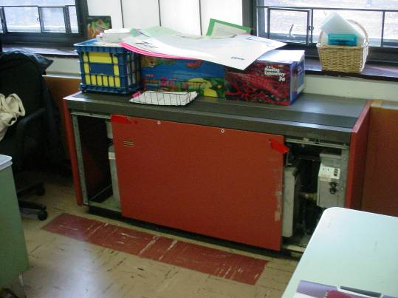

Classroom Univent, Note Missing Panels

Picture 2

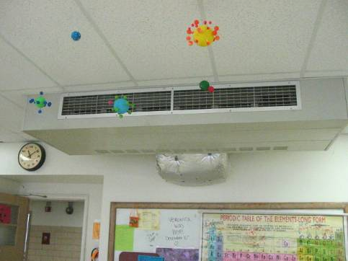

Ceiling-Mounted Univent
Picture 3

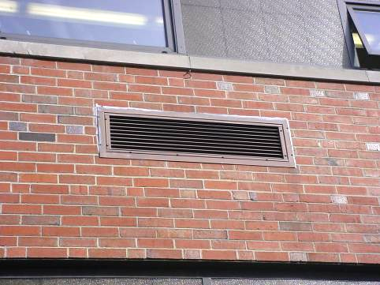

Univent Fresh Air Intake Exterior Wall
Picture 4

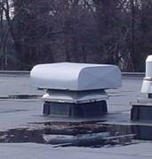

Rooftop Univent Fresh Air Intake for Interior Room
Picture 5

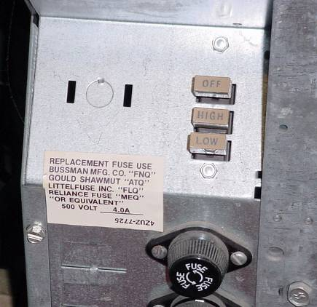

Univent Control Switches Found in Interior of Cabinet

Picture 6

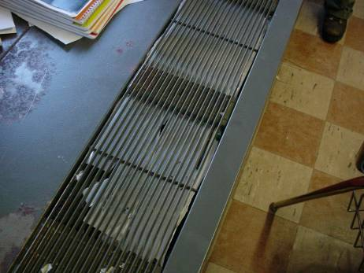

Univent Air Diffuser Sealed with Sheet-Metal
Picture 7

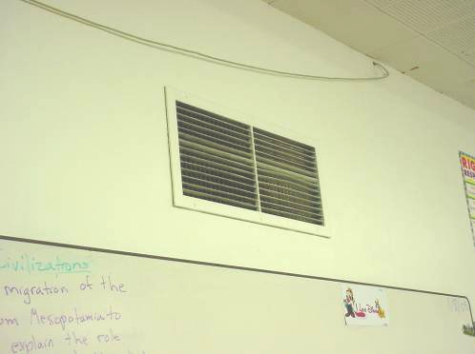

Wall-Mounted Exhaust Vent

Picture 8

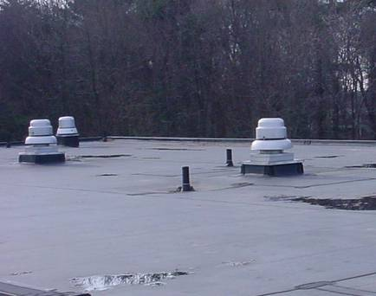

Rooftop Exhaust Motors
Picture 9

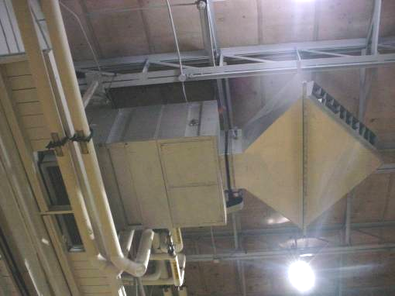

Ceiling-Mounted Air Handling Unit in Gym (One of Four)

Picture 10

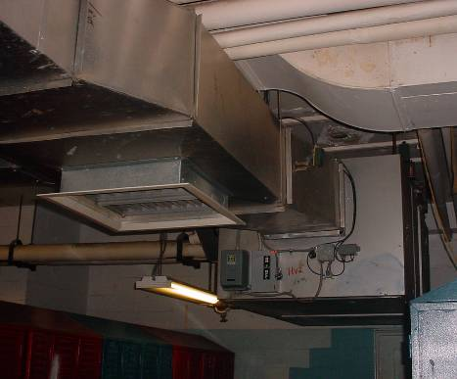

Deactivated AHU in Locker Room
Picture 11

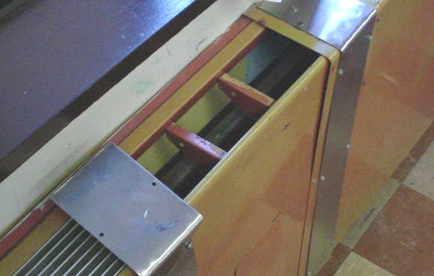

Missing Grates to Radiator System along Exterior Wall in Classroom 112

Picture 12

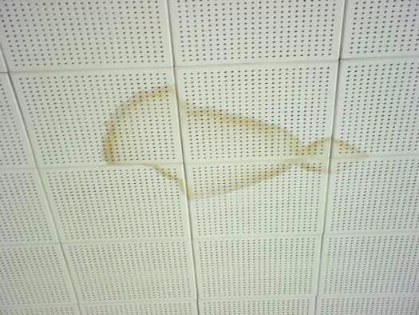

Water Damaged Ceiling Tiles
Picture 13

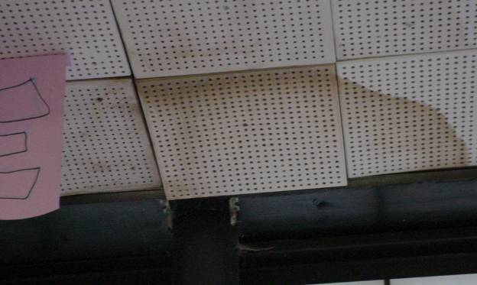

Water Damaged/Loose Ceiling Tiles along Exterior Wall/Window System

Picture 14

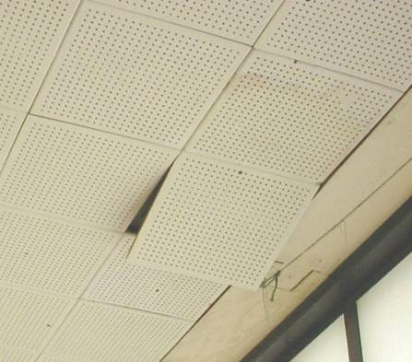

Water Damaged Ceiling Tiles, Note Hanging Tile
Picture 15

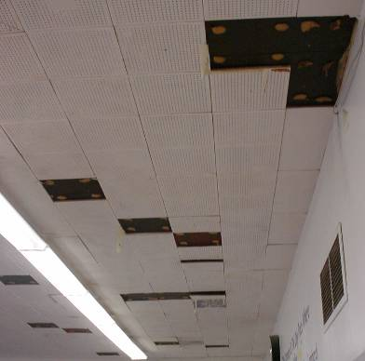

Numerous Missing/Water Damaged Ceiling Tiles in Classroom

Picture 16

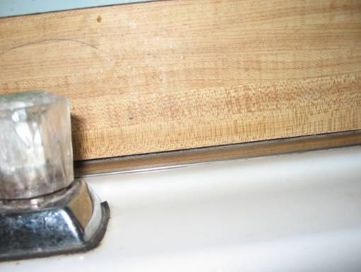

Open Seam between Sink and Wall
Picture 17

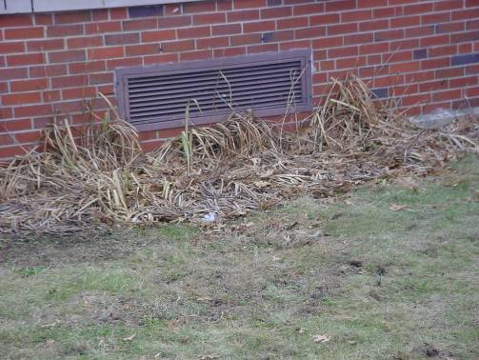

Plants Growing in front of Univent Fresh Air Intake

Picture 18

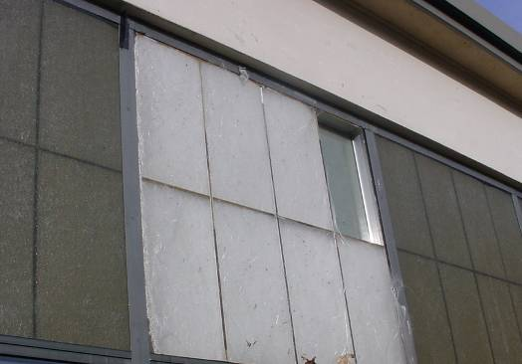

Missing/Damaged Wall Panels along Rear Exterior of Building (Center)
Exposing a Fibrous Mesh Material (Compare to Right and Left)
Picture 19

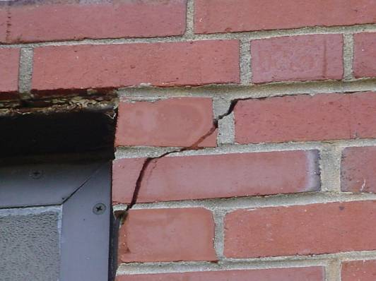

Damaged Brickwork
Picture 20

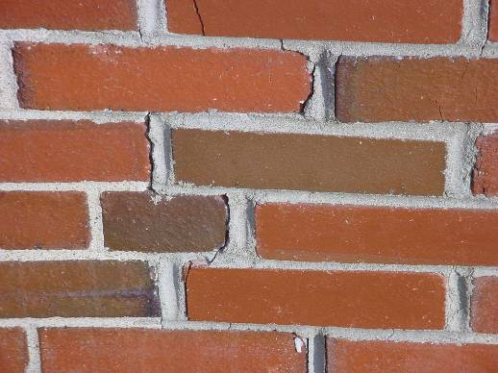

Missing/Damaged Mortar around Brickwork
Picture 21

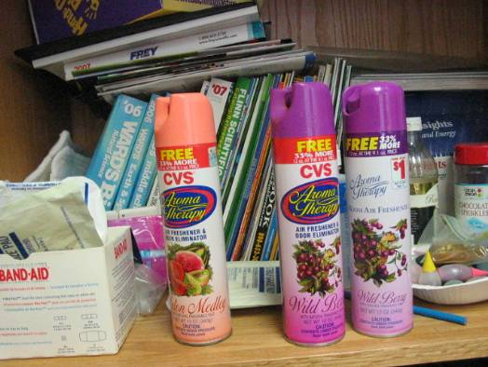

Accumulated Items and Spray Air Fresheners

Picture 22

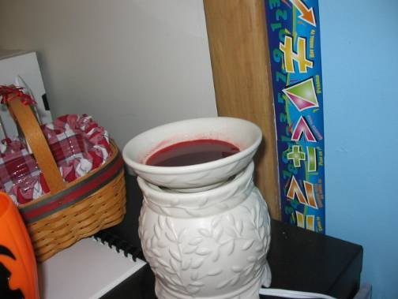

Air Deodorizer
Picture 23

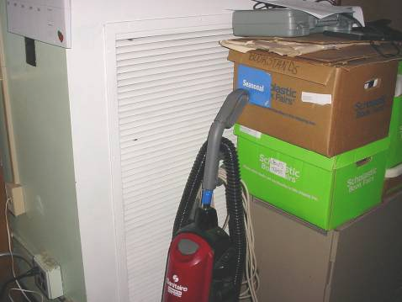

Accumulated Items

Picture 24

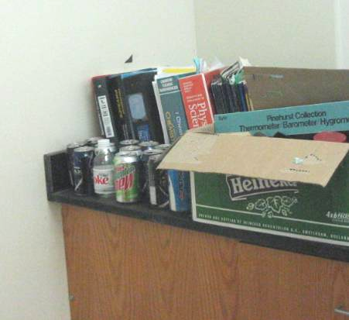

Accumulated Items
Picture 25

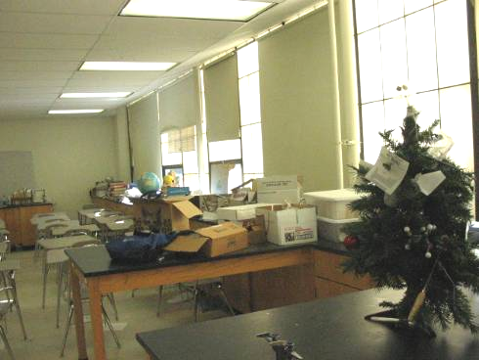

Accumulated Items

Picture 26

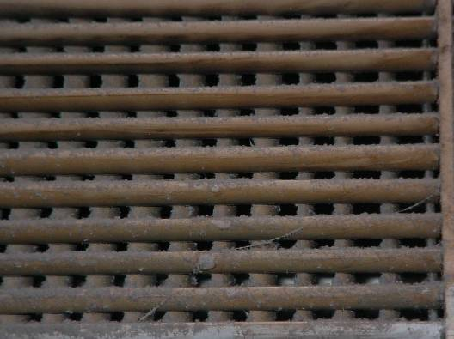

Accumulated Dust/Debris on Exhaust Vent
Picture 27

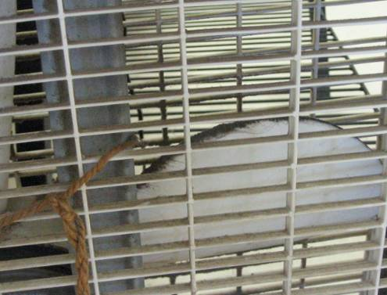

Accumulated Dust/Debris on Personal Fan

Picture 28

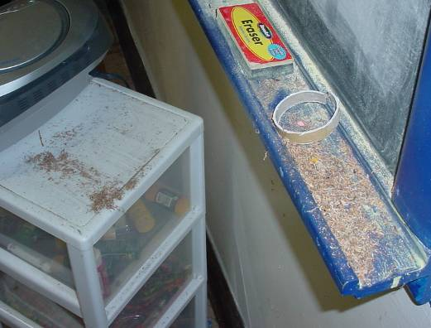

Accumulation of Chalk Dust and Pencil Shavings
Picture 29

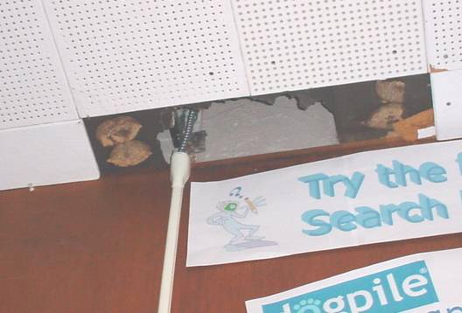

Missing Ceiling Tile in Library

Picture 30

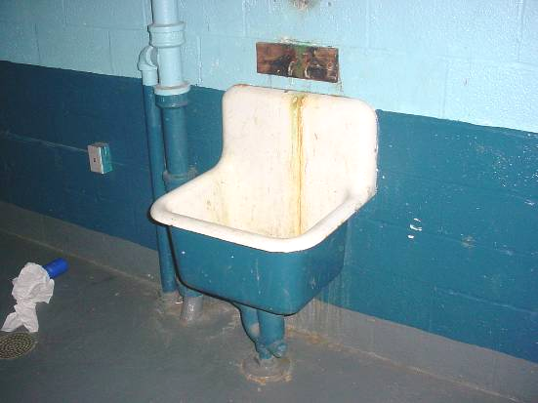

Abandon Sink in Locker Room
Picture 31

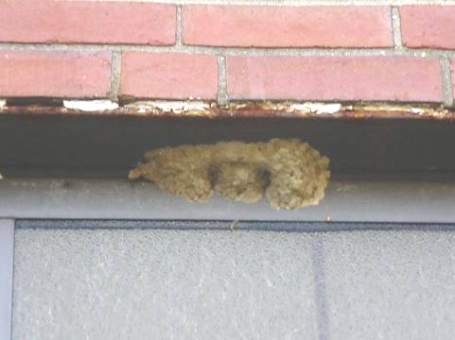

Insect Nest above Window on Exterior of Building

Location/ Room | Occupants  in Room | Temp  (°F) | Relative  Humidity  (%) | Carbon  Dioxide  (ppm) | Carbon Monoxide  (ppm) | TVOCs  (ppm) | PM2.5  (µg/m³) | Windows  Openable | Ventilation |  | Remarks
 |  |  |  |  |  |  |  |  | Supply | Exhaust | Remarks
background |  | 55 | 64 | 359 | ND | ND | 47 |  |  |  | Unseasonably warm;  scattered clouds
101 | 26 | 72 | 42 | 1656 | ND | ND | 21 | Y | Y | Y | UV-Off; DO; CT-WD; CD
102 | 6 | 72 | 43 | 912 | ND | ND | 35 | Y | Y | Y | UV-Off, missing panels
102A | 0 | 73 | 38 | 807 | ND | ND | 24 | Y | Y | Y
103 | 21 | 72 | 43 | 1221 | ND | ND | 26 | Y | Y | Y | UV-Off; blocked; Exhaust-Off; Windows open; CD; DEM; CT-WD
104 | 20 | 74 | 40 | 1266 | ND | ND | 35 | Y | Y | Y | UV-Off, missing panels
105 | 0 | 72 | 40 | 935 | ND | ND | 25 | Y | Y | Y | UV-Off; Items on top; Exhaust-Off, dusty; 7 CT-WD; DEM
106 | 13 | 73 | 44 | 1218 | ND | ND | 38 | Y | Y | Y | UV-Off; DEM
107 | 18 | 73 | 44 | 1187 | ND | ND | 25 | Y | Y | Y | DEM; DO; WD along ceiling, below windows; AC in window
108 | 5 | 74 | 40 | 1411 | ND | ND | 35 | Y | Y | Y | UV-Off; Exhaust-Off; DEM; MT; Dust Accumulation; Debris
109 | 0 | 75 | 38 | 789 | ND | ND | 24 | Y | Y | Y | UV-Off, blocked, draft behind; Exhaust-Off; AD; DEM; clutter; PF; tart burner
110 | 15 | 75 | 46 | 1811 | ND | ND | 40 | Y | Y | Y | UV-Off; Exhaust-Off; MT
111 | 9 | 69 | 44 | 901 | ND | ND | 26 | Y | Y | Y | UV-Off; Exhaust-Weak; Windows open; 6 MT; Full cans on chalk board
112 | 1 | 74 | 40 | 1126 | ND | ND | 33 | Y | Y | Y | 7 occupants gone 1 min;  ½ UVs-On; Off UV sealed; Exhaust-Weak; CT-WD; PS; CD; Active leaks near windows; Missing radiator grates
113A | 7 | 74 | 37 | 871 | ND | ND | 22 | Y | Y | Y | DEM; CD; DO; 13 CT-WD
113B | 0 | 73 | 38 | 935 | ND | ND | 21 | Y | N | N | 1 CT-WD
113C | 0 | 72 | 39 | 1384 | ND | ND | 22 | N |  |  | Passive Supply and Exhaust; subdivided; 8 MT
114 | 26 | 72 | 48 | 1900 | ND | ND | 23 | Y | Y | Y | Exhaust-Off; Window open; DEM; 13 MT
115 | 0 | 72 | 37 | 858 | ND | ND | 17 | Y | Y | Y | CB; PF; 2 PCs; DEM; Crack between backsplash & counter; Dry sink trap; Chemicals under sink; 1 CT-WD
116 | 20 | 75 | 41 | 1481 | ND | ND | 18 | Y | Y | Y | UV-Off; Exhaust-Off; AC in window; DO; DEM; PF; 32 Computers
117 | 18 | 70 | 47 | 1101 | ND | ND | 22 | Y | Y | N | DEM; AC in window; 8 CT-WD
119 (CHARMS) | 8 | 74 | 45 | 1568 | ND | ND | 21 | Y | Y | Y | UV-Off, laminator on top; Exhaust-Off; AC covered; Chemicals under sink; DEM
159 (Portable) | 1 | 71 | 46 | 742 | ND | ND | 23 | Y | Y | Y | AC in window; AC filter dirty; DEM; DO
160 (Portable) | 1 | 70 | 45 | 480 | ND | ND | 23 | Y | Y | Y | UV-Off; Exhaust-Off; AC in window; AC filter dirty; DEM; DO
201 | 0 | 72 | 43 | 1159 | ND | ND | 30 | Y | Y | Y | UV-Off; Exhaust-Weak; Plants; DEM; DO
202 | 29 | 72 | 49 | 2124 | ND | ND | 49 | Y | Y | Y | UV-Off; DO; CT-WD
203 | 0 | 74 | 39 | 1025 | ND | ND | 25 | Y | Y | Y | Exhaust-Weak; Dusty; PF; DEM; AT; 6 CT-WD
204 | 22 | 74 | 46 | 1977 | ND | ND | 44 | Y | Y | Y | UV-Off; DEM; DO; CT-WD; dusty exhaust
205 | 1 | 74 | 41 | 1963 | ND | ND | 29 | Y | Y | Y | 26 occupants gone 2 mins; UV-Off; Exhaust-Weak; Terra/aqua; Items hanging; Breach in CT system; AD; DO; PF-dusty; Unlabeled bottles; Food storage
206 | 1 | 75 | 40 | 1413 | ND | ND | 37 | Y | Y | Y | 25 occupants gone 3 mins; UV-On; Exhaust-Off
207 | 0 | 75 | 36 | 550 | ND | ND | 23 | Y | Y | Y | Lab hood; 5 CT-WD; DEM; Exposed fiberglass insulation around UV duct; clutter; unlabeled bottles; PF; DO
208 | 1 | 73 | 39 | 675 | ND | ND | 38 | Y | Y | Y | 18 occupants gone 22 mins;  2 UVs-Off; DEM; Dirty Exhaust
209 | 1 | 73 | 33 | 954 | ND | ND | 22 | Y | Y | Y | UV-Off; Exhaust-Weak; Lab hood-blocked; DEM; PF; 3 CT-WD; WD-Box
210 | 0 | 73 | 39 | 1200 | ND | ND | 21 | Y | Y | Y | UV-Blocked; Exhaust-Off; 2 CT-WD; DEM; 21 Computers
211 | 24 | 73 | 43 | 1658 | ND | ND | 31 | Y | Y | Y | UV-Off; Exhaust-Off;  DO; DEM; PF; 5 CT-WD
212 | 0 | 74 | 37 | 913 | ND | ND | 34 | Y | Y | Y | ½ UVs-On; Dust Accumulated on Surfaces; Books on UV
213A | 5 | 73 | 42 | 1197 | ND | ND | 26 | Y | Y | Y | UV-Off; Exhaust-Off; DEM; PF; 9 MT; 2 CT-WD
213B | 0 | 72 | 38 | 1145 | ND | ND | 23 | Y | N | N | 2 MT; 11 CT-WD
214 | 16 | 72 | 36 | 1219 | ND | ND | 20 | Y | Y | Y | Exhaust-Partially blocked; DEM; 4 MT; 8 CT-WD; Bubbling plaster
215 | 17 | 72 | 45 | 877 | ND | ND | 28 | Y | Y | Y | UV-Off; Exhaust-Off; DEM; 8 CT-WD; 4 MT; AT
Auditorium | 0 | 70 | 39 | 535 | ND | ND | 23 | N | Y | Y | Spaces under exterior door
Boys Bathroom |  |  |  |  |  |  |  | Y | N | Y | Exhaust-Off; Bathroom odors; Lack of flushing
Boys Bathroom | 0 | 69 | 42 | 1051 | ND | ND | 25 | Y | N | Y
Boys Locker Room | 0 | 69 | 43 | 830 | ND | ND | 31 | N | Y | Y | Vent Sys-Off; Showers decommissioned; Abandon sink
Boys Locker Room Bathroom |  |  |  |  |  |  |  |  |  |  | Exhaust-Off; Non-Functioning urinal, covered by trash bag
Café | 150 | 73 | 47 | 1901 | ND | ND | 31 | Y | Y | Y | Window open; DO
Copy Room | 0 | 74 | 43 | 954 | ND | ND | 36 | N | N | N | 2 PCs; No Mechanical Ventilation
Faculty Men’s Room |  |  |  |  |  |  |  |  | N | Y | Exhaust working
Faculty Room | 0 | 73 | 42 | 1834 | ND | ND | 28 | Y | N | N | CT-WD; AC in window
Faculty Women’s Room | 0 | 71 | 44 | 1590 | ND | ND | 30 | Y | N | N | Door vent
Girls Bathroom |  |  |  |  |  |  |  | Y | N | Y | Dry Floor Drain; Exhaust-Off
Girls Bathroom | 0 | 69 | 42 | 1321 | ND | ND | 24 | Y | N | Y | Ceiling repair; Floor drain
Girls Locker Room | 0 | 70 | 41 | 927 | ND | ND | 25 | N | Y | Y | Vent-Off; Abandon sink
Girls Locker Room Bathroom | 0 | 71 | 40 | 1076 | ND | ND | 20 | N | N | Y
Gym | 14 | 70 | 44 | 952 | ND | ND | 30 | N | Y | Y | Ventilation System Not Functioning
Library | 0 | 75 | 29 | 606 | ND | ND | 25 | Y | Y | Y | AD; Supply & Exhaust Off; CT-WD; MT; AC in network room; clutter; 20 Computers
Music | 0 | 71 | 39 | 792 | ND | ND | 26 | N | Y | Y | Dirty Exhaust
Nurse | 1 | 73 | 43 | 573 | ND | ND | 32 | Y | N | N | Windows open; AC in window
Nurse’s Boys Bathroom |  |  |  |  |  |  |  |  |  |  | Functional Vent
Nurse’s Girls Bathroom |  |  |  |  |  |  |  |  |  |  | Vent Off
Exterior/  Perimeter |  |  |  |  |  |  |  |  |  |  | Bee/wasps nests  Cracks in bricks/mortar  Damaged Fiber Panels outside Cafeteria, plants in front of Air intake for 119 (CHARMS)

