# BACKGROUND

**INDOOR AIR QUALITY**

**ASSESSMENT**

**Holbrook Public Safety Building**

**Holbrook Police Department**

**300 South Franklin Street**

**Holbrook, MA**

Exterior view of Holbrook Public Safety Building
Holbrook Police Department
300 South Franklin Street
Holbrook, MA


Prepared by:

Massachusetts Department of Public Health

Bureau of Climate and Environmental Health

Indoor Air Quality Program

September 2023

|  |  |
| --- | --- |
| Building: | Holbrook Public Safety Building (HPSB), Holbrook Police Department (HPD) |
| Address: | 300 South Franklin Street, Holbrook, MA |
| Assessment Requested by: | An assessment of the Holbrook Fire Dept (HFD) was requested by HFD staff. The HPD evaluation was coordinated through the Holbrook Board of Health, HFD Chief Luke Mcfadden, and HPD Chief William J. Smith. |
| Reason for Request: | General indoor air quality (IAQ) assessment |
| Date of Assessment: | June 1, 2023 |
| Massachusetts Department of Public Health/Bureau of Climate and Environmental Health (MDPH/BCEH) Staff Conducting Assessment: | Mike Feeney, Director and Cory Holmes, Assistant Director, IAQ Program |
| Building Description: | The HPSB is made up of a two- and three-story building constructed in the early 2000’s and opened in 2005. It houses both the HFD and HPD. Portions of the building were built into a hill with two stories in the front and three in the rear. The building has several peaked roofs with asphalt shingles. Roofs and siding were replaced over the last few years. The space consists of suspended ceiling tiles, carpet squares, some wall-to-wall carpet, and gypsum wallboard. The Communications Center, which is located adjacent to the HPD, was completed in 2020. Please note, the HFD and Communications Center are the subjects of separate reports. |
| Windows: | Openable |

**METHODS**

Please refer to the IAQ Manual for methods, sampling procedures, and interpretation of results (MDPH, 2015).

**RESULTS AND DISCUSSION**

The following is a summary of indoor air testing results (Table 1).

* ***Carbon dioxide*** levels were below the MDPH guideline of 800 parts per million (ppm), indicating adequate air exchange at the time of assessment.
* ***Temperature*** was within or close to the MDPH recommended range of 70°F to 78°F in all areas tested.
* ***Relative humidity*** was within the MDPH recommended range of 40 to 60%.
* ***Carbon monoxide*** levels were non-detectable (ND) in all areas tested.
* ***Fine particulate matter (PM2.5)*** concentrations measured were below the National Ambient Air Quality Standard (NAAQS) limit of 35 μg/m3 in all areas tested.

## Ventilation

A heating, ventilating, and air conditioning (HVAC) system has several functions. First it provides heating and, if equipped, cooling. Second, it is a source of fresh air. Finally, an HVAC system will dilute and remove normally occurring indoor environmental pollutants by not only introducing fresh air, but by filtering the airstream and ejecting stale air to the outdoors via exhaust ventilation. Even if an HVAC system is operating as designed, point sources of respiratory irritation may exist and cause symptoms in sensitive individuals.

The HVAC system for HPD consists of air handling units (AHUs) located in mechanical rooms, which draw in outside air and heat/cool it. Conditioned air is ducted to multi-directional, ceiling-mounted supply diffusers (Picture 1) and returned via ceiling vents back to AHUs in most areas. The former dispatch area had wall-mounted fresh air supply and return vents (Picture 2). The HVAC system is controlled by digital thermostats that feed into a computerized management system.

AHUs have filters, which should be changed 2-4 times a year or per the manufacturer’s recommendations. Filters should be at least a Minimum Efficiency Rating Value (MERV) of 8 *or higher*, if they fit and the equipment can handle the pressure reductions caused by more restrictive filters. Filters at HPSB were confirmed to be MERV 8 and HFD Chief Mcfadden reported that they are changed twice a year under a preventative maintenance program.

To have proper ventilation with a mechanical ventilation system, the systems must be balanced after installation to provide an adequate amount of fresh air to the interior of a room while removing stale air from the room. It is recommended that HVAC systems be re-balanced every five years to ensure adequate air systems function (SMACNA, 1994).

The garage/vehicle bay contains a carbon monoxide monitor (Picture 3), presumably that activates a local exhaust system and alerts occupants once a setpoint is met. It is important to note that any monitoring equipment with sensor technology should be calibrated or replaced as per the manufacturer’s instructions.

Restrooms have exhaust vents that seem to draw minimal air. Of note is that restroom doors do not have a space (undercut) between the threshold and the door (Picture 4) to allow for hallway air to be drawn into the restrooms, which is needed for exhaust vent fans to operate efficiently.

## Microbial/Moisture Concerns

A few water-damaged ceiling tiles were observed (Picture 5, Table 1), which are evidence of building envelope and/or plumbing leaks. When a water leak is discovered and repaired, water-damaged tiles should be changed.

Windows in the building are dual-paned energy efficient windows. In some areas, the gaskets on windows have failed (Picture 6). Failed window gaskets reduce the energy efficiency/insulation of the windows system, which in turn would make windows subject to temperature extremes when exposed to direct sunlight or in shade during cold/freezing weather.

## Other Concerns

Most of the floors are covered with carpet squares, some areas have wall-to-wall carpeting. In general, it is not recommended for police departments and other emergency response agencies to have carpeted floors due to the possible cross-contamination that may occur from footwear contact with automotive products, chemicals, or biological contamination. In addition, the Institute of Inspection, Cleaning and Restoration Certification (IICRC) discusses floor covering in its guideline, “Standard for Professional Cleaning of Textile Floor Coverings” (IICRC, 2015). Based on this standard, the IICRC recommends twice-daily vacuuming and/or pile-lifting cleaning for commercial carpeting in heavy traffic areas. This frequency of cleaning of the building as well as the use of vacuum cleaners equipped with high-efficiency particulate arrestance (HEPA) filters would remove respirable dust from the indoor air. Office areas were also mostly carpeted. Carpets in these areas should be cleaned annually (or semi-annually in soiled/high traffic areas) in accordance with Institute of Inspection, Cleaning and Restoration Certification (IICRC) recommendations (IICRC, 2012).

Finally, some supply, exhaust and return vents had accumulations of dust and debris (Table 1). This dust/debris can be reaerosolized under certain conditions, and should be cleaned periodically (e.g., during regular filter changes).

# CONCLUSIONS AND RECOMMENDATIONS

In view of the findings at the time of assessment, the following recommendations are made:

### **Ventilation recommendations**

1. Continue with preventative maintenance plans for general HVAC systems.
2. Continue to change filters for HVAC equipment 2-4 times a year using MERV 8 or the highest MERV rating the ventilation system can accommodate to improve air filtration as much as possible without significantly reducing airflow.
3. Clean the interior of AHUs during regular filter changes using a HEPA-filtered vacuum cleaner with brush attachment or compressed air.
4. Periodically check exhaust vents in restrooms for draw and make adjustments/repairs as needed.
5. Undercut restroom doors to create a 1-inch space to provide make-up air for efficient exhaust vent operation.
6. Have the HVAC system balanced every 5 years in accordance with SMACNA recommendations (SMACNA, 1994).

### **Water Damage recommendations**

1. Inspect gutters and downspouts periodically for proper drainage, make repairs as necessary.
2. Consult with a building engineer to ascertain if windows can be repaired or should be replaced. Have the consultant determine if the windows are creating thermal bridges[1] that reduce window efficiency.
3. Replace water-damaged ceiling tiles once any leaks have been addressed.

### **Other recommendations**

1. Clean supply, return, and exhaust vents regularly to remove accumulated dust/debris.
2. Consideration should be given to replacing the carpet with a different type of floor covering that can be readily cleaned. Until that time, clean carpeting in accordance with IICRC recommendations (IICRC, 2012); annually (or semi-annually in soiled/high traffic areas).
3. For buildings in New England, periods of low relative humidity during the winter are often unavoidable. Therefore, scrupulous cleaning practices should be adopted to minimize common indoor air contaminants whose irritant effects can be enhanced when the relative humidity is low. To control dust, a high efficiency particulate arrestance (HEPA) filter equipped vacuum cleaner in conjunction with wet wiping of all surfaces is recommended. Avoid the use of feather dusters. Drinking water during the day can help ease some symptoms associated with a dry environment (throat and sinus irritations).
4. Refer to resource manual and other related IAQ documents located on the MDPH’s website for further building-wide evaluations and advice on maintaining public buildings. These documents are available at: <http://mass.gov/dph/iaq>.

**REFERENCES**

IICRC. 2012. Institute of Inspection, Cleaning and Restoration Certification. Carpet Cleaning: FAQ.

IICRC. 2015. Institute of Inspection, Cleaning and Restoration Certification. Commercial Carpet Cleaning: FAQ.

MDPH. 2015. Massachusetts Department of Public Health. “Indoor Air Quality Manual: Chapters I-III”. Available at: [Indoor air quality - manual and appendices | Mass.gov](https://www.mass.gov/lists/indoor-air-quality-manual-and-appendices)

SMACNA. 1994. HVAC Systems Commissioning Manual. 1st ed. Sheet Metal and Air Conditioning Contractors’ National Association, Inc., Chantilly, VA.

UKEA. Unknown. Thermal Bridging Basics. UK Energy Assessors. [Thermal Bridging Basics (uk-energy-assessors.co.uk)](https://www.uk-energy-assessors.co.uk/knowledge-base/thermal-bridging-basics).

**Picture 1**

Four-way, ceiling-mounted fresh air supply vents
Note water-stained in ceiling tile, which may be a result of condensation from the fixture being cooled below the dew point


**Four-way, ceiling-mounted fresh air supply vents**

**Note water-stained in ceiling tile, which may be a result of condensation from the fixture being cooled below the dew point**

**Picture 2**

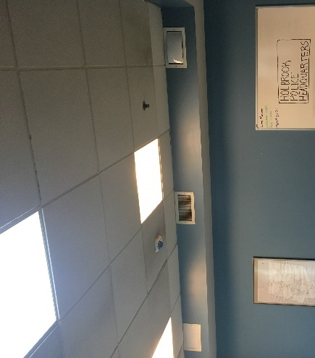

**Fresh air supply and return vent in former dispatch area**

**Picture 3**

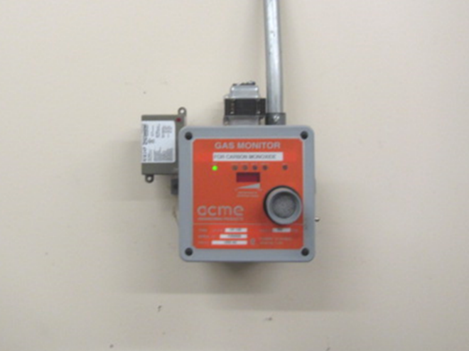

**Carbon monoxide monitor in Police garage/vehicle bay**

**Picture 4**

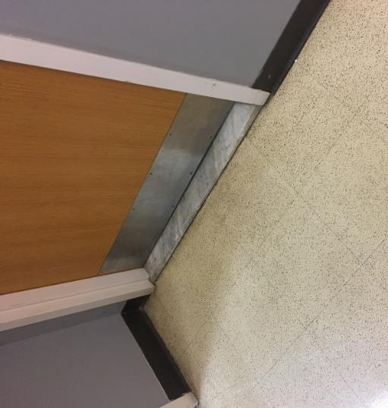

**Restroom door showing minimal door undercut restricting draw of air into restroom**

**Picture 5**

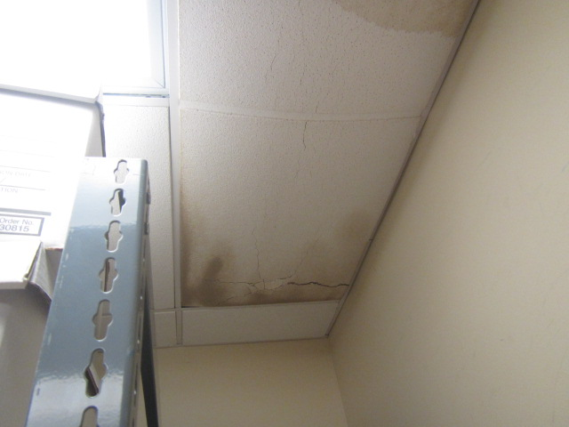

**Water-damaged ceiling tiles in Police archives room**

**Picture 6**

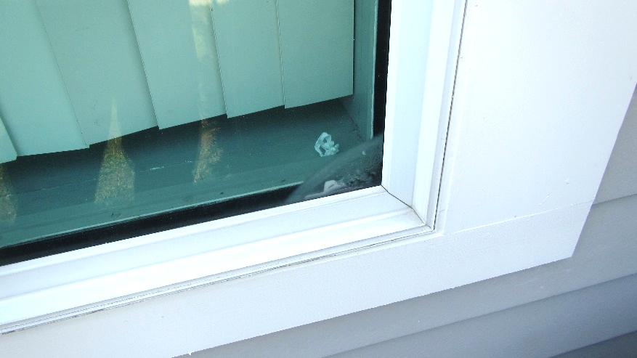

**Window with failed gasket, note condensation (arrow) inside of double windowpane and spaces in gasket**

| Location | **Carbon**  **Dioxide**  **(ppm)** | **Carbon Monoxide**  **(ppm)** | **Temp**  **(°F)** | **Relative**  **Humidity**  **(%)** | **PM2.5**  **(µg/m3)** | **Occupants**  **in Room** | **Windows**  **Openable** | **Ventilation** | | **Remarks** |
| --- | --- | --- | --- | --- | --- | --- | --- | --- | --- | --- |
| **Supply** | **Exhaust** |
| Background | 349 | ND | 83 | 60 | 13 |  |  |  |  | Unseasonably warm and humid |
| 206 | 393 | ND | 72 | 50 | 13 | 0 | Y | Y | Y |  |
| 107 | 399 | ND | 67 | 59 | 12 | 0 |  | Y | Y | Carpet, dehumidifier |
| Former Dispatch | 453 | ND | 71 | 55 | 10 | 0 | Y | Y | Y | Carpet, window temp (86-91**°**F**)** |
| Men’s Restroom |  |  |  |  |  |  | N | Y | Y, off |  |
| Day Room | 421 | ND | 70 | 56 | 9 | 1 | N | Y | Y | Refrigerator |
| 111 | 430 | ND | 69 | 59 | 11 | 0 | Y | Y | Y | Water-damaged supply vent, bowed ceiling tiles |
| 110 | 415 | ND | 69 | 59 | 11 | 0 | Y | Y | Y | Carpet, bowed ceiling tiles |
| 109 | 435 | ND | 69 | 59 | 11 | 0 | Y | Y | Y | Carpet, window temp (73**°**F**)** |
| 105 | 400 | ND | 70 | 55 | 9 | 0 | N | Y | Y | Dust/debris on vents, carpet |
| Men’s Locker Room | 569 | ND | 71 | 54 | 8 | 0 | N | Y | Y | Dust/debris on vents |
| Female Locker Room | 549 | ND | 71 | 53 | 9 | 0 | N | Y | Y | Dust/debris on vents |
| Archives | 570 | ND | 71 | 51 | 8 | 0 | N | Y | Y | 4 water-damaged ceiling tiles (historic water damage) |
| Storage | 534 | ND | 71 | 53 | 8 | 0 | Y | Y | Y | Wall to wall carpet |
| Garage Bay |  | ND |  |  |  | 0 |  |  |  | Carbon monoxide monitor/sensor |

1. Thermal bridges are areas of a building construction where there is a reduction of, or interruption or break in, insulation, resulting in higher heat transfer than surrounding materials (UKEA, unknown).