# BACKGROUND

**INDOOR AIR QUALITY**

**ASSESSMENT**

**Holbrook Regional Emergency Communications Center**

**300 South Franklin Street**

**Holbrook, MA**

Exterior view
Holbrook Regional Emergency Communications Center
300 South Franklin Street
Holbrook, MA


Prepared by:

Massachusetts Department of Public Health

Bureau of Climate and Environmental Health

Indoor Air Quality Program

September 2023

|  |  |
| --- | --- |
| Building: | Holbrook Regional Emergency Communications Center(HRECC) |
| Address: | 300 South Franklin Street, Holbrook, MA |
| Assessment Requested by: | An assessment of the Holbrook Fire Dept (HFD) was requested by HFD staff. The HRECC evaluation was coordinated through the Holbrook Board of Health, HFD Chief Luke McFadden, and HRECC Director Stephan A. Hooke. |
| Reason for Request: | General indoor air quality (IAQ) assessment |
| Date of Assessment: | June 1, 2023 |
| Massachusetts Department of Public Health/Bureau of Climate and Environmental Health (MDPH/BCEH) Staff Conducting Assessment: | Cory Holmes, Assistant Director, IAQ Program |
| Building Description: | The HRECC is a state of the art, regional communications center that provides dispatch and emergency services to six local towns. The HRECC is located adjacent to the Holbrook Public Safety Building (HPSB) and was completed in 2020. The space consists of a large communications area, offices, kitchen/breakroom, and storage areas. Please note, the HFD and Holbrook Police Department (HPD) will be the subjects of separate reports. |
| Windows: | Openable |

**METHODS**

Please refer to the IAQ Manual for methods, sampling procedures, and interpretation of results (MDPH, 2015).

**RESULTS and DISCUSSION**

The following is a summary of indoor air testing results (Table 1).

* ***Carbon dioxide*** levels were above the MDPH guideline of 800 parts per million (ppm) in two offices surveyed (112 and 113), indicating a need for increased air exchange at the time of assessment.
* ***Temperature*** was within the MDPH recommended range of 70°F to 78°F in all areas tested.
* ***Relative humidity*** was within the MDPH recommended range of 40 to 60%.
* ***Carbon monoxide*** levels were non-detectable (ND) in all areas tested.
* ***Fine particulate matter (PM2.5)*** concentrations measured were below the National Ambient Air Quality Standard (NAAQS) limit of 35 μg/m3 in all areas tested.

## Ventilation

A heating, ventilating, and air conditioning (HVAC) system has several functions. First it provides heating and, if equipped, cooling. Second, it is a source of fresh air. Finally, an HVAC system will dilute and remove normally occurring indoor environmental pollutants by not only introducing fresh air, but by filtering the airstream and ejecting stale air to the outdoors via exhaust ventilation. Even if an HVAC system is operating as designed, point sources of respiratory irritation may exist and cause symptoms in sensitive individuals.

The HVAC system consists of ceiling-mounted air handling units (AHUs) (Picture 1), that draw in outside air, heat/cool it and distribute it to occupied areas via multi-directional supply diffusers. Air is returned to the AHUs by ceiling-mounted (Picture 1) or wall-mounted vents (Picture 2). The HVAC system is controlled by digital thermostats that feed into a computerized management system. The MDPH IAQ Program recommends that fans be set to the “on” setting to provide continuous circulation/filtration during occupied hours.

AHUs have filters, which should be changed 2-4 times a year or per the manufacturer’s recommendations. Filters should be at least a Minimum Efficiency Rating Value (MERV) of 8 *or higher*, if they fit and the equipment can handle the pressure reductions caused by more restrictive filters.

To have proper ventilation with a mechanical ventilation system, the systems must be balanced after installation to provide an adequate amount of fresh air to the interior of a room while removing stale air from the room. It is recommended that HVAC systems be re-balanced every five years to ensure adequate air systems function (SMACNA, 1994).

## Microbial/Moisture Concerns

No evidence of water-damaged materials or mold growth were observed during the assessment.

## Other Concerns

Most of the floors are covered with carpet squares, one area had wall-to-wall carpeting. Carpets should be vacuumed regularly with a high efficiency particulate arrestance (HEPA) filter equipped vacuum cleaner and cleaned annually (or semi-annually in soiled/high traffic areas) in accordance with Institute of Inspection, Cleaning and Restoration Certification (IICRC) recommendations (IICRC, 2012).

Additionally, some supply, exhaust and return vents had accumulations of dust and debris (Table 1). This dust/debris can be reaerosolized under certain conditions, and should be cleaned periodically (e.g., during regular filter changes).

# CONCLUSIONS AND RECOMMENDATIONS

In view of the findings at the time of assessment, the following recommendations are made:

### **Ventilation recommendations**

1. Continue with preventative maintenance plans for general HVAC systems.
2. Continue to change filters for HVAC equipment 2-4 times a year using MERV 8 or the highest MERV rating the ventilation system can accommodate to improve air filtration as much as possible without significantly reducing airflow.
3. Clean the interior of AHUs and univents during regular filter changes.
4. Periodically check exhaust vents in restrooms for draw and make adjustments/repairs as needed.
5. Have the HVAC system balanced every 5 years in accordance with SMACNA recommendations (SMACNA, 1994).

### **Water Damage recommendations**

1. Inspect gutters and downspouts periodically for proper drainage, make repairs as necessary.

### **Other recommendations**

1. Clean supply, return, and exhaust vents regularly to remove accumulated dust/debris.
2. Clean carpeting in accordance with IICRC recommendations (IICRC, 2012); annually (or semi-annually in soiled/high traffic areas).
3. For buildings in New England, periods of low relative humidity during the winter are often unavoidable. Therefore, scrupulous cleaning practices should be adopted to minimize common indoor air contaminants whose irritant effects can be enhanced when the relative humidity is low. To control for dusts, a high efficiency particulate arrestance (HEPA) filter equipped vacuum cleaner in conjunction with wet wiping of all surfaces is recommended. Avoid the use of feather dusters. Drinking water during the day can help ease some symptoms associated with a dry environment (throat and sinus irritations).
4. Refer to resource manual and other related IAQ documents located on the MDPH’s website for further building-wide evaluations and advice on maintaining public buildings. These documents are available at: <http://mass.gov/dph/iaq>.

**REFERENCES**

IICRC. 2012. Institute of Inspection, Cleaning and Restoration Certification. Carpet Cleaning: FAQ.

MDPH. 2015. Massachusetts Department of Public Health. “Indoor Air Quality Manual: Chapters I-III”. Available at: [Indoor air quality – manual and appendices | Mass.gov](https://www.mass.gov/lists/indoor-air-quality-manual-and-appendices)

SMACNA. 1994. HVAC Systems Commissioning Manual. 1st ed. Sheet Metal and Air Conditioning Contractors’ National Association, Inc., Chantilly, VA.

**Picture 1**

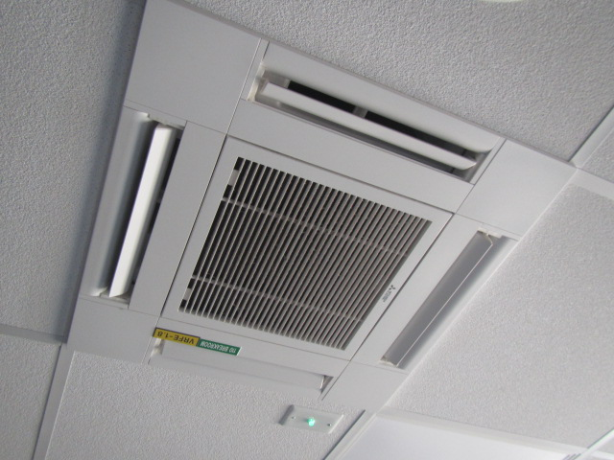

**Ceiling-mounted AHU**

**Picture 2**

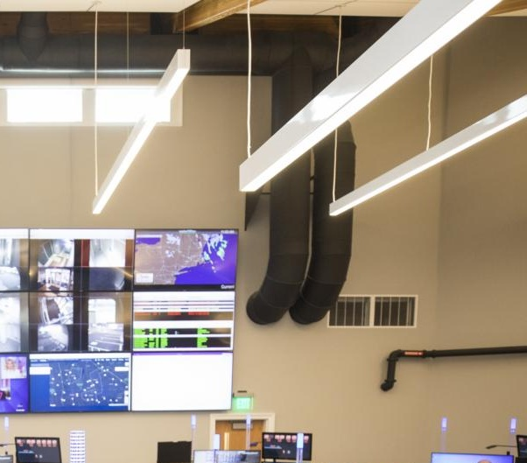

**Wall-mounted vents and ductwork**

| Location | **Carbon**  **Dioxide**  **(ppm)** | **Carbon Monoxide**  **(ppm)** | **Temp**  **(°F)** | **Relative**  **Humidity**  **(%)** | **PM2.5**  **(µg/m3)** | **Occupants**  **in Room** | **Windows**  **Openable** | **Ventilation** | | **Remarks** |
| --- | --- | --- | --- | --- | --- | --- | --- | --- | --- | --- |
| **Supply** | **Exhaust** |
| Background | 349 | ND | 83 | 60 | 13 |  |  |  |  | Unseasonably warm and humid |
| Comms Center | 749 | ND | 70 | 52 | 3 | 9 | N | Y | Y |  |
| Quiet Room | 669 | ND | 70 | 54 | 7 | 0 | N | Y | Y | Wall-to-wall carpeting |
| Break Room | 709 | ND | 70 | 53 | 5 | 0 | Y | Y | Y | Dust/debris on vents, carpet squares |
| 113 Office | 888 | ND | 71 | 55 | 5 | 0 | Y | Y | Y | Carpet squares |
| 112 Office | 882 | ND | 70 | 56 | 6 | 1 | Y | Y | Y | Carpet squares |
| Main Reception | 740 | ND | 71 | 56 | 8 | 0 | N | Y | Y | Carpet squares |