INDOOR AIR QUALITY/WATER DAMAGE ASSESSMENT

Holliston Town Hall
703 Washington Street
Holliston, MA

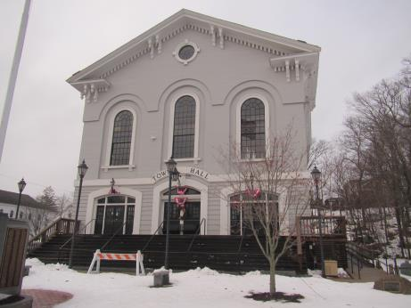

Prepared by:
Massachusetts Department of Public Health
Bureau of Environmental Health
Indoor Air Quality Program
January 2018

Background
Building: | Holliston Town Hall (HTH)
Address: | 703 Washington Street  Holliston, MA
Requested by: | Scott Moles, Director, Holliston Health Department
Reason for Request: | Water damage due to pipe break and general indoor air quality (IAQ)
Date of Assessment: | January 12, 2018
Massachusetts Department of Public Health/Bureau of Environmental Health (MDPH/BEH) Staff Conducting Assessment: | Ruth Alfasso, Environmental Engineer/Inspector, IAQ Program
Building Description: | The HTH is a wood framed building with a peaked roof originally constructed in the 1850s. A major interior renovation of the building was conducted in 2002/2003. Exterior renovations were conducted more recently.
Windows: | Windows are not openable.

Methods
Please refer to the IAQ Manual for methods, sampling procedures, and interpretation of results (MDPH, 2015).

Results
The following is a summary of indoor air testing results (Table 1).
- Carbon dioxide levels were below 800 parts per million (ppm) in all but one area assessed.
- Temperature was within the recommended range of 70°F to 78°F in most areas assessed with a few above the range due to the use of heating/drying equipment.
- Relative humidity was below the recommended range of 40% to 60% in all areas as is typical during the heating season in the Northeast.
- Carbon monoxide levels were non-detectable (ND) in all indoor areas assessed.
- Fine particulate matter (PM2.5) concentrations measured were below the National Ambient Air Quality Standard (NAAQS) level of 35 micrograms per cubic meter (μg/m³) in all occupied areas.

Discussion

Ventilation
A heating, ventilating, and air conditioning (HVAC) system has several functions. First it provides heating and, if equipped, cooling. Second, it is a source of fresh air. Finally, an HVAC system will dilute and remove normally occurring indoor environmental pollutants by not only introducing fresh air, but by filtering the airstream and ejecting stale air to the outdoors via exhaust ventilation. Even if an HVAC system is operating as designed, point sources of respiratory irritation may exist and cause symptoms in sensitive individuals.
The HVAC system in this space consists of air handling units (AHUs) located in utility closets (Picture 1) that draw in fresh air from intakes on the exterior wall of the building. Supply air is ducted to ceiling-mounted supply diffusers throughout the space (Picture 2). Air is returned to the AHU via ceiling-mounted return vents.
To maximize air exchange, the MDPH recommends that both supply and exhaust ventilation operate continuously during periods of occupancy. In order to have proper ventilation with a mechanical supply and exhaust system, the systems must be balanced to provide an adequate amount of fresh air to the interior of a room while removing stale air from the room. It is recommended that HVAC systems be re-balanced every five years to ensure adequate air systems function (SMACNA, 1994).
One of the AHUs in the building was the source of water that moistened building materials. During the evening of Friday January 5, 2017, when temperatures outside were less than 10°F, a door to the outside near where the AHU was located was reportedly left propped open, which led to freezing and damage to water coils in a unit (Picture 1). After the pipe developed pinhole leaks, water was distributed to several areas in the basement and first floor via the ducts. Note that because of the damage, this part of the HVAC system was not working at the time of the assessment. The water damage is discussed in greater detail in the Microbial/Moisture Concerns section of this report.

Microbial/Moisture Concerns
As mentioned previously, due to frozen pipes lead to water being distributed via ductwork into many offices and common areas in the building the night of Friday January 5, 2018 and Saturday morning. The water leak was reportedly discovered on Saturday (January 6) and remediation efforts were started that day, which included a contractor (ServPro) to begin removal and drying of materials that were moistened. Moistened materials included ceiling tiles, ceiling insulation, walls, and carpeting.
Remediation activities continued during the week of January 7, 2018. HTH staff in the affected areas were reportedly allowed to leave the office on Tuesday January 9, 2018, but were working normal hours during the rest of the week. The Holliston Health Department contacted the MDPH IAQ program for technical advice on Wednesday January 10. Reportedly, Town Hall staff were concerned that the water damage and ongoing remediation activities were creating conditions of poor IAQ. The BEH IAQ program visit was conducted on Friday January 12. At this time, remediation activities were continuing and were expected to be mostly completed over the long holiday weekend of January 13 through 15.
Remediation activities included:
- The use of large drying fans, dehumidifiers and HEPA filter units (Pictures 3 and 4);
- Removal of wet insulation and ceiling tiles;
- Replacement of insulation that had been removed from ductwork (Pictures 5 and 6); and
- Removal of coving from the base of walls and the drilling of holes into wallboard to allow for drying of the interior spaces (Picture 3).
Drying appeared to be proceeding effectively during the visit and no moldy or musty odors were detected. Note that The United States Environmental Protection Agency (US EPA) and the American Conference of Governmental Industrial Hygienists (ACGIH) recommend that porous materials be dried with fans and heating within 24 to 48 hours of becoming wet (US EPA, 2008; ACGIH, 1989). If porous materials are not dried within this time frame, mold growth may occur.
In a few areas, there were items such as plastic mats or furniture on the carpet. These items should be moved to ensure that carpeting can dry completely before they are put back.
Note that the lower level of the HTH is carpeted. The IAQ program does not recommend carpeting for below-grade areas in general due to the potential for moistening during humid weather when the carpeting is chilled due to contact with the concrete slab. In addition, this carpeting is visibly wrinkled in some areas. Given that the carpeting was installed during the renovations in 2002, this carpeting may be beyond its service life. In addition, the Institute of Inspection, Cleaning and Restoration Certification (IICRC), recommends that carpeting be cleaned annually (or semi-annually in soiled high traffic areas) (IICRC, 2012).
Other conditions were observed that could contribute to water damage and microbial growth in the office. There were several ductless air conditioning units observed (Picture 7). As shown in the picture, these units have a condensate hose and a pump to remove the collected water to drains. These hoses and pumps need to be inspected periodically to ensure they are functioning correctly. Clogs and leaks can moisten building materials with stagnant condensate. No porous materials should be stored under or adjacent to these units to prevent water damage if leaks occur.
Water dispenser jugs were stored in a carpeted area. This may lead to moistening of carpeting when water jugs are carried or changed. Water dispensing equipment should be located in non-carpeted areas or on a waterproof mat to protect carpets from spills and leaks.
Plants were observed in some areas of the office (Picture 8). Plants should be well maintained, not overwatered and kept away from the airstream of ventilation equipment to prevent odors, water damage, and pests.

Other Conditions
Hand sanitizers and scented cleaning products were also noted in some areas of the office space. These products can also cause irritation of the eyes, nose and respiratory system of some people.
Rodents were reported as an occasional problem in this office. To prevent rodent infestation the services of a licensed pest control professional should be used to develop a control program using the principles of Integrated Pest Management (IPM), which include exclusion of pests (e.g., tightly-sealed doors), removal of attractants (food and water) and harborage, and regular thorough cleaning.

Conclusions/Recommendations
Based on the observations made during the visit, the following is recommended:
- Continue drying activities until completed. Ensure that ServPro or other contractors check the moisture content of porous items such as carpeting and wallboard before putting furniture and other items back into place.
- Ensure that the affected areas are thoroughly cleaned to remove dust and debris from remediation activities from flat surfaces and carpeting. Have ceiling tiles installed to fit flush in the ceiling tile grid.
- If musty odors are detected after this drying process is completed, additional remediation will be required, which may involve removal of wallboard or carpeting. Remediate any water-damaged materials in accordance with the US EPA guidance “Mold Remediation in Schools and Commercial Buildings” (US EPA, 2008).
- Ensure that during periods of cold weather, all doors to the outside are kept closed to prevent freezing of pipes.
- Consider a plan to check on the building, either in person or using remote monitoring, during severe weather to be able to detect problems such as frozen pipes or leaks promptly.
- Operate the HVAC system to provide for continuous fresh air ventilation during occupied hours.
- If openable windows are used to supplement fresh air, ensure that they are kept closed when the HVAC system is operating in cooling mode to prevent condensation, and are tightly closed at the end of the day.
- Periodically check ductless AC systems and associated piping and pumps for leaks from condensate. Avoid storing porous materials under or adjacent to these units in case of leaks.
- Avoid storing water jugs or placing water dispensers and refrigerators on carpet. Place them on non-porous flooring or use a waterproof mat to protect the carpet from spills or leaks.
- Ensure plants are well maintained and not overwatered.
- For buildings in New England, periods of low relative humidity during the winter are often unavoidable. Therefore, scrupulous cleaning practices should be adopted to minimize common indoor air contaminants whose irritant effects can be enhanced when the relative humidity is low. To control for dusts, a high efficiency particulate arrestance (HEPA) filter equipped vacuum cleaner in conjunction with wet wiping of all surfaces is recommended. Avoid the use of feather dusters. Drinking water during the day can help ease some symptoms associated with a dry environment (throat and sinus irritations).
- Reduce or eliminate the use of scented cleaners and hand sanitizers to reduce irritation.
- Use the principles of IPM to control rodents, including reducing/eliminating access points, food, and harborage. Keep cooking and eating areas free from crumbs and store any food in tightly-sealed containers.
- Clean carpeting at least once per year according to IICRC recommendations (IICRC 2012). Consider replacing any carpeting that is beyond its service life. In below-grade areas, consider using non-porous flooring instead of carpeting when flooring is replaced.
- Consider setting up a balancing schedule to have the HVAC system balanced every five years.
- Ensure filters for AHUs are of a pleated variety, Minimum Efficiency Reporting Value (MERV) dust-spot efficiency 8 or higher, which are adequate in filtering out pollen and mold spores (ASHRAE, 2012). Filters should be changed 2-4 times a year or in accordance with the manufacture’s recommendations.
- Refer to resource manuals and other related IAQ documents for further building-wide evaluations and advice on maintaining public buildings. Copies of these materials are located on the MDPH’s website: http://mass.gov/dph/iaq.

References
ACGIH. 1989. Guidelines for the Assessment of Bioaerosols in the Indoor Environment. American Conference of Governmental Industrial Hygienists, Cincinnati, OH.
ASHRAE. 2012. American Society of Heating, Refrigeration and Air Conditioning Engineers. Standard 52.2-2012 -- Method of Testing General Ventilation Air-Cleaning Devices for Removal Efficiency by Particle Size (ANSI Approved).
IICRC. 2012. Institute of Inspection Cleaning and Restoration Certification. Institute of Inspection, Cleaning and Restoration Certification. Carpet Cleaning: FAQ. Retrieved from http://www.iicrc.org/consumers/care/carpet-cleaning.
MDPH. 2015. Massachusetts Department of Public Health. “Indoor Air Quality Manual: Chapters I-III”. Available at: http://www.mass.gov/eohhs/gov/departments/dph/programs/environmental-health/exposure-topics/iaq/iaq-manual/.
SMACNA. 1994. HVAC Systems Commissioning Manual. 1st ed. Sheet Metal and Air Conditioning Contractors’ National Association, Inc., Chantilly, VA.
US EPA. 2008. Mold Remediation in Schools and Commercial Buildings. US Environmental Protection Agency, Office of Air and Radiation, Indoor Environments Division, Washington, D.C. EPA 402-K-01-001. http://www.epa.gov/mold/mold-remediation-schools-and-commercial-buildings-guide
Picture 1
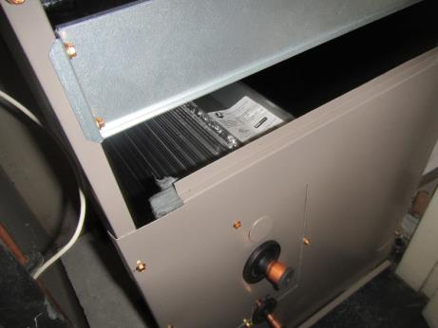
Air handling unit (AHU)
Picture 2
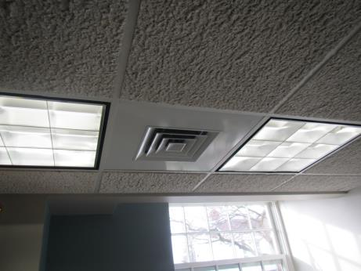
Typical ceiling-mounted supply vent
Picture 3
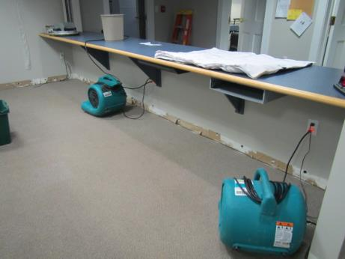
Drying fans, note removed coving and holes drilled in edge of wall
Picture 4
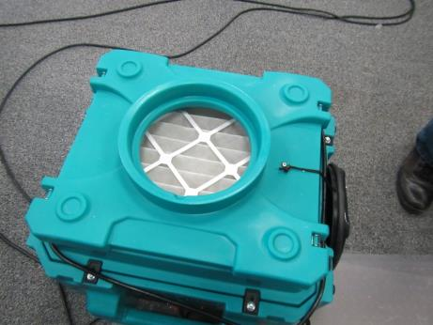
Large HEPA filter unit
Picture 5
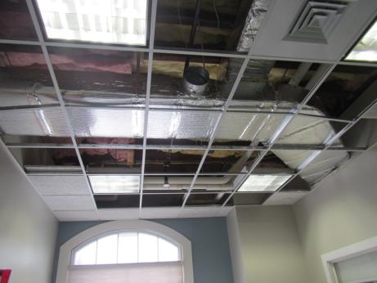
Removed ceiling tiles and new insulation around ductwork
Picture 6
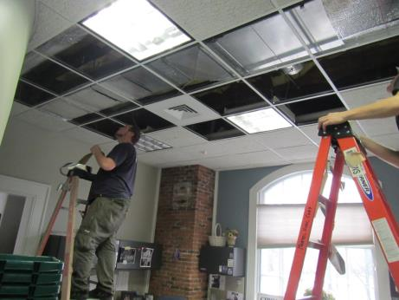
Installation of new duct insulation
Picture 7
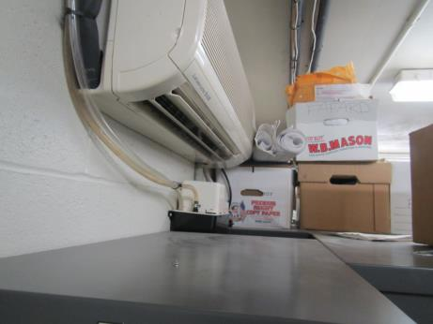
Ductless air conditioning unit and condensate hose and pump
Picture 8
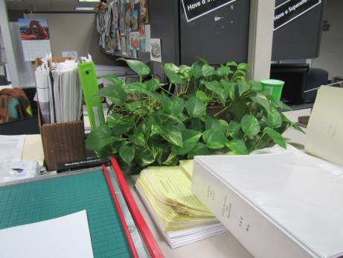
Plant in office on porous materials
Location | Carbon  Dioxide  (ppm) | Carbon Monoxide  (ppm) | Temp  (°F) | Relative  Humidity  (%) | PM2.5  (µg/m³) | Occupants  in Room | Windows  Openable | Ventilation |  | Remarks
 |  |  |  |  |  |  |  | Supply | Exhaust
Background | 521 | ND | 62 | 54 | 9 |  |  |  |  | Foggy and damp
005 Board of Health | 676 | ND | 71 | 39 | 5 | 2 | Y (slightly open) | Y | Y
Computer | 594 | ND | 71 | 38 | 6 | 0 | N | Y | Y | NC, DEM copier, ductless AC, remote-monitored thermostat
007 | 852 | ND | 72 | 38 | 6 | 1 | Y | Y | Y | CP
011 | 589 | ND | 73 | 37 | 6 | 1 | Y | Y | Y | DEM
013 | 562 | ND | 73 | 35 | 7 | 0 | Y | Y | Y | DEM, HS
015 | 565 | ND | 73 | 34 | 6 | 1 | Y | Y | Y | Plants, PF
017 | 604 | ND | 73 | 34 | 5 | 0 | Y | Y | Y | CT all removed, coving removed, water-damaged wall
006 vault | 559 | ND | 72 | 33 | 5 | 0 | N | N | N | NC, ductless AC
009 conference table area | 524 | ND | 71 | 36 | 5 | 0 | N | Y | Y | Printer, water jug storage on carpet, PC, HS
Lobby | 511 | ND | 71 | 36 | 5 | 0 | N | Y | Y
103 selectman’s office | 634 | ND | 73 | 38 | 6 | 2 | Y | Y | Y | Plant, currently installing vent/duct insulation
Selectman’s conference room | 716 | ND | 74 | 37 | 21 | 4 | Y | Y | Y | Worn carpeting, open CT plenum for installing duct insulation
102 | 631 | ND | 76 | 34 | 5 | 1 | Y | Y | Y
102 rear | 660 | ND | 76 | 34 | 5 | 1 | Y | Y | Y | Plant
102A | 785 | ND | 76 | 33 | 6 | 1 | Y | Y | Y | PF, fridge
Hallway 1st floor | 582 | ND | 75 | 34 | 5 | 0-3 | N | Y | Y
107 | 616 | ND | 76 | 34 | 5 | 0 | Y | Y | Y | MT, moistened carpet, new insulation on ducts
107A | 551 | ND | 80 | 31 | 5 | 0 | Y | Y | Y | Heater/fans running, CP
106 tax | 596 | ND | 80 | 29 | 5 | 3 | Y | Y | Y | Fridge, PF
106 back of office | 640 | ND | 79 | 30 | 5 | 1 | Y | Y | Y | Food
106 side | 622 | ND | 78 | 33 | 6 | 1 | Y one open | Y | Y | Items
Men’s room |  |  |  |  |  |  |  |  |  | HS, a few MTs
Women’s room |  |  |  |  |  |  |  |  |  | A few MTs
Great hall (upstairs) | 583 | ND | 76 | 38 | 6 | 0 | Y | Y | Y
Kitchen (upstairs) | 559 | ND | 75 | 33 | 4 | 0 | Y | Y | Y | Refrigerators, stove

0

