INDOOR AIR QUALITY ASSESSMENT

Holyoke City Hall Annex
20 Korean Veterans Plaza
Holyoke, Massachusetts

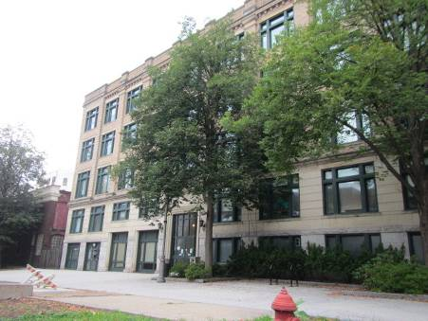

Prepared by:
Massachusetts Department of Public Health
Bureau of Environmental Health
Indoor Air Quality Program
October 2014

Background/Introduction
At the request of Ernest Mathieu, Chief Sanitarian for the City of Holyoke, the Massachusetts Department of Public Health (MDPH), Bureau of Environmental Health (BEH) provided assistance and consultation regarding indoor air quality (IAQ) at the Holyoke City Hall Annex (HCHA), 20 Korean Veterans Plaza, Holyoke. The request was prompted by health concerns related to odors and mold growth in the building. On August 22, 2014, a visit to conduct an IAQ assessment was made by Kathleen Gilmore, Environmental Analyst/Regional Inspector for the BEH/IAQ Program. James Kras, Facilities Director for the City of Holyoke, accompanied Ms. Gilmore during the assessment. On September 12, 2014, Michael Feeney, Director of BEH’s IAQ program returned to the HCHA, accompanied by Ms. Gilmore to complete the assessment.
The HCHA is a four-story brick/stone building constructed in 1913. It was originally built as the Holyoke Police Department (HPD), which occupied the first floor and basement of the building, with city offices and meeting rooms located on upper floors. In 1980, the HPD was relocated to a new site and the space in the HCHA has been unoccupied since that time. Currently, city offices occupy space in the building. Floors are carpeted in most areas. Windows are openable with the exception of some basement windows, which are original to the building.

Methods
Air tests for carbon dioxide, carbon monoxide, temperature and relative humidity were conducted with the TSI, Q-Trak, IAQ Monitor, Model 7565. Air tests for airborne particle matter with a diameter less than 2.5 micrometers were taken with the TSI, DUSTTRAK™ Aerosol Monitor Model 8520. BEH/IAQ staff also performed visual inspection of building materials for water damage and/or microbial growth.

Results
The HCHA has an employee population of approximately 40 and can be visited by over 50 visitors on a daily basis. Tests were taken under normal operating conditions and results appear in Table 1.

Discussion

Ventilation
It can be seen from Table 1 that carbon dioxide levels were below 800 parts per million (ppm), indicating adequate air exchange in all areas surveyed. It is important to note that several areas were empty/sparsely populated at the time measurements were taken, which can greatly reduce carbon dioxide levels. Carbon dioxide levels would be expected to increase with full occupancy.
The HCHA is not equipped with a mechanical ventilation system. The building was originally designed with a natural/gravity system heated by steam radiators with fresh air provided through openable windows. In addition to openable windows, the building has hinged windows located above hallway doors. These hinged windows or transoms (Picture 1) enable occupants to close hallway doors while maintaining a pathway for airflow into the rooms. This design allows for airflow to enter an open window, pass through a room, through the open transom to the hallway and subsequently pass through the open transom and window on the opposite side of the room on the leeward side (opposite the windward side) (Figure 1). This system fails if the windows or transoms are closed (Figure 2). Most windows in the building were found closed at the time of the assessment and many transoms were found closed/permanently sealed. Without a means for air exchange via windows or a mechanical supply and exhaust system, normally occurring indoor environmental pollutants can build up, leading to IAQ/comfort complaints.
Air-handling units (AHUs) provide cooling during warm months. These AHUs are located in hallways (Picture 2) and are not equipped with fresh air intakes outside the building. The intake vents on the AHUs draw return air from the hallways, cool, and deliver it to occupied spaces via ducted supply vents (Picture 3). The AHU on the third floor was making an atypical noise and weak or nonexistent airflow was detected from supply vents, primarily in south-facing offices on the third floor, indicating either the zones to which they were connected were not calling for air circulation, or that it was in need of maintenance. Of note, the fourth floor AHU that distributes air to the south-facing offices was non-functioning/inoperable. Although the units are cleaned and filters changed regularly, the operational lifespan of this equipment has been exceeded (> 20 years). This system is supplemented by using windows to introduce fresh air and window air conditioning (WAC; Table 1) units.
No dedicated exhaust vents (nor openable windows) were identified in the restrooms (Table 1). Exhaust ventilation is necessary to remove excess moisture and prevent restroom odors from penetrating into adjacent areas.
Minimum design ventilation rates are mandated by the Massachusetts State Building Code (MSBC). Until 2011, the minimum ventilation rate in Massachusetts was higher for both occupied office spaces and general classrooms, with similar requirements for other occupied spaces (BOCA, 1993). The current version of the MSBC, promulgated in 2011 by the State Board of Building Regulations and Standards (SBBRS), adopted the 2009 International Mechanical Code (IMC) to set minimum ventilation rates. Please note that the MSBC is a minimum standard that is not health-based. At lower rates of cubic feet per minute (cfm) per occupant of fresh air, carbon dioxide levels would be expected to rise significantly. A ventilation rate of 20 cfm per occupant of fresh air provides optimal air exchange resulting in carbon dioxide levels at or below 800 ppm in the indoor environment in each area measured. MDPH recommends that carbon dioxide levels be maintained at 800 ppm or below. This is because most environmental and occupational health scientists involved with research on IAQ and health effects have documented significant increases in indoor air quality complaints and/or health effects when carbon dioxide levels rise above the MDPH guidelines of 800 ppm for schools, office buildings and other occupied spaces (Sundell et al., 2011). The ventilation must be on at all times that the room is occupied. Providing adequate fresh air ventilation with open windows and maintaining the temperature in the comfort range during the cold weather season is impractical. Mechanical ventilation is usually required to provide adequate fresh air ventilation.
Carbon dioxide is not a problem in and of itself. It is used as an indicator of the adequacy of the fresh air ventilation. As carbon dioxide levels rise, it indicates that the ventilating system is malfunctioning or the design occupancy of the room is being exceeded. When this happens, a buildup of common indoor air pollutants can occur, leading to discomfort or health complaints. The Occupational Safety and Health Administration (OSHA) standard for carbon dioxide is 5,000 parts per million parts of air (ppm). Workers may be exposed to this level for 40 hours/week, based on a time-weighted average (OSHA, 1997).
The MDPH uses a guideline of 800 ppm for publicly occupied buildings. A guideline of 600 ppm or less is preferred in schools due to the fact that the majority of occupants are young and considered to be a more sensitive population in the evaluation of environmental health status. Inadequate ventilation and/or elevated temperatures are major causes of complaints such as respiratory, eye, nose and throat irritation, lethargy and headaches. For more information concerning carbon dioxide, please see Appendix A.
Temperature readings during the assessment ranged from 71° F to 76° F, which were within the MDPH recommended comfort range (Table 1). The MDPH recommends that indoor air temperatures be maintained in a range of 70° F to 78° F in order to provide for the comfort of building occupants. Thermal comfort/complaints were reported by employees in south-facing offices. In addition to the conditions of the AHUs described previously, the sun was streaming through south-facing windows, which is a source of solar heating (i.e., solar gain). Window shades/blinds should be used to reduce over-heating. In many cases concerning indoor air quality, fluctuations of temperature in occupied spaces are typically experienced, even in a building with an adequate fresh air supply.
The relative humidity at the time of the assessment ranged from 63 to 67 percent (Table 1), which was above the MDPH recommended comfort range. The MDPH recommends a comfort range of 40 to 60 percent for indoor air relative humidity. Note that at the time of the assessment, the relative humidity outdoors was measured at 83 percent, which influences the relative humidity inside the building, especially with no operating ventilation system and windows open. When relative humidity is above this comfort level, moisture removal is important since higher humidity at a given temperature reduces the ability of the body to cool itself by perspiration. “Heat index” is a measurement that takes into account the impact of a combination of heat and humidity on how hot it feels. At a given indoor temperature, the addition of humid air increases occupant discomfort and may generate heat complaints. If moisture levels are decreased, the comfort of the individuals increases. Relative humidity levels in the building would be expected to drop during the winter months due to heating. The sensation of dryness and irritation is common in a low relative humidity environment. Low relative humidity is a very common problem during the heating season in the northeast part of the United States.

Odors/Microbial/Moisture Concerns
As mentioned, concerns of odors and mold growth prompted the MDPH visit. In order for building materials to support mold growth, a source of water exposure is necessary. The basement of the HCHA houses the former HPD cell block, mechanical rooms and custodial offices. A musty odor was detected upon entering the HCHA, which intensified in the basement. Microbial growth would be expected to be present in an unconditioned basement space that is subjected to moisture. BEH/IAQ staff observed numerous conditions in the basement, which are likely sources for odors, moisture and pollutants to migrate into above areas. Holes and spaces surrounding sewer, plumbing and utility pipes were observed throughout the basement (Pictures 4 and 5). Airflow tends to rise and these breaches can serve as pathways to draw air, odors and particulates from the basement into stairwells, hallways and offices. This condition is known as the stack effect.
As previously mentioned, the HPD originally occupied the first floor and basement; although unoccupied, conditions exist in the space which can affect IAQ in the building. An open stairwell exists leading from the cell block to the first floor (Pictures 6) allowing odors and associated pollutants to migrate to occupied spaces above via breaches around plumbing/utility pipes. BEH/IAQ staff recommended that facilities staff inspect the basement and all occupied areas of the building for holes/gaps surrounding pipes and seal with a fire-rated sealant foam or other appropriate material.
In addition, a ramp exists leading from the basement to the side entrance of the building (Picture 7). It was reported by facilities staff that the access doors at the base and top of the ramp are routinely left open. BEH/IAQ staff noted musty odors at the top of the ramp and found the doors were ill-fitting and did not seal tightly when closed. The door at the base of the ramp should be replaced with an airtight fire-rated door and kept closed to prevent the migration of odors and pollutants to occupied spaces.
Although no visible mold growth was observed in the basement, several signs of water penetration/damage were identified. The mechanical room had deteriorated/missing brick around the windows (Picture 8). Efflorescence was observed on walls, ceilings, pipes and window frames throughout the space (Picture 9). Efflorescence is a characteristic sign of water damage but it is not mold growth. As the solution moves to the surface of the material, the water evaporates, leaving behind white, powdery mineral deposits. As moisture penetrates and works its way through mortar, brick or plaster, water-soluble compounds dissolve, creating a solution.
Peeling paint/plaster was observed on ceilings and walls throughout the cell block space (Picture 10), and porous items (e.g., boxes and papers) were observed in the area (Picture 11). Porous materials should not be stored in basements due to chronic moisture and elevated relative humidity. Windows in the cell block, original to the building, were found with cracked/missing panes, and deteriorated/rotted wood frames and sills.
Two skylights in the roof of the building had cracked/missing glass and/or were painted over (Picture 12). Water-damaged walls and ceilings and water staining on wooden floors were observed on the fourth floor atrium below the skylights, which is indicative of chronic water penetration (Pictures 13 and 14). HCHA staff reported that buckets are routinely used to collect water leakage during/following heavy storms.
Several rooms in the building had water-damaged ceiling tiles, plaster and peeling paint (Table 1; Pictures 15 and 16), which may stem from roof leaks, plumbing leaks and/or condensation from WAC components. If repeatedly moistened, ceiling tiles can be a mold growth medium. Water-damaged ceiling tiles should be replaced after a water leak is discovered and repaired.
Water dispensers were located in several rooms over carpeting (Table 1; Picture 17). Overflow/spills from water coolers/fountains can moisten carpeting. It is recommended that these dispensers be located on non-porous flooring or a waterproof mat. It is also important that the catch basin of water coolers be cleaned regularly as stagnant water can be a source of odors.
The US EPA and the American Conference of Governmental Industrial Hygienists (ACGIH) recommend that porous materials be dried with fans and heating within 24 to 48 hours of becoming wet (US EPA, 2001; ACGIH, 1989). If porous materials are not dried within this time frame, mold growth may occur. Once mold has colonized porous materials, they are difficult to clean and should be removed and discarded.
Plants were observed in several offices and numerous plants were located in the fourth floor atrium (Table 1; Picture 18). Plant soil, standing water and drip pans can be potential sources of mold growth. Drip pans should be inspected periodically for mold growth and over watering should be avoided.
BEH/IAQ staff examined the exterior of the building to identify breaches in the building envelope and/or other issues that could provide a source of water penetration. Brickwork and mortar along the south-facing wall of the building had an extensive vertical crack. In addition, the wall was bulging and the bars of the adjacent cell block windows were found dislodged/separated from the damaged wall (Picture 19). Not only are these breaches a source of water penetration to the building interior, the condition of the wall can compromise the structural integrity of the building envelope.
A gutter/downspout exists on the west side (rear) of the building (Picture 20). On the day of the assessment water was observed draining from the center of the gutter indicating that the junction of the gutter/downspout system may be clogged with debris or the gutter has breaches/holes preventing proper drainage. No other areas of the roof had rain gutters/downspouts installed. Without a gutter/downspout system, water can pool at the base of the foundation and penetrate basement walls.
Several other potential sources of water penetration/damage on the exterior of the building were identified:
- Cracks/deterioration in the stone foundation, walls and columns likely due to chronic exposure to wind driven rains and water pooling along the foundation (Pictures 21 through 23).
- Missing/damaged brickwork along walls and windows (Pictures 24).
- Damaged flashing along the roofline (Picture 25).
- Plant and grass growth along the foundation in a number of areas (Picture 26). The growth of roots along exterior walls can hold moisture and eventually lead to cracks and/or fissures in the foundation below ground level.
- Deteriorated/rotted wood and cracked/missing glass in windows.
Over time, these conditions can undermine the integrity of the building envelope and provide a means of water entry into the building via capillary action through foundation concrete and masonry (Lstiburek & Brennan, 2001). The freezing and thawing of water during winter months can lead to further damage and subsequent water penetration into the interior of the building. In addition, these breaches can be a pathway for rodents and other pests to enter the building.

Other Indoor Air Evaluations
Indoor air quality can be negatively influenced by the presence of respiratory irritants, such as products of combustion. The process of combustion produces a number of pollutants. Common combustion emissions include carbon monoxide, carbon dioxide, water vapor, and smoke (fine airborne particle material). Of these materials, exposure to carbon monoxide and particulate matter with a diameter of 2.5 micrometers (μm) or less (PM2.5) can produce immediate, acute health effects upon exposure. To determine whether combustion products were present in the indoor environment, BEH/IAQ staff obtained measurements for carbon monoxide and PM2.5.

Carbon Monoxide
Carbon monoxide is a by-product of incomplete combustion of organic matter (e.g., gasoline, wood and tobacco). Exposure to carbon monoxide can produce immediate and acute health effects. Several air quality standards have been established to address carbon monoxide and prevent symptoms from exposure to these substances. The MDPH established a corrective action level concerning carbon monoxide in ice skating rinks that use fossil-fueled ice resurfacing equipment. If an operator of an indoor ice rink measures a carbon monoxide level over 30 ppm, taken 20 minutes after resurfacing within a rink, that operator must take actions to reduce carbon monoxide levels (MDPH, 1997).
The American Society of Heating Refrigeration and Air Conditioning Engineers (ASHRAE) has adopted the National Ambient Air Quality Standards (NAAQS) as one set of criteria for assessing indoor air quality and monitoring of fresh air introduced by HVAC systems (ASHRAE, 1989). The NAAQS are standards established by the US EPA to protect the public health from six criteria pollutants, including carbon monoxide and particulate matter (US EPA, 2006). As recommended by ASHRAE, pollutant levels of fresh air introduced to a building should not exceed the NAAQS levels (ASHRAE, 1989). The NAAQS were adopted by reference in the Building Officials & Code Administrators (BOCA) National Mechanical Code of 1993 (BOCA, 1993), which is now an HVAC standard included in the Massachusetts State Building Code (SBBRS, 2011). According to the NAAQS, carbon monoxide levels in outdoor air should not exceed 9 ppm in an eight-hour average (US EPA, 2006).
Carbon monoxide should not be present in a typical, indoor environment. If it is present, indoor carbon monoxide levels should be less than or equal to outdoor levels. Outdoor carbon monoxide concentrations were non-detect (ND) on the day of the assessment (Table 1). No measurable levels of carbon monoxide were detected in the building during the assessment (Table 1).

Particulate Matter
The US EPA has established NAAQS limits for exposure to particulate matter. Particulate matter includes airborne solids, which can result in eye and respiratory irritation if exposure occurs. The NAAQS originally established exposure limits to particulate matter with a diameter of 10 μm or less (PM10). According to the NAAQS, PM10 levels should not exceed 150 micrograms per cubic meter (μg/m³) in a 24-hour average (US EPA, 2006). These standards were adopted by both ASHRAE and BOCA. Since the issuance of the ASHRAE standard and BOCA Code, US EPA established a more protective standard for fine airborne particles. This more stringent PM2.5 standard requires outdoor air particle levels be maintained below 35 μg/m³ over a 24-hour average (US EPA, 2006). Although both the ASHRAE standard and BOCA Code adopted the PM10 standard for evaluating air quality, MDPH uses the more protective PM2.5 standard for evaluating airborne particulate matter concentrations in the indoor environment.
Outdoor PM2.5 was measured at 13 μg/m³ (Table 1) on the day of the visit. PM2.5 levels measured indoors ranged from 8 to 13 μg/m³ (Table 1), which were below the NAAQS PM2.5 level of 35 μg/m³. Frequently, indoor air levels of particulates (including PM2.5) can be at higher levels than those measured outdoors. A number of mechanical devices and/or activities that occur in buildings can generate particulate matter during normal operations. Sources of indoor airborne particulates may include but are not limited to particles generated during the operation of fan belts in the HVAC system, use of stoves and/or microwave ovens in kitchen areas; use of photocopiers, fax machines and computer printing devices; operation of an ordinary vacuum cleaner and heavy foot traffic indoors.

Volatile Organic Compounds
Indoor air concentrations can be greatly impacted by the use of products containing volatile organic compounds (VOCs). VOCs are carbon-containing substances that have the ability to evaporate at room temperature. Frequently, exposure to low levels of total VOCs (TVOCs) may produce eye, nose, throat and/or respiratory irritation in some sensitive individuals. For example, chemicals evaporating from a paint can stored at room temperature would most likely contain VOCs. In an effort to identify materials that can potentially increase indoor VOC concentrations, BEH/IAQ staff examined the office space for products containing respiratory irritants.
BEH/IAQ staff detected an odor of hydraulic fluid near the elevator. Hydraulic fluid has a distinct odor and contains volatile organic compounds (VOCs), which can be irritating to the eyes, nose and throat. Normally, elevator shafts have a fan to provide ventilation and exhaust odors generated by the hydraulic mechanism. The elevator in the HCHA is configured with passive vents that draw air from the adjacent mechanical room (Picture 27). Upon inspection, BEH/IAQ staff observed the generator was leaking fuel and oil-soaked towels were on the floor of the mechanical room. Facilities staff reported that a firm had been contacted to make needed repairs.
There are photocopiers in the office space (Table 1). Photocopiers can be sources of pollutants such as VOCs, ozone, heat and odors, particularly if the equipment is older and in frequent use. Both VOCs and ozone are respiratory irritants (Schmidt Etkin, 1992). Photocopiers and laminators should be kept in well ventilated rooms, and should be located near windows or exhaust vents.
A few offices contained dry erase boards and related materials. Materials such as dry erase markers and dry erase board cleaners may contain VOCs, such as methyl isobutyl ketone, n-butyl acetate and butyl-cellusolve (Sanford, 1999), which can be irritating to the eyes, nose and throat.
Hand sanitizer was also found in some spaces (Table 1; Picture 28). Hand sanitizer products may contain ethyl alcohol and/or isopropyl alcohol which are highly volatile and may be irritating to the eyes and nose, and may also contain fragrances to which some people may be sensitive (GOJO, 2007).

Other Conditions
Other conditions which may affect indoor air quality were observed during the assessment. In several rooms, items were observed on the floor, windowsills, tabletops, counters, bookcases and desks (Table 1; Picture 29). The large number of items stored in office spaces provides a source for dust to accumulate. These items (e.g., papers, folders, boxes) make it difficult for custodial staff to clean.
Dust was also observed accumulated on the blades of personal fans and supply vents (Table 1; Picture 3). Vents and fans should be cleaned periodically in order to prevent them from serving as a source of aerosolized particulates.
As mentioned, floors in most of the HCHA are covered by wall-to-wall carpeting. It was not clear whether a carpet cleaning program is in place. The Institute of Inspection, Cleaning and Restoration Certification (IICRC), recommends that carpeting be cleaned annually (or semi-annually in soiled high traffic areas) (IICRC, 2012). It was reported that the carpeting was installed in the 1970s. The average lifespan of carpeting is approximately 11 years (Bishop, 2002); therefore, consideration should be given to planning for new flooring. Disintegrating textiles can be a source of airborne particulates, which can be irritating to the eyes, nose and throat.

Conclusions/Recommendations
Based on findings during the assessment, the BEH/IAQ Program recommends a two-phase approach to improving indoor environmental conditions at the HCHA. The first consists of short-term measures to improve air quality and the second consists of long-term measures that will require planning and resources to adequately address overall IAQ/building concerns.
Short Term Recommendations
- Supplement inoperable/non-functioning air conditioning units with window air conditioners to provide cooling during warm months.
- Open windows (weather permitting) to temper rooms and provide fresh outside air. Care should be taken to ensure windows are properly closed at night and weekends during winter months to avoid the freezing of pipes and potential flooding. In addition, keep windows closed during hot, humid weather to maintain indoor temperatures and to avoid condensation problems when air conditioning is activated.
- For buildings in New England, periods of low relative humidity during the winter are often unavoidable. Therefore, scrupulous cleaning practices should be adopted to minimize common indoor air contaminants whose irritant effects can be enhanced when the relative humidity is low. To control for dusts, a high efficiency particulate arrestance (HEPA) filter equipped vacuum cleaner in conjunction with wet wiping of all surfaces is recommended. Avoid the use of feather dusters. Drinking water during the day can help ease some symptoms associated with a dry environment (throat and sinus irritations).
- Seal holes/spaces and other penetrations in the ceilings and walls around plumbing and utility pipes throughout the building, particularly in the basement and first floor of the former HPD with an expandable, fire-rated sealing compound.
- Install a fire-rated airtight door at the base of the ramp adjacent to the side entrance. Consider installing an armature if the door is to be used as an access for the public/visitors.
- Remove all papers and boxes from the cell block space and ensure porous materials are not stored in the basement.
- Repair/replace missing/broken glass in skylights.
- Remove water-damaged ceiling tiles and examine for source of water. Monitor for future leaks. After necessary repairs are made, replace any water-damaged ceiling tiles.
- Repair water-damaged/peeling paint and plaster on walls and ceilings.
- Reduce the number plants in the building, especially the fourth floor atrium area. Ensure indoor plants are equipped with drip pans. Examine drip pans periodically for mold growth and disinfect with an appropriate antimicrobial, as needed. Move plants away from the air stream of mechanical ventilation equipment.
- Consider moving water dispensing equipment to areas with tiled floors instead of carpeting, or installing waterproof mats to prevent leaks from damaging carpet.
- Remove grass, plants and debris from the exterior wall/foundation of the building to prevent water penetration into basement and crawlspace.
- Make repairs as needed to the elevator generator to prevent exposures to VOCs.
- Refrain from using air fresheners and deodorizers to prevent exposure to VOCs.
- Clean accumulated dust and debris periodically from supply vents and blades of personal fans.
- Clean carpeting annually (or semi-annually in soiled high traffic areas) as per the recommendations of the Institute of Inspection, Cleaning and Restoration Certification (IICRC, 2012). Copies of the IICRC fact sheet are available at: http://www.iicrc.org/consumers/care/carpet-cleaning/.
- Refer to resource manuals and other related indoor air quality documents for further building-wide evaluations and advice on maintaining public buildings. These materials are located on the MDPH’s website: http://mass.gov/dph/iaq.

Long Term Recommendations
- Based on the age, physical deterioration and availability of parts, the MDPH recommends that an HVAC engineering firm evaluate options for providing adequate ventilation building-wide. Such an evaluation is necessary to determine the feasibility of repairing/replacing the existing equipment.
- Install exhaust ventilation in restrooms to prevent the migration of odors, moisture and pollutants into occupied spaces.
- Install gutters and downspouts to direct rainwater at least 5 feet away from foundation.
- Consider a long-term plan to replace windows (where needed) to prevent air/moisture infiltration.
- Consult with an architect or masonry engineering firm to develop a plan to address building envelope concerns (e.g., damaged skylights; cracked/ missing brick, stone, and mortar; permeable areas of foundation; and deteriorated interior/exterior walls/foundation) in order to eliminate water infiltration.
- Consider replacing carpeting as it is at end of its useful lifespan with a non-porous surface such as tile.

References
ACGIH. 1989. Guidelines for the Assessment of Bioaerosols in the Indoor Environment. American Conference of Governmental Industrial Hygienists, Cincinnati, OH.
ASHRAE. 1989. Ventilation for Acceptable Indoor Air Quality. American Society of Heating, Refrigeration and Air Conditioning Engineers. ANSI/ASHRAE 62-1989.
Bishop. 2002. Bishop, J. & Institute of Inspection, Cleaning and Restoration Certification. A Life Cycle Cost Analysis for Floor Coverings in School Facilities.
BOCA. 1993. The BOCA National Mechanical Code/1993. 8th ed. Building Officials and Code Administrators International, Inc., Country Club Hill, IL.
GOJO. 2007. Material Safety Data Sheet for Purell® Instant Hand Sanitizer. GOJO Industries, Akron, OH. October 15, 2007.
IICRC. 2012. Institute of Inspection, Cleaning and Restoration Certification. Carpet Cleaning: FAQ. Retrieved from http://www.iicrc.org/consumers/care/carpet-cleaning/#faq.
Lstiburek, J. & Brennan, T. 2001. Read This Before You Design, Build or Renovate. Building Science Corporation, Westford, MA. U.S. Department of Housing and Urban Development, Region I, Boston, MA.
MDPH. 1997. Requirements to Maintain Air Quality in Indoor Skating Rinks (State Sanitary Code, Chapter XI). 105 CMR 675.000. Massachusetts Department of Public Health, Boston, MA.
OSHA. 1997. Limits for Air Contaminants. Occupational Safety and Health Administration. Code of Federal Regulations. 29 C.F.R 1910.1000 Table Z-1-A.
Sanford. 1999. Material Safety Data Sheet (MSDS No: 198-17). Expo Dry Erase Markers Bullet, Chisel, and Ultra Fine Tip. Sanford Corporation. Bellwood, IL.
SBBRS. 2011. Mechanical Ventilation. State Board of Building Regulations and Standards. Code of Massachusetts Regulations, 8th edition. 780 CMR 1209.0
Schmidt Etkin, D. 1992. Office Furnishings/Equipment & IAQ Health Impacts, Prevention & Mitigation. Cutter Information Corporation, Indoor Air Quality Update, Arlington, MA.
Sundell. 2011. Sundell, J., H. Levin, W. W. Nazaroff, W. S. Cain, W. J. Fisk, D. T. Grimsrud, F. Gyntelberg, Y. Li, A. K. Persily, A. C. Pickering, J. M. Samet, J. D. Spengler, S. T. Taylor, and C. J. Weschler. Ventilation rates and health: multidisciplinary review of the scientific literature. Indoor Air, Volume 21: pp 191–204.
US EPA. 2001. Mold Remediation in Schools and Commercial Buildings. US Environmental Protection Agency, Office of Air and Radiation, Indoor Environments Division, Washington, D.C. EPA 402-K-01-001. March 2001.
US EPA. 2006. National Ambient Air Quality Standards (NAAQS). US Environmental Protection Agency, Office of Air Quality Planning and Standards, Washington, DC. http://www.epa.gov/air/criteria.html.
Picture 1

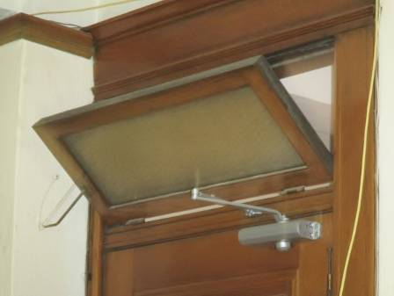

Transom over door

Picture 2

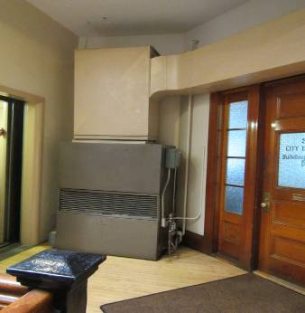

AHU located in hallway
Picture 3

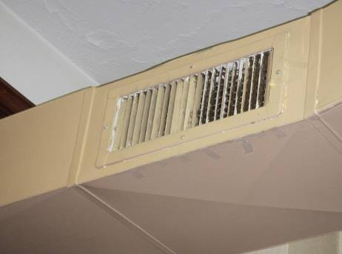

Ducted supply vent in hallway (note dirt/debris)

Picture 4

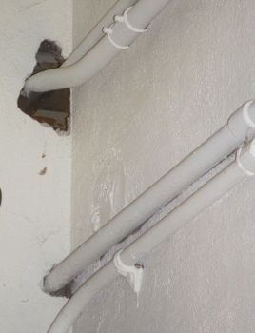

Holes/gaps around utility pipe in basement
Picture 5

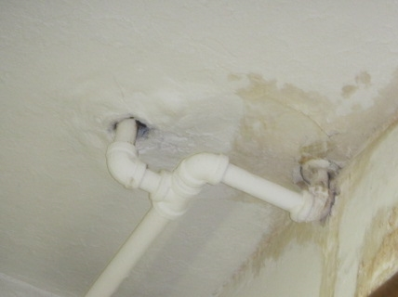

Holes/gaps around utility pipe in cell block (note: water damage)

Picture 6

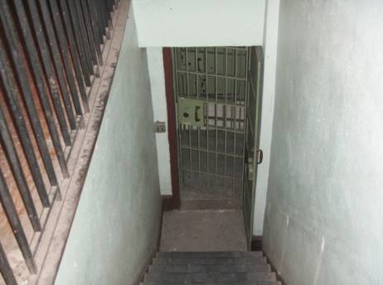

Open stairwell from basement cell block to first floor
Picture 7

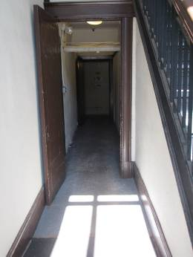

Ramp leading from basemen to first floor entrance (note: open door)

Picture 8

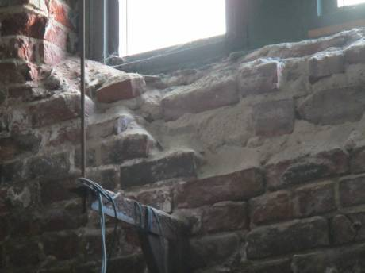

Missing/deteriorated brick in mechanical room
Picture 9

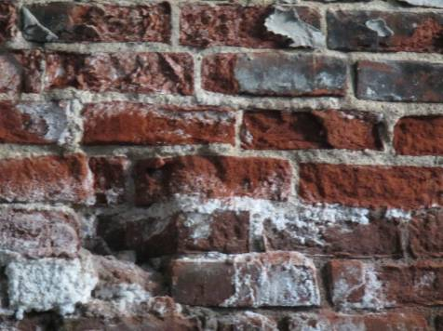

Efflorescence on wall of the mechanical room
Picture 10

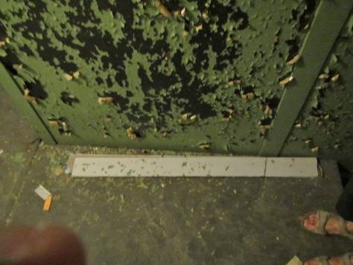

Peeling paint in cell block
Picture 11

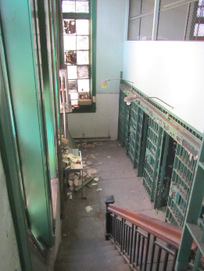

Accumulated water-damaged boxes/papers in cell block

Picture 12

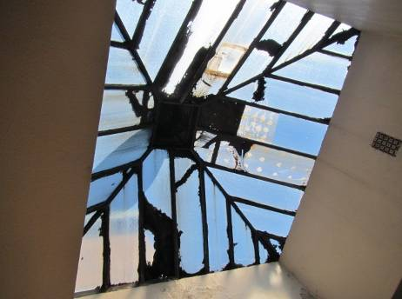

Skylight with cracked/missing/painted over glass
Picture 13

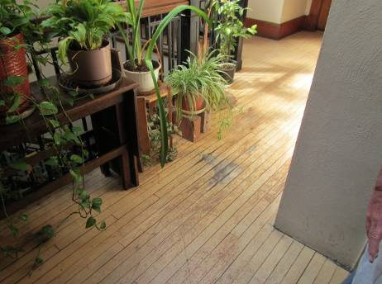

Water staining on fourth floor (note: number of plants)

Picture 14

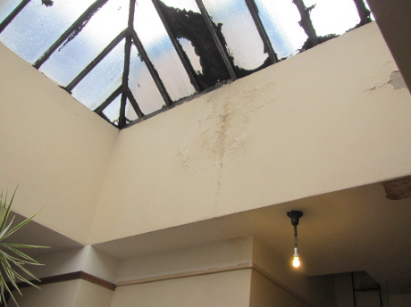

Water-damaged wall plaster in fourth floor atrium
Picture 15

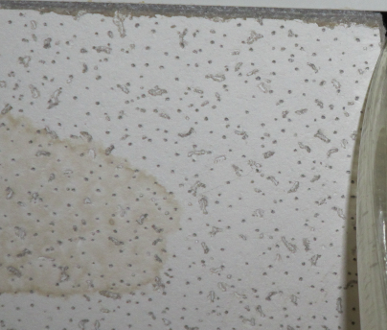

Water-damaged ceiling tile
Picture 16

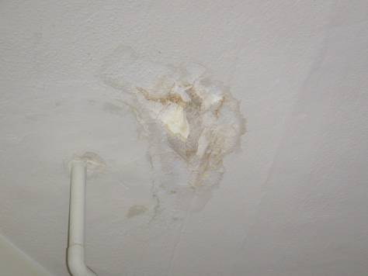

Water-damaged ceiling plaster
Picture 17

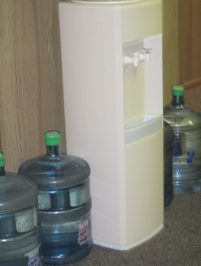

Water dispenser located on carpet

Picture 18

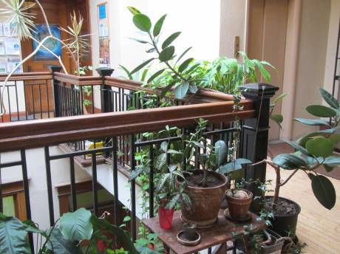

Plants in fourth floor atrium
Picture 19

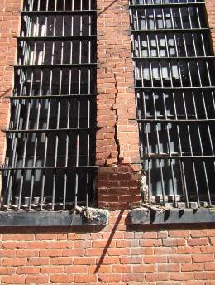

Cracked/damaged brick/mortar on south-facing wall

Picture 20

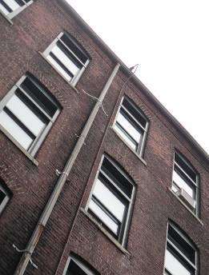

Gutter/downspout attached to the rear of the building
Picture 21

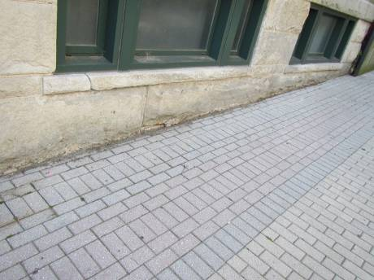

Damaged stone foundation along sidewalk

Picture 22

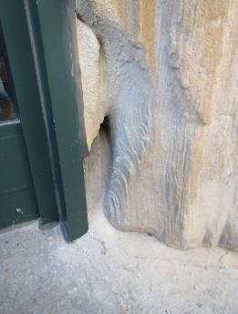

Deteriorated stone column adjacent to side entrance of the building
Picture 23

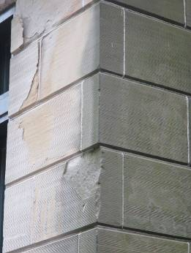

Cracked/damaged stone on north side of the building

Picture 24

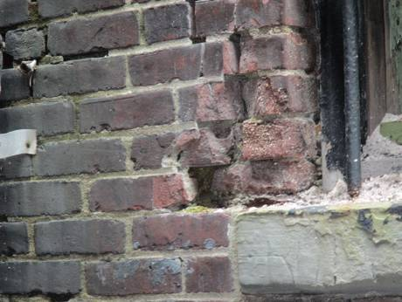

Cracked/damaged brick and mortar
Picture 25

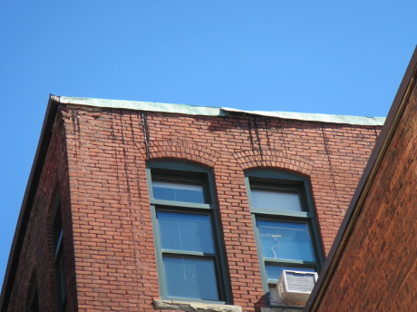

Damaged flashing along the roofline

Picture 26

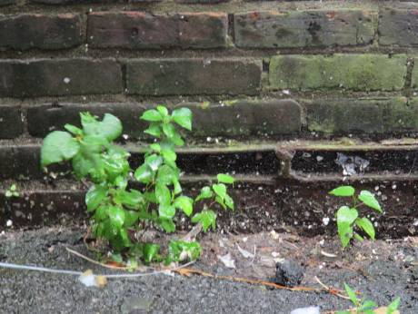

Plants growing along the foundation
Picture 27

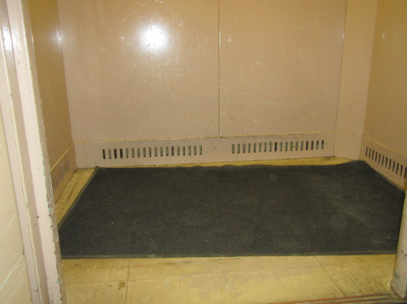

Passive vents located on the interior of the elevator

Picture 28

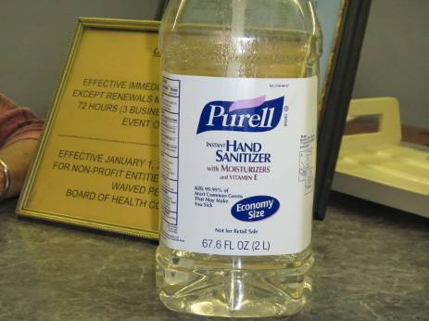

Hand sanitizer
Picture 29

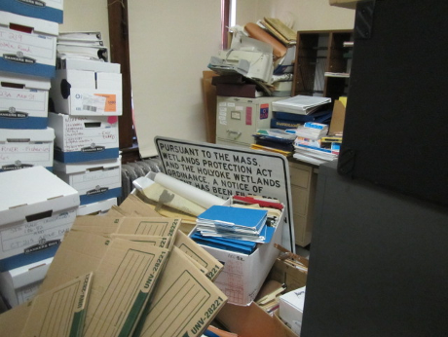

Boxes, paper and clutter in an office space
Location | Carbon  Dioxide  (ppm) | Carbon Monoxide  (ppm) | Temp  (°F) | Relative  Humidity  (%) | PM2.5  (µg/m³) | Occupants  in Room | Windows  Openable | Ventilation |  |  | Remarks
 |  |  |  |  |  |  |  | Supply | Exhaust |  | Remarks
Background | 359 | ND | 67 | 83 | 13 |  |  |  |  |  | Cloudy, intermittent showers
Animal Control Office | 566 | ND | 76 | 64 | 12 | 0 | Y (open) | N |  | N | DO, WD-CT, PF dirty
Auditor Office 1 | 406 | ND | 73 | 67 | 11 | 0 | N | Y (off) |  | N | DO,WAC, WD-CP/WP, PCs (2), scanner/laminator, clutter/boxes
Auditor Office 2 | 498 | ND | 72 | 67 | 12 | 0 | Y (open) | Y (off) |  | N | DO, peeling CP/WP, WC on carpet, clutter/boxes on floor, plants
Auditor Office 3 | 436 | ND | 73 | 67 | 12 | 1 | Y (open) | Y (off) |  | N | DO, WAC, plants, clutter, feather duster
Auditor Office 4 | 461 | ND | 74 | 67 | 11 | 0 | Y | Y (off) |  | N | WD-CP, PF dirty, clutter, WC on carpet
Board of Appeals Office | 421 | ND | 74 | 65 | 10 | 0 | Y | N |  | N
Board of Health Conference Room | 599 | ND | 75 | 64 | 12 | 0 | Y | Y |  | N
Board of Health Director Office | 546 | ND | 76 | 64 | 11 | 3 | Y | Y |  | N | DO, peeling CP, WAC
Board of Health Inspector Office | 601 | ND | 74 | 63 | 13 | 1 | Y | Y |  | N | WAC
Board of Health Licensing Office | 646 | ND | 73 | 63 | 10 | 0 | Y | N |  | N | DO, peeling, WD-CP, WAC, PF dirty
Board of Health Reception | 543 | ND | 76 | 63 | 12 | 1 | N | Y |  | N | PC, WC on carpet, plants, PF dirty
Board of Health Storage Room | 627 | ND | 73 | 65 | 11 | 0 | N | N |  | N | WD-CP/WP, boxes on floor, clutter
Break Room  (fourth floor) | 450 | ND | 75 | 66 | 11 | 0 | Y | Y |  | N | DO, refrigerator, microwave
Break Room (third floor) | 388 | ND | 73 | 67 | 12 | 0 | Y | Y |  | N | DO, WD-CT, refrigerator, toaster, microwave, WC on carpet
Building Inspector Clerical Office | 622 | ND | 74 | 63 | 11 | 1 | Y (open) | Y |  | N
Building Inspector Office | 547 | ND | 73 | 65 | 12 | 0 | Y (open) | Y |  | N | DO, WAC, PC, PF dirty
City Engineer Clerk Office | 541 | ND | 73 | 64 | 10 | 1 | Y | Y |  | N
City Engineer Office | 419 | ND | 74 | 65 | 11 | 2 | Y (open) | Y |  | N | PC, plants, peeling CP, paper, boxes, clutter
Community Development Office 1 | 467 | ND | 74 | 63 | 13 | 1 | Y (open) | Y |  | N | WC on carpet
Community Development Office 2 | 537 | ND | 75 | 64 | 13 | 1 | Y | Y |  | N | DO, plants, DEM
Community Development Office 3 | 473 | ND | 74 | 64 | 12 | 0 | Y | Y |  | Y
Conservation Office | 489 | ND | 76 | 65 | 10 | 1 | Y (open) | Y |  | Y | Clutter, paper, boxes
Law Administrator Office | 444 | ND | 74 | 63 | 10 | 1 | Y | Y |  | N | DO, WD-CT, WAC, PC, plant
Law Office 1 | 466 | ND | 73 | 65 | 11 | 0 | Y (open) | Y |  | N | DO, PC
Law Office 2 | 472 | ND | 72 | 66 | 10 | 1 | Y (open) | Y |  | N | DO, WAC
Law Office 3 | 419 | ND | 74 | 65 | 11 | 1 | Y | Y |  | N | WD-CT, WAC
Law Office Break Room | 489 | ND | 73 | 67 | 11 | 0 | Y | Y |  | N | DO, WC on carpet, refrigerator, microwave
Law Office Storage | 411 | ND | 71 | 64 | 10 | 0 | N | N |  | N | Boxes on floor
Planning Board Conference Room | 411 | ND | 73 | 67 | 9 | 0 | Y | N |  | N | DO, WAC
Planning Board Office 1 | 550 | ND | 74 | 65 | 8 | 1 | Y | N |  | N | Plants, clutter, boxes, paper
Planning Board Office 2 | 632 | ND | 74 | 64 | 9 | 2 | Y | N |  | N | DO, PC, WAC, WC on carpet
Planning Board Office 3 | 419 | ND | 74 | 64 | 9 | 2 | Y | N |  | N | DO, WAC, PF dirty
Public Health Nurse Office | 552 | ND | 75 | 65 | 12 | 0 | Y | Y |  | N | DO, peeling-CP, clutter, PF dirty, hand sanitizer
Restroom (women)  (second floor) | 677 | ND | 75 | 65 | 12 |  | N | N |  | N | WD/peeling-CP
Restroom (men)  (third floor) | 609 | ND | 75 | 66 | 12 |  | N | N |  | N
Restroom (public) | 499 | ND | 75 | 67 | 12 |  | N | N |  | N | Hand sanitizer
Restroom (women)  (second floor) | 662 | ND | 75 | 66 | 10 |  | N | N |  | N | WD/peeling-CP
Retirement Board Office 1 | 420 | ND | 72 | 63 | 12 | 1 | Y (open) | Y |  | N | DO, WD-CT,WAC, PC, plants
Retirement Board Office 2 | 406 | ND | 72 | 64 | 11 | 0 | Y | Y |  | Y | DO, WAC, plants
Retirement Board Storage Room | 450 | ND | 76 | 67 | 12 | 0 | N | N |  | N | Clutter, boxes on floor

