|  |
| --- |
| **INDOOR AIR QUALITY ASSESSMENT**  **Holyoke City Hall**  **536 Dwight Street**  **Holyoke, Massachusetts**    Prepared by:  Massachusetts Department of Public Health  Bureau of Environmental Health  Indoor Air Quality Program  October 2014 |

# Background/Introduction

At the request of Ernest Mathieu, Health Agent for the City of Holyoke, the Massachusetts Department of Public Health (MDPH), Bureau of Environmental Health (BEH) provided assistance and consultation regarding indoor air quality (IAQ) at the Holyoke City Hall (HCH), 536 Dwight Street, Holyoke. The request was prompted by concerns related to odors in the building primarily following heavy rainstorms and during hot, humid weather. On May 16, 2014, a visit to conduct an indoor air quality (IAQ) assessment was made by Michael Feeney, Director of BEH’s IAQ Program and Kathleen Gilmore, Environmental Analyst/Regional Inspector for the BEH/IAQ Program. James Kras, Facilities Director for the City of Holyoke, accompanied Mr. Feeney and Ms. Gilmore during the assessment.

The HCH is a three-story stone building constructed in 1876. City offices are located on the basement (ground floor) and the first floor. The second floor is the former grand ballroom and is used for community meetings. Floors are carpeted in most areas. Windows are openable. A below-grade sub-basement exists for utilities and the boiler room.

# Methods

Air tests for carbon dioxide, carbon monoxide, temperature and relative humidity were conducted with the TSI, Q-Trak, IAQ Monitor, Model 7565. Air tests for airborne particle matter with a diameter less than 2.5 micrometers were taken with the TSI, DUSTTRAK™ Aerosol Monitor Model 8520. BEH/IAQ staff also performed visual inspection of building materials for water damage and/or microbial growth.

# Results

The HCH has an employee population of approximately 40 and can be visited by approximately 50 members of the public on a daily basis. Tests were taken under normal operating conditions and results appear in Table 1.

# Discussion

## Ventilation

It can be seen from Table 1 that carbon dioxide levels were below 800 parts per million (ppm), indicating adequate air exchange in all areas surveyed. It is important to note that several areas were empty/sparsely populated at the time carbon dioxide measurements were taken, which can greatly reduce carbon dioxide levels. Carbon dioxide levels would be expected to increase with full occupancy.

Mechanical ventilation is not available in most areas of the building. The HCH was originally designed with a natural/gravity system heated by steam radiators with fresh air provided through openable windows. In addition to openable windows, the building has hinged windows located above hallway doors. These hinged windows or transoms (Picture 1) enable occupants to close hallway doors while maintaining a pathway for airflow into the rooms. This design allows for airflow to enter an open window, pass through a room, through the open transom to the hallway and subsequently pass through the open transom and window on the opposite side of the room on the leeward side (opposite the windward side) ([Figure 1](http://www.mass.gov/eohhs/docs/dph/environmental/iaq/appendices/open-transoms-figure.rtf)). This system fails if the windows or transoms are closed ([Figure 2](http://www.mass.gov/eohhs/docs/dph/environmental/iaq/appendices/closed-transoms-figure.rtf)). Most windows in the building were found closed at the time of the assessment and many transoms were found closed/permanently sealed. Without a means for air exchange via windows or a mechanical supply and exhaust system, normally occurring indoor environmental pollutants can build up, leading to indoor air quality/comfort complaints.

Most offices have window air-conditioners (WAC, Table 1) which provide conditioned air in warm weather and can provide limited air exchange. The Treasurer and Parks and Recreation offices have wall-mounted air-handling units (AHU) located in the office spaces (Picture 2). These AHUs do not provide fresh air but cool air and deliver it to occupied spaces via ducted supply vents (Picture 3). The City Council Chambers has a dedicated system for air-conditioning (Table 1). An AHU located in a closet space draws in fresh, outdoor air through air intakes located on the exterior of the building. The AHU delivers conditioned air via ducted supply vents and air is returned back to the AHU via ducted exhaust vents. Mr. Kras reported that all filters in air-conditioning units are cleaned and or replaced as needed twice each year.

No dedicated exhaust vents were identified in the restrooms. Exhaust ventilation is essential to remove excess moisture and prevent restroom odors from penetrating into adjacent areas.

To maximize air exchange, the MDPH recommends that both supply and exhaust ventilation operate continuously during periods of occupancy. In order to have proper ventilation with a mechanical supply and exhaust system, the systems must be balanced to provide an adequate amount of fresh air to the interior of a room while removing stale air from the room. It is recommended that HVAC systems be re-balanced every five years to ensure adequate air systems function (SMACNA, 1994). The system in the building cannot be balanced.

Minimum design ventilation rates are mandated by the Massachusetts State Building Code (MSBC). Until 2011, the minimum ventilation rate in Massachusetts was higher for both occupied office spaces and general classrooms, with similar requirements for other occupied spaces (BOCA, 1993). The current version of the MSBC, promulgated in 2011 by the State Board of Building Regulations and Standards (SBBRS), adopted the 2009 International Mechanical Code (IMC) to set minimum ventilation rates. **Please note that the MSBC is a minimum standard that is not health-based**. At lower rates of cubic feet per minute (cfm) per occupant of fresh air, carbon dioxide levels would be expected to rise significantly. A ventilation rate of 20 cfm per occupant of fresh air provides optimal air exchange resulting in carbon dioxide levels at or below 800 ppm in the indoor environment in each area measured. MDPH recommends that carbon dioxide levels be maintained at 800 ppm or below. This is because most environmental and occupational health scientists involved with research on IAQ and health effects have documented significant increases in indoor air quality complaints and/or health effects when carbon dioxide levels rise above the MDPH guidelines of 800 ppm for schools, office buildings and other occupied spaces (Sundell et al., 2011). The ventilation must be on at all times that the room is occupied. Providing adequate fresh air ventilation with open windows and maintaining the temperature in the comfort range during the cold weather season is impractical. Mechanical ventilation is usually required to provide adequate fresh air ventilation.

Carbon dioxide is not a problem in and of itself. It is used as an indicator of the adequacy of the fresh air ventilation. As carbon dioxide levels rise, it indicates that the ventilating system is malfunctioning or the design occupancy of the room is being exceeded. When this happens, a buildup of common indoor air pollutants can occur, leading to discomfort or health complaints. The Occupational Safety and Health Administration (OSHA) standard for carbon dioxide is 5,000 parts per million parts of air (ppm). Workers may be exposed to this level for 40 hours/week, based on a time-weighted average (OSHA, 1997).

The MDPH uses a guideline of 800 ppm for publicly occupied buildings. A guideline of 600 ppm or less is preferred in schools due to the fact that the majority of occupants are young and considered to be a more sensitive population in the evaluation of environmental health status. Inadequate ventilation and/or elevated temperatures are major causes of complaints such as respiratory, eye, nose and throat irritation, lethargy and headaches. For more information concerning carbon dioxide, please see [Appendix A](http://www.mass.gov/eohhs/docs/dph/environmental/iaq/appendices/carbon-dioxide.doc).

Temperature readings during the assessment ranged from 70° F to 75° F which were within the MDPH recommended comfort range (Table 1). The MDPH recommends that indoor air temperatures be maintained in a range of 70° F to 78° F in order to provide for the comfort of building occupants. In many cases concerning indoor air quality, fluctuations of temperature in occupied spaces are typically experienced, even in a building with an adequate fresh air supply.

The relative humidity at the time of the assessment ranged from 70 to 73 percent (Table 1), which was above the MDPH recommended comfort range. The MDPH recommends a comfort range of 40 to 60 percent for indoor air relative humidity. Note that at the time of assessment, the relative humidity outdoors was measured at 83 percent, which influences the relative humidity inside the building, particularly due to the lack of an operating ventilation system and windows open. When relative humidity is above this comfort level, moisture removal is important since higher humidity at a given temperature reduces the ability of the body to cool itself by perspiration. “Heat index” is a measurement that takes into account the impact of a combination of heat and humidity on how hot it feels. At a given indoor temperature, the addition of humid air increases occupant discomfort and may generate heat complaints. If moisture levels are decreased, the comfort of the individuals increases. Relative humidity levels in the building would be expected to drop during the winter months due to heating. The sensation of dryness and irritation is common in a low relative humidity environment. Low relative humidity is a very common problem during the heating season in the northeast part of the United States.

## Microbial/Moisture Concerns

As mentioned, the HCH has a below-grade sub-basement, thus microbial growth would be expected to be present given an unconditioned cement floor that is subjected to moisture. Efforts should be made to reduce moisture and reduce/eliminate potential pathways for mold, spores, and associated odors to migrate into occupied areas. The most obvious means for odors and pollutants to migrate between the sub-basement and occupied areas on the basement level and the ground floor are holes and spaces surrounding sewer, plumbing and utility pipes (see *Odor Concerns* section below). Airflow tends to rise and these breaches can serve as pathways to draw air, odors and particulates from the sub-basement into stairwells, hallways and offices. This condition is known as the stack effect. All holes and gaps should be sealed with fire-rated sealant foam or other appropriate material.

Given the high relative humidity measured in the building at the time of the assessment, condensation, particularly in areas chilled by the action of air conditioning or adjacent to the ground, may occur during humid weather. Condensation can moisten building materials such as carpeting and upholstery which may lead to microbial growth. Carpeting is not recommended to be used in areas that are below grade.

Several rooms in the building had water-damaged ceiling tiles (Table 1; Picture 4), which may stem from roof leaks, plumbing leaks and/or condensation from WAC components (Table 1). If repeatedly moistened, ceiling tiles can be a medium on which mold can grow. Water-damaged tiles should be replaced after a water leak is discovered and repaired.

Water dispensers were located in some rooms over carpeting (Table 1). Overflow/spills from water coolers/water fountains can moisten carpeting. It is recommended that these dispensers be located on non-porous flooring or a waterproof mat. It is also important that the catch basin of water coolers be cleaned regularly as stagnant water can be a source of odors.

The US EPA and the American Conference of Governmental Industrial Hygienists (ACGIH) recommend that porous materials be dried with fans and heating within 24 to 48 hours of becoming wet (US EPA, 2001; ACGIH, 1989). If porous materials are not dried within this time frame, mold growth may occur. Once mold has colonized porous materials, they are difficult to clean and should be removed and discarded.

## Odor Concerns

As mentioned, concerns of odors in the HCH prompted the IAQ assessment. BEH/IAQ staff observed a number of conditions throughout the building that could serve as potential sources of odors as well as pathways for odors, moisture and pollutants to penetrate occupied areas of the building.

The HCH was constructed with a public restroom that has an entrance in the northwest corner of the exterior wall. Due to a variety of issues, the use of this space as a restroom was discontinued and it is now used for storage. BEH staff detected a strong sewer odor in the City Messenger’s office immediately above this abandoned restroom. Breaches in the floor of this office were noted. BEH staff entered the abandoned restroom and detected a strong sewer odor immediately within the restroom. Also of note was at least one large hole in the ceiling, which would allow for odor, water vapor and air to enter the HCH interior floor and wall cavities. Other gaps/breaches were noted in the floor and ceiling of the space around sewer and plumbing pipes (Picture 5). BEH/IAQ staff noted that a sewer drain pipe that terminated in the space appeared not to be capped/sealed. These conditions could allow the migration of odors from the sub-basement into occupied spaces in the basement level and first floor of the building. As mentioned previously, the former restroom door on the exterior of the building had a damaged sweep and weather stripping, which would allow for the outdoor air to pressurize this space to force odors into the wall and floor cavities, particularly during northwesterly wind conditions. Exterior doors can also serve as a source of water entry into the building as well as a pathway for insects, rodents and other pests into the building.

The Election Room is a basement level space that was formerly an interior restroom. It is currently used as storage space. Strong sewer/musty odors were noted in the space. Abandoned sewer drain pipes in the floor were found opened or filled with plastic, and appeared to be uncapped (Pictures 6 and 7). A floor drain was also observed in the space (Picture 8). Drains are typically designed with traps to prevent sewer odors/gases from penetrating into occupied spaces. When water is poured into a trap, an air-tight seal is created by the water in the U-bend section of the pipe. These drains must have water poured into them to maintain the integrity of the seal. Without water, the sewer is open to the room and sewer odors can occur. Given that the drain is no longer needed it should be permanently capped/sealed. In addition, holes and breaches were observed in the floor and ceiling of the room from abandoned plumbing and utility pipes (Picture 9). Breaches were also observed around plumbing and utility pipes in occupied offices on the basement and first floor levels.

As previously mentioned, airflow tends to rise and these numerous breaches can serve as pathways to draw air, odors and particulates from the sub-basement into stairwells, hallways and offices via the stack effect. At the time of the assessment, BEH/IAQ staff recommended that facilities staff inspect all areas of the building for open drains and holes and ensure they are capped/sealed throughout the building are sealed with fire-rated sealant foam or other appropriate material.

As mentioned previously, a sewer/musty odor was detected in the City Messenger’s office (Room 10). BEH/IAQ located a sink that had a cut/open drain pipe with a hole in the floor (Picture 10). Another possible source of odors may be the seal on the toilet adjacent to this office. If the wax seal holding the toilet to the floor is not airtight, sewer gas odors can be drawn from underneath the toilet. BEH/IAQ noted that the wax ring/sealant appeared to be degraded and should be replaced.

## Other Indoor Air Evaluations

Indoor air quality can be negatively influenced by the presence of respiratory irritants, such as products of combustion. The process of combustion produces a number of pollutants. Common combustion emissions include carbon monoxide, carbon dioxide, water vapor, and smoke (fine airborne particle material). Of these materials, exposure to carbon monoxide and particulate matter with a diameter of 2.5 micrometers (μm) or less (PM2.5) can produce immediate, acute health effects upon exposure. To determine whether combustion products were present in the indoor environment, BEH/IAQ staff obtained measurements for carbon monoxide and PM2.5.

### Carbon Monoxide

Carbon monoxide is a by-product of incomplete combustion of organic matter (e.g., gasoline, wood and tobacco). Exposure to carbon monoxide can produce immediate and acute health affects. Several air quality standards have been established to address carbon monoxide and prevent symptoms from exposure to these substances. The MDPH established a corrective action level concerning carbon monoxide in ice skating rinks that use fossil-fueled ice resurfacing equipment. If an operator of an indoor ice rink measures a carbon monoxide level over 30 ppm, taken 20 minutes after resurfacing within a rink, that operator must take actions to reduce carbon monoxide levels (MDPH, 1997).

The American Society of Heating Refrigeration and Air-Conditioning Engineers (ASHRAE) has adopted the National Ambient Air Quality Standards (NAAQS) as one set of criteria for assessing indoor air quality and monitoring of fresh air introduced by HVAC systems (ASHRAE, 1989). The NAAQS are standards established by the US EPA to protect the public health from six criteria pollutants, including carbon monoxide and particulate matter (US EPA, 2006). As recommended by ASHRAE, pollutant levels of fresh air introduced to a building should not exceed the NAAQS levels (ASHRAE, 1989). The NAAQS were adopted by reference in the Building Officials & Code Administrators (BOCA) National Mechanical Code of 1993 (BOCA, 1993), which is now an HVAC standard included in the Massachusetts State Building Code (SBBRS, 2011). According to the NAAQS, carbon monoxide levels in outdoor air should not exceed 9 ppm in an eight-hour average (US EPA, 2006).

*Carbon monoxide should not be present in a typical, indoor environment*. If it *is* present, indoor carbon monoxide levels should be less than or equal to outdoor levels. Outdoor carbon monoxide concentrations were non-detect (ND) on the day of the assessment (Table 1). No measureable levels of carbon monoxide were detected in the building during the assessment (Table 1).

### Particulate Matter

The US EPA has established NAAQS limits for exposure to particulate matter. Particulate matter includes airborne solids, which can result in eye and respiratory irritation if exposure occurs. The NAAQS originally established exposure limits to particulate matter with a diameter of 10 μm or less (PM10). According to the NAAQS, PM10 levels should not exceed 150 micrograms per cubic meter (μg/m3) in a 24-hour average (US EPA, 2006). These standards were adopted by both ASHRAE and BOCA. Since the issuance of the ASHRAE standard and BOCA Code, US EPA established a more protective standard for fine airborne particles. This more stringent PM2.5 standard requires outdoor air particle levels be maintained below 35 μg/m3 over a 24-hour average (US EPA, 2006). Although both the ASHRAE standard and BOCA Code adopted the PM10 standard for evaluating air quality, MDPH uses the more protective PM2.5 standard for evaluating airborne particulate matter concentrations in the indoor environment.

Outdoor PM2.5 was measured at 10 μg/m3 (Table 1) on the day of the visit. PM2.5 levels measured indoors ranged from 6 to 19 μg/m3 (Table 1), which were below the NAAQS PM2.5 level of 35 μg/m3. Frequently, indoor air levels of particulates (including PM2.5) can be at higher levels than those measured outdoors. A number of mechanical devices and/or activities that occur in buildings can generate particulate during normal operations. Sources of indoor airborne particulates may include but are not limited to particles generated during the operation of fan belts in the HVAC system, use of stoves and/or microwave ovens in kitchen areas; use of photocopiers, fax machines and computer printing devices; operation of an ordinary vacuum cleaner and heavy foot traffic indoors.

### Volatile Organic Compounds

Indoor air concentrations can be greatly impacted by the use of products containing volatile organic compounds (VOCs). VOCs are carbon-containing substances that have the ability to evaporate at room temperature. Frequently, exposure to low levels of total VOCs (TVOCs) may produce eye, nose, throat and/or respiratory irritation in some sensitive individuals. For example, chemicals evaporating from a paint can stored at room temperature would most likely contain VOCs. In an effort to identify materials that can potentially increase indoor VOC concentrations, BEH/IAQ staff examined the office space for products containing respiratory irritants.

There are photocopiers in the office space (Table 1). Photocopiers can be sources of pollutants such as VOCs, ozone, heat and odors, particularly if the equipment is older and in frequent use. Both VOCs and ozone are respiratory irritants (Schmidt Etkin, 1992). Photocopiers and laminators should be kept in well ventilated rooms, and should be located near windows or exhaust vents.

## Other Conditions

There were reports of occasional rodent problems in the building. Rodent infestation can result in indoor air quality related symptoms due to materials in their wastes. Mouse urine contains a protein that is a known sensitizer (US EPA, 1992). A sensitizer is a material that can produce symptoms (e.g., running nose or skin rashes) in sensitive individuals after repeated exposure. A three-step approach is necessary to eliminate rodent infestation:

* removal of the rodents;
* cleaning of waste products from the interior of the building; and
* reduction/elimination of pathways/food sources that are attracting rodents.

To eliminate exposure to allergens, rodents must be removed from the building. Please note that removal, even after cleaning, may not provide immediate relief since allergens can exist in the interior for several months after rodents are eliminated (Burge, 1995). Once the infestation is eliminated, a combination of cleaning and increased ventilation and filtration should serve to reduce allergens associated with rodents.

As mentioned, floors in most rooms of the HCH are covered by wall-to-wall carpeting. It was not clear whether a carpet cleaning program is in place at the HCH. The Institute of Inspection, Cleaning and Restoration Certification (IICRC), recommends that carpeting be cleaned annually (or semi-annually in soiled high traffic areas) (IICRC, 2012). If the carpeting is beyond its service life, consideration should be given towards replacement. As noted above, carpeting is not recommended in below-grade spaces and other areas that may be subject to condensation or chronic moist conditions.

# Conclusions/Recommendations

In view of the findings at the time of the assessment, the following recommendations are made.

1. Facilities management should work with a licensed plumbing firm to ensure all abandoned sewer drain pipes in former restrooms are capped/sealed and make repairs on active plumbing as needed.
2. Seal holes/spaces and other penetrations in the ceilings and floors around plumbing and utility pipes in the abandoned restrooms with an expandable, fire rated sealing compound.
3. Examine all occupied office spaces for spaces/breaches around plumbing and utility pipes and seal with an expandable, fire-rated sealing compound.
4. Repair the toilet and replace the wax ring in Room 10 restroom.
5. Open windows (weather permitting) to temper rooms and provide fresh outside air. Care should be taken to ensure windows are properly closed at night and weekends during winter months to avoid the freezing of pipes and potential flooding. In addition, keep windows closed during hot, humid weather to maintain indoor temperatures and to avoid condensation problems when air conditioning is activated.
6. Consider installing exhaust ventilation in restrooms to prevent the migration of odors, moisture and pollutants into occupied spaces.
7. Consider adopting a balancing schedule of every 5 years for all mechanical ventilation systems, as recommended by ventilation industrial standards (SMACNA, 1994).
8. Use air conditioning to reduce relative humidity in the building during periods of high outdoor humidity. Additional dehumidification units may be warranted in below-grade areas.
9. Remove water-damaged ceiling tiles and examine for source of water. Monitor for future leaks. After necessary repairs are made, replace any water-damaged ceiling tiles with new ones.
10. Consider moving water dispensing equipment to areas with tiled floors instead of carpeting, or installing waterproof mats to prevent leaks from damaging carpet.
11. For buildings in New England, periods of low relative humidity during the winter are often unavoidable. Therefore, scrupulous cleaning practices should be adopted to minimize common indoor air contaminants whose irritant effects can be enhanced when the relative humidity is low. To control for dusts, a high efficiency particulate arrestance (HEPA) filter equipped vacuum cleaner in conjunction with wet wiping of all surfaces is recommended. Avoid the use of feather dusters. Drinking water during the day can help ease some symptoms associated with a dry environment (throat and sinus irritations).
12. Use the principles of integrated pest management (IPM) to rid this building of pests. Activities that can be used to eliminate pest infestation may include the following:
    1. Keep list/inventory of location of all rodent bait/sticky traps, monitor on a regular basis and replace as needed to prevent odors from rodent die off. Do not place rodent traps in the airstream of ventilation equipment;
    2. Do not use recycled food containers for other purposes. Seal containers to be recycled in a container with a tight fitting lid to prevent rodent access;
    3. Remove non-food items that rodents are consuming or using as bedding;
    4. Store foods in tight fitting containers;
    5. Avoid eating at workstations. In areas were food is consumed, vacuum periodically to remove crumbs;
    6. Regularly clean crumbs and other food residues from toasters, toaster ovens, microwave ovens coffee pots and other food preparation equipment;
    7. Examine each room and the exterior walls of the building for means of rodent egress and seal appropriately. Holes as small as ¼” is enough space for rodents to enter an area. If doors do not seal at the bottom, install a weather strip as a barrier to rodents;
    8. Reduce harborages (cardboard boxes, paper) where rodents may reside; and
    9. Refer to the IPM Guide, which can be obtained at the following Internet address: <http://www.mass.gov/eea/docs/agr/pesticides/publications/ipm-kit-for-bldg-mgrs.pdf>.
13. Clean carpeting annually (or semi-annually in soiled high traffic areas) as per the recommendations of the Institute of Inspection, Cleaning and Restoration Certification (IICRC, 2012). Consider a schedule for replacing worn carpeting that is beyond its service life. Copies of the IICRC fact sheet are available at: [http://www.iicrc.org/consumers/care/carpet-cleaning/#faq.](http://www.iicrc.org/consumers/care/carpet-cleaning/" \l "faq)
14. Refer to resource manuals and other related indoor air quality documents for further building-wide evaluations and advice on maintaining public buildings. These materials are located on the MDPH’s website: <http://mass.gov/dph/iaq>.

# References

ACGIH. 1989. Guidelines for the Assessment of Bioaerosols in the Indoor Environment. American Conference of Governmental Industrial Hygienists, Cincinnati, OH.

ASHRAE. 1989. Ventilation for Acceptable Indoor Air Quality. American Society of Heating, Refrigeration and Air Conditioning Engineers. ANSI/ASHRAE 62-1989.

BOCA. 1993. The BOCA National Mechanical Code/1993. 8th ed. Building Officials and Code Administrators International, Inc., Country Club Hill, IL.

Burge, H.A. 1995. *Bioaerosols*. Lewis Publishing Company, Boca Raton, FL.

IICRC.  2012. Institute of Inspection, Cleaning and Restoration Certification.  Carpet Cleaning: FAQ.  Retrieved from [http://www.iicrc.org/consumers/care/carpet-cleaning/#faq](https://email.state.ma.us/OWA/redir.aspx?C=H6rjxlVPDEecYx7f56r0qDe3jH1DM9FIfrJ8T7xEg-XU7CEkLSKtalfLUo0OiM49mZvA3ziSGuA.&URL=http%3a%2f%2fwww.iicrc.org%2fconsumers%2fcare%2fcarpet-cleaning%2f%23faq).

MDPH. 1997. Requirements to Maintain Air Quality in Indoor Skating Rinks (State Sanitary Code, Chapter XI). 105 CMR 675.000. Massachusetts Department of Public Health, Boston, MA.

OSHA. 1997. Limits for Air Contaminants. Occupational Safety and Health Administration. Code of Federal Regulations. 29 C.F.R 1910.1000 Table Z-1-A.

SBBRS. 2011. Mechanical Ventilation. State Board of Building Regulations and Standards. Code of Massachusetts Regulations, 8th edition. 780 CMR 1209.0

Schmidt Etkin, D. 1992. Office Furnishings/Equipment & IAQ Health Impacts, Prevention & Mitigation. Cutter Information Corporation, Indoor Air Quality Update, Arlington, MA.

SMACNA. 1994. HVAC Systems Commissioning Manual. 1st ed. Sheet Metal and Air Conditioning Contractors’ National Association, Inc., Chantilly, VA.

Sundell. 2011. Sundell, J., H. Levin, W. W. Nazaroff, W. S. Cain, W. J. Fisk, D. T. Grimsrud, F. Gyntelberg, Y. Li, A. K. Persily, A. C. Pickering, J. M. Samet, J. D. Spengler, S. T. Taylor, and C. J. Weschler. Ventilation rates and health: multidisciplinary review of the scientific literature. Indoor Air, Volume 21: pp 191–204.

US EPA. 1992. Indoor Biological Pollutants. US Environmental Protection Agency, Environmental Criteria and Assessment Office, Office of Health and Environmental Assessment, research Triangle Park, NC. EPA 600/8-91/202. January 1992.

US EPA. 2001. Mold Remediation in Schools and Commercial Buildings. US Environmental Protection Agency, Office of Air and Radiation, Indoor Environments Division, Washington, D.C. EPA 402-K-01-001. March 2001.

US EPA. 2006. National Ambient Air Quality Standards (NAAQS). US Environmental Protection Agency, Office of Air Quality Planning and Standards, Washington, DC. <http://www.epa.gov/air/criteria.html>.

**Picture**

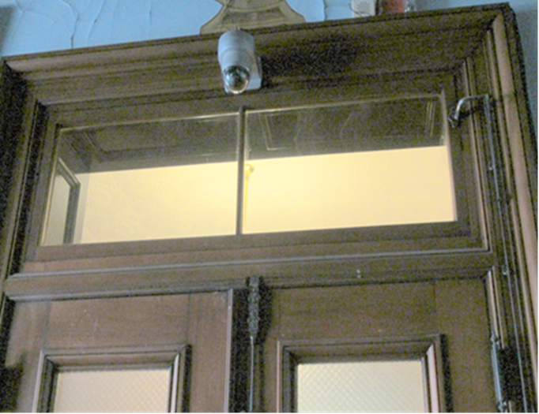

**Transom over office door**

**Picture**

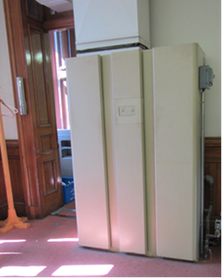

**Wall-mounted AHU in Treasurer’s office**

**Picture**

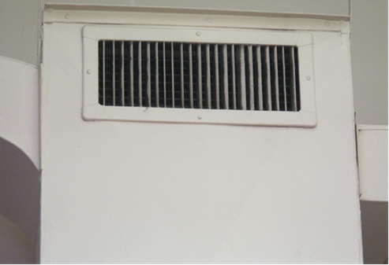

**Supply vent in Treasurer’s Office**

**Picture**

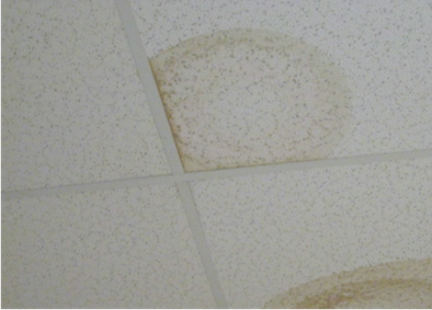

**Water-damaged ceiling tiles**

**Picture**

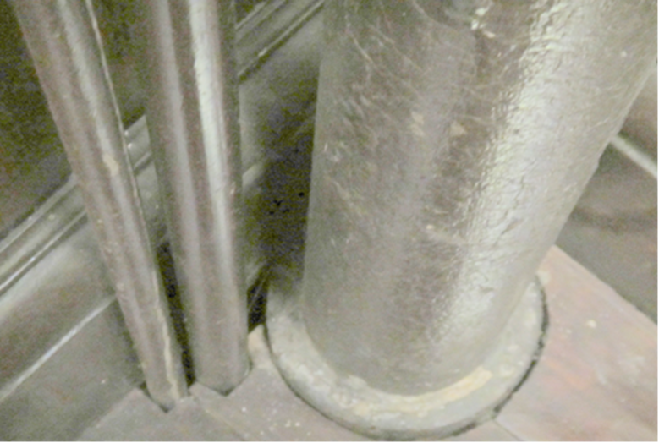

**Hole/gaps around sewer drain and plumbing pipes in abandoned restroom**

**Picture**

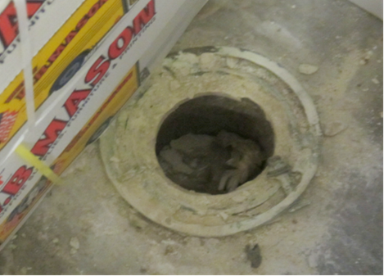

**Uncapped sewer drain in storage room floor**

**Picture**

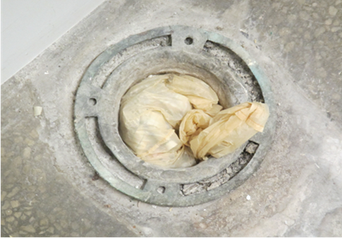

**Sewer drain filled with plastic**

**Picture**

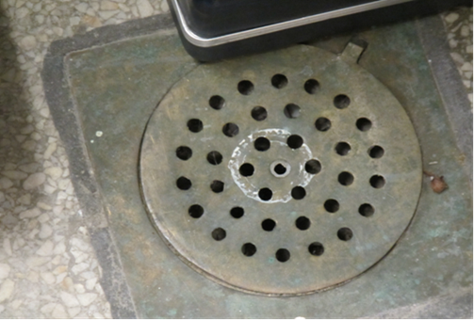

**Open floor drain in storage room**

**Picture**

**Title: Picture 9 - Description: Open plumbing/utility holes in the storage room floor

**

**Open plumbing/utility holes in the storage room floor**

**Picture**

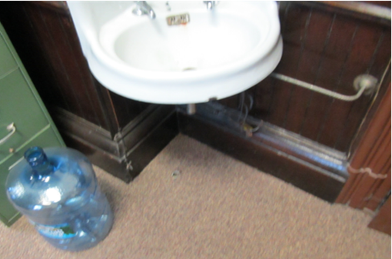

**Hole in floor below cut sink drain**

| **Location/ Room** | **Carbon Dioxide**  **(ppm)** | **Carbon Monoxide**  **(ppm)** | **Temp**  **(°F)** | **Relative Humidity (%)** | **PM2.5**  **(µg/m3)** | **Occupants in Room** | **Windows**  **Openable** | **Ventilation** | | **Remarks** |
| --- | --- | --- | --- | --- | --- | --- | --- | --- | --- | --- |
| **Supply** | **Exhaust** |
| Background | 404 | ND | 69 | 83 | 10 |  |  |  |  | Rain, humid |
| Assessor’s office | 566 | ND | 72 | 70 | 14 | 2 | N | Y | Y | DO, holes/gaps around pipes |
| Abandoned restroom | 635 | ND | 70 | 73 | 15 | 0 | N | N | N | Open sewer pipe, gaps in floor and ceiling |
| Clerk Messenger’s office (room 10) | 538 | ND | 73 | 72 | 10 | 1 | Y | N | N | Cut sink drain with hole in floor, slight sewer/musty odor in restroom, degraded wax ring, cut sink drain |
| Clerk’s assistant’s office | 529 | ND | 72 | 71 | 19 | 2 | Y | N | N | WAC |
| Clerk’s office | 530 | ND | 72 | 71 | 13 | 0 | N | N | N | WAC, transom, holes/gaps around pipes |
| Council Chamber | 512 | ND | 73 | 71 | 8 | 0 | Y | Y | Y | Transom painted over |
| Election office/storage room | 544 | ND | 72 | 70 | 10 | 0 | Y | N | N | Transom, floor drain, open sewer pipes, holes in floor and ceiling |
| Mayor’s office | 531 | ND | 72 | 70 | 12 | 0 | Y | N | N | DO, WD-CT, PC |
| Park and Recreation office | 567 | ND | 72 | 71 | 15 | 2 | Y | Y | Y | Air-handling unit, window open, water cooler on carpet, holes/gaps around pipes |
| Registrar of Voter’s office | 552 | ND | 74 | 70 | 14 | 1 | Y  open | N | N | WD-CT, WAC, transom, PC, water cooler on carpet |
| Room 15 | 572 | ND | 72 | 71 | 6 | 1 | N | Y | Y | Transom painted over |
| Tax Collector’s office | 539 | ND | 75 | 72 | 17 | 2 | Y  open | N | N | WD-CT, PC, WAC, water cooler on carpet, transom, holes/gaps around pipes |
| Treasurer’s office | 594 | ND | 72 | 71 | 9 | 1 | Y | N | N | Air-handling unit, window open, PC |
| Vault | 519 | ND | 72 | 71 | 13 | 0 | N | N | N |  |