INDOOR AIR QUALITY ASSESSMENT

Holyoke Soldiers’ Home
Main Building, floors 2 through 5
110 Cherry Street
Holyoke, Massachusetts

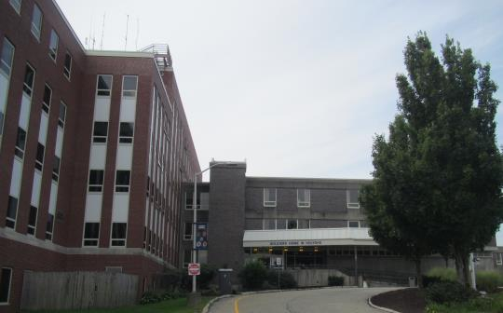

Prepared by:
Massachusetts Department of Public Health
Bureau of Environmental Health
Indoor Air Quality Program
October 2018

BACKGROUND
Building: | Holyoke Soldiers’ Home (HSH), Main Building, floors 2 through 5
Address: | 110 Cherry Street, Holyoke, MA
Assessment Requested by: | Bennett Walsh, Superintendent, HSH
Reason for Request: | General indoor air quality (IAQ) and reported condensation in this location
Date of Assessment: | September 19, 2018
Massachusetts Department of Public Health/Bureau of Environmental Health (MDPH/BEH) Staff Conducting Assessment: | Ruth Alfasso, Environmental Engineer/Inspector, IAQ Program
Building Description: | The HSH is an elder care facility that consists of multiple wings. The original building was constructed in 1951.
Windows: | Windows are openable.

Methods
Please refer to the IAQ Manual for methods, sampling procedures, and interpretation of results (MDPH, 2015).

RESULTS and DISCUSSION
The following is a summary of indoor air testing results (Table 1).
- Carbon dioxide levels were above the MDPH recommended guideline of 800 parts per million (ppm) in about two thirds of areas assessed.
- Temperature was within the MDPH recommended range of 70°F to 78°F in all areas.
- Relative humidity was above the MDPH recommended range of 40% to 60% in most areas assessed.
- Carbon monoxide levels were non-detectable (ND) in all indoor areas assessed.
- Fine particulate matter (PM2.5) concentrations measured were below the National Ambient Air Quality Standard (NAAQS) level of 35 micrograms per cubic meter (μg/m³) in all areas.

Discussion

Ventilation
The building has mechanical ventilation provided by a combination of individual Fan Coil Units (FCUs) with univents connected to the outside. The FCUs provide cooling and air circulation via supply and return vents located in the ceiling (Pictures 1 and 2), while heat during the heating season is provided by radiators. The fresh air supplies are located on the outside of the building (Picture 3) with a vent for each floor and wing. As shown by Table 1, the current configuration/condition of the system is not bringing in adequate amount of fresh air on the third and second floor to reduce carbon dioxide levels below the MDPH recommendation of 800 ppm. Building staff indicated that there are plans to balance the system in the near future, which should improve airflow as well as fresh air supply.
It is recommended that HVAC systems be re-balanced every five years to ensure adequate air systems function (SMACNA, 1994). To maximize air exchange, the MDPH recommends that both supply and exhaust ventilation operate continuously during periods of occupancy. In order to have proper ventilation with a mechanical supply and exhaust system, the systems must be balanced to provide an adequate amount of fresh air to the interior of a room while removing stale air from the room.
The building also has openable windows in almost every room. These can be used to supply fresh air during temperate weather. However, when the air conditioning is operating, windows should remain closed to prevent the introduction of hot humid air that can lead to condensation on chilled surface and problems maintaining a comfortable temperature.
Humidity in the building was also higher than the MDPH recommended levels (Table 1), which is reflective of outdoor conditions on the day of the assessment, as well as heavy rains the previous day. High relative humidity can be uncomfortable, increasing feelings of heat via decreasing the ability of the body to cool itself with sweat. Relative humidity in excess of 70 percent for extended periods of time can also provide an environment for mold and fungal growth (ASHRAE, 1989). The relative humidity higher than outside conditions found in areas such as the showers (Table 1) also indicates that there is insufficient means for stale air and moisture to be removed from the indoor environment. Exhaust venting is necessary to remove excess moisture from the indoor air in restrooms, showers, and other areas where moisture, odors and pollutants may be generated.

Microbial/Moisture Concerns
Water-damaged ceiling tiles were observed in several areas (Pictures 4 and 5; Table 1). These stem from roof leaks, particularly on the 5th floor, where several tiles were still wet from recent rains (Picture 4). Water-damaged ceiling tiles on other floors were reportedly due to leaks through the building envelope through gaps in the masonry. Building staff reported that a project to repair damaged masonry in this building is in the planning phase.
Plants were observed in some areas (Picture 6). Plants can be a source of mold, pollen and odors. They should be well-maintained, not overwatered, and be kept away from the flow of air from the HVAC system.

Other Issues
Exposure to low levels of total volatile organic compounds (TVOCs) may produce eye, nose, throat, and/or respiratory irritation in some sensitive individuals. BEH/IAQ staff examined spaces for products containing VOCs. BEH/IAQ staff noted air fresheners, hand sanitizers, cleaning products, and dry erase materials in the office space (Table 1). All of these products have the potential to be irritants to the eyes, nose, throat, and respiratory system of sensitive individuals.
Items were observed on flat surfaces, such as windowsills, tabletops, counters, bookcases, and desks. These items (e.g. papers, decorative items) also make it difficult for custodial staff to clean. Items should be relocated and/or be cleaned periodically to avoid excessive dust build up.
Most of the bedrooms had fabric curtains (Picture 7). Upholstered furniture was also present in many rooms. In order to remove dust mites and other pollutants, frequent vacuuming of upholstered furniture is recommended (Berry, M.A., 1994). It is also recommended that upholstered furniture be professionally cleaned on an annual basis. If outdoor conditions or indoor activities (e.g., renovations) create an excessively dusty environment, cleaning frequency should be increased (every six months).
Some areas were carpeted. Carpets should be cleaned annually (or semi-annually in soiled/high traffic areas) in accordance with Institute of Inspection, Cleaning and Restoration Certification (IICRC) recommendations, (IICRC, 2012).

CONCLUSIONS/RECOMMENDATIONS
Based on the observations made during the visit, the following recommendations are made:
- Keep windows closed in hot, humid weather to prevent condensation on chilled components of HVAC system.
- Have the HVAC system balanced soon, and every 5 years in accordance with SMACNA recommendations (SMACNA, 1994).
- Make necessary changes/repairs to the HVAC system controls to ensure that it is operating properly including exhausting moisture-laden air from restrooms and showers.
- Supplement fresh air as needed using openable windows as needed (with the exception of when the HVAC system is in cooling mode). Ensure that windows are closed in hot, humid weather to prevent condensation and mold growth.
- Replace water-damaged ceiling tiles. Check above the ceiling tile system for any water-damaged materials or microbial growth and clean/repair as necessary.
- Continue with plans to repair/repoint masonry to stop leaks.
- Keep plants in good condition, avoid overwatering, and avoid placing them in the airstream of any HVAC equipment.
- For buildings in New England, periods of low relative humidity during the winter are often unavoidable. Therefore, scrupulous cleaning practices should be adopted to minimize common indoor air contaminants whose irritant effects can be enhanced when the relative humidity is low. To control for dusts, a high efficiency particulate arrestance (HEPA) filter equipped vacuum cleaner in conjunction with wet wiping of all surfaces is recommended. Avoid the use of feather dusters. Drinking water during the day can help ease some symptoms associated with a dry environment (throat and sinus irritations).
- Clean upholstery and curtains on a regular schedule including periodic deep cleaning.
- Clean carpeting annually (or semi-annually in soiled high traffic areas) as per the recommendations of the Institute of Inspection, Cleaning and Restoration Certification (IICRC).
- Refer to resource manuals and other related IAQ documents for further building-wide evaluations and advice on maintaining public buildings. Copies of these materials are located on the MDPH’s website: http://mass.gov/dph/iaq.

REFERENCES
ASHRAE. 1989. Ventilation for Acceptable Indoor Air Quality. American Society of Heating, Refrigeration and Air Conditioning Engineers. ANSI/ASHRAE 62-1989.
Berry, M.A. 1994. Protecting the Built Environment: Cleaning for Health. Michael A. Berry, Chapel Hill, NC.
IICRC. 2012. Carpet Cleaning FAQ 4 Institute of Inspection, Cleaning and Restoration Certification. Institute of Inspection Cleaning and Restoration, Vancouver, WA.
MDPH. 2015. Massachusetts Department of Public Health. “Indoor Air Quality Manual: Chapters I-III”. Available at: http://www.mass.gov/eohhs/gov/departments/dph/programs/environmental-health/exposure-topics/iaq/iaq-manual/.
SMACNA. 1994. HVAC Systems Commissioning Manual. 1st ed. Sheet Metal and Air Conditioning Contractors’ National Association, Inc., Chantilly, VA.
Picture 1
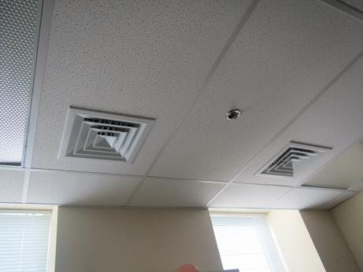
Typical supply vents
Picture 2
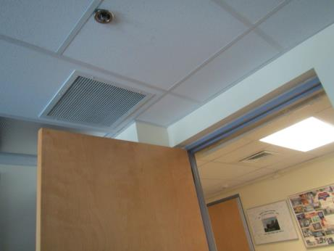
Return vent in patient room
Picture 3
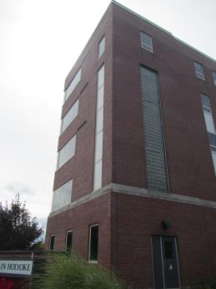
Intake vents on one wing of the building (arrows)
Picture 4
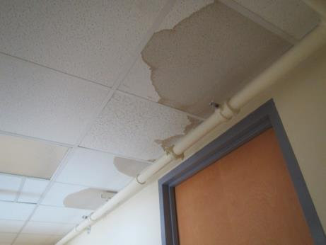
Recently water-damaged ceiling tiles
Picture 5
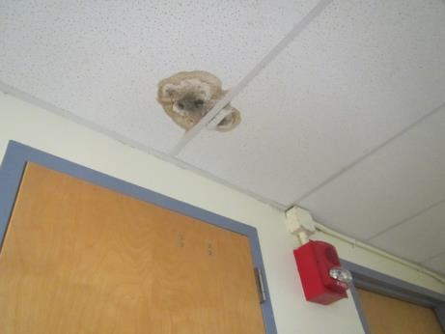
Water-damaged ceiling tile with likely mold colonization
Picture 6
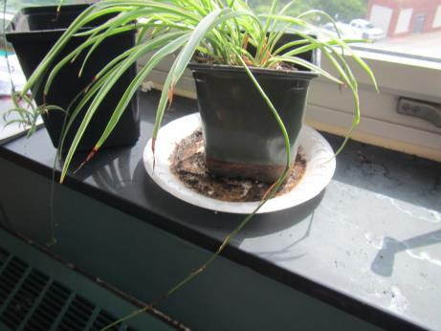
Plant with debris and possible microbial colonization in drip pan
Picture 7
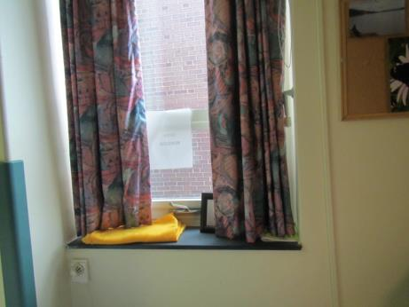
Curtains in a patient room

Location | Carbon  Dioxide  (ppm) | Carbon Monoxide  (ppm) | Temp  (°F) | Relative  Humidity  (%) | PM2.5  (µg/m³) | Occupants  in Room | Windows  Openable | Ventilation |  |  | Remarks
 |  |  |  |  |  |  |  | Supply | Exhaust
Background | 440 | ND | 76 | 69 | 14 |  |  |  |  |  | Partly cloudy
5th floor (used to be the operating room area. known roof leaks some of which have been repaired)
Conference | 571 | ND | 73 | 65 | 5 | 3 | Y | Y |  | Y | Carpeted -- newish, 1 WD CT, computers
Office/small conference | 564 | ND | 73 | 63 | 5 | 0 | Y | Y |  | Y
516 | 578 | ND | 73 | 64 | 4 | 2 | Y | Y |  | Y | NC, used to be the sterilization room, microwave, PC
522 | 607 | ND | 74 | 71 | 2 | 1 | Y | Y |  | Y | Carpet, PF, PC, 1 WD CT, microwave
Women’s RR |  |  |  |  |  |  |  |  |  | Y | Exhaust flow weak or off
4th floor
401 | 550 | ND | 73 | 65 | 16 | 0 | Y | Y |  | Y | 1 window open, PF, UF, NC
442 | 641 | ND | 74 | 66 | 15 | 1 | Y | Y |  | Y
450 | 682 | ND | 73 | 65 | 12 | 1 | Y | Y |  | Y
452 | 704 | ND | 74 | 65 | 12 | 2 | Y | Y |  | Y
456 | 669 | ND | 72 | 62 | 10 | 0 | Y | Y |  | Y | Food, NC
459 | 675 | ND | 73 | 62 | 9 | 0 | Y | Y |  | Y
463 | 641 | ND | 74 | 67 | 10 | 2 | Y | Y |  | Y
Solarium | 575 | ND | 74 | 66 | 12 | 1 | Y | Y |  | Y | WD CT, one window open
464 | 623 | ND | 74 | 66 | 12 | 0 | Y | Y |  | Y
Nurse area | 658 | ND | 74 | 62 | 10 | 4 | Y | Y |  | Y
467 | 618 | ND | 74 | 68 | 12 | 0 | Y | Y |  | Y | odors
471 | 508 | ND | 73 | 69 | 14 | 0 | Y | Y |  | Y | plush items
473 solarium | 499 | ND | 73 | 63 | 12 | 0 | Y | Y |  | Y
472 | 493 | ND | 73 | 64 | 11 | 1 | Y | Y |  | Y
468 | 593 | ND | 73 | 67 | 12 | 0 | Y | Y |  | Y
407 | 619 | ND | 73 | 60 | 14 | 0 | Y | Y |  | Y
Veteran’s care center | 696 | ND | 74 | 65 | 16 | 0 | Y | Y |  | Y
427 | 662 | ND | 74 | 66 | 13 | 0 | Y | Y |  | Y
426 | 730 | ND | 74 | 65 | 11 | 1 | Y | Y |  | Y
431 | 614 | ND | 74 | 66 | 12 | 1 | Y | Y |  | Y
Solarium | 674 | ND | 74 | 64 | 12 | 0 | Y | Y |  | Y
430 | 662 | ND | 73 | 65 | 12 | 0 | Y | Y |  | Y
434 | 541 | ND | 74 | 75 | 15 | 0 | Y | Y |  | Y
435 | 500 | ND | 74 | 70 | 16 | 2 | Y | Y |  | Y | Curtains closed
438 | 514 | ND | 74 | 69 | 24 | 0 | Y | Y |  | Y | 1 window open
Solarium | 499 | ND | 73 | 66 | 22 | 0 | Y | Y |  | Y | 2 WD CT
439 | 514 | ND | 73 | 70 | 28 | 0 | Y | Y |  | Y
401 family waiting | 558 | ND | 74 | 63 | 12 | 1 | Y | Y |  | Y | 2 WD CT
Rec room | 1076 | ND | 74 | 63 | 8 | 21 | Y | Y |  | Y
Rec office | 1103 | ND | 73 | 63 | 7 | 0 | Y | Y |  | Y | sink, stove, fridge
Rec area RR | 1056 | ND | 72 | 63 | 8 | 0 | N | N |  | Y
3rd floor
3N waiting | 1159 | ND | 73 | 65 | 10 | 2 | N | Y |  | Y | WD cork board, UF
Nurse area in 3N | 1175 | ND | 73 | 65 | 10 | 1 | N | Y |  | Y
N333 | 1430 | ND | 73 | 65 | 13 | 1 | N | Y |  | Y | curtains closed
Restroom |  |  |  |  |  | 0 | N | N |  | Y
N327 | 1218 | ND | 74 | 67 | 11 | 0 | Y | Y |  | Y
330 kitchen | 1168 | ND | 74 | 65 | 11 | 0 | N | Y |  | Y
N325 | 1115 | ND | 74 | 64 | 10 | 0 | Y | Y |  | Y
N320 | 1037 | ND | 74 | 65 | 11 | 0 | Y | Y |  | Y
Shower room | 1130 | ND | 75 | 89 | 16 | 0 | N | Y |  | Y
N317 | 960 | ND | 74 | 66 | 8 | 0 | Y | Y |  | Y | Curtains closed
N315 | 934 | ND | 74 | 65 | 8 | 0 | Y | Y |  | Y
N314 | 934 | ND | 75 | 66 | 10 | 0 | Y | Y |  | Y
Utility on 3rd floor |  | ND |  |  |  |  |  |  |  |  | 1 WD CT
Restroom |  | ND |  |  |  |  |  |  |  |  | exhaust weak
N307 | 1041 | ND | 73 |  |  |  | Y | Y |  | Y
N304 | 1124 | ND | 74 | 65 | 10 | 0 | Y | Y |  | Y
348 | 1375 | ND | 73 | 63 | 13 | 1 | Y | Y |  | Y | 1 WD CT
Nurse’s station | 1222 | ND | 73 | 62 | 15 | 4 | N | Y |  | Y
360 | 1365 | ND | 73 | 61 | 19 | 1 | N | Y |  | Y
362 | 1437 | ND | 73 | 60 | 20 | 0 | Y | Y |  | Y | 2 WD CT
366 | 1443 | ND | 72 | 58 | 19 | 3 | Y | Y |  | Y
365 | 1448 | ND | 73 | 58 | 20 | 1 | Y | Y |  | Y
366 | 1470 | ND | 73 | 59 | 17 | 2 | Y | Y |  | Y | WD CT
371 | 1312 | ND | 73 | 65 | 14 | 0 | Y | Y |  | Y | Curtains drawn
373 | 1368 | ND | 73 | 65 | 12 | 2 | Y | Y |  | Y
372 solarium | 1370 | ND | 73 | 60 | 14 | 2 | Y | Y |  | Y
370 | 1350 | ND | 73 | 63 | 12 | 1 | Y | Y |  | Y
368 | 1366 | ND | 72 | 64 | 12 | 2 | Y | Y |  | Y
312 | 1192 | ND | 73 | 65 | 9 | 0 | Y | Y |  | Y
315 | 1171 | ND | 73 | 66 | 9 | 1 | Y | Y |  | Y
319 | 1224 | ND | 73 | 65 | 8 | 1 | Y | Y |  | Y | Window leak reported
Veteran’s care center | 1261 | ND | 74 | 67 | 7 | 1 | Y | Y |  | Y
337 | 1363 | ND | 74 | 61 | 7 | 1 | Y | Y |  | Y | Flowers, WD CT
336 | 1351 | ND | 73 | 66 | 6 | 1 | Y | Y |  | Y
338 | 1346 | ND | 73 | 68 | 7 | 0 | Y | Y |  | Y | 1 WD CT
340 | 1324 | ND | 74 | 69 | 7 | 1 | Y | Y |  | Y
341 solarium | 1255 | ND | 74 | 69 | 7 | 2 | Y | Y |  | Y | Plants
2nd floor
281 | 1013 | ND | 74 | 64 | 10 | 1 | Y | Y |  | Y
Solarium | 1031 | ND | 74 | 66 | 11 | 8 | Y | Y |  | Y | UF
208 | 999 | ND | 73 | 61 | 9 | 0 | Y | Y |  | Y
211 | 1050 | ND | 74 | 63 | 9 | 2 | Y | Y |  | Y
215 | 1056 | ND | 74 | 63 | 8 | 0 | Y | Y |  | Y
231 | 1063 | ND | 73 | 61 | 8 | 0 | Y | Y |  | Y
232 | 1036 | ND | 73 | 61 | 8 | 1 | Y | Y |  | Y
231 | 1084 | ND | 74 | 62 | 9 | 0 | Y | Y |  | Y
234 | 1040 | ND | 74 | 62 | 9 | 1 | Y | Y |  | Y
233 | 1039 | ND | 74 | 62 | 9 | 1 | Y | Y |  | Y
236 | 1012 | ND | 74 | 61 | 10 | 1 | Y | Y |  | Y
235 solarium | 931 | ND | 74 | 61 | 11 | 0 | Y | Y |  | Y
339 | 1346 | ND | 73 | 70 | 7 | 2 | Y | Y |  | Y
329 | 1317 | ND | 73 | 64 | 6 | 0 | Y | Y |  | Y
330 | 1314 | ND | 73 | 65 | 7 | 1 | Y | Y |  | Y
331 | 1328 | ND | 73 | 66 | 5 | 1 | Y | Y |  | Y
334 | 1367 | ND | 74 | 65 | 5 | 1 | Y | Y |  | Y
333 solarium | 1330 | ND | 73 | 66 | 5 | 4 | Y | Y |  | Y
332 | 1335 | ND | 74 | 65 | 7 | 2 | Y | Y |  | Y
272 | 956 | ND | 74 | 64 | 12 | 0 | Y | Y |  | Y
273 | 974 | ND | 74 | 63 | 12 | 0 | Y | Y |  | Y
279 | 1016 | ND | 74 | 63 | 12 | 1 | Y | Y |  | Y
278 | 1060 | ND | 74 | 65 | 13 | 2 | Y | Y |  | Y
280 | 1038 | ND | 74 | 64 | 11 | 0 | Y | Y |  | Y
225 | 1057 | ND | 74 | 61 | 7 | 0 | Y | Y |  | Y
224 | 1094 | ND | 74 | 61 | 7 | 1 | Y | Y |  | Y | PF on
226 | 1093 | ND | 74 | 61 | 8 | 0 | Y | Y |  | Y
227 | 1077 | ND | 74 | 61 | 8 | 1 | Y | Y |  | Y
228 | 940 | ND | 74 | 60 | 8 | 0 | Y | Y |  | Y
229 solarium | 909 | ND | 74 | 60 | 8 | 0 | Y | Y |  | Y | UF, plants

