BACKGROUND

INDOOR AIR QUALITY
MOISTURE ASSESSMENT

Holyoke Soldiers’ Home
Storeroom
110 Cherry Street
Holyoke, MA

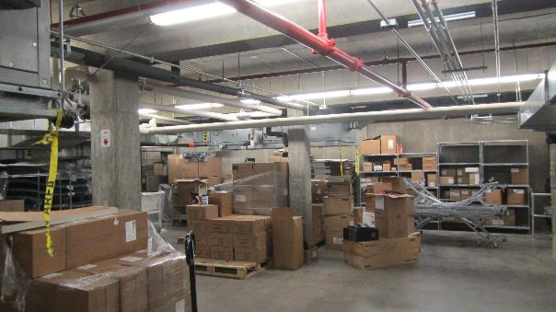

Prepared by:
Massachusetts Department of Public Health
Bureau of Environmental Health
Indoor Air Quality Program
July 2022
Building: | Holyoke Soldiers’ Home (HSH) storeroom
Address: | 110 Cherry Street, Holyoke, MA
Assessment Requested by: | Jeremy M. Meade, Maintenance Foreman, HSH
Reason for Request: | Water damage/mold concerns in storeroom
Date of Assessment: | July 22, 2022
Massachusetts Department of Public Health/Bureau of Environmental Health (MDPH/BEH) Staff Conducting Assessment: | Michael Feeney, Director, Indoor Air  Quality (IAQ) Program
Date of Building Construction/Renovation: | 1951
Building Description: | The HSH is an elder care facility that consists of multiple wings. The original building was constructed in 1951. The storeroom is located on a ground floor with access from a hallway shared with the kitchen.
Windows: | Openable

INTRODUCTION

The IAQ Program was asked to assess conditions in the HSH storeroom. Visible debris accumulated on the outside of storeroom ductwork on the surface duct sealant. The IAQ Program assessed the storeroom to identify the possible causes of mold growth as well as make recommendations regarding methods that may be used to limit such water damage during hot, humid conditions.

METHODS
MDPH IAQ staff conducted a series of visual assessments and temperature, and relative humidity measurements to identify likely areas that could be prone to condensation in hot, humid weather. Please refer to the IAQ Manual for methods, sampling procedures, and interpretation of results (MDPH, 2015).

RESULTS AND DISCUSSION
The following is a summary of testing results (Table 1):
- Temperature was within the MDPH recommended range of 70°F to 78°F in all areas tested.
- Relative Humidity was above the DPH recommended range of 40 to 60% in all areas tested.

Ventilation
A heating, ventilating, and air conditioning (HVAC) system has several functions. First, it provides heating and, if equipped, cooling. Second, it is a source of fresh air. Finally, an HVAC system will dilute and remove normally occurring indoor environmental pollutants by not only introducing fresh air, but by filtering the airstream and ejecting stale air to the outdoors via exhaust ventilation. Even if an HVAC system is operating as designed, point sources of respiratory irritation may exist and cause symptoms in sensitive individuals.
The storeroom has an HVAC system that provides heating and cooling. This HVAC system does not have a fresh air or exhaust system. Two air handling units (AHU 1 and AHU 2) are installed in the storeroom ceiling which provide heating/cooling and fresh air for the reception/lobby and the chapel. Supply ducts to the lobby and chapel inside the storeroom are not insulated.

Microbial/Moisture Concerns

IAQ staff observed wet, black debris on joint sealant for the AHU ducts that connect to the lobby and chapel (Picture 1). Surface temperatures were measured on various components of the AHU and associated ductwork. The AHU 1 and 2 ducts, as well as the joint sealant were found to have a temperature that was below the dew point of the air in the storeroom (Table 1). When warm, moist air passes over a cooler surface, condensation can form. Condensation is the collection of moisture on a surface at or below the dew point. The dew point is the temperature that air must reach for saturation to occur. If a building material/component has a temperature below the dew point, condensation will accumulate on that material. Over time, condensation can collect and form water droplets (Picture 2), as seen on the storeroom ceiling-mounted ducts connected to AHU 1 and 2. Condensation can moisten porous materials, including dust or debris on surfaces, and lead to mold growth.

Potential excess humidity sources were noted in the storeroom, primarily access doors with significant space between the floor and bottom of the door. One set of doors opens to the loading dock, so gaps under doors can allow unconditioned outside air into the storeroom. Limiting relative humidity sources can help reduce condensation and prevent moistening of stored materials.

Insulation was hanging from the duct joint of one of the AHUs (Picture 3) and was found to be moistened by condensation. Insulation must be intact and installed properly to prevent temperature transfer and condensation at this joint.

IAQ staff examined the lobby and chapel for conditions that could result in condensation or debris accumulation. These areas did not have any observable black debris on fresh air supplies or other sources. In addition, there were no floor, wall, or fresh air supply vents with temperatures at or below the dew point.

According to American Society of Heating, Refrigerating and Air-Conditioning Engineers (ASHRAE), if relative humidity exceeds 70%, mold growth may occur due to wetting of building materials even in the absence of liquid water (ASHRAE, 2019). Relative humidity measured in the building was below 70% in all locations measured during this assessment (Table 1). If relative humidity above 70% exists in a location for greater than 48 hours, porous materials such as cardboard and other materials may develop mold colonization. In addition, it is recommended that porous material be dried with fans and heating within 24 to 48 hours of becoming wet (US EPA, 2008, ACGIH, 1989). If porous materials are not dried within this time frame, they should be removed and discarded, as mold growth may occur. Water-damaged porous materials cannot be adequately cleaned to remove mold growth.

RECOMMENDATIONS
The HSH storeroom has a number of issues related to moisture. The following documents can provide guidance that can be used to reduce the impact of hot, humid weather in buildings.
- Preventing mold growth in Massachusetts schools during hot, humid weather: https://www.mass.gov/service-details/preventing-mold-growth-in-massachusetts-schools-during-hot-humid-weather
- Remediation and prevention of mold growth and water damage in public schools and buildings to maintain air quality: https://www.mass.gov/service-details/remediation-and-prevention-of-mold-growth-and-water-damage-in-public-schools-and

To remedy building problems, two sets of recommendations are made: short-term measures that may be implemented as soon as practicable and long-term measures that will require planning and resources to address overall IAQ concerns. In view of the findings at the time of the visit, the following recommendations are provided:

Short Term Recommendations

Clean debris that accumulates on joint compound as needed.

Remove and repair insulation shown in Picture 3.

Consider raising the temperature set point for both AHUs to limit condensation.

Do not store any cardboard, cloth, soft plastic or other porous materials beneath the AHU 1 and 2 ducts.

Install door sweeps on the bottom of all storeroom access doors.

Remove and replace hanging insulation for the AHU joint.

Consider installing a strip door curtain to reduce unconditioned air entering the storeroom from the loading dock during deliveries.

Long-Term Recommendation
- Consider installing insulation that has an appropriate R-value over supply ducts for AHU 1 and 2. Appropriately installed insulation will prevent condensation on ductwork.

REFERENCES
ACGIH. 1989. Guidelines for the Assessment of Bioaerosols in the Indoor Environment. American Conference of Governmental Industrial Hygienists, Cincinnati, OH.
ASHRAE, 2019. American Society of Heating, Refrigeration and Air Conditioning Engineers (ASHRAE) Ventilation for Acceptable Indoor Air Quality. ANSI/ASHRAE Standard 62.1-2019. Atlanta, GA. (https://ashrae.iwrapper.com/ASHRAE_PREVIEW_ONLY_STANDARDS/STD_62.1_2019)
MDPH. 2015. Massachusetts Department of Public Health. Indoor Air Quality Manual: Chapters I-III. Available at: https://www.mass.gov/lists/indoor-air-quality-manual-and-appendices#indoor-air-quality-manual-.
US EPA. 2008. “Mold Remediation in Schools and Commercial Buildings”. Office of Air and Radiation, Indoor Environments Division, Washington, DC. EPA 402-K-01-001. September 2008. Available at: http://www.epa.gov/mold/mold-remediation-schools-and-commercial-buildings-guide

Picture 1

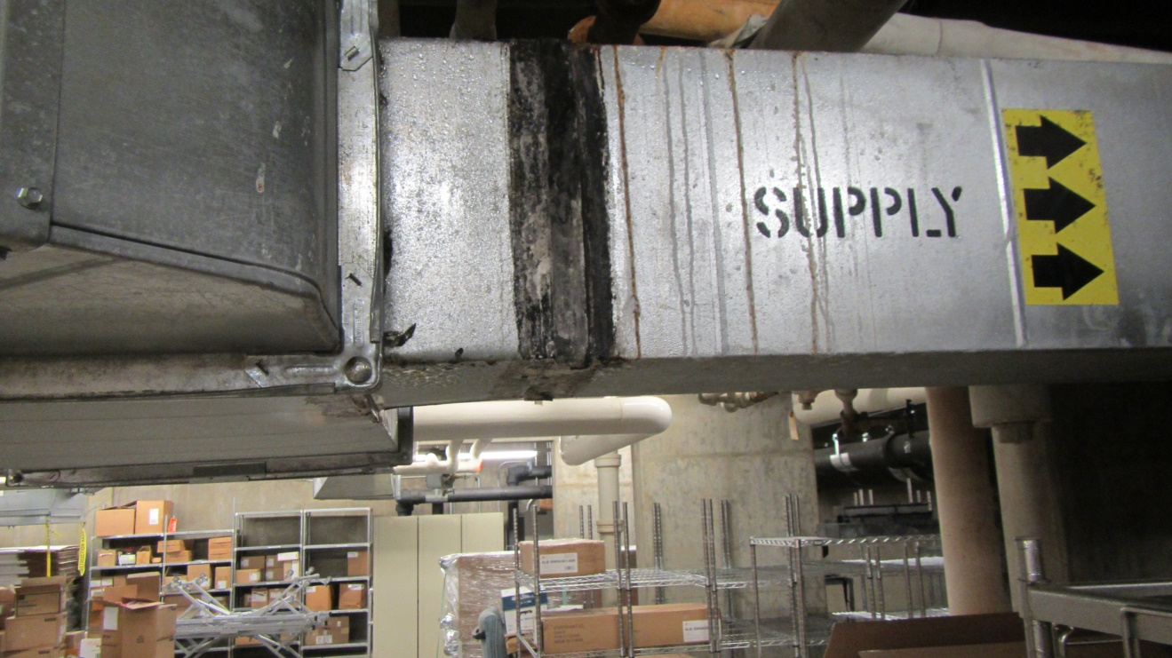

Black material on duct sealant

Picture 2

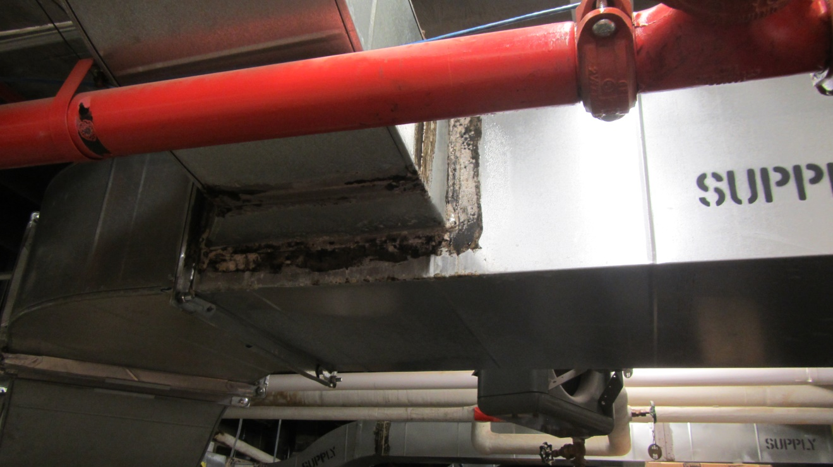

Condensation water droplets on duct

Picture 3

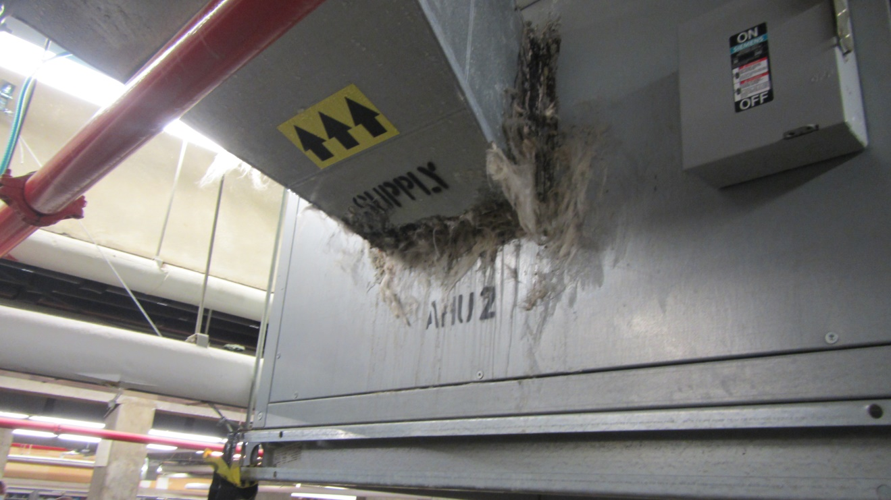

Damaged insulation at AHU/duct junction

Location | Air Temp  (ºF) | Relative Humidity  (%) | Dew Point  (ºF) | Floor Temp  (ºF) | Duct Surface Temp  (ºF) | Ventilation |  |  | Comments
 |  |  |  |  |  | Windows openable | Supply | Exhaust
Background (outdoors) | 87 | 47 | 64
Storeroom
Storeroom AHU | 74 | 67 | 62 | 66 | 67 | N | Y | Y
Beneath AHU 1 | 73 | 69 | 62 | 62 | 57 | N | N | N | Duct surface temperature below dew point  Surface wet with condensation
Loading dock door | 75 | 65 | 62 | 74 |  | N | N | N
Refrigerator | 75 | 65 | 62 | 65 |  | N | N | N
Beneath AHU 2 | 73 | 68 | 62 | 67 | 59 | N | N | N | Duct surface temperature below dew point  Surface wet with condensation
Other Locations
Lobby | 76 | 64 | 63 |  | 64 | N | Y | Y | Duct surface temperature above dew point
Chapel | 75 | 62 | 60 |  | 62 | N | Y | Y | Duct surface temperature above dew point

