INDOOR AIR QUALITY ASSESSMENT

Hopkinton High School
Field House
90 Hayden Rowe Street
Hopkinton, Massachusetts

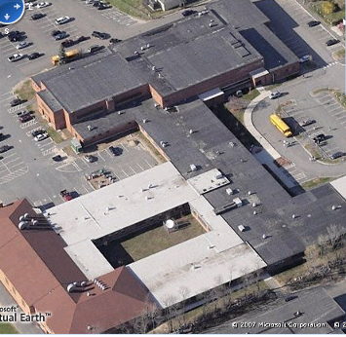

Prepared by:
Massachusetts Department of Public Health
Bureau of Environmental Health
Emergency Response/Indoor Air Quality Program
February 2008

Background/Introduction
At the request of a parent, the Massachusetts Department of Public Health (MDPH), Bureau of Environmental Health (BEH) provided assistance and consultation regarding indoor air quality (IAQ) concerns at Hopkinton High School (HHS), 90 Hayden Rowe Street, Hopkinton, MA. The request was prompted by an IAQ complaint during an indoor track meet held in the Field House.
On January 12, 2008, a visit to conduct an indoor air quality assessment was made to the HHS Field by Mike Feeney, Director of BEH’s IAQ Program. Mr. Feeney was assisted by Cory Holmes, an Environmental Analyst in BEH’s IAQ Program. BEH staff were accompanied during the assessment by Mr. Al Rodgers, Director of Maintenance, Hopkinton Public Schools.
The HHS Field House is a brick structure built in 2001 that houses the schools gymnasium, an indoor track, track and field equipment, locker rooms, team rooms and office space for the athletic staff. The Field House also contains a penthouse that houses the schools boiler plant and mechanical ventilation equipment.

Methods
Air tests for carbon monoxide, carbon dioxide, temperature and relative humidity were conducted with the TSI, Q-Trak, IAQ Monitor, Model 8551. Air tests for airborne particle matter with a diameter less than 2.5 micrometers were taken with the TSI, DUSTTRAK™ Aerosol Monitor Model 8520. Screening for total volatile organic compounds (TVOCs) was conducted using a Thermo Environmental Instruments Inc., Model 580 Series Photo Ionization Detector (PID). BEH staff performed a visual inspection of building materials for water damage and/or microbial growth.

Results
The HHS Field House serves as an indoor track and field facility, basketball court and holds events for both in-school and after school activities and is visited by several hundred individuals daily. The tests were taken during normal operations and appear in Table 1.

Discussion
Ventilation
It can be seen from Table 1 that carbon dioxide levels were below 800 parts per million (ppm) in all areas surveyed, indicating adequate ventilation in the Field House at the time of the assessment. The heating, ventilation and air conditioning (HVAC) system consists of air-handling units (AHU) located in a mechanical room (Picture 1). Fresh outside air is drawn into the AHUs via an exterior vent (Picture 2) and conditioned air is delivered to occupied areas via ducted air diffusers (Pictures 3 and 4) and returned back to the AHUs by ducted wall vents (Pictures 5 and 6). This system was in operation during the assessment.
To maximize air exchange, the MDPH recommends that both supply and exhaust ventilation operate continuously during periods of occupancy. In order to have proper ventilation with a mechanical supply and exhaust system, the systems must be balanced to provide an adequate amount of fresh air to the interior of a room while removing stale air from the room. It is recommended that HVAC systems be re-balanced every five years to ensure adequate air systems function (SMACNA, 1994). The date of the last balancing of these systems was not available at the time of the assessment.
The Massachusetts Building Code requires that gymnasiums have a minimum ventilation rate of 20 cubic feet per minute (cfm) per occupant of fresh outside air or openable windows (SBBRS, 1997; BOCA, 1993). The ventilation must be on at all times that the room is occupied. Providing adequate fresh air ventilation with open windows and maintaining the temperature in the comfort range during the cold weather season is impractical. Mechanical ventilation is usually required to provide adequate fresh air ventilation.
Carbon dioxide is not a problem in and of itself. It is used as an indicator of the adequacy of the fresh air ventilation. As carbon dioxide levels rise, it indicates that the ventilating system is malfunctioning or the design occupancy of the room is being exceeded. When this happens, a buildup of common indoor air pollutants can occur, leading to discomfort or health complaints. The Occupational Safety and Health Administration (OSHA) standard for carbon dioxide is 5,000 parts per million parts of air (ppm). Workers may be exposed to this level for 40 hours/week, based on a time-weighted average (OSHA, 1997).
The MDPH uses a guideline of 800 ppm for publicly occupied buildings. A guideline of 600 ppm or less is preferred in schools due to the fact that the majority of occupants are young and considered to be a more sensitive population in the evaluation of environmental health status. Inadequate ventilation and/or elevated temperatures are major causes of complaints such as respiratory, eye, nose and throat irritation, lethargy and headaches. For more information concerning carbon dioxide, please see Appendix A.
Temperature readings ranged from 67º F to 71 º F, which were within or close to the lower end of the MDPH recommended comfort guidelines during the assessment. The MDPH recommends that indoor air temperatures be maintained in a range of 70 º F to 78 º F in order to provide for the comfort of building occupants. In many cases concerning indoor air quality, fluctuations of temperature in occupied spaces are typically experienced, even in a building with an adequate fresh air supply.
The relative humidity measured in the building ranged from 31 to 34 percent, which was below the MDPH recommended comfort range during the assessment. The MDPH recommends a comfort range of 40 to 60 percent for indoor air relative humidity. Relative humidity levels in the building would be expected to drop during the winter months due to heating. The sensation of dryness and irritation is common in a low relative humidity environment. Low relative humidity is a very common problem during the heating season in the northeast part of the United States.

Other IAQ Evaluations
Indoor air quality can be negatively influenced by the presence of respiratory irritants, such as products of combustion. The process of combustion produces a number of pollutants. Common combustion emissions include carbon monoxide, carbon dioxide, water vapor and smoke (fine airborne particle material). Of these materials, exposure to carbon monoxide and particulate matter with a diameter of 2.5 micrometers (μm) or less (PM2.5) can produce immediate, acute health effects upon exposure. To determine whether combustion products were present in the school environment, MDPH staff obtained measurements for carbon monoxide and PM2.5.
Carbon monoxide is a by-product of incomplete combustion of organic matter (e.g., gasoline, wood and tobacco). Exposure to carbon monoxide can produce immediate and acute health affects. Several air quality standards have been established to address carbon monoxide and prevent symptoms from exposure to these substances. The MDPH established a corrective action level concerning carbon monoxide in ice skating rinks that use fossil-fueled ice resurfacing equipment. If an operator of an indoor ice rink measures a carbon monoxide level over 30 ppm, taken 20 minutes after resurfacing within a rink, that operator must take actions to reduce carbon monoxide levels (MDPH, 1997).
The American Society of Heating Refrigeration and Air-Conditioning Engineers (ASHRAE) has adopted the National Ambient Air Quality Standards (NAAQS) as one set of criteria for assessing indoor air quality and monitoring of fresh air introduced by HVAC systems (ASHRAE, 1989). The NAAQS are standards established by the US EPA to protect the public health from six criteria pollutants, including carbon monoxide and particulate matter (US EPA, 2006). As recommended by ASHRAE, pollutant levels of fresh air introduced to a building should not exceed the NAAQS levels (ASHRAE, 1989). The NAAQS were adopted by reference in the Building Officials & Code Administrators (BOCA) National Mechanical Code of 1993 (BOCA, 1993), which is now an HVAC standard included in the Massachusetts State Building Code (SBBRS, 1997). According to the NAAQS, carbon monoxide levels in outdoor air should not exceed 9 ppm in an eight-hour average (US EPA, 2006).
Carbon monoxide should not be present in a typical, indoor environment. If it is present, indoor carbon monoxide levels should be less than or equal to outdoor levels. On the day of assessment, outdoor carbon monoxide concentrations were non-detect (ND) (Table 1). Carbon monoxide levels measured in the Field House were also ND.
The US EPA has established NAAQS limits for exposure to particulate matter. Particulate matter is airborne solids that can be irritating to the eyes, nose and throat. The NAAQS originally established exposure limits to particulate matter with a diameter of 10 μm or less (PM10). According to the NAAQS, PM10 levels should not exceed 150 microgram per cubic meter (μg/m³) in a 24-hour average (US EPA, 2006). These standards were adopted by both ASHRAE and BOCA. Since the issuance of the ASHRAE standard and BOCA Code, US EPA has established a more protective standard for fine airborne particles. This more stringent PM2.5 standard requires outdoor air particle levels be maintained below 35 μg/m³ over a 24-hour average (US EPA, 2006). Although both the ASHRAE standard and BOCA Code adopted the PM10 standard for evaluating air quality, MDPH uses the more protective PM2.5 standard for evaluating airborne particulate matter concentrations in the indoor environment.
Outdoor PM2.5 concentrations the day of the assessment were measured at 10 μg/m³ (Table 1). PM2.5 levels measured in the Field House ranged from 6 to 10 μg/m³, which were below the NAAQS of 35 μg/m³ (Table 1). Frequently, indoor air levels of particulates can be at higher levels than those measured outdoors. A number of mechanical devices and/or activities that occur in schools can generate particulates during normal operation. Sources of indoor airborne particulate may include but are not limited to particles generated during the operation of fan belts in the HVAC system, cooking in the cafeteria stoves and microwave ovens; use of photocopiers, fax machines and computer printing devices, operating an ordinary vacuum cleaner and heavy foot traffic indoors.
Indoor air quality can also be negatively influenced by the presence of materials containing volatile organic compounds (VOCs). VOCs are carbon-containing substances that have the ability to evaporate at room temperature. Frequently, exposure to low levels of total VOCs (TVOCs) may produce eye, nose, throat and/or respiratory irritation in some sensitive individuals. For example, chemicals evaporating from a paint can stored at room temperature would most likely contain VOCs. A slight rubber odor (from the track) was detected in the gymnasium portion of the field house, which was more prevalent on the north side where the return vents for the HVAC system are located (Picture 5). In an effort to determine whether measurable levels of VOCs were present in the building, air monitoring for TVOCs was conducted. An outdoor air sample was taken for comparison. Outdoor TVOC concentrations were ND (Table 1). Indoor TVOC concentrations were ND in all areas surveyed.
Please note, TVOC air measurements are only reflective of the indoor air concentrations present at the time of sampling. Although no measurable levels of TVOCs were detected in relation to the rubber odor of the track (Picture 7), the odor can still serve as a source of irritation for certain sensitive individuals. As mentioned the odor was more prevalent on the northeast side of the gym where the return vents are located. This is because the supply vents pressurize the south side of the gym and force air towards the north side as the return vents draw air and/or odors.
Accumulated dust was observed on and around supply return and exhaust vents in several areas of the field house (Pictures 4 and 6). Dust can be irritating to the eyes, nose and respiratory tract and can provide a medium for mold growth if moistened repeatedly. Flat surfaces should be wet wiped and/or cleaned with a vacuum equipped with the high efficiency particulate arrestance (HEPA) filter on a regular basis.
Finally, although no specific complaints of sewer gas odors were reported, BEH staff identified a potential source. AHUs at HHS provide air-conditioning during warm months. AHUs that provide air-conditioning require the installation of condensation drains to prevent water build up inside the casing and ductwork. The condensation drainpipes for the AHUs at HHS terminate above floor drains that are connected to the building drainage system (Picture 8). Drains are usually designed with traps in order to prevent sewer odors/gases from penetrating into occupied spaces. When water enters a drain, the trap fills and forms a watertight seal. Without periodic input of water (e.g., every other day), traps can dry, breaking the watertight seal. Without a watertight seal, odors or other materials can travel up the drain and enter the occupied space. Both the floor drains and condensation drains have traps. During the heating season, AHUs do not produce condensation, which dries the traps. The AHUs were found to be drawing air into the unit through the condensation drains (Picture 9). With each condensation drain acting as a vacuum, odors from the floor drain without a water-sealed trap can draw into the AHUs and be distributed to occupied areas in the building.

Conclusions/Recommendations
In view of the findings at the time of the visit, the following recommendations are made:
- Consider sealing the floor drains in the penthouse mechanical room during the heating season or ensure water is poured into the drains every other day to maintain the integrity of the traps.
- Seal the condensation drains for AHUs during the heating season. Please note that these drains must be unsealed during the air-conditioning season in order to drain condensation. Failure to remove condensation drain seals can result in water back up into AHUs and the potential for mold growth.
- Ventilation industrial standards recommend that mechanical ventilation systems be balanced every five years (SMACNA, 1994). Consult a ventilation engineer concerning re-balancing of the ventilation systems.
- For buildings in New England, periods of low relative humidity during the winter are often unavoidable. Therefore, implementation of scrupulous cleaning practices should be implemented. This will minimize common indoor air contaminants whose irritant effects can be enhanced when the relative humidity is low. Use of vacuum cleaning equipment outfitted with a high efficiency particulate arrestance (HEPA) filter is recommended. Drinking water during the day can help ease some symptoms associated with a dry environment (throat and sinus irritations).
- Clean/change filters AHUs as per the manufacture’s instructions or more frequently if needed.
- Clean supply and return/exhaust vents regularly of accumulated dust.
- Consider adopting the US EPA (2000) document, “Tools for Schools”, as an instrument for maintaining a good indoor air quality environment in the building. This document is available at: http://www.epa.gov/iaq/schools/index.html.
- Refer to resource manual and other related indoor air quality documents located on the MDPH’s website for further building-wide evaluations and advice on maintaining public buildings. These documents are available at: http://mass.gov/dph/indoor_air.

References
ASHRAE. 1989. Ventilation for Acceptable Indoor Air Quality. American Society of Heating, Refrigeration and Air Conditioning Engineers. ANSI/ASHRAE 62-1989
BOCA. 1993. The BOCA National Mechanical Code/1993. 8th ed. Building Officials & Code Administrators International, Inc., Country Club Hills, IL.

MDPH. 1997. Requirements to Maintain Air Quality in Indoor Skating Rinks (State Sanitary Code, Chapter XI). 105 CMR 675.000. Massachusetts Department of Public Health, Boston, MA.
OSHA. 1997. Limits for Air Contaminants. Occupational Safety and Health Administration. Code of Federal Regulations. 29 C.F.R 1910.1000 Table Z-1-A.

SBBRS. 1997. Mechanical Ventilation. State Board of Building Regulations and Standards. Code of Massachusetts Regulations. 780 CMR 1209.0

SMACNA. 1994. HVAC Systems Commissioning Manual. 1st ed. Sheet Metal and Air Conditioning Contractors’ National Association, Inc., Chantilly, VA.

US EPA. 2000. Tools for Schools. Office of Air and Radiation, Office of Radiation and Indoor Air, Indoor Environments Division (6609J). EPA 402-K-95-001, Second Edition. http://www.epa.gov/iaq/schools/tools4s2.html

US EPA. 2006. National Ambient Air Quality Standards (NAAQS). US Environmental Protection Agency, Office of Air Quality Planning and Standards, Washington, DC. http://www.epa.gov/air/criteria.html.
Picture 1

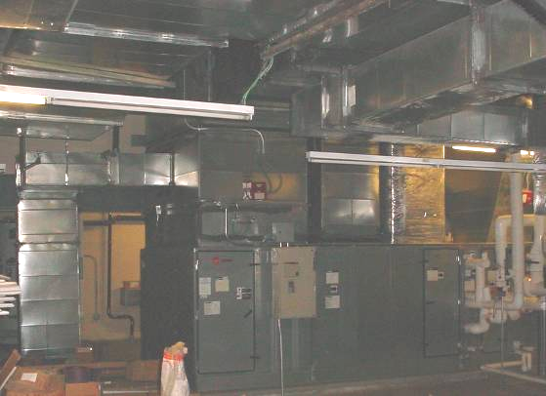

AHU for Field House in Mechanical Room

Picture 2

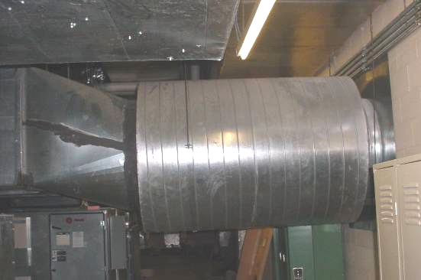

Fresh Air Intake for Field House AHU, Note Penetration through Exterior Wall

Picture 3

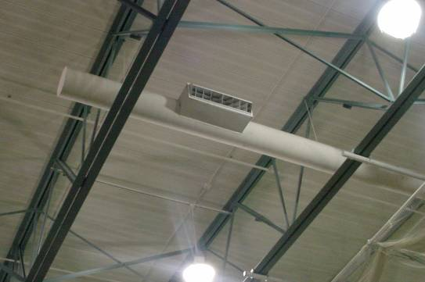

Ceiling-Mounted Supply Diffuser, Note Terminus (Capped) on Northeast Side of Field House

Picture 4

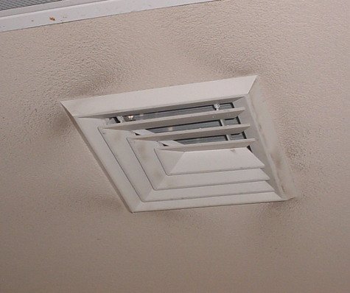

Supply Air Diffuser for Team/Locker Rooms, Note Dust Accumulation on and around Vent
Picture 5

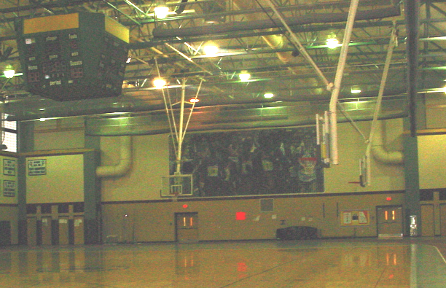

Return Vents for HVAC System on Southeast Wall Where Odors Were More Prominent

Picture 6

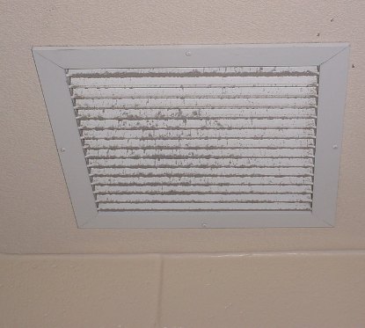

Return Vent for Team/Locker Rooms, Note Dust Accumulation on Vent
Picture 7

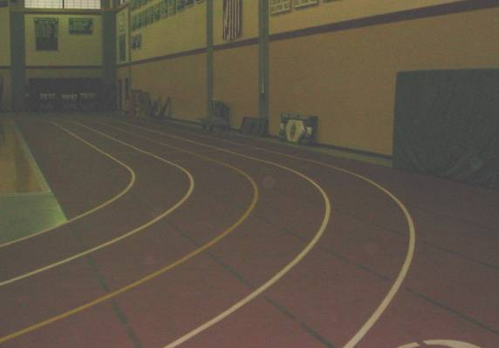

Indoor Track Comprised of Rubber Material

Picture 8

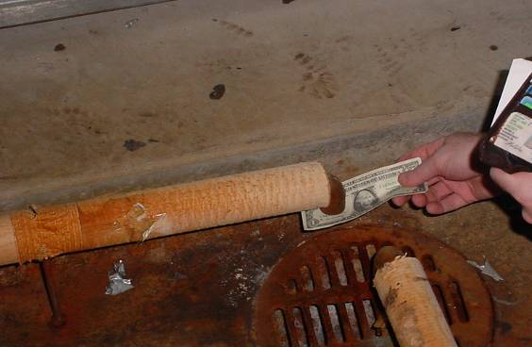

Condensate Drain for AHU over Floor Drain, Note Dollar Bill
Picture 9

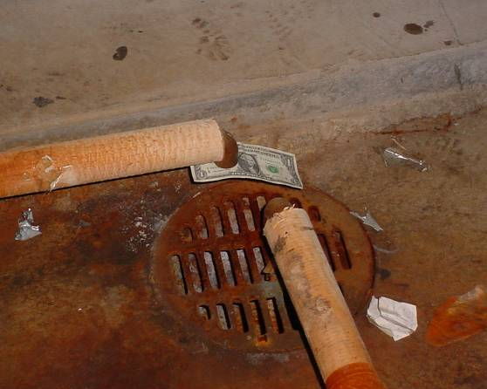

Condensate Drain for AHU over Floor Drain, Note Suction of Dollar Bill
Location/ Room | Occupants  in Room | Temp  (°F) | Relative  Humidity  (%) | Carbon  Dioxide  (ppm) | Carbon Monoxide  (ppm) | TVOCs  (ppm) | PM2.5  (µg/m3) | Windows  Openable | Ventilation |  | Remarks
 |  |  |  |  |  |  |  |  | Supply | Exhaust | Remarks
background | 49 | 37 | 92 | 360 | ND | ND | 10 |  |  |  | Moderate to heavy rain, winds: West 8-21 mph (gusts up to 26)
Gym NW | 30+ | 67 | 34 | 533 | ND | ND | 7 | N | Y | Y | More prominent rubber odor from track
Gym So | 30+ | 67 | 34 | 560 | ND | ND | 8 | N | Y | Y | Slight rubber odor from track
Gym SE | 30+ | 67 | 34 | 569 | ND | ND | 6 | N | Y | Y | Slight rubber odor from track
Gym NE  (return vents) | 30+ | 67 | 34 | 563 | ND | ND | 6 | N | Y | Y | More prominent rubber odor from track
Girl’s Locker Room | 0 | 69 | 33 | 569 | ND | ND | 6 | N | Y | Y | Dust accumulation on vents
Girl’s Team Room | 0 | 70 | 32 | 544 | ND | ND | 10 | N | Y | Y | Dust accumulation on vents
Boy’s Team Room | 0 | 71 | 32 | 587 | ND | ND | 7 | N | Y | Y | Dust accumulation on vents
Boys Locker Room | 0 | 71 | 31 | 567 | ND | ND | 9 | N | Y | Y | Dust accumulation on vents, missing access panel to ceiling

