INDOOR AIR QUALITY ASSESSMENT

Hopkinton Town Hall
18 Main Street
Hopkinton, Massachusetts

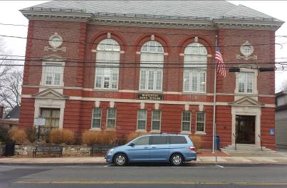

Prepared by:
Massachusetts Department of Public Health
Bureau of Environmental Health
Indoor Air Quality Program
January 2014

Background/Introduction
The Massachusetts Department of Public Health (MDPH), Bureau of Environmental Health (BEH) conducted an Indoor Air Quality (IAQ) assessment at the Hopkinton Town Hall (HTH), located at 18 Main Street, Hopkinton, Massachusetts in response to concerns regarding IAQ. The assessment was done at the request of Mr. Ed Wirtanen, Public Health Administrator for the Town of Hopkinton. On November 12, 2013, Ruth Alfasso, Environmental Engineer/Inspector for BEH’s IAQ Program visited the building to conduct an assessment; she was accompanied by Mr. Wirtanen.
The HTH is a three-story building with a basement originally built in 1902 as town offices. It is currently on the Historic Register. The building’s interior has been remodeled several times, most recently about three years ago. The exterior brickwork façade was repaired reportedly in the last year. Most areas are carpeted. Most windows in the building are openable.

Methods
Air tests for carbon monoxide, carbon dioxide, temperature and relative humidity were conducted with the TSI, Q-Trak, IAQ Monitor, Model 7565. Air tests for airborne particle matter with a diameter less than 2.5 micrometers were taken with the TSI, DUSTTRAK™ Aerosol Monitor Model 8520. BEH/IAQ staff also performed visual inspection of building materials for water damage and/or microbial growth.

Results
Approximately 26 people work in the HTH. Programs within the building provide services to the public. The building is also used for public meetings. Tests were taken during normal operations and results appear in Table 1.

Discussion

Ventilation
It can be seen from Table 1 that carbon dioxide levels were above 800 parts per million (ppm) in four of twenty-four areas surveyed, indicating adequate air exchange in most areas at the time of assessment (Table 1). There are a variety of heating, ventilation and air conditioning (HVAC) systems in the building, which reportedly have been retrofitted at various times. The basement is equipped with air handling units (AHUs) located in a mechanical space along one side of the basement. Fresh air for these units is brought in through an outside vent (Picture 1), and is heated/cooled and distributed to the basement via ducts and diffusers (Picture 2). Exhaust air is drawn into wall vents (Picture 3) and returned to the AHUs.
Another pair of AHUs are located in a small mechanical space located above the Planning Department on the 3rd floor (Picture 4). These AHUs distribute heated/cooled air to the upper floor through ducts to supply vents primarily to serve the IT department (Picture 5). The fresh air intake for these AHUs could not be ascertained. An exhaust vent returns air to them.
On the second floor, the Selectmen’s Meeting Room and the Conference Room are served by unit ventilators (univents, Picture 6). A univent is designed to draw air from outdoors through a fresh air intake located on the exterior wall of the building. Return air is drawn through an air intake located at the base of each unit where fresh and return air are mixed, filtered, heated or cooled and provided through an air diffuser located in the top of the unit (Figure 1). Univents were found deactivated in both locations (Table 1). In order for univents to provide fresh air as designed, intakes/returns must remain free of obstructions. Importantly, these units must remain on and be allowed to operate while rooms are occupied. Other areas have no supply for fresh air apart from, in many cases, openable windows (Table 1).
Restrooms at HTH are equipped with exhaust vents that vent to the outside that are operated by light switches, which are typically kept off. Exhaust vents in restrooms should be kept on when the building is occupied to remove moisture and odors generated inside. Some of the janitorial/utility closets were also observed to have exhaust vents; these did not appear to be operational (Picture 7). Make-up air vents were noted in the doors to these rooms which, in the absence of a flow of exhaust air, would allow odors from janitorial processes to migrate into adjacent areas. For example, a musty odor was traced to a partially-full mop bucket observed in one of the closets (Table 1).
Supplemental heating is provided by forced hot water baseboard heaters in many areas of the building. In several areas not supplied with other HVAC equipment, ductless air conditioning (Picture 8) units and wall-mounted/window-mounted air conditioners (Picture 9) were observed (Table 1). Window/wall air conditioners can function to provide a limited amount of fresh air when operating in “fresh air” mode, even when cooling is not needed. Ductless air conditioners, on the other hand, only cool mixed indoor air and do not provide any source of outside air.
To maximize air exchange, the MDPH recommends that both supply and exhaust ventilation operate continuously during periods of occupancy. In order to have proper ventilation with a mechanical supply and exhaust system, the systems must be balanced to provide an adequate amount of fresh air to the interior of a room while removing stale air from the room. It is recommended that HVAC systems be re-balanced every five years to ensure adequate air systems function (SMACNA, 1994). The date of last balancing was not available at the time of the assessment.
Minimum design ventilation rates are mandated by the Massachusetts State Building Code (MSBC). Until 2011, the minimum ventilation rate in Massachusetts was higher for both occupied office spaces and general classrooms, with similar requirements for other occupied spaces (BOCA, 1993). The current version of the MSBC, promulgated in 2011 by the State Board of Building Regulations and Standards (SBBRS), adopted the 2009 International Mechanical Code (IMC) to set minimum ventilation rates. Please note that the MSBC is a minimum standard that is not health-based. At lower rates of cubic feet per minute (cfm) per occupant of fresh air, carbon dioxide levels would be expected to rise significantly. A ventilation rate of 20 cfm per occupant of fresh air provides optimal air exchange resulting in carbon dioxide levels at or below 800 ppm in the indoor environment in each area measured. MDPH recommends that carbon dioxide levels be maintained at 800 ppm or below. This is because most environmental and occupational health scientists involved with research on IAQ and health effects have documented significant increases in indoor air quality complaints and/or health effects when carbon dioxide levels rise above the MDPH guidelines of 800 ppm for schools, office buildings and other occupied spaces (Sundell et al., 2011). The ventilation must be on at all times that the room is occupied. Providing adequate fresh air ventilation with open windows and maintaining the temperature in the comfort range during the cold weather season is impractical. Mechanical ventilation is usually required to provide adequate fresh air ventilation.
Carbon dioxide is not a problem in and of itself. It is used as an indicator of the adequacy of the fresh air ventilation. As carbon dioxide levels rise, it indicates that the ventilating system is malfunctioning or the design occupancy of the room is being exceeded. When this happens, a buildup of common indoor air pollutants can occur, leading to discomfort or health complaints. The Occupational Safety and Health Administration (OSHA) standard for carbon dioxide is 5,000 parts per million parts of air (ppm). Workers may be exposed to this level for 40 hours/week, based on a time-weighted average (OSHA, 1997).
The MDPH uses a guideline of 800 ppm for publicly occupied buildings. A guideline of 600 ppm or less is preferred in schools due to the fact that the majority of occupants are young and considered to be a more sensitive population in the evaluation of environmental health status. Inadequate ventilation and/or elevated temperatures are major causes of complaints such as respiratory, eye, nose and throat irritation, lethargy and headaches. For more information concerning carbon dioxide, please see Appendix A.
Temperatures in occupied areas ranged from 70º F to 74º F, which were within the MDPH recommended comfort guidelines. The MDPH recommends that indoor air temperatures be maintained in a range of 70º F to 78º F in order to provide for the comfort of building occupants. In many cases concerning indoor air quality, fluctuations of temperature in occupied spaces are typically experienced, even in a building with an adequate fresh air supply.
The relative humidity measured in occupied areas ranged from 22 to 35 percent, which was below the MDPH recommended comfort range in all areas surveyed. The MDPH recommends a comfort range of 40 to 60 percent for indoor air relative humidity. The sensation of dryness and irritation is common in a low relative humidity environment. Low relative humidity is a very common problem during the heating season in the northeast part of the United States.

Microbial/Moisture Concerns
In order for building materials to support mold growth, a source of water exposure is necessary. Water-damaged ceiling tiles were seen in a few areas on the first floor (Picture 10), suggesting leaks from the roof or plumbing. Some windowsills were also found to be water-damaged (Table 1), indicating that windows are not tight in these areas.
It was reported that the basement had been subject to periodic flooding during wet weather events up until recent repairs of the façade. No damp materials were observed in the basement; however floor tiles showed evidence of previous water damage/infiltration in that mastic/glue could be seen coming up from between tiles. The rear entryway also showed significant signs of water damage (Picture 11), including wall plaster and possible evidence of water flowing through an electrical socket (Picture 12), which can damage the wiring and present a fire hazard. Water infiltration to the rear hallway appears to be related to the construction/design of the handicapped-access ramp which may function to channel storm water into this area of the building.
BEH/IAQ staff examined the outside perimeter of the building to identify breaches in the building envelope and/or other conditions that could provide a source of water penetration. Downspouts were observed to drain only a short distance from the building (Picture 13). If downspouts are not configured to drain correctly, water from the roof may accumulate against the walls or foundation. These conditions can undermine the integrity of the building envelope and provide a means of water entry by capillary action into the building through exterior walls, foundation concrete and masonry (Lstiburek & Brennan, 2001).
The ductless air conditioners are equipped with condensation collection receptacles and pumps to direct collected water outside. These should be regularly examined/maintained to ensure that they are functioning to remove condensation when the air conditioners are in use.
Plants were noted in some areas (Table 1). Plants can be a source of pollen and mold which can be respiratory irritants to some individuals. Plants should be properly maintained and equipped with drip pans and should be located away from air flow source to prevent the aerosolization of dirt, pollen and mold.
Water dispensers and refrigerators were observed in carpeted areas (Picture 14). Spills or leaks from these appliances can moisten carpeting. Stained carpeting was observed in the vicinity of at least one refrigerator (Picture 15). Water-dispensing and other appliances should be located in an area with non-porous flooring or on a waterproof mat.
The basement was equipped with portable dehumidifiers, which can be helpful in removing moisture from the basement environment. These appliances need to have the collected water removed and to be cleaned/maintained on a regular schedule.
The backsplash on the kitchen sink in the basement was not tightly sealed. Water can penetrate into this area and cause the wood to swell, increasing the potential for water damage and/or mold growth.
The US Environmental Protection Agency (US EPA) and the American Conference of Governmental Industrial Hygienists (ACGIH) recommend that porous materials (e.g., ceiling tiles, carpeting) be dried with fans and heating within 24 to 48 hours of becoming wet (US EPA, 2001; ACGIH, 1989). If not dried within this time frame, mold growth may occur. Once mold has colonized porous materials, they are difficult to clean and should be removed/discarded.

Other IAQ Evaluations
Indoor air quality can be negatively influenced by the presence of respiratory irritants, such as products of combustion. The process of combustion produces a number of pollutants. Common combustion emissions include carbon monoxide, carbon dioxide, water vapor and smoke (fine airborne particle material). Of these materials, exposure to carbon monoxide can produce immediate, acute health effects upon exposure. To determine whether combustion products were present in the building environment, BEH/IAQ staff obtained measurements for carbon monoxide.

Carbon Monoxide
Carbon monoxide is a by-product of incomplete combustion of organic matter (e.g., gasoline, wood and tobacco). Exposure to carbon monoxide can produce immediate and acute health effects. Several air quality standards have been established to address carbon monoxide and prevent symptoms from exposure to these substances. The MDPH established a corrective action level concerning carbon monoxide in ice skating rinks that use fossil-fueled ice resurfacing equipment. If an operator of an indoor ice rink measures a carbon monoxide level over 30 ppm, taken 20 minutes after resurfacing within a rink, that operator must take actions to reduce carbon monoxide levels (MDPH, 1997).
The American Society of Heating, Refrigerating and Air-Conditioning Engineers (ASHRAE) has adopted the National Ambient Air Quality Standards (NAAQS) as one set of criteria for assessing indoor air quality and monitoring of fresh air introduced by HVAC systems (ASHRAE, 1989). The NAAQS are standards established by the US EPA to protect the public health from six criteria pollutants, including carbon monoxide and particulate matter (US EPA, 2006). As recommended by ASHRAE, pollutant levels of fresh air introduced to a building should not exceed the NAAQS levels (ASHRAE, 1989). The NAAQS were adopted by reference in the Building Officials & Code Administrators (BOCA) National Mechanical Code of 1993 (BOCA, 1993), which is now an HVAC standard included in the Massachusetts State Building Code (SBBRS, 2011). According to the NAAQS, carbon monoxide levels in outdoor air should not exceed 9 ppm in an eight-hour average (US EPA, 2006).
Carbon monoxide should not be present in a typical, indoor environment. If it is present, indoor carbon monoxide levels should be less than or equal to outdoor levels. On the day of assessment, outdoor carbon monoxide concentrations were non-detect (ND) (Table 1). No measureable levels of carbon monoxide were detected inside the building during the assessment (Table 1).
BEH/IAQ staff observed a gas stove/oven unit in the basement area kitchen. No exhaust ventilation was observed above or adjacent to the stove. Gas stoves can be a source of pollutants, including carbon monoxide, particulate matter and nitrogen oxides. This and other combustion equipment should be used in a ventilated area and maintained/adjusted so that the flames are as clean as possible (US EPA, 2012).

Particulate Matter
The US EPA has established NAAQS limits for exposure to particulate matter. Particulate matter includes airborne solids, which can result in eye and respiratory irritation if exposure occurs. The NAAQS originally established exposure limits to particulate matter with a diameter of 10 μm or less (PM10). According to the NAAQS, PM10 levels should not exceed 150 micrograms per cubic meter (μg/m³) in a 24-hour average (US EPA, 2006). These standards were adopted by both ASHRAE and BOCA. Since the issuance of the ASHRAE standard and BOCA Code, US EPA established a more protective standard for fine airborne particles. This more stringent PM2.5 standard requires outdoor air particle levels be maintained below 35 μg/m³ over a 24-hour average (US EPA, 2006). Although both the ASHRAE standard and BOCA Code adopted the PM10 standard for evaluating air quality, MDPH uses the more protective PM2.5 standard for evaluating airborne particulate matter concentrations in the indoor environment.
Outdoor PM2.5 was measured at 5 μg/m³ (Table 1). Indoor PM2.5 levels ranged from 3 to 11 μg/m³ (Table 1). Both indoor and outdoor PM 2.5 levels were below the NAAQS PM2.5 level of 35 μg/m³. Frequently, indoor air levels of particulates (including PM2.5) can be at higher levels than those measured outdoors. A number of mechanical devices and/or activities that occur indoors can generate particulate during normal operations. Sources of indoor airborne particulates may include but are not limited to particles generated during the operation of fan belts in the HVAC system, use of stoves and/or microwave ovens in kitchen areas; use of photocopiers, fax machines and computer printing devices; operation of an ordinary vacuum cleaner and heavy foot traffic indoors.

Volatile Organic Compounds
Indoor air concentrations can be greatly impacted by the use of products containing volatile organic compounds (VOCs). VOCs are carbon-containing substances that have the ability to evaporate at room temperature. Frequently, exposure to low levels of total VOCs (TVOCs) may produce eye, nose, throat and/or respiratory irritation in some sensitive individuals. For example, chemicals evaporating from a paint can stored at room temperature would most likely contain VOCs. In an effort to identify materials that can potentially increase indoor VOC concentrations, BEH/IAQ staff examined rooms for products containing these respiratory irritants.
Some offices contained dry erase boards and related materials (Table 1). Materials such as dry erase markers and dry erase board cleaners may contain VOCs, such as methyl isobutyl ketone, n-butyl acetate and butyl-cellusolve (Sanford, 1999), which can be irritating to the eyes, nose and throat.
A scented candle was observed in one room, and cleaning products and air fresheners were observed in restrooms (Table 1). Air fresheners and other scented products contain chemicals that can be irritating to the eyes, nose and throat of sensitive individuals. Many air fresheners contain 1,4-dichlorobenzene, a VOC which may cause reductions in lung function (NIH, 2006). Furthermore, deodorizing agents do not remove materials causing odors, but rather mask odors that may be present in the area.

Other Conditions
In a number of areas, items were observed on the floor, windowsills, tabletops, counters, bookcases and desks. The large number of items stored provides a source for dusts to accumulate. These items (e.g., papers, folders, boxes) make it difficult for custodial staff to clean. Items should be relocated and/or be cleaned periodically to avoid excessive dust build up. In addition, these materials can accumulate on flat surfaces (e.g., desktops, windowsills and carpets) in occupied areas and subsequently be re-aerosolized causing further irritation.
Many areas of the building contain wall-to-wall carpeting, some of which is new and some of which is worn, damaged and past its service life. Occupants expressed concerns that carpet cleaning was not performed regularly by janitorial staff. The Institute of Inspection, Cleaning and Restoration Certification (IICRC), recommends that carpeting be cleaned annually (or semi-annually in soiled high traffic areas) (IICRC, 2005).
Food and food preparation equipment was observed in several areas of the building. Food, including crumbs remaining on food preparation equipment can attract pests and cause odors. Food should be kept in tightly-sealed containers and food preparation areas should be cleaned regularly.
Since the building originally served as a police station, there is an old jail cell/lockup in the basement adjacent to the facility manager’s office, which is currently used for storage. This area should be examined to ensure that there are no existing drains, vents or other penetrations that might allow outside air or sewer odors into the building.
A number of air diffusers, exhaust/return vents and personal fans were found to have accumulated dust/debris (Picture 16; Table 1). If exhaust vents are not functioning, backdrafting can occur, which can re-aerosolize accumulated dust particles. Re-activated supply, exhaust/return vents and fans can also aerosolize dust accumulated on vents/fan blades.
Univent filters need to be changed regularly; typically this is done 2-4 times a year. Window-style air conditioners and ductless air conditioners are also equipped with filters that need to be cleaned on a regular basis to prevent the build-up of dust and debris.

Conclusions/Recommendations
In view of the findings at the time of the visit, the following recommendations are made to improve IAQ:
- Operate HVAC systems continuously during periods of occupancy to maximize air circulation and filtration. Use operable windows in areas without other sources of fresh air during periods of temperate weather. Ensure that all windows are securely closed at the end of the work day.
- Consider changing operation of restroom exhaust vents to continuous operation during the work day.
- Consider reactivating/repairing exhaust vents for janitorial/utility closets.
- For buildings in New England, periods of low relative humidity during the winter are often unavoidable. Therefore, scrupulous cleaning practices should be adopted to minimize common indoor air contaminants whose irritant effects can be enhanced when the relative humidity is low. To control for dusts, a high efficiency particulate arrestance (HEPA) filter equipped vacuum cleaner in conjunction with wet wiping of all surfaces is recommended. Avoid the use of feather dusters. Drinking water during the day can help ease some symptoms associated with a dry environment (throat and sinus irritations).
- Ensure leaks are repaired and remove/replace water-damaged ceiling tiles. Examine the area above and around these areas for mold growth. Disinfect areas of water leaks with an appropriate antimicrobial.
- Repair any water-damaged windowsills and ensure that windows are rendered as tight as possible.
- Repair the water-damaged material in the basement hallway and check the operability/safety of the potentially-impacted electrical socket.
- Repair/seal the backplash in the basement kitchen.
- Maintain the condensation collection system for ductless air conditioners.
- Maintain dehumidifiers and remove collected water regularly.
- Ensure downspouts drain at least five feet away from the outside of the building.
- Prevent water damage by using drip pans for plants and cleaning them regularly.
- Consider outfitting water dispensers and refrigerators with a rubber/plastic mat to prevent damage to carpeting.
- Consider adding exhaust ventilation to the basement kitchen if the gas stove is to be used.
- Avoid the use of air fresheners and scented products.
- Relocate or consider reducing the amount of stored materials to allow for more thorough cleaning. Clean items regularly with a wet cloth or sponge to prevent excessive dust build-up.
- Consider consolidating areas where food is stored and heated, keep food in tightly-sealed containers, and keep food preparation areas clean.
- Examine the lockup area for the presence of drains, vents or other penetrations and seal as applicable.
- Clean ceiling fans, personal fans and vents regularly.
- Change filters in AHUs, univents and air conditioning units in accordance with manufacturer’s recommendations.
- Clean carpeting annually or semi-annually in soiled high traffic areas as per the recommendations of the Institute of Inspection, Cleaning and Restoration Certification (IICRC). Copies of the IICRC fact sheet can be downloaded at: http://1.cleancareseminars.net/?page_id=185 (IICRC, 2005).
- Refer to resource manuals and other related indoor air quality documents for further building-wide evaluations and advice on maintaining public buildings. Copies of these materials are located on the MDPH’s website: http://mass.gov/dph/iaq.

References
ACGIH. 1989. Guidelines for the Assessment of Bioaerosols in the Indoor Environment. American Conference of Governmental Industrial Hygienists, Cincinnati, OH.
ASHRAE. 1989. Ventilation for Acceptable Indoor Air Quality. American Society of Heating, Refrigeration and Air Conditioning Engineers. ANSI/ASHRAE 62-1989
BOCA. 1993. The BOCA National Mechanical Code-1993. 8th ed. Building Officials & Code Administrators International, Inc., Country Club Hills, IL.
IICRC. 2005. Carpet Cleaning FAQ 4 Institute of Inspection, Cleaning and Restoration Certification. Institute of Inspection Cleaning and Restoration, Vancouver, WA.
Lstiburek, J. & Brennan, T. 2001. Read This Before You Design, Build or Renovate. Building Science Corporation, Westford, MA. U.S. Department of Housing and Urban Development, Region I, Boston, MA
MDPH. 1997. Requirements to Maintain Air Quality in Indoor Skating Rinks (State Sanitary Code, Chapter XI). 105 CMR 675.000. Massachusetts Department of Public Health, Boston, MA.
NIH. 2006. Chemical in Many Air Fresheners May Reduce Lung Function. NIH News. National Institute of Health. July 27, 2006. http://www.nih.gov/news/pr/jul2006/niehs-27.htm
OSHA. 1997. Limits for Air Contaminants. Occupational Safety and Health Administration. Code of Federal Regulations. 29 C.F.R 1910.1000 Table Z-1-A.
Sanford. 1999. Material Safety Data Sheet (MSDS No: 198-17). Expo® Dry Erase Markers Bullet, Chisel, and Ultra Fine Tip. Sanford Corporation. Bellwood, IL.
SBBRS. 2011. Mechanical Ventilation. State Board of Building Regulations and Standards. Code of Massachusetts Regulations, 8th edition. 780 CMR 1209.0.
SMACNA. 1994. HVAC Systems Commissioning Manual. 1st ed. Sheet Metal and Air Conditioning Contractors’ National Association, Inc., Chantilly, VA.
Sundell. 2011. Sundell, J., H. Levin, W. W. Nazaroff, W. S. Cain, W. J. Fisk, D. T. Grimsrud, F. Gyntelberg, Y. Li, A. K. Persily, A. C. Pickering, J. M. Samet, J. D. Spengler, S. T. Taylor, and C. J. Weschler. Ventilation rates and health: multidisciplinary review of the scientific literature. Indoor Air, Volume 21: pp 191–204.
US EPA. 2001. “Mold Remediation in Schools and Commercial Buildings”. Office of Air and Radiation, Indoor Environments Division, Washington, DC. EPA 402-K-01-001. March 2001. Available at: http://www.epa.gov/iaq/molds/mold_remediation.html
US EPA. 2006. National Ambient Air Quality Standards (NAAQS). US Environmental Protection Agency, Office of Air Quality Planning and Standards, Washington, DC. http://www.epa.gov/air/criteria.html
US EPA. 2012. An Introduction to Indoor Air Quality: Sources of Combustion Products. US Environmental Protection Agency, Washington, DC. http://www.epa.gov/iaq/combust.html.
Picture 1

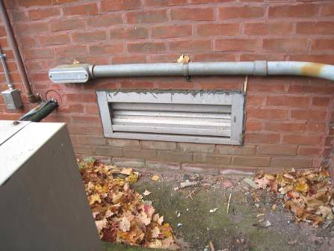

Fresh air vent for basement AHU

Picture 2

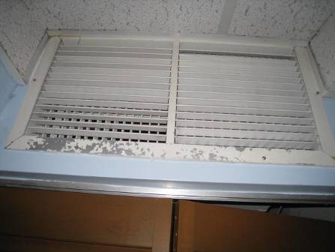

Supply vent in the basement

Picture 3

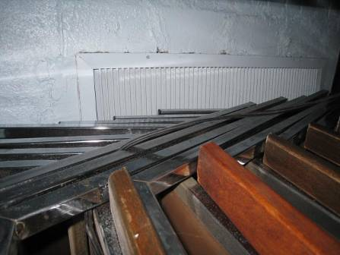

Exhaust vent for the basement; note partial blockage with stored items

Picture 4

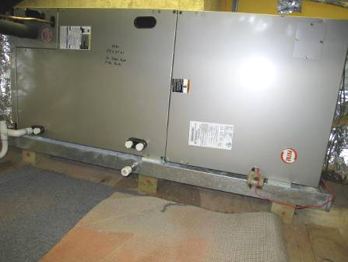

AHU in attic space above Planning Department

Picture 5

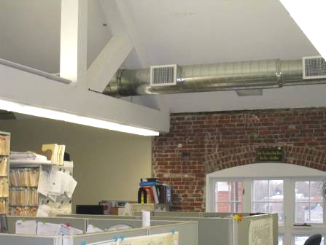

Supply duct with vents on the third floor

Picture 6

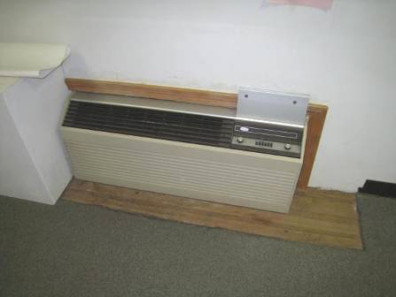

Unit ventilator (univent) in the conference room

Picture 7

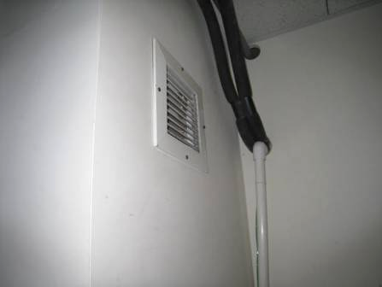

Exhaust vent in janitorial closet

Picture 8

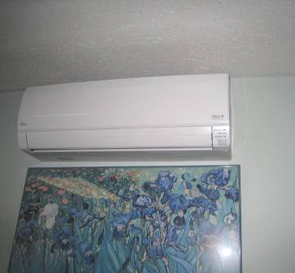

Ductless air conditioning unit

Picture 9

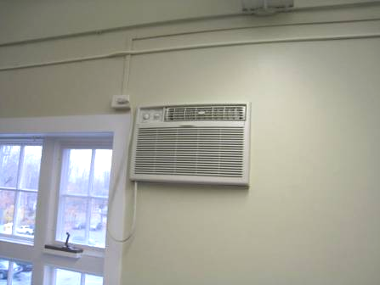

Wall-mounted window-type air conditioning unit

Picture 10

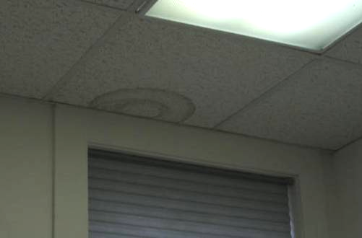

Water-damaged ceiling tile

Picture 11

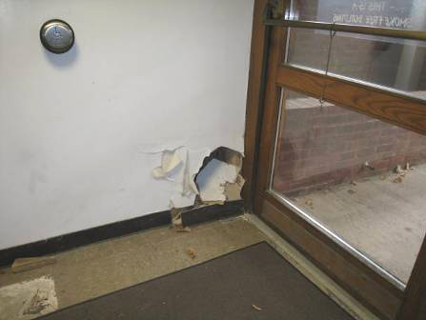

Water-damaged wall in rear entryway

Picture 12

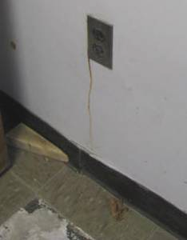

Water stain below electrical socket in rear entryway

Picture 13

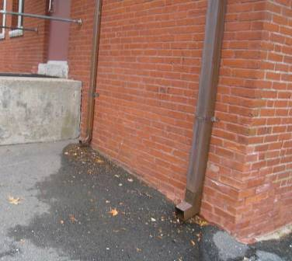

Drainage spouts emptying directly next to the building

Picture 14

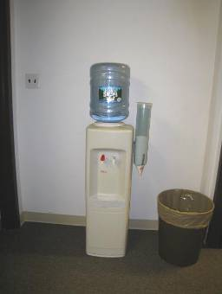

Water dispenser on carpet

Picture 15

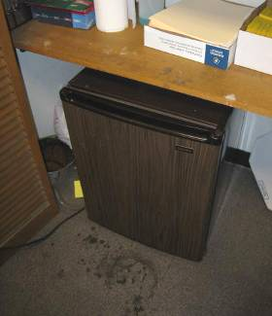

Stained carpeting in front of refrigerator

Picture 16

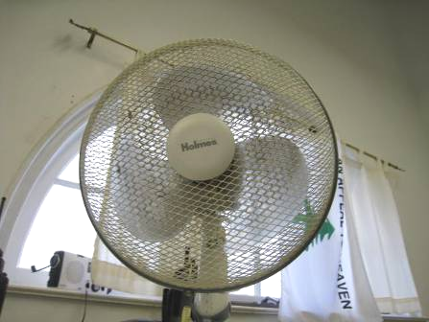

Dusty personal fan
Location/ Room | Carbon  Dioxide  (ppm) | Carbon Monoxide  (ppm) | Temp  (°F) | Relative Humidity  % | PM2.5  (µg/m³) | Occupants  In Room | Windows  Openable | Ventilation |  | Remarks
 |  |  |  |  |  |  |  | Supply | Exhaust | Remarks
Background | 405 | ND | 55 | 20 | 5 |  |  |  |  | Busy parking lot, cloudy, breezy and raw
Third Floor
3rd Floor Restroom |  |  |  |  |  |  | Y | N | Y | CP
Board of Health | 837 | ND | 73 | 31 | 11 | 2 | Y | N | N | WAC, PC, large printer, PF dusty, water cooler on carpet
Land Use Planning | 609 | ND | 74 | 26 | 4 | 1 | Y | N | N | DO
Planning Department (Cubicles) | 599 | ND | 74 | 26 | 4 | 0 | Y | Y | Y | Microwave, coffeepot, toaster, food, plants, records storage, fridge on carpet
Planning Department (Inspectional Services Area) | 609 | ND | 74 | 27 | 3 | 1 | Y | Y | Y | PF
Planning Department (Reception) | 608 | ND | 74 | 27 | 4 | 0 | Y | Y | Y | PC, carpeted
Second Floor
#202 Selectmen’s Office | 642 | ND | 72 | 27 | 5 | 2 | Y | N | N | Scented candle, plant, PC
2nd Floor Ladies Room |  |  |  |  |  |  | Y |  | Y | Switch activated exhaust, CP/AF
Conference/Meeting Room | 1365 | ND | 72 | 31 | 5 | 0  (several just left) | Y | Y  (UV off) | N
Employee Lunchroom | 692 | ND | 72 | 29 | 4 | 0 | Y | N | N | No carpet, food preparation equipment, ductless AC with condensate pump
Hallway between Meeting Rooms | 596 | ND | 72 | 27 | 4 | 0 | N | N | N | WD carpet
Human Resources | 689 | ND | 72 | 27 | 4 | 0 | Y | N | N | DEM, plants
IT |  |  |  |  |  |  |  |  |  | Wire channels in ceiling
Selectmen’s Meeting Room | 564 | ND | 71 | 27 | 4 | 0 | Y | Y  (UV, off) | N | CF, PF, UV automated systems for heat
Town Manager’s Office | 725 | ND | 72 | 29 | 4 | 1 | Y | N | N | DO, ductless AC, items
Youth Services | 601 | ND | 73 | 26 | 4 | 1 | Y | N | N | Ductless AC, DEM, WD windowsill, stained carpet, food, AT
First Floor
Accounting (104) | 617 | ND | 71 | 25 | 5 | 1 | Y | N | N | New carpet, DO, drafty windows
Accounting (Interior) | 706 | ND | 72 | 25 | 5 | 2 | Y | N | N | Plants, DO, WD CT, fruit
Assessor’s Office (105) | 956 | ND | 73 | 27 | 5 | 5 | Y | N | N | CF, PC, food, some old carpet, ductless AC, plant, stained carpet near fridge
Assessor’s Office (Interior) | 1057 | ND | 74 | 29 | 5 | 1 | Y | N | N | Plant, heater
Finance Director (105) | 573 | ND | 74 | 22 | 4 | 0 | Y | N | N | DEM
Parks and Recreation | 634 | ND | 70 | 27 | 5 | 1 | Y | N | N | DO, old carpeting, DEM
Principal Assessor (107) | 571 | ND | 74 | 22 | 5 | 1 | Y | N | N | Plants
Service Closet |  |  |  |  |  |  |  |  | Y (off) | Mop bucket has water, odors
Town Clerk | 608 | ND | 72 | 25 | 4 | 1 | Y | N | N | CF, WAC (in wall), WD CT, plants, small fridge on carpet, PC, plants
Basement
Big meeting/open area | 478 | ND | 70 | 27 | 4 | 0 | N | Y | Y | Reports of previous flooding, tile evidence of WD.
Facilities Office | 532 | ND | 71 | 35 | 4 | 0 | N | N | N | DEM, PF, DO, old lockup
Kitchen | 517 | ND | 70 | 25 | 5 | 0 | N | Y | Y | Gas stove, no hood/vent. WD sink backsplash
Vault |  |  |  |  |  |  |  |  |  | Used for records storage
Hallway to Back Door |  |  |  |  |  |  |  |  |  | WD wall plaster, electrical switch, flooring

