INDOOR AIR QUALITY ASSESSMENT

Horace Mann Charter School
730 Osterville West Barnstable Road
Marston Mills, Massachusetts

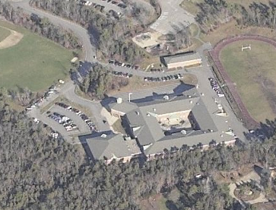

Prepared by:
Massachusetts Department of Public Health
Bureau of Environmental Health
Indoor Air Quality Program
June 2012

Background/Introduction
At the request of the Barnstable Public Schools (BPS), the Massachusetts Department of Public Health (MDPH), Bureau of Environmental Health (BEH) provided assistance and consultation regarding indoor air quality (IAQ) concerns at the Horace Mann Charter School (HMCS) located at 730 Osterville West Barnstable Road, Marston Mills, Massachusetts. On March 16, 2012, Michael Feeney, Director of BEH’s IAQ Program made a visit to the HMCS to conduct an assessment. Mr. Feeney was accompanied by Cory Holmes, Environmental Analyst/Regional Inspector in BEH’s IAQ Program. Chronic issues with moisture and mold growth in the building prompted the assessment.
The HMCS is a two-story brick building completed in 1994. The building contains a centralized courtyard, general classrooms, science classrooms, art rooms, music rooms, kitchen, cafeteria, gymnasium, faculty workrooms and office space. Windows are openable throughout the building.

Methods
Air tests for carbon monoxide, carbon dioxide, temperature and relative humidity were conducted with the TSI, Q-Trak, IAQ Monitor, Model 7565. Air tests for airborne particle matter with a diameter less than 2.5 micrometers were taken with the TSI, DUSTTRAK™ Aerosol Monitor Model 8520. BEH staff also performed visual inspection of building materials for water damage and/or microbial growth.

Results
The school houses approximately 800 children in grades 4 and 5 with a staff of approximately 90. Tests were taken during normal operations at the school. Results appear in Table 1.

Discussion

Ventilation
It can be seen from Table 1 that carbon dioxide levels were below 800 parts per million (ppm) in 51 of 67 areas, indicating adequate air exchange in the majority of areas surveyed during the assessment. A number of classrooms were empty/sparsely populated or had open windows at the time of the testing, however, which contributes to lower carbon dioxide levels. Carbon dioxide levels would be expected to be higher with full occupancy and with windows closed.
Fresh air in classrooms is supplied by unit ventilators (univents) (Picture 1). A univent is designed to draw air from outdoors through a fresh air intake located on the exterior wall of the building (Picture 2). Return air is drawn through an air intake located at the base of each unit where fresh and return air are mixed, filtered, heated and provided to classrooms through an air diffuser located in the top of the unit (Figure 1).
Univents were found deactivated or obstructed with classroom items in a number of areas (Table 1). In order for univents to provide fresh air as designed, intakes/returns must remain free of obstructions. Importantly, these units must remain “on” and be allowed to operate while rooms are occupied. It was reported by school officials that the mechanical ventilation control systems were failing, and a plan to replace them was in progress.
Exhaust ventilation in classrooms is provided by wall or ceiling vents ducted to rooftop motors (Picture 3). Exhaust ventilation was found deactivated in a number of areas during the assessment (Table 1), which may indicate that they were shut off or in need of repair. As with univents, in order to function properly, exhaust vents must be activated and allowed to operate while rooms are occupied. Without adequate supply and exhaust ventilation, excess heat and environmental pollutants can build up and lead to indoor air/comfort complaints. In addition, some return/exhaust vents are located near classroom doors (Table 1). Due to their location, the exhaust capabilities of these vents can be diminished when the doors are open. With the classroom doors open, the return/exhaust vent tends to draw air from the hallway into the classroom rather than remove stale air out of the classroom.
Rooftop air-handling units (AHUs) provide mechanical ventilation to common areas such as the cafeteria, gymnasium, library and music room. AHUs draw in fresh, outside air through a set of intake louvers and then through a bank of filters. Air is then distributed to interior areas via ceiling or wall-mounted air diffusers. Exhaust ventilation is provided by ceiling or wall-mounted return vents ducted back to rooftop AHUs.
To maximize air exchange, the MDPH recommends that both supply and exhaust ventilation operate continuously during periods of occupancy. In order to have proper ventilation with a mechanical supply and exhaust system, the systems must be balanced to provide an adequate amount of fresh air to the interior of a room while removing stale air from the room. It is recommended that heating, ventilating and air conditioning (HVAC) systems be re-balanced every five years to ensure adequate air systems function (SMACNA, 1994). The date of the last balancing of these systems was not available at the time of the assessment. Once control systems have been replaced, the system should be re-balanced by an HVAC engineering firm.
The Massachusetts Building Code requires that each room have a minimum ventilation rate of 15 cubic feet per minute (cfm) per occupant of fresh outside air or openable windows (SBBRS, 1997; BOCA, 1993). The ventilation must be on at all times the room is occupied. Providing adequate fresh air ventilation with open windows and maintaining the temperature in the comfort range during the cold weather season is impractical. Mechanical ventilation is usually required to provide adequate fresh air ventilation.
Carbon dioxide is not a problem in and of itself. It is used as an indicator of the adequacy of the fresh air ventilation. As carbon dioxide levels rise, it indicates that the ventilating system is malfunctioning or the design occupancy of the room is being exceeded. When this happens, a buildup of common indoor air pollutants can occur, leading to discomfort or health complaints. The Occupational Safety and Health Administration (OSHA) standard for carbon dioxide is 5,000 parts per million parts of air (ppm). Workers may be exposed to this level for 40 hours/week, based on a time-weighted average (OSHA, 1997).
The MDPH uses a guideline of 800 ppm for publicly occupied buildings. A guideline of 600 ppm or less is preferred in schools due to the fact that the majority of occupants are young and considered to be a more sensitive population in the evaluation of environmental health status. Inadequate ventilation and/or elevated temperatures are major causes of complaints such as respiratory, eye, nose and throat irritation, lethargy and headaches. For more information concerning carbon dioxide, consult Appendix A.
Indoor temperature measurements ranged from 70 °F to 79 °F (Table 1), which were within or very close to the MDPH recommended comfort range on the day of the assessment. As mentioned, the HVAC control systems have reportedly failed in the building leading to temperature control/airflow complaints. The MDPH recommends that indoor air temperatures be maintained in a range of 70 °F to 78 °F in order to provide for the comfort of building occupants. In many cases concerning indoor air quality, fluctuations of temperature in occupied spaces is typical, even in a building with an adequate fresh air supply.
The relative humidity measured in the building ranged from 23 to 34 percent, which was below the MDPH recommended comfort range in all areas surveyed during the assessment (Table 1). The MDPH recommends a comfort range of 40 to 60 percent for indoor air relative humidity. Relative humidity levels in the building would be expected to drop during the winter months due to heating. The sensation of dryness and irritation is common in a low relative humidity environment. Low relative humidity is a very common problem during the heating season in the northeast part of the United States.

Microbial/Moisture Concerns
Water-damaged ceiling tiles were observed in a number of areas and peeling paint and water-damaged ceiling material was observed adjacent to the rotunda in the library. These indicate current/historic plumbing and/or roof leaks (Pictures 3 though 6, Table 1). Water-damaged ceiling tiles can provide a source of mold and should be replaced after a water leak is discovered and repaired. Bowed/warped ceiling tiles and wrinkled carpeting was also observed in a number of areas throughout the building indicating chronic issues with moisture/humidity control (Pictures 7 through 9).
The US Environmental Protection Agency (US EPA) and the American Conference of Governmental Industrial Hygienists (ACGIH) recommend that porous materials (e.g., carpeting, gypsum wallboard) be dried with fans and heating within 24 to 48 hours of becoming wet (US EPA, 2001; ACGIH, 1989). If not dried within this time frame, mold growth may occur. Once mold has colonized porous materials, they are difficult to clean and should be removed/discarded.
Several areas had dehumidifiers present (Table 1), in one case, a dehumidifier had both the “bucket full” and “clean filter” indicator lights on (Picture 10). Dehumidifiers should be cleaned and maintained as per the manufacturer’s instructions to prevent standing water and mold growth.
Plants were noted in a few classrooms (Table 1). Plants can be a source of pollen and mold which can be respiratory irritants to some individuals. Plants should be properly maintained and equipped with drip pans and should be located away from univents to prevent the aerosolization of dirt, pollen and mold.
Breaches exist between countertops and sink backsplashes in a number of classrooms (Picture 11; Table 1). Water can penetrate through backsplash seams if they are not watertight. Water penetration and chronic exposure of porous and wood-based materials can cause these materials to swell and show signs of water damage. As discussed, moistened materials that are not dried within 24 to 48 hours can become potential sources for mold growth.
BEH staff conducted a perimeter inspection of the building’s exterior to identify other potential sources of water penetration. A likely source of moisture contributing to elevated relative humidity in the building is a man-made pond that is located in the central courtyard (Pictures 12 through 14). This body of water can become stagnant providing a source of mold, bacteria and associated odors. It can also serve as an attractant to aquatic bird life (e.g., geese, ducks) and the waste products associated with these animals. Finally, the manmade structure can flood during heavy rain events. If its capacity were to be exceeded or its structural integrity fails, it could result in a tremendous water load on the exterior walls of the building and lead to water penetration and damage to interior building materials.
During the BEH assessment, water staining was observed on exterior walls. This pattern of staining may result from water trapped behind the exterior wall. During an examination of the building’s exterior, BEH staff found weep holes closed with cement (Pictures 15 and 16).
In modern construction, brick exterior wall systems are usually designed to prevent moisture penetration into the building interior. An exterior wall system usually consists of an exterior brick curtain wall (Figure 2). Behind the curtain wall is an air space that allows for water to drain downward and for the exterior cladding system to dry. At the base of the curtain wall should be weep holes that allow for water drainage. Opposite the exterior wall and across the air space is a continuous, water-resistant material adhered to the backup wall that forms the drainage plane.
The purpose of the drainage plane is to prevent moisture that crosses the air space from penetrating into interior building systems. The plane also directs moisture downwards toward the weep holes. The drainage plane can consist of a number of water-resistant materials, such as tarpaper or, in newer buildings, plastic wraps, and should be continuous. Where breaks exist in the drainage plane (e.g., window systems, door systems and univent fresh air intakes), additional materials (e.g., flashing) are installed as transitional surfaces to direct water to weep holes. If the drainage plane is discontinuous, missing flashing, or lacking air space, rainwater may accumulate inside the wall cavity and lead to moisture penetration into the building.
In order to allow for water to drain from the exterior brick wall system, a series of weep holes is customarily installed at or near the foundation slab/exterior wall system junction (Figure 2). Weep holes allow for accumulated water to drain from a wall system (Dalzell, 1955). Failure to install weep holes in brickwork or clogging/burial of weep holes below grade will allow water to accumulate in the base of walls, resulting in seepage and possible moistening of building components (Figure 3).
Over time, these conditions can undermine the integrity of the building envelope and provide a means of water entry into the building via capillary action through foundation concrete and masonry (Lstiburek & Brennan, 2001). The freezing and thawing action of water during the winter months can create cracks and fissures in the foundation. In addition, these breaches may provide a means for pests/rodents to enter the building.
As mentioned, concerns regarding water damage and mold prompted the visit to the HMCS. The specific concerns related to dark staining and black substances on and around floor tiles in some of the ground floor classrooms (Picture 17). MDPH staff could not confirm if a vapor barrier was installed beneath the slab to prevent the seepage of moisture from sub-slab areas through the floor. Without a vapor retarder moisture can be drawn upward through the concrete slab by hydrostatic pressure and/or capillary action. Moisture can dissolve alkalis in concrete to form a solution, resulting in higher pH levels beneath flooring that can lead to the breakdown of adhesives (Donnelly, 2005). Since mastic material is sticky, it may collect dirt, dust and debris and provide a medium for mold growth, especially if wetted repeatedly (e.g., mopping, high humidity over an extended period/several days). Mastic residue, however, is not mold growth.
If a nearby water source exists to increased localized hydraulic pressure on the underside of a building’s slab, water penetration may increase. Although water infiltration may be a possible source of moisture impacting floor tiles, humidity during summer months also appears to be a potential source for moisture in the building. In particular, it was reported that the issues with the floor tiles may have coincided with humid weather. Since the floor is on slab, the temperature of the floor may be lower than that of the air. Under conditions of high humidity, a colder floor may be lower than the dew point of the air. The dew point is used as a way to describe humidity–the dew point is the temperature at which the water in the air will start to condense. If there are surfaces with temperatures below the dew point, water condensation may occur. If the floor tiles at HMCS are at a lower temperature than the dew point during warm, humid weather, this may contribute to moistening of the materials with associated mastic integrity problems, other water damage, and potential mold growth. The location of the affected rooms along the northern side of the building, which is shaded by the building, and is near an adjacent forested area, may also subject this area of the building to more condensation/moisture than other parts of the building. Keeping the floors clean of dust and debris, using cleaning practices that dry floors thoroughly, and limiting the introduction of humid air into the building, are all steps that will help prevent water damage and mold on floor tiles in these locations.

Other IAQ Evaluations
Indoor air quality can be negatively influenced by the presence of respiratory irritants, such as products of combustion. The process of combustion produces a number of pollutants. Common combustion emissions include carbon monoxide, carbon dioxide, water vapor and smoke (fine airborne particle material). Of these materials, exposure to carbon monoxide and particulate matter with a diameter of 2.5 micrometers (μm) or less (PM2.5) can produce immediate, acute health effects upon exposure. To determine whether combustion products were present in the indoor environment, BEH staff obtained measurements for carbon monoxide and PM2.5.

Carbon Monoxide
Carbon monoxide is a by-product of incomplete combustion of organic matter (e.g., gasoline, wood and tobacco). Exposure to carbon monoxide can produce immediate and acute health effects. Several air quality standards have been established to address carbon monoxide and prevent symptoms from exposure to these substances. The MDPH established a corrective action level concerning carbon monoxide in ice skating rinks that use fossil-fueled ice resurfacing equipment. If an operator of an indoor ice rink measures a carbon monoxide level over 30 ppm, taken 20 minutes after resurfacing within a rink, that operator must take actions to reduce carbon monoxide levels (MDPH, 1997).
The American Society of Heating Refrigeration and Air-Conditioning Engineers (ASHRAE) has adopted the National Ambient Air Quality Standards (NAAQS) as one set of criteria for assessing indoor air quality and monitoring of fresh air introduced by HVAC systems (ASHRAE, 1989). The NAAQS are standards established by the US EPA to protect the public health from six criteria pollutants, including carbon monoxide and particulate matter (US EPA, 2006). As recommended by ASHRAE, pollutant levels of fresh air introduced to a building should not exceed the NAAQS levels (ASHRAE, 1989). The NAAQS were adopted by reference in the Building Officials & Code Administrators (BOCA) National Mechanical Code of 1993 (BOCA, 1993), which is now an HVAC standard included in the Massachusetts State Building Code (SBBRS, 1997). According to the NAAQS, carbon monoxide levels in outdoor air should not exceed 9 ppm in an eight-hour average (US EPA, 2006).
Carbon monoxide should not be present in a typical, indoor environment. If it is present, indoor carbon monoxide levels should be less than or equal to outdoor levels. On the day of the assessment, outdoor carbon monoxide concentrations were non-detect (ND) (Table 1). No measurable levels of carbon monoxide were detected inside the building (Table 1).

Particulate Matter
The US EPA has established NAAQS limits for exposure to particulate matter. Particulate matter is airborne solids that can be irritating to the eyes, nose and throat. The NAAQS originally established exposure limits to particulate matter with a diameter of 10 μm or less (PM10). According to the NAAQS, PM10 levels should not exceed 150 micrograms per cubic meter (μg/m³) in a 24-hour average (US EPA, 2006). These standards were adopted by both ASHRAE and BOCA. Since the issuance of the ASHRAE standard and BOCA Code, US EPA established a more protective standard for fine airborne particles. This more stringent PM2.5 standard requires outdoor air particle levels be maintained below 35 μg/m³ over a 24-hour average (US EPA, 2006). Although both the ASHRAE standard and BOCA Code adopted the PM10 standard for evaluating air quality, MDPH uses the more protective PM2.5 standard for evaluating airborne particulate matter concentrations in the indoor environment.
Outdoor PM2.5 concentrations were measured at 5 μg/m³ (Table 1). PM2.5 levels measured in the school were between 2 to 23 μg/m³ (Table 1), which were below the NAAQS PM2.5 level of 35 μg/m³. Frequently, indoor air levels of particulates (including PM2.5) can be at higher levels than those measured outdoors. A number of activities that occur indoors and/or mechanical devices can generate particulates during normal operations. Sources of indoor airborne particulates may include but are not limited to particles generated during the operation of fan belts in the HVAC system, use of stoves and/or microwave ovens in kitchen areas; use of photocopiers, fax machines and computer printing devices; operation of an ordinary vacuum cleaner and heavy foot traffic indoors.

Volatile Organic Compounds
Indoor air concentrations can be greatly impacted by the use of products containing volatile organic compounds (VOCs). VOCs are carbon-containing substances that have the ability to evaporate at room temperature. Frequently, exposure to low levels of total VOCs (TVOCs) may produce eye, nose, throat and/or respiratory irritation in some sensitive individuals. For example, chemicals evaporating from a paint can stored at room temperature would most likely contain VOCs. In an effort to identify materials that can potentially increase indoor VOC concentrations, BEH staff examined rooms for products containing these respiratory irritants.
Cleaning and sanitization products were observed in some rooms. These products contain chemicals that can be irritating to the eyes, nose and throat of sensitive individuals. Cleaning products should be properly labeled and stored in an area inaccessible to children. In addition, a Material Safety Data Sheets (MSDS) should be available at a central location for each product in the event of an emergency. Consideration should be given to providing teaching staff with school issued cleaning products and supplies to prevent any potential for adverse chemical interactions between residues left from cleaners used by the facilities staff and those left by cleaners brought in by others.
The majority of classrooms contained dry erase boards and related materials. Materials such as dry erase markers and dry erase board cleaners may contain VOCs, such as methyl isobutyl ketone, n-butyl acetate and butyl-cellusolve (Sanford, 1999), which can be irritating to the eyes, nose and throat.
Air fresheners were observed in some areas. Air fresheners contain chemicals that can be irritating to the eyes, nose and throat of sensitive individuals. Further, air fresheners do not remove materials causing odors, but rather, mask odors which may be present in the area.

Other Conditions
In many classrooms, large numbers of items were on the floor, windowsills, tabletops, counters, bookcases and desks, which provide a source for dusts to accumulate (Picture 18). These items (e.g., papers, folders, boxes) make it difficult for custodial staff to clean. Items should be relocated and/or be cleaned periodically to avoid excessive dust build up. In addition, dust and debris can accumulate on flat surfaces (e.g., desktops, shelving and carpets) in occupied areas and subsequently be re-aerosolized causing further irritation.
A number of air diffusers, exhaust/return vents and personal fans were found to have accumulated dust/debris (Picture 3). If exhaust vents are not functioning, backdrafting can occur, which can re-aerosolize accumulated dust particles. Re-activated supply, exhaust/return vents and fans can also aerosolize dust accumulated on vents/fan blades.
Room 116 contained dry drain traps. Due to lack of use, drains are prone to having dry traps that can allow sewer gases/odors to migrate from the drainage system into occupied space. These drains should be filled regularly with water or sealed to prevent such occurrences.
Other issues can be associated with the man-made pond that is located in the central courtyard. The pond does not appear to have a means to circulate or drain/refill the water, which can lead to stagnation, algae growth and odors. In addition, standing water can serve as a breeding ground for mosquitoes and should be removed where found.

Conclusions/Recommendations
In view of the findings at the time of the visit, the following recommendations are made:
- Continue with plans for replacement of HVAC control systems. Ensure school/school department personnel are properly trained in use of system to provide and maintain good airflow/thermal comfort of building occupants.
- Operate all ventilation systems throughout the building (e.g., gym, cafeteria, classrooms) continuously during periods of occupancy to maximize air exchange.
- Adjust the percentage of fresh air supplied to and/or exhausted by the HVAC system to improve air exchange.
- Work with an HVAC engineering firm with input from staff and building maintenance personnel, to troubleshoot and make adjustments in areas with temperature/airflow complaints.
- Remove all blockages/items from the surface of univent air diffusers and return vents (along front/bottom) to ensure adequate airflow.
- Ensure classroom doors are closed for proper operation of HVAC system and to maintain comfort.
- Once HVAC control systems are installed, the system should be balanced by an HVAC engineering firm. Consider adopting a balancing schedule of every 5 years for all mechanical ventilation systems, as recommended by ventilation industrial standards (SMACNA, 1994).
- For buildings in New England, periods of low relative humidity during the winter are often unavoidable. Therefore, scrupulous cleaning practices should be adopted to minimize common indoor air contaminants whose irritant effects can be enhanced when the relative humidity is low. To control dusts, a high efficiency particulate arrestance (HEPA) filter equipped vacuum cleaner in conjunction with wet wiping of all surfaces is recommended. Avoid the use of feather dusters. Drinking water during the day can help ease some symptoms associated with a dry environment (throat and sinus irritations).
- Remove blockages from affected weep holes to ensure proper operation of drainage plane.
- Consider contacting a building engineering firm, public works and/or building envelope specialist to determine methods of preventing chronic water infiltration/condensation in below grade areas.
- Work with HVAC engineering firm to monitor conditions in classrooms as needed, and adjust the HVAC system to avoid elevated relative humidity (>70%) which can create conditions for condensation generation and/or mold growth.
- Do not open windows if HVAC system is in its air-conditioning setting to avoid condensation.
- Continue to supplement the HVAC system, as needed, in susceptible/problem areas with portable dehumidifiers during humid months. Ensure that dehumidifiers are cleaned and maintained per the manufacturer’s instructions, to prevent standing water and mold growth.
- Ensure roof/plumbing leaks are repaired and replace any remaining water-damaged ceiling tiles. Examine the area above these tiles for mold growth. Disinfect areas of water leaks with an appropriate antimicrobial, as needed.
- Refinish water-damaged ceiling in library near rotunda.
- Consider discontinuing use of manmade pond in courtyard.
- Ensure plants, trees and shrubs are located at least five feet away from exterior walls/foundation of the building.
- Ensure indoor plants are equipped with drip pans. Examine drip pans periodically for mold growth and disinfect with an appropriate antimicrobial, as needed. Move plants away from the air stream of mechanical ventilation equipment.
- Seal breaches, seams and spaces between sink countertops and backsplashes to prevent water damage.
- Store cleaning products properly and out of reach of students. All cleaning products used at the facility should be approved by the school department with MSDS’ available at a central location.
- Refrain from using air fresheners and deodorizers to prevent exposure to VOCs.
- Relocate or consider reducing the amount of materials stored in classrooms to allow for more thorough cleaning of classrooms. Clean items regularly with a wet cloth or sponge to prevent excessive dust build-up.
- Clean air diffusers, exhaust/return vents and personal fans periodically of accumulated dust.
- Clean carpeting annually or semi-annually in soiled high traffic areas as per the recommendations of the Institute of Inspection, Cleaning and Restoration Certification (IICRC). Copies of the IICRC fact sheet can be downloaded at: http://www.cleancareseminars.com/carpet_cleaning_faq4.htm (IICRC, 2005)
- Consider a long-term plan to replace all carpeting in the building as funds become available. Consider replacing carpeting with a non-porous surface such as vinyl tile particularly in below-grade areas.
- Pour water into all little used sinks throughout the building and floor/shower drains at least twice weekly in order to prevent sewer gases from entering the facility. If drains are not in use, consider sealing permanently.
- Consider adopting the US EPA (2000) document, “Tools for Schools”, as an instrument for maintaining a good indoor air quality environment in the building. This document is available at: http://www.epa.gov/iaq/schools/index.html.
- Refer to resource manual and other related indoor air quality documents located on the MDPH’s website for further building-wide evaluations and advice on maintaining public buildings. These documents are available at: http://mass.gov/dph/iaq.
References
ACGIH. 1989. Guidelines for the Assessment of Bioaerosols in the Indoor Environment. American Conference of Governmental Industrial Hygienists, Cincinnati, OH.
ASHRAE. 1989. Ventilation for Acceptable Indoor Air Quality. American Society of Heating, Refrigeration and Air Conditioning Engineers. ANSI/ASHRAE 62-1989.
BOCA. 1993. The BOCA National Mechanical Code/1993. 8th ed. Building Officials & Code Administrators International, Inc., Country Club Hills, IL.
Dalzell, J.R. 1955. Simplified Masonry Planning and Building. McGraw-Hill Book Company, Inc. New York, NY.
Donnelly, G. 2005. Summary of Cause and Measurement Concrete Moisture Vapor Emission and In-Situ Relative Humidity. George Donnelly, http://www.moisturetesting.com/concrete_moisture_vapor.htm
IICRC. 2005. Carpet Cleaning FAQ 4 Institute of Inspection, Cleaning and Restoration Certification. Institute of Inspection Cleaning and Restoration, Vancouver, WA.
Lstiburek, J. & Brennan, T. 2001. Read This Before You Design, Build or Renovate. Building Science Corporation, Westford, MA. U.S. Department of Housing and Urban Development, Region I, Boston, MA.
MDPH. 1997. Requirements to Maintain Air Quality in Indoor Skating Rinks (State Sanitary Code, Chapter XI). 105 CMR 675.000. Massachusetts Department of Public Health, Boston, MA.
OSHA. 1997. Limits for Air Contaminants. Occupational Safety and Health Administration. Code of Federal Regulations. 29 C.F.R 1910.1000 Table Z-1-A.
Sanford. 1999. Material Safety Data Sheet (MSDS No: 198-17). Expo® Dry Erase Markers Bullet, Chisel, and Ultra Fine Tip. Sanford Corporation, Bellwood, IL.
SBBRS. 1997. Mechanical Ventilation. State Board of Building Regulations and Standards. Code of Massachusetts Regulations. 780 CMR 1209.0.
SMACNA. 1994. HVAC Systems Commissioning Manual. 1st ed. Sheet Metal and Air Conditioning Contractors’ National Association, Inc., Chantilly, VA.
US EPA. 2000. Tools for Schools. Office of Air and Radiation, Office of Radiation and Indoor Air, Indoor Environments Division (6609J). EPA 402-K-95-001, Second Edition. http://www.epa.gov/iaq/schools/tools4s2.html
US EPA. 2001. “Mold Remediation in Schools and Commercial Buildings”. Office of Air and Radiation, Indoor Environments Division, Washington, DC. EPA 402-K-01-001. March 2001. Available at: http://www.epa.gov/iaq/molds/mold_remediation.html
US EPA. 2006. National Ambient Air Quality Standards (NAAQS). US Environmental Protection Agency, Office of Air Quality Planning and Standards, Washington, DC. http://www.epa.gov/air/criteria.html
Picture 1

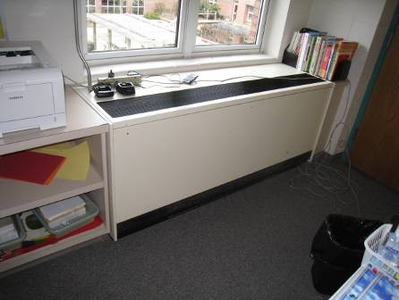

Classroom Univent

Picture 2

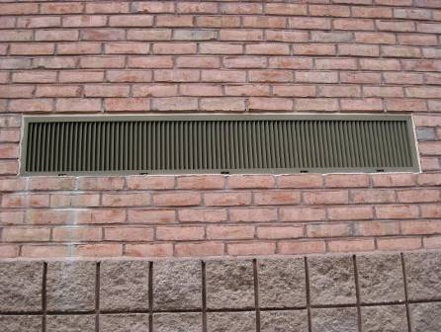

Univent Fresh Air Intake

Picture 3

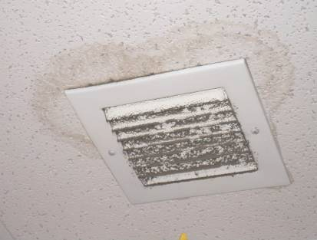

Ceiling-Mounted Exhaust Vent in Library Office, Note Dust/Debris Accumulation on Vent and Water-Damaged Ceiling Tile

Picture 4

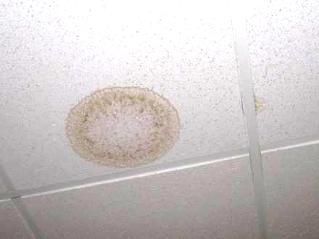

Water-Damaged Ceiling Tile

Picture 5

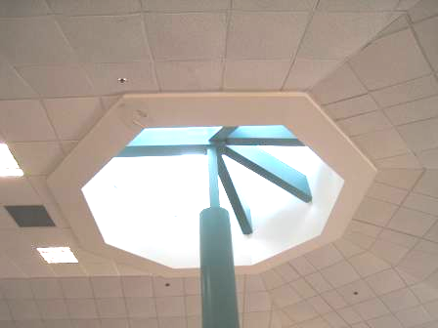

Peeling Paint and Water-Damaged Ceiling Material (Arrow) near Library Rotunda

Picture 6

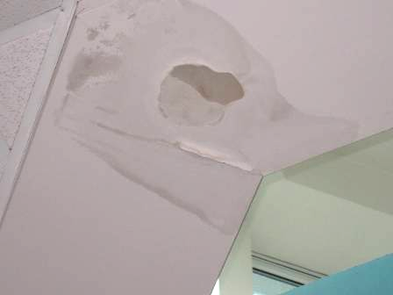

Close-up of Peeling Paint and Water-Damaged Ceiling Material near Library Rotunda

Picture 7

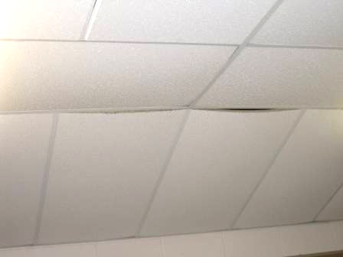

Bowed Ceiling Tiles in Classroom

Picture 8

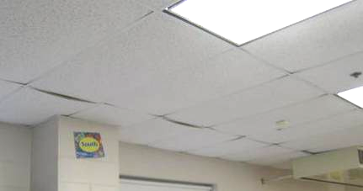

Bowed Ceiling Tiles in Classroom

Picture 9

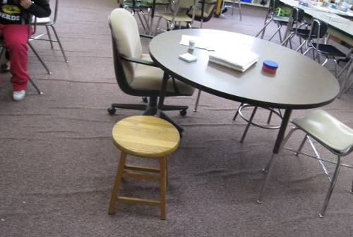

Wrinkled Carpeting in Classroom

Picture 10

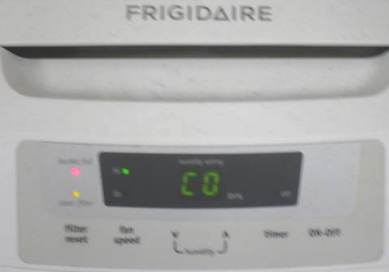

Dehumidifier in Classroom, Note “Bucket Full” and “Clean Filter” Lights are Lit (Arrows)

Picture 11

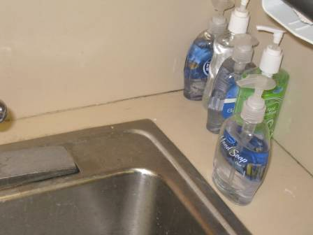

Spaces between Sink Countertop and Backsplash

Picture 12

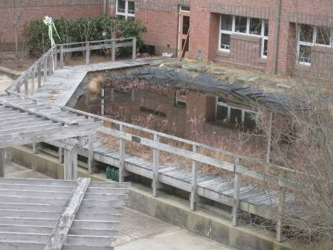

Manmade Marsh in Central Courtyard, Note Build-up of Material against Exterior Wall

Picture 13

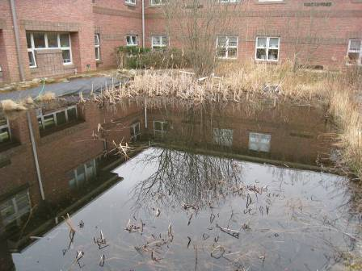

Manmade Marsh in Central Courtyard, Note Build-up of Material against Exterior Wall

Picture 14

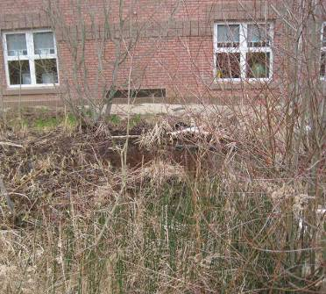

Manmade Marsh near Univent Fresh Air Intake (Arrow)

Picture 15

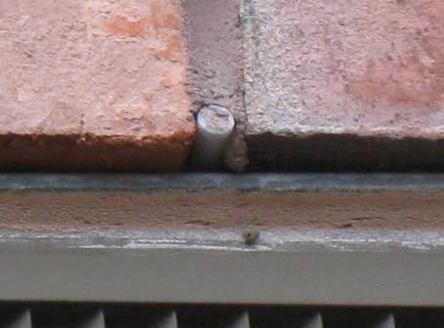

Weep Holes Sealed with Cement

Picture 16

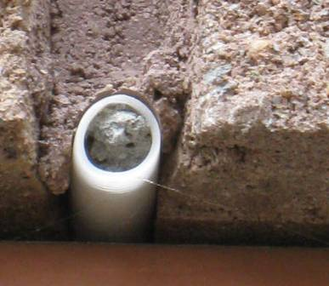

Close-up of Weep Holes Sealed with Cement

Picture 17

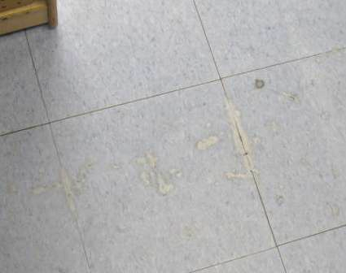

Damaged Floor Tile

Picture 18

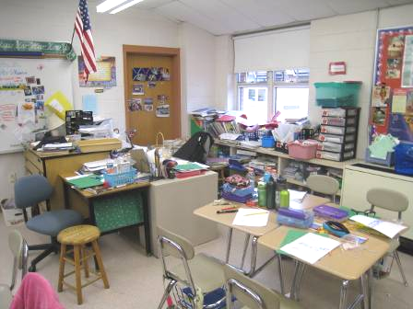

Accumulated Items on Flat Surfaces in Classroom
Location/ Room | Carbon  Dioxide  (ppm) | Carbon Monoxide  (ppm) | Temp  (°F) | Relative  Humidity  (%) | PM2.5  (µg/m³) | Occupants  in Room | Windows  Openable | Ventilation |  | Remarks
Background | 320 | ND | 46 | 44 | 5 |  |  |  |  | Cold, mostly cloudy, winds SE 3-10 mph
Library | 586 | ND | 75 | 29 | 11 | 35 | Y | Y | Y | WD peeling paint on ceiling around rotunda
Library Office | 734 | ND | 75 | 27 | 11 | 0 | Y | Y | Y | Dust/debris on vents, WD CT around exhaust vent, DO, spaces sink countertop
Guidance | 660 | ND | 76 | 26 | 11 | 3 | Y | Y | Y | Chronic heat/poor airflow complaints, DO, 2 WD CTs
Prevention Office | 593 | ND | 78 | 25 | 13 | 4 | Y | Y | Y | DO
Main Office | 514 | ND | 71 | 28 | 2 | 7 | N | Y | Y | DO
Health Office | 945 | ND | 72 | 31 | 4 | 4 | N | Y | Y | WD CT, DO
Cafeteria | 816 | ND | 74 | 32 | 8 | 9 | Y | Y | Y
102 | 446 | ND | 72 | 28 | 5 | 2 | Y | Y | Y | DO
105 | 953 | ND | 71 | 31 | 16 | 7 | N | Y | Y | DO
106 A | 586 | ND | 74 | 28 | 6 | 1 | Y | Y | Y | DO
108 A | 1134 | ND | 73 | 32 | 5 | 0 | N | Y
109 | 577 | ND | 73 | 25 | 7 | 1 | Y | Y | Y
114 |  |  |  |  |  |  |  |  |  | Carpet ripped
116 | 739 | ND | 71 | 31 | 11 | 19 | Y | Y | Y | Dry drain traps sink and hood
116 Office | 659 | ND | 71 | 30 | 7 | 0 | N | Y | Y | Supply = transfer air vent
117 | 502 | ND | 73 | 25 | 14 | 17 | Y | Y | Y | Dehumidifier, DO, WD floor tile seams
118 | 608 | ND | 78 | 28 | 12 | 21 | Y  Open | Y | Y | WD/MT, DO, clutter
119 | 586 | ND | 70 | 28 | 8 | 19 | Y | Y | Y
121 | 708 | ND | 71 | 29 | 11 | 19 | Y | Y | Y
122 | 638 | ND | 79 | 26 | 4 | 2 | Y | Y | Y | MT
123 | 869 | ND | 77 | 25 | 19 | 20 | Y | Y  Off | Y
125 | 407 | ND | 75 | 23 | 5 | 3 | Y | Y | Y | WD CT
126 | 1149 | ND | 73 | 34 | 13 | 16 | Y | Y  Off | Y
131 | 380 | ND | 70 | 27 | 3 | 0 | Y | Y | Y
132 | 715 | ND | 71 | 31 | 9 | 16 | Y | Y | Y | WD CT
133 | 529 | ND | 71 | 29 | 4 | 19 | Y | Y | Y | DO
205 | 768 | ND | 78 | 27 | 9 | 17 | Y  Open | Y  Off | Y | DO
208 | 680 | ND | 71 | 31 | 13 | 21 | Y | Y | Y
209 | 793 | ND | 71 | 34 | 12 | 23 | Y | Y | Y | Sink spaces countertop
210 | 546 | ND | 70 | 29 | 9 | 9 | Y | Y | Y | Dehumidifier-Filter change light “on”/bucket full light “on”
211 | 718 | ND | 74 | 31 | 12 | 22 | Y | Y | Y
212 | 464 | ND | 74 | 25 | 10 | 0 | Y | Y | Y | Exhaust over door, DO, dehumidifier
213 | 488 | ND | 73 | 28 | 9 | 0 | Y | Y | Y | DO
214 Conference Room | 527 | ND | 73 | 26 | 10 | 0 | Y | Y | Y | DO
215 | 1360 | ND | 77 | 32 | 23 | 22 | Y | Y  Off | Y  Off
217 | 817 | ND | 73 | 31 | 15 | 23 | Y  Open | Y | Y  Off | Moss growth on roof outside window, items on UV
218 | 543 | ND | 71 | 30 | 8 | 1 | Y | Y | Y  Off | 21 occupants gone ~ 10 mins, DO, dehumidifier
219 | 713 | ND | 76 | 28 | 17 | 3 | Y | Y  Off | Y  Off | Heat issues
220 | 654 | ND | 74 | 30 | 12 | 4 | Y  Open | Y | Y | Wrinkled carpet, UV-in need of repair-waiting on parts
221 | 559 | ND | 72 | 28 | 11 | 0 | Y | Y | Y  Off | DO, WD CT near exhaust vent, plants
222 | 492 | ND | 72 | 27 | 11 | 1 | Y | Y | Y  Off
223 | 584 | ND | 73 | 27 | 10 | 0 | Y | Y | Y  Off | Sink spaces countertop
224 | 692 | ND | 70 | 31 | 8 | 21 | Y | Y | Y  Off
225 | 1091 | ND | 75 | 34 | 19 | 22 | Y | Y  Off | Y  Off | Sink spaces countertop, DO
228 Conference Room | 564 | ND | 72 | 29 | 11 | 0 | Y | Y | Y
229 | 795 | ND | 71 | 30 | 10 | 18 | Y | Y | Y
230 | 910 | ND | 76 | 31 | 16 | 21 | Y | Y | Y | UV deactivated due to mechanical issues, DO
231 | 903 | ND | 74 | 34 | 15 | 23 | Y | Y  Off | Y | 1 bowed CT, DO, exhaust over door
232 | 488 | ND | 74 | 29 | 9 | 3 | Y | Y | Y | Wrinkled carpet
233 | 724 | ND | 71 | 30 | 10 | 18 | Y | Y | Y | Accumulated items
234 | 823 | ND | 76 | 30 | 10 | 17 | Y  Open | Y  Off | Y | Sink spaces countertop, DO
235 | 783 | ND | 75 | 28 | 12 | 23 | Y | Y | Y | DO
236 | 1033 | ND | 77 | 33 | 10 | 22 | Y | Y | Y | Turtle tank, DO, exhaust over door, sink spaces countertop
237 | 712 | ND | 73 | 29 | 8 | 21 | Y | Y | Y | Exhaust over door, DO
238 | 702 | ND | 77 | 27 | 17 | 2 | Y | Y | Y | UV-no airflow, DO
239 | 1071 | ND | 78 | 29 | 12 | 19 | Y | Y  Off | Y | DO
240 | 728 | ND | 78 | 29 | 12 | 19 | Y | Y | Y | Exhaust over door
241 | 828 | ND | 74 | 28 | 9 | 22 | Y | Y | Y | Exhaust near door
242 Storage | 472 | ND | 74 | 27 | 11 | 0 | N | Y  Passive door vent | Y  Off | 2 PCs
243 | 636 | ND | 70 | 29 | 9 | 21 | Y | Y | Y  Off | Bowed CTs, exhaust near door, space sink countertop
244 | 527 | ND | 72 | 29 | 17 | 21 | Y | Y | Y  Off | Occupants just returned from lunch, DO
245 | 400 | ND | 71 | 27 | 8 | 0 | Y | Y | Y  Off | Exhaust over door, DO
246 | 701 | ND | 71 | 31 | 15 | 20 | Y | Y | Y  Off
247 | 437 | ND | 70 | 29 | 9 | 0 | Y | Y | Y  Off | 1 WD CT over UV, occupants at lunch, DO
248 | 585 | ND | 74 | 27 | 14 | 0 | Y  Open | Y  Off | Y  Off | Occupants at lunch
249 | 833 | ND | 70 | 31 | 10 | 20 | Y | Y | Y  Off | Items on UV
250 | 450 | ND | 73 | 25 | 13 | 2 | Y | Y | Y | Exhaust over door, DO
251 | 782 | ND | 70 | 29 | 11 | 25 | Y | Y | Y  Off | Spaces sink countertop, DO

