Commonwealth of Massachusetts
Executive Office of Health and Human Services

Office of Medicaid
www.mass.gov/masshealth

MassHealth
Hospice Bulletin 12
February 2018
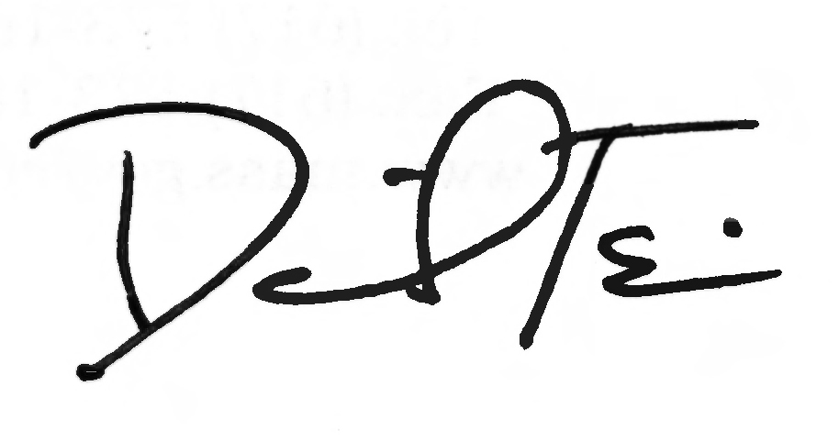

TO: Hospice Providers Participating in MassHealth

FROM: Daniel Tsai, Assistant Secretary for MassHealth

RE: Changes to MassHealth Policy on Diagnoses That Are Not Appropriate for Reporting as Principal Diagnoses on Hospice Claims

Background

As of October 1, 2014, the Centers for Medicare & Medicaid Services (CMS) provided an update regarding, among other changes, new editing instructions for diagnoses that are not appropriate for reporting on hospice claims. CMS Transmittal 3032, available at https://www.cms.gov/Regulations-and-Guidance/Guidance/Transmittals/Downloads/R3032CP.pdf, provides the following guidelines:
Hospices are to report diagnosis coding on the hospice claim, as required by ICD-10-CM Coding Guidelines. The principal diagnosis reported on the claim is the diagnosis most contributory to the terminal prognosis. ICD-10-CM Coding Guidelines state that codes listed under the classification of Symptoms, Signs, and Ill-defined Conditions are not to be used as principal diagnoses when a related definitive diagnosis has been established or confirmed by the provider. Hospice providers may not report diagnosis codes that cannot be used as the principal diagnosis according to ICD-10-CM Coding Guidelines and require further compliance with various ICD-10-CM coding conventions, such as those that have principal diagnosis code sequencing or etiology/manifestation guidelines.

Changes to MassHealth Policy on Diagnoses That Are Not Appropriate for Reporting as Principal Diagnoses on Hospice Claims

MassHealth’s policy pertaining to diagnoses that are no longer appropriate will follow the CMS guidelines. Effective upon the date of this bulletin and in accordance with the above referenced changes to the CMS hospice rules:
- The principal diagnosis reported on the claim should be the diagnosis most contributory to the terminal prognosis.
- Hospice may not report ICD-10-CM–Z codes as the principal diagnosis on hospice claims.
- Both “debility” and “adult failure to thrive” are considered nonspecific, symptom diagnoses according to ICD-10-CM Coding Guidelines.

(continued on next page)

MassHealth

Hospice Provider Bulletin 12

February 2018

Page 2

Changes to MassHealth Policy on Diagnoses That Are not Appropriate for Reporting as Principal Diagnoses on Hospice Claims (cont.)

- “Debility” (R53.81), “Adult failure to Thrive” (R62.7), and “Other Malaise and Fatigue” (R53.8) are not to be used as principal hospice diagnoses on the hospice claim form.
- Additionally, hospices are not to report dementia codes, classified as unspecified, or which have a “code first” sequencing convention, as principal hospice diagnoses on the hospice claim. The dementia codes under the classification, ‘‘Mental, Behavioral, and Neurodevelopmental Disorders," are not appropriate as principal diagnoses because of etiology/manifestation guidelines or sequencing conventions under the ICD-10-CM Coding Guidelines. According to ICD-10-CM Coding Guidelines, the underlying condition must be coded as the principal diagnosis and the aforementioned dementia conditions would be appropriate as secondary diagnoses.
- See Attachment A: Hospice Invalid Principal Diagnosis Codes for a list of dementia codes no longer allowed per CMS Transmittal 3032: https://www.cms.gov/Regulations-and-Guidance/Guidance/Transmittals/Downloads/R3032CP.pdf
- Diagnosis codes F02.80, “Dementia in diseases classified elsewhere without behavioral disturbance,” and F02.81, “Dementia in diseases classified elsewhere with behavioral disturbance,” are included in an existing Medicare Code Editor edit, which does not allow these diagnoses to be coded as principal. This Medicare Code Editor edit will be implemented as a “Manifestation code as principal diagnosis” edit in the Integrated Outpatient Code Editor (IOCE). Additionally, new edits for the codes in Attachment A will be implemented, as these codes are part of sequencing or other coding convention in ICD-10-CM coding guidelines.
- Unspecified codes are only to be used when the medical record, at the time of the encounter, is insufficient to assign a more specific code. However, it is recognized that the underlying neurologic condition causing dementia may be difficult to code because the medical record may not provide sufficient information. There are codes listed under “Diseases of the Nervous System” that do provide for appropriate principal code selection under those circumstances, and hospice providers are encouraged to look at the coding conventions under that classification for coding dementia conditions on hospice claims.
- If any of these diagnoses mentioned in the document as inappropriate are reported as a principal diagnosis, the claim will be returned to the provider for a more definitive hospice diagnosis based on ICD-10-CM Coding Guidelines.
- All of a patient’s coexisting or additional diagnoses that are related to the terminal illness and related conditions should be reported on the hospice claim.

Questions

If you have any questions about the information in this bulletin, please contact the MassHealth Customer Service Center at 1-800-841-2900, email your inquiry to providersupport@mahealth.net, or fax your inquiry to 617-988-8974.

