August 1, 2023

Executive Office of Health and Human Services
Department of Public Health
250 Washington Street
Boston, MA 02108-4619

RE: Proposed Amendments to 105.000, Licensure of Hospice Programs

Dear Robert Goldstein, MD, Members of the Public Health Council, and Elizabeth Kelley, Bureau Director, Bureau of Health Care Safety and Quality,

The Hospice & Palliative Care Federation of Massachusetts (HPCFM) appreciates the opportunity to provide comment to the Massachusetts Department of Public Health regarding the recent amendments, filed on July 7, 2023, to the following regulations: 105 CMR 141.000, Licensure of Hospice Programs.

HPCFM is the membership organization representing hospice and palliative care programs in the Commonwealth of Massachusetts. HPCFM represents over 60 hospice locations and more than 3,000 hospice professionals in Massachusetts, caring for the majority of the state’s hospice patients. The organization is committed to improving end-of-life care and expanding access to hospice care with the goal of creating an environment in which individuals and families facing serious illness, death, and grief will experience the best that humankind can offer.

Often referred to as the voice for hospice in Massachusetts, HPCFM works collaboratively with the National Hospice and Palliative Care Organization (NHPCO) relative to hospice issues on the national level and in fact shares one voice in representing hospice agencies across the country, as well as local, statewide associations representing other stakeholder provider groups across the post-acute care continuum.

HPCFM is appreciates the effort of the Department in its approach to the proposed regulations regarding vaccines and making efforts to closely align them with CMS.

Hospice care is person-centered care. Hospice care impacts patients and families. Hospice providers continue to strive for excellence in all aspects of the care they deliver, including staff, patient and family safety.

Considering that hospice providers (and all branches of healthcare) are experiencing workforce challenges along with the controversy that surrounds vaccinations in general, HPCFM’s overarching request is for the Department to recognize and consider the added burden of the mandate and not create added administrative, burdensome processes for hospice providers and jeopardize managing an already fractured workforce which has the potential to impact operations and access to care.

CONTINUED ON NEXT PAGE

HPCFM has two specific comments regarding the proposed amendments relative to sections g and h, under 141.201 (D) included below for convenience.

(g) Documentation.
i. A program shall require and maintain for each individual proof of current vaccination against COVID-19 virus pursuant to 105 CMR 141.201(D)(1)(b) or the individual’s exemption statement pursuant to 105 CMR 141.201(D)(1)(e).
ii. Each program shall maintain a central system to track the vaccination status of all personnel.
iii. If a program is unable to provide or arrange for COVID-19 vaccination for any individual, it shall document the reasons such vaccination could not be provided or arranged for.
(h) Reporting and Data Collection. Each program shall report information to the Department documenting the program’s compliance with the personnel vaccination requirements of 105 CMR 141.201(D)(1) in accordance with reporting and data collection guidelines of the Commissioner.

- Documentation - Given the scope of the proposed changes, the opportunities to opt out of COVID vaccination, and the added record keeping, hospice providers would respectfully advocate for consideration that any added documentation be minimized as to reduce the burden to providers.
- Reporting - Understanding the need to report data to the Department, HPCFM respectfully requests information and clear direction regarding the processes, forms, schedules, and timeframes to submit the required data with an eye to reducing administrative burden verses adding to it.

On behalf of HPCFM and its membership, thank you for your consideration of these comments.

Please do reach out with any questions, comments or concerns.

Sincerely,
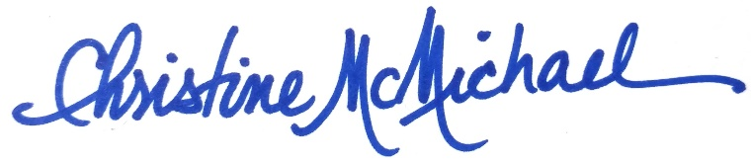
Christine McMichael
HPCFM Executive Director

