HOSPITAL MANUAL FOR COMPLETING THE MASSACHUSETTS REPORT OF FETAL DEATH
(FORM R304-102014)

Registry of Vital Records and Statistics
Massachusetts Department of Public Health
Executive Office of Health and Human Services
150 Mt. Vernon Street
1st Floor
Dorchester, MA 02125

October 2014
TABLE OF CONTENTS

Section | Page
Table of Contents | 2 - 2
Introduction | 3 - 5
For State Use Only | 6 - 6
Facility | 7 - 8
Fetus | 9 - 11
Mother/Parent | 12 - 14
Marital Status | 14 - 14
Father/Parent | 15 - 16
Disposition | 17 - 18
Board of Health Info | 19 - 19
Cause of Death | 20 - 23
Certifier | 24 - 24
Attendant | 25 - 25
Prenatal Care Information | 26 - 27
Pregnancy History | 28 - 29
Delivery Information | 30 - 31
Medical Information | 32 - 35
Reported Alcohol and Tobacco Use | 36 - 36
Demographic Information | 37 - 38
Appendix | 39 - 75
Massachusetts Cities and Towns | 40 - 50
MGL, Chapter 38, Section 3: Duty to report deaths; failure to report | 51 - 51
MGL, Chapter 211, Section 202: Fetal deaths; reports; confidentiality;  disposition of remains; violations; forms | 52 - 52
Report of Fetal Death | 53 - 56
Hospital Worksheet on Report of Fetal Death | 57 - 60
Instructions for Completing the Report of Fetal Death | 61 - 74
INTRODUCTION
INTRODUCTION
This manual is intended to reference cases of fetal death that occur in or are transferred into a general hospital or birthing center. This manual does not cover unique and individual cases where the Medical Examiner assumes jurisdiction. For cases that do not appear to be covered by the manual, call the Registry of Vital Records and Statistics for advice before proceeding with the completion of the Report of Fetal Death.

THE 2014 CHANGES
The 2014 revision of the Report of Fetal Death (form R304-102014) contains a number of changes. Most changes are in order to make Massachusetts compliant with the federally, and state-mandated, required minimum data set for fetal deaths. The national standard, developed by the National Center for Health Statistics (NCHS), closely resembles the birth certificate and death certificate, containing the relevant items of the two.

Although the Department recognizes that in some cases, the availability of certain data may be less accessible than for birth certificate reporting, in general those items appearing on the legal portion of the birth certificate and on the death certificate are to be considered required. All other items are required as available from hospital and prenatal sources.

Fetal Death Reporting
Massachusetts General Law oversees most of the vital events registration process. Chapter 111, Section 202 governs the reporting of fetal death information. The Report of the Fetal Death should be received by the Registry of Vital Records within 10 days of the fetal death. Although we recognize that in a limited number of cases, problems may develop which will not allow the facility to report the fetal death within 10 days; no report should be held by the facility for more than 30 days. Incomplete records should never be retained by the facility for more than 30 days.

Reportable Fetal Deaths
If a stillbirth is delivered at 20 weeks gestation or more and/or weighs 350 grams or more, a report of fetal death must be completed. In order for it to be a reportable fetal death, the fetus may either be delivered at 20 weeks gestation or more OR weighs 350 grams or more. The fetus does not have to meet both the gestational age requirement and the weight requirement for it to be a reportable fetal death.

Massachusetts General Law (MGL Chapter 111, Section 202) is very specific in that the death is determined at the time of complete “expulsion or extraction” of the fetus. Gestational Age at delivery is determined by length of time in utero, i.e., weeks between last menstrual period and date of delivery. This may differ from the clinical estimate of gestation at time of death, which is not a determinant of reportability. “Fetal death” does not include an abortion as defined in MGL Chapter 112, Section 12 K.

Non-Reportable Fetal Deaths
If a stillbirth is delivered, extracted or expulsed, before 20 weeks gestation AND weighs less than 350 grams, it is a non-reportable fetal death. No Report of Fetal Death should be completed. In cases where a private disposition is arranged, it will be necessary for the hospital to provide a hospital letter of notification for the funeral director or the family to obtain a permit rather than a Report of Fetal Death. The Standard Certificate of Death and the Standard Certificate of Live Birth should also NEVER be used with a fetal death of any gestation.

Confidentiality
Reports of Fetal Death are not public records, differing in this way from birth and death certificates. The fetal death reports shall be confidential and shall be released by the Department only upon written request of the parent, his or her guardian, executor, attorney or any other person designated by the parent in writing. Such reports may also be released to the National Center for Health Statistics, and to persons authorized by the Commissioner of Public Health under section twenty-four A of this chapter to conduct research studies. The department may release copies of such reports or information contained therein, to other persons only in a manner in which does not allow identification of the parents. See Appendix on MGL Chapter 111, Section 202.

The information collected from the confidential items is used for aggregate data only. That is, no names or other identifying information is ever made available to others outside of rigorously reviewed approved public health research activities.

The finalized fetal death data files at the State Registry have a multitude of uses, not least of which is a tool for health professionals in implementing programs to improve maternal and child health. Good data quality is vital in assessing where health problems exist, and this depends on fully completed fetal death reports.

Worksheets
An accompanying Worksheet for Completing the Report of Fetal Death is a recommended tool for the completion of fetal death reports. However, there is NO Parent Worksheet as there is for birth certificates.

The method that the facility uses to complete the fetal death report is left to the discretion of the facility. Use of the hospital worksheet provided by the Registry is strongly recommended. A facility may develop its own worksheet(s), but in doing so, it is important to remember that all items assigned to categories on the Registry worksheet must remain the same and must be continually updated to conform to Registry changes. It is recommended that any worksheet used by the facility be sent to the Registry to insure that the required information is being collected. In this way, many potential problems may be avoided. It is also recommended that worksheets be retained for at least a year, in case problems develop with the fetal death report.

Because the elements of the Report of Fetal Death are exactly the same as the birth certificate for most items, if the hospital has received a completed or partially completed birth certificate worksheet (i.e. Parent Worksheet for Birth Certificates, Preregistration Worksheet for Birth Certificates, Hospital Worksheet or Prenatal Provider Worksheet), they can be used to complete the Report of Fetal Death when it becomes necessary.

Although the Report of Fetal Death contains elements found on the Parent Worksheet for Birth Certificates, the Registry STRONGLY DISCOURAGES hospitals from giving parents a Parent Worksheet after a fetal demise. Except for those elements found on the front side of the Report of Fetal Death, parents should not be asked to complete any of the statistical items such as race, education, smoking status, etc. The hospital should complete these elements to the best of its ability, by making use of previously completed Preregistration Worksheets or from hospital medical records. The Registry recognizes that in some cases, the parent demographic statistical information may not be available.

Information Collection
Assignment of the unit responsible for fetal death report data collection is left to the discretion of the facility. Varying among facilities, it may be the medical records departments, OB/GYN units, or admitting departments having responsibility for the fetal death report. It is important to note that even if the mother is not admitted to the hospital, e.g., and emergency room delivery, or ambulance delivery en-route to the hospital, the hospital is still required to complete the Report of Fetal Death.

Certification
All items on the Report of Fetal Death must be completed in full. The report must be signed by medical doctor, medical examiner, or nurse practitioner. The original Report of Fetal Death must be sent to the Registry of Vital Records and Statistics. A copy of the report must be kept at the hospital. If the fetus is to be buried or cremated, the funeral director (or the family) will need a copy of the report in order to obtain the burial permit.
For non-reportable fetal deaths, for which the parent(s) wish for private disposition, a letter should be provided on hospital letterhead stationery and it must contain the following information: date of delivery, parent(s) name, gestational age and weight. The letter must be signed by a medical doctor, nurse practitioner or a hospital administrator. A Report of Fetal Death should never be completed for a non-reportable fetal death.

Disposition
If the fetal disposition takes place in a hospital facility, the hospital is responsible for providing the information in sections labeled “Method of Disposition” and “Place of Disposition”. Otherwise, the Board of Health is responsible for completing the information after receipt of the photocopy from the funeral director or the family. It is important to note, that in the case of fetal death, whether or not the fetal death is reportable, that the parents may elect to have private disposition. Under Massachusetts General Law, Chapter 111, Section 202, “…Before disposition, the physician or person in charge of the hospital shall ensure that the parent is informed of his right to direct either burial, entombment or cremation of the fetal remains, or disposal of the remains by the hospital or physician. Before disposition, the parent shall be informed in writing of the hospital policy relating to disposal of fetal remains, and shall be informed of the availability of a chaplain if any for counsel.”

Live Birth
If a live birth occurs, regardless of weight or gestational age, a Standard Certificate of Live Birth must be completed even if the gestational age and/or birthweight do not meet the requirements for a Report of Fetal Death.

Questions
Hospitals should call the Registry with any questions prior to submitting a Report of Fetal Death. Because copies of the Report may be issued to the parents by the Registry of Vital Records and Statistics, it is important that the Report of Fetal Death be as neat and legible as possible. A carelessly completed report, or one that contains errors, may be distressing to the parents.
Questions about the Report of Fetal Death should be directed to (617) 740-2681.

FOR STATE USE ONLY
State File #:
The Registry assigns a consecutive six-digit number to all Report of Fetal Death records as they are processed. Please leave blank. The Registry will complete State File #.

Date Received by Registrar:
The date Report of Fetal Death record is received by the Registry as they are processed.
Please leave blank. The Registry will complete Date Received by Registrar.

FACILITY
Items 1-6 identify the place of delivery, which is used to study relationships of hospital and nonhospital pregnancy terminations. It is also used by many States to produce statistical data by specific facility. Information on place of delivery, together with residence information, provides data to evaluate the utilization and distribution of health services.

Item 1: Facility ID (Number)
The Facility ID is the unique four-digit identifier of the facility completing the report of fetal death. It is used for simplifying fetal death processing.
Please leave blank. The Registry will complete Item 1: Facility ID (Number) upon receipt of completed Report of Fetal Death.

Item 2: Facility Name
THIS ITEM IS REQUIRED. DO NOT LEAVE THIS ITEM BLANK.

Determine the Place of Death:
If the fetal death occurred in a:

GENERAL HOSPITAL OR BIRTHING CENTER:
The place of delivery is the facility. Provide the full name of the facility. DO NOT provide facility name if facility is other than a general hospital or birthing center.

MOVING CONVEYANCE EN ROUTE OR UPON ARRIVAL TO HOSPITAL:
The place of delivery is the hospital. Enter the full name of the facility followed by the notation “EN ROUTE” (e.g. YOUR HOSPITAL NAME: EN ROUTE”).

MOVING CONVEYANCE NOT EN ROUTE TO GENERAL HOSPITAL OR BIRTHING FACILITY
The place of delivery is the exact site where the fetus was first removed from the conveyance. Enter the street number AND street name where fetus was first removed from the conveyance (e.g. address, not name, of the airport if the fetus was delivered in flight, or home address if mother delivered in a car en route to her home). DO NOT use a mailing address (e.g. a post office box).

OTHER SITE, NOT A MOVING CONVEYANCE, INCLUDING HOME:
The place of delivery is the actual site of fetal death occurrence. Enter the street number and street name where the fetal death occurred. If the fetal death occurred in a school or institution other than a hospital or birthing center (e.g. in a correctional or mental health facility), DO NOT name the institution. Enter the address only. Facility name should be completed only for a general hospital or birthing center. In all cases, do not use a mailing address.
Item 3: City, Town, or Location of Delivery
THIS ITEM IS REQUIRED. DO NOT LEAVE THIS ITEM BLANK.
Recommended Sources of Information: Hospital Worksheet, Medical Records

Enter the name of the city or town in which the fetal death delivery occurred. The city or town should be one of the 351 communities in Massachusetts. For example, if a fetal death occurs in Dorchester, the city should read “BOSTON”. See Appendix for a list of Massachusetts cities, towns, and corresponding counties.

Item 4: Place Where Delivery Occurred (Check one):
THIS ITEM IS REQUIRED. DO NOT LEAVE THIS ITEM BLANK.
Recommended Sources of Information: Hospital Worksheet, Medical Record

Check the box that best describes the type of place where the fetal death delivery occurred. If the type of place is not known, check the “Unknown” box.
- Hospital
- Clinic/Doctor’s Office
- Freestanding birthing center
- Home Delivery
  - Planned to deliver at home? Yes No
- Unknown
- Other (specify) __________________________________________
Item 5: Zip Code of Delivery
THIS ITEM IS REQUIRED. DO NOT LEAVE THIS ITEM BLANK.

Enter the zip code of the city or town in which the fetal death delivery occurred.

Item 6: County of Delivery
THIS ITEM IS REQUIRED. DO NOT LEAVE THIS ITEM BLANK.
Recommended Sources of Information: Hospital Worksheet, Medical Record

Enter the name of the county in which the fetal death delivery occurred. Whenever possible, check to make sure that the county coincides with the city/town of delivery. See Appendix for a list of Massachusetts cities, towns and corresponding counties.

FETUS

Name of Fetus (optional-at the discretion of the parents)
The fetus name is optional. If the parents do not wish to name the fetus, leave Items 7a to 7c blank.

If the parents wish to name the fetus, enter the first, middle, last name as requested by the mother. DO NOT enter “Baby Smith” or any other designation that is not specifically requested by the mother.

Hospitals can make the mother aware, if they feel that this would be appropriate or helpful, that a name can be given to the fetus for the purposes of completing the Report of Fetal Death.

If a name is not given at the time of the Report, the parent s may later request a Certificate of Birth Resulting in Stillbirth. The parents will have the option to name the fetus by completing the Request Form for a Certificate of Birth Resulting in Stillbirth.

Item 7a: First Name
Enter the first name of fetus.

Item 7b: Middle Name
Enter the middle name of fetus.

Item 7c: Last Name
Enter the last name of fetus.

Item 8: Time of Delivery (24 hr)
THIS ITEM IS REQUIRED. DO NOT LEAVE THIS ITEM BLANK.
Recommended Sources of Information: Hospital Worksheet, Medical Record, or Labor & Delivery Log
This item documents the exact time of delivery for various legal uses, such as the order of delivery in plural deliveries. When the delivery occurs around midnight, the exact hour and minute may affect the date of death. For deliveries occurring at the end of the year, the hour and minute affect not only the day but also the year of death.

Enter the time of delivery the fetus was extracted or expulsed based on a 24-hour clock (military time). Based on the recommendation the National Center for Health Statistics received from the National Institute of Standards and Technology, it is strongly recommended that the 24-hour clock with the range of 00:00-23:59 be used. 00.00 is considered the start of the new day.

In cases of plural deliveries, the exact time that the fetus was delivered should be recorded as the hour and minute of delivery.

Item 9: Sex
THIS ITEM IS REQUIRED. DO NOT LEAVE THIS ITEM BLANK.
Recommended Sources of Information: Hospital Worksheet, Medical Record, or Labor & Delivery Log
This information is used to measure fetal and perinatal mortality by sex. This information helps identify differences in the impact of environmental and biological factors between the sexes.

Check the appropriate box to indicate whether the fetus is male or female. If the sex cannot be determined after verification of medical records or other sources, check the “Unknown” box.

Item 10: Weight of Fetus (grams)
THIS ITEM IS REQUIRED. DO NOT LEAVE THIS ITEM BLANK.
Recommended Sources of Information: Hospital Worksheet, Medical Record, or Labor & Delivery Log
Weight of fetus is the single most important characteristic associated with the viability of the fetus. It is also related to prenatal care, socioeconomic status, marital status and other factors surrounding the delivery. It is useful in evaluating the effectiveness of health care.

Enter the weight (in grams) of the fetus as it is recorded in the hospital record.

Item 11: Obstetric Estimate of Gestation at Delivery (completed weeks)
THIS ITEM IS REQUIRED. DO NOT LEAVE THIS ITEM BLANK.
Recommended Sources of Information: Hospital Worksheet, Medical Record, or Labor & Delivery Log
This item is intended to provide an alternate estimate of gestational age when the date last normal menses began is missing or apparently incompatible with the weight of the fetus. This item is required as a primary determinant of fetal death reportability. It is the weeks of gestation at time of extraction or expulsion, which may differ from Item 15: Clinical Estimate of Gestation that is reported on the report.
Enter the best obstetric estimate of the infant’s gestation in completed weeks.

This item should reflect the number of weeks the fetus was carried in utero. If the fetus died at the 10th week, but was not delivered until the 37th week, the weeks gestation in this item should read “37 weeks”.

If a fraction of a week is given (e.g. 32.2 weeks), round down to the next whole week (e.g. 32 weeks). DO NOT complete this item based solely on the date of delivery and the mother’s date of last menses.

If the number of weeks is less than 20, but the weight of the fetus at delivery is 350 grams or more, the fetal death is REPORTABLE. The fetal death is not reportable only when BOTH the weight is less than 350 grams and the number of weeks is also less than 20.

Item 12: Date of Delivery (Month, Day, Year)
THIS ITEM IS REQUIRED. DO NOT LEAVE THIS ITEM BLANK.
Recommended Sources of Information: Hospital Worksheet, Medical Record, or Labor & Delivery Log
This item is used in conjunction with the date of last normal menses began to calculate the length of gestation, which is an essential element in the study of low birth weight deliveries.

Enter the exact month, day and year that the fetus was delivered.

MONTH: Use full or alphabetic abbreviated name of the month (e.g. JAN, FEB). DO NOT USE A NUMBER FOR THE MONTH. Numeric designations for months are susceptible to error or misinterpretation across cultures.

DAY: Enter the exact numeric day of the delivery.

YEAR: Use four-digit designation for the year of delivery. Vital records are permanent records and have been recorded over centuries. For this reason, it is important to distinguish records through the centuries.

Item 13: Plurality (specify)
THIS ITEM IS REQUIRED IF PLURAL BIRTH. DO NOT LEAVE THIS ITEM BLANK.
Recommended Sources of Information: Hospital Worksheet, Medical Record, or Labor & Delivery Log

If this is a singleton delivery, leave this item blank. For multiple deliveries, check the appropriate box to indicate the order that this fetus was delivered in the set, e.g. first, second, third, other. Count all live births and fetal deaths delivered at any point during the pregnancy. “Reabsorbed” fetuses, those which are not “delivered”—expulsed or extracted from the mother—should not be counted.

NOTE: If a mother delivers a fetal death as part of a multiple birth, the hospital is responsible for completing a separate report for each fetus and/or birth in the delivery.
- A plural delivery occurs whenever there are two or more products of conception from one pregnancy. For example, if a woman has a fetal death at 19 weeks gestation which is later extracted at the time of birth of a second child at 36 weeks, the birth is considered a plural birth and the fetal death is reportable.

- However, if the first twin died at ten weeks, and was reabsorbed s so that the mother only delivered one product of the pregnancy, then record the live birth as a single birth and the fetal death is not reportable.
NOTE: A live birth less than 350 grams in weight or under 20 weeks gestation is to be considered a live birth and a birth certificate must be prepared. A fetus born dead under 350 grams and under 20 weeks at time of extraction or expulsion does not require a fetal death report.

Item 14: Birth Order (specify if plural birth)
THIS ITEM IS REQUIRED. DO NOT LEAVE THIS ITEM BLANK.
Recommended Sources of Information: Hospital Worksheet, Medical Record, or Labor & Delivery Log

Specify the order in which the fetus being reported was delivered, e.g., FIRST, SECOND, THIRD, etc. Count all live births and fetal deaths at any point in the pregnancy.

Item 15: Clinical Estimate of Gestation (in weeks)
This reflects the date of death that is prior to the expulsion or extraction of the fetus. Reportability is determined by Item 11: Obstetric Estimate of Gestation at Delivery.

Enter the clinical estimate of gestation, in weeks.

MOTHER/PARENT

Item 16a-16d: Mother’s Name
THESE ITEMS ARE REQUIRED. DO NOT LEAVE THESE ITEMS BLANK.
Recommended Sources of Information: Mother’s Preregistration Worksheet, Admission Records (with verification from mother)
Mother’s name is needed for identification of the fetal death. The mother’s surname at birth or adoption (maiden name) is an important part of an index to birth/death and fetal death files in that the last name of the child being registered and the mother’s married name may change several times, but the maiden name will always stay the same.

Enter the mother’s current legal name in Items 16a-16d.

Item 16a: First Name
Enter the mother’s first name.

Item 16b: Middle Name
Enter the mother’s middle name. If there is no middle name, leave this item blank. DO NOT enter NMI, NMN, etc.

Item 16c: Last Name
Enter the mother’s current last name. This item will still need to be completed even if the name is the same as in Item 16d.

Item 16d: Surname at Birth or Adoption (Maiden Name)
Enter the mother’s maiden surname. This would be the name that is listed on her birth certificate. This item will still need to be completed even if the name is the same as in Item 16c.

Item 17: Date of Birth (Month, Day, Year)
THIS ITEM IS REQUIRED. DO NOT LEAVE THIS ITEM BLANK.
Recommended Sources of Information: Preregistration Worksheet, Mother’s Medical Record
This item is used to compute mother’s age. Mother’s age is one of the most important factors in studying childbearing and child health patterns. For example, there have been many studies which have shown relationships between the age of the mother at birth and the child’s weight, illness patterns and other factors.

Enter the exact month, day and year that the mother was born.

MONTH: Use alphabetic full or alphabetic abbreviated name of the month (e.g. JAN, FEB). DO NOT USE A NUMBER FOR THE MONTH.
DAY: Enter the exact numeric day of mother’s birth.
YEAR: Use four-digit designation for year of mother’s birth (e.g. 1975).

Item 18: Birthplace (City/Town, State, Country)
THIS ITEM IS REQUIRED. DO NOT LEAVE THIS ITEM BLANK.
Recommended Sources of Information: Preregistration Worksheet, Patient Interview
The birthplace item may become an important identifier for legal purposes to link family relationships. As a statistical item, it is used together with census data to compare child bearing patterns of women who reside in the state where they were born with that of women who reside in a state other than their state of birth. Birthplace is also used for studying migration patterns of generations and tracing family histories.

CITY/TOWN
For mothers born in the United States, enter the proper name of the city or town of mother’s birth.
For mothers born outside of the United States, enter the name of the city or town of mother’s birth.
DO NOT use the name of a subsection of a municipality or a village (e.g. “BOSTON” not “DORCHSTER”). Use only proper city and town names whenever possible.

For mothers born outside of New England, the birthplace may be a jurisdiction other than a city or town name, e.g. a county.

If this information cannot be obtained from hospital sources, enter “---”.

STATE/COUNTRY
For mothers born in the United States, enter the name of the state of the mother’s birth.
For mothers born outside of the United States, enter the name of the country of the mother’s birth.
e.g. BOSTON, MA NOT DORCHESTER, MA
CAMBODIA NOT UNKNOWN, CAMBODIA
UNKNOWN

Item 19a-19g: Mother/Parent’s Residence Information
THESE ITEMS ARE REQUIRED. DO NOT LEAVE THESE ITEMS BLANK.
Recommended Sources of Information: Hospital Admission Records, Mother’s Preregistration Worksheet, or Patient Interview
Statistics on fetal deaths are tabulated by place of residence of the mother. This makes it possible to compute fetal and perinatal death rates based on the population residing in that area. These data are used in planning for and evaluating community services and facilities, including maternal and child health programs. “Inside City Limits” is used to properly assign residence to either the city or the remainder of the county.

These items refer to the mother’s residence address, not her postal address. Do not include post office boxes or rural route numbers.

The mother’s residence is the place where her household is located. This is not necessarily the same as her home state, voting residence, mailing address, or legal residence. The state, county, city and street address should be for the place where the mother actually lives. Never enter a temporary residence, such as one used during a visit, business trip or vacation. Residence for a short time at the home of a relative, friend, or home for unwed mothers for the purpose of awaiting the birth of the child is considered temporary and should not be entered here. However, place of residence during a tour of military duty or during attendance at a college is not considered temporary and should be entered on the certificate as the mother’s place of residence.

Item 19a: Residence of Mother-Number and Street Address
Enter the actual address where the mother lives now, including the street name, number and proper city/town name. DO NOT use a post office box or other address used for mailing purposes only.

Item 19b: Apt #
Enter the apartment, unit or room number of the mother’s residence. Leave this blank if not applicable.

Item 19c: City/Town
If the mother is a US resident, enter the name of the city, town, or location in which the mother lives. DO NOT list a neighborhood, village or other subdivision name.

Item 19d: County
If the mother is a US resident, enter the county in which the mother lives. Leave this blank if the mother is not a US resident.

Item 19e: State
If the mother is a US resident, enter the US state or territory where the mother lives.
If the mother is a Canadian resident, enter the name of the province or territory followed by “Canada” (e.g. “British Columbia, Canada”).
If the mother is not a resident of the US, enter the name of the county of residence.
Item 19f: Zip Code
Enter the zip code for the mother’s residence. Leave this blank if not applicable.

Item 19g: Inside City Limits? (if not MA resident)
Check whether the mother’s residence city town (Item 19c) is incorporated (if non-MA resident) and if the mother’s residence is inside its boundaries; otherwise, mark “No”.

If the mother is not a U.S. resident, leave this item blank.

Item 20: Mother’s Marital Status
Marital status is used to monitor the special health problems and risk factors encountered among unmarried women and their children. It has been shown that unmarried women are more likely to have less prenatal care, and a higher incidence of lower birthweight babies and infant mortality. By including this information on the fetal death report, these factors can be considered in studies of fetal deaths.
Recommended Sources of Information: Mother’s Preregistration Worksheet, Admission Records or Medical Records.

Check the appropriate box to indicate mother’s marital status.

If the mother is separated from her husband, she is still considered to be legally married until the divorce has been finalized. Therefore answer “MARRIED” in this section.

The mother’s marital status has no impact on her ability to name a father of her choice on the Report of Fetal Death. A mother may be unmarried or married to a person other than the biological father, but may list the biological father on the Report of Fetal Death without affidavits of paternity or denial.

FATHER/PARENT

Item 21a-d: Father’s Name
Recommended Sources of Information: Mother’s Preregistration Worksheet, Patient Interview
Father’s information may be included regardless of mother’s marital status. The Report of Fetal Death is not a legal record, but rather a legally mandated report. An unmarried mother may list father’s information without providing paternity affidavits; and a married mother may list a father other than her spouse without providing denial of paternity affidavits. HOWEVER, listing a father on the Report of Fetal Death does not constitute proof of paternity.

If the parents are unmarried, father’s information may be listed, without documentation of parentage. However, if the mother does not wish to name a father, insert dashes in all father information items on the front of the form, and in any reverse side of the form items as cannot be completed.

Item 21a: First Name
Enter the father’s first name.

Item 21b: Middle Name
Enter the father’s middle name. If there is no middle name leave this item blank. Do not enter NMI, NMN, etc.

Item 21c: Last Name
Enter the father’s last name. Enter any suffixes following the last name.
Include Generational designations such as “JR” or “III” as a part of the father’s last name.

Item 21d: Surname at Birth or Adoption
Enter the father’s surname at birth or adoption. This would be the name that is listed on his birth certificate.

Item 22: Date of Birth (Month, Day, Year)
Recommended Sources of Information: Mother’s Preregistration Worksheet, Patient Interview

Enter the exact month, day and year that the father was born. If no father is listed, enter dashes “---” in this item.

MONTH: Use alphabetic full or alphabetic abbreviated name of the month (e.g. JAN, FEB). DO NOT USE A NUMBER FOR THE MONTH.
DAY: Enter the exact numeric day of father’s birth.
YEAR: Use four-digit designation for year of father’s birth (e.g. 1975).

Item 23: Birthplace (City/Town, State, Country)
Recommended Source of Information: Mother’s Preregistration Worksheet
The birthplace item may become an important identifier for legal purposes to link family relationships. Birthplace is also used for studying migration patterns of generations and tracing family histories.

CITY/TOWN
For fathers born in the United States, enter the proper name of the city or town of father’s birth.
For fathers born outside of the United States, enter the name of the city or town of father’s birth.

Do NOT use the name of a subsection of a municipality or a village (e.g. “BOSTON” not “DORCHSTER”). Use only proper city and town names.

For fathers born outside of New England, the birthplace may be a jurisdiction other than a city or town name, e.g. a county. When this occurs, you must contact the Registry before entering the information.

STATE/COUNTRY
For fathers born in the United States, enter the name of the state of the father’s birth.
For fathers born outside of the United States, enter the name of the country of the father’s birth.
Spell out or use appropriate postal abbreviations for US states.
e.g. BOSTON, MA NOT DORCHESTER, MA
CAMBODIA NOT UNKNOWN, CAMBODIA
UNKNOWN
If the information is unknown, enter “---”.

DISPOSITION

ITEM 24: METHOD OF DISPOSITION AND ITEM 25: PLACE OF DISPOSITION ARE REQUIRED. DO NOT LEAVE THESE ITEMS BLANK.
If the disposition is not known to the hospital, leave these items blank. They will be completed by the Board of Health.

Item 24: Method of Disposition
THIS ITEM IS REQUIRED. DO NOT LEAVE THIS ITEM BLANK.
This information indicates whether the fetus was disposed of as required by law. It also serves to help locate the fetus in case of exhumation, autopsy, or transfer is required later.
Check the box corresponding to the method of disposition of the fetus. Removal from state indicates the body was removed or shipped out of MA for burial or other disposition. Only one box should be marked.

If the fetus is to be used by a hospital, medical or mortuary school for scientific or educational purposes, check “Donation” and specify the name and location of the institution in Items 25a-25e. “Donation” refers only to the entire fetus, not to individual organs.

If the disposition is not known to the hospital, leave this item blank. It will be completed by the Board of Health.
- Burial: Check this box if the immediate method of disposition by the funeral director listed is burial. This means that the fetus is not being shipped out of state for subsequent burial, nor is the fetus being held for later burial after the ground thaws, nor is the body being cremated.

- Cremation: Check this box if the immediate disposition by the funeral director listed is cremation. Even if the remains will subsequently be buried in a family plot, the immediate disposition is cremation.

- Entombment: Check this box if the body is entombed as the immediate disposition. For example, a fetus dies in January, and the remains are being held in a tomb for subsequent burial in the spring. The immediate disposition is entombment.

- Removal from state: Check this box if the fetus is being transported out of state by the listed funeral director. If for example, a Massachusetts funeral director is shipping a body out of country for disposition this box would be marked.

- Donation: Check this box if the fetus is donated for medical research and education.

- Medical Waste: Check this box if hospital is handling fetal disposition as pathological waste.

- Other (specify): Another common “other” might be “HOLDING” if the funeral director is holding the remains at his facility for later burial or transportation.
Item 25a-f: Place of Disposition
THESE ITEMS ARE REQUIRED. DO NOT LEAVE THEM BLANK.
Enter the disposition information of the fetal death in Items 25a-25f.
If the disposition is not known to the hospital, leave these items blank. They will be completed by the Board of Health.

Item 25a: Name (i.e. cemetery, crematory, hospital, etc.)
Enter the name of the cemetery, crematory, or other facility where the immediate fetal disposition occurred.

Item 25b: City/Town, State
Enter the name of the city or town and state where the immediate fetal disposition occurred.

Item 25c: Funeral Service Licensee (if any)
Enter the name of the funeral service licensee responsible for the immediate disposition listed on the Report of Fetal Death. If the disposition takes place in a hospital facility, and there is no funeral director involved, then write “NONE”.

If the fetus is being shipped out-of-state for final disposition, list the funeral director that removes the fetus from the hospital.

Item 25d: License #
Enter the personal state license number of the funeral service licensee, if any. If the license number is not from Massachusetts, enter the 2-character US Postal abbreviation prior to the license number.

Item 25e: Name of Facility (if any)
Enter the name of the facility handling the fetal remains prior to burial or other disposition. The funeral director listed must be associated with this facility.

Item 25f: Date of Disposition (Month, Day, Year)
Enter the exact month, day and year of disposition.

Month: Use full or alphabetic abbreviated name of the month of disposition (e.g. JAN, FEB). DO NOT USE A NUMBER FOR THE MONTH.

Day: Enter the exact numeric day of disposition.

Year: Use four-digit designation for the year of disposition (e.g. 1979).
If “Removal from State” is stated, then the date of disposition should be the date the remains are shipped, not the date of ultimate disposition.

BOARD OF HEALTH INFO

Item 26a-b: Board of Health Info
The city/town Board of Health is the responsible agency to issue the disposition permit. The funeral home can provide the following to the city/town Board of Health:
- If a fetal death occurs that is reportable to the Registry of Vital Records and Statistic (20 weeks or more in gestational age or weight of 350 grams or more), a photocopy only Page 1 of 4 AND Page 2 of 4 (Cause of Death and Certifier Info) of the Report of Fetal Death is used to issue the permit. The Report of Fetal Death is a confidential report that is retained for 30 days only by the burial agent and is not forwarded to the city/town clerk.

- If an unreportable fetal death occurs (less than 20 weeks in gestational age or less than 350 grams in weight), a letter from the physician or hospital stating the facts of the case is used to obtain the burial permit. A Report of Fetal Death is not completed.
Item 26a: Date Report Was Received
Enter the date the Report of Fetal Death was received by the city/town Board of Health clerk.

Item 26b: City/Town of Board of Health
Enter the city/town of where the disposition permit is issued for fetal death.

CAUSE OF FETAL DEATH

For research and statistical purposes, it is important that the reported information on the fetal death report be as specified as precisely as possible.

Cause of death is one of the most important statistical and research items on the fetal death report. It provides medical information that serves as a basis for describing trends in human health and mortality and for analyzing the conditions leading to death. Mortality statistics provide a basis for epidemiological studies that focus on leading causes of death by age, race and sex. They also provide a basis for research in disease etiology and evaluation of diagnostic techniques, which in turn lead to improvements in patient care. Fetal death reports differ from death certificates, in that maternal conditions are sought more extensively in cause of death, and other statistical items that follow. Causes of fetal death are examined by both fetal and maternal conditions, and relationships between the two.

Items 27a: Initiating Cause/Condition and 27b: Other Significant Cause or Conditions:
THESE ITEMS ARE REQUIRED. DO NOT LEAVE THEM BLANK.

These items are to be completed by the person whose name appears in Item 33b to 33d.

The cause of death section consists of two parts. The initiating cause/condition (Item 27a) is for reporting a single condition that most likely began the sequence of events resulting in the death of the fetus. Other significant causes or conditions (Item 27b) include all other conditions contributing to death. These conditions may be triggered by the initiating cause (Item 27a) or causes that are not among the sequence of events triggered by the initiating cause (Item 27a).

The cause-of-death information should be the certifier’s best medical opinion. Report a specific condition in the space most appropriate to the given situation. A condition can be listed as “probable” even if it has not been definitively diagnosed. In reporting the causes of fetal death, conditions in the fetus or mother, or of the placenta, cord, or membranes, should be reported if they are believed to have adversely affected the fetus.

Cause of fetal death should include information provided by the pathologist if tissue analysis, autopsy, or another type of postmortem exam was done. If microscopic exams for a fetal death are still pending at the time the report is filed, the additional information should be reported to the Registry as soon as it is available.

Common problems in fetal death certification
Uncertainty:
Often several acceptable ways of writing a cause-of-death statement exist. Optimally, a certifier will be able to provide a simple description of the initiating cause and other contributing causes that is etiologically clear and to be confident that this is correct. However, realistically, description of the process is sometimes difficult because the certifier is not certain.

In this case, the certifier should think through the causes about which he/she is confident and what possible etiologies could have resulted in these conditions. The certifier should select the causes that are suspected to have been involved and use words such as “probable” or “presumed” to indicate that the description provided is not completely certain. Causes of death on the fetal death report should not include terms such as “prematurity” without explaining the etiology because they have little value for public health or medical research.

Reporting a cause of fetal death as unknown should be a last resort.

When a number of conditions or multiple organ/system failure resulted in death, the physician, medical examiner, or nurse practitioner should choose a single condition which most likely began the sequence of events resulting in the fetal death and list the other conditions in Item 27b: Other Significant Cause or Conditions. “Multiple system failure” could be included as an “other significant cause or condition” but also specify the systems involved to ensure that the detailed information is captured. Maternal conditions may have initiated or affected the sequence

that resulted in a fetal death. These maternal conditions should be reported in the cause-of-death statement in addition to the fetal causes.

Avoid ambiguity:
Most certifiers will find themselves, at some point, in the circumstance in which they are unable to provide a simple description of the process of death. In this situation, the certifier should try to provide an initiating condition, qualify the causes about which he/she is uncertain, and be able to explain the certification chosen.

Item 27a: Initiating Cause/Condition
Among the choices below, select the ONE which most likely began the sequence of events resulting in the death of the fetus. If it is not clear where to report a condition, write it on the “(Specify)” line that seems most appropriate.
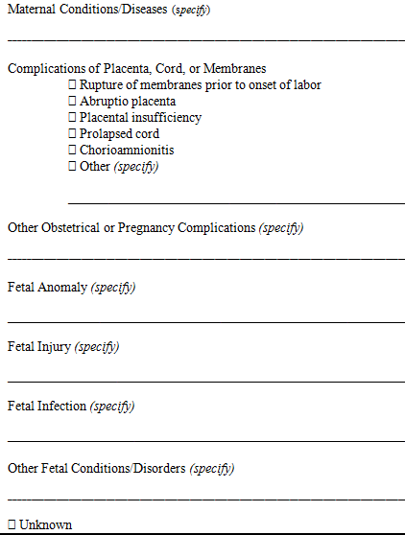

Item 27b: Initiating Cause/Condition
Select or specify all other conditions contributing to death in Item 27b.
Item 28: Estimated Time of Fetal Death
This item is used as a check to ensure that the delivery was properly reported as a fetal death and was not a live birth. It also gives information on care.
Indicate when the fetus died by specifying one choice.
- Dead at time of first assessment, no labor ongoing
- Dead at time of first assessment, labor ongoing
- Died during labor, after first assessment
- Unknown time of fetal death
Item 29: Was the case referred to a Medical Examiner?
Massachusetts General Law requires that ALL fetal deaths must be referred to a medical examiner. (See Appendix about MGL Chapter 38, Section 3)
Report “Yes” if the case was referred to the medical examiner, even if the medical examiner did not assume jurisdiction.

Item 30: Was an autopsy performed?
An autopsy is important in giving additional insight into the conditions that led to death. This additional information is particularly important when the cause is not immediately clear.

Check the “Yes” box if a partial or complete autopsy was performed or is being performed at the time of filing of the fetal death record.
Check “No” if no autopsy has been performed and no autopsy is planned.

Check “Planned” if an autopsy is not being performed at the time of the filing of the fetal death record but one is going to be performed.
Item 31: Was a histological placental examination performed?
A histological placental examination provides additional information about the conditions that led to death. This may provide insight into the appropriate causes of death to report.
Check the “Yes” box if any Histological Placental Examination was performed or is being performed at the time of filing.

Check the “Planned” box if a Histological Placental Examination is not being performed at the time of the filing of the fetal death record but one is going to be performed.

Check the “No” box if no Histological Placental Examination has been performed and no Histological Placental Examination is planned.
Item 32: Were autopsy or histological placental examination results used in determining the cause of fetal death?
This information assists in determining whether information was available to assist in ascertaining the cause of death. Knowing whether the exam results were available gives insight into the quality of the cause-of death data.
If “Yes” is checked for Item 30 OR Item 31, complete Item 32. If “No” is checked for both Item 30 AND Item 31, check “Not applicable” in Item 32.

CERTIFIER

Item 33a-i: Certifier
All certifier information must be provided. The certifier accepts the responsibility of certifying that “to the best of my knowledge, the fetus was delivered at the time, date, and place as shown and fetal death was due to the cause(s) as stated:” on the certificate. The certification must come from a physician, medical examiner or nurse practitioner in all cases of fetal death. Signatures must be written in permanent black ink.

A midwife or certified nurse-midwife may be listed as an attendant on the fetal death certificate; however they may not be listed as a certifier. Only a physician, medical examiner, or nurse practitioner may be listed as the certifier on the fetal death certificate.

Item 33a: Is Certifier a Medical Examiner?
Indicate whether the certifying physician is a medical examiner at the Massachusetts Office of the Chief Medical Examiner.

Item 33b: Signature of Certifying Physician, Medical Examiner, or Nurse Practitioner
The signature must be handwritten in permanent black ink.

Item 33c: Title
Check the appropriate box to indicate whether the certifier is a physician, medical examiner, or nurse practitioner.

Item 33d: Type or Print-Name of Certifying Physician or Medical Examiner
Enter the name of certifying physician, medical examiner, or nurse practitioner.

Item 33e: License #
Enter the license number of the certifier.

Item 33f: Certifier Street # and Address
Enter the street # and work address of the certifier.

Item 33g: City/Town
Enter the city/town of the certifier’s work address.

Item 33h: State
Enter the state of the certifier’s work address.

Item 33i: Zip Code
Enter the zip code of the certifier’s work address.

ATTENDANT

Item 34a-c: Attendant (if different)
The attendant at delivery is the individual physically present at the delivery who is responsible for the delivery. For example, if an intern or nurse-midwife delivers a fetus under the supervision of an obstetrician who is present in the delivery room, the obstetrician is to be reported as the attendant.

Enter the name of the attendant (if different from the certifying physician, medical examiner, or nurse practitioner).
Item 34a: Type or Print-Name of Attendant
Enter the name of the person who attended the delivery.

Item 34b: Title
Check one box to specify the attendant’s title. If the “Other (specify)” box is checked, enter the title of the attendant. Examples include: nurse, father, police office, EMS technician, etc.

Item 34c: License #
Enter the license number of the attendant at birth. If certifier is the same as the Certifier, enter “---”.

PRENATAL CARE INFORMATION
Item 35: Date of First Prenatal Care Visit
This item identifies when during the pregnancy the patient entered prenatal care and is needed as the basis for measures of how soon patients initiate prenatal care and for measures of the appropriate utilization of services. This information is also used to study the impact of prenatal care on pregnancy outcome.

Prenatal care begins when a physician or other health professional first examines and/or counsels the pregnant woman as part of an ongoing program of care for the pregnancy.
Recommended Sources of Information: Hospital Worksheet, Prenatal Care Records, Mother’s Medical Record

Enter the month, day, and year of the first prenatal care visit in the following format: MM/DD/YYYY. Complete all parts of the date that are available; use 9s for unknowns. If it is not known whether the patient had prenatal care, enter “99/99/9999” for unknown. If month and day is unknown, enter “99/99/YYYY”; if day is unknown, MM/99/YYYY.
If the mother did not receive prenatal care at any time during the pregnancy, check the “No prenatal care” box and leave the date blank.

Item 36: Date of Last Prenatal Care Visit
Enter the date of the last visit recorded in the mother’s prenatal records in the following format: MM/DD/YYYY. Complete all parts of the date that are available; use 9s for unknowns. Complete all parts of the date that are available; use 9s for unknowns. If it is not known whether the patient had prenatal care, enter “99/99/9999” for unknown. If month and day is unknown, enter “99/99/YYYY”; if day is unknown, MM/99/YYYY.

Item 37: Total # of prenatal care visits for this pregnancy
This item is needed as the basis for measures of utilization of prenatal care services. It is also used in conjunction with “Date of First Prenatal Care Visit” to assess the adequacy of prenatal care.
Enter the total number of prenatal care visits for this pregnancy in this space.

If the patient had no prenatal care, enter “0” in the space. NOTE: the “No prenatal care” box should also be checked in item 35.

If the patient had prenatal care but the number of visits is not known, enter “99” in the space.

Item 38: Did mother get WIC food for herself during this pregnancy?
WIC is the nutrition program for Women, Infants, and Children and gives pregnant women and/or their children food, checks, or vouchers for food. Public health program planners would like to know if women sign up for WIC because they become pregnant and if receiving WIC food during pregnancy helps mothers deliver healthier babies.
Check the appropriate box to indicate if mother received WIC food for herself because she was pregnant during this pregnancy.
Item 39: Insurance (Prenatal Care Source of Payment)
This item is an indicator of the patterns of change occurring in the delivery of prenatal care. In conjunction with other items relating to prenatal care, it is used to determine relationships between quality of prenatal care and birth outcomes.
Recommended Sources of Information: Hospital Worksheet, Clinician’s Prenatal Worksheet, Mother’s Medical Record, Prenatal Record

Check the appropriate box to indicate the source of payment for prenatal care during this pregnancy. If the “Other” box is marked, enter the other source of payment for prenatal care. If mother did not receive prenatal care, please leave blank.
- Medicaid: A public health insurance program for Massachusetts residents who meet general and financial eligibility requirements.

- Private Insurance: A health insurance program not provided by the government (e.g. Blue Cross/Blue Shield, Aetna, etc.).

- Self-pay: Prenatal care was paid for privately, without insurance, HMO or government payment sources. No third party identified.

- Indian Health Service: The Indian Health Service is an agency within the Department of Health and Human Services that is responsible for providing federal health services to American Indians and Alaska Natives.

- CHAMPUS/TRICARE: Military health insurance that pays for Active Duty, Retired, Reserve, Guard, Veteran, and family members.

- Other Government (Fed, State, Local): Other health plans provided by the government (e.g. Medicare)

- Other: Specify prenatal care source of payment that do not belong to listed options.

- Unknown: Prenatal care source of payment is not known.

PREGNANCY HISTORY

The information in Items 40-44 is essential for determining live-birth and total-birth order, which are important in studying trends in childbearing and child spacing. The information is useful in studying health problems associated with birth order. The dates of last live birth and last other pregnancy outcome permit the calculation of intervals between live births and fetal deaths and between pregnancies. This information allows researchers to analyze the relationship of various maternal characteristics and pregnancy outcomes with birth and pregnancy intervals.
Recommended Sources of Information: Hospital Worksheet, Prenatal Care Records, Mother’s Medical Record, Labor & Delivery Log

Item 40: Number of Previous Live Births: Now Living
Enter the number of children born alive to this mother previous to this birth, and who are still living. If the mother has not had any live births, or if all live-born children have died, mark “None”. For multiple deliveries, include live born infants born before this fetus in the multiple set. If information cannot be obtained from medical records, enter “99” for unknown.

Item 41: Number of Previous Live Births: Now Dead
Enter the number of children born alive to this mother who are now dead. If the mother has not had any live births, or if all live-born children are currently living, mark “None”. For multiple deliveries, include live born infants born before this multiple set who subsequently died. If information cannot be obtained from medical records, enter “99” for unknown.

Item 42: Date of Last Live Birth
Enter the date of the last live birth for this mother in the following month and year format: MM/YYYY. If the answers to both Items 40 and 41 are “None”, leave Item 42 blank. Complete all parts of the date that are available; use 9s for unknowns. If it is not known whether the patient had a previous live birth, enter “99/9999” for unknown. If month is unknown, enter “99/YYYY”.

If this certificate is for the second delivery of a twin set, enter the date of birth for the first baby of the set, if it was born alive. Similarly for triplets or other multiple births, enter the date of birth of the previous live birth of the set. If all previously born members of a multiple set were born dead, enter the date of the mother’s last delivery that resulted in the live birth.

Item 43: Number of Other Pregnancy Outcomes (do not include this fetus)
Enter the number of previous pregnancy outcomes that did not result in a live birth, regardless of the length of gestation. Include fetal losses of any gestational age-spontaneous losses, induced losses, and/or ectopic pregnancies. If this was a multiple delivery, include all fetal losses delivered before this fetus in the pregnancy. If information cannot be obtained from medical records, enter “99” for unknown.

Item 44: Date of Last Other Pregnancy Outcome
Enter the date when last pregnancy which did not result in a live birth ended in the following month and year format: MM/YYYY. If the answer to Item 43 is “None”, skip Item 44. If the answer to Item 43 is other than “None”, enter the date if known. Complete all parts of the date that are available; use 9s for unknowns. If it is not known whether the patient had another pregnancy outcome, enter “99/9999” for unknown. If month is unknown, enter “99/YYYY”.
Item 45: Date Last Normal Menses Began
This item provides information on the length of gestation, which can be associated with weight of fetus to determine the maturity of the fetus at delivery. It is also associated with infant morbidity and mortality, and is important in medical research.
Recommended Sources of Information: Hospital Worksheet, Prenatal Care Records, Clinician’s Prenatal Worksheet, Mother’s Medical Record

Enter the mother’s date last normal menses began in the following format: MM/DD/YYYY. Complete all parts of the date that are available; use 9s for unknowns. If the date is unknown, enter “99/99/9999”. If month is unknown, enter “99/DD/YYYY; if day is unknown, enter “MM/99/YYYY”.
Item 46: Mother’s Weight at Delivery and Item 47: Mother’s Prepregnancy Weight
In combination with known statistics about weight gain during pregnancy, public health researchers want to study pre-pregnancy weights to see if some weight ranges result in healthier mothers and babies.
Recommended Sources of Information: Hospital Worksheet, Clinician’s Prenatal Worksheet, Mother’s Medical Record

Item 46: Mother’s Weight at Delivery
Enter the mother’s weight at the time of admission for delivery in pounds. If the mother’s delivery weight is not known, enter “999” in the item’s space. Record weight in whole pounds only. Do not include fractions.
____ (pounds)

Item 47: Mother’s Prepregnancy Weight
Enter the mother’s weight in pounds before delivery. If the mother’s delivery weight is not known, enter “999” in the item’s space. Record weight in whole pounds only. Do not include fractions.
____ (pounds)

Item 48: Mother’s Height
Enter the mother’s height in feet and inches. If the record indicates height in fractions such as 5 feet and 6 and one-half inches, truncate and enter 5 feet, 6 inches. If the patient’s height is unknown, enter “99” for feet and “99” for inches.
____ (feet) _____ (inches)

DELIVERY INFORMATION

The delivery information in items 49a-50b provide information on current obstetric practices and outcomes. The final route and method of delivery portion will allow for a more complete report of the obstetric intervention used to effect delivery. Cesarean data are needed to evaluate the impact of the current emphasis on vaginal delivery in pregnancies subsequent to a cesarean delivery.
Recommended Sources of Information: Hospital Worksheet, Mother’s Medical Record, Labor and Delivery Log

Item 49a: Fetal presentation at delivery
Check ONE of the three boxes.
- Cephalic: Presenting part of the fetus listed as vertex, occiput anterior (OA), occiput posterior (OP)

- Breech: Presenting part of the fetus listed as breech, complete breech, frank breech, footling breech

- Other: Any other presentation not listed above

Item 49b: Final route and method of delivery
Check ONE of the boxes.
- Vaginal/Spontaneous: Delivery of the entire fetus through the vagina by the natural force of labor with or without manual assistance from the delivery attendant

- Vaginal/Forceps: Delivery of the fetal head through the vagina by application of obstetrical forceps to the fetal head

- Vaginal/Vacuum: Delivery of the fetal head through the vagina by application of a vacuum cup or ventouse to the fetal head

- Cesarean: Extraction of the fetus, placenta and membranes through an incision in the maternal abdominal and uterine walls

  - If cesarean, was a trial of labor attempted?
Labor was allowed, augmented or induced with plans for a vaginal delivery.
Check Yes or No.

Item 49c: Hysterotomy/Hysterectomy
Check the appropriate box to indicate if mother had either procedure.
A hysterotomy is an incision into the uterus extending into the uterine cavity. It may be performed vaginally or transabdominally.

A hysterotomy is applicable to fetal deaths only.
A hysterectomy is the surgical removal of the uterus, which may be performed abdominally or vaginally.

Item 50a-b: Mother’s Transfer
Transfer information is important in identifying high-risk deliveries and follow up on maternal and infant deaths. Transfers include hospital to hospital, birth facility to hospital, etc.

Item 50a: Was mother transferred for maternal medical or fetal indications for delivery?
Check the “No” box if this is the first facility the mother was admitted to for delivery.

Check the “Yes” box if the mother was transferred from one facility to another facility before the fetus was delivered and enter the name of facility from which the mother was transferred (Item 50b).
Transfers include hospital to hospital, birth facility to hospital, etc. DOES NOT INCLUDE home to hospital.

Item 50b: If yes, enter name of facility mother transferred from _____________________
If the name of the facility is not known, enter “Unknown.”

If the mother was transferred more than once, enter the name of the last facility from which she was transferred.

MEDICAL INFORMATION

Item 51: Risk Factors in this pregnancy (Check all that apply)
Recommended Sources of Information: Hospital Worksheet, Mother’s Medical Record, Labor and Delivery Log

The mother may have more than one risk factor, check all boxes that apply. If the mother had none of the risk factors, check the “None of the above”.

- Diabetes – Prepregnancy: Glucose intolerance requiring treatment-Diagnosis before this pregnancy
(If diabetes is present, check either prepregnancy or gestational diabetes. DO NOT check both.)

- Diabetes – Gestational: Glucose intolerance requiring treatment-Diagnosis during this pregnancy
(If diabetes is present, check either prepregnancy or gestational diabetes. DO NOT check both.)

- Hypertension – Prepregnancy (Chronic): Elevation of blood pressure above normal for age, gender, and physiological condition diagnosed prior to the onset of this pregnancy

- Hypertension – Gestational (PIH, preeclampsia): Elevation of blood pressure above normal for age, gender, and physiological condition diagnosed during this pregnancy (may include proteinuria (protein in the urine), without seizures or coma and pathologic edema (generalized swelling, including swelling of the hands, legs and face)).

- Hypertension – Eclampsia: Pregnancy induced hypertension with proteinuria with generalized seizures or coma (may include pathologic edema).

- Previous preterm birth: History of pregnancy (ies) terminating in a live birth of less than 37 completed weeks of gestation

- Other previous poor pregnancy: History of pregnancies continuing into the 20th week of gestation and resulting in any of the listed outcomes: perinatal death (including fetal and neonatal deaths), small-for-gestational age/intrauterine growth restricted birth.

- Pregnancy resulted from infertility treatment: Any assisted reproduction technique used to initiate the pregnancy. Includes fertility-enhancing drugs (e.g. Clomid, Pergonal), artificial insemination, or intrauterine insemination and assisted reproduction technology (ART) procedures (e.g. IVF, GIFT, and ZIFT). If checked, please see Birth Trends and Technologies section.

- Mother had a previous cesarean delivery: Previous operative delivery by extraction of the fetus, placenta and membranes through an incision in the maternal abdominal and uterine walls. If yes, how many___

- None of the above

Item 52: Infections Present and/or Treated During This Pregnancy (Check all that apply)
All of the listed infections are known to cause concomitant fetal and/or subsequent neonatal infection and thus have significant public health implications. In addition, there is no current national reporting system for these infections that focuses on the prevalence of perinatal transmission.
Below are infections present at start of pregnancy or confirmed diagnosis during pregnancy with or without documentation of treatment.
If the prenatal record is not available and the information is not available from other medical records, enter “Unknown”
- Chlamydia: A diagnosis of or positive test for Chlamydia trachomatis.
- Cytomegalovirus (CMV): A diagnosis of or positive test for the cytomegalovirus.
- Gonorrhea: A diagnosis of or positive test for Neisseria gonorrhoeae.

- Group B Streptococcus (GBS): A diagnosis of or positive test for Streptococcus agalactiae or group B streptococcus.
- Listeria (LM): A diagnosis of or positive test for Listeria monocytogenes.
- Syphilis (also called lues): A diagnosis of or positive test for Treponema pallidum.
- Parvovirus (B19): A diagnosis of or positive test for Parvovirus B19.
- Toxoplasmosis (Toxo): A diagnosis of or positive test for Toxoplasma gondii
- Other (specify) _________________
- None of the above

Item 53: Congenital Anomalies of the Fetus (Check all that apply)
Malformations of the fetus diagnosed prenatally or after delivery regardless of whether they contributed to fetal death. The items selected for this section will provide more specific information regarding fetal death events. Identifying the conditions and contributing causes of fetal death is necessary to understanding why they occur and may lead to possible prevention of fetal loss in the future. For “Downs Syndrome” and “Suspected Chromosomal Disorder”, if karyotype status is unknown leave both the “Karyotype confirmed” and “Karyotype pending” boxes blank.
Recommended Sources of Information: Hospital Worksheet, Medical Record, Labor and Delivery Log

- Anencephaly: Partial or complete absence of the brain and skull. Also called anencephalus, acrania, or absent brain. Also includes fetuses with craniorachischisis (anencephaly with a contiguous spine defect).

- Cleft Lip with or without Cleft Palate: Incomplete closure of the lip. May be unilateral, bilateral, or median.

- Cleft Palate alone: Incomplete fusion of the palatial shelves. May be limited to the soft palate or may extend into the hard palate. Cleft palate in the presence of cleft lip should be included in the “Cleft Lip with or without Cleft Palate” category above.

- Congenital diaphragmatic hernia: Defect in the formation of the diaphragm allowing herniation of abdominal organs into the thoracic cavity.

- Cyanotic congenital heart disease: Congenital heart defects which cause cyanosis. Includes but is not limited to: transposition of the great arteries (vessels), tetratology of Fallot, pulmonary or pulmonic valvular atresia, tricuspid atresia, truncus arteriosus, total/partial anomalous pulmonary venous return with or without obstruction.

- Down Syndrome: Trisomy 21
Check if a diagnosis of Down syndrome, Trisomy 21, is confirmed or pending
  - Karyotype confirmed
  - Karyotype pending

- Gastroschisis: An abnormality of the anterior abdominal wall, lateral to the umbilicus, resulting in herniation of the abdominal contents directly into the amniotic cavity. Differentiated from omphalocele by the location of the defect and the absence of a protective membrane.

- Hypospadias: Incomplete closure of the male urethra resulting in the urethral meatus opening on the ventral surface of the penis. Includes first degree (on the glans ventral to the tip); second degree (in the coronal sulcus); and third degree (on the penile shaft).

- Limb reduction defect: (excluding congenital amputation and dwarfing syndromes) - Complete or partial absence of a portion of an extremity associated with failure to develop.

- Meningomyelocele/Spina bifida: Spina bifida is herniation of the meninges and/or spinal cord tissue through a bony defect of spine closure. Meningomyelocele is herniation of meninges and spinal cord tissue. Meningocele (herniation of meninges without spinal cord tissue) should also be included in this category. Both open and closed (covered with skin) lesions should be included. DO NOT include Spina bifida occulta (a midline bony spinal defect without protrusion of the spinal cord or meninges).

- Omphalocele: A defect in the anterior abdominal wall, accompanied by herniation of some abdominal organs through a widened umbilical ring into the umbilical stalk. The defect is covered by a membrane (different from gastroschisis [see above]), although this sac may rupture. Also called exomphalos. DO NOT include umbilical hernia (completely covered by skin) in this category.

- Suspected chromosomal disorder: Includes any constellation of congenital malformations resulting from or compatible with known syndromes caused by detectable defects in chromosome structure.
Check if a diagnosis of a suspected chromosomal disorder is confirmed or pending (May include Trisomy 21)
  - Karyotype confirmed
  - Karyotype pending

- None of the anomalies listed above

Item 54: Maternal Morbidity (Check all that apply)
Serious complications experienced by the mother associated with labor and delivery.

- Admission to intensive care unit: Any admission, planned or unplanned, of the mother to a facility or unit designated as providing intensive care.

- Maternal transfusion: Includes infusion of whole blood or packed red blood cells associated with labor and delivery.

- Ruptured uterus: Tearing of the uterine wall.

- Third or fourth degree perineal laceration: 3° laceration extends completely through the perineal skin, vaginal mucosa, perineal body and anal sphincter. 4° laceration is all of the above with extension through the rectal mucosa.

- Unplanned hysterectomy: Surgical removal of the uterus that was not planned before the admission. Includes an anticipated, but not definitively planned hysterectomy.

- Unplanned operating room procedure following delivery: Any transfer of the mother back to the surgical area for an operative procedure that was not planned before the admission for delivery. Excludes postpartum tubal ligations.

- None of the above

Item 55: Birth Trends and Technologies (Check all that apply)
Better information about use of fertility drugs and assisted reproductive technologies will allow researchers to determine trends in the use of new types of treatments. This data will also help obstetricians and their patients know more about what risks and benefits there may be to mothers and newborns, depending on mother’s age, genetic relationship to the child, and other characteristics.

- Fertility-enhancing drugs: Progesterone, Gonadotrophins (e.g. Clomid®, Serophene), Gonadotrophin-releasing Hormone Agonists (GnRH Agonists) (e.g. Synarel, Zolodex), Gonadotrophin-releasing Hormone Antagonists (GnRH Antagonists) (e.g. Cetrotide)

- Artificial insemination: Fertility treatment in which sperm were collected and placed in the female reproductive tract. Do not include intrauterine insemination.

- Intrauterine insemination: Fertility treatment in which sperm were collected and placed in the woman’s uterus.

- Assisted reproductive technology: Include in vitro fertilization [IVF], gamete intrafallopian transfer [GIFT], zygote intrafallopian transfer [ZIFT], intracytoplasmic sperm injection [ICSI], frozen embryo transfer, or donor embryo transfer.

- Other medical treatment, Other (Specify): _______________________

- Anonymous egg donor

- Anonymous sperm donor

- Surrogacy

- None of these apply

REPORTED ALCOHOL AND TOBACCO USE

Item 56: Cigarette Smoking Before and During Pregnancy
Recommended Sources of Information: Mother’s Preregistration Worksheet, Medical and Prenatal Record
Information about tobacco use by mothers before and during pregnancy helps doctors provide better information to pregnant women on the effects of smoking on birth weight and other birth outcomes. This question will help to find out whether reducing or increasing smoking at different stages during the pregnancy has different results.
For each time period, enter either the average number of cigarettes or the average number of packs of cigarettes smoked per day. If none, enter “0”.

This item is to be completed by the facility based on information obtained from the patient. If the delivery did not occur in a facility, it is to be completed by the attendant or certifier based on information obtained from the patient.

If the patient’s worksheet indicates “Unknown” or “Refused”, enter “Unknown”. Enter either the average number of cigarettes or the average number of packs of cigarettes smoked for each time period. If none, enter “0”.

This item provides information on changes in tobacco use before and during pregnancy, which has an important impact on pregnancy outcome.

Item 57: Alcohol Use Before and During Pregnancy
Recommended Sources of Information: Mother’s Preregistration Worksheet, Medical and Prenatal Record
This question will help to find out which amounts of alcohol have an effect on birth weight and other birth outcomes and if drinking at different times during pregnancy has different results. With real data about alcohol use during pregnancy, doctors can give better advice to pregnant mothers.

For each time period, enter the number of drinks (beer, wine or cocktails) mother had in an average week. If none, enter “0”

DEMOGRAPHIIC INFORMATION

Item 58: Mother/Parent Race
Recommended Sources of Information: Mother’s Preregistration Worksheet, Admission Systems
Information about race of parents help researchers understand more about birth rates, health conditions and other factors relating to race that may affect birth outcomes and health service needs in Massachusetts communities.
Check one or more boxes that best describe the race of the mother/parent.

Item 59: Mother/Parent Ethnicity
Recommended Sources of Information: Mother’s Preregistration Worksheet, Admission Systems
Information about ethnicities of parents help researchers understand more about genetic conditions, cultures, and geographic locations of existing and new ethnic communities that may affect the availability of quality prenatal care services, outcomes of pregnancies, and future health needs of young children and their families.
Check one or more boxes that best describe the ethnicity of the mother/parent.

Item 60: Mother/Parent Education
Recommended Sources of Information: Mother’s Preregistration Worksheet, Admission Forms and Systems
Information about education of parents helps researchers understand more about trends in age and education levels of Massachusetts parents, choices in delivery methods and assisted reproductive technologies, reading levels required for health education materials, health information needs in schools by district, and other factors that may affect birth outcomes and maternal and child health.
Check the box that best describes the highest degree or level of schooling completed at the time of delivery. If no box is checked, check “Unknown”.

Item 61: Mother/Parent Occupation and Item 62: Mother/Parent Industry
Mother’s occupation is useful in studying occupationally related infant mortality, birth defects, and other complications. These items are used to determine potential health-hazards of different work environments on the fetus and in identifying specific job-related risk areas. Mother’s occupation and industry can also be used as a socio-economic indicator that may be related to the mother’s access to prenatal care.
Recommended Sources of Information: Mother’s Preregistration Worksheet, Admitting Forms/Systems

Item 61: Mother/Parent Occupation
Examples: computer programmer, cashier, homemaker, unemployed
Enter the specific occupation of the mother/parent most recently held during the past 12 months.

Item 62: Mother/Parent Industry
Examples: software company, Smith’s Supermarket, own home
Enter the kind of business or industry to which the occupation listed previously is related.
Company names are acceptable responses for an industry, when a category description cannot be determined.

Item 63 Father/Parent Race:
Recommended Source of Information: Mother’s Preregistration Worksheet
Information about race of parents help researchers understand more about birth rates, health conditions and other factors relating to race that may affect birth outcomes and health service needs in Massachusetts communities.
Check one or more boxes that best describe the race of the father/parent.

Item 64: Father/Parent Ethnicity
Information about ethnicities of parents help researchers understand more about genetic conditions, cultures, and geographic locations of existing and new ethnic communities that may affect the availability of quality prenatal care services, outcomes of pregnancies, and future health needs of young children and their families.
Check one or more boxes that best describe the ethnicity of the father/parent.

Item 65: Father/Parent Education
Recommended Sources of Information: Mother’s Preregistration Worksheet, Admission Forms and Systems
Information about education of parents helps researchers understand more about trends in age and education levels of Massachusetts parents, choices in delivery methods and assisted reproductive technologies, reading levels required for health education materials, health information needs in schools by district, and other factors that may affect birth outcomes and maternal and child health.
Check the box that best describes the highest degree or level of schooling completed at the time of delivery. If no box is checked, check “Unknown”.

Item 66: Father/Parent Occupation and Item 67: Father/Parent Industry
Recommended Sources of Information: Mother’s Preregistration Worksheet, Admitting Forms/Systems
Father’s occupation and industry are important statistical items used with mother’s information to establish birthrates in populations of different occupations and socioeconomic status. It is used also to establish any correlations between father’s occupation and adverse birth outcomes. Father’s occupation and industry can also be used as a socio-economic indicator that may be related to the mother’s access to prenatal care.

Item 66: Father/Parent Occupation
Recommended Sources of Information: Mother’s Preregistration Worksheet, Admitting Forms/Systems
Examples: computer programmer, cashier, homemaker, unemployed
Enter the specific occupation of the father/parent most recently held during the past 12 months.

Item 67: Father/Parent Industry
Examples: software company, Smith’s Supermarket, own home
Enter the kind of business or industry to which the occupation above is related.
Company names are acceptable responses for an industry, when a category description cannot be determined.

APPENDIX

MASSACHUSETTS CITIES AND TOWNS
CITY CODE | COMMUNITY | COUNTY CODE | COUNTY
001 | ABINGTON | 12 | PLYMOUTH
002 | ACTON | 09 | MIDDLESEX
003 | ACUSHNET | 03 | BRISTOL
004 | ADAMS | 02 | BERKSHIRE
005 | AGAWAM | 07 | HAMPDEN
006 | ALFORD | 02 | BERKSHIRE
007 | AMESBURY | 05 | ESSEX
008 | AMHERST | 08 | HAMPSHIRE
009 | ANDOVER | 05 | ESSEX
010 | ARLINGTON | 09 | MIDDLESEX
011 | ASHBURNHAM | 14 | WORCESTER
012 | ASHBY | 09 | MIDDLESEX
013 | ASHFIELD | 06 | FRANKLIN
014 | ASHLAND | 09 | MIDDLESEX
015 | ATHOL | 14 | WORCESTER
016 | ATTLEBORO | 03 | BRISTOL
017 | AUBURN | 14 | WORCESTER
018 | AVON | 11 | NORFOLK
019 | AYER | 09 | MIDDLESEX
020 | BARNSTABLE | 01 | BARNSTABLE
021 | BARRE | 14 | WORCESTER
022 | BECKET | 02 | BERKSHIRE
023 | BEDFORD | 09 | MIDDLESEX
024 | BELCHERTOWN | 08 | HAMPSHIRE
025 | BELLINGHAM | 11 | NORFOLK
026 | BELMONT | 09 | MIDDLESEX
027 | BERKLEY | 03 | BRISTOL
028 | BERLIN | 14 | WORCESTER
029 | BERNARDSTON | 06 | FRANKLIN
030 | BEVERLY | 05 | ESSEX
031 | BILLERICA | 09 | MIDDLESEX
032 | BLACKSTONE | 14 | WORCESTER
033 | BLANDFORD | 07 | HAMPDEN
034 | BOLTON | 14 | WORCESTER
035 | BOSTON | 13 | SUFFOLK
036 | BOURNE | 01 | BARNSTABLE
037 | BOXBOROUGH | 09 | MIDDLESEX

MASSACHUSETTS CITIES AND TOWNS
CITY CODE | COMMUNITY | COUNTY CODE | COUNTY
038 | BOXFORD | 05 | ESSEX
039 | BOYLSTON | 14 | WORCESTER
040 | BRAINTREE | 11 | NORFOLK
041 | BREWSTER | 01 | BARNSTABLE
042 | BRIDGEWATER | 12 | PLYMOUTH
043 | BRIMFIELD | 07 | HAMPDEN
044 | BROCKTON | 12 | PLYMOUTH
045 | BROOKFIELD | 14 | WORCESTER
046 | BROOKLINE | 11 | NORFOLK
047 | BUCKLAND | 06 | FRANKLIN
048 | BURLINGTON | 09 | MIDDLESEX
049 | CAMBRIDGE | 09 | MIDDLESEX
050 | CANTON | 11 | NORFOLK
051 | CARLISLE | 09 | MIDDLESEX
052 | CARVER | 12 | PLYMOUTH
053 | CHARLEMONT | 06 | FRANKLIN
054 | CHARLTON | 14 | WORCESTER
055 | CHATHAM | 01 | BARNSTABLE
056 | CHELMSFORD | 09 | MIDDLESEX
057 | CHELSEA | 13 | SUFFOLK
058 | CHESHIRE | 02 | BERKSHIRE
059 | CHESTER | 07 | HAMPDEN
060 | CHESTERFIELD | 08 | HAMPSHIRE
061 | CHICOPEE | 07 | HAMPDEN
062 | CHILMARK | 04 | DUKES
063 | CLARKSBURG | 02 | BERKSHIRE
064 | CLINTON | 14 | WORCESTER
065 | COHASSET | 11 | NORFOLK
066 | COLRAIN | 06 | FRANKLIN
067 | CONCORD | 09 | MIDDLESEX
068 | CONWAY | 06 | FRANKLIN
069 | CUMMINGTON | 08 | HAMPSHIRE
070 | DALTON | 02 | BERKSHIRE
071 | DANVERS | 05 | ESSEX
072 | DARTMOUTH | 03 | BRISTOL

MASSACHUSETTS CITIES AND TOWNS
CITY CODE | COMMUNITY | COUNTY CODE | COUNTY
073 | DEDHAM | 11 | NORFOLK
074 | DEERFIELD | 06 | FRANKLIN
075 | DENNIS | 01 | BARNSTABLE
076 | DIGHTON | 03 | BRISTOL
077 | DOUGLAS | 14 | WORCESTER
078 | DOVER | 11 | NORFOLK
079 | DRACUT | 09 | MIDDLESEX
080 | DUDLEY | 14 | WORCESTER
081 | DUNSTABLE | 09 | MIDDLESEX
082 | DUXBURY | 12 | PLYMOUTH
083 | EAST BRIDGEWATER | 12 | PLYMOUTH
084 | EAST BROOKFIELD | 14 | WORCESTER
085 | EAST LONGMEADOW | 07 | HAMPDEN
086 | EASTHAM | 01 | BARNSTABLE
087 | EASTHAMPTON | 08 | HAMPSHIRE
088 | EASTON | 03 | BRISTOL
089 | EDGARTOWN | 04 | DUKES
090 | EGREMONT | 02 | BERKSHIRE
091 | ERVING | 06 | FRANKLIN
092 | ESSEX | 05 | ESSEX
093 | EVERETT | 09 | MIDDLESEX
094 | FAIRHAVEN | 03 | BRISTOL
095 | FALL RIVER | 03 | BRISTOL
096 | FALMOUTH | 01 | BARNSTABLE
097 | FITCHBURG | 14 | WORCESTER
098 | FLORIDA | 02 | BERKSHIRE
099 | FOXBOROUGH | 11 | NORFOLK
100 | FRAMINGHAM | 09 | MIDDLESEX
101 | FRANKLIN | 11 | NORFOLK
102 | FREETOWN | 03 | BRISTOL
103 | GARDNER | 14 | WORCESTER
104 | GAY HEAD | 04 | DUKES
105 | GEORGETOWN | 05 | ESSEX
106 | GILL | 06 | FRANKLIN

MASSACHUSETTS CITIES AND TOWNS
CITY CODE | COMMUNITY | COUNTY CODE | COUNTY
107 | GLOUCESTER | 05 | ESSEX
108 | GOSHEN | 08 | HAMPSHIRE
109 | GOSNOLD | 04 | DUKES
110 | GRAFTON | 14 | WORCESTER
111 | GRANVILLE | 07 | HAMPDEN
113 | GREAT BARRINGTON | 02 | BERKSHIRE
114 | GREENFIELD | 06 | FRANKLIN
115 | GROTON | 09 | MIDDLESEX
116 | GROVELAND | 05 | ESSEX
117 | HADLEY | 08 | HAMPSHIRE
118 | HALIFAX | 12 | PLYMOUTH
119 | HAMILTON | 05 | ESSEX
120 | HAMPDEN | 07 | HAMPDEN
121 | HANCOCK | 02 | BERKSHIRE
122 | HANOVER | 12 | PLYMOUTH
123 | HANSON | 12 | PLYMOUTH
124 | HARDWICK | 14 | WORCESTER
125 | HARVARD | 14 | WORCESTER
126 | HARWICH | 01 | BARNSTABLE
127 | HATFIELD | 08 | HAMPSHIRE
128 | HAVERHILL | 05 | ESSEX
129 | HAWLEY | 06 | FRANKLIN
130 | HEATH | 06 | FRANKLIN
131 | HINGHAM | 12 | PLYMOUTH
132 | HINSDALE | 02 | BERKSHIRE
133 | HOLBROOK | 11 | NORFOLK
134 | HOLDEN | 14 | WORCESTER
135 | HOLLAND | 07 | HAMPDEN
136 | HOLLISTON | 09 | MIDDLESEX
137 | HOLYOKE | 07 | HAMPDEN
138 | HOPEDALE | 14 | WORCESTER
139 | HOPKINTON | 09 | MIDDLESEX
140 | HUBBARDSTON | 14 | WORCESTER
141 | HUDSON | 09 | MIDDLESEX
142 | HULL | 12 | PLYMOUTH

MASSACHUSETTS CITIES AND TOWNS
CITY CODE | COMMUNITY | COUNTY CODE | COUNTY
143 | HUNTINGTON | 08 | HAMPSHIRE
144 | IPSWICH | 05 | ESSEX
145 | KINGSTON | 12 | PLYMOUTH
146 | LAKEVILLE | 12 | PLYMOUTH
147 | LANCASTER | 14 | WORCESTER
148 | LANESBOROUGH | 02 | BERKSHIRE
149 | LAWRENCE | 05 | ESSEX
150 | LEE | 02 | BERKSHIRE
151 | LEICESTER | 14 | WORCESTER
152 | LENOX | 02 | BERKSHIRE
153 | LEOMINSTER | 14 | WORCESTER
154 | LEVERETT | 06 | FRANKLIN
155 | LEXINGTON | 09 | MIDDLESEX
156 | LEYDEN | 06 | FRANKLIN
157 | LINCOLN | 09 | MIDDLESEX
158 | LITTLETON | 09 | MIDDLESEX
159 | LONGMEADOW | 07 | HAMPDEN
160 | LOWELL | 09 | MIDDLESEX
161 | LUDLOW | 07 | HAMPDEN
162 | LUNENBURG | 14 | WORCESTER
163 | LYNN | 05 | ESSEX
164 | LYNNFIELD | 05 | ESSEX
165 | MALDEN | 09 | MIDDLESEX
166 | MANCHESTER BY THE SEA | 05 | ESSEX
167 | MANSFIELD | 03 | BRISTOL
168 | MARBLEHEAD | 05 | ESSEX
169 | MARION | 12 | PLYMOUTH
170 | MARLBOROUGH | 09 | MIDDLESEX
171 | MARSHFIELD | 12 | PLYMOUTH
172 | MASHPEE | 01 | BARNSTABLE
173 | MATTAPOISETT | 12 | PLYMOUTH
174 | MAYNARD | 09 | MIDDLESEX
175 | MEDFIELD | 11 | NORFOLK
176 | MEDFORD | 09 | MIDDLESEX

MASSACHUSETTS CITIES AND TOWNS
CITY CODE | COMMUNITY | COUNTY CODE | COUNTY
177 | MEDWAY | 11 | NORFOLK
178 | MELROSE | 09 | MIDDLESEX
179 | MENDON | 14 | WORCESTER
180 | MERRIMAC | 05 | ESSEX
181 | METHUEN | 05 | ESSEX
182 | MIDDLEBOROUGH | 12 | PLYMOUTH
183 | MIDDLEFIELD | 08 | HAMPSHIRE
184 | MIDDLETON | 05 | ESSEX
185 | MILFORD | 14 | WORCESTER
186 | MILLBURY | 14 | WORCESTER
187 | MILLIS | 11 | NORFOLK
188 | MILLVILLE | 14 | WORCESTER
189 | MILTON | 11 | NORFOLK
190 | MONROE | 06 | FRANKLIN
191 | MONSON | 07 | HAMPDEN
192 | MONTAGUE | 06 | FRANKLIN
193 | MONTEREY | 02 | BERKSHIRE
194 | MONTGOMERY | 07 | HAMPDEN
195 | MOUNT WASHINGTON | 02 | BERKSHIRE
196 | NAHANT | 05 | ESSEX
197 | NANTUCKET | 10 | NANTUCKET
198 | NATICK | 09 | MIDDLESEX
199 | NEEDHAM | 11 | NORFOLK
200 | NEW ASHFORD | 02 | BERKSHIRE
201 | NEW BEDFORD | 03 | BRISTOL
202 | NEW BRAINTREE | 14 | WORCESTER
203 | NEW MARLBOROUGH | 02 | BERKSHIRE
204 | NEW SALEM | 06 | FRANKLIN
205 | NEWBURY | 05 | ESSEX
206 | NEWBURYPORT | 05 | ESSEX
207 | NEWTON | 09 | MIDDLESEX
208 | NORFOLK | 11 | NORFOLK
209 | NORTH ADAMS | 02 | BERKSHIRE
210 | NORTH ANDOVER | 05 | ESSEX

MASSACHUSETTS CITIES AND TOWNS
CITY CODE | COMMUNITY | COUNTY CODE | COUNTY
211 | NORTH ATTLEBOROUGH | 03 | BRISTOL
212 | NORTH BROOKFIELD | 14 | WORCESTER
213 | NORTH READING | 09 | MIDDLESEX
214 | NORTHAMPTON | 08 | HAMPSHIRE
215 | NORTHBOROUGH | 14 | WORCESTER
216 | NORTHBRIDGE | 14 | WORCESTER
217 | NORTHFIELD | 06 | FRANKLIN
218 | NORTON | 03 | BRISTOL
219 | NORWELL | 12 | PLYMOUTH
220 | NORWOOD | 11 | NORFOLK
221 | OAK BLUFFS | 04 | DUKES
222 | OAKHAM | 14 | WORCESTER
223 | ORANGE | 06 | FRANKLIN
224 | ORLEANS | 01 | BARNSTABLE
225 | OTIS | 02 | BERKSHIRE
226 | OXFORD | 14 | WORCESTER
227 | PALMER | 07 | HAMPDEN
228 | PAXTON | 14 | WORCESTER
229 | PEABODY | 05 | ESSEX
230 | PELHAM | 08 | HAMPSHIRE
231 | PEMBROKE | 12 | PLYMOUTH
232 | PEPPERELL | 09 | MIDDLESEX
233 | PERU | 02 | BERKSHIRE
234 | PETERSHAM | 14 | WORCESTER
235 | PHILLIPSTON | 14 | WORCESTER
236 | PITTSFIELD | 02 | BERKSHIRE
237 | PLAINFIELD | 08 | HAMPSHIRE
238 | PLAINVILLE | 11 | NORFOLK
239 | PLYMOUTH | 12 | PLYMOUTH
240 | PLYMPTON | 12 | PLYMOUTH
241 | PRINCETON | 14 | WORCESTER
242 | PROVINCETOWN | 01 | BARNSTABLE
243 | QUINCY | 11 | NORFOLK

MASSACHUSETTS CITIES AND TOWNS
CITY CODE | COMMUNITY | COUNTY CODE | COUNTY
244 | RANDOLPH | 11 | NORFOLK
245 | RAYNHAM | 03 | BRISTOL
246 | READING | 09 | MIDDLESEX
247 | REHOBOTH | 03 | BRISTOL
248 | REVERE | 13 | SUFFOLK
249 | RICHMOND | 02 | BERKSHIRE
250 | ROCHESTER | 12 | PLYMOUTH
251 | ROCKLAND | 12 | PLYMOUTH
252 | ROCKPORT | 05 | ESSEX
253 | ROWE | 06 | FRANKLIN
254 | ROWLEY | 05 | ESSEX
255 | ROYALSTON | 14 | WORCESTER
256 | RUSSELL | 07 | HAMPDEN
257 | RUTLAND | 14 | WORCESTER
258 | SALEM | 05 | ESSEX
259 | SALISBURY | 05 | ESSEX
260 | SANDISFIELD | 02 | BERKSHIRE
261 | SANDWICH | 01 | BARNSTABLE
262 | SAUGUS | 05 | ESSEX
263 | SAVOY | 02 | BERKSHIRE
264 | SCITUATE | 12 | PLYMOUTH
265 | SEEKONK | 03 | BRISTOL
266 | SHARON | 11 | NORFOLK
267 | SHEFFIELD | 02 | BERKSHIRE
268 | SHELBURNE | 06 | FRANKLIN
269 | SHERBORN | 09 | MIDDLESEX
270 | SHIRLEY | 09 | MIDDLESEX
271 | SHREWSBURY | 14 | WORCESTER
272 | SHUTESBURY | 06 | FRANKLIN
273 | SOMERSET | 03 | BRISTOL
274 | SOMERVILLE | 09 | MIDDLESEX
275 | SOUTH HADLEY | 08 | HAMPSHIRE
276 | SOUTHAMPTON | 08 | HAMPSHIRE
277 | SOUTHBOROUGH | 14 | WORCESTER
278 | SOUTHBRIDGE | 14 | WORCESTER

MASSACHUSETTS CITIES AND TOWNS
CITY CODE | COMMUNITY | COUNTY CODE | COUNTY
279 | SOUTHWICK | 07 | HAMPDEN
280 | SPENCER | 14 | WORCESTER
281 | SPRINGFIELD | 07 | HAMPDEN
282 | STERLING | 14 | WORCESTER
283 | STOCKBRIDGE | 02 | BERKSHIRE
284 | STONEHAM | 09 | MIDDLESEX
285 | STOUGHTON | 11 | NORFOLK
286 | STOW | 09 | MIDDLESEX
287 | STURBRIDGE | 14 | WORCESTER
288 | SUDBURY | 09 | MIDDLESEX
289 | SUNDERLAND | 06 | FRANKLIN
290 | SUTTON | 14 | WORCESTER
291 | SWAMPSCOTT | 05 | ESSEX
292 | SWANSEA | 03 | BRISTOL
293 | TAUNTON | 03 | BRISTOL
294 | TEMPLETON | 14 | WORCESTER
295 | TEWKSBURY | 09 | MIDDLESEX
296 | TISBURY | 04 | DUKES
297 | TOLLAND | 07 | HAMPDEN
298 | TOPSFIELD | 05 | ESSEX
299 | TOWNSEND | 09 | MIDDLESEX
300 | TRURO | 01 | BARNSTABLE
301 | TYNGSBOROUGH | 09 | MIDDLESEX
302 | TYRINGHAM | 02 | BERKSHIRE
303 | UPTON | 14 | WORCESTER
304 | UXBRIDGE | 14 | WORCESTER
305 | WAKEFIELD | 09 | MIDDLESEX
306 | WALES | 07 | HAMPDEN
307 | WALPOLE | 11 | NORFOLK
308 | WALTHAM | 09 | MIDDLESEX
309 | WARE | 08 | HAMPSHIRE
310 | WAREHAM | 12 | PLYMOUTH
311 | WARREN | 14 | WORCESTER
312 | WARWICK | 06 | FRANKLIN
313 | WASHINGTON | 02 | BERKSHIRE

MASSACHUSETTS CITIES AND TOWNS
CITY CODE | COMMUNITY | COUNTY CODE | COUNTY
314 | WATERTOWN | 09 | MIDDLESEX
315 | WAYLAND | 09 | MIDDLESEX
316 | WEBSTER | 14 | WORCESTER
317 | WELLESLEY | 11 | NORFOLK
318 | WELLFLEET | 01 | BARNSTABLE
319 | WENDELL | 06 | FRANKLIN
320 | WENHAM | 05 | ESSEX
321 | WEST BOYLSTON | 14 | WORCESTER
322 | WEST BRIDGEWATER | 12 | PLYMOUTH
323 | WEST BROOKFIELD | 14 | WORCESTER
324 | WEST NEWBURY | 05 | ESSEX
325 | WEST SPRINGFIELD | 07 | HAMPDEN
326 | WEST STOCKBRIDGE | 02 | BERKSHIRE
327 | WEST TISBURY | 04 | DUKES
328 | WESTBOROUGH | 14 | WORCESTER
329 | WESTFIELD | 07 | HAMPDEN
330 | WESTFORD | 09 | MIDDLESEX
331 | WESTHAMPTON | 08 | HAMPSHIRE
332 | WESTMINSTER | 14 | WORCESTER
333 | WESTON | 09 | MIDDLESEX
334 | WESTPORT | 03 | BRISTOL
335 | WESTWOOD | 11 | NORFOLK
336 | WEYMOUTH | 11 | NORFOLK
337 | WHATELY | 06 | FRANKLIN
338 | WHITMAN | 12 | PLYMOUTH
339 | WILBRAHAM | 07 | HAMPDEN
340 | WILLIAMSBURG | 08 | HAMPSHIRE
341 | WILLIAMSTOWN | 02 | BERKSHIRE
342 | WILMINGTON | 09 | MIDDLESEX
343 | WINCHENDON | 14 | WORCESTER
344 | WINCHESTER | 09 | MIDDLESEX
345 | WINDSOR | 02 | BERKSHIRE

MASSACHUSETTS CITIES AND TOWNS
CITY CODE | COMMUNITY | COUNTY CODE | COUNTY
346 | WINTHROP | 13 | SUFFOLK
347 | WOBURN | 09 | MIDDLESEX
348 | WORCESTER | 14 | WORCESTER
349 | WORTHINGTON | 08 | HAMPSHIRE
350 | WRENTHAM | 11 | NORFOLK
351 | YARMOUTH | 01 | BARNSTABLE

Massachusetts General Laws, Chapter 38, Section 3: Duty to report deaths; failure to report
https://malegislature.gov/Laws/GeneralLaws/PartI/TitleVI/Chapter38/Section3

Section 3. It shall be the duty of any person having knowledge of a death which occurs under the circumstances enumerated in this paragraph immediately to notify the office of the chief medical examiner, or the medical examiner designated to the location where the death has occurred, of the known facts concerning the time, place, manner, circumstances and cause of such death:
(1) death where criminal violence appears to have taken place, regardless of the time interval between the incident and death, and regardless of whether such violence appears to have been the immediate cause of death, or a contributory factor thereto;
(2) death by accident or unintentional injury, regardless of time interval between the incident and death, and regardless of whether such injury appears to have been the immediate cause of death, or a contributory factor thereto;
(3) suicide, regardless of the time interval between the incident and death;
(4) death under suspicious or unusual circumstances;
(5) death following an unlawful abortion;
(6) death related to occupational illness or injury;
(7) death in custody, in any jail or correctional facility, or in any mental health or mental retardation institution;
(8) death where suspicion of abuse of a child, family or household member, elder person or disabled person exists;
(9) death due to poison or acute or chronic use of drugs or alcohol;
(10) skeletal remains;
(11) death associated with diagnostic or therapeutic procedures;
(12) sudden death when the decedent was in apparent good health;
(13) death within twenty-four hours of admission to a hospital or nursing home;
(14) death in any public or private conveyance;
(15) fetal death, as defined by section two hundred and two of chapter one hundred and eleven, where the period of gestation has been twenty weeks or more, or where fetal weight is three hundred and fifty grams or more;
(16) death of children under the age of 18 years from any cause;
(17) any person found dead;
(18) death in any emergency treatment facility, medical walk-in center, child care center, or under foster care; or
(19) deaths occurring under such other circumstances as the chief medical examiner shall prescribe in regulations promulgated pursuant to the provisions of chapter thirty A.

A physician, police officer, hospital administrator, licensed nurse, department of children and families social worker, or licensed funeral director, within the commonwealth, who, having knowledge of such an unreported death, fails to notify the office of the chief medical examiner of such death shall be punished by a fine of not more than five hundred dollars. Such failure shall also be reported to the appropriate board of registration, where applicable.

Massachusetts General Laws, Chapter 211, Section 202: Fetal deaths; reports; confidentiality; disposition of remains; violations; forms
https://malegislature.gov/Laws/GeneralLaws/PartI/TitleXVI/Chapter111/Section202

Section 202. As used in this section, “fetal death” means death prior to the complete expulsion or extraction from its mother of a fetus, irrespective of the duration of pregnancy, as indicated by the fact that after such expulsion or extraction the fetus does not breathe or show any other evidence of life such as beating of the heart, pulsation of the umbilical cord, or definite movement of voluntary muscles. “Fetal death” does not include an abortion as defined in section twelve K of chapter one hundred and twelve.

When a fetal death occurs in a hospital, if a fetus is of twenty weeks gestation or more, or a weight of three hundred and fifty grams or more, the physician in attendance shall prepare and transmit a report of such death to the person in charge of the hospital or his designated representative, who shall file such report with the commissioner within ten days after such death.

When a fetal death occurs outside a hospital, if a fetus is of twenty weeks gestation or more, or a weight of three hundred and fifty grams or more, the physician in attendance at or immediately after delivery shall prepare and file a report of such death with said commissioner within ten days after such death.

When a fetal death occurs without medical attendance at or immediately after delivery or when the fetal death may have occurred from violence or unnatural causes, if a fetus is of twenty weeks gestation or more, or a weight of three hundred and fifty grams or more, the medical examiner shall investigate the cause and shall prepare and file a report of such death with said commissioner within ten days after such death.

Said commissioner may compile an annual statistical report of fetal deaths, and may make such further use of such records as he deems useful for administrative and research purposes connected with health programs and population studies.

Fetal death reports shall be confidential and shall be released by the department only upon written request of the parent, his or her guardian, executor, attorney, or any other person designated by the parent in writing. Such reports may also be released to the National Center for Health Statistics in the Department of Health, Education and Welfare, and to persons authorized by said commissioner under section twenty-four A of this chapter to conduct research studies. The department may release copies of such reports, or information contained therein, to other persons only in a manner which does not allow identification of the parents.

Disposition of fetal remains shall be made at the direction of the parent in either manner as hereinafter provided: the remains may be buried, entombed or cremated in accordance with chapter one hundred and fourteen and a copy of a report required by this section shall constitute the certificate required by section forty-five of said chapter one hundred and fourteen. Said copy shall, within thirty days after the issuance of a burial permit, be destroyed by the local board of health; or in all other circumstances, the fetal remains shall be disposed of by the hospital or as directed by the attending physician or medical examiner in a manner which does not create a hazard to the public health. Such disposition shall not be subject to the provisions of said chapter one hundred and fourteen. Before disposition, the physician or person in charge of the hospital shall ensure that the parent is informed of his right to direct either burial, entombment or cremation of the fetal remains, or disposal of the remains by the hospital or physician. Before disposition, the parent shall be informed in writing of the hospital policy relating to disposal of fetal remains, and shall be informed of the availability of a chaplain if any for counsel.

The provisions of chapter forty-six regarding the reporting of deaths shall not apply to fetal deaths.

A physician or medical examiner neglecting or refusing to file a report required by this section, or who makes a false statement therein, shall be subject to a fine of not more than fifty dollars.

The commissioner shall prescribe the form for the making of reports under this section, which shall be consistent with the United States standard report of fetal death.

Report of Fetal Death

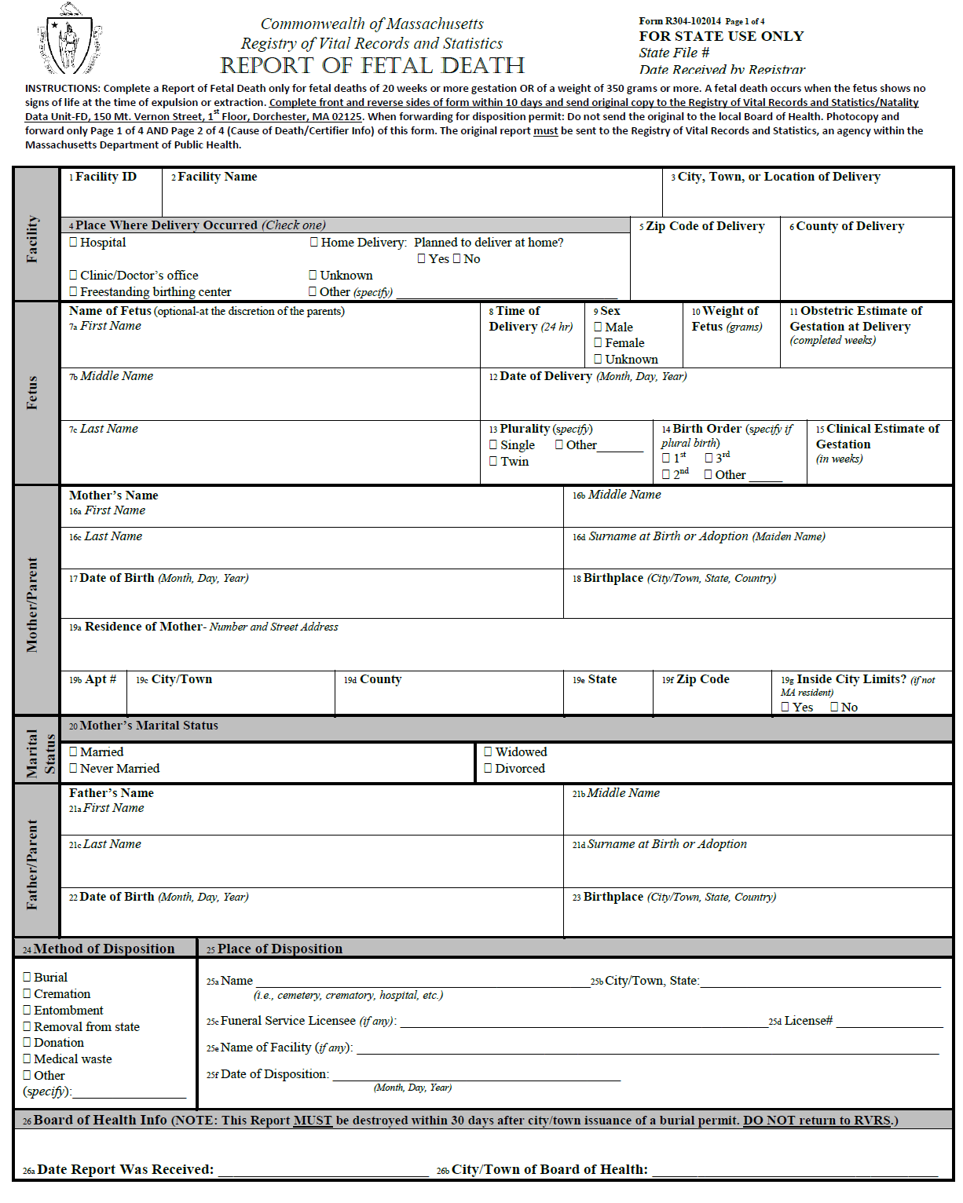

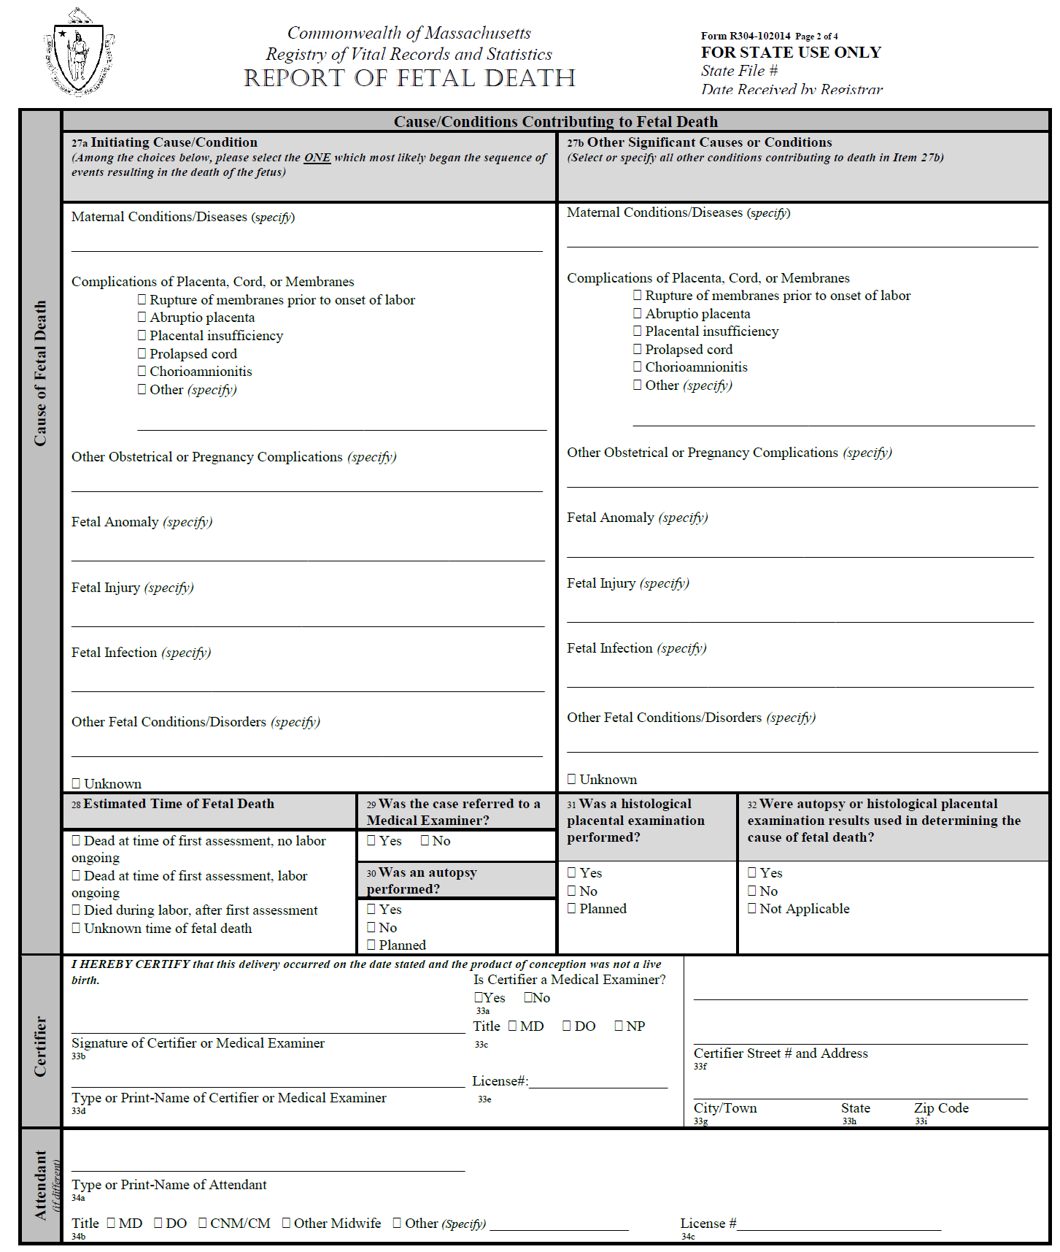

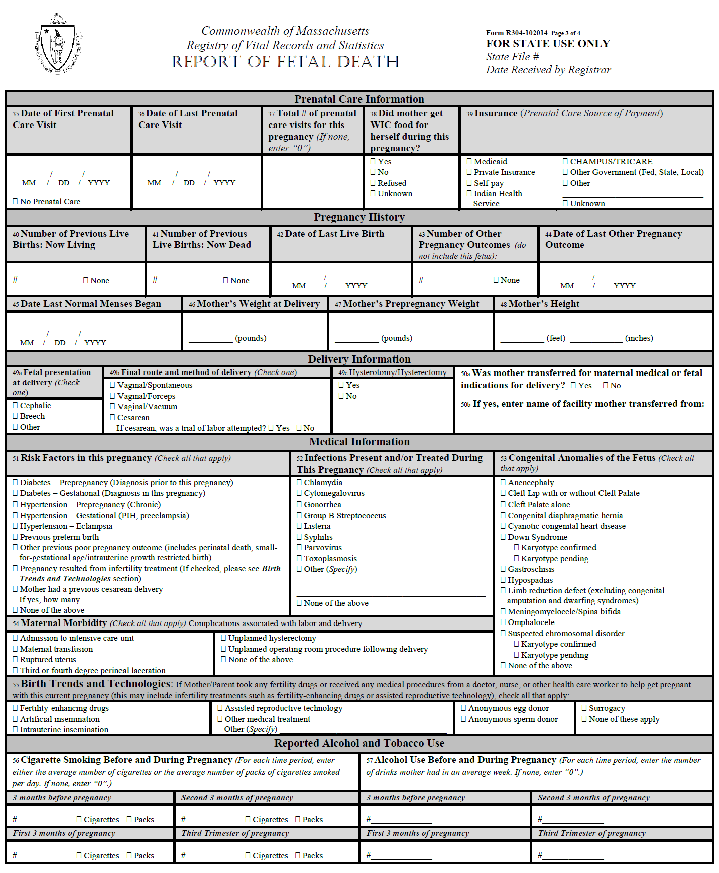

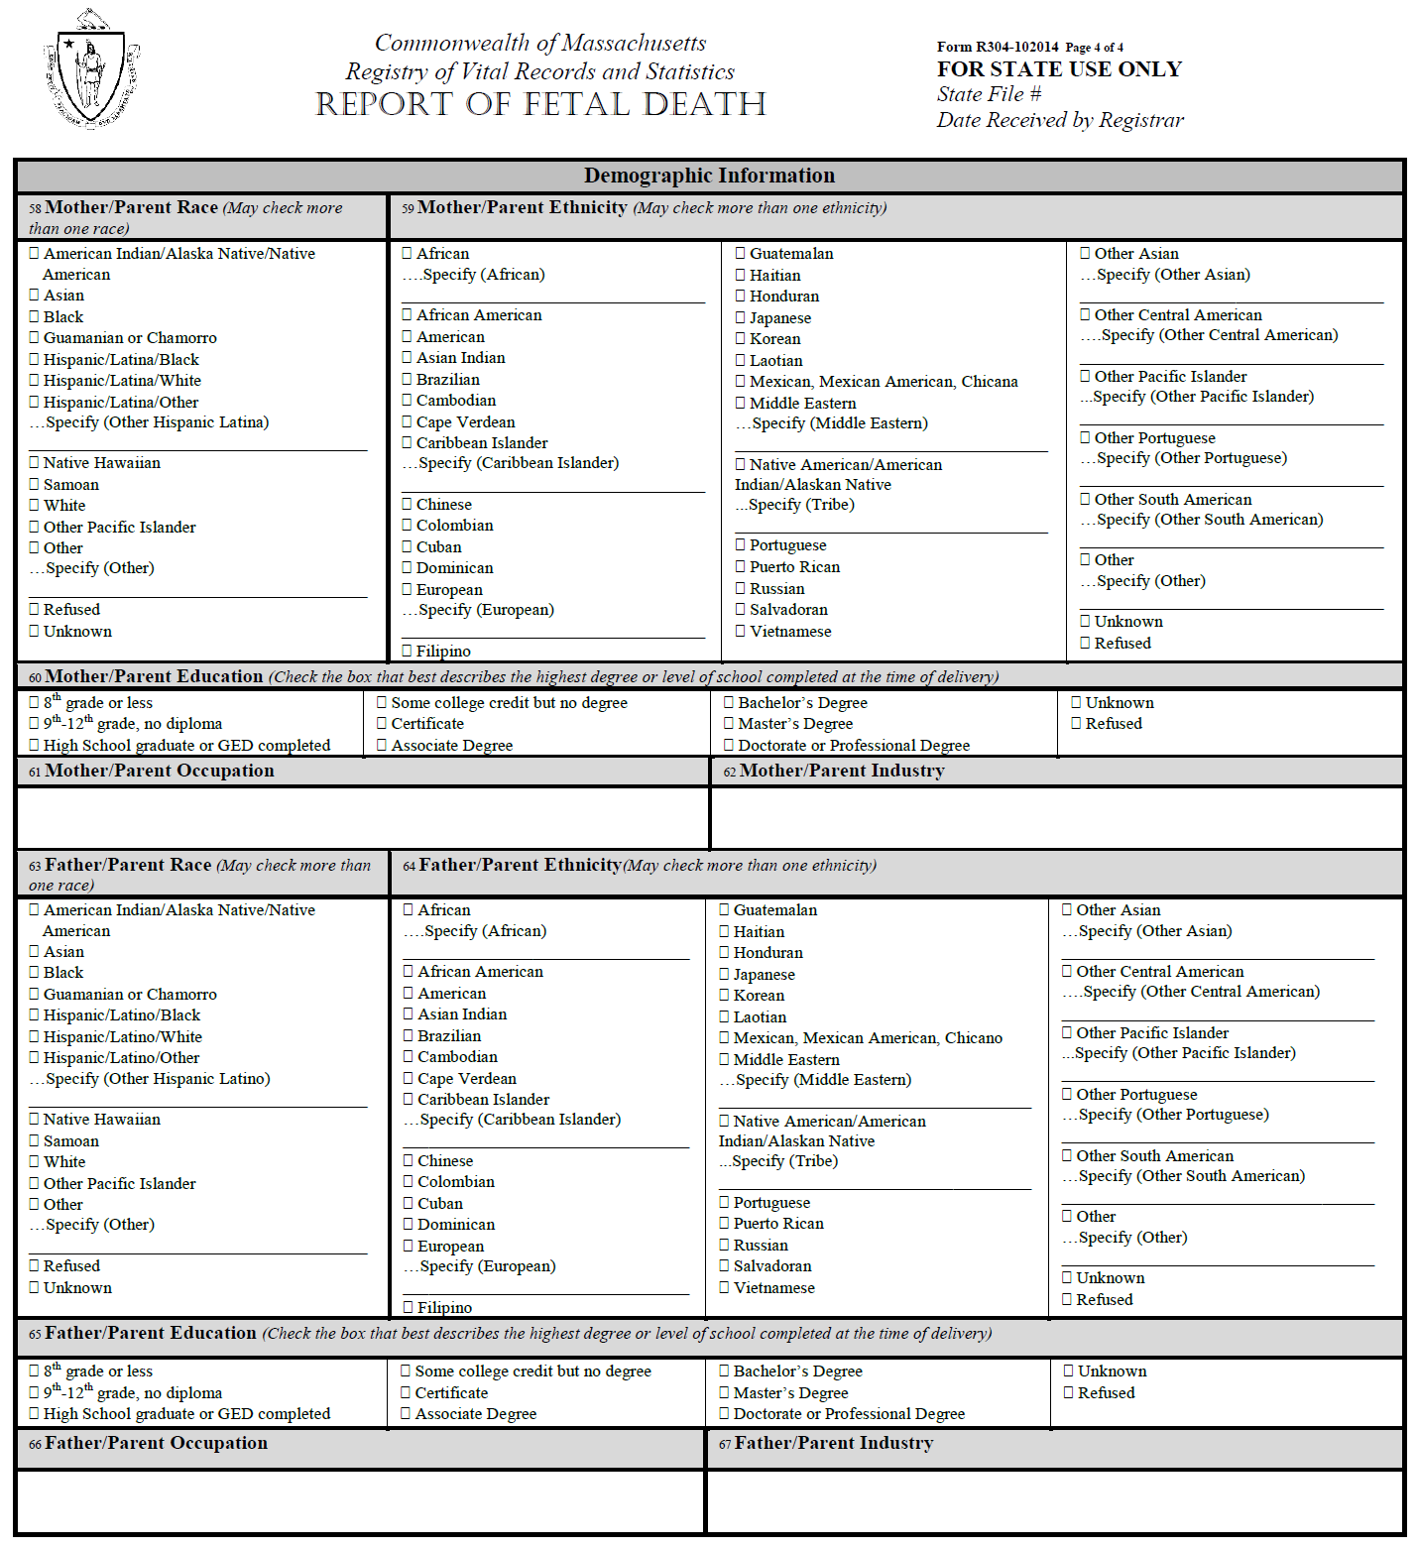

Hospital Worksheet
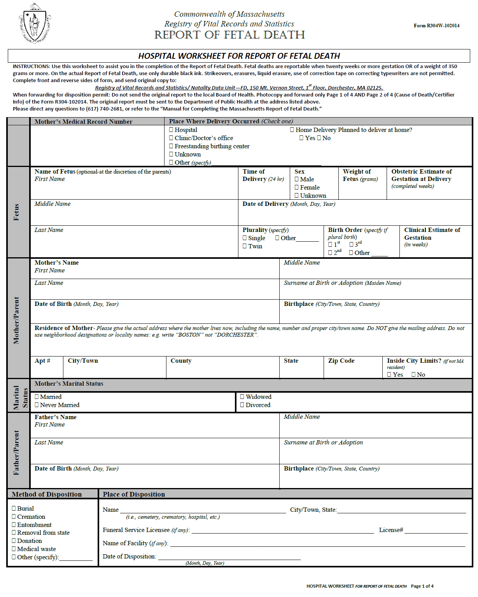

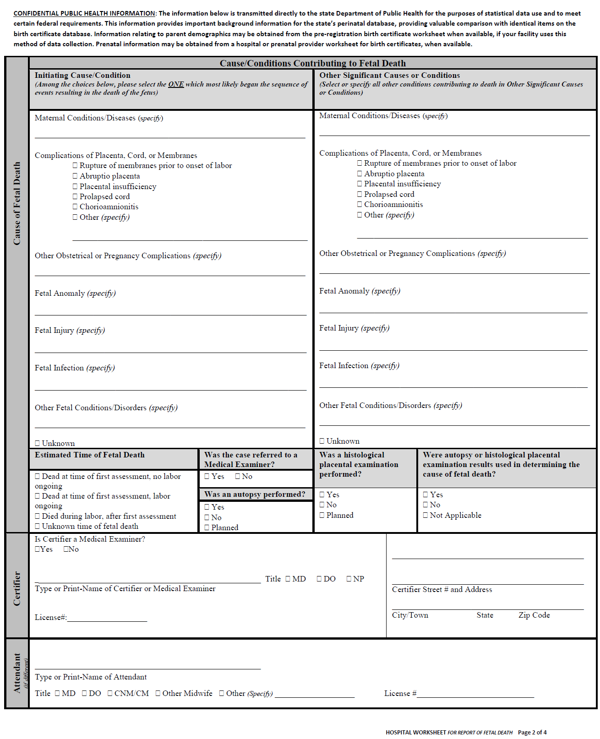

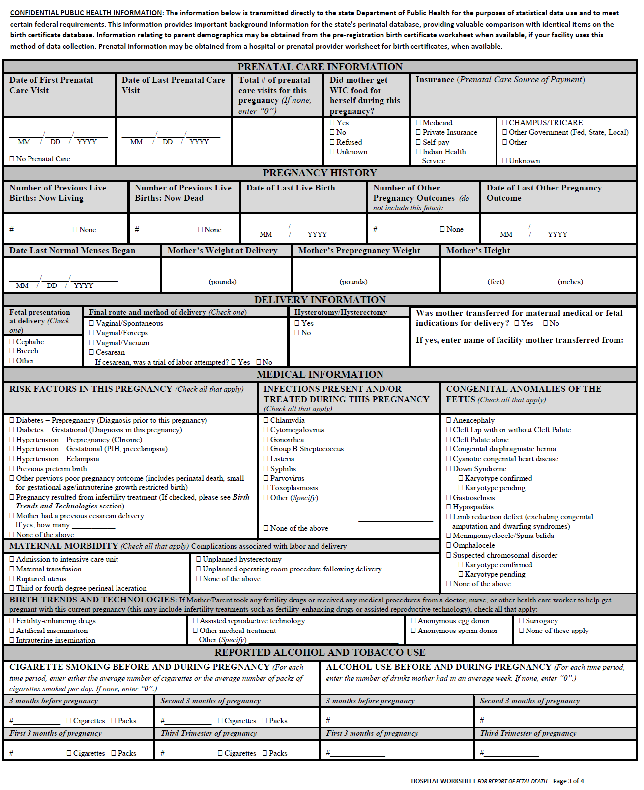

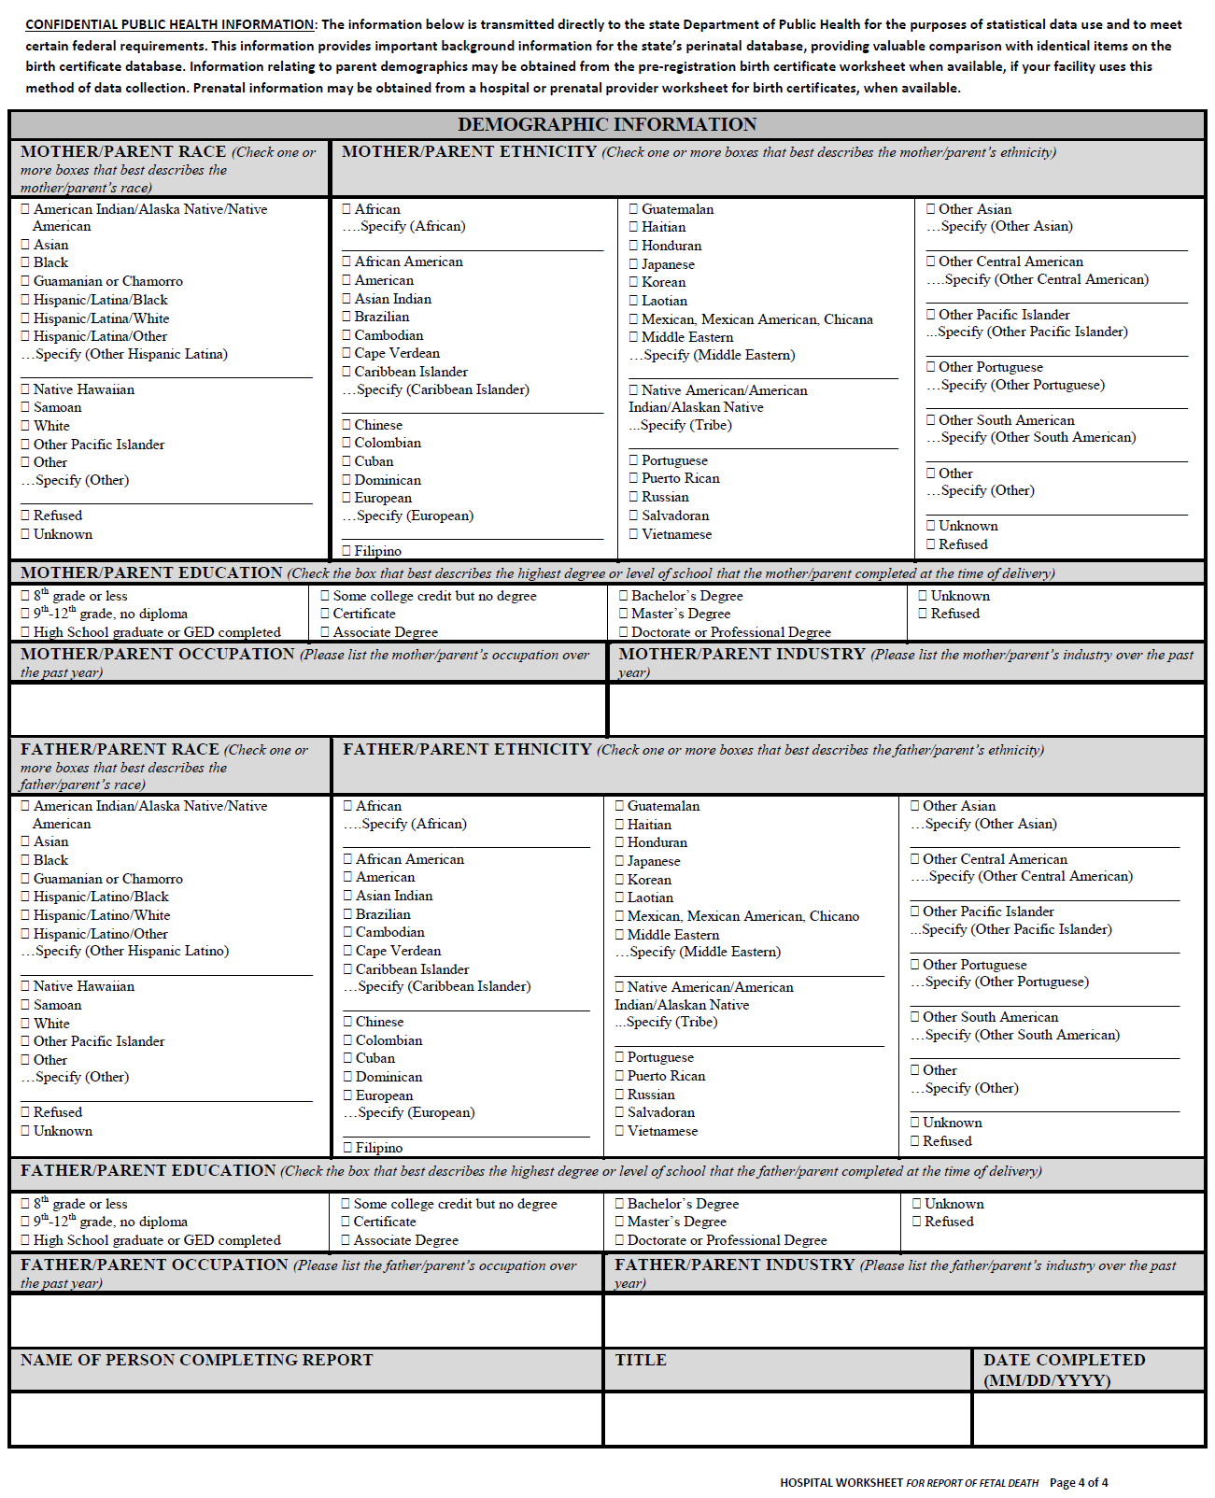

Instructions
