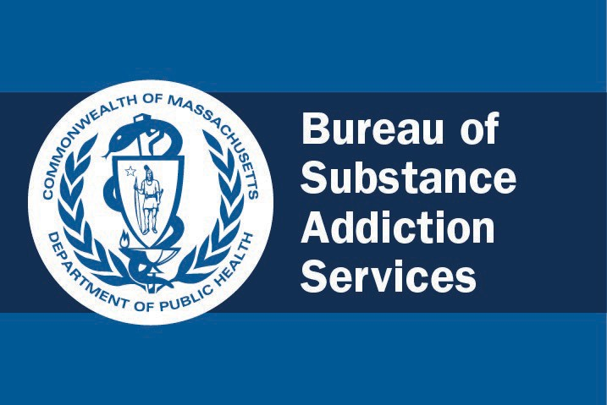

BSAS Disenrollment Assessment Manual

**for the Hospital-Based Substance Use Disorder Initiative**

**Table of Contents**

Introduction 1

Overview 1

Why Collect Disenrollment Assessment Data? 1

Gathering Disenrollment Assessment Data 1

Protecting Patient Confidentiality 2

Items in the Disenrollment Assessment 3

ESM Client ID 3

Provider ID 4

Disenrollment Date 4

Disenrollment Reason 5

First Name, Middle Initial, Last Name, and Suffix 6

Client Code 6

Intake/Clinician Initials 7

Client Referrals at Disenrollment 8

Did you START Medication for Addiction Treatment while in this engagement

(or encounter) with the bridge clinic or addiction consult services? 10

## Introduction

This document is a resource for hospital-based addiction consult teams and/or bridge clinics that are either co-located with or located close to an emergency department (ED) and are engaged in the Massachusetts Bureau of Substance Addiction Services (BSAS) hospital-based Substance Use Disorder (SUD) initiative. Hospitals participating in this initiative are working to increase access to

substance use disorder services and continuity of care in the community for patients who are inpatient or at the ED with a substance use disorder-related concern.

#### Overview

As a part of this initiative, participating hospitals are responsible for collecting intake, enrollment, and disenrollment information for every patient enrolled or seen by the bridge clinic and/or addiction consult team affiliated with a participating hospital. Patient enrollment and disenrollment data are collected using the Executive Office of Health and Human Services’ business application called Enterprise Invoice Management-Enterprise Service Management (EIM-ESM), which is accessed through the web-based portal called the Virtual Gateway.

Enrollment assessment data are gathered when a patient is first seen at the bridge clinic or by an addiction consult team. Providers are encouraged to gather enrollment assessment data as close as possible to when the patient is first seen. Disenrollment assessment data are gathered when a patient leaves the bridge clinic or ends consultation with the addiction consult team.

This manual is a guide for gathering patient data for the disenrollment assessment. It also offers recommendations for documenting patients’ responses. For information about the enrollment assessment, see the *BSAS Enrollment Assessment Manual for the Hospital-Based Substance Use Disorder Initiative*.

#### Why Collect Disenrollment Assessment Data?

Data collected through the disenrollment assessment will be aggregated and presented to the Massachusetts Opioid Recovery and Remediation Fund (ORFF) Advisory Council, the funding entity for this initiative, and will be used to assess the impact of the hospital SUD initiative on improving access and linkages to care. The data will also be used by BSAS for contract management.

#### Gathering Disenrollment Assessment Data

The intake form and enrollment and disenrollment assessments must be completed by providers in bridge clinics and addiction consult teams with patient input.

Some items in the disenrollment assessment do not appear in a question format. Providers should ask these questions using their own wording, while adhering to the intent of the item.

Questions marked with  in the disenrollment assessment must be completed.

For response boxes in the disenrollment assessment that are marked with an asterisk (*), refer to the key at the end of the assessment, where you will find codes for the response options.

#### Protecting Patient Confidentiality

Collecting some identifying information about patients enables BSAS to:

* Monitor patient service utilization patterns
* More accurately estimate patient outcomes
* Identify system gaps and enhance treatment and other wraparound services

Confidentiality in health care refers to the obligation of professionals with access to patient records to hold that information in confidence. BSAS’s infrastructure, processes, access rules, and reporting requirements comply with all federal and state regulations that protect the privacy and confidentiality of patients’ substance use records. This includes federal regulations governing the confidentiality of

alcohol and drug substance abuse treatment patient records (i.e., Code of Federal Regulations, Chapter 42, Part II) and state laws and regulations protecting personally identifiable information.

Every patient seen in the bridge clinic or by an addiction consult team should complete [this Release](https://www.mass.gov/doc/eimesm-release-of-clientconfidential-information-english-0/download)  [of Client/Confidential Information form](https://www.mass.gov/doc/eimesm-release-of-clientconfidential-information-english-0/download). Participating hospitals do not need to submit the completed forms to BSAS; instead, they may be kept with the hospital’s patient records.

# Items in the Disenrollment Assessment

This section of the manual describes the items that appear in the disenrollment assessment. For each item, there is a description of what the question is asking and why, the response options, and how to record responses, including do’s and don’ts.

You may reach out to the EIM/ESM Management Office (EEMO) at [DPH-DL-EEMO@MassMail.State.](mailto:DPH-DL-EEMO@MassMail.State) MA.US with questions about items in the disenrollment assessment.

## ESM Client ID

*This is a required item in the disenrollment assessment.*

### WHAT

The ESM client ID is a unique identifier for every individual who uses state services. When a patient’s data is entered in the EIM-ESM system for the first time, an ESM client ID is

automatically generated. The ESM client ID is used on all subsequent forms associated with the patient, including the disenrollment assessment.

### WHY

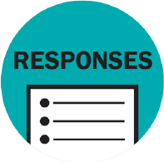Because BSAS does not have access to patient names, using the ESM client ID ensures that all enrollment, billing, and disenrollment data for a patient share this common field.

### RESPONSE OPTIONS

Open text field (The ESM client ID is generated by the EIM-ESM system.)

### HOW

The system automatically assigns ESM client IDs; this information is prepopulated.

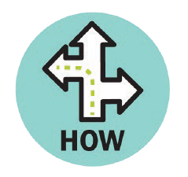

**Do’s**

* To avoid creating a duplicate record for a patient in the EIM/ESM system, be sure to **use the patient’s full, legal name, date of birth, and Social Security number** when searching for a patient or entering a new record in the system.
* If you are communicating to BSAS staff about a patient, use the **ESM client ID only,**

not the patient’s name.

**Don’ts**

* If you are completing a paper version of the disenrollment assessment, **do not fill in** the ESM client ID field in the paper version of the assessment. It will be populated in the EIM/ESM system.

## Provider ID

### WHAT

This field may be used by providers in any way that is helpful in managing patient records. The provider ID is not included or entered in the EIM-ESM system.

### WHY

Some organizations assign each provider an ID, which may be entered at this location in the disenrollment assessment.

### RESPONSE OPTIONS

Open text field

### HOW

If your organization has assigned you a provider ID, you may enter it here.



**Do’s**

* If your organization doesn’t assign providers an ID or code, you may leave this item

**blank.**

## Disenrollment Date

*This is a required item in the disenrollment assessment.*

### WHAT

This item inquires about the date the patient was last seen at the bridge clinic or by the addiction consult team.



**WHY**

Patients’ disenrollment dates are used to track treatment and wraparound services.

### RESPONSE OPTIONS

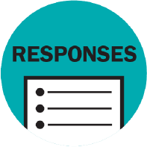MM/DD/YYYY

### HOW

Enter the date the patient was last seen at the bridge clinic or by the addiction consult team.

**Do’s**

* Enter the date using the format MM/DD/YYYY. The MM must be 01 through 12 and DD must be 01 through 31 (e.g., 11/02/2024).

## Disenrollment Reason

*This is a required item in the disenrollment assessment.*

### WHAT

This item inquires why the patient’s engagement with the bridge clinic or addiction consult team ended.

### WHY

Documenting why patients end their engagement with the bridge clinic or addiction consult team helps to understand patients’ trajectories and outcomes.

### RESPONSE OPTIONS

(Select one)

* Discharged from Hospital (Inpatient Stay)
* Left Against Medical Advice—(AMA)/As Patient-Directed Discharge
* Administrative/non-compliant Discharge
* Discharged from ED
* Discharged from Bridge Clinic
* Transferred to Medication for Addiction Treatment
* Transferred to inpatient psychiatric unit
* Transferred to another inpatient unit
* Transferred to another SUD Program
* Patient declined referrals and ongoing care
* Lost to follow-up
* Deceased

### HOW

The reason for a patient’s disenrollment can be found in the patient’s electronic medical record.

**Do’s**

* If there are multiple reasons for a patient’s disenrollment, record the leading or primary reason for disenrollment.

## First Name, Middle Initial, Last Name, and Suffix

### WHAT

This item asks for the patient’s first name, middle initial, last name, and suffix (if applicable).

### WHY

To report on patient outcomes and other measures, BSAS is required to collect information such as patients’ full names and date of birth. Public-facing reports from BSAS never include patients’ full names.

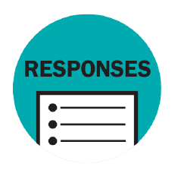

**RESPONSE OPTIONS**

Open text field

### HOW

Ask the patient what their first name, middle initial, last name, and suffix (if relevant) are.

**Do’s**

* When completing a paper version of the disenrollment assessment, be sure to **enter the patient’s first name first,** then the middle initial, then the last name.
* Try to obtain the patient’s **middle initial,** if available.

**Don’ts**

* **Do not record** shortened names, such as Bill for William, or nicknames like Buddy.

## Client Code

*This is a required item in the disenrollment assessment.*

### WHAT

The client code is a five-character code composed of capital letters from the patient’s full name.

### WHY

The client code is used to uniquely identify patients. It can be used to link records across years to monitor treatment utilization and trends.

### RESPONSE OPTIONS

Open text field

### HOW

Record the client code that appears in the patient’s enrollment assessment. It is a five- character code that is unique to each patient and is assigned as follows:

* **First character:** First letter of the patient’s first name
* **Second character:** Third letter of the patient’s first name
* **Third character:** Patient’s middle initial (If none, enter 4)
* **Fourth character:** First letter of the patient’s last name
* **Fifth character:** Third letter of the patient’s last name

If a patient’s first or last name does not have three letters, a 4 is used in place of the third letter. For example, Dustin Kip Vo would be DSKV4 and Angela Jenkins-Jones would be AG4JN.

## Intake/Clinician Initials

*This is a required item in the disenrollment assessment.*

### WHAT

This item asks for the initials of the staff member or clinician who completed the disenrollment assessment.

### WHY

In case there is an issue with how the information in the assessment is collected or recorded and there is a need to follow up, this item asks for the initials of the staff member or clinician who completed the assessment.

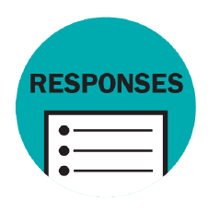

**RESPONSE OPTIONS**

Open text field

### HOW

Enter the initials of the clinician conducting the disenrollment assessment interview.

## Client Referrals at Disenrollment

*This is a required item in the disenrollment assessment.*

### WHAT

A referral is an action step taken by a clinician, navigator, social worker, or other provider on behalf of the patient that results in an active referral (e.g., a warm hand-off, scheduling an appointment, making a phone call to establish a connection between the patient and another provider). Simply providing a patient with information about services available (e.g., giving the patient a brochure) is not a referral.

This item inquires about the services that staff in the bridge clinic or addiction consult team (e.g., recovery support navigator) referred the patient to when they last engaged with the patient. This includes referrals to other substance use disorder services, harm reduction services, and other services that address social determinants of health.

### WHY

Documenting the referrals that patients receive from the bridge clinic or addiction consult team helps to understand patients’ linkages to community-based services.

### RESPONSE OPTIONS

(Check all that apply. At least one item must be selected.)

**Referral Not Needed:** Assessment indicates that client does not require entering formal treatment

**Referral Not Needed:** Appropriate **mental health** clinical services already in place

**Referral Not Needed:** Appropriate **substance use disorder** clinical services already in place

**Referral Not Made:** Client left prior to referral process

**Referral Not Made:** Not wanted by client **Acute Treatment Services (ATS)/Detox Transitional Support Services (TSS) Clinical Stabilization Services (CSS-CMID) Residential Treatment**

**Outpatient SUD Counseling Opioid Treatment Program (OTP)**

**Office-Based Opioid Treatment (OBOT) Other Medication for Addiction Treatment Acupuncture**

**Access to Recovery (ATR) Sober House**

**Recovery Support Center**

**Recovery Coaching or Peer Support**

**Recovery High School**

**Recovery Exercise Program (e.g., Phoenix Gym) Mobile Addiction Services**

**HIV Prevention Program (PrEP) Hepatitis C Treatment Program (HCV) Infectious Disease Field Epidemiologist Syringe Service Program**

**Mutual Aid or 12-Step Program Other Harm Reduction Program Bridge Clinic**

**Other Substance Addiction Treatment Community Behavioral Health Center (CBHC) Community or Religious Organization Employment Support Services**

**Financial Support Service Food Security Support Service Gambling Program**

**Legal Support Service**

**Mental Health Care Professional**

**Non-Addiction Specialty Health Care Professional Other Behavioral Health Counseling**

**Other Community Program or Service School Personnel, School System/College Shelter**

**Transportation Support Services Department of Youth Services Department of Children and Families Department of Mental Health Department of Developmental Services Department of Public Health Department of Transitional Assistance Department of Early Education and Care**

**Massachusetts Rehabilitation Commission Massachusetts Commission for the Blind**

**Massachusetts Commission for the Deaf & Hard of Hearing Division of Medical Assistance/MassHealth**

**Other State Agency Unknown**

### HOW

The services and programs that a patient was referred to at disenrollment can be found in

## Did you START Medication for Addiction Treatment while in this engagement (or encounter) with the bridge clinic or addiction consult services?

### WHAT

This item inquires whether the patient began receiving medication for addiction treatment while engaged with the bridge clinic or addiction consult services.

### WHY

It is important to know whether patients who engage with the bridge clinic or addiction consult team started on Medication for Addiction Treatment while engaged with the clinic or team.



**RESPONSE OPTIONS**

Yes; No (If No, skip to end)

### HOW

Ask the patient if they began receiving medication for addiction treatment while engaged with the bridge clinic or addiction consult services. This information may also be gathered from the patient’s electronic medical record.

**Do’s**

* If the patient answers yes, proceed to 4a-c.

**Don’ts**

* Do not record medication for addiction treatment that a patient received in the past.

1. **Did you receive methadone treatment?** *(If yes, skip to end; if no, go to 4b and 4c)*

**RESPONSE OPTIONS:** Yes; No

1. **Did you receive a prescription for buprenorphine or naltrexone (injectable or oral) treatment?**

**RESPONSE OPTIONS:** Buprenorphine (Suboxone, Sublocade, Brixadi); Extended release injectable naltrexone (Vivitrol) or oral naltrexone

1. **Is your buprenorphine or naltrexone prescription for alcohol use disorder, opioid use disorder, or both?**

**RESPONSE OPTIONS:** Alcohol use disorder; Opioid use disorder; Both