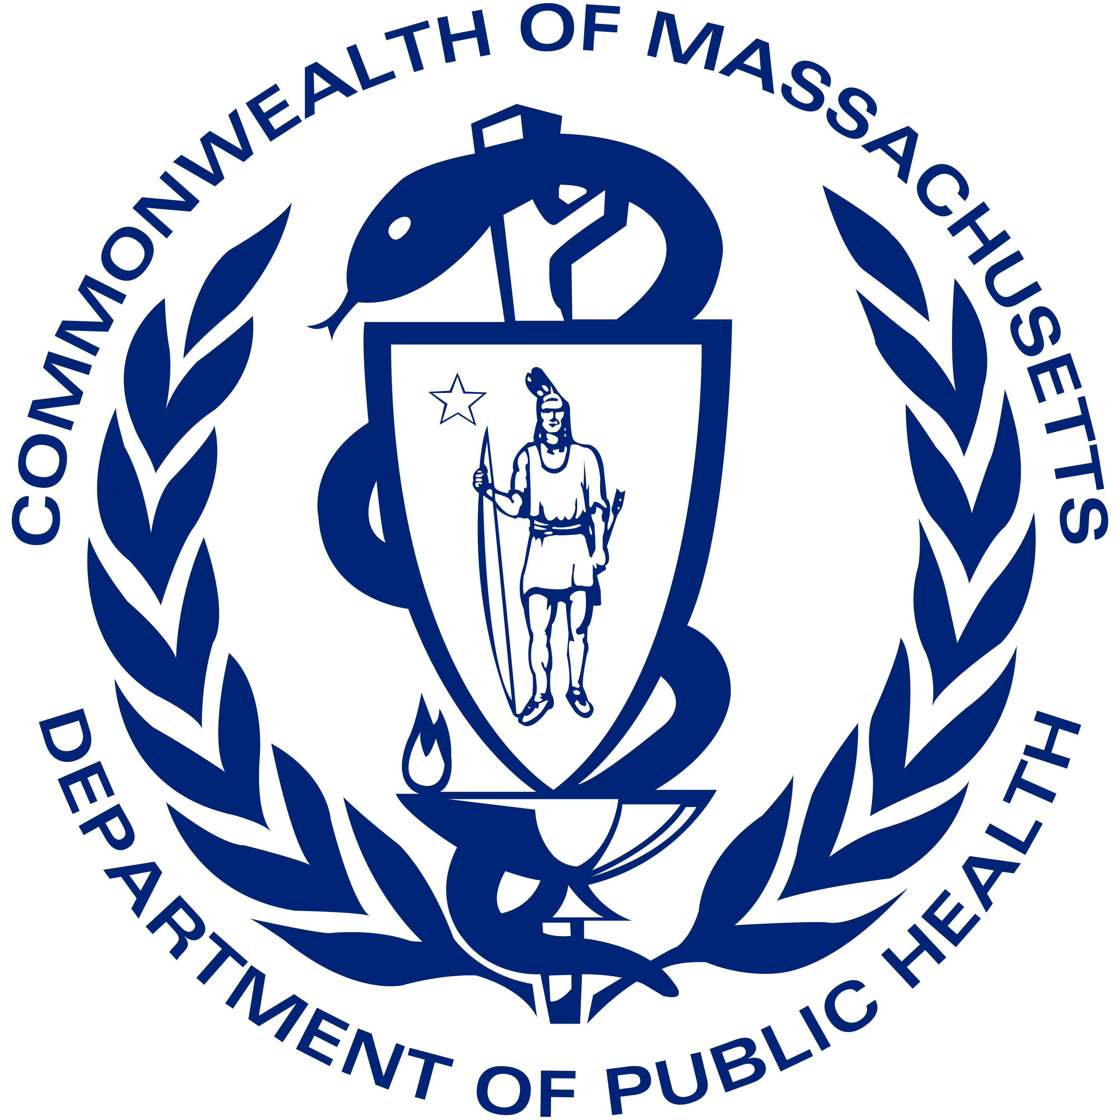
Toolkit: Hosting a Mobile Vaccination Clinic
Updated: May 2022

Introduction:
The Massachusetts Department of Public Health (DPH) in partnership with schools, community and faith-based organizations, and local boards of health, is offering on-site COVID-19 mobile vaccination clinics. Mobile vaccination clinics can make accessing vaccines convenient for large groups, or hard-to-reach groups of individuals.

COVID-19 vaccines are safe and effective. Getting vaccinated against COVID-19 can lower the risk of getting and spreading the COVID-19 virus and can help prevent serious illness and death. COVID-19 vaccines are an important tool in keeping the population healthy and therefore keeping business, schools, and community and faith-based organizations open and safe.

Evidence shows that vaccine access, paired with intentional outreach, engagement and resources, aids in building vaccine confidence and uptake. With that, hosts should leverage the trusted relationships of community members and leaders. This toolkit aims to provide guidance in a number of these areas.

Contact: dphmobilevaxclinic@jsi.com with any questions.

How to Host a Clinic:

Logistics:
- Connect with a vaccine provider. If you are not already working with a vaccine provider and would like to host a COVID-19 mobile vaccination clinic, submit a request to the DPH Mobile Vaccination Clinic Request Form. A response may take 5-10 business days.
- Select an appropriate space and prepare the site. Not all sites are suitable for a vaccination clinic. For example, when selecting a site, consider the following: Indoor vs. Outdoor Clinics: Indoor spaces are preferred in the winter months, and generally overall.
  - Locale: Is the clinic location easily accessible to those you hope to vaccinate?
  - Resources: Will electrical power, Wi-Fi, bathroom access, chairs, tables, and volunteers be available?
  - Waiting/Recovery Area: Consider the space where folks will wait before their shot and sit for 15 minutes after their shot during observation.
- Distribute Consent Forms: Distribute and post multilingual flyers and parent/guardian consent forms to all students. Plan to receive the consent forms ahead of time and allow families to be present at the clinic, as appropriate.
If you expect children and families at your clinic:

Child-Family Friendly Clinic Practices:
- Take a whole-family-approach: vaccinate parents/caregivers, grandparents, older siblings, etc. with primary series and boosters at the clinic
- Hold clinics in the evening and/or weekends, outside of traditional school and work hours
- Ensure language support/capacity
- Provide specialized supports for children with sensory sensitivities
- Ensure clinics are accessible to children and adults with physical and intellectual disabilities
- Include a trusted voice to answer family / caregiver questions at the clinic
- Organize vaccine town halls for parents of school age children to get questions answered
- Engage trusted community members to share messaging and/or participate at the townhall (i.e. community leader, faith leader, school coach, etc.)
- Provide activities and games to occupy children during waiting and observation periods (example: balloon animals, movies, arts and crafts, comfort kits)
- Provide snacks
- Provide Buzzy’s or other injection pain reduction devices

Promote the vaccination clinic:
Spreading the word about your vaccination clinic and getting people to come to it are integral parts of hosting the clinic. Include information about masks, testing, and therapeutic options in your messaging to use this opportunity to provide critical covid-related information.

Consider making a community event out of the clinic or hosting the clinic at a community event.

The below steps are recommended to help promote vaccination clinics:

Step 1: Finalize Plans
Make the plans final. For example, confirm: the date, time, and location; that all walk-ups are welcome, and which types of vaccines are offered. If your clinic is going to have pre-registration for appointments, ask the vaccination provider for a “sign-up link”. This link can be distributed to people in advance so they can go online and schedule appointments.

Step 2: Advertise the clinic
Getting the word out about the clinic is an important piece of a successful clinic. A host can work with partners to reach all community members. A range of media strategies, and collaboration with a variety of partners may be required to optimize reach.

Create a clinic-specific flyer to spread the news.

Ways to spread the news:
- Mass email to community members and listservs.
- Social media campaign:
  - Partner with key influencers on a coordinated social media effort.
  - Paid social media.
- Mail (postcards, flyers, letters) with clinic-specific information.
- Phone calls and/or text messages to community members (ex. From Mayor’s Office).
- Flyers placed around the community.
- Inserts in bulletins, local newspapers, newsletters.
- Interviews with local media.

Work with partners to help spread news and information:
- Trusted community members/leaders (i.e. libraries, YMCAs, faith-based organizations).
- Local board of health director.
- Members of your organization connecting with their personal networks.
- Vaccinated community members helping to reach others.
- Elected officials and their networks
- Newspaper, radio, and television organizations.
- Neighborhood groups.
- Local chambers of commerce or school groups.
- Local businesses, nonprofits, and faith communities.

Additional outreach ideas:
- Offer vaccination information at community events (partner with health care providers or other trusted community voices).
- Provide vaccine information at community centers/events; places of worship; retail centers; restaurants; and other places people gather.
- Partner with community organizations to staff phone banks and canvass neighborhoods.
- Partner with popular restaurants, eateries, or bars to offer incentives to get vaccinated.
- Adapt key messages to the language, tone, and format that will resonate with the populations you aim to reach.
- Print copies of CDC posters or download Massachusetts videos and flyers and use them as handouts or post them in highly visible places in your offices, buildings, and other employee locations.

Step 3: During the Clinic
- Distribute some type of small incentive, whether via gift cards, free items, or stickers
- Invite the local media to the clinic to do a story; have photo release forms on hand so you can get permission to use photos of people visiting the clinic.
- Post about the clinic on social media.
- Consider a quick exit survey to find out how people heard about your clinic and why they came; this will help you plan and publicize your next clinic.
- Continue to have canvassers canvass the local area letting people know about the clinic.

Helpful Resources:
U.S. Department of Health and Human Services, We Can Do This Back to School Toolkit: Resources to help increase confidence, answer questions, and outline school guidance.

CDC, COVID-19 Vaccines for Children and Teens: CDC recommends everyone 12 years and older should get a COVID-19 vaccination to help protect against COVID-19.

COVID-19 Frequently Asked Questions: Frequency Asked Questions by Individuals across the Commonwealth.

Trust the Facts, Get the Vax Creative Materials Toolkit: Resources to help increase confidence using the state’s researched public messaging campaign.

Massachusetts COVID-19 Education Materials

COVID-19 Vaccination Clinic Flyers (multiple languages)

Letter to Child and Family Support Program Leaders

