HOUSATONIC RIVER BASIN – RIVER SEGMENT ASSESSMENTS

The following segments in the Housatonic River Basin are included in this report:

HOUSATONIC RIVER BASIN – RIVER SEGMENT ASSESSMENTS
SOUTHWEST BRANCH HOUSATONIC RIVER (Segment MA21-17) Error: Reference source not found
WEST BRANCH HOUSATONIC RIVER (Segment MA21-18) Error: Reference source not found
EAST BRANCH HOUSATONIC RIVER (Segment MA21-01) Error: Reference source not found
EAST BRANCH HOUSATONIC RIVER (Segment MA21-02) Error: Reference source not found
CLEVELAND BROOK (Segment MA21-08) Error: Reference source not found
CADY BROOK (Segment MA21-12) Error: Reference source not found
WINDSOR BROOK (Segment MA21-09) Error: Reference source not found
WAHCONAH FALLS BROOK (Segment MA21-11) Error: Reference source not found
ANTHONY BROOK (Segment MA21-10) Error: Reference source not found
HOUSATONIC RIVER (Segment MA21-04) Error: Reference source not found
HOUSATONIC RIVER (Segment MA21-19) Error: Reference source not found
GOOSE POND BROOK (Segment MA21-07) Error: Reference source not found
HOUSATONIC RIVER (Segment MA21-20) Error: Reference source not found
FURNACE BROOK (Segment MA21-21) Error: Reference source not found
WILLIAMS RIVER (Segment MA21-06) Error: Reference source not found
LONG POND BROOK (Segment MA21-14) Error: Reference source not found
SEEKONK BROOK (Segment MA21-22) Error: Reference source not found
KARNER BROOK (Segment MA21-16) Error: Reference source not found
UNNAMED TRIBUTARY (Segment MA21-24) Error: Reference source not found
HUBBARD BROOK (Segment MA21-15) Error: Reference source not found
KONKAPOT RIVER (Segment MA21-25) Error: Reference source not found
KONKAPOT RIVER (Segment MA21-26) Error: Reference source not found
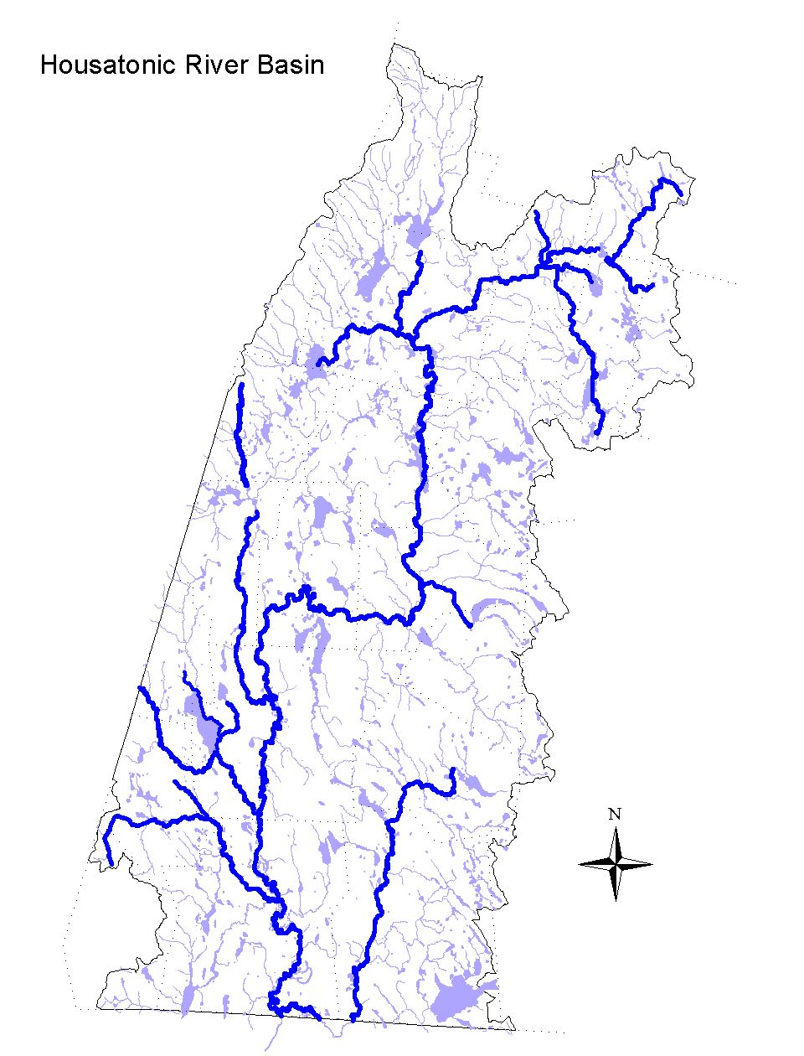

Figure 4. Housatonic River Basin – Rivers

SOUTHWEST BRANCH HOUSATONIC RIVER (Segment MA21-17)
Location: Outlet of Richmond Pond, Pittsfield to confluence with West Branch Housatonic River, Pittsfield. Segment Length: 5.8 miles. Classification: Class B, Cold Water Fishery.

Segment DESCRIPTION

The Southwest Branch Housatonic River, a Class B Cold Water Fishery, originates at the outlet of Richmond Pond in Pittsfield. The river lies between the Taconic Range to the northwest and Lenox Mountain on the southeast. Three streams, Shaker, Jacoby and Smith Brooks, whose headwaters lie in the Pittsfield State Forest, flow southeast into the Southwest Branch Housatonic River. In the southeastern portion of the river’s watershed, land-use includes the Pittsfield Municipal Airport, the Bousquet Ski Area, and the newly developed Stearns Industrial Park. Two unnamed tributaries to the Southwest Branch Housatonic River drain around the airport. Maloy Brook is the last stream that flows into the Southwest Branch Housatonic River prior to its confluence with the West Branch Housatonic River south of Pittsfield Center.
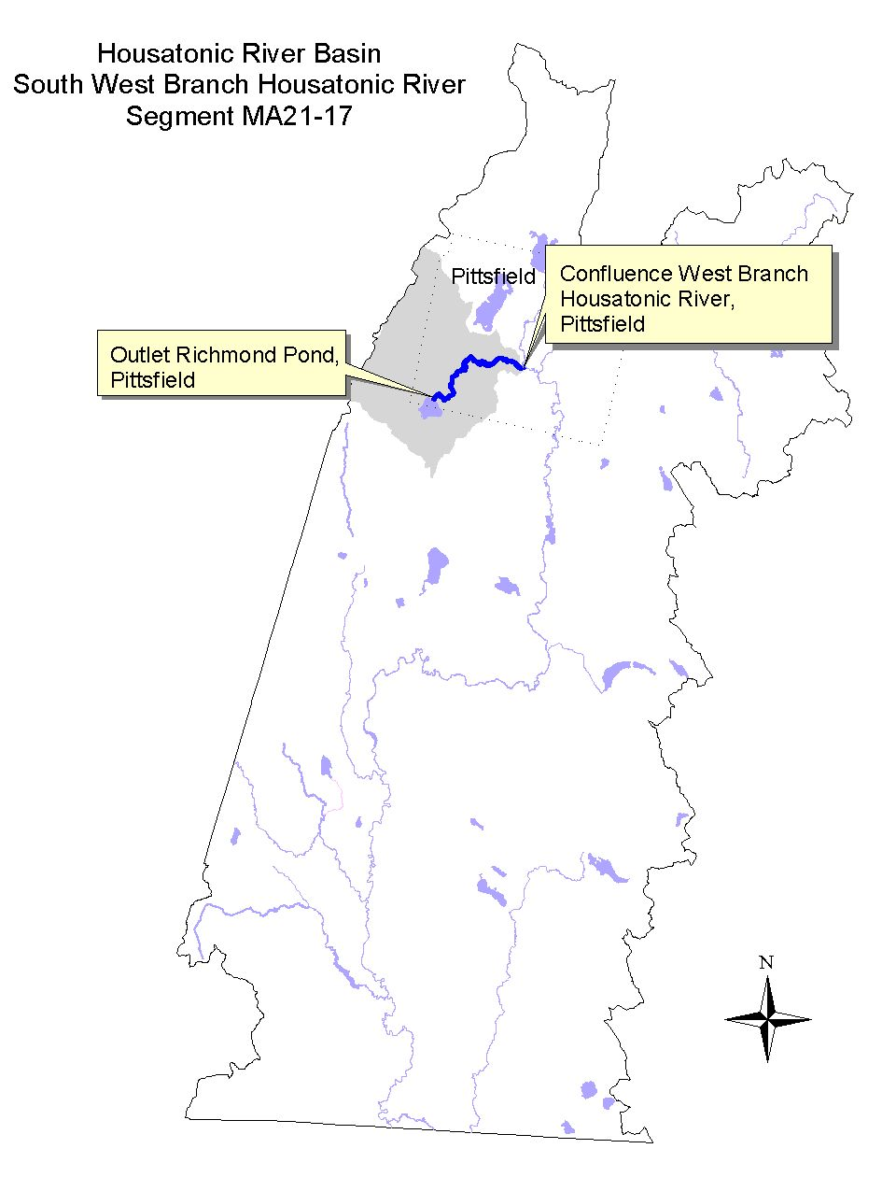

Land-use estimates for the subwatershed (map inset, gray shaded area):
Forest | 63%
Agriculture | 12%
Open Land | 8%

Land-use estimates in the 100’ riparian zone from the streambanks:
Forest | 53%
Residential | 27%
Open Land | 6%

WITHDRAWALS AND DISCHARGES

NPDES:
- MA0028410 - Lakeside Christian Camp has connected to the Pittsfield City Sewer System. EPA closed the permit file (Vergara 1999).

Stormwater:
Several operators at the Pittsfield Municipal Airport applied for the general stormwater permits (Berkshire Regional Planning Commission 1999, unless otherwise noted):
- MAR00B310 ALNASCO,
- MAR00B331 Lyon Aviation, Inc.,
- MAR00B312 BETNR Industrial Development,
- MAR00B313 H. G. Maxymillian, Inc., and
- MAR00B316 The City of Pittsfield (MA DEP 2000b).

USE ASSESSMENT

Benthic macroinvertebrate sampling was conducted by DWM biologists in August 1997 in the Southwest Branch Housatonic River (station HW02S) downstream from Barker Road in Pittsfield (approximately 0.5 miles upstream of the confluence with the West Branch Housatonic River) (Appendix B, Table B1). In April 2000, the Housatonic Valley Association (HVA) conducted a windshield survey of the Southwest Branch Housatonic River. Sediment sampling in the Southwest Branch Housatonic River between Route 20 and Barker Road for total PCB has been conducted as part of the General Electric Pittsfield (GE) Housatonic River Project (Stefanosky 1999).

- Bioassessment/Habitat – The benthic macroinvertebrate community RBP III analysis resulted in a total metric score of 22 (as compared to 42 at the regional reference site KR11) indicating slight/moderate impairment (Appendix C). Habitat quality limitations (severe embeddedness of cobble substrates and nonpoint source pollution in the form of trash and debris) more than water quality was thought to be most limiting to biological integrity. Sand and other fine sediment loads – both organic and inorganic forms – were considered to be the greatest threat to the benthic community, however inorganic nutrient loadings, as reflected in the luxuriant algal community, also need to be considered.

No obvious sources of streambank erosion or riparian land-use that would result in siltation in the Southwest Branch Housatonic River was observed by HVA, although they did observe a fine layer of silt throughout the river (Regan 2000). According to HVA, instream deposition was very evident at Barker Road.

- Sediment Quality – Total PCB ranged between 0.00453 and 0.451 PPM dry weight in the 25 samples analyzed in sediment samples collected to a depth of < 1 ft. (Roy F. Weston, Inc. 1999). Twenty eight percent of these samples were less than or equal to the L-EL of 0.07 PPM. None of the samples exceeded the S-EL of 5.3 PPM assuming a TOC of 1%.

- Fishery Management Policy – According to Western Wildlife District of the DFWELE, the current management policy for the Southwest Branch Housatonic River consists of spring stocking of brook, brown and rainbow trout (Bell 1999). A qualitative assessment of fishing pressure indicates significant use as an urban fishery between Richmond Pond and Barker Road in Pittsfield.

The Aquatic Life Use is assessed as non-support based on the above information coupled with the habitat quality observations of the DWM biologists. The Aesthetics Use is assessed as support upstream of Barker Road and non-support downstream of Barker Road to the confluence with the West Branch Housatonic River.

- Fish Consumption Advisory – There is currently no specific fish consumption advisory for this river. The DPH fish consumption advisory in effect for the mainstem Housatonic River includes a provision that recommends that fish taken from feeder streams to the Housatonic River be trimmed of fatty tissue prior to cooking (MA DPH 1999). The intention of this provision is to minimize the potential risk associated with fish that may migrate in or out of the mainstem Housatonic River.

Designated Uses Status: Southwest Branch Housatonic River (Segment MA21-17)
Aquatic Life |  | NON-SUPPORT. The macroinvertebrate analysis indicated slight/moderate impairment, therefore the Aquatic Life Use is assessed as non-support. The lower 0.5 mile reach of this segment is also impaired by habitat quality limitations (severe sedimentation).
Fish Consumption |  | not assessed
Primary Contact |  | not assessed
Secondary Contact |  | not assessed
Aesthetics |  | SUPPORT. The upper 5.3 miles of this segment is evaluated as supporting this use.  NON-SUPPORT. The lower 0.5 mile reach of this segment does not support this use as evidenced by severe sedimentation, trash and debris.

RECOMMENDATIONS: SOUTHWEST BRANCH HOUSATONIC RIVER (SEGMENT MA21-17)

- Further investigate/isolate sources of both inorganic and organic sediment loads to the Southwest Branch Housatonic River; implement BMPs to reduce sedimentation.
- Conduct a stream cleanup effort to remove anthropogenic debris (trash, car parts, scrap metal, etc).
- Additional monitoring (nutrients, fecal coliform bacteria, and dissolved oxygen) is recommended to more completely evaluate the status of the recreational uses and locate sources of nutrient inputs.
- DPH recommends that fishes taken from tributaries to the Housatonic River should be trimmed of fatty tissue before cooking (MA DPH 1999). Since there is a lack of any instream barriers to fish migration between the Southwest Branch Housatonic River and the East Branch Housatonic River and the mainstem Housatonic River (where PCB contamination is extremely high), body burdens of PCB in the edible portion of fish from the Southwest Branch Housatonic River merits further investigation.
- The Bousquet Ski Area reports 98% snowmaking capacity. The ski area’s water withdrawal location(s) (PWS # 1236010-01G) and volume should be documented in order to determine whether or not a WMA permit is necessary.
- None of the general stormwater permittees reapplied for the more recent multi-sector stormwater permit (noticed in the Federal Register in September 1998). Stormwater controls at the airport should be evaluated for effectiveness.
- The BRPC report entitled Assessment of Land-use Activities and Nonpoint Source Pollution in the Housatonic River Watershed contains an up-to-date summary of existing and potential nonpoint sources of pollution in the Housatonic River Basin (Berkshire Regional Planning Commission 1999). The potential pollution sources identified in this report (e.g., Table IV-13 and pages IV-45-46) should be reviewed to help design future monitoring plans for the Southwest Branch Housatonic River subwatershed.

WEST BRANCH HOUSATONIC RIVER (Segment MA21-18)
Location: Outlet of Pontoosuc Lake, Pittsfield to confluence with Southwest Branch Housatonic River, Pittsfield. Segment Length: 4.1miles. Classification: Class B Cold Water Fishery.

Segment DESCRIPTION

The West Branch Housatonic River, a Class B Cold Water Fishery, flows south from the outlet of Pontoosuc Lake in Pittsfield towards the center of Pittsfield. The river receives the flow from Onota Brook (draining Onota Lake) just upstream of Wahconah Park. The former King Street Landfill, owned by the City of Pittsfield, is located off of King Street on the west side of the West Branch Housatonic River. The 82-acre site, which is part of the 110 acre Wahconah Park property, had been a municipal dump since the 1930s. The dump was used primarily for large items and demolition debris. There were, however, reports of other wastes including trash and GE Company wastes. After flowing around the park the river turns west for a short distance before heading south to its confluence with the Southwest Branch Housatonic River in Pittsfield. The confluence of these two branches forms the mainstem Housatonic River. Prior to reaching the Southwest Branch, the West Branch Housatonic River flows adjacent to the Dorothy Amos Park. This park was sampled for PCB contamination in the field season of 1997. PCB removal action took place in 1998 and the final landscaping activities at the park were completed in early 1999.
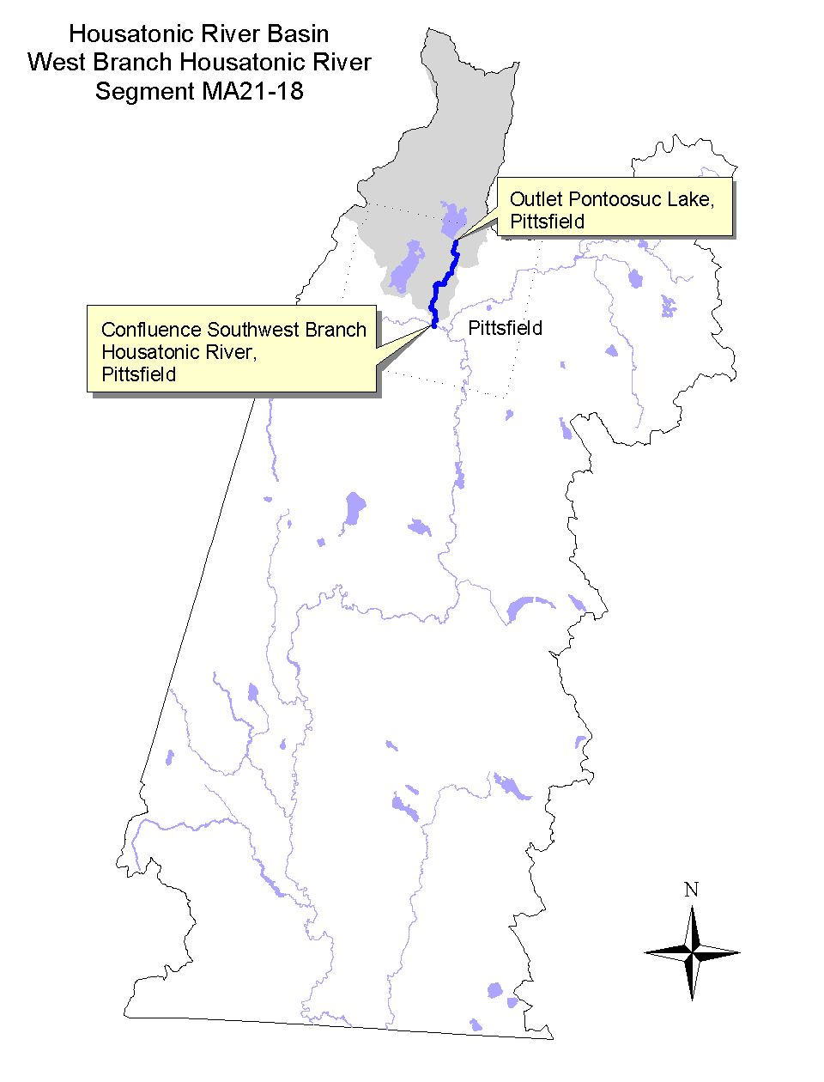

Land-use estimates for the subwatershed (map inset, gray shaded area):
Forest | 59%
Agriculture and Residential | 12%
Open Land | 8%

Land-use estimates in the 100’ riparian zone from the streambanks:
Residential | 44%
Wetlands | 20%
Forest | 13%

WITHDRAWALS AND DISCHARGES

Stormwater:
- MAR00A975 - Clock Tower Condominium (Pittsfield Publications, Inc.) in Pittsfield applied for a general stormwater permit (Berkshire Regional Planning Commission 1999).
- MAR00A974 - The Clock Tower Condominium Unit 1 (The Eagle Publishing Company) in Pittsfield has applied for a general stormwater permit (MA DEP 2000b).

USE ASSESSMENT

Benthic macroinvertebrate sampling was conducted by DWM biologists in August 1997 in the West Branch Housatonic River (station HW01) downstream from Route 20 in Pittsfield (Appendix B, Table B1). The Housatonic River West Branch Stream Team conducted shoreline surveys of the West Branch Housatonic River in the fall of 1998 (Housatonic Valley Association 1999). Preliminary sampling for total PCB in the sediment of the West Branch Housatonic River was conducted by EPA in the vicinity of the King Street Landfill in 1999.

- Bioassessment/Habitat – The benthic macroinvertebrate RPB III analysis resulted in a total metric score of 22 (as compared to 42 at the regional reference site KR11) indicating slight/moderate impairment (Appendix C). Both instream and riparian habitat conditions were extremely degraded throughout the sampling reach. Factors contributing to the habitat degradation included substantial deposits of sand and other fine sediments, various forms of trash and debris, erosion, and dense algal cover. Moderate turbidity was also visually observed. The benthic macroinvertebrate analysis suggests that organic enrichment may contribute to the impairment of the aquatic community.

The West Branch Stream Team also identified trash and debris as being prevalent throughout the entire segment (Housatonic Valley Association 1999). Sewage odors were also noted in their shoreline survey results near Wahconah Park and near Mill Street bridge.

- Sediment Quality – Total PCB ranged between 0.306 and 76.8 PPM dry weight in the 14 samples analyzed in sediment samples collected to a depth of < 1ft. (Stefanosky 1999). None of the samples were less than or equal to the L-EL of 0.07 PPM. Twenty nine percent of the samples exceeded the S-EL of 5.3 PPM and 14% of the samples exceeded the S-EL of 53 PPM. One sediment sample was also collected in the impoundment of the West Branch Housatonic River near Wahconah Street (upstream of the former King Street Landfill). This sediment sample contained 0.56 PPM dry weight of total PCB.

- Fishery Management Policy - According to the Western Wildlife District of the DFWELE, there is no management policy for the West Branch Housatonic River (Bell 1999). Pontoosuc Lake, however, is actively managed for both coldwater (brown/rainbow trout) and coolwater (tiger muskie/northern pike) fisheries. Improper installation of the fish screen at Pontoosuc Lake Dam results in the escape of these and other fishes into the river system.

- Fish Consumption Advisory – There is currently no specific fish consumption advisory for this river. The DPH fish consumption advisory in effect for the mainstem Housatonic River includes a provision that recommends that fish taken from feeder streams to the Housatonic River be trimmed of fatty tissue prior to cooking (MA DPH 1999). The intention of this provision is to minimize the potential risk associated with fish that may migrate in or out of the mainstem Housatonic River.

Designated Uses Status: West Branch Housatonic River (Segment MA21-18)
Aquatic Life |  | NON-SUPPORT. The entire 4.1 mile length of this segment is evaluated as not supporting this use due to habitat quality impairment and enrichment, and sediment contamination.
Fish Consumption |  | not assessed
Primary Contact |  | not assessed
Secondary Contact |  | not assessed
Aesthetics |  | NON-SUPPORT. The entire 4.1 mile length of this segment is evaluated as not supporting this use as evidenced by severe sedimentation, trash and debris, moderate turbidity, and dense algal mats.

RECOMMENDATIONS: WEST BRANCH HOUSATONIC RIVER (Segment MA21-18)

- Isolate sources of sediment loads to the West Branch Housatonic River, and implement BMPs to reduce sedimentation.
- Stream cleanups to remove trash and debris to improve aesthetics.
- Additional monitoring (nutrients, fecal coliform bacteria, and dissolved oxygen) is recommended to more completely evaluate the status of the recreational uses and locate sources of nutrient inputs.
- Body burdens of PCB in the edible portion of fish should be further investigated considering the close proximity to the GE Pittsfield sites and lack of any barriers to migration and including the vicinity of the former King Street Landfill.
- Continue to monitor the status of the former King Street Landfill cleanup effort. The landfill is a contaminated site and the City of Pittsfield and GE have been requested by DEP to investigate it.
- Monitor for PCB in the sediments of the West Branch Housatonic River in the vicinity (upstream and downstream) of the former King Street Landfill.
- The West Branch Stream Team identified the dam behind the Eagle Building off of Mill Street, Pittsfield as being a potential safety hazard. Determine if dam removal or renovation plans are underway.
- Address fish screen problems (retrofit outlet structure) at Pontoosuc Lake Dam to prevent/control downstream migration of sport fishes.
- Continue to implement recommendations set forth in the 1998/1999 Pontoosuc Lake Diagnostic Feasibility Study (ENSR 1999). Implementation of selected recommendations is underway as part of the Pontoosuc Lake Restoration Project No. 99-03/319 (MA DEP 2000a).
- Continue to implement recommendations set forth in the Diagnostic/Feasibility Study for Onota Lake, Pittsfield, Massachusetts (International Technology Corporation 1991). Implementation of selected recommendations is underway as part of the Onota Lake D/F Implementation Project No. 00-01/319 (MA DEP 2000a).
- The BRPC report entitled Assessment of Land-use Activities and Nonpoint Source Pollution in the Housatonic River Watershed contains an up-to-date summary of existing and potential nonpoint sources of pollution in the Housatonic River Basin (Berkshire Regional Planning Commission 1999). The potential pollution sources identified in this report (e.g., Table IV-13 and pages IV-44-45) should be reviewed to help design future monitoring plans for the West Branch Housatonic River subwatershed.

EAST BRANCH HOUSATONIC RIVER (Segment MA21-01)
Location: Outlet of Muddy Pond, Washington to the outlet of Center Pond, Dalton.
Segment Length: 9.0 miles. Classification: Class B, Cold Water Fishery.

Segment DESCRIPTION

The East Branch Housatonic River originates at the outlet of Muddy Pond in Washington. This Class B, Cold Water Fishery flows in a northerly direction receiving the flow from Bennett Brook. This brook flows from the outlet of Ashmere Lake to its confluence with the East Branch Housatonic in Hinsdale. The confluence of Bennett Brook and the East Branch Housatonic, and a major beaver dam have created the significant wetland in Hinsdale Flats, Dalton. The River then flows into the Hinsdale Flats State Wildlife Refuge (part of the Hinsdale Flats Watershed ACEC). As it nears Hinsdale Center, the East Branch Housatonic River receives the flow from Frisell Brook (draining the Plunkett Reservoir subwatershed). As it winds its way north at a very high velocity, the East Branch Housatonic River flows in close proximity to Route 8, toward the town of Dalton. In Dalton, the river slows, receives the flow from Cleveland Brook, and turns west as it nears the inlet to Center Pond. Center Pond was formed by the construction of a dam built by the Byron Weston Company (a subsidiary of the Crane & Co., Inc. today).
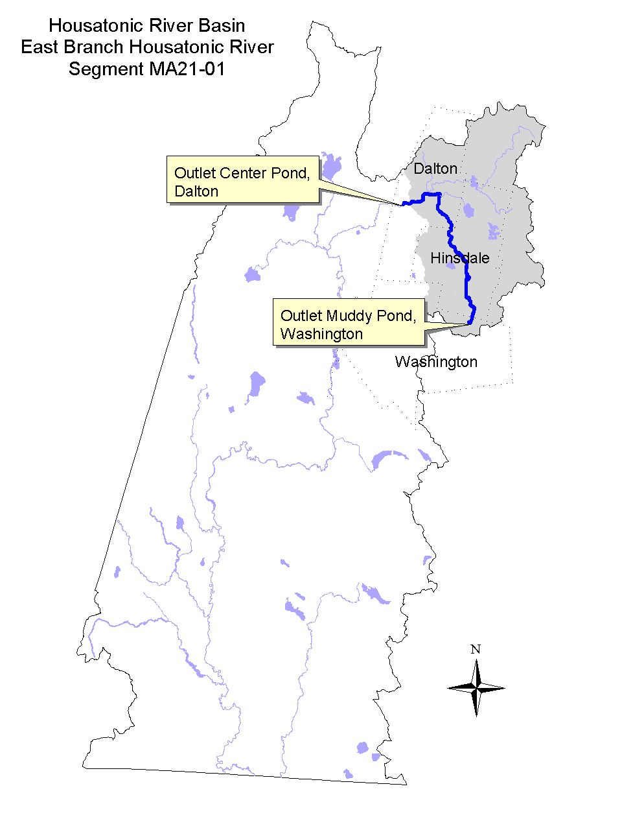

Land-use estimates for the subwatershed (map inset, gray shaded area):
Forest | 80%
Agriculture | 6%
Residential | 5%

Land-use estimates in the 100’ riparian zone from the streambanks:
Wetlands | 41%
Forest | 32%
Residential | 10%

WITHDRAWALS AND DISCHARGES

Stormwater:
- MAR05A048 - Dufour Escorted Tours in Hinsdale applied for a general stormwater permit (Berkshire Regional Planning Commission 1999).

USE ASSESSMENT

Historically, this segment of the East Branch Housatonic River had received untreated wastewater as it flowed through the center of Hinsdale (DEQE 1981). According to the 1981 Housatonic River Water Quality Management Plan, the raw sewage discharge from Hinsdale was eliminated in June 1977 when Hinsdale was connected into the Dalton sewer system which then conveys sewage for treatment to the Pittsfield WWTP. The Town of Hinsdale is currently undergoing expansion of their sewer service area around both Ashmere Lake and Plunkett Reservoir (Berkshire Regional Planning Commission 1999). Additionally, there is a State Revolving Fund (SRF) Project listed for Hinsdale, the Ashmere Lake Collector Sewers. When construction is completed this should result in improved conditions along this segment. Without any recent fecal coliform bacteria data, however, this segment was not assessed for either the Primary or Secondary Contact Recreational Use.

GE Pittsfield collects water from this segment of the East Branch Housatonic River at the bridge on Old Dalton Road just off Route 8 in Hinsdale which they use as dilution water for their effluent toxicity tests.

- Ambient toxicity testing - Survival of the cladaceron, Daphnia pulex, exposed to East Branch Housatonic River water (48-hour) has been 100% in the 30 tests conducted between January 1991 and December 1998 (Dallaire 2000). Dilution water physical/chemical data from this segment of the river were as follows: pH ranged from 6.3 to 8.2 SU, alkalinity between 30 and 128 mg/L, hardness between 40 and 140 mg/L. There were no detectable concentrations of ammonia-nitrogen in any of the samples analyzed (all measurements <0.1 mg/L), and there were low concentrations of total suspended solids (<1.0 to 18 mg/L). Only one chloride measurement exceeded 15 mg/L. Conductivity ranged from 80 to 300 μmho/cm with one exception (450 μ mho/cm).

- Fishery Management Policy - According to the Western Wildlife District of the DFWELE, there is no management plan for the East Branch Housatonic River due to contamination issues (Bell 1999). However between Bullards Crossing Road in Hinsdale and the East Branch Housatonic River’s confluence with Cleveland Brook, DFWELE’s current management policy calls for multiple spring stockings of brook, brown and rainbow trout. The Western Wildlife District classified the stream as a stable, coldwater fishery.

- Tissue Chemistry - Fish tissue burdens of total PCB in yellow perch and trout collected upstream of Center Pond (station F1A) in 1980 and 1982 did not exceed 0.31 mg/kg wet weight (Stewart Laboratories, Inc. 1982).

Based on these data the Aquatic Life Use is assessed as support. The Aesthetics Use is also evaluated as support based on field reconnaissance, land-use data and low concentrations of total suspended solids.

- Fish Consumption Advisory – The state issued a fish consumption advisory for the Housatonic River in 1982. The advisory recommended that the general public should not consume fish, frogs and turtles from the Housatonic River between Dalton and Sheffield because of PCB contamination. In 1995, DPH updated their advisory to include a recommendation that fish taken from feeder streams to the Housatonic River should be trimmed of fatty tissue prior to cooking (MA DPH 1999). Because of this advisory, the Fish Consumption Use is not supported in the East Branch Housatonic River from the Dalton/Hinsdale town line and the outlet of Center Pond in Dalton. Upstream of the Dalton/Hinsdale line, the Fish Consumption Use is not assessed.

Designated Use Status: East Branch Housatonic River (Segment MA21-01)
Aquatic Life |  | SUPPORT. The entire 9.0 mile length of this segment is evaluated as supporting this use.
Fish Consumption |  | NOT ASSESSED. The upper 7.5 miles of this segment is not assessed for this use.  NOT SUPPORT. The lower 1.5 miles of this segment do not support this use because of the DPH advisory to eat no fish, frogs and turtles due to PCB contamination from Dalton to Sheffield.
Primary Contact |  | not assessed.
Secondary Contact |  | not assessed.
Aesthetics |  | SUPPORT. The entire 9.0 mile length of this segment is evaluated as supporting this use.

RECOMMENDATIONS: EAST BRANCH HOUSATONIC RIVER (Segment MA21-01)

- Conduct fecal coliform bacteria sampling to assess the status of the Primary and Secondary Contact Recreational uses after the completion of the sewer service area expansion around both Ashmere Lake and Plunkett Reservoir.
- Protect the surface water resources. Consider development of a management plan for the Hinsdale Flats Watershed ACEC.
- The BRPC report entitled Assessment of Land-use Activities and Nonpoint Source Pollution in the Housatonic River Watershed contains an up-to-date summary of existing and potential nonpoint sources of pollution in the Housatonic River Basin (Berkshire Regional Planning Commission 1999). The potential pollution sources identified in this report (e.g., Table IV-13 and pages IV-41-43) should be reviewed to help design future monitoring plans for East Branch Housatonic River subwatershed.
- The DPH fish consumption advisory to eat no fish, frogs and turtles from the Housatonic River from Dalton to Sheffield because of PCB contamination results in the Fish Consumption Use being assessed as non-support. Whether or not the biota in the East Branch Housatonic River upstream of Center Pond in Dalton are contaminated by PCB is currently being investigated by EPA as part of their Ecological Risk Assessment. The DPH should review the results of this investigation and adjust the fish consumption advisory as needed.

EAST BRANCH HOUSATONIC RIVER (Segment MA21-02)
Location: Outlet of Center Pond, Dalton to confluence with the Housatonic River, Pittsfield.
Segment Length: 7.9 miles. Classification: Class B, Warm Watery Fishery.

Segment DESCRIPTION

This segment of the East Branch Housatonic River begins at the outlet of Center Pond in Dalton, and flows in a westerly direction where it is impounded by six dams associated with the mills of the Crane & Co., Inc. Paper Makers. The dams were once used by the company for the diversion of water for supply or power production. From upstream to downstream the dams can be identified as follows: Byron Weston Mill Dam #1, Byron Weston Mill Dam #2, Old Berkshire Mill Dam #3, Pioneer Mill Dam #4, Bay State Mill Dam #5 and the Government Mill Dam #6 (Noel 1999). The permitting for the possible breach of the Old Berkshire Mill Dam #3 has been initiated. An evaluation of the other dams between (not including) #1 and #6 is planned by the company and a phased approach for either their breach or repair will be done. The Crane & Co., Inc. treated process wastewater discharge to the East Branch Housatonic River is located in between the Bay State and Government Mill Dams. The river flows through these impoundments in Dalton, then crosses into the city of Pittsfield, and passes by the USGS gage at Coltsville. From there, the East Branch Housatonic River turns and meanders in a southerly direction, receiving the flow from Barton Brook from the east and Unkamet Brook from the northwest. The river then turns and meanders in a westerly direction, where it receives flow from Brattle Brook from the southeast, is bordered by the GE Pittsfield facility along its northern bank and runs adjacent to the Pittsfield landfill. The river then continues in a southwesterly direction through Pittsfield to its confluence with the mainstem Housatonic River.
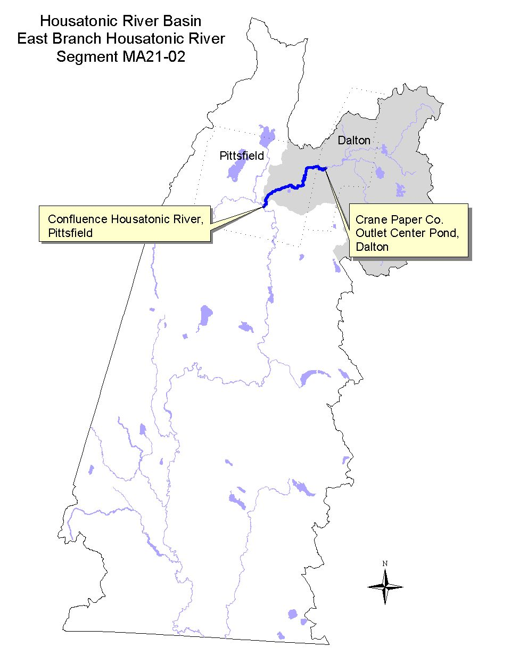

Land-use estimates for the subwatershed (map inset, gray shaded area):
Forest | 71%
Residential | 10%
Agriculture | 6%

Land-use estimates in the 100’ riparian zone from the streambanks:
Wetlands | 32%
Residential | 17%
Industrial | 15%

GE Company Pittsfield Waste Site Cleanup
In 1981, DEP Bureau of Waste Site Cleanup (BWSC) issued an Administrative Consent Order designating the GE Company Pittsfield and the river as a hazardous waste site because of severe PCB contamination (Steenstrup 1999). Under the Massachusetts Contingency Plan (MCP), DEP established the following GE sites as priority disposal sites under M.G.L. c. 21E on the following dates (MA DEP 1995):

East Street Area II on February 24, 1986
East Street Area I on November 6, 1987
Housatonic River on January 9, 1988
Unkamet Brook on April 7, 1988
Newell Street Area I on December 6, 1988
Hill 78 Landfill Area on January 11, 1990
GE/Facility (Remainder/General) on February 5, 1990
Lyman Street Parking Lot on December 20, 1990
Allendale School Yard on November 20, 1991
Newell Street Area II on August 4, 1993
Former Oxbows A, B, C, E, F, J and K on January 28, 1994

Highly contaminated sediment and riverbank soils in the vicinity of Building 68, located at the GE facility were removed in 1998 (Steenstrup 1999). Additional contaminated sediments and riverbank soils in the stretch from Newell Street down to the Lyman Street Bridge (known as the “1/2 mile stretch”) were scheduled for removal commencing in late summer/early fall 1999 and expected to be completed by June 2001. In 1999, however, additional dense non-aqueous phase liquids (DNAPL) were found at sites along the river in the “1/2 mile stretch”. Prior to initiating the cleanup effort additional source control measures in the form of sheetpiling, and the installation of additional recovery wells were implemented to ensure that sources of contamination to the river (both Light NAPL and DNAPL) would be contained. Source control activities were undertaken in the East Street Area II, Newell Street Parking Lot and the Lyman Street Parking Lot sites. These measures were required to prevent recontamination of the river by sources adjacent to the river after the excavation and capping effort in the river is completed (Steenstrup 1999). Due to the segmented nature of the cleanup activities, the magnitude of PCB contamination in the river is ever changing.

WITHDRAWALS AND DISCHARGES

WMA:
- WMA Reg. #10207002 for Crane & Co., Inc. to withdraw a total of 2.97 MGD of water from three surface water intakes (two at the Byron Weston and one at the Pioneer Mill) and seven groundwater wells.
- WMA Permit #9P10223601 for Altresco Pittsfield L.P., to withdraw a total of 1.58 MGD of water from four wells.

NPDES:
- MAG250956 – issued September 1995 to Crane & Co., Inc. Byron Weston Mill’s discharge via outfall #001 of non-contact cooling water to the East Branch Housatonic River. (This discharge was formerly permit # MA0000680 which is now closed.) The facility discharges a maximum of 1.1MGD average monthly flow (1.65 MGD daily maximum flow) with a maximum daily temperature (T) limit of 83°F. The permit also states that the instream rise in temperature due to the discharge shall not exceed Δ T of 5°F. Outfall # 003 (non-contact cooling water discharge from turbine condenser cooling) is no longer permitted.
- MAG250955 – issued September 1995 to Crane & Co., Inc. Pioneer Mill discharge via outfall #001 of non-contact cooling water to the East Branch Housatonic River. (This discharge was formerly permit # MA0000663 which is now closed.) The facility discharges 0.576 MGD average monthly flow (0.864 MGD daily maximum flow) with a maximum daily temperature (T) limit of 83°F. The permit also states that the instream rise in temperature due to the discharge shall not exceed Δ T of 5°F.
- MA0000671 - issued in September 1989 to the Crane & Co., Inc. authorizing the discharge of treated process wastewater via outfall # 001 to the East Branch Housatonic River. Although there is no flow limit in the permit, the discharge ranges between 3.0 and 5.5 MGD. The permit limits for whole effluent toxicity are LC₅₀ > 100% and CNOEC > 63% effluent. EPA and DEP are currently developing a new permit.
- MA0035718- issued in September 1993 to Lockheed Martin and subsequently transferred to General Dynamics Defense Systems, Inc. (GDDS) authorizing the discharge via outfall #011 of ordnance plant treated process water, non-contact cooling water, cooling tower blowdown and stormwater runoff to the East Branch Housatonic River. This permit was terminated on 16 February 1999 by EPA since GDDS discontinued all process discharges to outfall #011-1, 011-T, 012-1 and 12-T and physically removed outfalls 011-G and 012-G (LeBeau 1999). Remaining stormwater discharges are currently permitted under the Multi-Sector General Stormwater Permit # MAR05B285.
- MA0003891 - issued in May 1992 to the General Electric Company (GE), Pittsfield authorizing the discharge of the following:
*Outfall #001-for a maximum daily flow up to 2.55 MGD of non-contact cooling water and stormwater runoff into Silver Lake,
*Outfall #004- for a maximum daily flow up to 2.09 MGD of contact and non-contact cooling water and stormwater runoff into Silver Lake,
*Outfall #005- for a maximum daily flow up to 1.08 MGD of contact and non-contact cooling water, treated process wastewater, treated groundwater and stormwater runoff into the East Branch Housatonic River,
*Outfall #007- report the maximum daily and average monthly discharge of non-contact cooling water and stormwater runoff into the East Branch Housatonic River with a maximum daily temperature limit of 75°F,
*Outfall #009- report the maximum daily and average monthly discharge of non-contact cooling water, treated process water and stormwater runoff into Unkamet Brook, and
#Outfalls 05A and 006- monitoring of the maximum daily discharge of non-process water from the operation of barrel screens to the East Branch Housatonic River.
*Note: Denotes that a composite sample will be made by combining discharges from these outfalls and outfall #011 in NPDES permit MA0035718 for Lockheed Martin into a 24-hour proportionate-to-flow composite sample. This composite sample shall be tested for acute and chronic toxicity. The acute toxicity tests are to be conducted monthly with a NOAEL (where 90% or more of the test organisms survive after 48 hours) is > 35% effluent. (One acute test per quarter, however, is to be conducted under wet weather conditions -- a monitoring only requirement.) The results of the chronic tests conducted in July, August, and September are to be reported only (no limit).

Only outfalls #005 and 009 currently discharge from MA0003891. Stormwater discharges are covered under the general stormwater permit MAR05A021. Tentatively, this NPDES permit will be reissued in 2000.

Stormwater (facilities listed in Berkshire Regional Planning Commission 1999 unless otherwise noted):
- MAR00B300 Test Track Garage General Defense Systems Inc. General Dynamics in Dalton.
- MAR00B298 OP8 General Defense Systems Inc. General Dynamics in Dalton.
- MAR00B299 OP3 General Defense Systems Inc. General Dynamics in Pittsfield.
- MAR00A214 General Electric Company Lyman Street Parking Lot in Pittsfield.
- MAR05B184 Pittsfield Generating Co. LP in Pittsfield.
- MAR00A796 Altresco Pittsfield LP in Pittsfield.
- MAR05B199 Berkshire Regional Transportation Authority in Pittsfield (MA DEP 2000b).
- MAR05A537 The Lane Construction Corporation in Pittsfield.
- MAR05A010 The USPS Springfield District, Pittsfield VMF in Pittsfield.

USE ASSESSMENT

Artificial substrate sampling devices were deployed in triplicate by DEP DWM biologists both upstream (station 21-EBH01) and downstream (station 21-EBH02) of the Crane & Co., Inc. WWTP discharge in August 1997(Appendix B, Table B1). The samplers were left instream for approximately six weeks, during which time the substrates were colonized by invertebrates, and were retrieved in October 1997. A comparison of the invertebrates found at the downstream station to those upstream was conducted to evaluate differences in these communities that might be attributable to the discharge. Whole effluent toxicity testing data from Crane & Co., Inc. (required by their NPDES permit) from February 1993 and 1999 was also reviewed (Dallaire 2000). The last dam owned by Crane & Co., Inc. is located on the East Branch Housatonic River downstream from their treated process wastewater discharge (approximately 200m upstream of Hubbard Avenue Pittsfield). Downstream from this dam, the East Branch Housatonic River runs adjacent to the Pittsfield landfill and the GE Company Pittsfield (including Lockheed Martin) facility down to its confluence (just downstream of Pomeroy Avenue Bridge) with the mainstem Housatonic River in Pittsfield. PCB data from sediments and biota have been collected by various agencies as part of the GE Company Pittsfield waste site cleanup investigations.

The USGS NAWQA study site (which included both fish tissue and sediment sampling data) on the East Branch Housatonic River was located downstream from the GE Pittsfield facility nearer to the confluence of the East Branch with the mainstem Housatonic River (Harris 1997and Coles 1998).

- Ambient toxicity testing - Survival of the cladaceron, Ceriodaphnia dubia, test organisms exposed to East Branch Housatonic River water collected from the bridge on South Street in Dalton for seven days has been >90% in the 25 tests conducted between February 1993 and 1999 (Dallaire 2000). Fathead minnow (Pimephales promelas), test organisms survival has been >83%. Dilution water physical/chemical data from this segment of the river were as follows: pH ranged from 7.2 to 8.3 SU, alkalinity between 32 and 128 mg/L, hardness between 52 and 164 mg/L. Ammonia-nitrogen concentrations were low ranging between <0.02 and 0.84 mg/L. Total suspended solids were generally below detection although two samples analyzed were slightly elevated (29 mg/L). Conductivity ranged from 126 to 322 μmho/cm. These data were generally within the same range of those reported in the GE Pittsfield dilution water samples collected in the East Branch Housatonic River in the upstream segment (MA21-01).

- Bioassessment/Habitat - The Crane & Co., Inc. WWTP discharge was found to be causing moderate impacts to the benthic macroinvertebrate community in the East Branch Housatonic River (Appendix D). The communities were found to be significantly different based on the statistical analysis, and substantially different when the taxa lists and the relative abundances of various organism types found at the two stations were compared. There was an abundance of naidid worms at the downstream station, which are fairly tolerant of low oxygen conditions. None were found at the upstream site. There was a substantial layer of floc on the artificial substrates at the downstream site (Szal 2000). Oxygen transmission through the floc to the substrates was most likely less than optimal, perhaps rendering the substrates inhospitable to organisms that need higher concentrations of dissolved oxygen to survive. No attempt was made to quantify the depth of floc or the distance downstream from the discharge that the floc persisted.

Crane & Co., Inc. WWTP
- Effluent Toxicity Testing: Between February 1993 and 1999, the Crane & Co., Inc. WWTP discharge has generally met the acute whole effluent toxicity limit of LC₅₀ >100 % (with one exception in the 25 test events) although chronic toxicity (< 63% effluent) has been documented sporadically (Dallaire 2000). The Crane WWTP discharge has induced chronic toxicity to C. dubia in seven of the 25 tests events. The CNOEC results in those seven tests ranged from 6.25 to 50% effluent.
- Field sampling observations: On the two occasions in the summer/fall of 1997, DEP DWM biologists observed an abundance of rust-colored floc in the treatment plant clarifiers, coating the discharge canal, and coating the bottom of the streambed downstream of the discharge.

GE Company, Pittsfield
- Effluent Toxicity Testing: The effluent toxicity tests from the GE Company in Pittsfield are conducted on composite samples (flow-weighted) from various outfalls (see above for permit requirements) which actually discharge into three different waterbodies (Unkamet Brook, Silver Lake and the East Branch Housatonic River). Because of this, the whole effluent toxicity testing data cannot be used to evaluate potential instream impacts to the East Branch Housatonic River for the purpose of this water quality assessment report.

- Fishery Management Policy - According to the Western Wildlife District of the DFWELE, there is no management plan for the East Branch Housatonic River due to contamination issues (Bell 1999).

- Sediment Quality - The following data from this segment of the East Branch Housatonic River were collected prior to waste site cleanup remediation activities as described in the segment description. Total PCB concentrations in the 525 sediment samples (collected to a depth of < 1ft.) analyzed as part of the GE Company Pittsfield waste site cleanup investigations ranged between 0.02 and 9411 PPM dry weight (Stefanosky 1999). Ninety-eight percent of the samples exceeded the L-EL of 0.07 PPM. Forty-nine percent of the samples exceeded the S-EL of 5.3 PPM* and 12% of the samples exceeded the S-EL of 53 PPM*. It should be noted, however, that the majority of the contamination (and sampling) is below the Newell Street Bridge. In the 21 samples collected in the East Branch Housatonic River upstream of Newell Street, total PCB ranged between 0.02 and 1.8 PPM, dry weight. Twenty-four percent of these samples were less than the L-EL of 0.07 and no samples exceeded the S-EL.

Additionally, USGS as part of their NAWQA study, analyzed sediment collected from the East Branch Housatonic River near its confluence with the mainstem Housatonic River. The concentration of total PCB was 13,000 PPM (Harris 1997). This sediment sample was comprised primarily of sand (87%) and silt (12%).
*Note: The S-EL guideline for PCB varies depending on the total organic carbon content (TOC) in the sample. Results have been summarized above using a conservative TOC estimate of 1% (where the S-EL = 5.3 PPM) and the maximum guidance allowable TOC of 10% (where the S-EL = 53 PPM).

Several heavy metals (Cu, Pb, Hg, and Ni) in East Branch Housatonic River sediment collected as part of the GE Company Pittsfield waste site cleanup investigations between Center Pond and Hubbard Avenue exceeded the L-EL guidance in Persaud et al. 1993 (Blasland, Bouck & Lee, Inc. 1996). Between the “boomed” area near East Street and the Pomeroy Avenue Bridge over the East Branch Housatonic River the following metals also exceeded the L-EL guidance: As, Cu, Cr, Hg, Ni, Pb and Zn. Both Cu and Pb exceeded the S-EL guidance (as high as 129 and 15,500 PPM, respectively) in sediment collected at the Lyman Street Bridge. Similar results were documented in the USGS NAWQA study (Harris 1997). These concentrations were also “enriched” (enrichment ratios or ERs > 1 based on normalization to aluminum concentration) above average crustal concentrations.

- Tissue Chemistry - Fish tissue burdens of total PCB in sunfish, yellow perch, and bass collected approximately from the outlet of Center Pond and downstream of the Hubbard Avenue Bridge (station F1B) in 1980 and 1982 were as high as 2.7 PPM (Stewart Laboratories, Inc. 1982). The concentration of PCB in the trout sample collected in 1982 was 135 PPM.

NAQWA - The concentration of PCB in the whole fish composite sample (comprised of eight white suckers, Catastomas commersoni) was 55,000μg/kg wet weight (Coles 1998). This level of PCB greatly exceeded (110 times) the NAS/NAE guideline for total PCB (in Coles 1998) of 500μg/kg wet weight for the protection of fish-eating wildlife.

EPA initiated an Ecological Risk Assessment investigation that included sampling of river biota at a variety of trophic levels (including fish, frogs, and ducks) in 1998. The results of this ongoing investigation are not yet available.

Based on the high survival of organisms exposed to East Branch Housatonic River water, the Aquatic Life Use is assessed as support upstream of the Crane WWTP discharge. Downstream from the Crane & Co. Inc., WWTP discharge, the Aquatic Life Use is assessed as non-support due to moderate impacts to the benthic macroinvertebrate community (attributable to the discharge) and severe PCB sediment contamination (from the GE Pittsfield facility).

- Fish Consumption Advisory – The state issued a fish consumption advisory for the Housatonic River in 1982. The advisory recommended that the general public should not consume fish, frogs and turtles from the Housatonic River between Dalton and Sheffield because of PCB contamination. In 1995, DPH updated their advisory to include a recommendation that fish taken from feeder streams to the Housatonic River should be trimmed of fatty tissue prior to cooking (MA DPH 1999). Because of this advisory, the Fish Consumption Use is not supported in this segment of the East Branch Housatonic River.

- Aesthetics – Downstream from the Crane & Co., Inc. WWTP discharge, floc was observed coating the streambed of the East Branch Housatonic River (Szal 2000). The spatial extent of this problem was not determined. Further downstream, the East Branch Housatonic River has been impaired in the past by oil sheens and visual turbidity problems in the reach between the confluence with Unkamet Brook and the confluence with the mainstem Housatonic River in Pittsfield. Although sheens have diminished considerably in frequency, during the past year the GE Pittsfield Company remediation activities have been initiated in the “½ mile stretch” between Newell Street and Lyman Street (Steenstrup 2000). Additionally DNAPL have been found in the “½ mile stretch” during the ongoing river cleanup activities. Due to the remedial actions underway in the East Branch Housatonic River, the Aesthetics Use is not assessed at this time.

Designated Use Status: East Branch Housatonic River (Segment MA21-02)
Aquatic Life |  | SUPPORT. The upper 2.3 mile reach of this segment is evaluated as supporting this use. NON-SUPPORT. The lower 5.6 mile length of the segment does not support the use as a result of the Crane and Company, Inc. WWTP discharge and the severe sediment contamination problem with PCB from the GE Pittsfield facility.
Fish Consumption |  | NON-SUPPORT. The entire 7.9 miles of this segment of the East Branch Housatonic River does not support this use because of the DPH fish consumption advisory against eating fish, frogs and turtles in all towns from Dalton to Sheffield because of PCB contamination.
Primary Contact |  | NOT ASSESSED.
Secondary Contact |  | NOT ASSESSED.
Aesthetics |  | NOT ASSESSED.

RECOMMENDATIONS: EAST BRANCH HOUSATONIC RIVER (Segment MA21-02)

- The DPH fish consumption advisory to eat no fish, frogs and turtles from the Housatonic River from Dalton to Sheffield because of PCB contamination results in the Fish Consumption Use being assessed as non-support. Whether or not the biota in the East Branch Housatonic River upstream of the Crane & Co., Inc. dams (which pose a barrier to fish migration) are contaminated by PCB is currently being investigated by EPA as part of their Ecological Risk Assessment. The DPH should review the results of this investigation and adjust the fish consumption advisory as needed.
- The BRPC report entitled Assessment of Land-use Activities and Nonpoint Source Pollution in the Housatonic River Watershed contains an up-to-date summary of existing and potential nonpoint sources of pollution in the Housatonic River Basin (Berkshire Regional Planning Commission 1999). The potential pollution sources identified in this report (e.g., Table IV-13 and pages IV-41-44) should be reviewed to help design future monitoring plans for East Branch Housatonic River subwatershed.

RECOMMENDATIONS - Continued: EAST BRANCH HOUSATONIC RIVER (Segment MA21-02)

Crane & Co., Inc. WWTP:
- Crane & Co., Inc. should substantially reduce the amount of floc being discharged by their WWTP into the East Branch Housatonic River. A concentration-based limit for TSS should be considered for their next NPDES permit. It is highly likely that the solids in the wastewater discharge are having a negative effect on the benthic macroinvertebrate community (Szal 2000).
- The Crane & Co., Inc. NPDES permit requirements for whole effluent toxicity testing should be reduced to one organism (C. dubia) which has been the more sensitive test organism (one exception in 25 tests). The analysis of several effluent variables can also be eliminated in the toxicity testing requirements: Ag, Cd, Cr, Ni, Pb, Cn, and phenols. Although some chronic toxicity has been present in the effluent, DEP DWM personnel recommend that the solids issue should be addressed prior to toxicity issues (Szal 2000).
- The non-contact cooling water permits MAG250956 and MAG250955 for Crane & Co., Inc. should contain monitoring requirements (in development) to evaluate whether or not water quality standards are being met with regard to temperature.

GE Company Pittsfield:
- The GE Company Pittsfield NPDES permit requirements for effluent toxicity testing need to be revised. Each outfall of concern should be tested individually (no flow-weighted composite samples of various outfalls). Permit limits should be developed that are consistent with the Massachusetts Water Quality Standards Implementation Policy for the Control of Toxic Pollutants in Surface Waters. Two test organisms, C. dubia and P. promelas, should be required.
- Continue to monitor the effectiveness of the GE Company Pittsfield waste site cleanup activities and document these results in a comprehensive report including data and analyses.
- EPA is in the process of collecting additional data on river sediments and bank soils from Dalton through Sheffield, although this data is not yet available (expected sometime in 2000). EPA has also been collecting considerable data (sampling in 1998 and 1999) on river biota at a variety of trophic levels (including fish, frogs, and ducks) as part of their Ecological Risk Assessment. Additional data may also be collected in 2000. Review and evaluate these data when available.

CLEVELAND BROOK (Segment MA21-08)
Location: Outlet Cleveland Brook Reservoir, Hinsdale to confluence with East Branch Housatonic River, Dalton. Segment Length 2.3 miles. Classification: Class B.

Segment DESCRIPTION

This Class B brook flows in a generally north then westerly direction from the outlet of the Cleveland Brook Reservoir in Hinsdale to its confluence with the East Branch Housatonic River, approximately one half mile upstream of Center Pond in Dalton. The brook flows through the Wahconah Country Club in its lower reach.
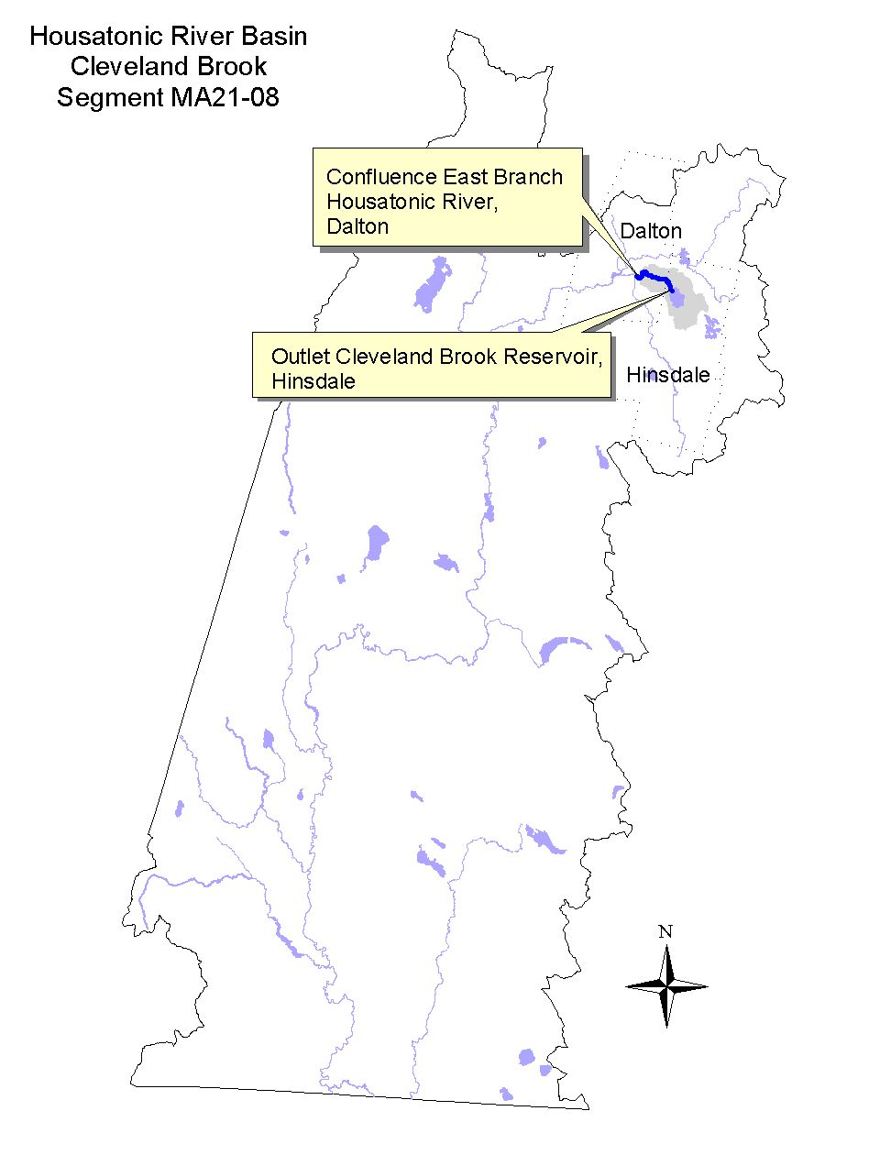

Land-use estimates for the subwatershed (map inset, gray shaded area):
Forest | 76%
Residential and Open Land | 6%
Wetlands and Agriculture | 2%

Land-use estimates in the 100’ riparian zone from the streambanks:
Open Land | 21%
Residential | 19%
Agriculture | 6%

WITHDRAWALS AND DISCHARGES

An unknown volume of water is withdrawn by the Wahconah Country Club which is neither registered nor permitted (Prendergast 1999).

WMA:
- The Pittsfield Water Department is registered (10223601) to withdraw 13.5 MGD of water from six reservoirs (Lower Ashley Intake, Sandwash, Farnham, Sackett, Ashley Lake and Cleveland). Cleveland Reservoir, Pittsfield Water Department’s primary source, has a safe yield of 9.4MGD (14.5 cfs) and an average use of approximately 7.5-8.0 MGD (11.6 - 12.4 cfs) (Prendergast 1999).

USE ASSESSMENT

The following information has been excerpted from the 1992 Housatonic River Tributary Biomonitoring Survey Assessing instream impacts to biota from surface water supply withdrawals report (Kennedy et al. 1993).
The first order tributary from the outlet of Cleveland Reservoir, Cleveland Brook, was sampled on 5 August 1992. The flow appeared to be similar to that which was noted during the July reconnaissance survey. Stream discharge measured 1.3 cfs. The water quality of Cleveland Brook was the most well buffered of all the stations in the Dalton/Hinsdale area. Deposition on the streambed was responsible for the slightly lower habitat score at this station. Deposition appeared to be a result of very steep banks on one side of the stream as well as road sand runoff on the downstream side of the bridge. The benthic macroinvertebrate community was well balanced with a richness of 17 families and the % contribution of the dominant family of only 15. Fish abundance was also excellent at 49.5 fish/100m². Eastern brook trout and brown trout (all age classes) dominated the fish population at this station. One longnose dace was also collected, and many YOY (young-of-the-year) dace were observed.

It should also be mentioned here that Cleveland Reservoir receives the total flow of Windsor Brook through an aqueduct; however, this large volume of flow (approximately 22 cfs) was not evident in Cleveland Brook (approx. 1.3 cfs) at the time of sampling. Cleveland Brook contained flow more representative of a first order stream with a relatively small drainage area (3.3 km²).

Although no sampling has been conducted in Cleveland Brook by DWM since 1992, conditions are believed to be similar since the upper watershed is protected as a public surface water supply.

- Fishery Management Policy – According to Western Wildlife District of the DFWELE, there is no management policy for Cleveland Brook, however it is classified as a coldwater, stable fishery (Bell 1999).

Designated Use Status: Cleveland Brook (Segment MA21-08)
Aquatic Life |  | SUPPORT. The entire 2.3 mile length of this segment is evaluated as supporting this use.
Fish Consumption |  | not assessed.
Primary Contact |  | not assessed.
Secondary Contact |  | not assessed.
Aesthetics |  | SUPPORT. The entire 2.3 mile length of this segment is evaluated as supporting this use.

RECOMMENDATIONS: CLEVELAND BROOK (Segment MA21-08)

- If the DFWELE endorses, in the next revision of the Massachusetts Surface Water Quality Standards, designate Cleveland Brook as a Cold Water Fishery.
- Minimize road (sand) runoff using stormwater BMPs.
- Determine volume of withdrawal by Wahconah Country Club. If withdrawal exceeds WMA threshold, develop permit.
- Encourage Wahconah Country Club to participate in a program similar to the National Audubon Society’s Cooperative Sanctuary Program that recognizes golf courses that employ ecologically sound land management and conservation of natural resources (Berkshire Regional Planning Commission 1999).
- The BRPC report entitled Assessment of Land-use Activities and Nonpoint Source Pollution in the Housatonic River Watershed contains an up-to-date summary of existing and potential nonpoint sources of pollution in the Housatonic River Basin (Berkshire Regional Planning Commission 1999). The potential pollution sources identified in this report (e.g., Table IV-13 and pages IV-41-44) should be reviewed to help design future monitoring plans for East Branch Housatonic River subwatershed.

Pittsfield Water Department
- In 1998, approximately 74% of the Pittsfield Water Department supply was withdrawn from Cleveland Reservoir (LeVangie 2000). The Pittsfield Water Department should implement water conservation/water supply system efficiency recommendations as described in the DEM report entitled Water Resources of the Housatonic River Basin: Water Use and Hydrology (MA DEM 1999).

CADY BROOK (Segment MA21-12)
Location: Source, Peru to Windsor Reservoir, Hinsdale. Segment Length: 3.5 miles.
Classification: Class A.

Segment DESCRIPTION

Cady Brook originates in a small wetland in the northeast corner of Peru. This Class A stream meanders in a generally northwesterly direction through northern Hinsdale. An aqueduct is located on Cady Brook near a small impoundment approximately 0.5 miles upstream of Windsor Reservoir. The aqueduct diverts water into Cleveland Brook Reservoir.
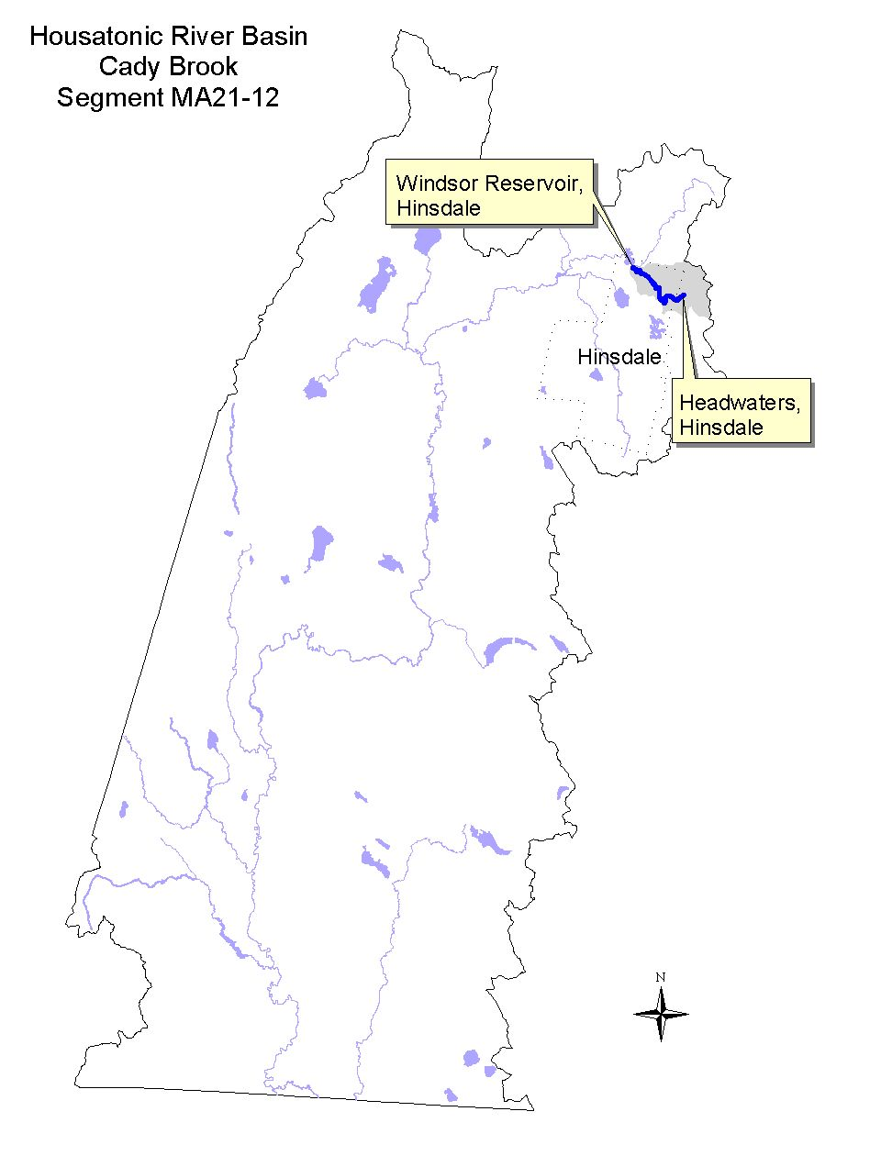

Land-use estimates for the subwatershed (map inset, gray shaded area):
Forest | 96%
Open Land | 2%
Wetlands and Residential | 5%

Land-use estimates in the 100’ riparian zone from the streambanks:
Forest | 89%
Wetlands | 10%
Open Land | 1%

WITHDRAWALS AND DISCHARGES

WMA:
- The City of Pittsfield owns two aqueducts one of which draws water from Cady Brook. These aqueducts are very old and have never had any withdrawal restrictions (Prendergast 1999). The water is directed into Cleveland Reservoir. In 1998 the Pittsfield Water Department withdrew 7.89 MGD of water from Cleveland Reservoir out of a system-wide total of 10.67MGD (LeVangie 2000).

USE ASSESSMENT

The following information has been excerpted from the 1992 Housatonic River Tributary Biomonitoring Survey Assessing instream impacts to biota from surface water supply withdrawals report (Kennedy et al. 1993). Sampling of Cady Brook was conducted off of New Windsor Road in Hinsdale (upstream of the aqueduct withdrawal).

Cady Brook, a small third order tributary with a drainage area of 7.5 km², was sampled as a regional reference station on 5 August 1992. Stream flow (3.8 cfs) appeared to have subsided some from the previous day's heavy rains. Although hardness and alkalinity were still low, pH was near neutral (6.8). Habitat was rated as excellent overall, although there appeared to be a slight lack of defined pools and streamside cover. The macroinvertebrate community appeared to be evenly distributed and rich in intolerant organisms. Three species of fish were collected. Species present, in order of abundance, included eastern brook trout, blacknose dace and one brown trout. Although only one brown trout was collected, it appeared to be a native fish, as it was much smaller (approximately 100 mm in length) than those normally stocked by the Massachusetts Division of Fisheries and Wildlife (MDFW). A total of fifty eight fish (not including YOY) were collected in this reach (39 fish/100m²), and it was obvious that many YOY dace were passing through the nets.
Although no sampling has been conducted in Cady Brook by DWM since 1992, conditions are believed to be similar since the watershed is protected as a public surface water supply.

- Fishery Management Policy – According to Western Wildlife District of the DFWELE, there is no management policy for Cady Brook which was last stocked with rainbow trout in 1974 (Bell 1999). Fish sampling in 1995 confirmed the presence of slimy sculpin and brook trout. The stream is classified as a coldwater, stable fishery.

Designated Use Status: Cady Brook (Segment MA21-12)
Aquatic Life |  | SUPPORT. The upper 3.0 mile length of this segment is evaluated as supporting this use.  NOT ASSESSED. The lower 0.5 mile length of this segment is not assessed.
Fish Consumption |  | NOT ASSESSED.
Drinking Water | 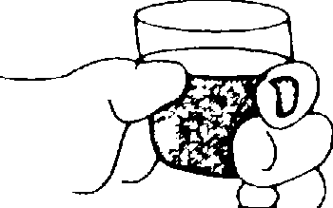 | The DEP Drinking Water Program maintains current drinking water supply data.
Primary Contact |  | NOT ASSESSED.
Secondary Contact |  | NOT ASSESSED.
Aesthetics |  | SUPPORT. The upper 3.0 mile length of this segment is evaluated as supporting this use.  NOT ASSESSED. The lower 0.5 mile length of this segment is not assessed.

RECOMMENDATIONS: CADY BROOK (Segment MA21-12)

- Designate Cady Brook as a Cold Water Fishery, with DFWELE support, in the next revision of the Massachusetts Surface Water Quality Standards.
- The BRPC report entitled Assessment of Land-use Activities and Nonpoint Source Pollution in the Housatonic River Watershed contains an up-to-date summary of existing and potential nonpoint sources of pollution in the Housatonic River Basin (Berkshire Regional Planning Commission 1999). The potential pollution sources identified in this report (e.g., Table IV-13 and pages IV-41-44) should be reviewed to help design future monitoring plans for East Branch Housatonic River subwatershed.

Pittsfield Water Department
- Determine how much water the Pittsfield Water Department withdraws from Cady Brook via the aqueduct. In 1998, approximately 74% of the Pittsfield Water Department supply was withdrawn from Cleveland Reservoir. The actual volumes from the Cady and Windsor Brook aqueduct sources are currently unknown.
- Optimize the aqueduct withdrawal practices to maintain a minimum streamflow in Cady Brook. This should be a priority for the Pittsfield Water Department which is currently well below their registered volume of 13.5 MGD.
- Collect additional data to document the frequency, duration and severity of low-flow conditions and occurrences of de-watered streambeds below the aqueduct withdrawal on Cady Brook. Document this information via photographs and/or stream depth and velocity measurements.
- DEP DWM should explore the necessity of the Pittsfield Water Department filing for a WMA permit for these aqueduct diversions.
- The Pittsfield Water Department should implement water conservation/water supply system efficiency recommendations as described in the DEM report entitled Water Resources of the Housatonic River Basin: Water Use and Hydrology (MA DEM 1999).

WINDSOR BROOK (Segment MA21-09)
Location: Source, southeast of Fobes Hill (west of Savoy Hollow Road), Windsor to the Windsor Reservoir, Hinsdale. Segment Length: 5.6 miles. Classification: Class A.

Segment DESCRIPTION

Windsor Brook, a Class A waterbody, originates in the Windsor State Forest and flows in a generally southwesterly direction towards Hinsdale. An aqueduct is located on Windsor Brook approximately 0.2 miles upstream of Windsor Reservoir. The aqueduct diverts water into Cleveland Brook Reservoir.
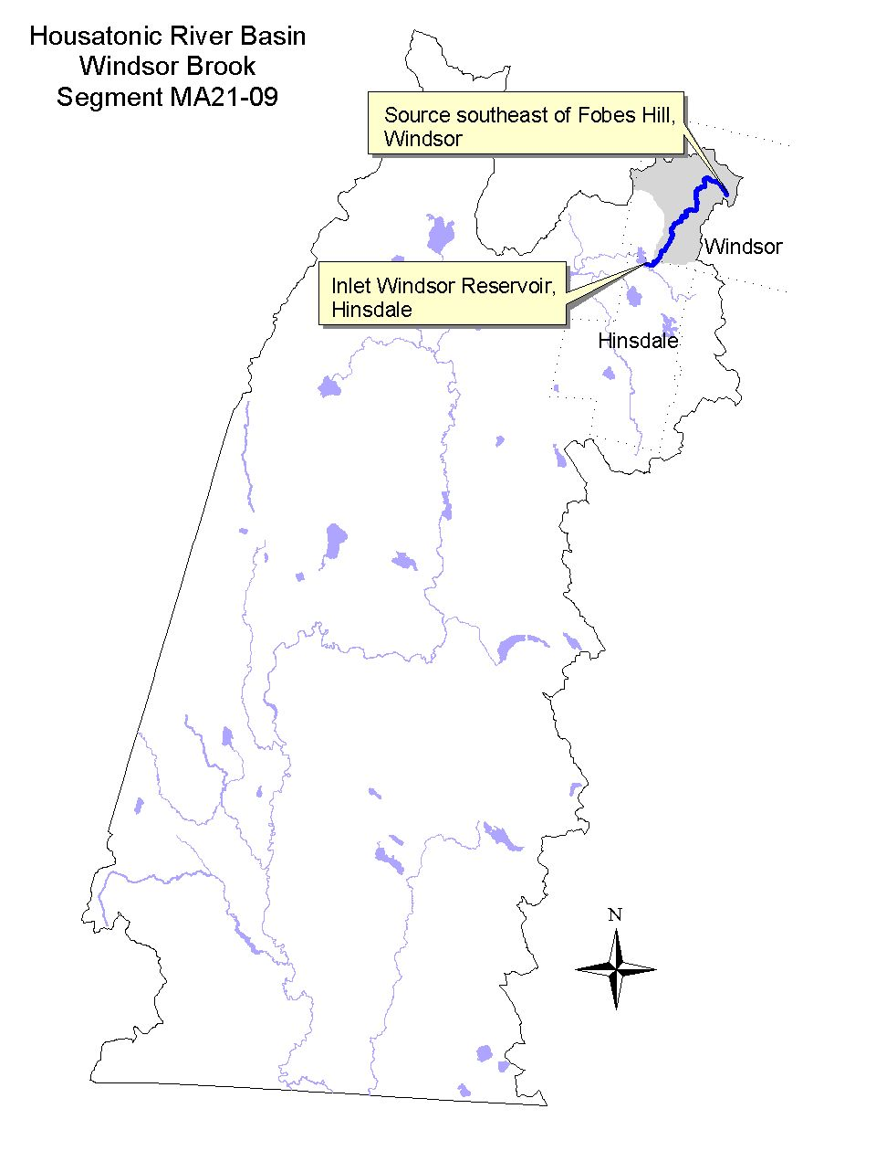

Land-use estimates for the subwatershed (map inset, gray shaded area):
Forest | 84%
Wetlands and Residential | 3%
Open Land | 2%

Land-use estimates in the 100’ riparian zone from the streambanks:
Forest | 73%
Wetlands | 19%
Agriculture | 7%

WITHDRAWALS AND DISCHARGES

WMA:
- The City of Pittsfield owns two aqueducts one of which draws water from Windsor Brook. These aqueducts are very old and have never had any withdrawal restrictions (Prendergast 1999). The water is directed into Cleveland Reservoir. In 1998 the Pittsfield Water Department withdrew 7.89 MGD of water from Cleveland Reservoir out of a system-wide total of 10.67MGD (LeVangie 2000).

USE ASSESSMENT

The following information has been excerpted from the 1992 Housatonic River Tributary Biomonitoring Survey Assessing instream impacts to biota from surface water supply withdrawals report (Kennedy et al. 1993).

Windsor Brook, a large third order stream (drainage area = 24.6 km²), is currently being diverted into Cleveland Reservoir. This regional reference site had a streamflow of 22.5 cfs on 5 August 1992 that appeared consistent with what was noted during the July reconnaissance survey. The stream appeared to be better buffered in comparison to the Egypt Brook and Anthony Pond Brook systems with an alkalinity of 27 mg/L as CaCO₃ and a pH of 7.5. The habitat was excellent, although the canopy was primarily open at the site. The benthos were found to be diverse and well-balanced with the dominant family comprising only 21% of the sample. Electroshocking efficiency was rated poor (<50% pick-up) due to the width of the stream. Two electroshocking units would have been more appropriate at this site. Eastern brook trout dominated the collection at this station. One longnose dace was collected, however, due to the poor electrofishing efficiency, other longnose dace and additional species may have been present in Windsor Brook.
The aqueduct on Windsor Brook, which supplies water to Cleveland Reservoir, has resulted in the elimination of approximately 0.25 miles of the brook. At the time of the field survey at WB01, the entire flow of Windsor Brook (22.5 cfs) was shunted through the aqueduct.

Although no sampling has been conducted in Windsor Brook by DWM since 1992, conditions are believed to be similar since the watershed is protected as a public surface water supply.

- Fishery Management Policy – According to Western Wildlife District of the DFWELE, the current management policy for Windsor Brook consists of spring stocking of brook trout (Bell 1999). No DFWELE survey data is available although the stream is classified as a coldwater, stable fishery.

Designated Use Status: Windsor Brook (Segment MA21-09)
Aquatic Life |  | SUPPORT. The upper 5.4 mile length of this segment is evaluated as supporting this use.  NON-SUPPORT. The lower 0.2 mile length of the segment does not support the use because of flow alteration (de-watered/dry streambed) below the aqueduct.
Fish Consumption |  | not assessed.
Drinking Water |  | not assessed.
Primary Contact |  | not assessed.
Secondary Contact |  | not assessed.
Aesthetics |  | SUPPORT. The upper 5.4 mile length of this segment is evaluated as supporting this use.  NOT ASSESSED. The lower 0.2 mile length of the segment is not assessed

RECOMMENDATIONS: WINDSOR BROOK (Segment MA21-09)
- Designate Windsor Brook as a Cold Water Fishery, with DFWELE support, in the next revision of the Massachusetts Surface Water Quality Standards.
- The BRPC report entitled Assessment of Land-use Activities and Nonpoint Source Pollution in the Housatonic River Watershed contains an up-to-date summary of existing and potential nonpoint sources of pollution in the Housatonic River Basin (Berkshire Regional Planning Commission 1999). The potential pollution sources identified in this report (e.g., Table IV-13 and pages IV-41-44) should be reviewed to help design future monitoring plans for East Branch Housatonic River subwatershed.

Pittsfield Water Department
- Determine how much water the Pittsfield Water Department withdraws from Windsor Brook via the aqueduct. In 1998, approximately 74% of the Pittsfield Water Department supply was withdrawn from Cleveland Reservoir. The actual volumes from the Cady and Windsor Brook aqueduct sources are currently unknown.
- Optimize the aqueduct withdrawal practices to maintain a minimum streamflow in Windsor Brook. This should be a priority for the Pittsfield Water Department which is currently well below their registered volume of 13.5 MGD. The Pittsfield Water Department should maintain a minimum streamflow in Windsor Brook downstream of the aqueduct.
- Collect additional data to document the frequency, duration and severity of low-flow conditions and occurrences of de-watered streambeds below the aqueduct withdrawal on Windsor Brook. Document this information via photographs and/or stream depth and velocity measurements.
- DEP DWM should explore the necessity of the Pittsfield Water Department filing for a WMA permit for these aqueduct diversions.
- The Pittsfield Water Department should implement water conservation/water supply system efficiency recommendations as described in the DEM report entitled Water Resources of the Housatonic River Basin: Water Use and Hydrology (MA DEM 1999).

WAHCONAH FALLS BROOK (Segment MA21-11)
Location: Outlet of Windsor Reservoir, Windsor to confluence with East Branch Housatonic River, Dalton. Segment Length: 2.7 miles. Classification: Class B.

Segment DESCRIPTION

Wahconah Falls Brook, a Class B High Quality Water, originates at the outlet of Windsor Reservoir in Windsor. The brook flows in a westerly direction through plunge pools and waterfalls along the upstream end of the reach which are part of the Wahconah Falls State Park. The brook continues to flow in a westerly direction and is joined by Weston Brook from the north. From here Wahconah Falls Brook meanders through some agricultural land area, crosses Route 9/8A and picks up flow from the unnamed stream draining Egypt Reservoir, crosses 9/8A again and receives the flow from Anthony Brook. Wahconah Falls Brook then flows into the East Branch Housatonic River at Center Pond in Dalton.
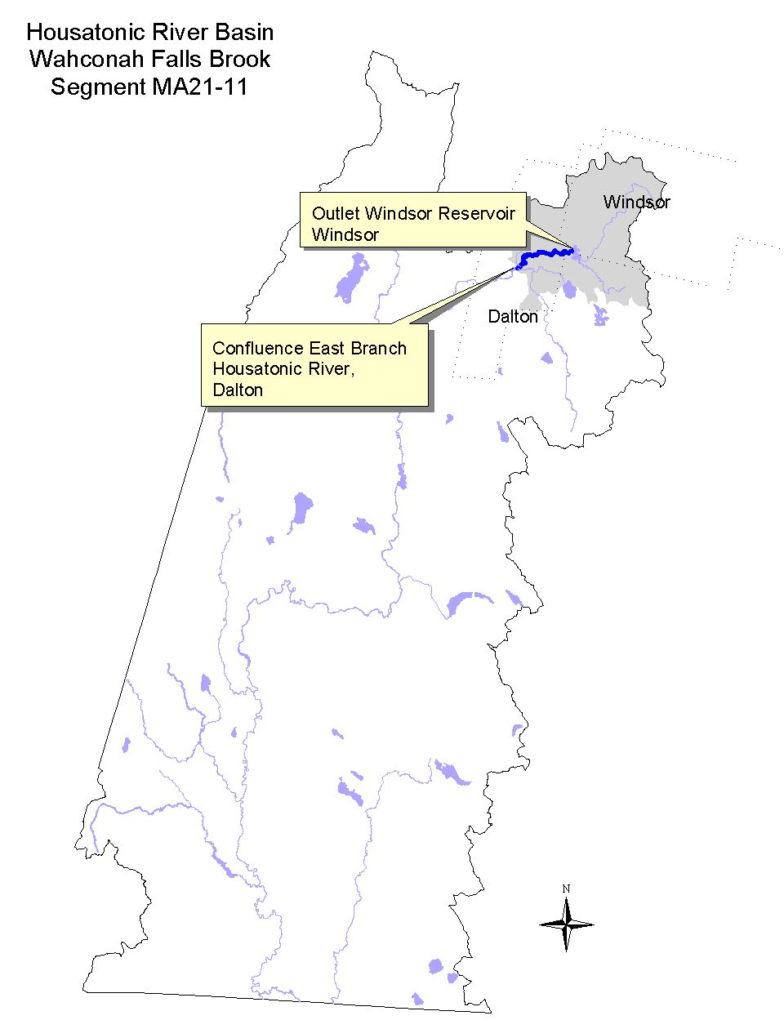

Land-use estimates for the subwatershed (map inset, gray shaded area):
Forest | 84%
Agriculture | 7%
Residential | 4%

Land-use estimates in the 100’ riparian zone from the streambanks:
Forest | 48%
Agriculture | 27%
Wetlands | 11%

WITHDRAWALS AND DISCHARGES

WMA:
- The Dalton Fire District is registered (10207003) to withdraw 0.67 MGD of water from three sources: Anthony Pond and Windsor and Egypt reservoirs. Cleveland Reservoir was removed as a source of water for the District in January 1999 (Prendergast 2000). In 1998 the Dalton Fire District withdrew 0.464 MGD from their three sources as follows: 0.014 MGD from Anthony Pond (locally known as the Anthony Brook Reservoir), 0.273 MGD from Egypt Reservoir, and 0.177 MGD from Windsor Reservoir. Although the District has utilized Egypt Reservoir more heavily within the last few years, Windsor Reservoir is considered the District’s primary source. In addition, the District is also allowed at least 0.69 MGD from the Pittsfield Water system through the Cleveland Reservoir system. In 1998 they obtained a total of 1.678 MGD from the City Pittsfield (LeVangie 2000).
- The Dalton Fire District also has a well source (PWS #1070000-01G) which supplies a mobile home park located just below Windsor Reservoir. The well has a safe yield of 15 GPM. In 1998 the average annual withdrawal was 0.0098 MGD (LeVangie 2000). Since the withdrawal volume of the Trailer Park well is below 100,000 GPD (way below), the well is not subject to the WMA provided the Dalton Fire District overall use does not exceed 0.77 MGD (LeVangie 2000).

USE ASSESSMENT

The following information has been excerpted from the 1992 Housatonic River Tributary Biomonitoring Survey Assessing instream impacts to biota from surface water supply withdrawals report (Kennedy et al. 1993).

Wahconah Falls Brook, a medium sized third order stream (drainage area = 14.7 km²) was sampled on 5 August 1992. Streamflow was about half that of Windsor Brook, at 11.3 cfs. Although pH was slightly low (5.7), water quality was quite similar to that of Windsor Brook as the stream had an alkalinity and hardness of 28 and 34 mg/L as CaCO₃, respectively…. Benthic samples collected from this station appeared to indicate a well-balanced invertebrate community with the dominant taxon contributing only 17% and a taxa richness of 21 families. Stream conditions included slightly colored water, a totally enclosed canopy, and slick substrates that made electroshocking difficult; however, this station still produced the most diverse fish assemblage of all stations sampled. Fish density was also excellent at 19.7 fish/100m². Increased productivity, as evidenced by the extensive coverage of the bottom by periphyton, most likely as a result of the proximity of the station to Windsor Reservoir, was probably responsible for the increased species richness and abundance at this station.

At the time of the 1992 survey, nonpoint source pollution problems were evident at the Wahconah Falls State Park parking area. Washout channels filled with sand and silt were present at the lower end of the parking area a result of road erosion and parking lot runoff. While the runoff did not impact the stream reach sampled (the brook was braided and the island separated the stream reach from the erosion area), the erosion problem needs to be corrected.

Although no sampling has been conducted in Wahconah Falls Brook by DWM since 1992, conditions are believed to be similar in the upper 0.9 miles (to the confluence with Weston Brook). Downstream from this confluence, the uses are not assessed because of the change in land-use (residential and/or agricultural development) and the lack of any water quality data.

- Fishery Management Policy – According to Western Wildlife District of the DFWELE, the current management policy for Wahconah Falls Brook consists of spring stocking of brook trout (Bell 1999). DFWELE fish survey data from 1984 reported nine fish species present dominated by longnose and blacknose dace. Brook and brown trout were also present. The stream is classified as a coldwater, stable fishery.

Designated Use Status: Wahconah Falls Brook (Segment MA21-11)
Aquatic Life |  | SUPPORT. The upper 0.9 mile length of this segment supports this use.  NOT ASSESSED. The lower 1.8 miles are not assessed due to residential and agricultural land-use and a lack of data.
Fish Consumption |  | not assessed.
Primary Contact |  | not assessed.
Secondary Contact |  | not assessed.
Aesthetics |  | SUPPORT. The upper 0.9 mile length of this segment supports this use.  NOT ASSESSED. The lower 1.8 miles are not assessed due to residential and agricultural land-use and a lack of data.

RECOMMENDATIONS: WAHCONAH FALLS BROOK (Segment MA21-11)

- Designate Wahconah Falls Brook as a Cold Water Fishery, with DFWELE support, in the next revision of the Massachusetts Surface Water Quality Standards.
- Determine if stormwater runoff is still causing erosion and sedimentation problems at the Wahconah Falls State Park parking area and if it is currently impacting the brook. Implement (design and construct) stormwater BMPs if necessary.
- Determine via a shoreline survey if livestock currently have access to the stream. Evaluate the stability of the streambanks. Where necessary, stabilization/erosion control measures should be developed and implemented (e.g., BMP projects, education/outreach, etc.)
- Collect bacteria samples at sites throughout the segment including the state park swimming area, bracketing tributaries and major changes in land-use (e.g., livestock grazing areas) on multiple dates to establish current conditions.
- The BRPC report entitled Assessment of Land-use Activities and Nonpoint Source Pollution in the Housatonic River Watershed contains an up-to-date summary of existing and potential nonpoint sources of pollution in the Housatonic River Basin (Berkshire Regional Planning Commission 1999). The potential pollution sources identified in this report (e.g., Table IV-13 and pages IV-41-44) should be reviewed to help design future monitoring plans for East Branch Housatonic River subwatershed.

Dalton Fire District
- The Dalton Fire District should implement water conservation/water supply system efficiency recommendations as described in the DEM report entitled Water Resources of the Housatonic River Basin: Water Use and Hydrology (MA DEM 1999).

ANTHONY BROOK (Segment MA21-10)
Location: Outlet of Anthony Pond (locally known as Anthony Brook Reservoir), Dalton to confluence with Wahconah Falls Brook, Dalton. Segment Length: 2.4 miles. Classification: Class B.

Segment DESCRIPTION

Anthony Brook is a Class B waterbody which originates at the outlet of Anthony Pond (locally known as the Anthony Brook Reservoir) and flows in a southeasterly direction down the southern side of North Mountain. The brook’s direction changes as it approaches the base of the mountain near Holiday Road in Dalton. From here Anthony Brook flows southwest, through farmland, and then southeast prior to its confluence with Wahconah Falls Brook just upstream of Center Pond in Dalton. The lower section of this segment has experienced recent housing development.
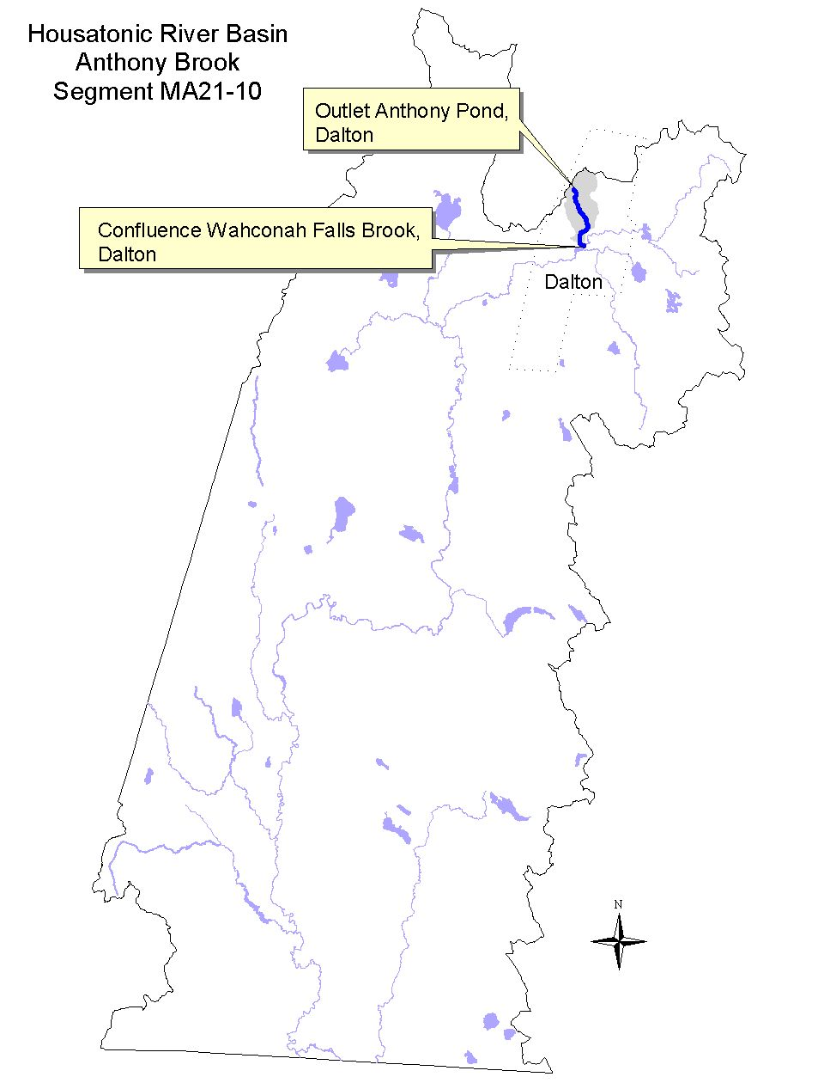

Land-use estimates for the subwatershed (map inset, gray shaded area):
Forest | 90%
Residential | 6%
Open Land | 1%

Land-use estimates in the 100’ riparian zone from the streambanks:
Forest | 71%
Residential | 10%
Agriculture | 6%

WITHDRAWALS AND DISCHARGES

WMA:
- The Dalton Fire District is registered (10207003) to withdraw 0.67 MGD of water from three sources one of which is Anthony Pond. In 1998 the Dalton Fire District withdrew 0.014 MGD from Anthony Pond.

USE ASSESSMENT

The following information has been excerpted from the 1992 Housatonic River Tributary Biomonitoring Survey Assessing instream impacts to biota from surface water supply withdrawals report (Kennedy et al. 1993).

Anthony Brook, a first order stream that runs parallel to the Egypt Reservoir drainage was also sampled on 4 August 1992. The susceptibility of the stream to acidification was evident from the physicochemical data. Alkalinity was below 1.0 mg/L although the pH was higher (5.3) than at the reference station ER01. Habitat, however, was rated as excellent. The macroinvertebrate community was considered non-impacted although the fish density seemed low (8 fish/100m²) based on professional judgement in relationship to the available habitat. Eastern brook trout was the only species collected or observed.

Although no sampling has been conducted in Anthony Brook by DWM since 1992, conditions are believed to be similar since the upper watershed is protected as a public surface water supply.
- Fishery Management Policy – According to Western Wildlife District of the DFWELE, there is no management policy for Anthony Brook, however it is classified as a coldwater fishery (Bell 1999).

Designated Use Status: Anthony Brook (Segment MA21-10)
Aquatic Life |  | SUPPORT. The entire 2.4 mile length of this segment is evaluated as supporting this use.
Fish Consumption |  | NOT ASSESSED.
Primary Contact |  | NOT ASSESSED.
Secondary Contact |  | NOT ASSESSED.
Aesthetics |  | SUPPORT. The entire 2.4 mile length of this segment is evaluated as supporting this use.

RECOMMENDATIONS: ANTHONY BROOK (Segment MA21-10)

- Designate Anthony Brook as a Cold Water Fishery, with DFWELE support, in the next revision of the Massachusetts Surface Water Quality Standards.
- The BRPC report entitled Assessment of Land-use Activities and Nonpoint Source Pollution in the Housatonic River Watershed contains an up-to-date summary of existing and potential nonpoint sources of pollution in the Housatonic River Basin (Berkshire Regional Planning Commission 1999). The potential pollution sources identified in this report (e.g., Table IV-13 and pages IV-41-44) should be reviewed to help design future monitoring plans for East Branch Housatonic River subwatershed.

Dalton Fire District
- The Dalton Fire District should implement water conservation/water supply system efficiency recommendations as described in the DEM report entitled Water Resources of the Housatonic River Basin: Water Use and Hydrology (MA DEM 1999). They should also optimize the flow into Anthony Brook.

HOUSATONIC RIVER (Segment MA21-04)
Location: Confluence of Southwest Branch Housatonic River and West Branch Housatonic River, Pittsfield to Outlet of Woods Pond, Lee/Lenox. Segment Length: 11.3 miles. Classification: Class B, Warm Water Fishery.

Segment DESCRIPTION

The Housatonic River, a Class B warm water fishery, is formed at the confluence of the Southwest Branch Housatonic River and the West Branch Housatonic River near the southwest side of Pittsfield Center. The river meanders in a southeasterly direction, receives the flow from the East Branch Housatonic River, then picks up the flow from the outlet of Morewood Lake. From here the river continues to meander in a generally easterly direction, then turns and meanders south towards Lenox. The river receives flow from Sackett and Sykes brooks prior to passing by the Pittsfield Municipal Wastewater Treatment Plant, located at the southernmost end of the city of Pittsfield near the Lenox town line. The river continues to meander south, receives flow from Mill and Yokun Brooks, and becomes the municipal boundary between Lee and Lenox. The river then enters and flows through Woods Pond. A new outlet structure, constructed in the late 1980s, has replaced the old dam that was originally built by the Smith Paper Company (Wright and DeGabriele 1975). The Smith Paper Company has since become the P.J. Schweitzer Paper Company and is today the Schweitzer-Mauduit Paper Company. The Housatonic River Valley State Wildlife Management Area and the October Mountain State Forest Area encompass a great deal of land area along the Housatonic River in this segment.
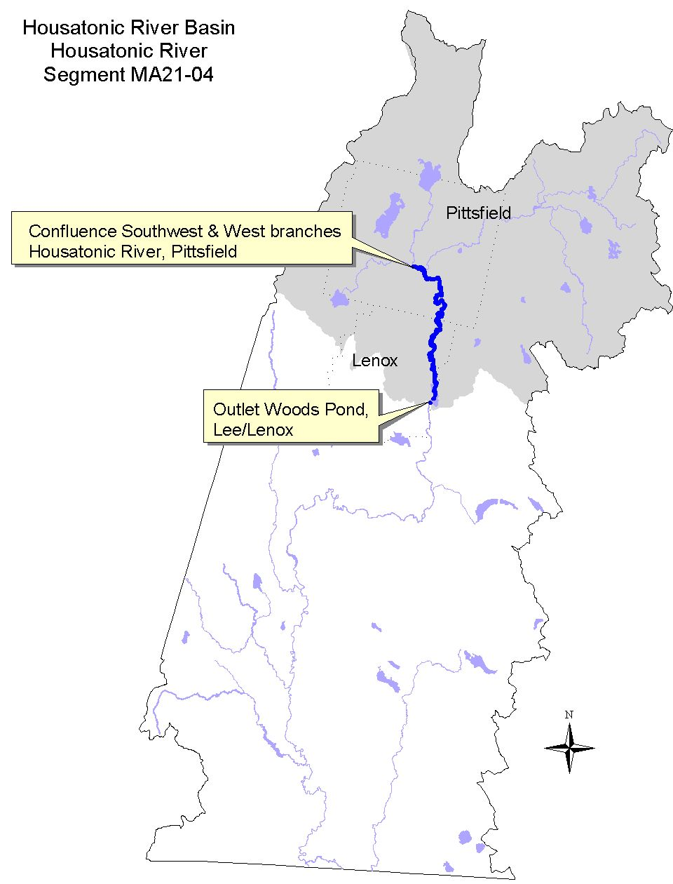

Land-use estimates for the subwatershed (map inset, gray shaded area):
Forest | 68%
Residential | 10%
Agricultural | 8%

Land-use estimates in the 100’ riparian zone from the streambanks:
Forest | 28%
Wetlands | 22%
Agriculture | 4%

WITHDRAWALS AND DISCHARGES

WMA:
Although there are no direct water withdrawals from this segment of the Housatonic River, the Pittsfield Water Department utilizes surface water from the Sackett and Mill brook subwatersheds that are tributaries to this segment of the Housatonic River. Additionally, Pittsfield Country Club is registered (# 10223603) to withdraw 0.12 MGD from Morewood Lake.

NPDES:
- MA0101681 – Pittsfield Wastewater Treatment Plant was issued a permit in September 1990 to discharge via outfall #003 of 17MGD average monthly flow (28.7MGD daily maximum flow) of treated sanitary wastewater to the Housatonic River.

USE ASSESSMENT

Artificial substrate sampling devices were installed in triplicate by DEP DWM biologists both upstream (station 21-HR01) and downstream (station 21-HR02) of the Pittsfield POTW discharge in August 1997 (Appendix B, Table B1). The samplers were left instream for approximately six weeks, during which time the substrates were colonized by invertebrates, and were retrieved in October 1997. A comparison of the invertebrates found at the downstream station to those upstream was conducted to evaluate differences in these communities that might be attributable to the discharge (Appendix D).

The Pittsfield WWTP collects water from two locations in this segment of the Housatonic River: winter sampling at the Pomeroy Avenue Bridge in Pittsfield while the spring/summer/fall sampling is from the Housatonic River on the upstream side of the plant property near the old bridge footings. These river water samples are used as dilution water for the Pittsfield POTW effluent toxicity tests. Whole effluent toxicity testing data from the Pittsfield POTW (required by their NPDES permit) between January 1991 and 1999 was also reviewed (Dallaire 2000).

Downstream from the confluence with the East Branch Housatonic River, the mainstem is severely contaminated with PCB from the GE Company Pittsfield. PCB data from sediments and biota have been collected by various agencies as part of the GE Company Pittsfield waste site cleanup investigations (Roy F. Weston, Inc. 1998). Blasland, Bouck, and Lee, Inc. (1999) collected young-of-the-year fish for PCB analysis in 1994 and 1998 from two locations in this segment of the Housatonic River; station HR2 in the vicinity of the confluence with Roaring Brook and station WP1 in Woods Pond.

The USGS NAWQA study sampled one site in Woods Pond for both fish tissue and sediment in this segment of the Housatonic River (Harris 1997 and Coles 1998).

- Bioassessment/Habitat – The benthic macroinvertebrate community analyses for the Southwest Branch (segment MA21-17) and West Branch (segment MA21-18) Housatonic River, (the headwaters of the mainstem Housatonic River), indicated slight/moderate impairment. Habitat quality imitations (severe embeddedness of cobble substrates and degraded instream and riparian habitat conditions) were also observed (Appendix C).

The DEP DWM analysis of the artificial substrate data found that the invertebrate community downstream of the Pittsfield POTW discharge was 85% comparable to the upstream (reference) station (Appendix D). Differences in the taxa lists were considered minor. Although it was noted that the test station samplers were not always in the direct path of the discharge plume, the discharge did not appear to be causing any impacts to the benthos. Results and the discussion of the benthic macroinvertebrate analysis can be found in Appendix D.

- Ambient toxicity testing –The following data were collected as part of Pittsfield WWTP NPDES permit requirements. Survival of the cladaceron, Ceriodaphnia dubia, test organisms exposed to Housatonic River water (7-day) has been >90% in the 33 tests conducted between January 1991 and 1999 (Dallaire 2000). Fathead minnow (Pimephales promelas), test organism survival has been >87%. Dilution water physical/chemical data from this segment of the river were as follows: pH ranged from 7.3 to 8.0 SU, alkalinity between 33 and 152 mg/L, hardness between 47 and 176 mg/L. Ammonia-nitrogen concentrations were low ranging between <0.02 and 1.0 mg/L. Total suspended solids were generally below detection. The highest measurement was 9 mg/L. Conductivity ranged from 210 to 700 μmho/cm (Dallaire 2000).

- Pittsfield POTW Effluent Toxicity Testing - Between January 1991 and 1999, the Pittsfield WWTP discharge has met the acute whole effluent toxicity limit of LC₅₀ >100 % and chronic toxicity limit (CNOEC) of > 50% effluent. The CNOEC results ranged from 75 to 100% effluent.

- Tissue Chemistry - NAQWA - The concentration of PCB in the whole fish composite sample (comprised of eight white suckers, Catastomas commersoni) was 72,000μg/kg wet weight (Coles, 1998). This level of PCB greatly exceeded (144 times) the NAS/NAE guideline for total PCB (in Coles 1998) of 500μg/kg wet weight for the protection of fish-eating wildlife. Chlordane was not detected in the white sucker composite sample. The DDT concentration was 260μg/kg wet weight, which did not exceed the NAS/NAE guideline for total DDT (in Coles 1998) of 1,000μg/kg wet weight for the protection of fish-eating wildlife.

Blasland, Bouck, & Lee, Inc. (1999) - The concentration of PCB in young-of-the-year fish collected at station HR2 ranged between 15,000 and 40,000 μg/kg wet weight (PPB) in largemouth bass, yellow perch, bluegill and pumpkinseed and at station WP1 between 15,000 and 38,000 μg/kg wet weight (PPB) in largemouth bass, yellow perch, and bluegill. All of these data exceed (30 to 80 times) the NAS/NAE guideline for total PCB (in Coles 1998) of 500μg/kg wet weight for the protection of fish-eating wildlife.

- Sediment Chemistry - PCB data from sediments in the mainstem Housatonic River have been collected by various agencies as part of the GE Company Pittsfield waste site cleanup investigations (Stefanosky 1999). Total PCB ranged between 0.028 and 4.2 PPM dry weight in the 26 samples analyzed in sediment samples collected to a depth of < 1 ft. from the confluence of the Southwest and West Branches of the Housatonic River to the confluence of the East Branch Housatonic River. This represents the upper one-mile of the mainstem Housatonic River. Eighty-nine percent of the samples exceeded the L-EL of 0.07 PPM. None of the samples exceeded the S-EL of 5.3 PPM.

In the reach between the confluence with the East Branch Housatonic River and Woods Pond, total PCB ranged between 0.027 and 278 PPM dry weight in the 376 samples analyzed in sediment samples collected to a depth of < 1 ft. (Stefanosky 1999). Two of the samples were less than or equal to the L-EL of 0.07 PPM. Fifty-eight percent of the samples exceeded the S-EL of 5.3 PPM and 10% of the samples exceeded the S-EL of 53 PPM.

In Woods Pond, total PCB ranged between 0.07 and 210 PPM dry weight in the 42 samples analyzed in sediment samples collected to a depth of < 1 ft. (Stefanosky 1999). One sample was less than the L-EL of 0.07 PPM while 67 and 36% of the samples exceeded the S-EL of 5.3 and 53 PPM, respectively.

High concentrations (20 PPM dry weight) of PCB were also measured (sample collected 15 May 1996) as part of the NAWQA study in the sediment of the Housatonic River in Woods Pond (Breault and Harris, 1997).

- Fishery Management Policy – According to Western Wildlife District of the DFWELE, there is no management policy for the Housatonic River (Bell 1999). Tiger muskie introduced originally in Pontoosuc Lake now reside in this stretch of the river, as do northern pike, and are taken in significant numbers, particularly from Woods Pond, through the ice.

The Aquatic Life Use in this segment of the Housatonic River is evaluated as non-support. The upper 1.0 mile reach is evaluated as non-support based on the extrapolation of the biological data from the Southwest and West Branch Housatonic Rivers. The Aquatic Life Use in the lower 10.3 miles of this segment is evaluated as non-support due to PCB contamination.

- Fish Consumption Advisory - The state issued a fish consumption advisory for the Housatonic River in 1982. The advisory recommended that the general public should not consume fish, frogs and turtles from the Housatonic River between Dalton and Sheffield because of PCB contamination. In 1995, DPH updated their advisory to include a recommendation that fish taken from feeder streams to the Housatonic River should be trimmed of fatty tissue prior to cooking (MA DPH 1999). Because of the DPH advisory, the Fish Consumption Use is not supported in this segment of the Housatonic River.

- Aesthetics - Visual observations of turbidity have been noted along this reach of the Housatonic River by DEP DWM field crew (Appendix B, able B10 - Woods Pond and Appendix D). These observations indicate that in some areas slumped banks were common, as were completely denuded, severely eroded areas. While these conditions are to some extent naturally occurring, they are also most likely exacerbated by stormwater runoff due to urbanization. The Aesthetics Use is evaluated as partial support because of instream turbidity.

Designated Use Status: Housatonic River (Segment MA21-04)
Aquatic Life |  | NON-SUPPORT. The upper 1.0 mile reach of this segment is evaluated as non-support (extrapolated from the biological assessments in the Southwest and West Branch Housatonic Rivers and the lower 10.3 miles of this segment are evaluated as non-support as a result of PCB contamination.
Fish Consumption |  | NOT ASSESSED. Between the confluence of the Southwest and West Branches to the confluence of the East Branch (1 mile), this use is not assessed.  NON-SUPPORT. Downstream from the confluence of the East Branch Housatonic River to the outlet of Woods Pond (10.3 miles) this use is not supported due to PCB contamination (elevated levels of PCB in frogs, fish and turtles) from the GE Company Pittsfield plant.
Primary Contact |  | NOT ASSESSED.
Secondary Contact |  | NOT ASSESSED.
Aesthetics |  | PARTIAL SUPPORT. The entire 11.3 mile length of this segment is evaluated as partial support because of instream turbidity.

RECOMMENDATIONS: HOUSATONIC RIVER (Segment MA21-04)

- Continue to monitor the effectiveness of the GE Company Pittsfield waste site cleanup activities and document these results in a comprehensive report including data and analyses.
- Cleanup goals for the river are currently being finalized in a cleanup agreement between GE Company Pittsfield, EPA and DEP.
- EPA is in the process of collecting additional data on streambed sediments and river bank soils from Dalton through Sheffield, although this data is not yet available (expected sometime in 2000). EPA has also been collecting considerable data (sampling in 1998 and 1999) on river biota at a variety of trophic levels (including fish, frogs, and ducks) as part of their Ecological Risk Assessment. Additional data may also be collected in 2000. Review and evaluate these data when available.
- The BRPC report entitled Assessment of Land-use Activities and Nonpoint Source Pollution in the Housatonic River Watershed contains an up-to-date summary of existing and potential nonpoint sources of pollution in the Housatonic River Basin (Berkshire Regional Planning Commission 1999). The potential pollution sources identified in this report (e.g., Table IV-13 and pages IV-46) should be reviewed to help design future monitoring plans for the Housatonic River subwatershed.

RECOMMENDATIONS - Continued: HOUSATONIC RIVER (Segment MA21-04)

Pittsfield POTW:
- The Pittsfield NPDES permit requirements for whole effluent toxicity testing should be reduced to one organism, (C. dubia), which has been the more sensitive test organism (three of the test events). The minimum detection limit for the Cu and Pb testing, however, is 0.005 mg/L. The analysis of several effluent variables can also be eliminated in the toxicity testing requirements: Ag, Cd, Cr, Ni, Cn, and phenols.

Pittsfield Water Department:
- The Pittsfield Water Department is registered (10223601) to withdraw 13.5 MGD of water from six reservoirs (Ashley Lake, Lower Ashley Intake, Sandwash, Farnham, Sackett, and Cleveland). Effects of these withdrawals on Sackett, Ashley, Mill and Roaring brooks, tributaries to this segment of the Housatonic River, merits further investigation.
- The Pittsfield Water Department should implement water conservation/water supply system efficiency recommendations as described in the DEM report entitled Water Resources of the Housatonic River Basin: Water Use and Hydrology (MA DEM 1999).

HOUSATONIC RIVER (Segment MA21-19)
Location: Outlet of Woods Pond, Lee/Lenox to the outlet of Risingdale Impoundment, Great Barrington Segment Length: 20.0 miles. Classification: Class B, Warm Water Fishery.

Segment DESCRIPTION

From the outlet of Woods Pond, the Housatonic River flows south. It receives the flow from the Lenox WWTP, which has recently been upgraded to accept the flow from the Lenoxdale WWTP. The Lenoxdale WWTP has been decommissioned. In Lee, the river slows as it nears the dam at the Columbia Mill of the Schweitzer-Mauduit Paper Company. Just below this dam the Housatonic River enters the Lee business district, south of which it picks up the flow from Goose Pond Brook. The river then receives the discharge from the Lee WWTP and then Hop Brook after which it turns and flows in a westerly direction. The river then is joined by Beartown Brook from the south (draining part of Beartown State Forest) and the Mead Corporation – Specialty Paper Division Laurel Mill discharge on its northern bank. Just before it leaves Lee, the river is slowed down by the Willow Mill Dam at Mead’s Willow Mill. Downstream of the dam the river receives the treated discharge of the Willow Mill. The river winds its way west through the center of Stockbridge and receives the discharge from the Stockbridge WWTP just upstream of its confluence with Larrywaug Brook, the outlet stream of Stockbridge Bowl. In western Stockbridge, the velocity of the mainstem is slowed by the dam in Glendale Village that is once again being operated as a hydroelectric facility. Downstream of this dam, the Housatonic River turns south and enters Great Barrington. The Housatonic River enters the village of Housatonic, flows adjacent to the Monument Mills buildings and again becomes impounded by the Rising Pond Dam marking the end of this segment.
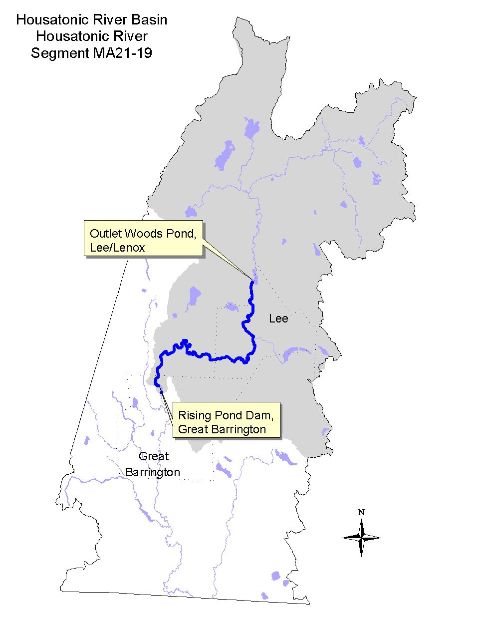

Land-use estimates for the subwatershed (map inset, gray shaded area):
Forest | 70%
Residential | 9%
Agriculture | 8%

Land-use estimates in the 100’ riparian zone from the streambanks:
Forest | 29%
Open Land | 8%
Wetlands | 7%

WITHDRAWALS AND DISCHARGES

WMA:
- Permit #9P210215002/Registration #10215002 for Schweitzer-Mauduit International, Inc. authorizing a system-wide withdrawal of 6 MGD from three wells (located near the Housatonic River between Woods Pond and Lenoxdale) and two surface waters sources (the Housatonic River near the Columbia Mill and Laurel Lake). Wells #2 and #4, are located near to the outlet of Woods Pond. In 1993, an average of 1.3 MGD was withdrawn from these two sources while more recently (1997 and 1998) slightly less water (1.1 and 1.0 MGD, respectively) has been withdrawn (Prendergast 1999). The third Schweitzer-Mauduit well #5, installed in 1991, provided 0.5 MGD of water to the paper company. Withdrawals from well #5, which has an approved rate of 1.44 MGD, was as high as 0.88 MGD (1996 average annual withdrawal). The facility typically withdraws just over 2.0 MGD of water from the Housatonic River at the Columbia Mill intake for their operations. Approximately 1.4 MGD of water was withdrawn from Laurel Lake in 1993, while 0.14 and 0.29 MGD of water is discharged via outfalls 007 and 006, respectively (according to the flow schematic for Eagle Mill in the facilities NPDES reapplication file). These estimates indicate that approximately 30% of the water withdrawn from Laurel Lake is overflow. Average annual withdrawals from Laurel Lake between 1995 and 1998 have ranged between 1.0 and 1.2 MGD.
- Permit #9P10215001/Registration #10215001 for Mead Corporation – Specialty Paper Division. The company withdraws water from a total of six sources (system-wide withdrawal of 3.82 MGD) which supplies their two paper mills. Their sources include the following: two wells (the Boiler House Spring and Morart Warehouse Well) and four surface water sources (two small tributaries to Beartown Brook -- East and West Brooks, an intake from the Housatonic River at “river pumphouse lagoon” at the Laurel Mill and an intake in the basement of the Willow Mill from a canal running underground from the dam at the Willow Mill). The water supply to the Willow Mill includes the Willow Mill Spring (rated for 0.036 MGD, actual average daily withdrawal in 1998 was 0.012 MGD), a withdrawal from the Housatonic River (approved for 1.87 MGD, actual average daily withdrawal in 1998 was 0.81 MGD) and the average annual daily withdrawal from the two tributaries to Beartown Brook, East and West Brooks, in 1998 was 0.42 MGD. The approved rate of withdrawal from these sources is 0.45 MGD. The Morart Well has not been used since 1986.

NPDES:
- MA0100935 -- The Lenox Wastewater Treatment Plant discharges via outfall #001 0.91MGD average monthly flow of treated sanitary wastewater to the Housatonic River. This permit was issued in December 1985. The facility was recently upgraded to accept the flow from the Lenoxdale WWTP. The tie-in of the Lenoxdale WWTP flow was completed on March 31, 1998.
- MA0100943 – The Lenoxdale (Plant #2) Wastewater Treatment Plant discharge of 0.28 MGD was eliminated. The plant was decommissioned as of March 31, 1998.
- MA0005371 – issued September 1989 to Kimberly-Clark Corporation. A transfer of ownership on 30 November 1995 to Schweitzer-Mauduit International, Inc. The facility is engaged in the manufacturing of specialty paper and pulp. The facility is comprised of five mills; Eagle, Niagara, Columbia, Pulp, and Greylock Mills as well as a tailrace lagoon. A brief description of the facility’s five discharges (upstream to downstream) follows:
Outfall #008 – overflow from Niagara Mill fire protection canal
Outfall #002 – primary wastewater treatment plant effluent from Eagle, Niagara, Columbia Mills as well as the tailrace water. Combined flow of 3.47 MGD to the Housatonic River.
Outfall #003 – secondary wastewater treatment plant effluent from the Pulp and Greylock Mills of 1.6 MGD to the Housatonic River.
Outfall #006 – overflow from Laurel Lake, clear well storage
Outfall #007 – overflow from Laurel Lake, tower storage
The effluents from outfalls #002 and 003 (the primary and secondary wastewater treatment plant discharges) are flow composited for effluent quality monitoring required in the NPDES permit. The combined effluent limit for acute whole effluent toxicity is LC50 >100% and the CNOEC limit is > 15% effluent. The conventional pollutant limits (BOD, TSS, and phosphorus) are expressed in lbs/day rather than concentration based limitations (mg/L).
- MA0100153 – The Lee Wastewater Treatment Plant discharges via outfall #001 1.0 MGD (design flow in the 1994 permit) to the Housatonic River. The permit limit for whole effluent toxicity was LC₅₀ > 100% and the total residual chorine limit was 0.3 mg/L (monthly average) and 0.5 mg/L daily maximum. The dilution available to the facility discharge was 26 MGD (40.4 cfs). This facility is expanding and a new permit will be issued for a discharge of 1.5 MGD of treated wastewater.
- MA0001911 – The Southdown Corporation (formally Lee Lime Corporation) on Marble Street in Lee discharges to an unnamed swamp. Flow monitoring of the discharge is required in June. The permit expired in 1984 and has been administratively continued.
- MA0001716 – issued December 1995 to Mead Corporation – Specialty Paper Division – Laurel Mill authorizing the discharge of 2.0 MGD (average monthly flow) of treated paper mill wastewaters, boiler blowdown and excess treated river water via outfall #001 (2.5 MGD maximum daily flow) to the Housatonic River near the railroad trestle crossing. The Laurel Mill also currently discharges (maximum daily) up to 0.1 MGD of river water filter backwash via outfall #002 to the Housatonic River at the “river pumphouse lagoon”. The plant was upgraded in 1998 and the maximum daily discharge via outfall #001 is <2.0 MGD. The permit will be reissued in 2000.
- MA0001848 – issued December 1995 to Mead Corporation – Specialty Paper Division --Willow Mill authorizing the discharge of 1.5 MGD (average monthly flow) of treated paper mill wastewater and boiler blowdown via outfall #001 (2.0 MGD maximum daily flow) to the Housatonic River downstream from the Willow Mill Dam. The facility plans to upgrade the treatment system in 2000.
- MA0101087 – The Stockbridge Wastewater Treatment Plant discharges an average of 0.25 MGD (design flow of 0.32 MGD) via outfall #001 to the Housatonic River just upstream of its confluence with Larrywaug Brook in Stockbridge. The facility is operating under their old permit (signed June 1986) until a new permit is reissued. The facility upgraded to UV for disinfection in June 1986. The facility has not yet been required to conduct toxicity tests on their effluent. A Comprehensive Wastewater Management Plan (CWMP) is funded (SRF Project) that should include oil and grease removal issues (currently lacking) and septage waste from Tanglewood and other establishments that hydraulically shock the plant. Infiltration and inflow problems into the sewer collection system is significant and currently being studied. Waste sludge, grit, and screenings continue to be disposed of at the local landfill.

Stormwater:
- MAR05A884 – Schweitzer-Mauduit International, Inc. Columbia Mill in Lee
- MAR05A896 – Schweitzer-Mauduit International, Inc. Columbia Mill in Lee
- MAR05A885 – Schweitzer-Mauduit International, Inc. Eagle Mill in Lee
- MAR05A897 – Schweitzer-Mauduit International, Inc. Eagle Mill in Lee
- MAR05A886 – Schweitzer-Mauduit International, Inc. Greylock Mill in Lee
- MAR05A894 – Schweitzer-Mauduit International, Inc. Greylock Mill in Lee
- MAR05A887 – Schweitzer-Mauduit International, Inc. Niagara Mill in Lee
- MAR05A895 – Schweitzer-Mauduit International, Inc. Niagara Mill in Lee
- MAR05B465 – Mead Corporation Specialty Paper Division Laurel Mill in Lee
- MAR05B366 – Mead Corporation Specialty Paper Division Willow Mill in Lee
- MAR05A536 – The Lane Construction Corporation in Lee

Other:

Federal Energy Regulatory Commission (FERC) Permit
- P-2801 – The Glendale Project is authorized to operate as a “run-of-the-river” plant with no drawdown of the pool behind the existing dam; the outflow below the powerhouse shall at all times be equal to the inflows into the impoundment above the dam. A Water Quality Certification Revision for this hydroelectric facility (formerly known as Monument Mills Hydroelectric facility) was issued by DEP with these clarifications: a) the project be operated with no drawdown of the impoundment behind the existing dam, b) that a minimum of 10 cfs flow required for fisheries be maintained in the 2750 ft. main river channel parallel to the intake canal, and c) that the gates to the intake canal be open only when conditions a and b above are satisfied (McMahon 1986).

USE ASSESSMENT

Artificial substrate sampling devices were installed in triplicate by DWM biologists both upstream (station 21-HR03) and downstream (station 21-HR04) of the Schweitzer-Mauduit Company discharge in August 1997 (Appendix B, Table B1). The samplers were left instream for approximately six weeks, during which time the substrates were colonized by invertebrates, and were retrieved in October 1997. A comparison of the invertebrates found at the downstream station to those upstream was conducted to evaluate differences in these communities that might be attributable to the discharge.

Data from the following facilities who collect river water from this segment of the Housatonic River for use as dilution water in their effluent toxicity tests and have conducted whole effluent toxicity tests as specified in their NPDES permits was reviewed (Dallaire 2000):
- Schweitzer-Mauduit International, Inc. collects water from the inlet before their bar rack intake at the Columbia Mill dam. Data from the Schweitzer-Mauduit International, Inc. facility collected between January 1993 and April 1999 was reviewed.
- Lee WWTP collects water from the Housatonic River between 50 and 100 yards upstream of their WWTP outfall. Data from the Lee POTW between May 1995 and December 1998 was reviewed.
- The Mead Corporation Specialty Paper Division operates two mills on the Housatonic River in South Lee—the Laurel Mill and the Willow Mill. The company collects water from the Housatonic River just upstream of its confluence with Beartown Brook (upstream of both facilities) used as dilution water for both mill’s toxicity tests. Whole effluent toxicity testing data from both the Laurel and Willow Mills between July 1995 and March 1999 was reviewed.

The mainstem Housatonic River is contaminated with PCB from the GE Company Pittsfield. PCB data from sediments and biota have been collected by various agencies as part of the GE Company Pittsfield waste site cleanup investigations (Stefanosky 1998). Blasland, Bouck, and Lee, Inc. (1999) collected young-of-the-year fish samples for PCB analysis in 1998 from Glendale Dam.

A compliance review of flow releases at the Glendale Project by the Federal Energy Regulatory Commission was initiated in October 1998 (Springer 2000). Their review included an analysis of project operations and streamflow conditions relating to the Glendale Project license requirements for run-of-river.

- Bioassessment/Habitat – An upstream/downstream evaluation of the Schweitzer-Mauduit International, Inc. outfalls #002/003 was conducted by DWM biologists in the late summer of 1997. The discharge(s) was found to be causing moderate impacts to the benthic macroinvertebrate community. Results and the discussion of the benthic macroinvertebrate analysis can be found in Appendix D. One of the effluent discharges (either outfall 002 or 003) was opaque; resembling clay-colored milk. While water clarity upstream of the discharge was fine, visibility was reduced downstream of the discharge.

The two other discharges from the Schweitzer-Mauduit International, Inc. facility, outfalls #006 and 007, were located downstream of the benthic macroinvertebrate test station.

- Ambient Toxicity Testing - Schweitzer-Mauduit International, Inc. - The facility collects water from the inlet before their bar rack intake at the Columbia Mill dam in this segment of the Housatonic River. These river samples are used as dilution water for their effluent toxicity tests. Survival of the cladaceron, Ceriodaphnia dubia, test organisms exposed to Housatonic River water (7-day) has been >70% in the 26 tests conducted between January 1993 and April 1999. Fathead minnow (Pimephales promelas), test organism survival has been >80%. Dilution water physical/chemical data from this location were as follows: pH ranged from 7.0 to 8.2 SU, alkalinity between 42 and 152 mg/L, hardness between 47 and 144 mg/L. Ammonia-nitrogen concentrations were low ranging between <0.02 and 0.33 mg/L. Total suspended solids were generally low although two of 27 measurements exceeded 25 mg/L (the highest 190 mg/L). Conductivity ranged from 149 to 482 μmho/cm (Dallaire 2000).

The Lee WWTP discharges to the mainstem Housatonic River downstream of its confluence with Goose Pond Brook in Lee. The facility collects water for testing from the Housatonic River between 50 and 100 yards upstream of their WWTP outfall. Survival of the cladaceron, C. dubia, test organisms exposed to Housatonic River water (48 hour) has been >95% in the 14 tests conducted between May 1995 and December 1998. Fathead minnow (P. promelas) test organism survival has also been >95%. Dilution water physical/chemical data from this location were as follows: pH ranged from 7.6 to 8.3 SU, alkalinity between 74 and 160 mg/L, hardness between 69 and 160 mg/L. Ammonia-nitrogen concentrations were generally low ranging between 0.02 and 0.3 mg/L although one measurement was elevated -- 2.5 mg/L. Total suspended solids were generally low (< 12 mg/L) with one exception (55 mg/L). Conductivity ranged from 220 to 588 μmho/cm (Dallaire 2000).

The Mead Corporation Specialty Paper Division, which operates two mills on the Housatonic River in South Lee--the Laurel Mill and the Willow Mill, collects water for testing from the Housatonic River just upstream of its confluence with Beartown Brook (upstream of the Mead facilities). These river samples are used as dilution water for the effluent toxicity tests for both the Laurel and Willow Mills. Survival of the cladaceron, Ceriodaphnia dubia, test organisms exposed to Housatonic River water (7-day) has been >90% in all but one of the 15 tests conducted between July 1995 and March 1999. Fathead minnow (Pimephales promelas), test organism survival, however, has indicated some potential for instream chronic toxicity. Survival of the minnows at 48 hours has been > 90% while survival at the end of the 7-day exposure has ranged between 35 and 100% and survival has been < 70% in almost half of the tests. Dilution water physical/chemical data from this location were as follows: pH ranged from 6.9 to 8.0 SU, alkalinity between 32 and 141 mg/L, hardness between 50 and 166 mg/L. Ammonia-nitrogen concentrations were low ranging between <0.07 and 0.17 mg/L. Total suspended solids were generally low (<5 mg/L) although four of 17 measurements exceeded 25 mg/L. Conductivity ranged from 137 to 538 μmho/cm (Dallaire 2000).

- Effluent Toxicity Testing - The Schweitzer-Mauduit International, Inc. effluent (composite samples of outfalls #002 and 003) has not documented any acute whole effluent toxicity to either C. dubia or P. promelas. Chronic toxicity to C. dubia, however, has been documented with results ranging between <6.25 to 100 % effluent. While 20 of 26 test events indicated some level of chronic toxicity, three of the results did not meet the CNOEC limit of > 15% effluent (Dallaire 2000). The most sensitive test organism has been C. dubia.

The Lee WWTP discharge did exhibit acute toxicity to both C. dubia and P. promelas in one of 14 test events (LC₅₀ = 82 and 71% effluent respectively) and a second P. promelas test just met the permit limit LC₅₀ = 100%. The most sensitive test organism has been P. promelas. The Lee WWTP is presently under a Departmental Consent Order to upgrade the facility. The Lee WWTP has received SRF monies for planning to upgrade the treatment plant and to study I/I. These planning and I/I studies are ongoing under the review of DEP Division of Municipal Services. In addition, Lee has applied for additional SRF Money for the year 2000 period, to be used for construction.

The Mead Corporation Specialty Paper Division has conducted quarterly toxicity testing on their treated process wastewater effluents from both the Laurel and Willow Mills since July 1995 as required by their NPDES permits MA0001716 and MA0001848. A summary of the toxicity testing data for the mills follows (Dallaire 2000):

 | Laurel Mill (MA0001716) |  | Willow Mill (MA0001848)
Test Organism | LC50 | C-NOEC | LC50 | C-NOEC
C. dubia | 9.5 - >100% | <6.25 – 100% | <6.25 - >100% | <6.25 – 50%
P. promelas | 43.6 - >100% | 12.5 – 100% | <6.25 - >100% | <6.25 – 100%

Note: Mead Corporation Specialty Paper Division - Because of acute whole effluent toxicity present in the discharges of both the Laurel and Willow Mills, the Mead Corporation Specialty Paper Division was issued an administrative order by EPA (Docket No. 95-09 for the Willow Mill and 95-10 for the Laurel Mill) requiring that a Scope of Work and Schedule for attaining and maintaining compliance with the limitations and conditions of the NPDES permits. The schedule specifically required the following:
“Provisions and schedule deadlines for conducting a Toxicity Identification Evaluation (TIE) and a Toxicity Reduction Evaluation (TRE)…the outcome of the TIE and TRE shall be the identification of those pollutants causing acute and chronic toxicity to the effluent and the proposal of remedial action and a schedule for eliminating or treating those pollutants so as to comply with the Permit. Also in the Willow Mill Docket—Provisions and schedule deadlines for attaining and maintaining compliance with the effluent limitation for total zinc contained in the Permit.”

The Mead Corporation Specialty Paper Division has conducted the studies and has upgraded their wastewater treatment plant at the Willow Mill (installation completed in December 1998). Acute toxicity is still problematic at the Willow Mill on a very sporadic basis (appears to be associated with a production line infrequently used). The facility is working on solving this issue. The corporate headquarters has also recently approved their request to upgrade their wastewater treatment plant at the Laurel Mill. Construction of the upgrade will be complete by the end of 2000.

Additional environmental issues being addressed by the company: Mead pretreats their river water intake (average annual daily withdrawal of 1.5 MGD in 1998) for use in manufacturing processes at the Laurel Mill facility. Pretreatment consists of chlorination and aluminum sulfate (alum) addition followed by filtration through four sand filter beds. The filters are backwashed and presently discharged back to the Housatonic River via outfall #002. The filter backwash water contains both aluminum and total residual chlorine. In an effort to reduce total suspended solids in the backwash discharge as well as the temperature in the process discharge, Mead has proposed treatment modifications that would eliminate their discharge via outfall #002. Additionally, the facility has proposed to withdraw water from two deep (800’) (not installed as of 28 July 1999) to replace their river water intakes. This will supply cooler water to their facilities and reduce the thermal loading of their treated process wastewater discharges, from both mills, to the Housatonic River. The temperature limit in their current permits is 90°F, which both facilities occasionally violate when ambient river temperatures are elevated and streamflow is low. The use of chlorine and alum will also be eliminated.

- Water Quantity - Downstream of the Stockbridge WWTP, the Housatonic River continues to meander in a westerly direction until it enters the village of Glendale. Here the river is dammed at the Glendale Project (FERC P-2801), where the “run-of-the-river” hydroelectric generating facility is operated. Manipulation of streamflow was evident at the USGS gage on the Housatonic River at Great Barrington and at the request of a concerned citizen, FERC initiated a compliance review of the Glendale Project. The FERC compliance review found the Glendale Project operated in violation of run-of-river license requirements on many days in both 1998 and 1999 (Springer 2000). Two separate causes of violations were identified in the compliance review: operator action and equipment deficiencies (automatic controller). While many of the equipment difficulties causing operational problems have been repaired (improved data logging and in July/August 1999 changing the minimum flow release method to ¾” water over the dam crest replacing the dam notch), operator induced violations have not yet been resolved.

- Sediment Chemistry- GE Company Pittsfield waste site cleanup investigations - The concentration of total PCB in surficial sediment (less than 12 inches) of the Housatonic River in Rising Pond (also known as Risingdale Impoundment) ranged from detectable levels to 26 PPM (Blasland, Bouck & Lee, Inc. 1991, 1992 and 1996). The sediment total PCB data in the 1992 Addendum report (the only report that included TOC data) did not exceed the S-EL guideline however all the total PCB data exceeded the L-EL guideline (0.07 PPM).

- Tissue Chemistry- GE Company Pittsfield waste site cleanup investigations (Blasland, Bouck, & Lee, Inc. 1999) – The concentration of PCB in young-of-the-year fish collected at Glendale Dam ranged between 940 and 13,000 μg/kg wet weight (PPB) in largemouth bass, yellow perch, bluegill and pumpkinseed. All of these data exceed (2 to 26 times) the NAS/NAE guideline for total PCB (in Coles 1998) of 500μg/kg wet weight for the protection of fish-eating wildlife.

- Fishery Management Policy – According to Western Wildlife District of the DFWELE, there is no management policy for the Housatonic River (Bell 1999). Although the stretch of river between the Woods Pond Dam and the Columbia Mill Dam in Lee may support rainbow trout (suspected to have originated from possible upstream sources including the Southwest Branch Housatonic River, the East Branch Housatonic River, and Pontoosuc Lake), DFWELE indicates that anglers avoid fishing in this area because of the DPH fish consumption advisory (Keefe 2000).

The Aquatic Life Use is evaluated as non-support because of elevated levels of PCB in fish tissue and sediment as well as toxicity and instream impact(s) due to the NPDES discharges along this segment of the Housatonic River. The Aquatic Life Use is also threatened by hydromodification (bypass reach and excessive streamflow fluctuation) downstream of the Glendale Project facility (FERC P-2801).

- Fish Consumption Advisory – The state issued a fish consumption advisory for the Housatonic River in 1982. The advisory recommended that the general public should not consume fish, frogs and turtles from the Housatonic River between Dalton and Sheffield because of PCB contamination. In 1995, DPH updated their advisory to include a recommendation that fish taken from feeder streams to the Housatonic River should be trimmed of fatty tissue prior to cooking (MA DPH 1999). Because of this advisory, the Fish Consumption Use is not supported in this segment of the Housatonic River.

- Aesthetics – Upstream of the Schweitzer-Mauduit International, Inc. discharge (the upper 2.6 miles of this segment), water clarity in pooled areas was at least 4’ therefore the Aesthetics Use is evaluated as support. The effluent from the Schweitzer-Mauduit International, Inc. discharge, however, was completely opaque (resembling clay-colored milk) (Appendix D). The Housatonic River downstream of this discharge was visually turbid (water clarity was approximately 8-12 inches). Visual observations of turbidity have been frequently noted in the past along this reach of the Housatonic River between the Schweitzer-Mauduit International, Inc. discharge and the Mead Corporation Specialty Paper Division Willow Mill dam. In this reach of the river the aesthetic use is evaluated as non-support (6.7 miles). Downstream from this dam in the lower 10.7 miles reach, the Aesthetics Use is not assessed.

Designated Use Status: Housatonic River (Segment MA21-19)
Aquatic Life |  | NON-SUPPORT. The Aquatic Life Use is evaluated as non-support for the entire 20 mile length of this segment because of elevated levels of PCB in fish tissue and streambed sediment as well as impacts associated with NPDES discharges. Hydromodification (streamflow fluctuations) also threatens the biota in the lower 3.6 mile reach (below Glendale Project).
Fish Consumption |  | NON-SUPPORT. The entire 20 mile length of this segment does not support this use because of elevated levels of PCB in frogs, fish and turtles resulting from the GE Company Pittsfield plant.
Primary Contact |  | NOT ASSESSED.
Secondary Contact |  | NOT ASSESSED.
Aesthetics |  | SUPPORT. The upper 2.6 mile reach of this segment supports this use.  NON-SUPPORT. Between the Columbia Mill and Willow Mill dams, this use is not supported because of high instream turbidity (6.7 miles).  NOT ASSESSED. The lower 10.7 miles of this segment is not assessed.

RECOMMENDATIONS: HOUSATONIC RIVER (Segment MA21-19)

- Because of the frequency of the reduced survival of P. promelas in the Housatonic River downstream from the Lee WWTP discharge, additional instream studies (ambient chronic toxicity testing) should be conducted. If significant chronic toxicity is detected, determine cause(s) and source(s) of instream toxicity (e.g., evaluate the mixing zone of the Lee WWTP effluent and its potential to hug the bank, effects of other upstream discharges).
RECOMMENDATIONS - Continued: HOUSATONIC RIVER (Segment MA21-19)

- The BRPC report entitled Assessment of Land-use Activities and Nonpoint Source Pollution in the Housatonic River Watershed contains an up-to-date summary of existing and potential nonpoint sources of pollution in the Housatonic River Basin (Berkshire Regional Planning Commission 1999). The potential pollution sources identified in this report (e.g., Table IV-13 and pages IV-47-49) should be reviewed to help design future monitoring plans for the Housatonic River subwatershed.
- EPA is in the process of collecting additional data on river sediments and bank soils from Dalton through Sheffield, although this data has not yet become available (expected sometime in 2000). EPA has also been collecting considerable data (sampling in 1998 and 1999) on river biota at a variety of trophic levels (including fish, frogs, and ducks) as part of their Ecological Risk Assessment. Additional data may also be collected in 2000.
- Evaluate the possible erosional impacts downstream of the Glendale Project as a result of stream fluctuations. Determine whether streambank stabilization techniques (via S.319 funding) would be effective.

Lenox WWTP
- The NPDES permit needs to be reissued given that the facility was recently upgraded to accept the flow from the Lenoxdale WWTP. Need to determine the instream waste concentration of the new discharge at 7Q10 and establish permit limits (i.e., whole effluent toxicity testing, total residual chlorine, etc.).

Schweitzer-Mauduit International, Inc.
- The water balance provided in the Schweitzer-Mauduit International, Inc. NPDES permit application needs to be reviewed and updated (1994 vs. 1999 changes) as necessary based on the potential increase in production at the facility.
- Approximately 30% of the water withdrawn from Laurel Lake appears to be discharged as overflow water via outfalls #006 and 007. Attempts should be made to minimize the excess withdrawal and subsequent discharges.
- Effluent turbidity and/or total suspended solids in the process wastewater discharge has been documented as being a substantial problem. DEP DWM strongly recommends that this problem be eliminated to improve both the aesthetic quality in the Housatonic River as well as reduce the impacts of this discharge on the benthic macroinvertebrate community. Although some chronic toxicity has been present in the effluent, DEP DWM also recommends that the solids issue should be addressed prior to toxicity issues.
- Depending on location of effluent discharges, consider testing outfall 002 and 003 individually for toxicity. If the outfalls are “combined” prior to the actual discharge, the Schweitzer-Mauduit International, Inc. NPDES permit requirements for whole effluent toxicity testing should be reduced to one organism, C. dubia, which has been the more sensitive test organism. The analysis of several effluent variables can also be eliminated in the toxicity testing requirements: Ag, Cd, Cr, Fe, Ni, Cn, and phenols.
- Since the 1997 instream impact evaluation has shown moderate impacts to the benthos of the Housatonic River downstream from the Schweitzer-Mauduit International, Inc. wastewater treatment plant discharges, consideration should be given to following: imposing a concentration based TSS limit in the permit, requiring a TIE/TRE, and requiring an instream impact evaluation which would also evaluate the zone of impact.

Lee WWTP
- The Lee WWTP NPDES permit requirements for whole effluent toxicity testing should be reduced to one organism, P. promelas, which has been the more sensitive test organism. The analysis of several effluent variables can also be eliminated in the toxicity testing requirements: Al, Cd, Cr, Ni, and Pb. Lead can also be eliminated from the dilution water monitoring requirement.
- Depending on any increases in capacity at the Lee WWTP facility, readjust permit limits as necessary.
RECOMMENDATIONS - Continued: HOUSATONIC RIVER (Segment MA21-19)

Southdown Corporation
- Southdown Corporation (formerly a Lee Lime Corporation), on Marble Street in Lee, has an NPDES permit to discharge to an unnamed swamp presumably in the Willow Brook subwatershed. The original permit expired in 1984 and has been administratively continued.
- A site visit should be conducted at this facility to determine if the individual NPDES permit needs to be reissued or if the facility should apply for coverage under a general permit(s).

Mead Specialty Papers Laurel and Willow Mills
- Continue to monitor the effluents for acute and chronic toxicity to evaluate the effectiveness of the wastewater treatment plant upgrades. Mead has some acute toxicity that has been associated with one of their production lines. This occurs only periodically 3 days every six weeks (clutch paper production), but acute toxicity has been associated with this waste-stream.
- Mead has applied to DEP DWM for a WMA permit for two new wells, which have not yet been drilled.
- Instream temperatures may be elevated in the reach of Housatonic River between Schweitzer Mill operations and downstream to Mead Willow Mill discharge (see note for Mead Corporation Specialty Paper Division). Need to carefully review the thermal discharges and whether or not the permit limits protect the Class B standards. Consider requiring in-situ temperature monitoring.
- Evaluate whether or not there are any instream impacts associated with the Mead Specialty Paper Division water withdrawals from East and West brooks (tributaries to Beartown Brook). None of these three streams are currently included in the WBS database and are therefore unassessed (Dallaire 1999).

Stockbridge WWTP
- Update and reissue NPDES permit with appropriate requirements and limits (toxicity testing, sludge, industrial pretreatment, and potentially flow equalization). Evaluate and/or incorporate recommendations from the Comprehensive Wastewater Plan (SRF Project) in Stockbridge as approved by the agencies.

Glendale Project FERC P-2801
- Operator induced streamflow fluctuations have not yet been corrected at the Glendale Project and it is imperative that these fluctuations do not continue during the summer of 2000 (Springer 2000).
- A plan to eliminate occurrences of operator-induced streamflow fluctuations in the Housatonic River must be submitted to FERC by June 2000 (Springer 2000). Continue to monitor the effectiveness of compliance with “run-of-river” operations.
- Monthly reports of operational records for May through October 2000 and the date in 1999 when the minimum flow release was changed to the dam crest must be submitted to FERC (Springer 2000).
- Establish the August median flow for this segment of the Housatonic River as well as the aquatic base flow (ABF) in consultation with DEP and DFWELE/DFW. Amend the Glendale license as appropriate to maintain an adequate minimum flow in the bypass reach.

Lane Construction Corporation in Lee
- According to the Berkshire Regional Planning Commission Nonpoint Source Assessment Report (1999), this facility currently has no sediment controls and there is evidence of erosion problems and sediment deposition into the Housatonic River. This facility is listed as having a general stormwater permit (MAR05A536). A site visit should be conducted to evaluate the facility’s pollution prevention plan and to assess compliance with this plan. Erosion control and best management practices to control stormwater runoff from this operation must be implemented.

GOOSE POND BROOK (Segment MA21-07)
Location: Outlet of Goose Pond, Tyringham to confluence with Housatonic River, Lee.
Segment Length: 2.3 miles. Classification: Class B, Cold Water Fishery.

Segment DESCRIPTION

Goose Pond Brook, a Class B Cold Water Fishery, originates at the outlet of Goose Pond in Tyringham. The brook initially flows southwest but quickly turns and flows in a northwesterly direction, into Lee and passes by the abandoned building(s) of the Westfield River Paper Company. The brook continues down a steep gradient and then turns and heads in a more westerly direction. Goose Pond Brook is joined by Greenwater Brook (which drains a large portion of the subwatershed along Routes 20 and I-90), continues adjacent to Route 20, and flows through an industrialized area prior to discharging into the Housatonic River just downstream of the Route 102 bridge in Lee.

The majority of the watershed area is forested with the exception of the pond’s shoreline with residential development. A major construction project, an outlet mall, was recently built on a hillside adjacent to Goose Pond Brook visible from the Mass Pike Interchange at Lee near to its confluence with the mainstem Housatonic River.

Land-use estimates for the subwatershed (map inset, gray shaded area):
Forest | 86%
Residential | 4%
Wetlands | 2%

Land-use estimates in the 100’ riparian zone from the streambanks:
Forest | 78%
Residential | 11%
Industrial | 6%

WITHDRAWALS AND DISCHARGES

NPDES:
- MA0001031 – The Westfield River Paper Company, Inc. on Forest Street in Lee ceased its operation. The NPDES permit was terminated on 11 October 1994 and there are no longer any non-contact cooling water or treated process wastewater discharges to Goose Pond Brook. The hydroelectric plant is no longer in use.

USE ASSESSMENT

No sampling has been conducted, therefore all uses for Goose Pond Brook (Segment MA21-07) are currently not assessed. However, the problems associated with the construction of the Outlet Village Mall on the hillside adjacent to Goose Pond Brook were eliminated once the construction was completed.

- Fish Consumption Advisory – There is currently no specific fish consumption advisory for this river. The DPH fish consumption advisory in effect for the mainstem Housatonic River includes a provision that recommends that fish taken from feeder streams to the Housatonic River be trimmed of fatty tissue prior to cooking (MA DPH 1999). The intention of this provision is to minimize the potential risk associated with fish that may migrate in or out of the mainstem Housatonic River.

Aquatic Life | Fish Consumption | Primary Contact | Secondary Contact | Aesthetics

RECOMMENDATIONS: GOOSE POND BROOK (Segment MA21-07)

- The current status of Westfield River Paper Company landfill in the Goose Pond Brook watershed is unclear and may warrant further investigation to determine possible impacts on the brook.
- According to the Berkshire Regional Planning Commission Nonpoint Source Pollution Assessment Report, erosion rills are evident around the parking lots at the Outlet Village on Route 20 and additional stormwater runoff controls may be necessary (1999).
- Conduct regular maintenance inspections of BMPs to control stormwater runoff at the outlet mall.
- Despite the DPH recommendation that fishes taken from tributaries to the Housatonic River should be trimmed of fatty tissue before cooking (MA DPH 1999), body burdens of PCB in the edible portion of fish from Goose Pond Brook should be further investigated. Determination of natural or man-made barriers to migration in the tributaries of the Housatonic River, including Goose Pond Brook, would assist in the identification of stream reaches where the potential for PCB contaminated fishes is greatest.
- The BRPC report entitled Assessment of Land-use Activities and Nonpoint Source Pollution in the Housatonic River Watershed contains an up-to-date summary of existing and potential nonpoint sources of pollution in the Housatonic River Basin (Berkshire Regional Planning Commission 1999). The potential pollution sources identified in this report (e.g., Table IV-13 and page IV-48) should be reviewed to help design future monitoring plans for this segment of the Housatonic River.

HOUSATONIC RIVER (Segment MA21-20)
Location: Outlet of Risingdale Impoundment, Great Barrington to the state line Sheffield, MA/Canaan, CT. Segment Length: 22.5 miles. Classification: Class B, Warm Water Fishery.

Segment DESCRIPTION

From the outlet of the Rising Pond Dam in Great Barrington, the Housatonic River flows past the Fox River Paper Company, Rising Paper Division, and continues to meander in a southerly direction. Streamflow has been monitored by USGS since 1913 at their gage (01197500) at upstream of Division Street in the village of Van Deusenville. Approximately 0.5 miles downstream of the gage, the Housatonic River receives the flow of the Williams River, one of its largest tributaries. The second major tributary in this segment, the Green River, enters the Housatonic River after it has made its way through the Great Barrington business district, past the Great Barrington wastewater treatment plant and then the Great Barrington Fairgrounds located on its western shore. The Housatonic River continues to meander through the flat, broad flood plain and enters the town of Sheffield. Approaching Sheffield Plain, the river meanders begin to increase and many backwater pools are created during periods of high flows. Dairy and agricultural farming in this area is common. The Housatonic River receives the flow of two additional major tributaries in Sheffield, Hubbard Brook near Sheffield center and the Konkapot River, just before it leaves the state of Massachusetts and enters Canaan, Connecticut.
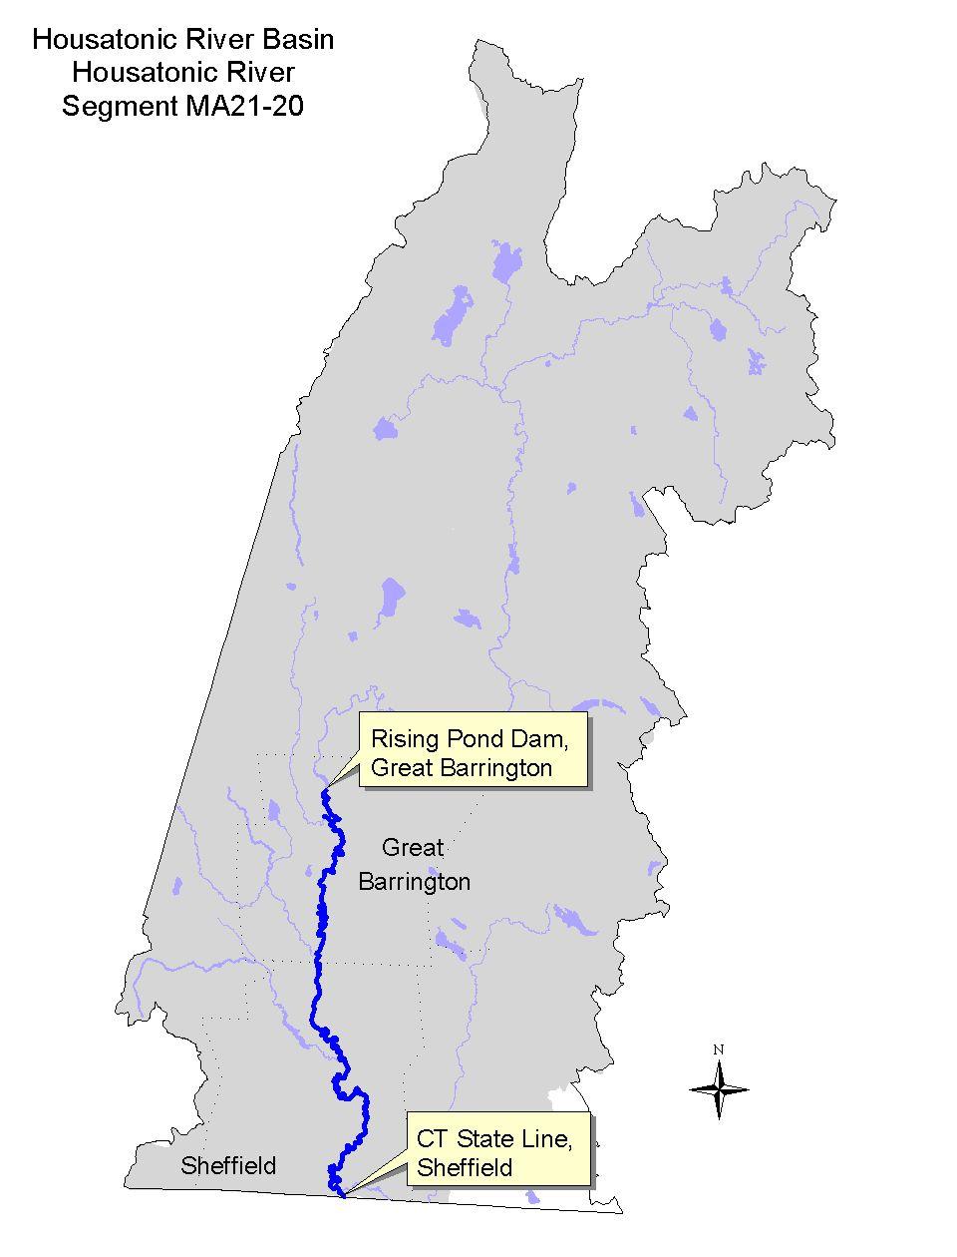

Land-use estimates for the subwatershed (map inset, gray shaded area):
Forest | 69%
Agriculture | 12%
Residential | 7%

Land-use estimates in the 100’ riparian zone from the streambanks:
Agriculture | 32%
Forest | 18%
Open Land | 5%

WITHDRAWALS AND DISCHARGES

WMA:
- Registration #10211303 for Fox River Paper Co.-Rising Paper Division authorizes a system-wide withdrawal of 1.04 MGD from two wells (Park Street Well and Park Street Well 2).

NPDES:
- MAG250821 – issued December 1994 to the Fox River Paper Company, Rising Paper Division for their discharge via outfall #001of 0.133 MGD average monthly flow of non-contact cooling water to the Housatonic River. (This discharge was formerly permit # MA0035157 which is now closed.) The 7Q10 of the Housatonic River at the Great Barrington gage is 69 cfs (USGS 1998). The process wastewater is discharged (without pretreatment) to the Great Barrington WWTP.
- MA0101524 – issued September 1990 to the Great Barrington WWTP authorizing an average monthly discharge of 3.2 MGD of treated wastewater (domestic and industrial) via outfall # 001 to the Housatonic River. The facility is a secondary wastewater treatment plant that uses chlorine for disinfection. The facility has an acute toxicity limit of LC50 > 100% effluent and a chronic monitor only requirement.

Stormwater:
- MAR05A587 – The Fox River Paper Company, Rising Paper Division in Great Barrington (Berkshire Regional Planning Commission 1999).

USE ASSESSMENT

A RBP III upstream/downstream evaluation (21-HR05 and 21-HR06) of the Great Barrington WWTP discharge was conducted by DEP DWM biologists in the late August 1997 (Appendix D).

The USGS conducted a suspended sediment study in the Housatonic River near Great Barrington and in the village of Ashley Falls, Sheffield between April 1994 and March 1996. These data are reported in Bent (1999b), Socolow et al. (1996) and Socolow et al. (1997).

To comply with their NPDES permit, the Great Barrington WWTP conducts whole effluent toxicity testing on two test organisms (C. dubia or P. promelas). Additionally the facility collects water from the Housatonic River at the Bridge Street bridge upstream of their effluent discharge for use as dilution in toxicity tests. Ambient and whole effluent toxicity testing data from the WWTP were reviewed (Dallaire 2000).

Blasland, Bouck, and Lee, Inc. (1999) collected young-of-the-year fish samples for PCB analysis in 1994 and 1998 from one station in this segment of the Housatonic River; station HR6 near the MA/CT state line. EPA is in the process of collecting additional PCB data on river sediments and bank soils from Dalton through Sheffield, although this data has not yet become available (expected sometime in 2000). EPA has also been collecting considerable PCB data (sampling in 1998 and 1999) on river biota at a variety of trophic levels (including fish, frogs, and ducks) as part of their Ecological Risk Assessment. Additional data may also be collected in 2000.

The USGS NAWQA study sampled one station in this segment of the Housatonic River in Great Barrington upstream of the Great Barrington WWTP (Harris 1997 and Coles 1998).

Effects of the Glendale Project on streamflow conditions were recorded in the instantaneous streamflow conditions from the USGS gage in Great Barrington (01197500). The stream fluctuations were investigated as a result of citizen complaints (Prendergast 1999).

- Bioassessment/Habitat - Although DEP DWM noted moderate impacts to the benthic macroinvertebrate community in the upstream/downstream comparison, the response may have been attributable, in part, to habitat differences. While the riparian zone at the upstream (reference) station had a high degree of stabilization, the riverbanks directly upstream of the test station were vertical, completely denuded of vegetation and had a high likelihood of eroding during high water. Results and the discussion of the benthic macroinvertebrate analysis can be found in Appendix D.

- Water Quality - Fourteen percent of the suspended sediment samples collected by USGS primarily during storm events in the Housatonic River near the village of Ashley Falls exceeded 25 mg/L (106 of 738 days) (Bent 1999b, Socolow et al. (1996) and Socolow et al. (1997). These were noticeably higher than those documented upstream at Great Barrington (2%). These exceedences, several of which were prolonged, are of concern since they are most likely the result of a combination of increased agricultural activities and natural conditions (geology and geomorpholoy).

- Water Quantity - Streamflow measurements (instantaneous) at the USGS gage on the Housatonic River in Great Barrington appear to be reflective of the hydromodification practices at the Glendale Project hydropower facility (rapid streamflow fluctuations). The Aquatic Life Use is considered threatened due to hydromodification based on these observations in the upper 1.5 mile reach (from the outlet of Risingdale Impoundment to the Housatonic’s confluence with the Williams River).

- Ambient Toxicity - The Great Barrington WWTP collects water from the Housatonic River at the Bridge Street bridge upstream of their effluent discharge. These river samples are used as dilution water for their effluent toxicity tests. Survival of the cladaceron, Ceriodaphnia dubia, test organisms exposed to Housatonic River water (7-day) has been >90% in the 24 tests conducted between March 1993 and 1999 (Dallaire 2000). Fathead minnow (Pimephales promelas), test organism survival has been >83%. Dilution water physical/chemical data from this location were as follows: pH ranged from 7.0 to 8.4 SU, alkalinity between 76 and 166 mg/L, hardness between 88 and 216 mg/L. Ammonia-nitrogen concentrations were low ranging between <0.07 and 0.55 mg/L. Total suspended solids were generally low although one of the 24 measurements exceeded 25 mg/L (47 mg/L). Conductivity ranged from 253 to 717 μmho/cm.

- Effluent Toxicity Testing - Effluent toxicity testing of the Great Barrington WWTP effluent has not documented any acute whole effluent toxicity to either C. dubia or P. promelas. Four of the 24 test events, however, indicated levels of chronic toxicity ranging between <6.25 to 50% effluent to C. dubia which appears to be the more sensitive organism (Dallaire 2000).

- Tissue Chemistry - Blasland, Bouck, & Lee, Inc. (1999) – The concentration of PCB in young-of-the-year fish collected at HR6 ranged between 1,000 and 4,500 μg/kg wet weight (PPB) in largemouth bass, yellow perch, and bluegill. All of these data exceed (2 to 9 times) the NAS/NAE guideline for total PCB (in Coles 1998) of 500μg/kg wet weight for the protection of fish-eating wildlife.

- Sediment Chemistry - The USGS NAWQA study sampled Housatonic River streambed sediment in Great Barrington upstream of the Great Barrington WWTP. The PCB concentration was 660 μg/kg dry weight (Harris 1997) which was 65 times higher (adjusting for organic carbon content) than the S-EL guideline (Persaud et al. 1993). This sediment sample was comprised primarily of sand (85%) and silt (14%). Iron and manganese both exceeded (slightly) the S-EL guidelines. Several trace metals (As, Cd, Cr, Cu, Pb, Hg, Ni, and Zn) exceeded the L-EL guideline.

The Aquatic Life Use for the entire 22.5 mile length of this segment is evaluated as non-support because of elevated levels of PCB in fish tissue and sediment. Hydromodification (abnormal streamflow fluctuation) is considered a threat to aquatic life in the upper 1.5 mile reach of this segment due to the Glendale Project.

- Fecal Coliform Bacteria - Fecal coliform bacteria data reported by USGS for the Housatonic River at Ashley Falls ranged between 55 and 760 cfu/100ml between November 1995 and September 1996 (Socolow et al. 1997). Four samples were collected during the primary contact recreation season, however the dataset is too limited to assess either of the recreational uses since this segment of the Housatonic River and many of its tributaries have such a high percentage of agriculture.

- Fish Consumption Advisory – The state issued a fish consumption advisory for the Housatonic River in 1982. The advisory recommended that the general public should not consume fish, frogs and turtles from the Housatonic River between Dalton and Sheffield because of PCB contamination. In 1995, DPH updated their advisory to include a recommendation that fish taken from feeder streams to the Housatonic River should be trimmed of fatty tissue prior to cooking (MA DPH 1999). Because of this advisory, the Fish Consumption Use is not supported for this segment of the Housatonic River.

- Aesthetics - The aesthetic quality of the Housatonic River downstream of the Great Barrington WWTP discharge was compromised by the highly colored (red) effluent noted during DEP DWM sampling (Appendix D). The plume was visible (mid-channel) for approximately 0.4 miles downstream. With the exception of the 0.4 miles downstream of the Great Barrington WWTP discharge, the Aesthetic Use of this segment of the Housatonic River is evaluated as support.

Designated Use Status: Housatonic River (Segment MA21-20
Aquatic Life |  | NON-SUPPORT. The entire 22.5 mile length of this segment is evaluated as non-support because of elevated levels of PCB in tissue and sediment. Hydromodification threatens the Aquatic Life Use downstream of the Glendale Project.
Fish Consumption |  | NON-SUPPORT. The entire 22.5 mile length of this segment does not support this use because of elevated levels of PCB in frogs, fish and turtles resulting from the GE Company Pittsfield plant.
Primary Contact |  | NOT ASSESSED.
Secondary Contact |  | NOT ASSESSED.
Aesthetics |  | SUPPORT. This use is evaluated as support for 22.1 miles.  NON-SUPPORT. The colored discharge from the Great Barrington WWTP impairs 0.4 miles of this segment.

RECOMMENDATIONS: HOUSATONIC RIVER (Segment MA21-20)

- The BRPC report entitled Assessment of Land-use Activities and Nonpoint Source Pollution in the Housatonic River Watershed contains an up-to-date summary of existing and potential nonpoint sources of pollution in the Housatonic River Basin (Berkshire Regional Planning Commission 1999). The potential pollution sources identified in this report (e.g., Table IV-13 and page IV-47-49) should be reviewed to help design future monitoring plans for this segment of the Housatonic River.
- EPA is in the process of collecting additional data on streambed sediments and river bank soils from Dalton through Sheffield, although this data has not yet become available (expected sometime in 2000). EPA has also been collecting considerable data (sampling in 1998 and 1999) on river biota at a variety of trophic levels (including fish, frogs, and ducks) as part of their Ecological Risk Assessment. Additional data may also be collected in 2000.
- Determine whether or not the elevated levels of suspended sediment in the lower Housatonic River are the result of naturally occurring conditions and/or a result of land-use practices (agricultural –either cropland or pasture land).
- The Massachusetts Department of Food and Agriculture and the U.S. Department of Agriculture’s Natural Resource Conservation Service should conduct outreach to farmers regarding the need for streambank stabilization and best management practices in the riparian zone.
- Conduct additional monitoring (increase spatial and temporal coverage) of fecal coliform bacteria to assess the status of Primary and Secondary Contact Recreational uses.
- Monitor the effectiveness of operation changes at the Glendale Project to monitor and reduce aberrant streamflow fluctuations in this segment of the Housatonic River.
- Evaluate the possible erosional impacts downstream of the Glendale Project as a result of stream fluctuations. Determine whether streambank stabilization techniques (via S.319 funding) would be effective.
RECOMMENDATIONS - Continued: HOUSATONIC RIVER (Segment MA21-20)

- The sediment sample collected by USGS as part of the NAWQA study (upstream of the Great Barrington WWTP) had the second highest concentration of Hg in the Connecticut, Housatonic, and Thames River Basins study unit. The need for additional monitoring of Hg contamination in both sediment and tissue merits further investigation.

Great Barrington WWTP:
- The Great Barrington WWTP NPDES permit requirements for whole effluent toxicity testing should be reduced to one organism, C. dubia, which has been the more sensitive test organism. The analysis of several effluent variables can also be eliminated in the toxicity testing requirements: Ag, Cd, Cr, Fe, and Ni.
- The Great Barrington WWTP NPDES permit should contain a color limit to protect the aesthetic quality of the Housatonic River. The Great Barrington WWTP receives a substantial portion of its wastewater from the Fox River Paper Co.-Rising Paper Division that apparently was not pre-treating their wastewater. Their NPDES permit (issued 1990) required the implementation of an industrial pretreatment program. DEP has issued a consent order to resolve the color pass through problem (Prendergast 1999). The WWTP is presently evaluating a new (DEP approved) process of adding chlorine as an oxidant to the wastewater influent to resolve the color problem.

FURNACE BROOK (Segment MA21-21)
Location: Headwaters south of Route 295 (Canaan Road), Richmond to inlet of Mud Ponds, West Stockbridge. Segment Length: 3.7 miles. Classification: Class B.

Segment DESCRIPTION

Furnace Brook, a Class B waterbody, originates just south of Canaan Road in Richmond and flows south to the inlet of Mud Ponds in West Stockbridge. An orchard is present in the upper watershed and the brook flows under the Conrail Railroad in the community of Richmond Furnace.
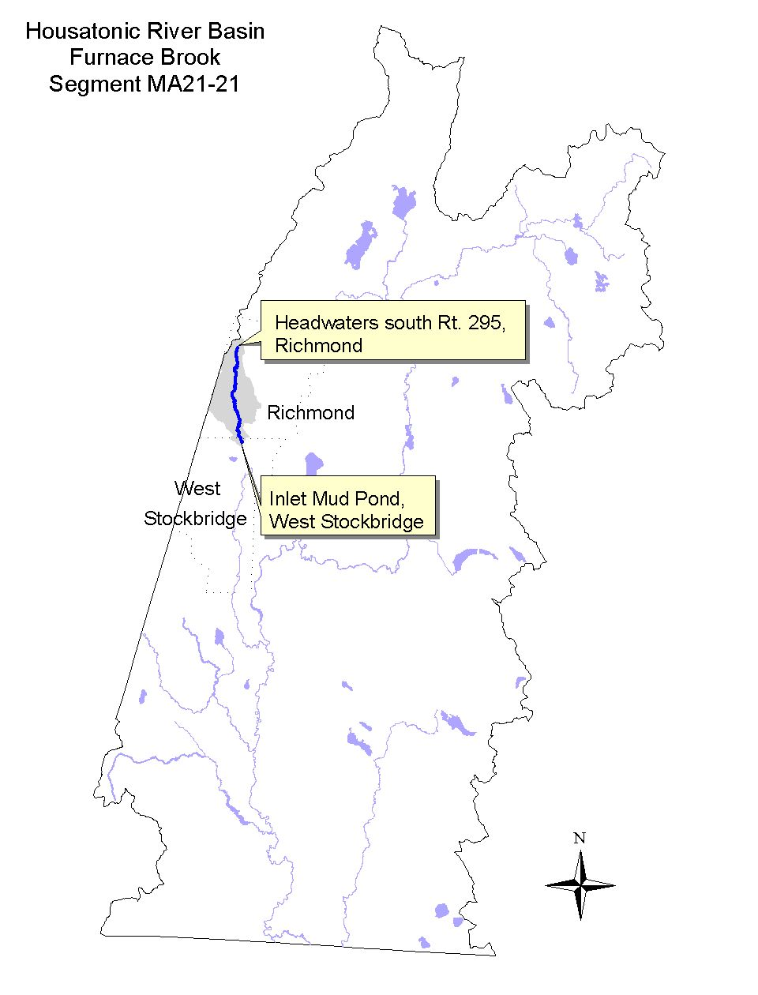

Land-use estimates for the subwatershed (map inset, gray shaded area):
Forest | 75%
Agriculture | 16%
Residential | 5%

Land-use estimates in the 100’ riparian zone from the streambanks:
Forest | 81%
Agriculture and Wetlands | 7%
Residential | 3%

WITHDRAWALS AND DISCHARGES

None known.

USE ASSESSMENT

DEP DWM conducted benthic macroinvertebrate sampling on 27 August 1997 in Furnace Brook (station FB01) just downstream of Furnace Road in Richmond (approximately 0.4 miles upstream of the inlet to Mud Ponds).

- Bioassessment/Habitat – The benthic community was found to be slightly impaired compared to the Konkapot River regional reference station (Appendix C). The slight impairment of the benthic community was thought to be the result of naturally reduced base-flows. The benthic community in Furnace Brook showed particularly high diversity including several pollution sensitive taxa and therefore the segment is assessed as fully supporting the Aquatic Life Use.

Designated Use Status: Furnace Brook (Segment MA21-21)
Aquatic Life |  | SUPPORT. The entire 3.7 mile length of this segment is evaluated as supporting this use.
Fish Consumption |  | NOT ASSESSED.
Primary Contact |  | NOT ASSESSED.
Secondary Contact |  | NOT ASSESSED.
Aesthetics |  | NOT ASSESSED.

RECOMMENDATIONS: FURNACE BROOK (Segment MA21-21)

- An investigation into the presence/extent of damming structures in the impoundments of this watershed (especially the unnamed impoundment immediately upstream of the benthic macroinvertebrate sampling station) is recommended (Appendix C). Additional water quantity information, should be collected to better assess the relationship between biological integrity and streamflow.
- Disturbances observed in the riparian zone (clearing of vegetation and trash deposits) can be prevented by blocking off the dirt road that leads from Furnace Road to the stream.
- The BRPC report entitled Assessment of Land-use Activities and Nonpoint Source Pollution in the Housatonic River Watershed contains an up-to-date summary of existing and potential nonpoint sources of pollution in the Housatonic River Basin (Berkshire Regional Planning Commission 1999). The potential pollution sources identified in this report (e.g., Table IV-13 and page IV-50-51) should be reviewed to help design future monitoring plans for the Williams River subwatershed.

WILLIAMS RIVER (Segment MA21-06)
Location: Outlet of Shaker Mill Pond, West Stockbridge to confluence with Housatonic River, Great Barrington. Segment Length: 10.0 miles. Classification: Class B, Cold Water Fishery.

Segment DESCRIPTION

The Williams River, a Class B Cold Water Fishery, originates at the outlet of Shaker Mill Pond in West Stockbridge. The river flows south and receives the flow from the West Stockbridge WWTP then close to a large quarry in the upper reach of this segment. The river continues to flow in a southerly direction throughout most of its length. There is a small dam in the Williams River located just downstream of the West Stockbridge/Great Barrington town line at the Old Maids Swimming Hole. The river continues in a southerly direction until it turns east in the village of Van Deusenville and meanders towards its confluence with the Housatonic River in Great Barrington.
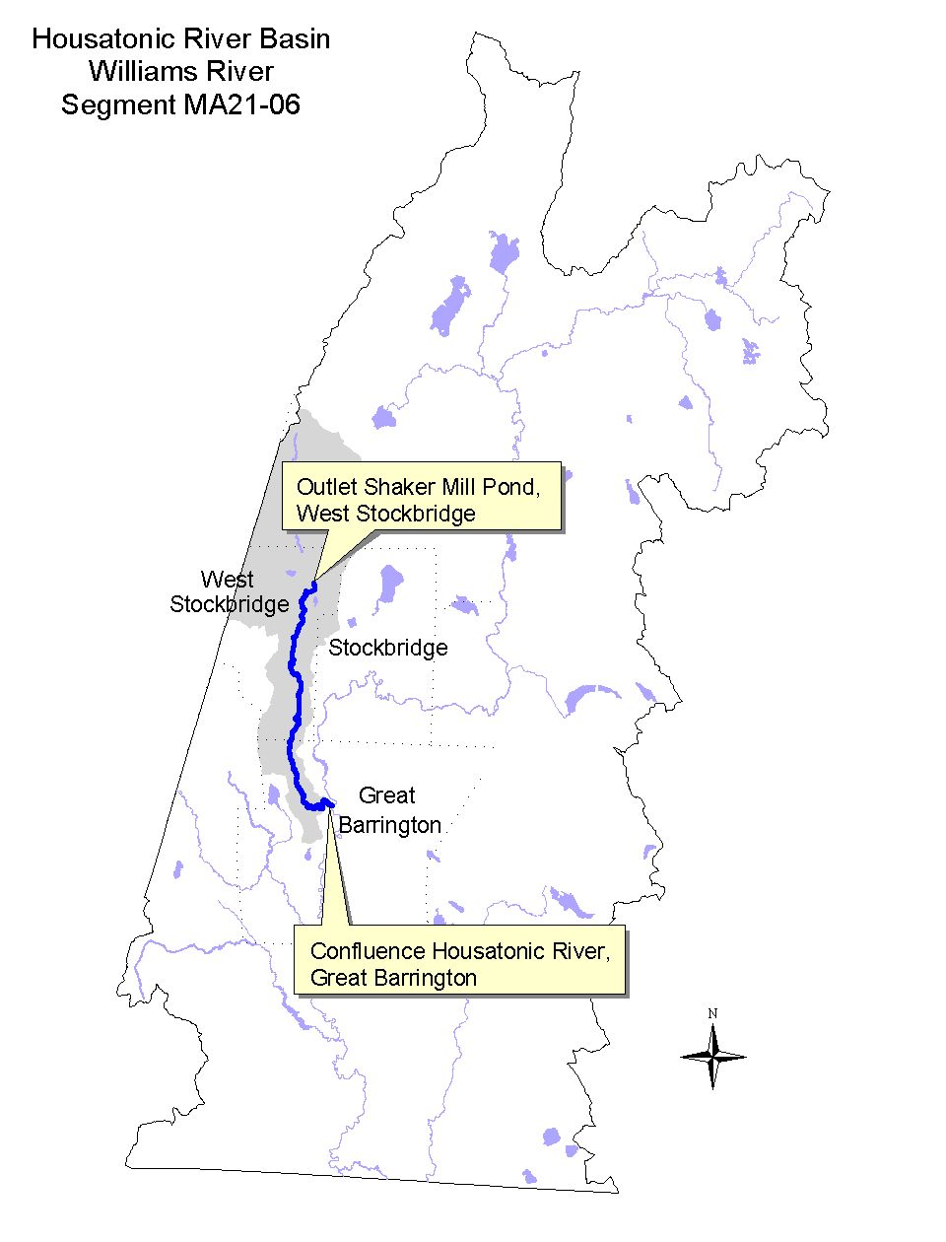

Land-use estimates for the subwatershed (map inset, gray shaded area):
Forest | 67%
Agriculture | 17%
Residential | 7%

Land-use estimates in the 100’ riparian zone from the streambanks:
Forest | 58%
Wetlands | 24%
Residential | 9%

WITHDRAWALS AND DISCHARGES

WMA:
There are no WMA registered or permitted withdrawals in this river. There are, however, smaller public water suppliers (withdrawals less than 100,000 GPD) listed below:
- PWS#1326000- West Stockbridge Water Department – Average use for 1998 was 0.045 MGD. Two groundwater sources. The original surface water supplies are no longer in use.
- PWS#1326001 – Mill Pond Trailer Park – Average use for 1996 was 0.0069 MGD for the one approved well.
- There are two additional wells in this segment that are not permitted since their withdrawals are <100,000 GPD.

NPDES:
- MA0103110 – The West Stockbridge WWTP is authorized to discharge 0.076 MGD average monthly flow of treated sanitary wastewater via outfall # 001 to the Williams River although their actual average monthly flows are much less. The annual monthly average flow of the facility in 1999 was 0.011 MGD. The facility is an advanced wastewater treatment plant that uses UV for disinfection. The facility has an acute toxicity limit of LC₅₀ > 100% effluent. The permit was issued in December 1990.

USE ASSESSMENT

The West Stockbridge WWTP collects water from the Williams River at the old train bridge located approximately 30’ upstream of their effluent discharge. These river samples are used as dilution water for their effluent toxicity tests. Whole effluent toxicity testing data from the West Stockbridge WWTP (required by their NPDES permit) from January 1993 and 1999 was also reviewed (Dallaire 2000).
DEP DWM conducted Benthic macroinvertebrate sampling in August 1997 in the Williams River (station WR01) between Route 41 and Division Street bridge in Great Barrington. The USGS sampled the Williams River at the railroad bridge (200’ south of Division Street) in Great Barrington as part of their suspended sediment study. Suspended sediment concentrations (mg/L), specific conductivity, and temperature, as well as instantaneous discharge were periodically measured between March 1994 and April 1996 (Socolow et al. 1996 and Socolow et al. 1997). Blasland, Bouck & Lee, Inc. collected fish from the Williams River off of Division Street in the village of Van Deusenville in September 1995 for PCB analysis as part of the GE Pittsfield Corporation MCP Supplemental Phase II/RCRA Facility Investigation (1996).

- Ambient toxicity testing - Survival of the cladaceron, Ceriodaphnia dubia, test organisms exposed to Housatonic River water (48-hours) has been >95% in the 20 tests conducted between January 1993 and 1999 (Dallaire 2000). Fathead minnow (Pimephales promelas), test organism survival has been >95%. Dilution water physical/chemical data from this location were as follows: pH ranged from 7.2 to 8.1 SU, alkalinity between 60 and 165 mg/L, hardness between 48 and 178 mg/L. Ammonia-nitrogen concentrations were low ranging between <0.05 and 0.16 mg/L. Total suspended solids were not detected. Conductivity ranged from 237 to 518 μmho/cm.

- Effluent toxicity testing – No acute whole effluent toxicity to either C. dubia or P. promelas from the West Stockbridge WWTP effluent has been detected (Dallaire 2000).

- Bioassessment/Habitat – Results of the DEP DWM benthic macroinvertebrate analysis indicated no impairment to the benthic community compared to the Konkapot River (regional reference station) (Appendix C).

- Water quality – The daily mean suspended sediment concentration ranged from 1 to 151 mg/L (Socolow et al. 1996 and Socolow et al. 1997). Instream temperatures exceeded 20°C on 7 of 18 days sampled during the summers of 1994 and 1995 (June through September). Conductivity measurements ranged between 236 and 430 μS/cm.

- Fish Tissue – In September 1995, fish (smallmouth bass and brown trout) were collected from the Williams River by Blasland, Bouck & Lee, Inc. (1996) and analyzed as scales off/skin on fillets. Total PCB concentrations ranged from 810 to 2,600 PPB wet weight.

Based on the results of the biological and ambient toxicity testing data, the entire length of the Williams River is assessed as supporting the Aquatic Life Use.

- Fish Consumption Advisory – There is currently no specific fish consumption advisory for this river. The DPH fish consumption advisory in effect for the mainstem Housatonic River includes a provision that recommends that fish taken from feeder streams to the Housatonic River be trimmed of fatty tissue prior to cooking (MA DPH 1999). The intention of this provision is to minimize the potential risk associated with fish that may migrate in or out of the mainstem Housatonic River.

Designated Use Status: Williams River (Segment MA21-06)
Aquatic Life |  | SUPPORT. The entire 10.0 mile length of this segment is evaluated as full support for this use.
Fish Consumption |  | NOT ASSESSED.
Primary Contact |  | NOT ASSESSED.
Secondary Contact |  | NOT ASSESSED.
Aesthetics |  | SUPPORT. The entire 10.0 mile length of this segment is evaluated as full support for this use.

RECOMMENDATIONS: WILLIAMS RIVER (Segment MA21-06)

- The West Stockbridge WWTP NPDES permit requirements for whole effluent toxicity should be reduced to one organism, C. dubia. The analysis of several effluent variables can also be eliminated in the toxicity testing requirements Cd, Cr, Ni, Pb, and Zn, while Cu, Pb, and Zn in the ambient water can also be eliminated.
- Nonpoint source pollution in the form of isolated trash deposits were observed along both banks. Dumping of trash from adjacent road crossings should be strongly discouraged. Cleanup efforts should be conducted to eliminate existing trash deposits.
- Determine if there are any areas that may require BMPs to abate stormwater runoff impacts adjacent to the Williams River (e.g., Massachusetts Turnpike Crossing).
- Suspended sediment concentrations exceeded 25 mg/L in approximately 17% of the samples collected near the mouth of the Williams River by USGS, and the instream summer temperatures (particularly during August) exceeded 20°C. Determine if DFWELE has any concerns or information regarding the status of the Williams River in terms of supporting a cold water fishery and whether or not these conditions also exist in its upper subwatershed.
- Despite the DPH recommendation that fishes taken from tributaries to the Housatonic River should be trimmed of fatty tissue before cooking (MA DPH 1999), body burdens of PCB in the edible portion of fish from the Williams River should be further investigated. Determination of natural or man-made barriers to migration in the tributaries of the Housatonic River, including the Williams River, would assist in the identification of stream reaches where the potential for PCB contaminated fishes is greatest.
- Conduct a site visit to the limestone/marble quarry adjacent to the east bank of the Williams River west of Route 41 in West Stockbridge to identify whether or not there are any stormwater or other discharges from the operation to the Williams River. The quarry is owned and/or operated by Lane Construction. Rock is extracted in large chunks of limestone and/or marble bedrock and then is broken up into smaller gravel-sized bits rather than a traditional gravel pit that mines heterogeneous gravel deposits of glacial origin (Cohen 2000). Establish if an NPDES permit (individual or general stormwater) is necessary.
- Fecal coliform bacteria sampling should routinely be conducted (under both wet and dry sampling conditions) along the Williams River at popular swimming hole areas. These data should be reported to DEP DWM (used to evaluate the status of the Primary and Secondary Contact Recreational uses).
- The BRPC report entitled Assessment of Land-use Activities and Nonpoint Source Pollution in the Housatonic River Watershed contains an up-to-date summary of existing and potential nonpoint sources of pollution in the Housatonic River Basin (Berkshire Regional Planning Commission 1999). The potential pollution sources identified in this report (e.g., Table IV-13 and page IV-50-51) should be reviewed to help design future monitoring plans for the Williams River subwatershed.

LONG POND BROOK (Segment MA21-14)
Location: Outlet of Long Pond, Great Barrington to confluence with Seekonk Brook, Great Barrington. Segment Length: 1.8 miles. Classification: Class B.

Segment DESCRIPTION

Long Pond Brook, a Class B waterbody, flows south southeast and bends to the west southwest through a small unnamed impoundment near Simons Rock Early College continuing to its confluence with Seekonk Brook in Great Barrington.
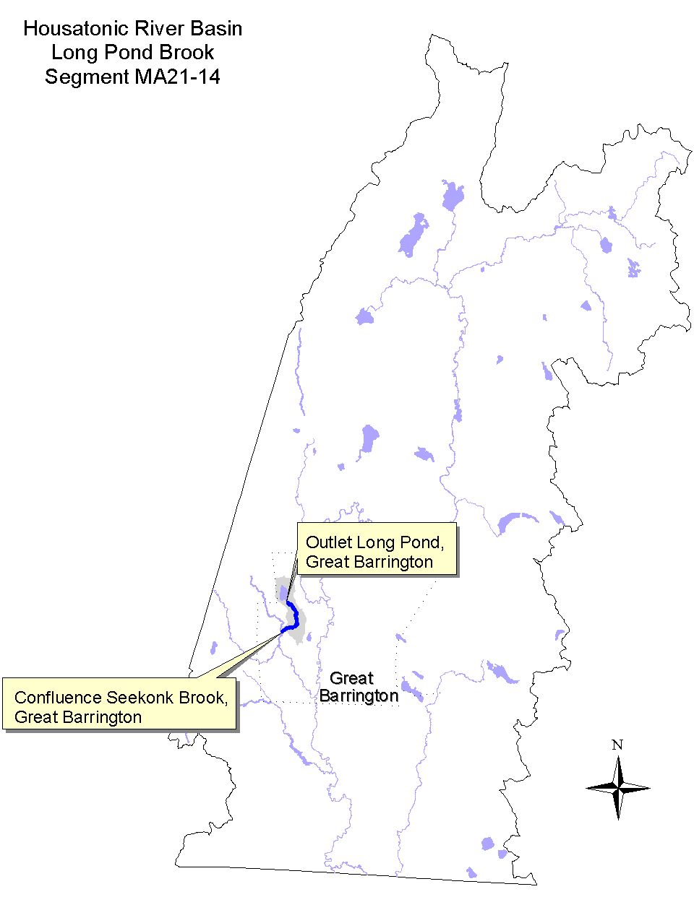

Land-use estimates for the subwatershed (map inset, gray shaded area):
Forest | 70%
Agriculture | 9%
Open Land | 8%

Land-use estimates in the 100’ riparian zone from the streambanks:
Forest | 55%
Wetlands | 21%
Open Land | 13%

WITHDRAWALS AND DISCHARGES

WMA:
- Housatonic Water Works Company in Great Barrington is registered (10211306) to withdraw 0.27 MGD of water from Long Pond. The Housatonic Water Works only supplies the village of Housatonic. In 1994, the average water use was 0.41 MGD, and in 1995 and 1998 it was 0.36 and 0.34 MGD respectively (Bent 1999a and Prendergast 1999).

USE ASSESSMENT

DEP DWM conducted a synoptic survey of Long Pond in August 1997. Construction activities were apparent during the 1997 field survey. According to DEP’s Western Regional Office, construction activities included the upgrading of the treatment facility, installation of a chlorine contact facility, a new storage facility, and general renovations (Prendergast 1999). Since no minimum flow is maintained out of the reservoir, conditions are believed to be similar to those encountered in 1992 (Kennedy et al. 1993). At that time withdrawals out of Long Pond resulted in the elimination of a portion of Long Pond Brook (approximately 0.25 miles). The Aquatic Life Use is therefore evaluated as non-support.

Designated Use Status: Long Pond Brook (Segment MA21-14)
Aquatic Life |  | NON-SUPPORT. The entire 1.8 mile length of this segment is evaluated as non-support because of flow alteration (A minimum flow is not maintained out of the reservoir).
Fish Consumption |  | NOT ASSESSED.
Primary Contact |  | NOT ASSESSED.
Secondary Contact |  | NOT ASSESSED.
Aesthetics |  | NOT ASSESSED.

RECOMMENDATIONS: LONG POND BROOK (Segment MA21-14)

- The BRPC report entitled Assessment of Land-use Activities and Nonpoint Source Pollution in the Housatonic River Watershed contains an up-to-date summary of existing and potential nonpoint sources of pollution in the Housatonic River Basin (Berkshire Regional Planning Commission 1999). The potential pollution sources identified in this report (e.g., Table IV-13 and page IV-52-53) should be reviewed to help design future monitoring plans for the Green River subwatershed.

Housatonic Water Works
- Determine if the Housatonic Water Works Company in Great Barrington can comply with their WMA registration via water conservation or other mechanisms. If not possible, a WMA permit with appropriate conditions (e.g., maintenance of minimum streamflow) is warranted. The Housatonic Water Works Company in Great Barrington should implement water conservation/water supply system efficiency recommendations as described in the DEM report entitled Water Resources of the Housatonic River Basin: Water Use and Hydrology (MA DEM 1999).
- Water conservation measures should be maximized by the Housatonic Water Works, to minimize the frequency and duration of no flow events in Long Pond Brook.
- Collect additional data to document the frequency, duration and severity of low-flow conditions and occurrences of dewatered and/or occasionally dry streambed in Long Pond Brook below the outlet of Long Pond. Document this information via photographs and/or stream depth and velocity measurements.

SEEKONK BROOK (Segment MA21-22)
Location: Outlet of small impoundment east of West Road, Alford to confluence with the Green River, Great Barrington Segment Length: 4.6 miles. Classification: Class B.

Segment DESCRIPTION

Seekonk Brook, a Class B waterbody, originates at the outlet of a series of small impoundments just east of West Road in Alford. The brook flows in a southeasterly direction into Great Barrington, where the original channel continued southeast, received the flow from Long Pond Brook, and continued south to its confluence with the Green River in Great Barrington. The brook appears on the 1987 USGS topographical map to have been diverted to the west upstream of Seekonk Road. This diversion runs parallel to Seekonk Cross Road, through two small unnamed impoundments, joining the Green River just upstream of its original channel.
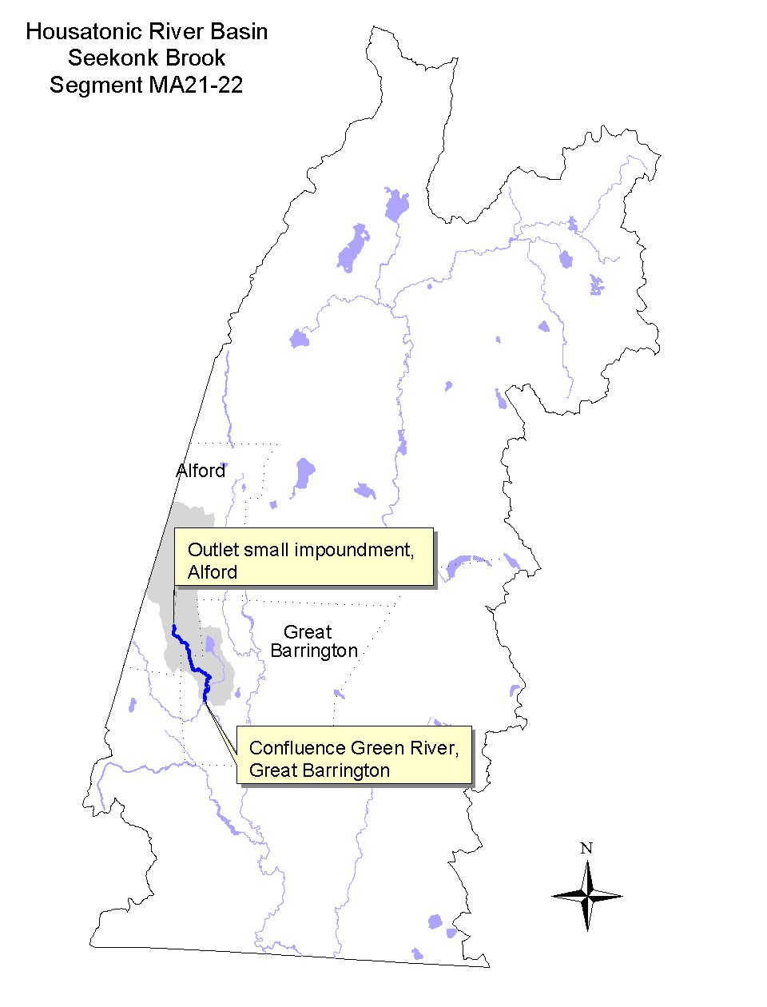

Land-use estimates for the subwatershed (map inset, gray shaded area):
Forest | 67%
Agriculture | 23%
Residential | 4%

Land-use estimates in the 100’ riparian zone from the streambanks:
Forest | 41%
Wetlands | 23%
Agriculture | 20%

WITHDRAWALS AND DISCHARGES

WMA:
There are no WMA registered or permitted withdrawals in this brook’s subwatershed. There is, however, a small non-community public water supplier (withdrawal less than 100,000 GPD).

USE ASSESSMENT

Too little data exists to evaluate the status of the designated uses, therefore all uses for Seekonk Brook (Segment MA21-22) are not assessed.

Aquatic Life | Fish Consumption | Primary Contact | Secondary Contact | Aesthetics

RECOMMENDATIONS: SEEKONK BROOK (Segment MA21-22)
- The BRPC report entitled Assessment of Land-use Activities and Nonpoint Source Pollution in the Housatonic River Watershed contains an up-to-date summary of existing and potential nonpoint sources of pollution in the Housatonic River Basin (Berkshire Regional Planning Commission 1999). The potential pollution sources identified in this report (e.g., Table IV-13 and page IV-52-53) should be reviewed to help design future monitoring plans for the Green River subwatershed.
GREEN RIVER (Segment MA21-23)
Location: Border of Hillsdale, New York and Alford, Massachusetts to confluence with the Housatonic River, Great Barrington. Segment Length: 9.8 miles. Classification: Class B, Cold Water Fishery.

Segment DESCRIPTION

The Green River, a Class B Cold Water Fishery, flows south-southeast out of New York state through Alford, MA and into the northeast corner of Egremont. The river then turns northeast after passing by the Great Barrington Airport. It receives the flow from Seekonk Brook, turns southeast past the discontinued USGS gaging station (01198000 at Hurlburt Street) and meanders to its confluence with the Housatonic River in southern Great Barrington.
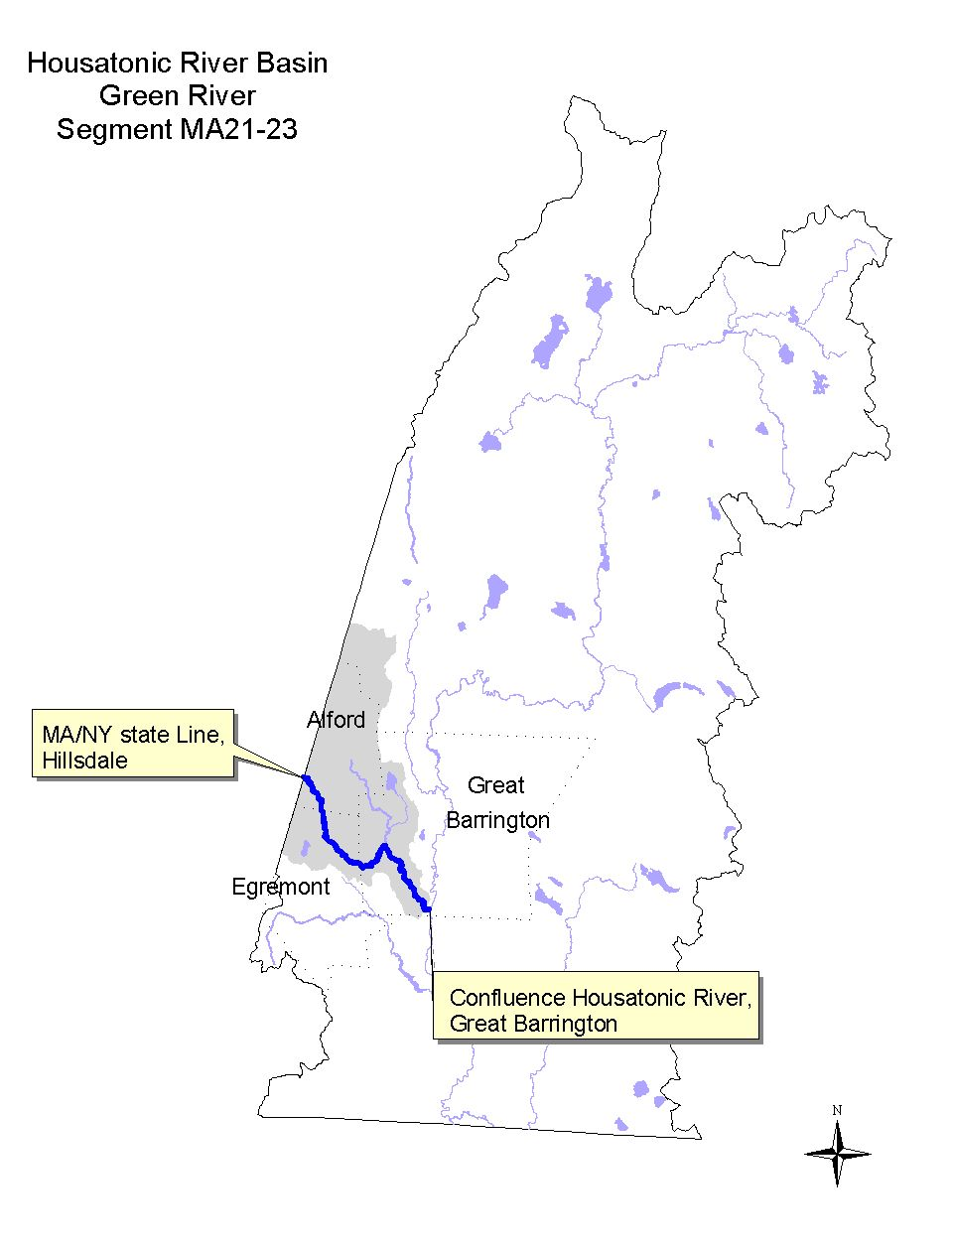

The Green River Bioengineering Demonstration Project (NPS 94-03), a hydrologic modification study, was funded through the s. 319 Nonpoint Source Competitive Grants program ($126,000). The three-year (1995-1998) project involved the design, implementation, demonstration and evaluation of soil bioengineering techniques to control local bank erosion and restore bank stability; establish and maintain a healthy riparian buffer zone; and improve fisheries habitat. This demonstration project was conducted on the Green River, in Great Barrington, adjacent to Strassler Farm (Cesan 1998). The results of the study indicate that the streambank stabilization efforts are partially successful; additional measures are required to further stabilize and repair the eroded streambanks.

Land-use estimates for the subwatershed (map inset, gray shaded area):
Forest | 60%
Agriculture | 29%
Residential | 5%

Land-use estimates in the 100’ riparian zone from the streambanks:
Forest | 59%
Agriculture | 28%
Open Land | 5%

WITHDRAWALS AND DISCHARGES

WMA:
- The Great Barrington Fire District is registered (#10211301) to withdraw 1.09 MGD from two sources in Great Barrington including the groundwater withdrawal from the Green River Infiltration Gallery in this subwatershed. The Gallery has been in use since at least 1970. The second source is from East Mountain Reservoir on the east side of the Housatonic River. The average water use by the Fire District in 1994 and 1995 was within their registration (1.05 and 0.94 MGD, respectively) (Bent 1999a). In 1998 their withdrawal was 1.145 MGD (Prendergast 1999). In 1993 the Great Barrington Fire District conducted a microparticulate analysis of the Infiltration Gallery water. This analysis indicated no direct connection between the potable water and the river (Prendergast 1999).

USE ASSESSMENT

The USGS sampled the Green River upstream of Hurlburt Street in Great Barrington (at their discontinued long-term gage #011980000) as part of their suspended sediment study. The USGS initiated their suspended sediment study sampling in March 1994 and continued to measure daily mean suspended sediment concentration (mg/L) and discharge through March 1996. This data is reported in Socolow et al. (1996) and Socolow et al. (1997). The USGS NAWQA study site on the Green River, which included both fish tissue and sediment sampling (including total PCB), was located near USGS’s discontinued long-term gaging station in Great Barrington (Harris 1997 and Coles 1998). Blasland, Bouck & Lee, Inc. collected fish from the Green River near its confluence with the Housatonic River in September 1995 for PCB analysis as part of the GE Pittsfield Corporation MCP Supplemental Phase II/RCRA Facility Investigation (1996).

- Water Quality – The daily mean suspended sediment concentration measured by USGS exceeded 25 mg/L only 4% of the time related to storm events (Socolow et al. 1996 and Socolow et al. 1997). The August median flow at the discontinued long-term USGS gage on the Green River was 5.4 MGD. Ninety-nine percent of the time the flow of the river exceeded 2.1 MGD.

Based on these data the Aesthetics Use in the Green River is assessed as full support.

- Sediment Quality - No PCB (<50 μg/kg dry weight) was detected in USGS’s sediment sample (Harris 1997). This sediment sample was comprised primarily of sand (85%), silt (13%) and clay (1%). Iron and manganese both exceeded the S-EL guidelines. Several trace metals (As, Cr, Cu, Pb, Ni and Zn) exceeded the L-EL guideline (Persaud et al. 1993).

- Fish Tissue – In September 1995, fish (rock bass and brown trout) were collected from the Green River by Blasland, Bouck & Lee, Inc. (1996) and analyzed as scales off/skin on fillets. Total PCB concentrations ranged from 160 to 21,000 PPB wet weight.

The concentration of PCB in the whole fish composite sample (comprised of eight white suckers, Catastomas commersoni) collected from the Green River by USGS was 620 μg/kg wet weight (Coles 1998). This level of PCB slightly exceeded (1.24 times) the NAS/NAE guideline of 500 μg/kg wet weight for total PCB (in Coles 1998) for the protection of fish-eating wildlife.

- Fish Consumption Advisory – There is currently no specific fish consumption advisory for this river. The DPH fish consumption advisory in effect for the mainstem Housatonic River includes a provision that recommends that fish taken from feeder streams to the Housatonic River be trimmed of fatty tissue prior to cooking (MA DPH 1999). The intention of this provision is to minimize the potential risk associated with fish that may migrate in or out of the mainstem Housatonic River.

Designated Use Status: Green River (Segment MA21-23)
Aquatic Life |  | NOT ASSESSED.
Fish Consumption |  | NOT ASSESSED.
Primary Contact |  | NOT ASSESSED.
Secondary Contact |  | NOT ASSESSED.
Aesthetics |  | SUPPORT. The entire 9.8 mile length of this segment is evaluated as supporting this use.

RECOMMENDATIONS: GREEN RIVER (Segment MA21-23)

- Despite the DPH recommendation that fishes taken from tributaries to the Housatonic River should be trimmed of fatty tissue before cooking (MA DPH 1999), body burdens of PCB in the edible portion of fish from the Green River should be further investigated. Determination of natural or man-made barriers to migration in the tributaries of the Housatonic River, including the Green River, would assist in the identification of stream reaches where the potential for PCB contaminated fishes is greatest.
- Water quality monitoring has not historically been conducted in this river since it does not receive any direct discharges, and there is very little development in the drainage basin. Since a fairly high percentage of the land-use adjacent to the river is agricultural, monitoring of fecal coliform bacteria levels as well as DO, pH, and temperature, are recommended to assess the status of the Primary and Secondary Contact Recreational and Aquatic Life uses. This monitoring is also specifically recommended at the local swimming hole in the Green River located just downstream of Route 23 in Great Barrington.
- Because of the predominance of agricultural land-use practices adjacent to the Green River, further investigation is needed to identify potential nonpoint source pollution (e.g., riparian zone disturbances).
- The BRPC report entitled Assessment of Land-use Activities and Nonpoint Source Pollution in the Housatonic River Watershed contains an up-to-date summary of existing and potential nonpoint sources of pollution in the Housatonic River Basin (Berkshire Regional Planning Commission 1999). The potential pollution sources identified in this report (e.g., Table IV-13 and page IV-52-53) should be reviewed to help design future monitoring plans for the Green River subwatershed.

KARNER BROOK (Segment MA21-16)
Location: Source, Mount Washington to the inlet of Mill Pond, South Egremont.
Segment Length: 4.2 miles. Classification: Class A, Public Water Supply.

Segment DESCRIPTION

Karner Brook, a Class A public water supply, originates in the northern part of Mount Washington. The brook flows north into Egremont, paralleling the Mount Washington Road and then turns east. The South Egremont Water Company withdraws water from the brook upstream of a small dam upstream of Jug End Road. The brook continues to flow east, receiving the discharge from Fenton Brook and an unnamed tributary draining Marsh Pond and meanders to the inlet of Mill Pond in South Egremont. This stream is part of the Karner Brook ACEC.
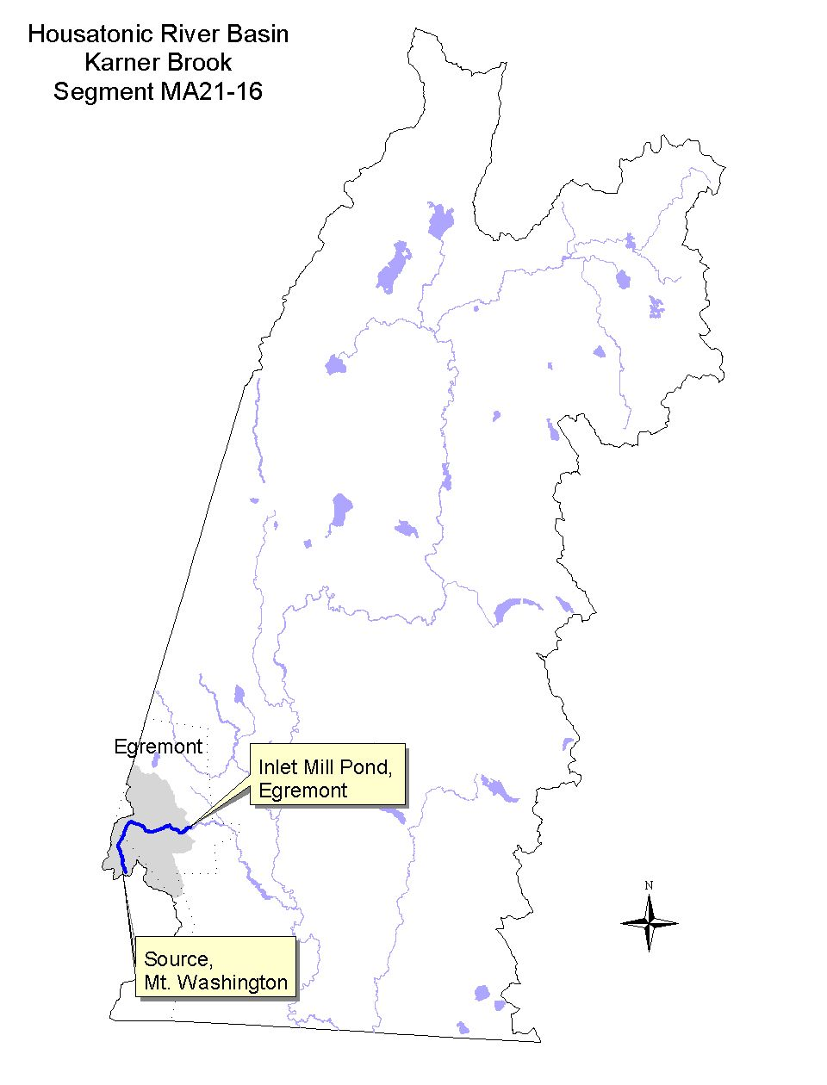

Land-use estimates for the subwatershed (map inset, gray shaded area):
Forest | 76%
Agriculture | 10%
Residential | 6%

Land-use estimates in the 100’ riparian zone from the streambanks:
Forest | 62%
Wetlands | 15%
Residential | 10%

WITHDRAWALS AND DISCHARGES

WMA:
- The South Egremont Water Company (PWS #1090000-01S) withdraws water directly from Karner Brook. In 1994, the average water use was 0.11 MGD and in 1995 was 0.12 MGD. Historically water was withdrawn directly from the stream and passed through one of two sand filter beds. Overflow was discharged back to the brook. A new water filtration facility was constructed and went on-line in January 2000. The construction included a slow sand filter, storage tank, and the renovation of most of the distribution system piping. This renovation/replacement should reduce water use for the system from 0.12 MGD to an approximate use of 0.06-0.08 MGD that is under the WMA permitting threshold of 0.1 MGD.
- In the Karner Brook subwatershed, the Catamount Ski Area is registered (#10109001) to withdraw 0.4 MGD from two sources--a well near Route 23 and a surface water withdrawal from a pond at their ski area in Egremont, MA.

NPDES:
- The Jug End in the Berkshires, Inc. permit (MA0021938) to discharge to Fenton Brook was terminated by EPA on 16 March 1988. The facility will utilize on-site septic systems rather than maintain a surface water discharge.

USE ASSESSMENT

DEP DWM conducted benthic macroinvertebrate and fish sampling in August 1997 at two stations (KB01 and KB02) in Karner Brook to bracket the water withdrawal of the South Egremont Water Company. The upstream station was located off of Mount Washington Road upstream from the pumphouse and the downstream station was located downstream from the pumphouse. Results and the discussion of the RBPIII benthic macroinvertebrate analysis are in Appendix C.

- Bioassessment/Habitat – The benthic community showed slight impairment downstream of the water withdrawal, therefore the Aquatic Life Use is assessed as partial support in the downstream reach. It should be noted, however, that a new water treatment facility is being constructed that could reduce (by half) the volume of water withdrawn from Karner Brook.

- Streamflow – Estimated 7Q10 flows in Karner Brook at the water withdrawal (using a drainage area ratio transformation to Fenton Brook’s 7Q10 in Reis 1999) is 0.008 cfs. The estimated August median flow in Karner Brook is 0.15 cfs.

- Fish Population - Fish sampling in Karner Brook revealed populations of cold water fishes at both sampling locations (Appendix B, Table B7). Brook trout were found upstream of the dam while brook trout and slimy sculpin were found downstream of the dam. Although it is unclear why slimy sculpin were not present upstream of the dam (possibly related to periodic drying or pooling of Karner Brook and/or the presence of the dam), it is not uncommon to see brook trout only inhabiting the uppermost reaches of first order streams.

Designated Use Status: Karner Brook (Segment MA21-16)
Aquatic Life |  | SUPPORT. The upper 2.2 mile length of this segment is evaluated as supporting this use.  PARTIAL SUPPORT. The lower 2.0 mile length of the segment partially supports this use based on slight impairment of the benthic macroinvertebrate community considered to be the result of reduced habitat related to flow alteration.
Fish Consumption |  | NOT ASSESSED.
Drinking Water |  | The DEP Drinking Water Program maintains current drinking water supply data.
Primary Contact |  | NOT ASSESSED.
Secondary Contact |  | NOT ASSESSED.
Aesthetics |  | SUPPORT. The entire 4.2 mile length of this segment is evaluated as supporting this use.

RECOMMENDATIONS: KARNER BROOK (Segment MA21-16)

- Based on the 7Q10 and August median low flow estimates by the DEP DWM, the South Egremont Water Company water withdrawal exceeds the 7Q10 flow of Karner Brook by a factor of 10. The withdrawal is estimated to reduce the August median flow in Karner Brook by approximately one half. Because of this concern, additional water quantity information should be collected for this stream to better assess the relationship between biological integrity and streamflow. This should include the development of a flow duration curve and a streamflow hydrograph.
- Continue to conduct instream biological monitoring (habitat, benthos and fish community) upstream and downstream of the water withdrawal in Karner Brook to evaluate the effectiveness of the new water treatment facility. If DWFELE endorses, designate this stream as a cold water fishery in the next revision of the SWQS.

South Egremont Water Company
- Continue to closely monitor the South Egremont Water Company withdrawal volumes to evaluate the effectiveness of their upgraded system. The company should carefully monitor water use and water loss to avoid unnecessary withdrawals from Karner Brook, particularly during low-streamflow conditions.

UNNAMED TRIBUTARY (Segment MA21-24)
Location: Outlet of Mill Pond, village of South Egremont to confluence with Hubbard Brook, Egremont. Segment Length: 1.5 miles. Classification: Class B.

Segment DESCRIPTION

This unnamed tributary meanders in an easterly direction through the village of South Egremont to its confluence with Hubbard Brook. The lower reach of the segment (downstream from Creamery Road) flows through a golf course.
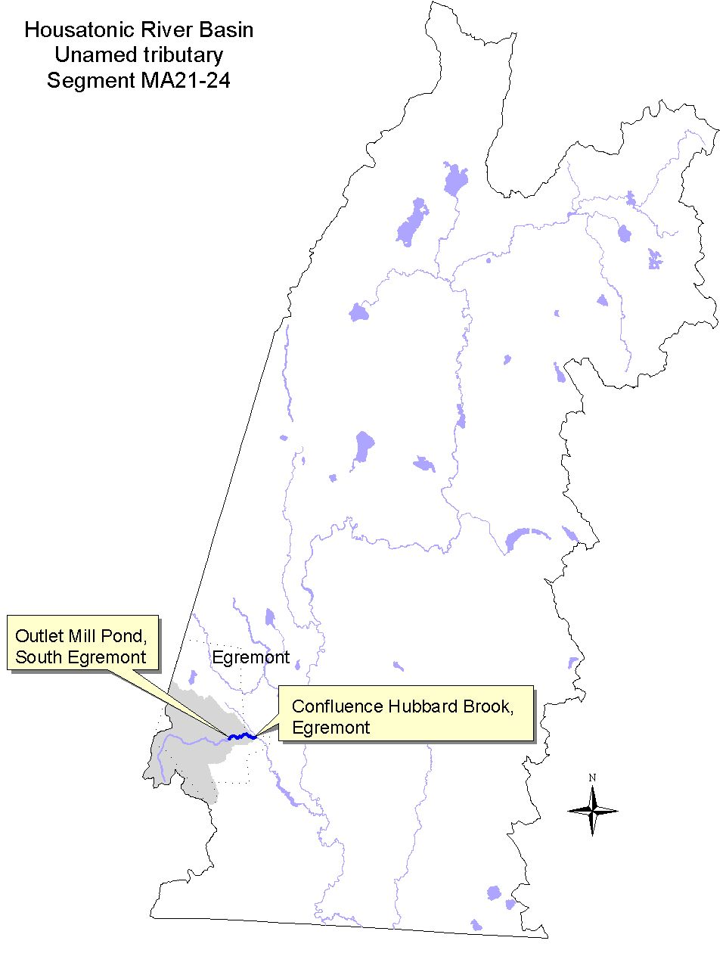

Land-use estimates for the subwatershed (map inset, gray shaded area):
Forest | 68%
Agriculture | 14%
Residential | 8%

Land-use estimates in the 100’ riparian zone from the streambanks:
Forest | 31%
Wetlands and Residential | 22%
Open Land | 20%

WITHDRAWALS AND DISCHARGES

None known.

USE ASSESSMENT

No sampling has been conducted in this stream (Unnamed Tributary Segment MA21-24), therefore all uses are currently not assessed.

Aquatic Life | Fish Consumption | Primary Contact | Secondary Contact | Aesthetics

RECOMMENDATIONS: UNNAMED TRIBUTARY (Segment MA21-24)

- The BRPC report entitled Assessment of Land-use Activities and Nonpoint Source Pollution in the Housatonic River Watershed contains an up-to-date summary of existing and potential nonpoint sources of pollution in the Housatonic River Basin (Berkshire Regional Planning Commission 1999). The potential pollution sources identified in this report (e.g., Table IV-13 and page IV-53-54) should be reviewed to help design future monitoring plans for the Hubbard Brook subwatershed.
- Evaluate potential water quality impacts in this stream in the vicinity of the golf course (e.g., water withdrawal, nutrient loading, riparian zone disturbances).

HUBBARD BROOK (Segment MA21-15)
Location: Source northwest of Townhouse Hill Road, Egremont to confluence with Housatonic River, Sheffield. Segment Length: 9.4 miles. Classification: Class B, Cold Water Fishery.

Segment DESCRIPTION

Hubbard Brook, a Class B Cold Water Fishery, flows primarily in a southeasterly direction through the southwest corner of Great Barrington where it is joined by an unnamed tributary from Root Pond. After crossing back into Egremont, Hubbard Brook is joined by the unnamed tributary from Mill Pond, and begins to meander in a southerly direction into Sheffield. It is joined by Willard Brook prior to flowing into Mill Pond in Sheffield. Hubbard Brook heads southeast as it exits Mill Pond and is fed by Schenob Brook just upstream of its confluence with the mainstem Housatonic River in Sheffield. Both Willard and Schenob brooks are part of the Schenob Brook ACEC.
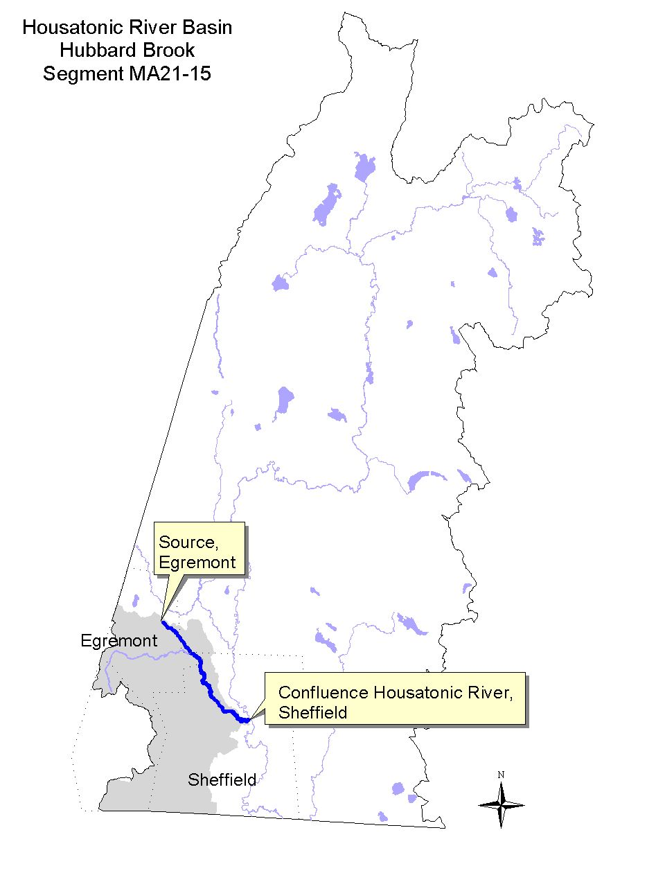

Land-use estimates for the subwatershed (map inset, gray shaded area):
Forest | 71%
Agriculture | 14%
Residential | 5%

Land-use estimates in the 100’ riparian zone from the streambanks:
Wetlands | 35%
Forest | 21%
Agriculture | 9%

WITHDRAWALS AND DISCHARGES

None known.

USE ASSESSMENT

The USGS initiated suspended sediment study sampling on Hubbard Brook (referred to as Schenob Brook at Sheffield MA gage 01198080) in March 1994 and continued to periodically measure suspended sediment concentrations, specific conductivity, and temperature as well as instantaneous discharge through September 1995. These data are reported in Socolow et al. (1996).

- Water Quality - The suspended sediment concentration measured on seven occasions ranged from 4 to 98 mg/L (Socolow et al. 1996). Instream temperature measurements exceeded 20°C on 7 of 11 days sampled during the summer months of 1994 and 1995 (July through September). Conductivity measurements ranged between 226 and 285 μS/cm. Backwater effects from the Housatonic River were encountered during medium to high flow situations that limited sampling (Bent 1999c).

- Fish Consumption Advisory – There is currently no specific fish consumption advisory for Hubbard Brook. The DPH fish consumption advisory in effect for the mainstem Housatonic River includes a provision that recommends that fish taken from feeder streams to the Housatonic River be trimmed of fatty tissue prior to cooking (MA DPH 1999). The intention of this provision is to minimize the potential risk associated with fish that may migrate in or out of the mainstem Housatonic River.

Too little data exists to evaluate the status of the designated uses, therefore all uses for Hubbard Brook (Segment MA21-15) are currently not assessed at this time.

Aquatic Life | Fish Consumption | Primary Contact | Secondary Contact | Aesthetics

RECOMMENDATIONS: HUBBARD BROOK (Segment MA21-15)

- Despite the DPH recommendation that fishes taken from tributaries to the Housatonic River should be trimmed of fatty tissue before cooking (MA DPH 1999), body burdens of PCB in the edible portion of fish from Hubbard Brook should be further investigated. Determination of natural or man-made barriers to migration in the tributaries of the Housatonic River, including Hubbard Brook, would assist in the identification of stream reaches where the potential for PCB contaminated fishes is greatest.
- Water quality monitoring has not historically been conducted in this brook since it does not receive any direct discharges, and there is very little development in the drainage basin. Monitoring may be warranted to develop baseline data (DO, pH, temperature, fecal coliform bacteria) in order to evaluate the Primary and Secondary Contact Recreational uses. Evaluate potential water quality impacts in this stream in the vicinity of the golf course located at the upstream end of this segment (e.g., water withdrawal, nutrient loading, riparian zone disturbances).
- Because of the predominance of agricultural land-use practices adjacent to the Hubbard Brook, further investigation is needed to identify potential nonpoint source pollution (e.g., riparian zone disturbances).
- The BRPC report entitled Assessment of Land-use Activities and Nonpoint Source Pollution in the Housatonic River Watershed contains an up-to-date summary of existing and potential nonpoint sources of pollution in the Housatonic River Basin (Berkshire Regional Planning Commission 1999). The potential pollution sources identified in this report (e.g., Table IV-13 and page IV-53-54) should be reviewed to help design future monitoring plans for the Hubbard Brook subwatershed.

KONKAPOT RIVER (Segment MA21-25)
Location: Outlet of Brewer Lake, Monterey, to the State Line New Marlborough, MA/Caanan, CT. Segment Length: 15.9 miles. Classification: Class B.

Segment DESCRIPTION

The Konkapot River, a Class B waterbody, originates at the outlet of Brewer Lake, Monterey, MA and flows primarily in a south, southwesterly direction over the dam at the Village of Mill River and through New Marlborough into Caanan, Connecticut. The land-use patterns in this watershed area are primarily forested, although small urban centers (e.g., village of Mill River) and agricultural activities are also present.
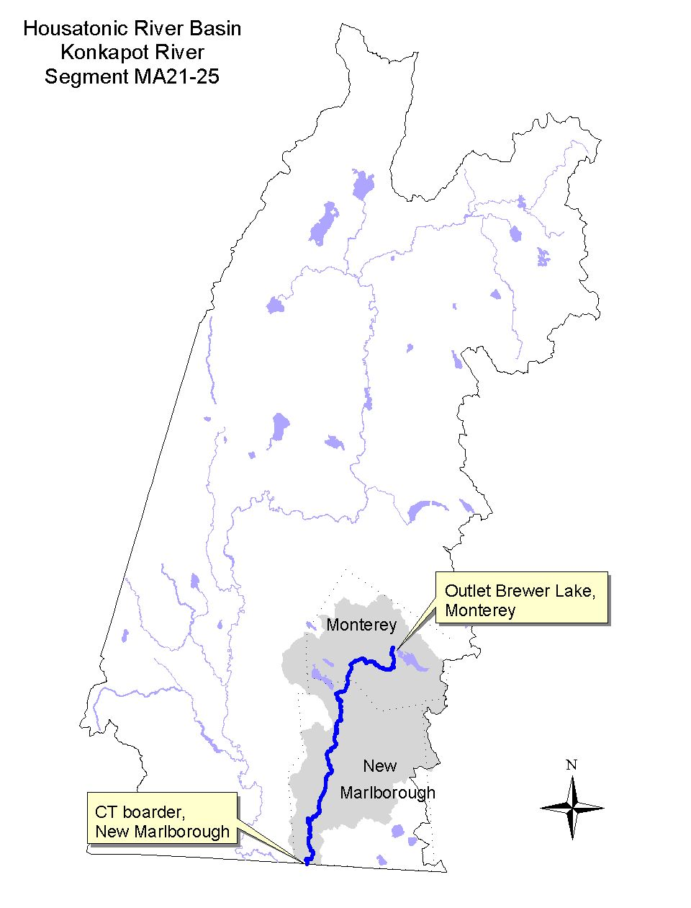

Land-use estimates for the subwatershed (map inset, gray shaded area):
Forest | 80%
Agriculture | 10%
Wetlands | 3%

Land-use estimates in the 100’ riparian zone from the streambanks:
Forest | 41%
Wetlands | 27%
Agriculture | 23%

WITHDRAWALS AND DISCHARGES

WMA:
- Lowland Farm is registered (#10219301) to withdraw 0.04 MGD from two surface water sources in Monterey (Rawson Brook subwatershed).
- Berkshire Trout Hatchery is registered (#10211302) to withdraw 0.33 MGD from an artesian wellfield upstream of Hartsville along the Konkapot River.

Two additional public water supplies in the Konkapot River subwatershed that are below the WMA permitting threshold of 100,000 GPD are (LeVangie 2000):

- The Monterey Water Company has two water withdrawal sources (PWSID# 1193000-01S and 01G) near the small, unnamed tributary from the outlet of Palmer Pond in Monterey. Their system-wide withdrawal volumes are only about 11,000 GPD. In 1999 they withdrew only 3.97 million gallons. Their summer service population is 155 people and their winter service is 126 people.
- Gould Farm in Monterey has two water withdrawals (PWS#1193003-01S and 01G) in the Rawson Brook subwatershed. The groundwater source is active and the surface water source is an emergency source. The actual system-wide withdrawal volume is very small, 2.13 million gallons in 1999. The system serves 80 people.

NPDES:
- MA0005401 – The Berkshire National Fish Hatchery permit to discharge to a small, unnamed tributary to the Konkapot River was issued in June 1979 and never reissued. This facility, now the Berkshire Trout Hatchery, which has been “dry” for the last five years (no fish produced), has recently been purchased.
- MA0022705 – Gould Farm discharges a monthly average flow of 0.012 MGD of treated sanitary effluent to Rawson Brook, a tributary of the Konkapot River, in Monterey. The permit was issued in 1975 and is still active.

USE ASSESSMENT

Water quality and fecal coliform bacteria data were collected by DEP DWM from 11 stations along this segment of the Konkapot River (Appendix B, Figure B2) although physicochemical (nutrients, suspended solids, hardness and alkalinity) sampling was conducted at only three of the stations (Appendix B, Table B1). Survey conditions are described in Appendix B, results – survey conditions. Benthic macroinvertebrate sampling was conducted by DEP DWM in August 1997 at eight stations in this segment of the Konkapot River (Appendix C, Figure C1). The results and discussion of the RBPIII benthic macroinvertebrate analysis can be found in Appendix C. Fish toxics monitoring by DEP was conducted in mid-October 1997 DWM in this segment of the Konkapot River at three stations, F0049, F0048, and F0047 (Appendix B, Figure B3).

- Water Quality - Although not representative of worse case (pre-dawn) conditions, the instream dissolved oxygen concentrations were not less than 7.4 mg/L (Appendix B, Table B4). Saturation ranged between 81 and 101%. The highest instream temperature (25.2°C) was recorded at station KR12, at the outlet of Brewer Lake at 13:19h. Although the majority of the temperature readings were below 20°C in this segment of the Konkapot River, 75% of the temperature readings on 22 July (collected between the outlet of Brewer Lake, Monterey and Hartsville Mill Road, New Marlborough) exceeded 20°C, the standard for a cold water fishery. The elevated temperatures were a likely result of the influence of Brewer Lake and Lake Buel on the river. The pH measurements from this segment of the Konkapot River were all above 7.0 SU, ranging between 7.5 and 8.4 SU. Conductivity increased from the outlet of Brewer Lake to where the Konkapot River enters Connecticut (KR03), most likely related to natural conditions (bedrock geology), as did hardness and alkalinity (Appendix B, Tables B4 and B5). According to USGS the Konkapot River is underlain by crystalline (60%) and carbonate (40%) (Breault and Harris 1997, Coles 1996, Grady and Mullaney 1998, and Harris 1997).

Other water quality variables analyzed in this segment of the Konkapot River indicated low levels of nutrients (NH₃-N < 0.02 mg/L and TP< 0.026 mg/L) throughout the segment with the exception of nitrate-nitrogen (Appendix B, Table B5). Low nitrate levels were measured near the outlet of Brewer Lake (< 0.02 mg/L) where the watershed land-use is primarily forest. Nitrate levels in the river increased slightly (up to 0.10 mg/L) near the village of Mill River, New Marlborough potentially a result of the extensive upstream wetlands. The 1997 DEP DWM data does not suggest problems related to suspended solids (Appendix B, Table B5), although the data set is too small and the spatial coverage too limited to capture any effects of storm water runoff. The in-situ turbidity dataset is also limited. Furthermore, the laboratory dataset for turbidity was consistently lower than the in-situ measurements, potentially an anomaly of field and/or analytical technique. No clear patterns of runoff related to changes in land-use were identified along this segment of the Konkapot River.

- Biology/habitat – The DEP DWM RBPIII benthic macroinvertebrate analysis detected slight impairment of the benthic community downstream from the outlet of Brewer Lake (KR12) probably the result of the upstream impoundment (Appendix C). Additionally, significant instream deposits (sedimentation) were observed in the KR12 sampling reach. No significant impairment was detected at any of the other seven stations (KR11, KR09, KR08, KR07, KR06, KR05, KR03) sampled in this segment (non/slightly impaired).

Based on these data the Aquatic Life Use is assessed as full support in this segment of the Konkapot River. Additionally the water quality data (i.e. suspended solids, turbidity) and field observations indicated no impairment to the aesthetic quality of this segment therefore the Aesthetics Use is also supported.

- Fish Consumption Advisory – Mercury levels in fish (brown trout and/or white sucker) collected by DEP DWM from this segment of the Konkapot River ranged between 0.08 and 0.56 mg/kg wet weight (Appendix B, Table B8). The % lipid concentrations ranged between 0.18 to 1.2. Neither PCB nor organochlorine pesticides were detected in any of the samples. Other species collected from the Konkapot River by DEP DWM included: longnose dace (Rhinichthys cataractae), blacknose dace (Rhinichthys atratulus ), slimy sculpin (Cottus cognatis), and common shiner (Notropis cornutus) (Appendix B). The DPH, using a trigger level of 0.5 mg/kg wet weight Hg, issued a Public Health Fish Consumption Advisory on 6 February 1998 for the Konkapot River (MA DPH 1998). The advisory warns children younger than 12 years old, pregnant women and nursing mothers not to eat fish from the Konkapot River from the village of Mill River to the confluence with the Housatonic River. The advisory also recommends that the general public should limit consumption of all fish caught from this segment of the Konkapot River to two meals per month. Based on this advisory, the Fish Consumption Use is assessed as non-support for the lower 6.1 miles (downstream from the dam at Mill River) because of high mercury in fish flesh.

Mercury contamination in edible fillets of freshwater fishes in Massachusetts is not uncommon. In 1994, DPH issued a statewide Interim Freshwater Fish Consumption Advisory for mercury (MA DPH 1994). This precautionary measure was aimed at pregnant women only; the general public was not considered to be at risk from fish consumption. The advisory encompasses all freshwaters in Massachusetts. Mercury contamination can be the result of both near- and far-field point and nonpoint sources. DEP recognizes that other local sources of mercury do exist, and that waters covered by the statewide advisory, as well as site-specific advisories, may in fact be impacted by unconfirmed local sources and/or by atmospheric deposition. Despite the fact that mercury concentrations in fish collected from the Konkapot River above the dam at Mill River did not exceed 0.28 mg/kg wet weight, the Fish Consumption Use in the upper 9.8 mile reach of the Konkapot River is not assessed (precluded by the statewide advisory).

Because of the statewide advisory, the upper 9.8 mile reach of this segment of the Konkapot River is not assessed for the Fish Consumption Use. This use is assessed as non-support for the lower 6.1 miles (downstream from the dam at Mill River) due to DPH’s Konkapot River fish consumption advisory.
Note: In response to the fish toxics monitoring data and subsequent Fish Consumption Advisory, screening work was performed by DEP DWM to determine the presence/absence of mercury in the sediments of the upper (above the dam at Mill River) and lower (above the dam at Ashley Falls) Konkapot River. Streambed sediments located behind dams are quite often the ultimate sink for a wide variety of environmental pollutants. Many contaminants are ubiquitous in nature and can be the result of such natural processes as forest fires, volcanic activity and microbial synthesis (Eisler 1987), however, anthropogenic activities mobilize these substances, often causing them to be enriched or concentrated above natural or baseline levels. On 19 May 1998, a sediment sample was collected by DEP DWM approximately 10 m above the dam at Mill River (station KR07A) in a depositional area near the eastern bank. Mercury was not detected (Appendix B, Table B9).

Waste Site Cleanup File Review: In October 1986, DEP’s Bureau of Waste Site Cleanup (BWSC) in the Western Regional Office (WERO) received a complaint from the New Marlborough Conservation Commission regarding an abandoned dump on the banks of the Umpachene River (MA DEP 1999b). The Umpachene River is a major tributary to the Konkapot River draining approximately 8.5 mi² of central New Marlborough and its village of Southfield. The dump was alleged to have been associated with a local tannery. According to DEP records, BWSC personnel investigated the alleged dump site located just upstream of Norfolk Road at its intersection with Mill River Southfield Road and New Marlborough Southfield Road. Limited water column and sediment sampling in the Umpachene River was conducted (5 February and 18 June 1987) to determine if the dump was a source of contamination to the river. The samples were analyzed for EPA Priority Pollutant Metals and volatile organic compounds (VOCs). Based on the sampling results at the time of investigation, the site was not considered a priority for further investigation by DEP, although the owner was required to submit additional information gathered from local records. In May 1988 the case (1-0121) was closed and the property was removed from the M.G.L. C.21E Site List (MA DEP 1999b). One sediment sample collected in the Umpachene River in the vicinity of the alleged dump was found to contain 0.55 mg/kg of mercury. No upstream sediment sample was collected due to the lack of soft substrate.

- Fecal Coliform Bacteria - The fecal coliform bacteria counts from the 11 stations sampled by DEP DWM along this segment of the Konkapot River ranged between <20 and 140 cfu/100 mls (Appendix B, Table B6). Both the Primary and Secondary Contact Recreational Uses are therefore evaluated as full support.

Designated Use Status: Konkapot River (Segment MA21-25)
Aquatic Life |  | SUPPORT. The entire 15.9 mile length of this segment is assessed as supporting this use.
Fish Consumption |  | NOT ASSESSED. The upper 9.8 miles of this segment are not assessed for this use because of the statewide fish consumption advisory.  NON-SUPPORT. The lower 6.1 miles do not support this use because of the DPH Fish Consumption Advisory for high mercury in fish flesh.
Primary Contact |  | SUPPORT. The entire 15.9 mile length of this segment is assessed as supporting this use.
Secondary Contact |  | SUPPORT. The entire 15.9 mile length of this segment is assessed as supporting this use.
Aesthetics |  | SUPPORT. The entire 15.9 mile length of this segment is assessed as supporting this use.

RECOMMENDATIONS: KONKAPOT RIVER (Segment MA21-25)

- Designate the Konkapot River as a Cold Water Fishery, with DFWELE support, in the next revision of the Massachusetts Surface Water Quality Standards.
- An investigation into the sources of sediment inputs to the Konkapot River near Bear Mountain Road, Monterey should be conducted (Appendix C). BMPs should be implemented if needed.
- The results of the benthic macroinvertebrate analysis indicated non/slight impairment in the Konkapot River in the vicinity of Mill River village, potentially related to organic enrichment. Although currently considered to be fully supporting the Aquatic Life Use, additional monitoring is necessary to determine if a downward trend in water quality resulting from development along this section of the river is occurring. Heavy applications of sand during the winter should be discouraged along this portion of Clayton-Mill River Road, or BMPs should be implemented to trap washout and prevent sand migration into the stream. Biomonitoring is recommended during the next Housatonic River Basin survey.
- Additional sampling is necessary to determine whether or not the presence of mercury in the sediments and fishes of the Konkapot River is a result of a potential point source within the watershed, a diffuse nonpoint source (i.e., atmospheric deposition), and/or from a natural source (i.e., crustal). It is unclear at this time whether or not mercuric compounds were utilized in the tanning process during the 1800s. The screening surveys conducted to date were not designed to assess the variability of mercury in the streambed sediments of the Konkapot River nor to determine whether the mercury in the sediment above the Mill River Dam was significantly lower than in the sediment above the Ashley Falls Dam. Several factors need to be taken into account in the design of any future monitoring plan to evaluate mercury contamination in the Konkapot River Watershed. Since sediment mercury concentrations can be highly variable, an increase in the number of sediment samples at each site would be necessary to account for variability and perhaps to determine significant differences in mercury concentrations between sites. Secondly, the fish collected in 1997 exhibited size/age variations between sites. Standardization of fish size/age would help to clarify differences in mercury concentrations. Finally, due to the fact that DFWELE stocks brown trout in the Konkapot River, these fish must be clearly identifiable so that wild brown trout are targeted in future fish toxics monitoring efforts.
- The BRPC report entitled Assessment of Land-use Activities and Nonpoint Source Pollution in the Housatonic River Watershed contains an up-to-date summary of existing and potential nonpoint sources of pollution in the Housatonic River Basin (Berkshire Regional Planning Commission 1999). The potential pollution sources identified in this report (e.g., Table IV-13 and page IV-54-55) should be reviewed to help design future monitoring plans for the Konkapot River subwatershed.
RECOMMENDATIONS - Continued: KONKAPOT RIVER (Segment MA21-25)

Berkshire Trout Hatchery
- Determine whether or not WMA and/or NPDES permits for the Berkshire Trout Hatchery (formerly Berkshire National Fish Hatchery) will be required. Develop permits if necessary.

Gould Farm
- The Gould Farm NPDES permit (MA0022705) should be reissued with appropriate limits/monitoring requirements.

KONKAPOT RIVER (Segment MA21-26)
Location: From the Connecticut State Line Sheffield, MA/Caanan, CT to the confluence with the Housatonic River, Sheffield. Segment Length: 2.8 miles. Classification: B.

Segment DESCRIPTION

After flowing 2.2 miles through forests and active agricultural farmlands (including livestock) in Caanan, CT, the Konkapot River flows back into Massachusetts in Sheffield. The river meanders 2.8 miles through Sheffield in a westerly direction, over the dam at Ashley Falls to its confluence with the Housatonic River.

Land-use estimates for the subwatershed (map inset, gray shaded area):
Forest | 79%
Agriculture | 10%
Residential | 4%

Land-use estimates in the 100’ riparian zone from the streambanks:
Agriculture | 50%
Forest | 33%
Wetlands | 10%

WITHDRAWALS AND DISCHARGES

None known.

USE ASSESSMENT

In 1997 DEP DWM collected water quality data at multiple stations in this segment of the Konkapot River (Appendix B, Figure B2). In-situ Hydrolab data were collected at three stations including two stations (KR03 and KR02) in North Canaan, CT. Instream physico/chemical data were collected at one station, KR01, in Ashley Falls. Survey conditions are described in Appendix B, results – survey conditions. Fecal coliform bacteria data were collected at six stations, three of which were located in North Canaan, CT. The bacteria sampling (stations KR03A, KR03, KR02A, KR02, KR01A and KR0), extended into the spring of 1998. USGS initiated a suspended sediment study on the Konkapot River in March 1994 and continued to periodically measure suspended sediment concentrations, specific conductivity, and temperature as well as instantaneous discharge through April 1996. These data are reported in Socolow et al. (1996) and Socolow et al., (1997). Benthic macroinvertebrate sampling was conducted by DEP DWM in August 1997 at two stations in this segment of the Konkapot River (Appendix C, Figure C1). Fish toxics monitoring, conducted on 26 August 1997, was initially conducted by DEP DWM in part to determine whether or not fish in the lower Konkapot River (below the dam at Ashley Falls) with migratory access to the Housatonic River bioaccumulate PCB. Fish sampling was conducted both upstream and downstream of the dam (stations F0046 and F0045, respectively) (Appendix B, Figure B3). The USGS, as part of the NAWQA study, sampled fish and sediment from the Konkapot River at Ashley Falls upstream from the dam. Sediment was collected in August 1994 on the upstream side of the Route 7 bridge along the eastern bank. According to USGS (Breault and Harris 1997), fine-grained streambed sediments were collected from a variety of depositional settings within the stream reach and composited. The samples were collected from the top 1-2 cm using a stainless steel scoop following national consistent protocols (Shelton and Capel 1994 as cited in Breault and Harris 1997). Samples collected for inorganic-constituent analysis were wet-sieved through a 63-μm polyethylene sieve, digested to complete dissolution, and analyzed.

- Water Quality - Although not representative of worse-case (pre-dawn) conditions, the instream dissolved oxygen concentrations measured by DEP DWM were not less than 8.6 mg/L (Appendix B, Table B4). Saturation ranged between 81and 97%. None of the temperature measurements exceeded 18.3°C. The pH measurements ranged between 7.8 and 8.0 SU. Conductivity, alkalinity and hardness at sampling station KR01 were the highest measured in the Konkapot River and are most likely related to natural conditions (bedrock geology) (Appendix B, Table B5). Other water quality variables analyzed at this station indicated low levels of nutrients (NH₃-N < 0.02 mg/L and TP< 0.02 mg/L) although nitrate levels were the highest measured (up to 0.53 mg/L). These samples were collected under both dry and wet weather sampling conditions (Appendix B, results - survey conditions). Agricultural activities located in close proximity to the river upstream of the sampling location may have resulted in the increased nitrate concentration.

While the 1997 DEP DWM data suggest that there are no problems related to suspended solids (< 2.8 mg/L), the data set is too small to capture any effects of storm water runoff (Appendix B, Table B5). The single in-situ vs. laboratory turbidity measurement at KR01 is an anomaly, potentially the result of field (sample collected in a bucket) and/or analytical technique, therefore the results are inconclusive (Appendix B, Table B4).

The daily mean suspended sediment concentration measured by USGS ranged between 1 and 720 mg/L during the 66 days sampled (Socolow et al. 1996 and Socolow et al. 1997). High levels of suspended sediment appear to be the result of runoff events and decrease quickly thereafter.

- Sediment Quality – The concentration of mercury in the USGS sample was 0.88 μg/g dry weight (Harris 1997), and grain size distribution was primarily sand (91%), silt (8.9%) and clay (0.3%). PCB were below detection (<50μg/kg dry weight) in the sediment of the Konkapot River (Harris 1997). Iron was at the S-EL guideline. Several trace metals (Cr, Cu, Pb, Mn, Ni, and Zn) exceeded the L-EL guidelines (in Persaud et al. 1993).

- Biology/habitat - Slight impairment was detected in the Konkapot River just prior to its re-entering the state of MA at the upstream end of this segment (KR02), which appeared to be the result of mild organic enrichment (Appendix C). The analysis of the benthic community in the Konkapot River downstream from the dam at Ashley Falls was borderline between the non to slightly impaired. Attached filamentous algae were also present at both stations. Though not yet indicative of a serious problem, these data should serve as an alert to review land management practices to minimize both sediment and nutrient loading from nonpoint source pollution (i.e., road runoff, agriculture) to the lower Konkapot River.

Based on these data, the Aquatic Life Use is assessed as partial support in this segment of the Konkapot River. While water quality (i.e. suspended solids, turbidity) and field observations indicated slight to no impairment to the aesthetic quality of this segment the Aesthetics Use is supported.

- Fish Consumption Advisory - Three brown trout (Salmo trutta) and one white sucker (Catostomus commersoni) were collected by DEP DWM from the Konkapot River above the dam at Ashley Falls (station F0046). Three fish, a brown trout, a largemouth bass (Micropterus salmoides), and a white sucker, were collected downstream of the dam (station F0045). All seven fish were analyzed individually for metals (As, Cd, Pb, Hg, and Se), PCB, organochlorine pesticides, and percent lipids. Arsenic, cadmium, and lead were not detected in the edible fillets of any sample analyzed nor were any organochlorine pesticides (Appendix B, Table B8). Selenium was detected in all samples analyzed ranging from 0.158 to 0.421 mg/kg wet weight. Elevated concentrations of mercury in fish tissue at both stations (0.41 – 1.06 mg/kg wet weight) was documented. The % lipid concentrations ranged between 0.21 to 1.5. PCB were only detected (0.08 μg/g wet weight) in the individual brown trout collected below the dam.

The concentration of PCB in the whole white sucker composite (comprised of eight fish) sample collected by USGS from the Konkapot River upstream of the dam at Ashley Falls was 50 μg/kg wet weight (Coles 1998). The DDT concentration was 17 μg/kg wet weight. Neither the PCB nor the DDT levels exceeded the NAS/NAE guidelines (500 μg/kg PCB, 1,000μg/kg DDT wet weight) for the protection of fish eating wildlife (in Coles 1998). Chlordane was not detected.

The DPH, using a trigger level of 0.5 mg/kg wet weight Hg, issued a Public Health Fish Consumption Advisory on 6 February 1998 for the Konkapot River (MA DPH 1998). The advisory warns children younger than 12 years old, pregnant women and nursing mothers not to eat fish from the Konkapot River from the village of Mill River to the confluence with the Housatonic River. The advisory also recommends that the general public should limit consumption of all fish caught from this segment of the Konkapot River to two meals per month. Based on this advisory, the Fish Consumption Use is assessed as non-support for this segment of the Konkapot River.
The DPH fish consumption advisory in effect for the mainstem Housatonic River includes a provision that recommends that fish taken from feeder streams to the Housatonic River be trimmed of fatty tissue prior to cooking (MA DPH 1999). The intention of this provision is to minimize the potential risk associated with fish that may migrate in or out of the mainstem Housatonic River.
[Note: In response to the fish toxics monitoring data and subsequent Fish Consumption Advisory, screening work was performed by DEP DWM to determine the presence/absence of mercury in the sediments of the upper (above the dam at Mill River) and lower (above the dam at Ashley Falls) Konkapot River. On 19 May 1998, sediment samples were collected approximately 15m above the dam at Ashley Falls in a depositional area near the northern bank and from an erosional area along the southern bank. The concentration of mercury in the coarse grained sediment samples collected by DEP DWM exceeded the S-EL published by Persaud et al. (1993) in the sample collected from the depositional area (Appendix B, Table B9). The sediment sample collected from the erosional area was at the L-EL level.]

- Fecal Coliform Bacteria - The fecal coliform bacteria data from this segment of the Konkapot River ranged between 140 and 700 cfu/100 mls, which is higher than those recorded from the upstream segment (Appendix B, Table B6). These data are similar those collected in 1992 (Dunn 1994), which led to the listing of this segment as impaired for Primary Contact Recreation (MA DEP 1999a). The ability to differentiate between wet and dry weather sampling conditions is difficult for this dataset (Appendix B, results – survey conditions) since it was necessary to extrapolate Konkapot River streamflow conditions from the USGS gage on the Housatonic River at Great Barrington. Since only two out of eight samples (25%) exceeded 400 cfu/100 mls during dry weather conditions and none exceeded 2,000 cfu/100 mls (wet weather guidance), the Primary Contact Recreational Use is assessed as partial support and the Secondary Contact Recreational Use is assessed as support.

Designated Use Status: Konkapot River (Segment MA21-26)
Aquatic Life |  | PARTIAL SUPPORT. The entire 2.8 mile length partially supports the Aquatic Life Use based on slight impairment to the benthic community potentially a result of mild organic enrichment.
Fish Consumption |  | NON-SUPPORT. The entire 2.8 mile length of this segment does not support this use because of a DPH Fish Consumption Advisory due to high mercury in fish flesh.
Primary Contact |  | PARTIAL SUPPORT. The entire 2.8 mile length of this segment partially supports this use based on elevated levels of fecal coliform bacteria.
Secondary Contact |  | SUPPORT. The entire 2.8 mile length of this segment supports this use.
Aesthetics |  | SUPPORT. The entire 2.8 mile length of this segment supports this use.

RECOMMENDATIONS: KONKAPOT RIVER (Segment MA21-26)

- Designate the Konkapot River as a Cold Water Fishery, with DFWELE support, in the next revision of the Massachusetts Surface Water Quality Standards.
- DPH should review the PCB dataset from the Konkapot River and make any necessary changes to the Housatonic River fish consumption advisory.
- Further investigation (bracketing of major land-use changes) is necessary to identify and quantify anthropogenic sources of sediment input(s) into this reach of the Konkapot River. Subsequently, BMPs should be implemented to control erosion and reduce sediment inputs to the Konkapot River. At a minimum, BMPs are needed at the Route 7A crossing to control road runoff.
- The results of the benthic macroinvertebrate analysis indicated slight impairment in this segment of the Konkapot River, potentially related to organic enrichment (Appendix C). Additional monitoring is necessary to determine any trends in water quality as a result of land-use activities. Adjacent agricultural activities are one obvious potential source of nutrient loadings, however other upstream sources may exist as well. Restoration of the riparian zone along the Konkapot River upstream of Route 124 in Caanan, CT may help to minimize NPS loadings.
- Biomonitoring in the Konkapot River at DEP DWM stations KR02 and KR01 is recommended during the next Housatonic River Basin survey.
- Additional sampling would be necessary to determine whether or not the presence of mercury in the sediments and fishes of the Konkapot River is a result of a potential point source within the watershed, a diffuse nonpoint source (i.e., atmospheric deposition), and/or from a natural source (i.e., crustal). It is unclear at this time whether or not mercuric compounds were utilized in the tanning process during the 1800s. This survey was not designed to assess the variability of mercury in the streambed sediments of the Konkapot River nor to determine whether the mercury in the sediment above the Mill River Dam was significantly lower than in the sediment above the Ashley Falls Dam. There are several factors that need to be taken into account in the design of future monitoring studies of mercury contamination in the Konkapot River Watershed. Since sediment mercury concentrations can be highly variable, an increase in the number of sediment samples at each site would be necessary to account for variability and perhaps to determine significant differences in mercury concentrations between sites. Secondly, the fish collected in 1997 exhibited size/age variations between sites. Standardization of fish size/age would help to clarify differences in mercury concentrations. Finally, due to the fact that DFWELE stocks brown trout in the Konkapot River, these fish must be clearly identifiable so that wild brown trout are targeted in future fish toxics monitoring efforts.
- The BRPC report entitled Assessment of Land-use Activities and Nonpoint Source Pollution in the Housatonic River Watershed contains an up-to-date summary of existing and potential nonpoint sources of pollution in the Housatonic River Basin (Berkshire Regional Planning Commission 1999). The potential pollution sources identified in this report (e.g., Table IV-13 and page IV-54-55) should be reviewed to help design future monitoring plans for the Konkapot River subwatershed.

HOUSATONIC RIVER BASIN - LAKE SEGMENT ASSESSMENTS

A total of 32 lakes, ponds or impoundments (the term "lakes" will hereafter be used to include all) have been assessed in the Housatonic River Watershed. Eleven of the lakes 32 lakes assessed are less than 50 acres in total surface area. The lakes surveyed in 1997 are located wholly or partly within 19 different communities and are fairly evenly distributed among them. Of the 5,227 acres of lakes in the Housatonic River Basin, 81%, or 4,254 acres, was assessed during the 1997 surveys. Designated water supplies (i.e., Class A) accounted for 12% (or 530 acres) of the assessed acreage.
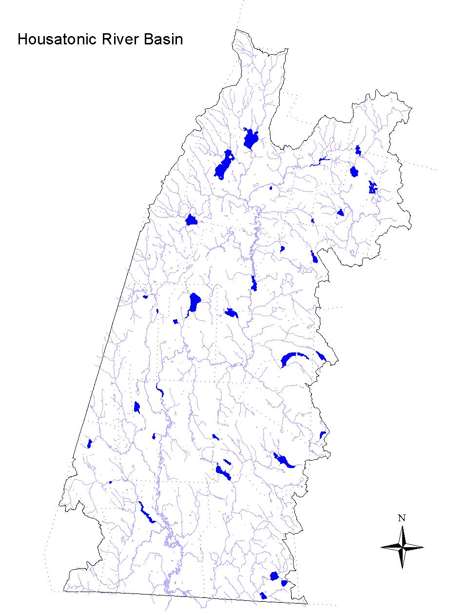

Figure 5. Location of Massachusetts lakes assessed in the Housatonic River Basin.

LAKE USE ASSESSMENTS

Synoptic surveys were conducted by DEP DWM, during the summer of 1997, at a total of 32 lakes in the Housatonic River Basin. Surveys consisted of taking observations from at least one access point on each lake (multiple access points on larger lakes). At each lake, an attempt was made to observe the entire surface area to determine the extent of areal macrophyte cover. The trophic status of each lake was estimated and the presence of non-native aquatic and/or wetland plant species was also noted (Appendix B, Table B10). The data gathered during these synoptic surveys, as well as DPH Fish Consumption Advisories (DPH 1999), were used to assess the status of the designated uses.

AQUATIC LIFE
Individual lake assessments are presented in Table 6. Three non-native, aquatic species and two non-native, wetland species were observed in the Housatonic River Basin lakes, as follows.

Non-native Aquatic Plants
Myriophyllum spicatum - Eurasian water milfoil
Najas minor - European naiad
Potamogeton crispus - Curly leaf pondweed

Non-native Wetland Plants
Lythrum Salicaria - Purple loosestrife
Phragmites australis - Reed grass

Of the 32 lakes surveyed, 15, or 47% had a confirmed non-native aquatic macrophyte observed. In the case of wetland species 16, or 50%, lakes had non-natives associated with them.

Non-native plant species represent a special cause of impairment that is not always directly related to the eutrophication process. Since these species are introduced from other parts of the country or world they are generally free from the natural control mechanisms (e.g., insects or diseases) that keep most native plant populations in check. Without controls the populations of many non-native species can grow rapidly to out-compete native plant species. This growth habit is termed invasive. It throws the biological community out of balance and can impair uses such as swimming (Primary Contact) and boating (Secondary Contact). In Massachusetts, the Division of Watershed Management is tracking the distribution of about a dozen of these non-native aquatic and wetland plant species and the impairment they are causing.

The distribution of these species is frequent to widespread, often in headwater areas, and since these species have good potential for spreading, it is likely that they have established themselves in unsurveyed lakes, segments of tributaries, and the mainstem Housatonic River. The listings in Table 5 indicate where non-native, aquatic species have been observed (in bold) and the likely, or potential, avenues of downstream spreading.

Lakes exhibiting impairment of the Aquatic Life Use because of macrophyte cover were noted as either partial or non-support (Table 6). However, if a lake met these criteria it, or part of its area, was listed as “not assessed” because no dissolved oxygen data were available.

The USGS NAWQA study sampled one site in Woods Pond for both fish tissue and sediment (Coles 1998 and Harris 1997). PCB data from sediments and biota have been collected by various agencies as part of the GE Company Pittsfield waste site cleanup investigations (Stefanosky 1998). Blasland, Bouck, and Lee, Inc. (1999) collected young-of-the-year fish for PCB analysis in 1994 and 1998 from a station (WP1) in Woods Pond. As Woods Pond is an impoundment of the Housatonic River, these data are also discussed in segment MA21-04, Housatonic River from the confluence of Southwest Branch Housatonic River and West Branch Housatonic River, Pittsfield to Outlet of Woods Pond, Lee/Lenox.

Woods Pond
- Tissue Chemistry:
- NAQWA - The concentration of PCB in the whole fish composite sample (comprised of eight white suckers, Catastomas commersoni) collected from Woods Pond was 72,000μg/kg wet weight (Coles 1998). This level of PCB greatly exceeded (144 times) the NAS/NAE guideline for total PCB (in Coles 1998) of 500μg/kg wet weight for the protection of fish-eating wildlife. Chlordane was not detected in the white sucker composite sample. The DDT concentration was 260μg/kg wet weight, which did not exceed the NAS/NAE guideline for total DDT (in Coles 1998) of 1,000μg/kg wet weight for the protection of fish-eating wildlife.
- Blasland, Bouck, & Lee, Inc. (1999) – The concentration of PCB in young-of-the-year fish collected at station WP1 was between 15,000 and 38,000 μg/kg wet weight (PPB) in largemouth bass, yellow perch, and bluegill. All of these data exceed (30 to 80 times) the NAS/NAE guideline for total PCB (in Coles 1998) of 500μg/kg wet weight for the protection of fish-eating wildlife.
- Sediment Chemistry:
- In Woods Pond, total PCB ranged between 0.07 and 210 PPM dry weight in the 42 samples analyzed in sediment samples collected to a depth of < 1 ft. (Stefanosky 1999). One sample was less than the L-EL of 0.07 PPM while 67 and 36% of the samples exceeded the S-EL of 5.3 and 53 PPM, respectively.
- High concentrations (20 PPM dry weight) of PCB were also measured (sample collected 15 May 1996) as part of the NAWQA study in the sediment of the Housatonic River in Woods Pond (Breault and Harris 1997).

PCB data from sediments and biota have been collected by various agencies as part of the GE Company Pittsfield waste site cleanup investigations (Stefanosky 1998). In September 1995, largemouth bass were collected from the Laurel Lake by Blasland, Bouck & Lee, Inc. (1996) and analyzed as scales off/skin on fillets.

Laurel Lake
Total PCB concentrations in fish tissue were not detected in four of the five samples and were low (65 PPB wet weight) in one sample.

PCB data from sediments and biota have been collected by various agencies as part of the GE Company Pittsfield waste site cleanup investigations (Stefanosky 1998). Blasland, Bouck, and Lee, Inc. (1999) collected young-of-the-year fish samples for PCB analysis in 1998 from Glendale Dam. As Risingdale is an impoundment of the Housatonic River, these data are also discussed in segment MA21-19, Housatonic River from Outlet of Woods Pond, Lee/Lenox to the outlet of Risingdale Impoundment, Great Barrington.

Risingdale Impoundment
The concentration of total PCB in surficial sediment (less than 12 inches) of the Housatonic River in Rising Pond (also know as Risingdale Impoundment) ranged from detectable levels to 26 PPM (Blasland, Bouck & Lee, Inc. 1991, 1992 and 1996). The sediment total PCB data in the 1992 Addendum report (the only report that included TOC data) did not exceed the S-EL guideline however all the total PCB data exceeded the L-EL guideline (0.07 PPM).
Table 5. Non-native, aquatic species locations (in bold) and possible paths of downstream spreading (MA DEP 1998).
Myriophyllum spicatum (Eurasian water milfoil)

-- Pontoosuc Lake (Pittsfield/ Lanesborough) ⇒ West Branch Housatonic River ⇒ Housatonic River
Onota Lake (Pittsfield/ Richmond) ⇒ Onota Brook ⇒⇑
(through Woods Pond, several unnamed impoundments, Risingdale Impoundment)

-- Richmond Pond (Pittsfield/ Richmond) ⇒ Southwest Branch Housatonic River ⇒ Housatonic River
(through Woods Pond, several unnamed impoundments, Risingdale Impoundment)

-- Ashmere Lake (Hinsdale) ⇒ Bennett Brook ⇒ East Branch Housatonic River ⇒ Housatonic River
Plunkett Reservoir (Hinsdale) ⇒ Frisell Brook ⇒⇑
(through Center Pond, Woods Pond, several unnamed impoundments, Risingdale Impoundment)

-- Laurel Lake (Lee/ Lenox) ⇒ unnamed tributary ⇒ Housatonic River
(through several unnamed impoundments, Risingdale Impoundment)

-- Upper Goose Pond (Lee/Tyringham) ⇒ Goose Pond (Lee/ Tyringham) ⇒ Goose Pond Brook ⇒ Housatonic River
Greenwater Lake (Becket) ⇒ Greenwater Brook ⇒⇑
(through several unnamed impoundments, Risingdale Impoundment)

-- Stockbridge Bowl (Stockbridge) ⇒ Larrywaug Brook ⇒ Housatonic River
Lake Averic (Stockbride) ⇒ wetland ⇒⇑
(through unnamed impoundments, Risingdale Impoundment)

-- Mansfield Pond (Great Barrington) ⇒ unnamed tributary ⇒ Housatonic River

-- Long Pond (Great Barrington) ⇒ Long Pond Brook (through a few small impoundments) ⇒ Seekonk
Brook ⇒ Green River ⇒ Housatonic River

-- Lake Buel (Monterey/ New Marlborough) ⇒ unnamed tributary ⇒ Konkapot River ⇒ Housatonic River

-- Thousand Acre Swamp Pond (New Marlborough) ⇒ Whiting River (into CT) ⇒ Housatonic River

Najas minor (European naiad)

-- Pontoosuc Lake (Pittsfield/ Lanesborough) ⇒ see description above for Myriophyllum spicatum

-- Onota Lake (Pittsfield/ Richmond) ⇒ see description above for Myriophyllum spicatum

-- Richmond Lake (Pittsfield/ Lanesborough) ⇒ see description above for Myriophyllum spicatum

-- Plunkett Reservoir (Hinsdale) ⇒ see description above for Myriophyllum spicatum

-- Laurel Lake (Lee/ Lenox) ⇒ see description above for Myriophyllum spicatum

-- Lake Buel (Monterey/ New Marlborough) ⇒ see description above for Myriophyllum spicatum

Potamogeton crispus (Curly leaf pondweed)

-- Pontoosuc Lake (Pittsfield/ Lanesborough) ⇒ see description above for Myriophyllum spicatum

-- Onota Lake (Pittsfield/ Richmond) ⇒ see description above for Myriophyllum spicatum

-- Goose Pond (Lee/ Tyringham) ⇒ see description above for Myriophyllum spicatum

-- Mansfield Pond (Great Barrington) ⇒ see description above for Myriophyllum spicatum

FISH CONSUMPTION

In April 1982 the state issued a fish consumption advisory for the Housatonic River. The advisory recommended that the general public should not consume fish, frogs and turtles from the Housatonic River between Dalton and Sheffield because of PCB contamination. In 1995, DPH updated their advisory to include a recommendation that fish taken from feeder streams to the Housatonic River should be trimmed of fatty tissue prior to cooking (MA DPH 1999). Additionally, in 1994, DPH issued a statewide Interim Freshwater Fish Consumption Advisory for mercury (MA DPH 1994). This precautionary measure was aimed at pregnant women only; the general public was not considered to be at risk from fish consumption (MA DPH 1994).

There are four lakes affected by non-consumption advisories in the watershed (Table 6). The DPH advisory for Pontoosuc Lake, Pittsfield/Lanesborough, recommends that children under 12 years of age, pregnant women, and nursing mothers should not consume any fish from Pontoosuc Lake because of a mercury hazard. All others should limit consumption of largemouth bass to two (2) meals per month (MA DPH 1999).

The three remaining lakes (Center Pond in Dalton, Woods Pond in Lee/Lenox, and Risingdale Impoundment in Great Barrington) are all affected by the DPH advisory for the mainstem Housatonic River from Dalton to Sheffield related to PCB contamination from the GE Pittsfield Company (MA DPH 1999).

PRIMARY AND SECONDARY CONTACT RECREATION AND AESTHETICS

Because the synoptic surveys focus on just three criteria (macrophyte cover, transparency, and biocommunity modifications) only a few uses could be assessed fully (Appendix B, Table B10). Since macrophyte cover is the only criterion used to assess the Secondary Contact Recreation, this use category was assessed at each lake surveyed (Table 6). Lakes exhibiting impairment of the Primary Contact Recreation Use (swimmable) because of macrophyte cover and/or transparency were noted as either partial or non-support. However, if a lake met these criteria it, or part of its area, was listed as not assessed because no data were available for fecal coliform bacteria. The Aesthetic Use category was generally assessed at the same level of impairment as the more severely impaired recreational use (Primary or Secondary Contact Recreation).

SUMMARY

Due to the focus of the surveys conducted, the major cause of impairment was aquatic plants (either noxious-native or non-native). Turbidity was also noted occasionally as a cause (Table 6). These causes may reflect symptoms of lake succession, a process of enrichment that can be accelerated from excessive plant nutrients and sediments being introduced to the lakes from cultural activities. This phenomenon is also reflected in the distribution of lake trophic conditions, which is skewed toward the more eutrophic categories. Additional causes of impairment include metals (mercury) and priority organics (PCB) associated with the DPH fish consumption advisories.

The sources of impairment are largely unknown, at least based on direct knowledge. However, it can be surmised that nutrients delivered from storm water runoff, failing substandard sewage disposal systems, and other non-point sources are likely to cause the increased algal or macrophyte productivity that has resulted in impairments. The exception to this is the source of PCB contamination, a result of the GE Pittsfield Company. This contamination has resulted in a DPH fish consumption advisory which impairs the Fish Consumption Use in three lakes.

With the above qualifications for the individual use assessments of lake resources in the Housatonic River Watershed, approximately 79% of the surveyed surface acreage of lakes is impaired (Table 6).
Table 6. Status of Housatonic River Basin lakes surveyed in summer 1997.
LAKE | LOCATION | SIZE (Acres) | TROPHIC STATE | USE ASSESSMENT (Acres) | IMPAIRMENT CAUSE(S)
Ashley Lake ** | Washington | 111 | U | 2° Contact-F(111)  Aesthetics-F(111) | NA
Ashmere Lake | Hinsdale | 217 | U | Aquatic Life-P(217)  2° Contact-F(217)  Aesthetics-F(217) | Non-native plants (Ms)
Lake Averic ** | Stockbridge | 38 | U | Aquatic Life-P(38)  2° Contact-F(38)  Aesthetics-F(38) | Non-native plants (Ms)
Benedict Pond (DEM, ‘95) | Great Barrington/ Monterey | 35 | M | 2° Contact-F(35)  Aesthetics-F(35) | NA
Lake Buel | Monterey/ New Marlborough | 194 | E | Aquatic Life- P(194)  2° Contact-F(194)  Aesthetics-F(194) | Non-native plants (Ms, Nm)
Center Pond | Dalton | 30 | U | Fish Consumption-N(30) | Priority organics (PCB)
Cleveland Brook Reservoir ** | Hinsdale | 145 | U | 2° Contact-F(145)  Aesthetics-F(145) | NA
Cookson Pond | New Marlborough | 67 | U | 2° Contact-F(67)  Aesthetics-F(67) | NA
Crane Lake | West Stockbridge | 28 | U | 1° Contact-N(7);U(21)  2° Contact-F(21);N(7)  Aesthetics-F(21);N(7) | Noxious plants
Farnham Reservoir ** | Washington | 42 | U | 2° Contact-F(42)  Aesthetics-F(42) | NA
Lake Garfield | Monterey | 262 | U | 2° Contact-F(262)  Aesthetics-F(262) | NA
Goose Pond | Lee/ Tyringham | 225 | M | Aquatic Life-P(225)  2° Contact-F(225)  Aesthetics-F(225) | Non-native plants (Ms, Pc; Fugro East, Inc., ‘95)
Greenwater Lake | Becket | 88 | U | Aquatic Life-P(88)  2° Contact-F(88)  Aesthetics-F(88) | Non-native plants (Ms)
Hayes Pond | Otis | 53 | U | 2° Contact-F(53)  Aesthetics-F(53) | NA
Laurel Lake | Lee/ Lenox | 165 | E | Aquatic Life-P(165)  2° Contact-F(165)  Aesthetics-F(165) | Non-native plants (Ms, Nm)
Long Pond ** | Great Barrington | 113 | E | Aquatic Life-P(113)  1° Contact-N(6);U(107)  2° Contact-F(107);N(6)  Aesthetics-F(107);N(6) | Non-native plants (Ms)  Noxious plants
Mansfield Pond | Great Barrington | 25 | E | Aquatic Life-P(25)  1° Contact-N(15);U(10)  2° Contact-F(10);N(15)  Aesthetics-F(10);N(15) | Non-native plants (Ms, Pc)  Noxious plants
Mill Pond | Egremont | 20 | E | 1° Contact-N(20)  2° Contact-N(20)  Aesthetics-N(20) | Noxious plants
Mill Pond | Sheffield | 107 | E | 1° Contact-N(107)  2° Contact-N(107)  Aesthetics-N(107) | Noxious plants
Onota Lake | Pittsfield/ Richmond | 617 | M | Aquatic Life-P(617)  2° Contact-F(617)  Aesthetics-F(617) | Non-native plants (Ms, Nm, Pc)
Plunkett Reservoir | Hinsdale | 73 | U | Aquatic Life-P(73)  2° Contact-F(73)  Aesthetics-F(73) | Non-native plants (Ms, Nm)
** Indicates Class A (water supply) waterbody; all others are Class B.
INFORMATION CODES: Trophic State-- E= Eutrophic, M= Mesotrophic, U= Undetermined.
Use Attainment-- F= Full support, N= Non-support, P= Partial support, U= Undetermined.
Non-native Plants-- Ms= Myriophyllum spicatum, Nm= Najas minor, Pc= Potamogeton crispus.
Table 6 (continued). Status of Housatonic River Basin lakes surveyed in summer 1997.
LAKE | LOCATION | SIZE (Acres) | TROPHIC STATE | USE ASSESSMENT (Acres) | IMPAIRMENT CAUSE(S)
Pontoosuc Lake | Pittsfield/ Lanesborough | 467 | U | Aquatic Life-P(467)  Fish Consumption-N(467)  2° Contact-F(467)  Aesthetics-F(467) | Metals (Hg)  Non-native plants (Ms, Nm, Pc)
Prospect Lake | Egremont | 55 | M | 2° Contact-F(55)  Aesthetics-F(55) | NA
Richmond Pond | Pittsfield/ Richmond | 218 | U | Aquatic Life-P(218)  2° Contact-F(218)  Aesthetics-F(218) | Non-native plants (Ms, Nm)
Risingdale Impoundment | Great Barrington | 43 | U | Fish Consumption-N(43) | Priority organics (PCB)
Stevens Pond | Monterey | 30 | U | 2° Contact-F(30)  Aesthetics-F(30) | NA
Stockbridge Bowl | Stockbridge | 382 | E | Aquatic Life-P(382)  2° Contact-F(382)  Aesthetics-F(382) | Non-native plants (Ms)
Thousand Acre Swamp Pond | New Marlborough | 155 | E | Aquatic Life-P(155)  1° Contact-N(75);U(80)  2° Contact-F(80);N(75)  Aesthetics-F(80);N(75) | Non-native plants (Ms)  Noxious plants
Upper Goose Pond | Lee/ Tyringham | 45 | M | Aquatic Life-P(45)  2° Contact-F(45)  Aesthetics-F(45) | Non-native plants (Ms)
Upper Sackett Reservoir ** | Hinsdale | 20 | U | 2° Contact-F(20)  Aesthetics-F(20) | NA
Windsor Reservoir ** | Hinsdale/ Windsor | 62 | M | 2° Contact-F(62)  Aesthetics-F(62) | NA
Woods Pond | Lee/ Lenox | 122 | E | Fish Consumption-N(122)  1° Contact-P(61);N(61)  2° Contact-P(61);N(61)  Aesthetics-P(61);N(61) | Noxious plants  Priority organics (PCB)  Turbidity
** Indicates Class A (water supply) waterbody; all others are Class B.

INFORMATION CODES: Trophic State-- E= Eutrophic, M= Mesotrophic, U= Undetermined.
Use Attainment-- F= Full support, N= Non-support, P= Partial support, U= Undetermined.
Non-native Plants-- Ms= Myriophyllum spicatum, Nm= Najas minor, Pc= Potamogeton crispus.

RECOMMENDATIONS - LAKES

- The DPH fish consumption advisory to eat no fish, frogs and turtles from the Housatonic River from Dalton to Sheffield because of PCB contamination results in the Fish Consumption Use being assessed as non-support in Center Pond. Whether or not the biota in the East Branch Housatonic River (including Center Pond) upstream of the Crane & Co., Inc. dams (which pose a barrier to fish migration) are contaminated by PCB is currently being investigated by EPA as part of their Ecological Risk Assessment. The DPH should review the results of this investigation and adjust the fish consumption advisory as needed.

- Continue to monitor the effectiveness of the GE Company Pittsfield PCB cleanup activities as they pertain to impoundments of the mainstem Housatonic River. Document these results in a comprehensive report including data and analyses.

- EPA is in the process of collecting additional data on streambed sediments and river bank soils from Dalton through Sheffield, although this data is not yet available (expected sometime in 2000). EPA has also been collecting considerable data (sampling in 1998 and 1999) on river biota at a variety of trophic levels (including fish, frogs, and ducks) as part of their Ecological Risk Assessment. Additional data may also be collected in 2000. Review and evaluate these data as they pertain to impoundments of the mainstem Housatonic River.

RECOMMENDATIONS (Continued) – LAKES

- For non-native aquatic or wetland plant species that were isolated to one or a few location(s) quick action is advisable to manage these populations in order to alleviate the need for costly and potentially fruitless efforts to do so in the future. Two courses of action should be pursued concurrently. More extensive surveys need to be conducted, particularly downstream from these recorded locations, to determine the extent of the infestation. And, "spot" treatments should be undertaken to control populations at these sites before they spread further. These treatments may be in the form of carefully hand pulling individual plants, in small areas, or selective herbicide applications in larger areas. In either case, the treatments should be undertaken prior to fruit formation and with a minimum of fragmentation of the individual plants. These cautions will minimize the spreading of the populations.

- The aquatic species Myriophyllum spicatum, Najas minor, and Potamogeton crispus and the wetland species Lythrum Salicaria and Phragmites australis have become more wide-spread in the Housatonic River Watershed lakes and wetlands. Accordingly these species will require an extensive program aimed at 1) determining the extent of the distribution, 2) reducing impairment, and 3) controlling further spreading to unaffected waterbodies.

- As with the isolated cases, a program to manage the more extensive plant infestations should include additional monitoring efforts to determine the extent of the problem. Plant control aspects of any plan to manage the non-native aquatic species mentioned above can select from several techniques (e.g., bottom barriers, drawdown, herbicides, etc.), each of which has advantages and disadvantages that need to be addressed for the specific site. However, methods that result in fragmentation (such as cutting or raking) should be discouraged because of the propensity for these plants to reproduce and spread vegetatively (from cuttings).

- Another important component of a management plan is prevention of further spreading of these plants. Once the extent of the problem is determined and control practices are exercised, vigilant monitoring needs to be practiced to guard against infestations occurring in unaffected areas and to ensure that managed areas stay in check. A key portion of the prevention program should be posting of boat access points with signs to educate and alert lake-users to the problem and responsibility of spreading these species.

- Diagnostic/feasibility (D/F) studies have been conducted on five lakes in the Housatonic River Basin. These include: Onota Lake in Pittsfield, Richmond Pond in Richmond, Stockbridge Bowl in Stockbridge, Prospect Lake in Egremont, and Mansfield Lake in Great Barrington. Another D/F study has recently been completed for Pontoosuc Lake in Pittsfield/Lanesborough (Project # 97-01/314) (ENSR 1999). Each of these studies has recommendations to deal with watershed and in-lake issues specific to the waterbody. Whether or not the recommendations have been implemented is unknown, although they should still be applicable and merit implementation. Two projects are currently underway in the Housatonic River Basin (MA DEP 2000a):

Pontoosuc Lake Watershed Resource Restoration (Project # 99-03-319). This project will improve water quality in Pontoosuc Lake by beginning implementation of the recommendations of the D/F Study, specifically, the installation of stormwater BMPs.

Implementing the Diagnostic/Feasibility Study Recommendations for Onota Lake (Project # 00-01-319). This project will implement in-lake and watershed management measures recommended in a comprehensive Diagnostic/Feasibility Study prepared by International Technology Corporation for Onota Lake, specifically installation of a large culvert to improve circulation and improve water quality.

- Coordinate with DEM to generate quality assured lakes data and conduct more intensive lake surveys to better determine the lake trophic and use support status and identify causes and sources of impairment.

