

How to Amend your Toxics Use Reduction Act (TURA) Filings using MassDEP’s eDEP Online Filing System
v. 2026
All Toxics Use Reduction Act (TURA) reports must be electronically filed via MassDEP’s eDEP Online Filing System. Effective calendar year 2024, MassDEP staff will no longer be able to make changes to forms for TURA reporters. TURA reporters who need to revise their reported information must do so electronically via the eDEP Amend feature. Amendments can be made to reports submitted from calendar year 2016 to present, reports older than 2016 are not able to be amended. Any user who has been granted access to a TURA report can amend a report.
The process to initiate an amend is as follows:
- Users must log in to their account on eDEP account by entering their username and password.
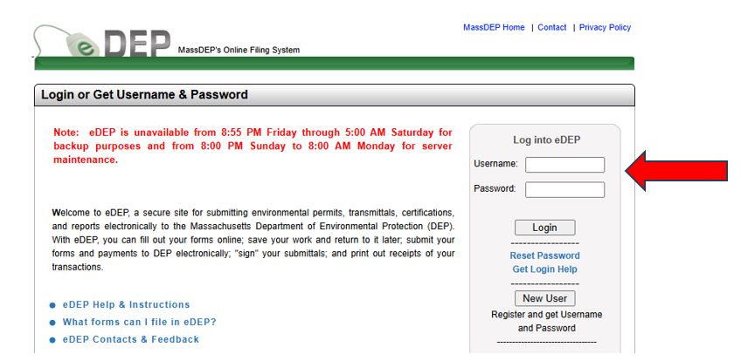
- Select the tab entitled Recent Submitted.
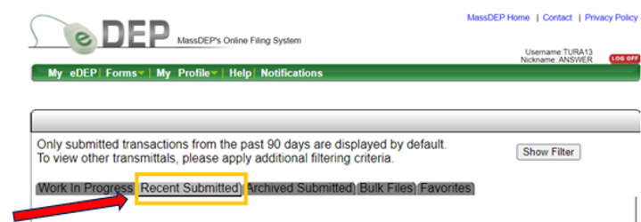
- Review the list of recent submissions and identify the filing that needs to be amended by locating the transaction number.
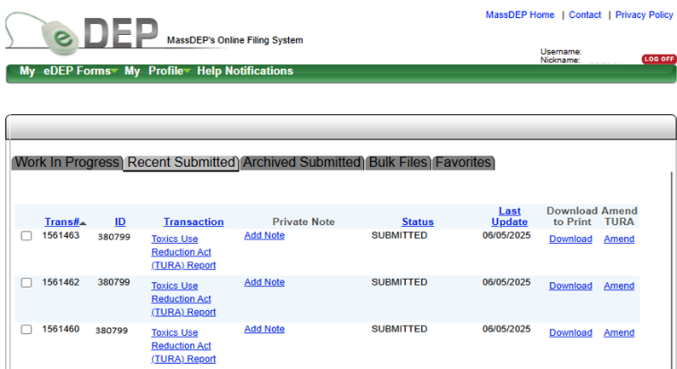
- Select the Amend button. Please note, it will take one hour for the system to generate an editable filing. The new filing may be visible before the hour has passed however users may encounter system and navigation errors if they try to edit the filing before the hour has elapsed.
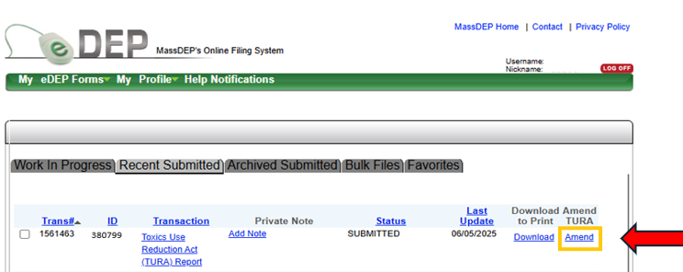
- After waiting an hour, navigate to the Work In Progress tab and locate the new transaction. Please note, a new transaction number will have been generated, however the transaction will be populated with the same answers as the previous transaction.
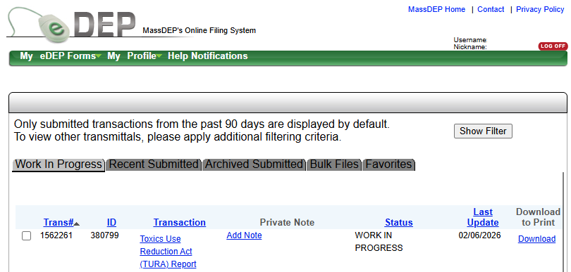
- Select Toxics Use Reduction Act (TURA) Report to open the Transaction Overview Screen.
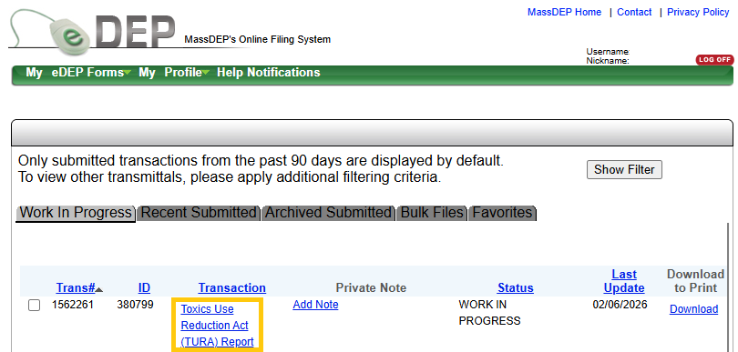
- On the Transaction Overview screen select the form from the list within the transaction that requires revision. Please note that depending on the type of revision made each subsequent form may require revision.
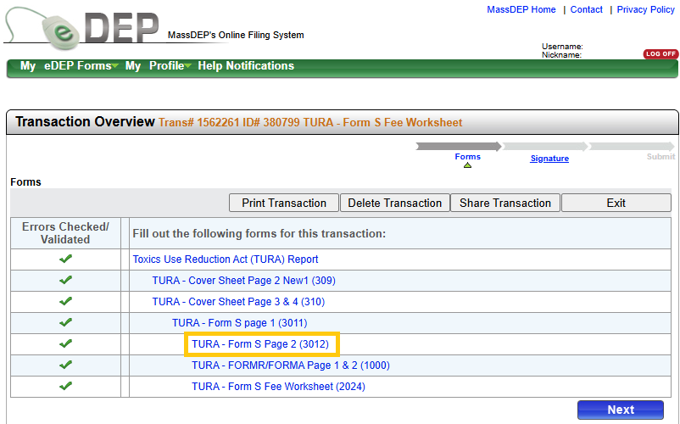
- Review each section of the form selected and make the necessary revisions (including adding/deleting chemicals, correcting data input).
- Once all revisions on the first page of the form have been made, select the Error Check & Next button located at the bottom of the page. If there are errors on the form, a list of the errors will be presented at the bottom of the page. If there are no errors on the form, selecting the Error Check & Next button will return you to the Transaction Overview Screen.
- Review the column of Errors Check/Validated beside the form names. Any form name that does not have a check next to it will need to be revalidated. Users can either manually select each form on the list for validation or can advance through the list by selecting the Next button. As each page loads users will need to complete and save any new data fields. If no new data fields are presented, scroll to the bottom of the page and select Error Check & Next.
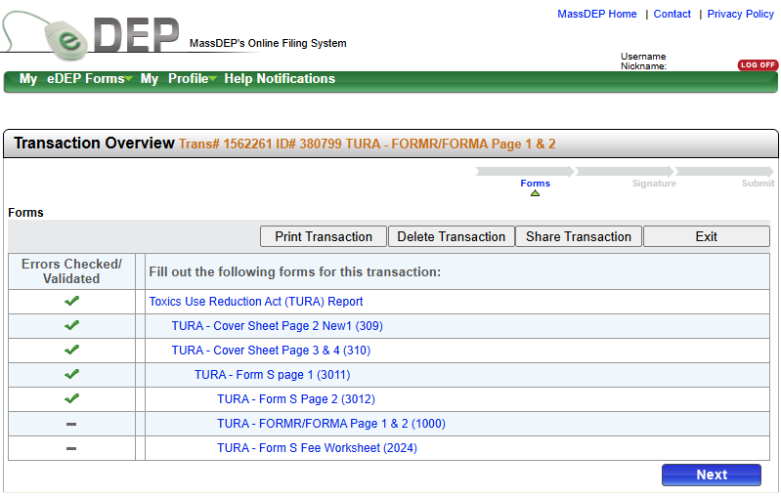
- After all forms have been validated, select the Next button which will advance to the Signature page. Forms packets must be resigned.
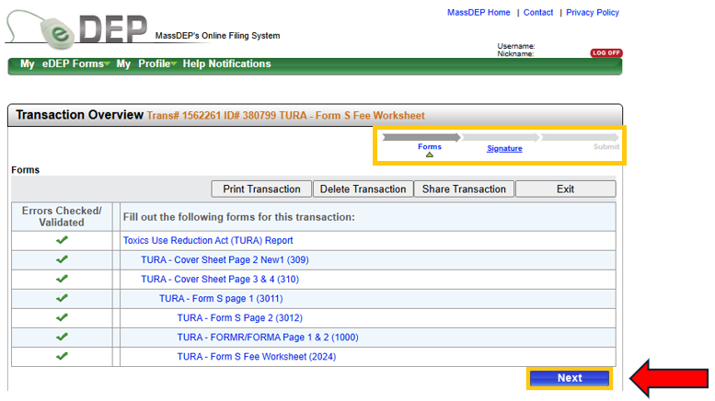
- Once the forms packet has been signed, click on the Next button and submit the transaction.
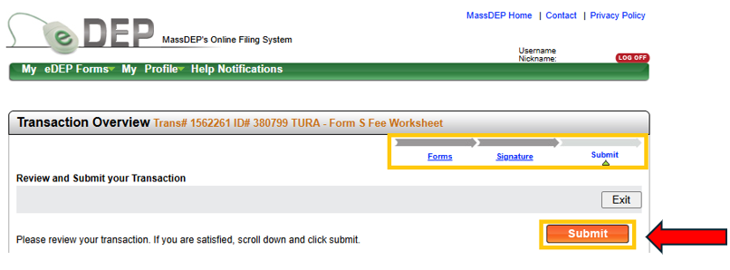

Amend Troubleshooting:
Q: What should I do if I can’t find the transaction I need to AMEND?
A: The Recent Submitted tab only displays transactions submitted within the last 90 days. To find older transactions navigate to the Archived Submitted tab.
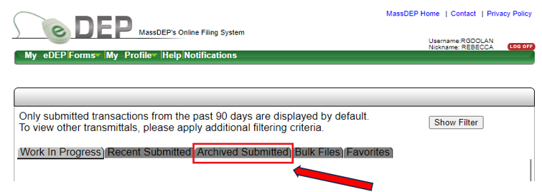
Once the Archived Submitted tab loads, select the Show Filter button.
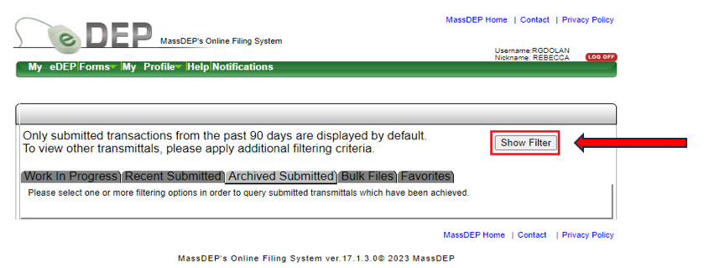
In the Last Update field, enter the beginning date range that corresponds to the filing you are looking to Amend. Select the Filter button.
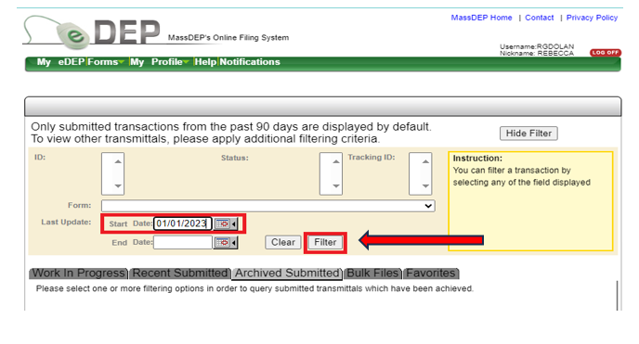
If users submit forms for multiple programs in eDEP, use the Form Dropdown and select Toxics Use Reduction Act (TURA) Reporting before selecting the Filter button. Once the list of transactions loads, locate the transaction the facility needs to Amend and select the Amend button.
Q: What do I do if the initial transaction was submitted by someone who is no longer with the company?
A: The facility’s new point of contact must have their own user account in eDEP. If the individual does not have an account, they can register for an account on the eDEP homepage. Once the new user has registered/verified you have an active eDEP account, contact TURA Program Staff Member Rebecca Dolan and indicate that the company needs to complete a Transfer of Work Product Form.
If you experience issues using the Amend feature, please contact TURA Program Staff Member Rebecca Dolan to coordinate a call for assistance.

