How to Bill for Nursing Facility Add-On Code S0315 (Also known as “Weekend Admission Add-On”)
Nursing Facilities Billing for Add-On Services Provided in a Nursing Facility
Beginning December 1, 2021, a nursing facility will be eligible for a Medicaid add-on of $200 per member per day for up to 2 days of a Fee-for-Service (FFS) member’s nursing facility stay, if the FFS member meets all the following criteria:

- MassHealth is the FFS member’s primary payer for nursing facility services at the time of admission. This includes members enrolled in the Primary Care Clinician (PCC) Plan or enrolled in a Primary Care Accountable Care Organization (PCACO).
- The FFS member was transferred to the nursing facility directly from an inpatient hospital in Massachusetts between 12:00 a.m. on Saturday and 11:59 p.m. on Sunday on or after December 1, 2021.
- The FFS member is not returning to the nursing facility from a medical leave of absence.

Nursing facilities will need to submit one claim for the member to be reimbursed for add-on services. Claims should be submitted directly to MassHealth as indicated below.

BILL NURSING FACILITY ADD-ON RATE USING AN INSTITUTIONAL 837I OUTPATIENT CLAIM
These are the values that are different than what a Nursing Facility normally bills for.
On the 837I transaction enter a Type of Bill TOB: 231
From and through dates of claim: Should be inclusive of the entire admitting weekend and cannot exceed 2 days. Claims may span multiple months.
Use a Revenue Code: 0220 Special Charges General Classification
With a HCPCS Code: S0315 DISEASE MANAGEMENT PROGRAM

Image from page 145 of the 837I Guide, annotated to instruct billers to use Type of Bill Code 231
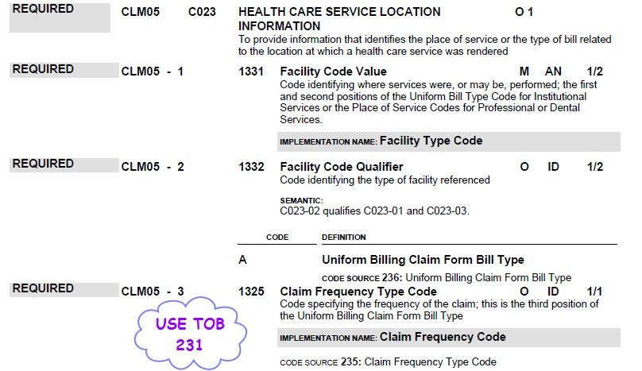

Image from page 284 of the 837I Guide to instruct billers on the use of Value Code 24

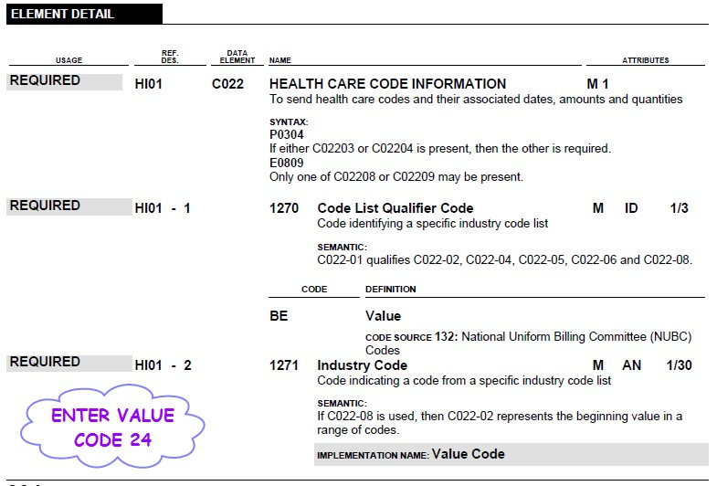

Image from pages 424, 425, and 426 of the 837I Guide, annotated to instruct billers on the use of Revenue Code 220 and corresponding HCPCS code
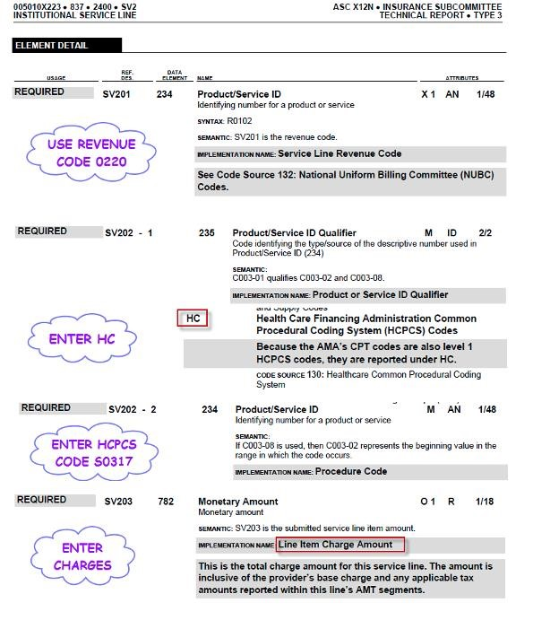
S0315

Image from page 428 of the 837I Guide, annotated to instruct Billers on inputting of required Days
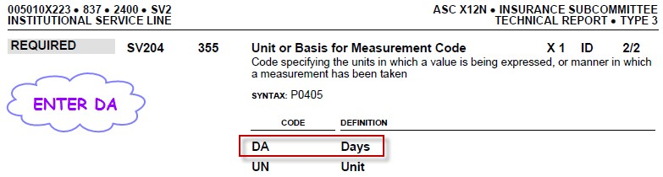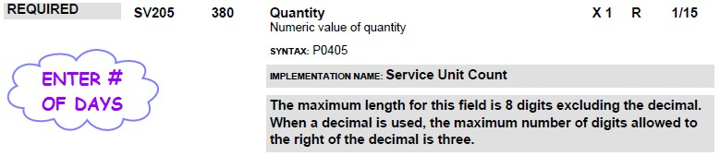

Image from pages 319-321 of the 837I Guide on the NPI requirements for Billers
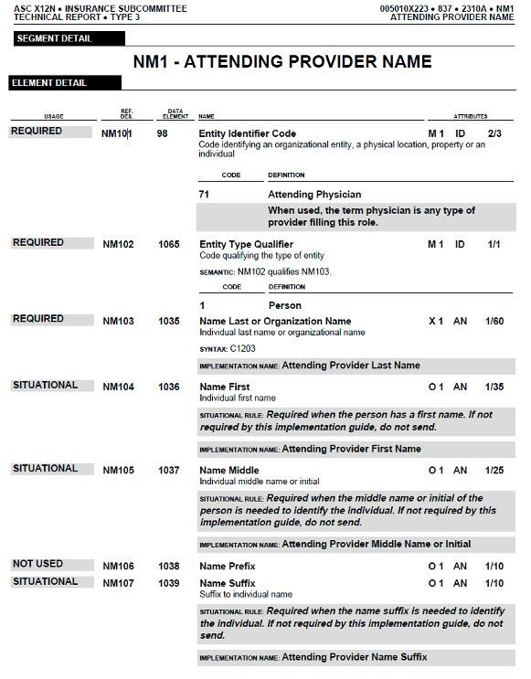
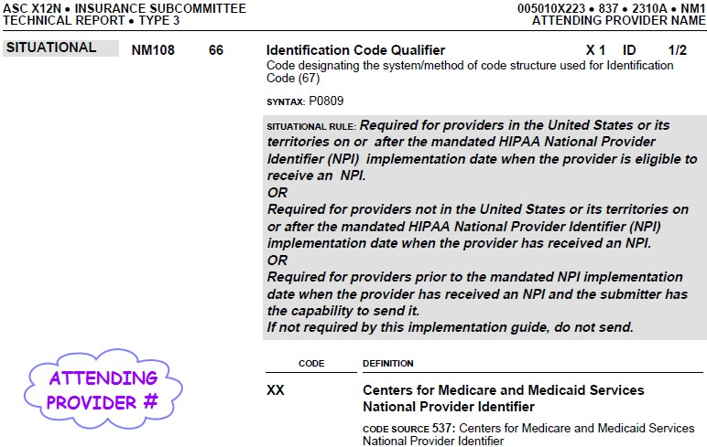

POSC SCREEN SHOTS IF MANUALLY BILLING VIA DIRECT DATA ENTRY (DDE)

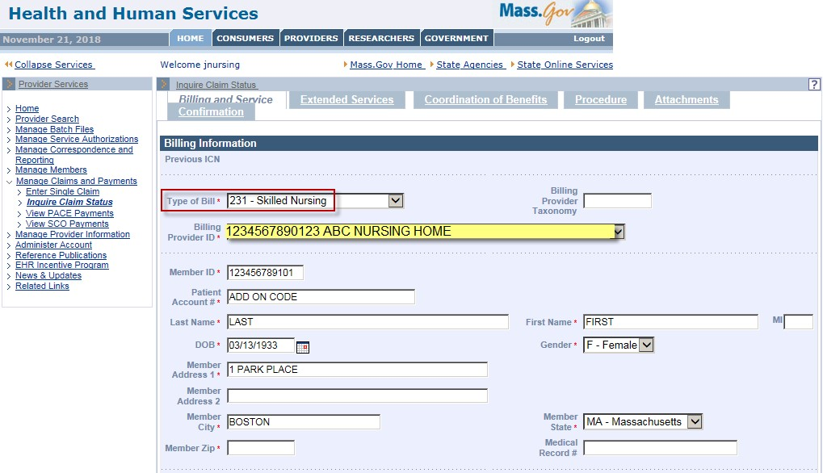
MUST INDICATE ATTENDING PROVIDER

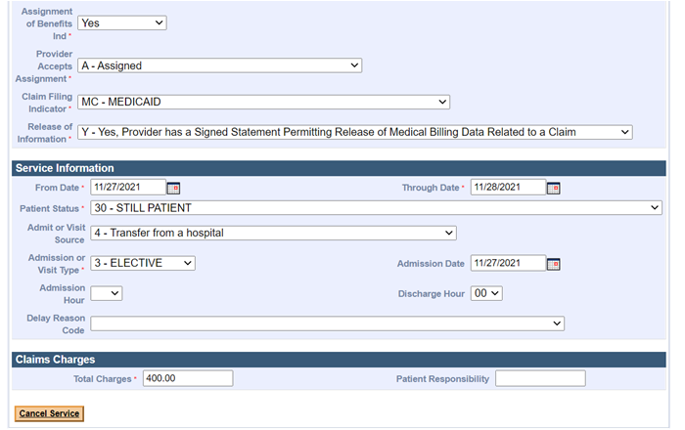

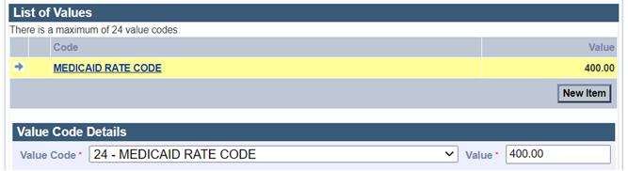
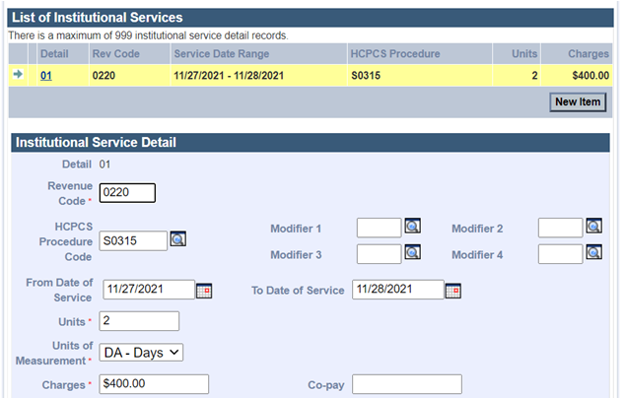

* Patient Account Number field: type in the Patient Account Number

