How to Bill for Nursing Facility Add-On Code S0316 (Also known as “Temporary Add-On”)

Nursing Facilities Billing for Add-On Services Provided in a Nursing Facility

Beginning October 1, 2021, a nursing facility will be eligible for a Medicaid temporary add-on of $130 per member per day for up to 30 days of the FFS member’s nursing facility stay, not including any leaves of absence, if the FFS member meets all the following criteria:
- MassHealth is the FFS member’s primary payer for nursing facility services
at the time of admission;
- The FFS member was transferred to the nursing facility directly from their home on or after October 1,2021; and
- The FFS member is discharged from the nursing facility to their home setting
within 30 calendar days.

Nursing facilities will need to submit one claim for the member’s entire stay to be reimbursed for add-on services. Claims should be submitted directly to MassHealth as indicated below.

BILL NURSING FACILITY ADD ON RATE USING AN INSTITUTIONAL 837I OUTPATIENT CLAIM

These are the values that are different than what a Nursing Facility normally bills for.

On the 837I transaction enter a Type of Bill TOB: 231

From and through dates of claim: Should be inclusive of the member’s entire inpatient NF stay and cannot exceed 30 days. Claims may span multiple months.

Use Patient status: 01 Discharge to home or self-care
Use Admit or Visit Source: 01 Non-Healthcare Facility Point of Origin Use a Revenue Code: 0220 Special Charges General Classification With a HCPCS Code: S0316 DISEASE MANAGEMENT PROGRAM; PER DIEM

IF BILLING ELECTRONICALLY ON THE INSTITUTIONAL 837I

Image from page 145 of the 837I Guide, annotated to instruct billers to use Type of Bill Code 231
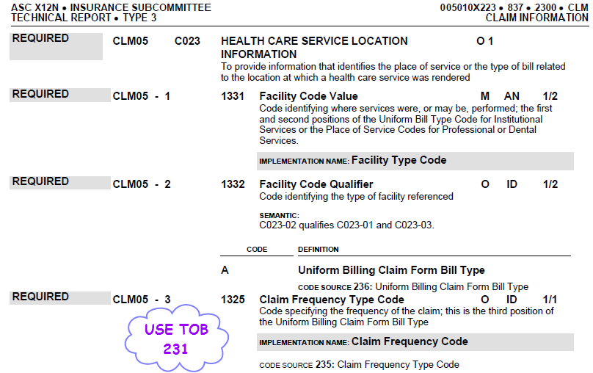

Image from page 284 of the 837I Guide to instruct billers on the use of Value Code 24
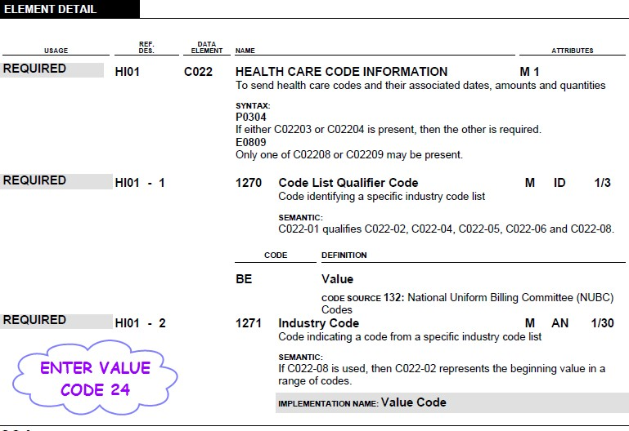

Image from pages 424, 425, and 426 of the 837I Guide, annotated to instruct billers on the use of Revenue Code 220 and corresponding HCPCS code

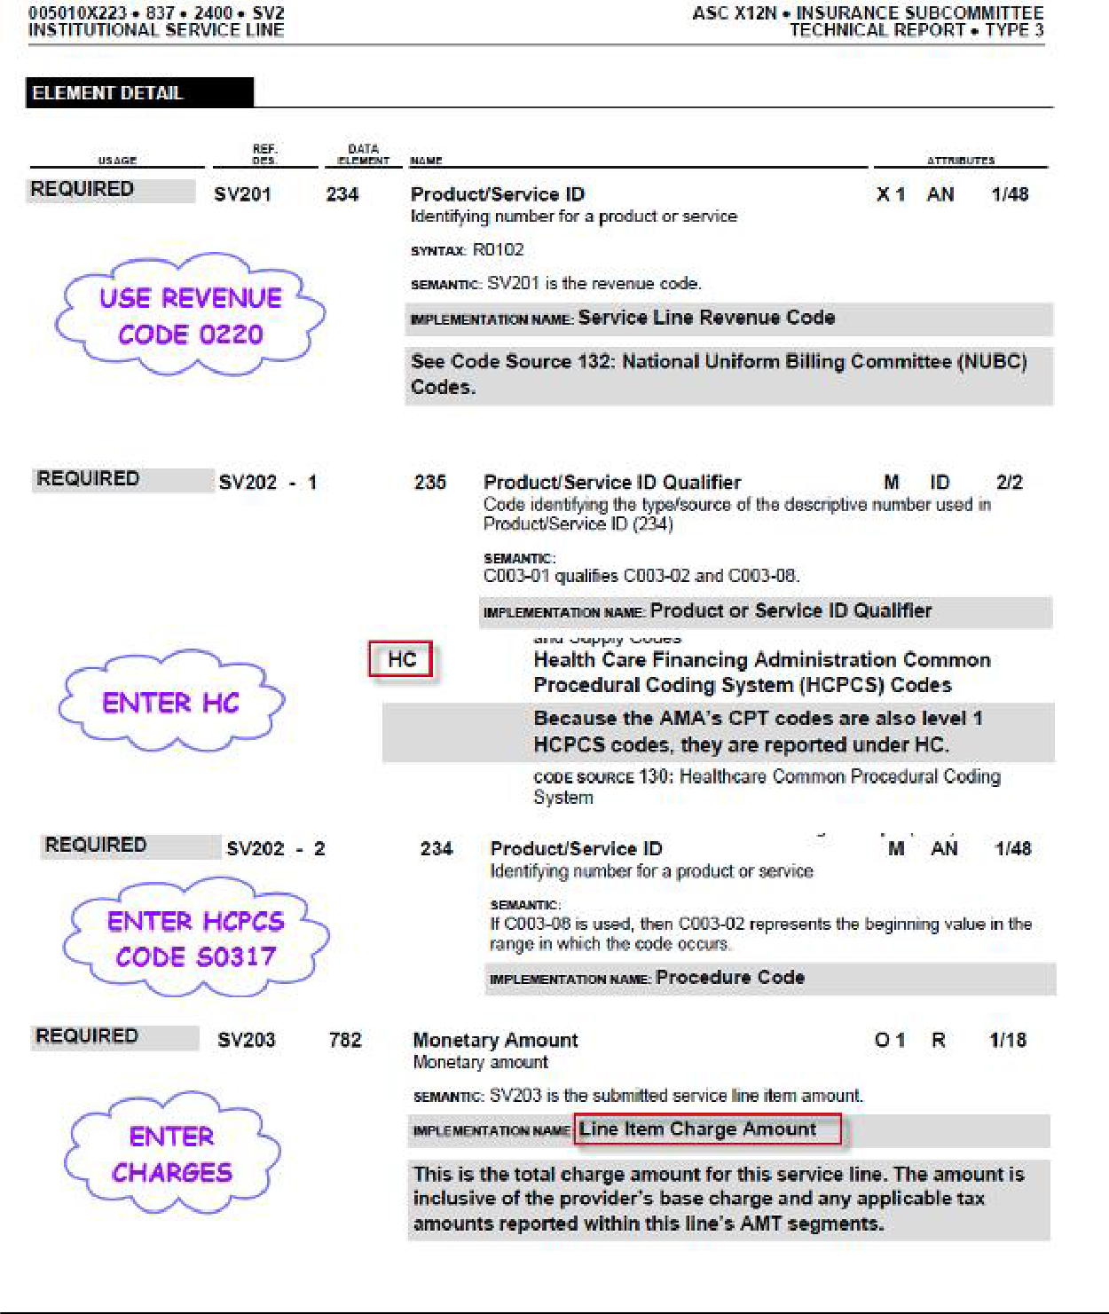S0316

Image from page 428 of the 837I Guide, annotated to instruct Billers on inputting of required Days
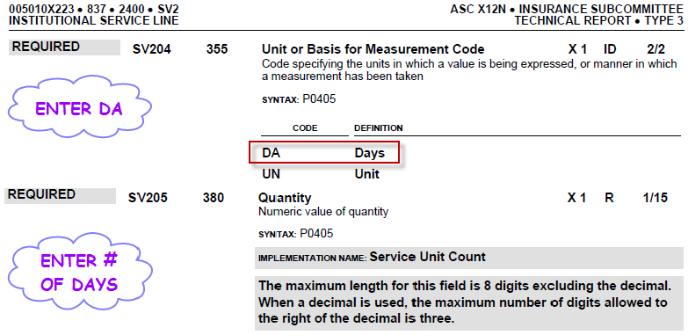

Image from pages 319-321 of the 837I Guide on the NPI requirements for Billers
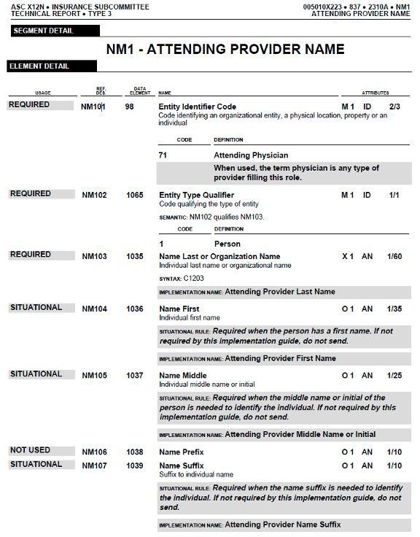

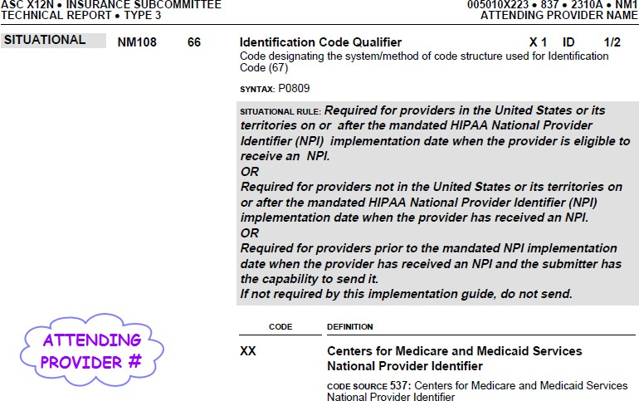

POSC SCREEN SHOTS IF MANUALLY BILLING VIA DIRECT DATA ENTRY (DDE)
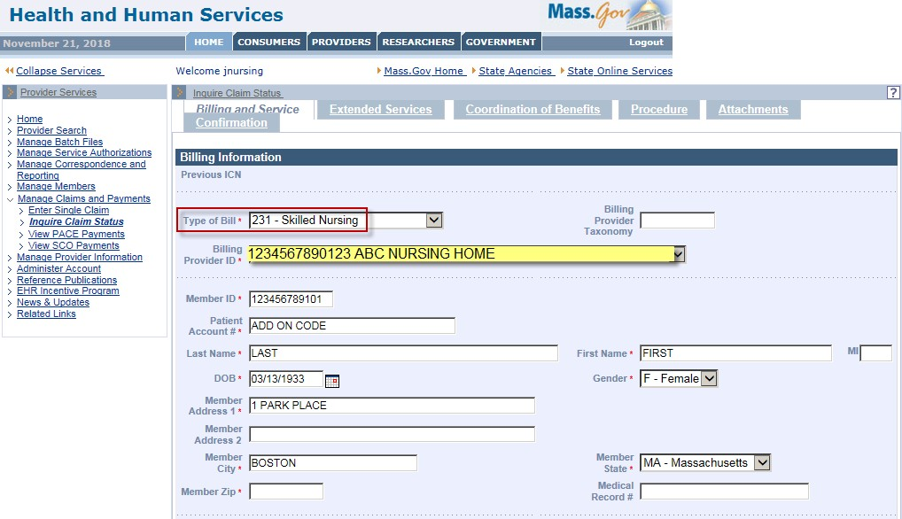
MUST INDICATE ATTENDING PROVIDER

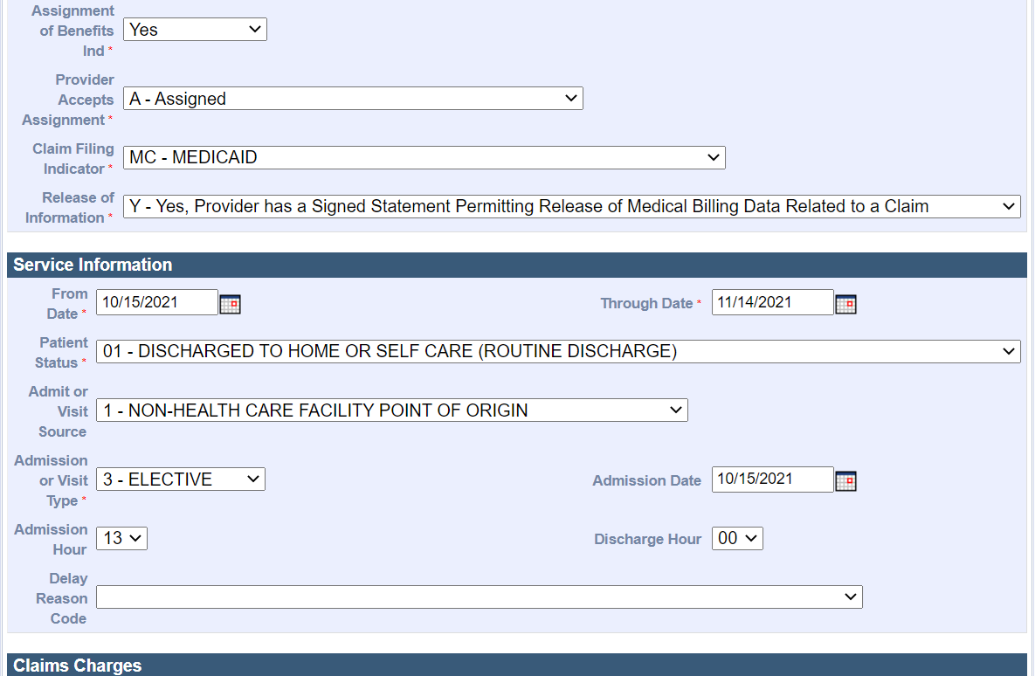

* Patient Account Number field: type in the Patient Account Number

