How to Bill for Nursing Facility Add-On Code S0317
(Also knows as “Medicaid Transitional Add-On”)

Nursing Facilities Billing for Add-On Services Provided in a Nursing Facility

Beginning January 25, 2021, a nursing facility will be eligible for a Medicaid Transitional add-on of $130 per member per day for the first 30 days of the FFS member’s nursing facility stay, not including any leaves of absence, if the FFS member meets all of the following criteria:
(a) MassHealth is the FFS member’s primary payer for nursing facility services at the time of admission;
(b) The FFS member was transferred to the nursing facility directly from an acute inpatient hospital on or after January 25, 2021; and
(c) The FFS member is not returning to the nursing facility from a medical leave of absence.

Nursing facilities should submit claims for the add-on services directly to MassHealth as indicated below.

BILL NURSING FACILITY ADD ON RATE USING AN INSTITUTIONAL 837I OUTPATIENT CLAIM

These are the values that are different than what a Nursing Facility normally bills for.

On the 837I transaction enter a Type of Bill TOB: 231

Use a Revenue Code: 0220 Special Charges General Classification

With a HCPCS Code: S0317 DISEASE MANAGEMENT PROGRAM; PER DIEM

Enter the total number of Days

IF BILLING ELECTRONICALLY ON THE INSTITUTIONAL 837I

Image from page 145 of the 837I Guide, annotated to instruct billers to use
Type of Bill Code 231

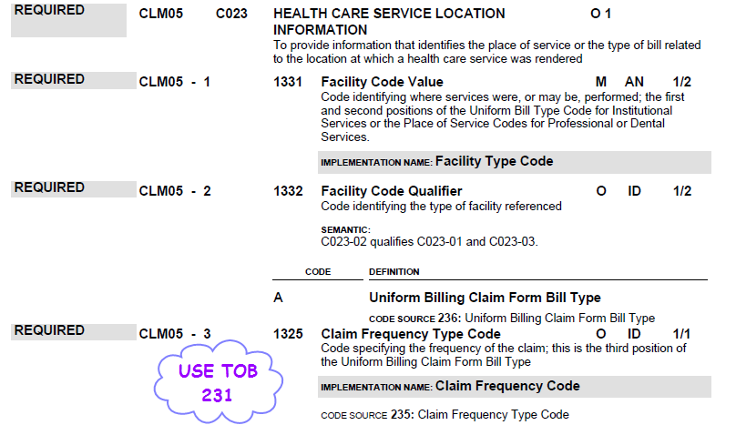

Image from page 284 of the 837I Guide to instruct billers on the use of
Value Code 24

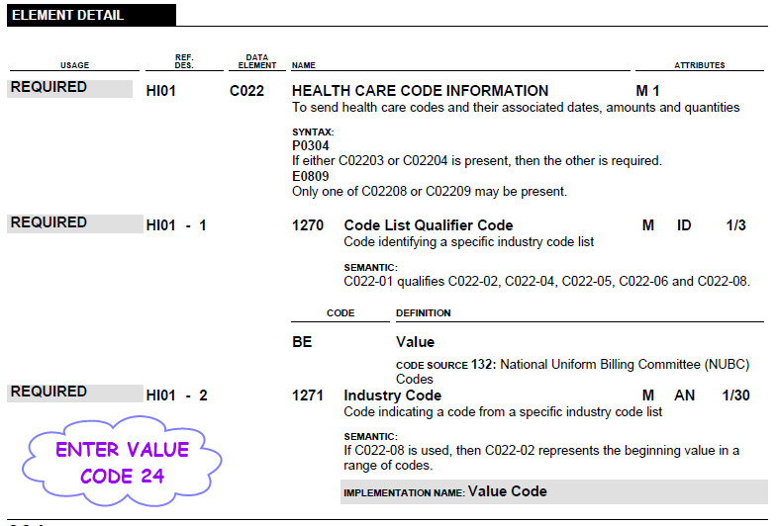

Image from pages 424, 425, and 426 of the 837I Guide, annotated to instruct billers on the use of Revenue Code 220 and corresponding HCPCS code

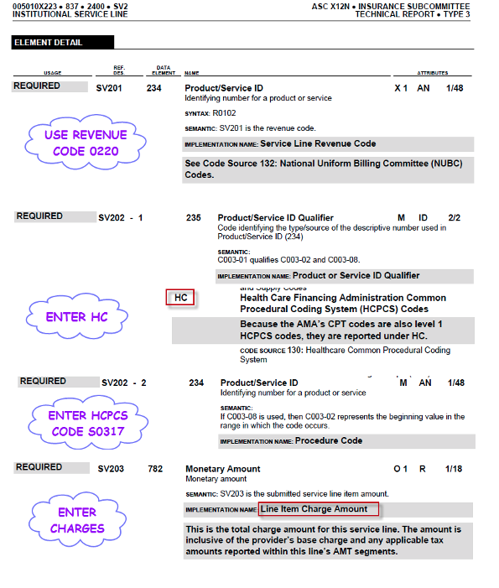

Image from page 428 of the 837I Guide, annotated to instruct Billers on inputting of required Days

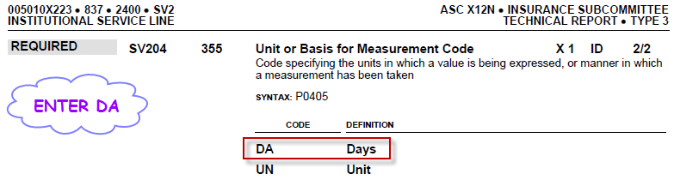
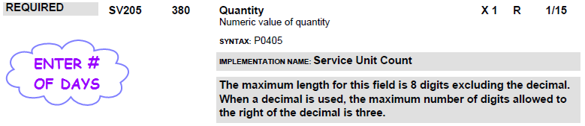

Image from pages 319-321 of the 837I Guide on the NPI requirements for Billers

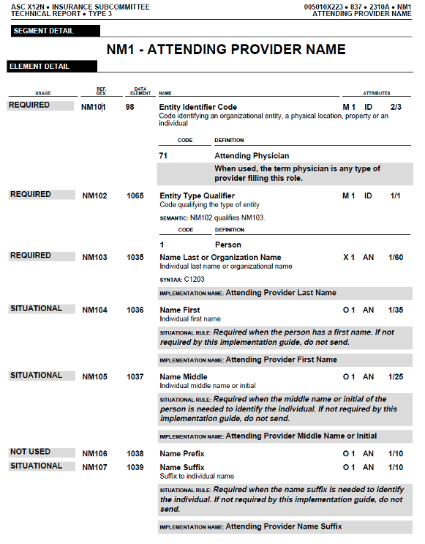
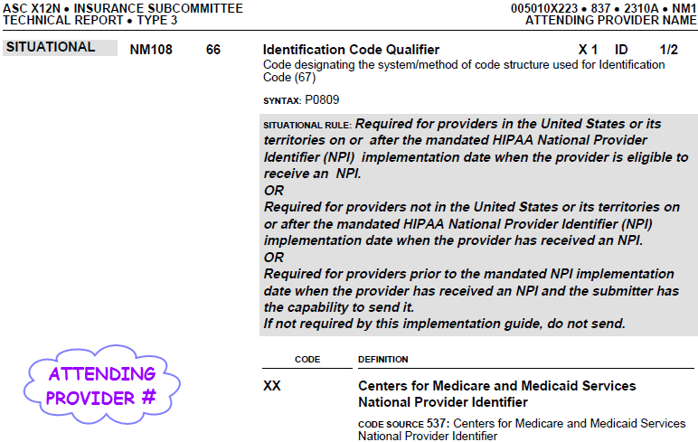

POSC SCREEN SHOTS IF MANUALLY BILLING VIA DIRECT DATA ENTRY (DDE)

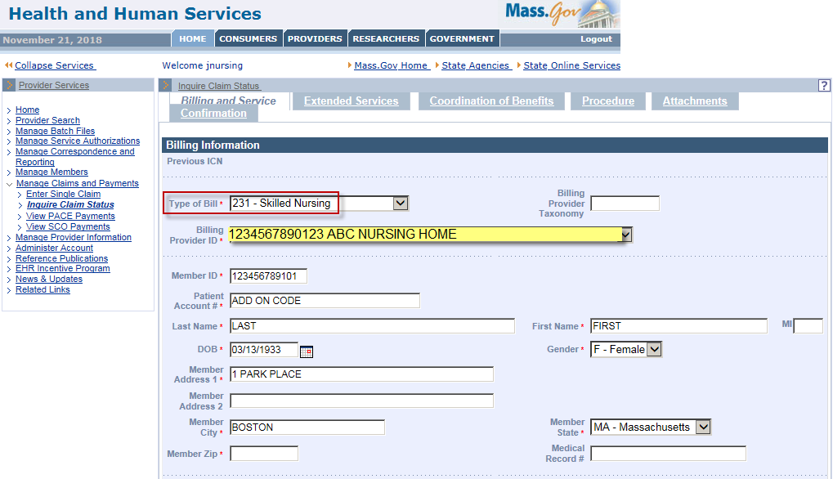
MUST INDICATE ATTENDING PROVIDER

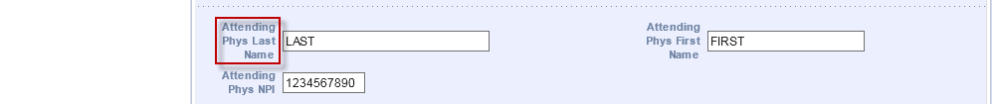

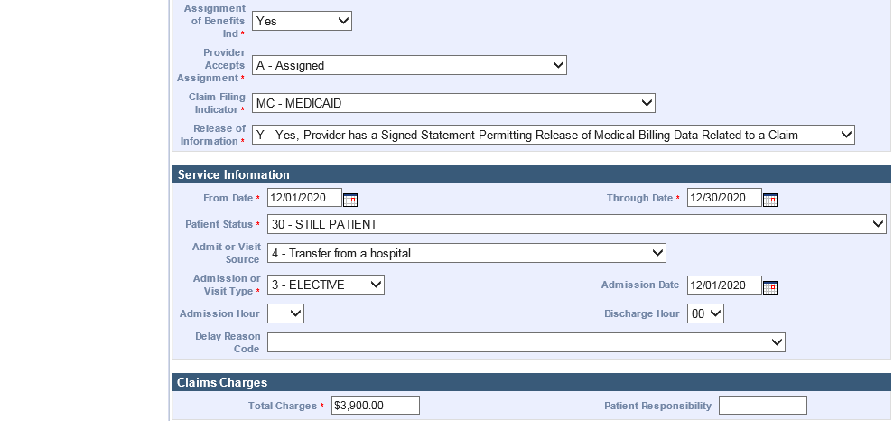

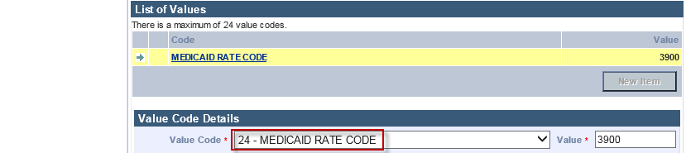

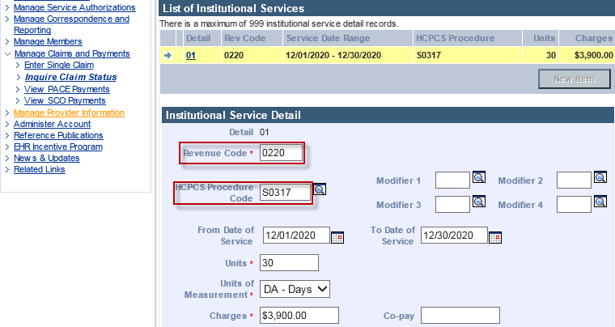

* Patient Account Number field: type in the Patient Account Number

