How to Bill for Payment for Administration of COVID-19 Monoclonal Antibody Products

AS A NURSING FACILITY ADD-ON CODE USING CODES Q0239-SL, M0239, Q0243-SL, M0243

Payment for COVID-19 Monoclonal Antibody Product Infusion

Beginning January 25, 2021, providers enrolled in the MassHealth Nursing Facility program may bill and receive payment for the administration of monoclonal antibody products at the rates identified below.

Code | Allowable Fee | Description of Code | Effective for Dates of Service On or After
Q0239 SL | $0.00 | Injection, bamlanivimab, 700 mg | 11/10/2020
M0239 | $309.60 | Intravenous infusion, bamlanivimab-xxxx, includes infusion and post administration monitoring | 11/10/2020
Q0243 SL | $0.00 | Injection, casirivimab and imdevimab, 2400 mg | 11/21/2020
M0243 | $309.60 | Intravenous infusion, casirivimab and imdevimab includes infusion and post administration monitoring | 11/21/2020

As noted above, the modifier “SL” indicates state-supplied vaccine or antibodies. This modifier is to be applied to codes to identify administration of vaccines or antibodies provided at no cost, whether by the Massachusetts Department of Public Health; another federal, state, or local agency; or a manufacturer. If providers receive the antibodies from one of these sources at no cost, providers must bill the code for the antibodies themselves, with modifier SL, and the codes for intravenous infusion of the antibodies. MassHealth will pay $0 for antibodies billed with the modifier SL, and the rates listed above for the intravenous infusion of the antibodies.

BILL SERVICES IN A NURSING FACILITY USING AN INSTITUTIONAL 837I OUTPATIENT CLAIM

USE REVENUE CODE 022x Special Charges; 0220 General Classification
WITH THE APPROPRIATE HCPCS CODE Q0239-SL and M0239 or Q0243-SL and M0243

MUST INDICATE ATTENDING PROVIDER

TYPE OF BILL 231

Image from page 145 of the 837I Guide annotated to instruct billers to use Type of Bill Code 231

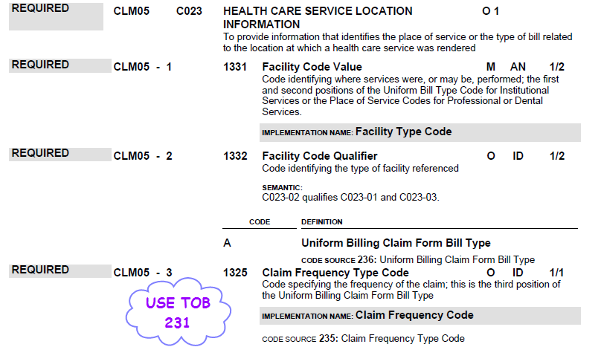

Image from page 284 of the 837I Guide, annotated to instruct billers on the use of Value Code 24

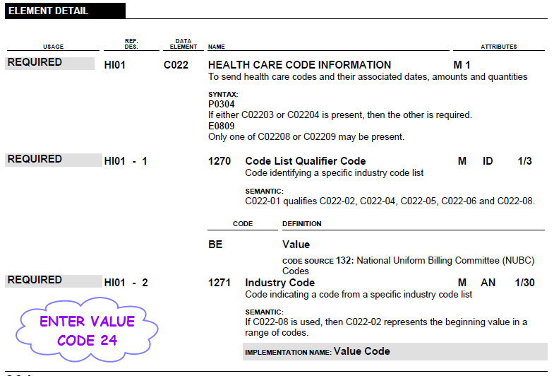

REVENUE AND HCPCS CODE

Image from pages 424, 425 and 426 of the 837I Guide annotated to instruct billers on the use of Revenue Code 220 and corresponding HCPCS codes

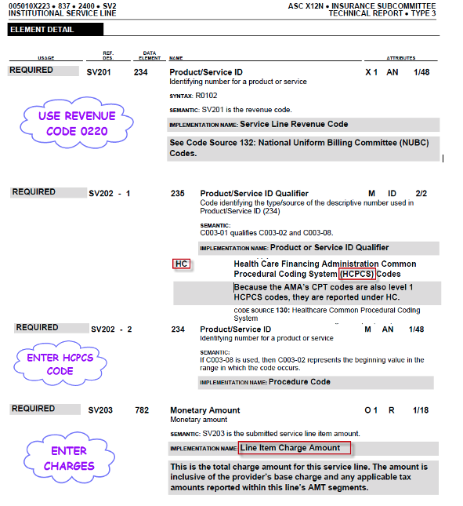

DAYS

Image from page 428 of the 837I Guide annotated to instruct Billers on inputting of required Days

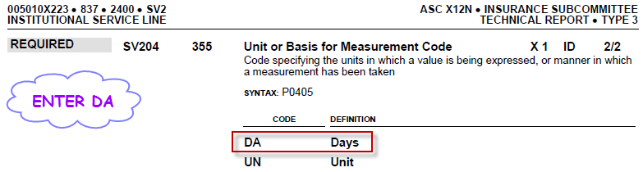
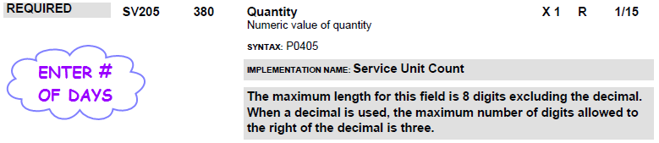

Image from page 319-321 of the 837I Guide on the NPI requirements for Billers

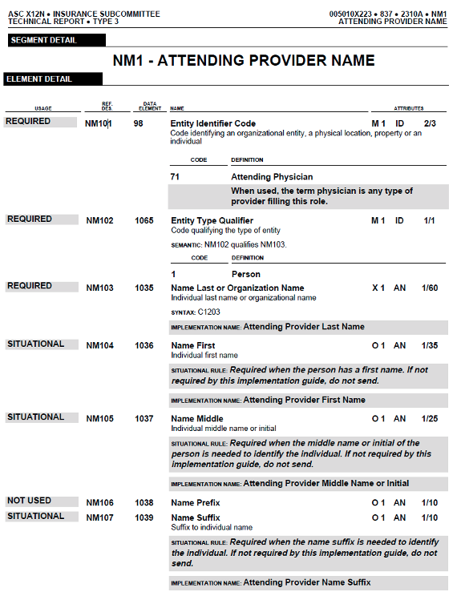

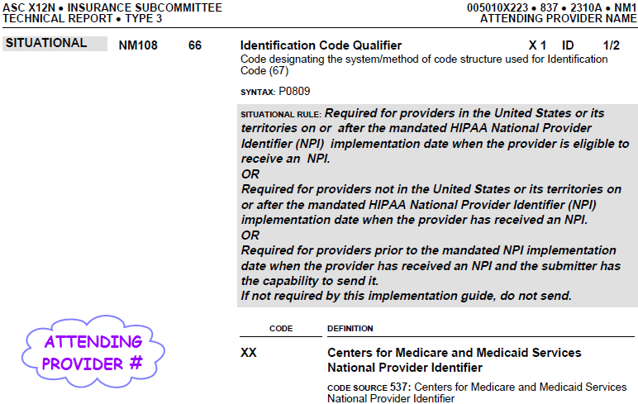

IF BILLING ON THE UB-04, USE THESE FIELDS ON THE UB-04

UB-04
Field No. | Field Name | Description
4 | Type of Bill | Enter 231 type of bill.
39-41 | Value Code Code/Amount | Enter Value Code 24 along with the total charge amount for HCPCS code.
42 | Rev. Cd. | Enter revenue code 0220.  022x Special Charges  0220 General Classification
42 | (Line 23) Rev Cd | Enter Revenue Code 0001.
44 | HCPCS Code | Enter HCPCS code.
46 | Serv. Units (Lines 1-22) | Enter the total number of days.
47 | Total Charges (Lines 1-22) | For each claim line, enter the total charges that apply to the revenue codes entered in Lines 1-22 in Field 42.
47 | Totals (Line 23) | Enter the total of all entries in this column on the bottom line. This is a required field.
67 | (Unnamed) | Enter the ICD-CM codes describing the principal diagnosis.
76 | Attending NPI | Enter the name and NPI of the physician who is primary responsible for the care of the patient reported in this claim.

