How do I complete the Verizon VID enrollment process?
Once your remote access (VPN) request has been completed you will receive an email from icsl.net that contains a link to complete the registration process to activate the account. Click the link in the email you received to proceed to reset your initial password.
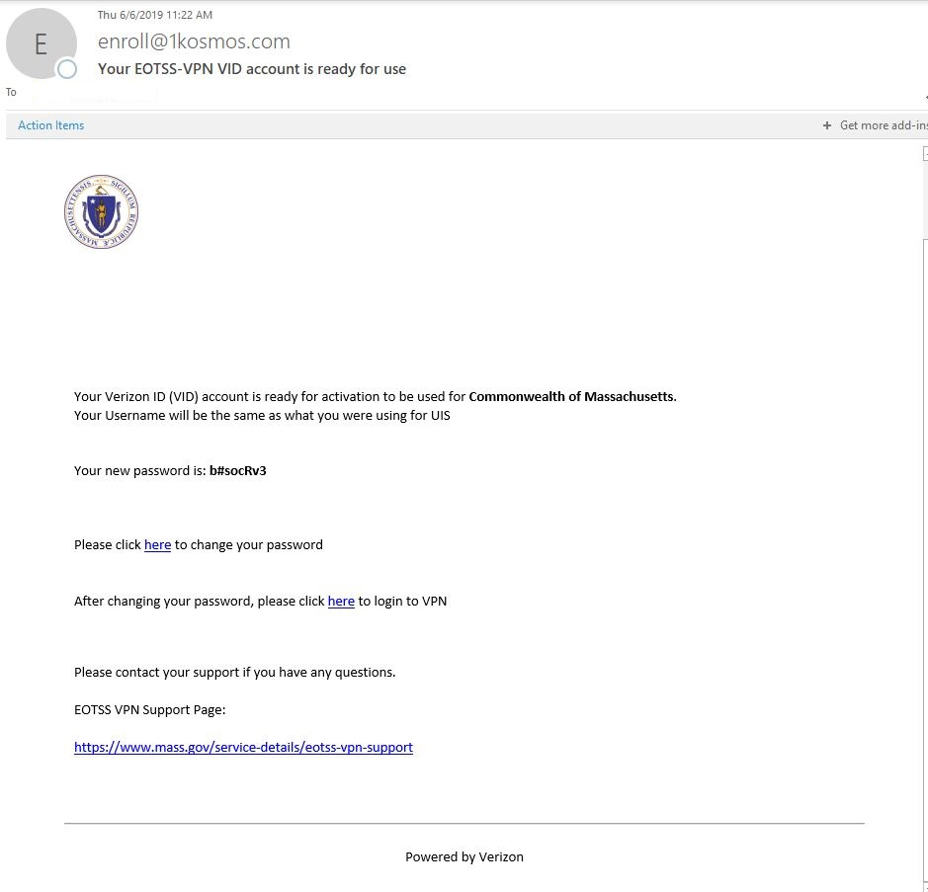
The link to change your password will bring you to the login page where users can edit their profile.
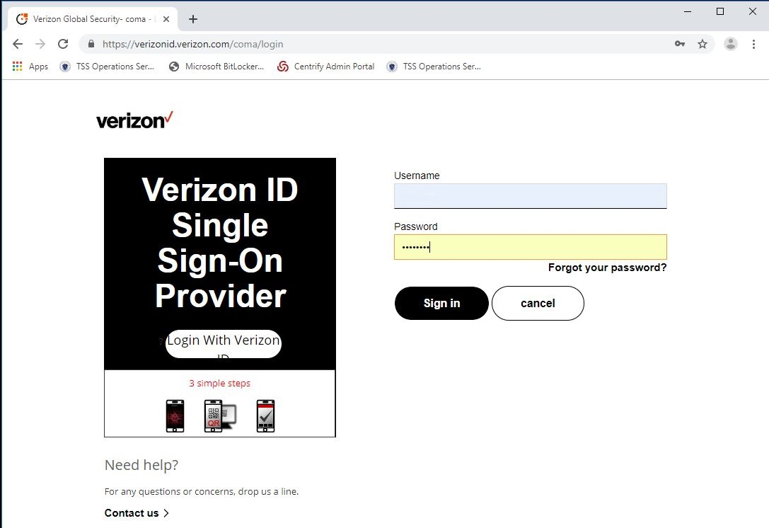
Put in your UAID and the password given to you in the enrollment email. Do not copy and paste the password because it usually adds a space at the end of the password.
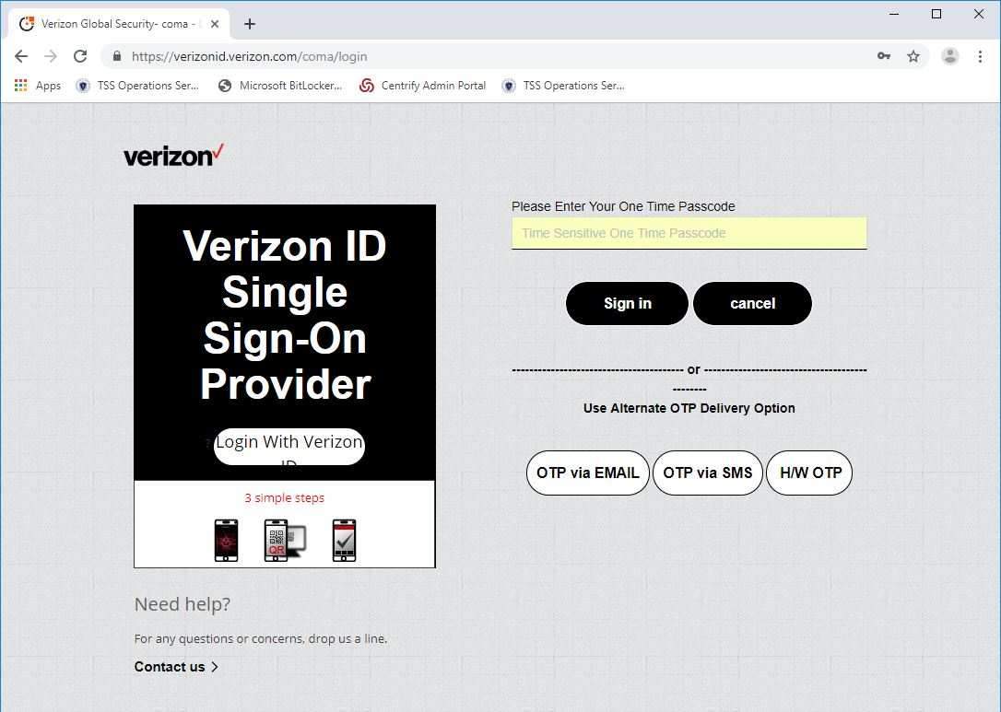
The next screen will prompt for the one time passcode. You receive the passcode by clicking OTP via EMAIL or OTP via SMS.
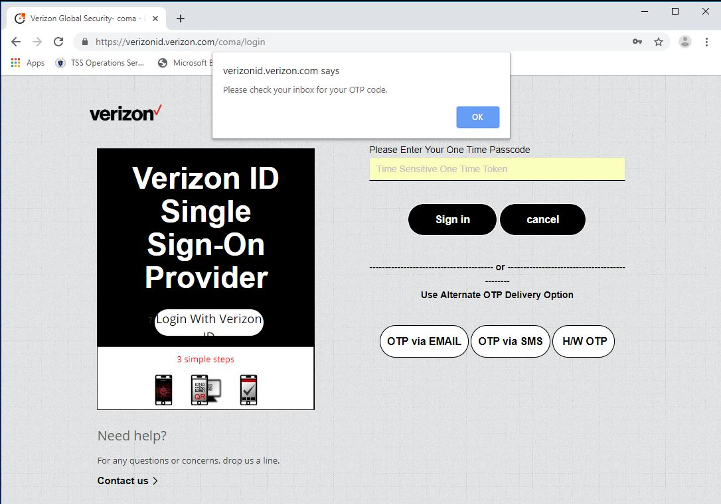
The page will notify you when you when your OTP has been sent.
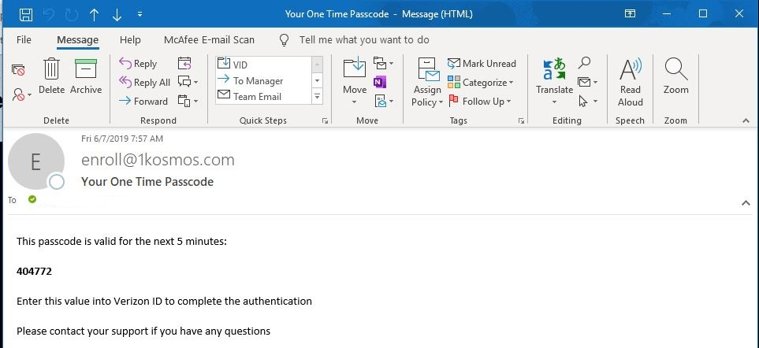
Above is an example of an email the user will receive with the One Time Passcode.

Once you have entered your onetime passcode and click sign in, you will be prompted to change your password.
When creating a password on the user portal, the following criteria must be met:
- Must contain at least 8 characters
- Must contain at least 1 special character
- Must contain at least 1 numeric character
- Cannot be the same as your VID username
- Cannot begin or end with a space
- Cannot repeat a character in four or more consecutive positions

For instructions on how to connect to the Verizon ID VPN, Please see the Logging into the VerizonID VPN for the first time link.

