Search for Courses

Users can Search the catalog for courses by following the following these steps:

Step 1: Search for Learning Field.
On the MassAchieve Learner home page use the Search for learning field to find: Agency specific, on-line courses and Instructor Led events form the Content Catalog offerings.
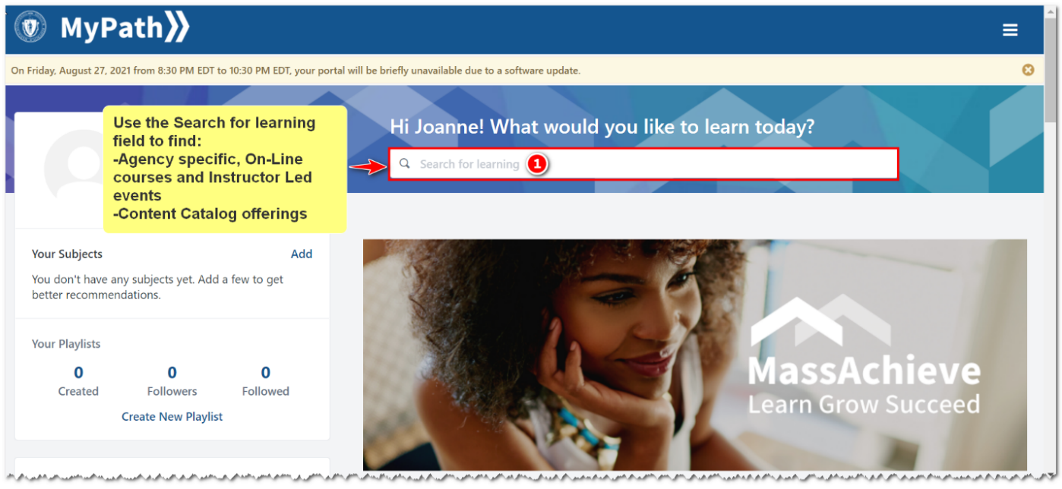

Steps 2 and 3. Type Subject and choose from populated list or entire list of courses
Step 2. Type the subject for which are searching in the Search for learning field. Step 3. Choose from the prepopulated list or press enter to see the entire list that meets your search criteria.
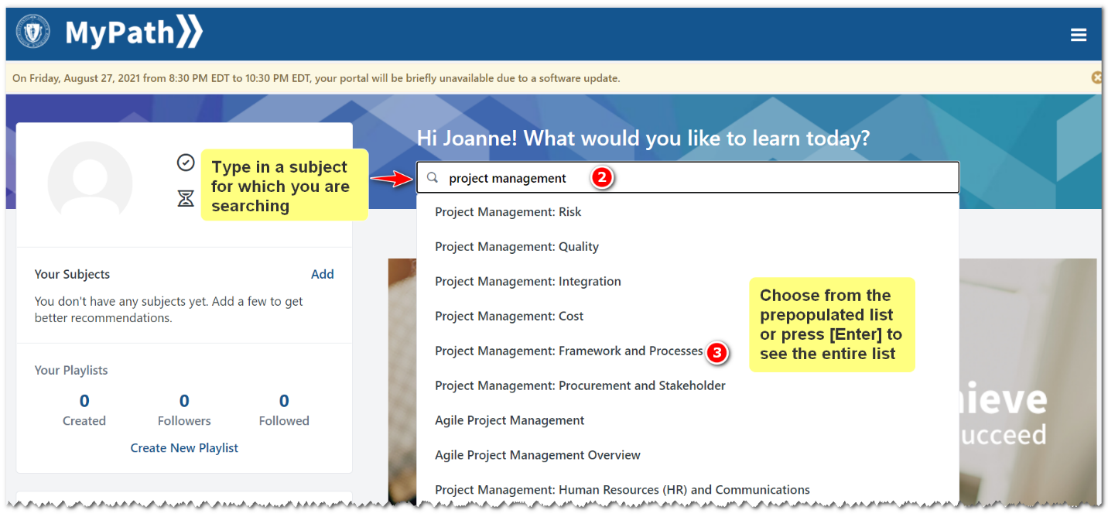

Steps 4 - 6 Using filters, viewing additional pages, launch a course.
Step 4: On the left side of the page you can use filters to narrow the search result list.
Step 5: At the bottom of the page there are additional pages form your search results to view additional pages of courses.
Step 6: You can click on any course name to launch and complete the course.
