# How to Log in Avaya one X Communicator

Note: You must be connected to the Pulse VPN before you log in.

Run Avaya One-x communicator and wait for the welcome screen below;



Please choose ‘Telephony Setup’

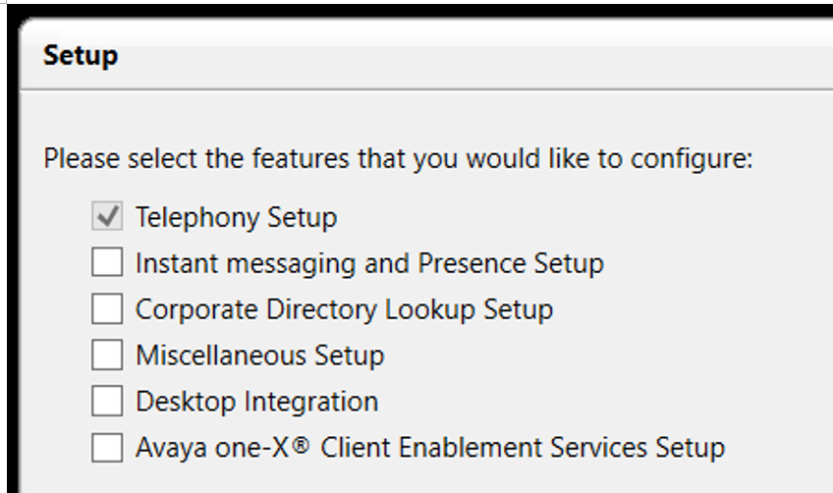

Please choose’H.323’

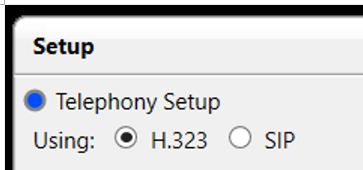

Please click the Add button

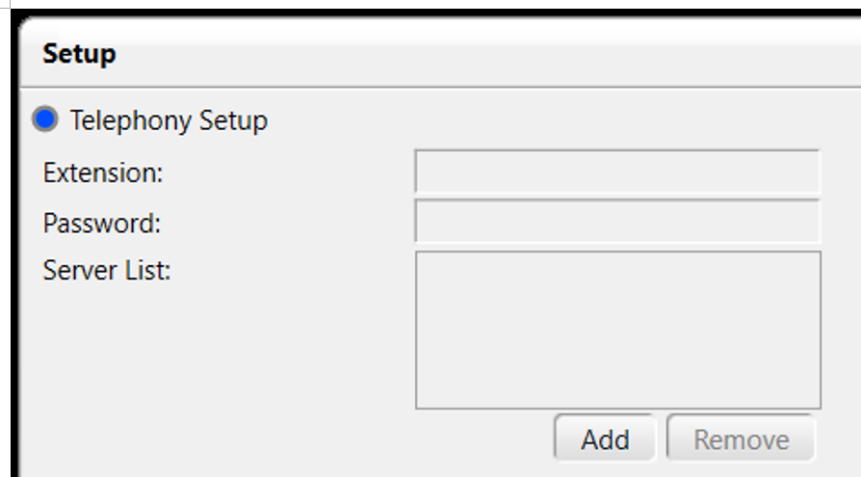

Please type 10.196.173.24 in the box of Server. And then, click the OK button.

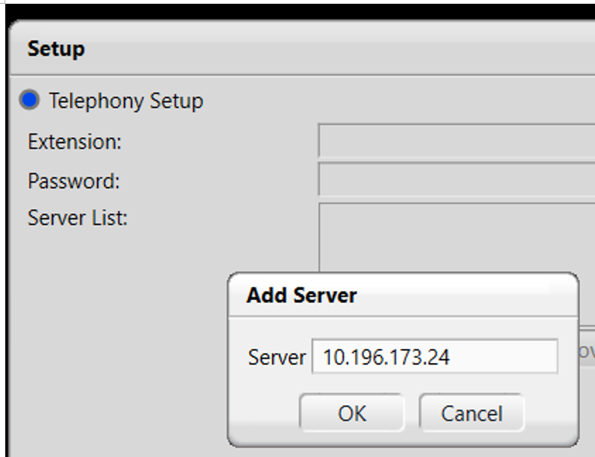

Please type your five-digit extension and password 12345. And then, click the Add button.

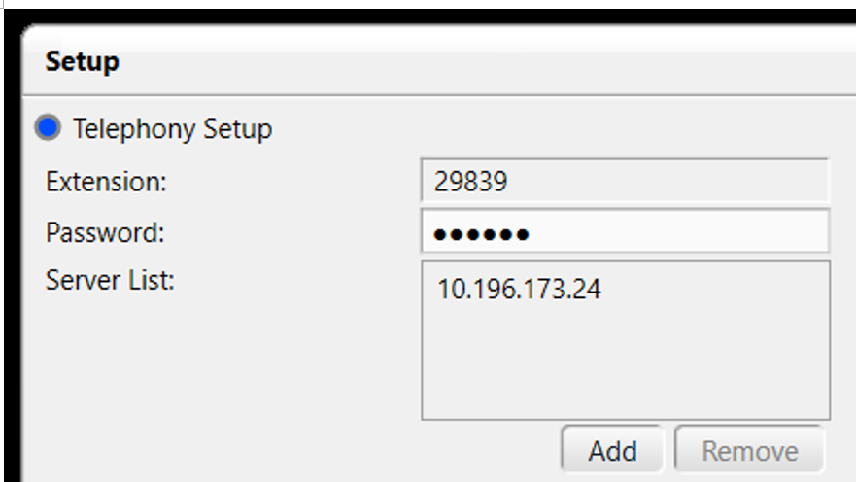

Please click the Next button.

Please choose ‘This Computer’. An then click the Next button.

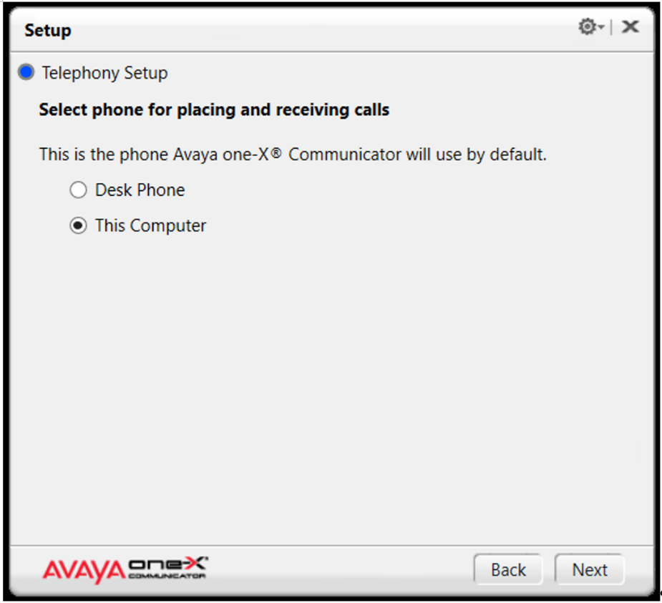

Please read the disclaimer and make sure the setting. And then click the Next button.

Note: Please do not use the softphone to dial 911 as it will direct services to the main office building and not your home.

You will have a message below. Please click the Finish button

Please re-launch Avaya one-x Communicator and log in. Please type your 5-digit extension and the default password 12345.

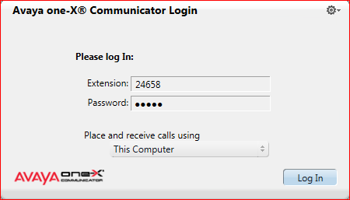

When you have a message of ‘Video Calling Not Available’, please unmark the check box

Please click the OK button.

After you login, you will see this screen below. If you hover your mouse over the Icons, it displays what they do. Selecting the highlighted button will show the dial pad and your programmable buttons.

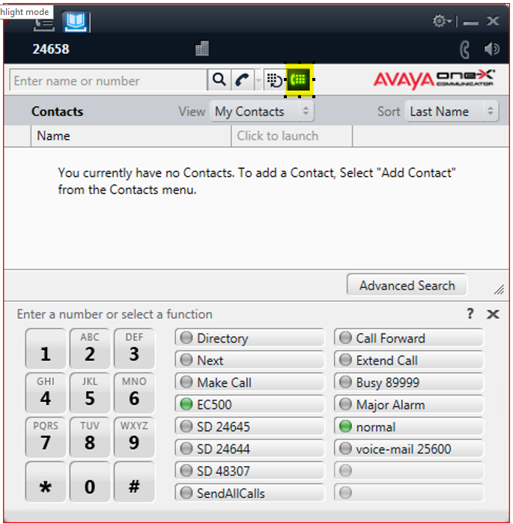

You should be able to use your numbers keypad on your Keyboard to dial any number. Use the buttons in the title bar to navigate, off hook, etc., and keypad to dial.

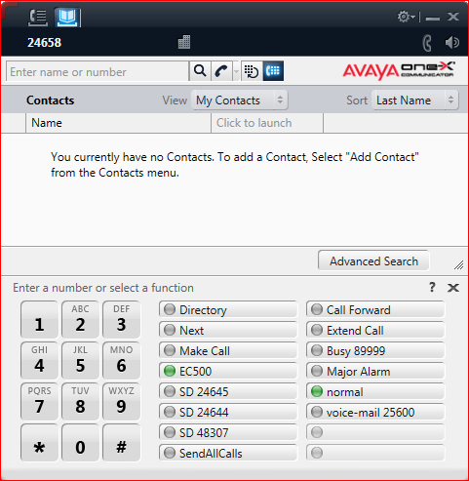

When finished, click the gear in the title bar to logout.

