## How to Obtain Work Search Log Submitted via UI Online

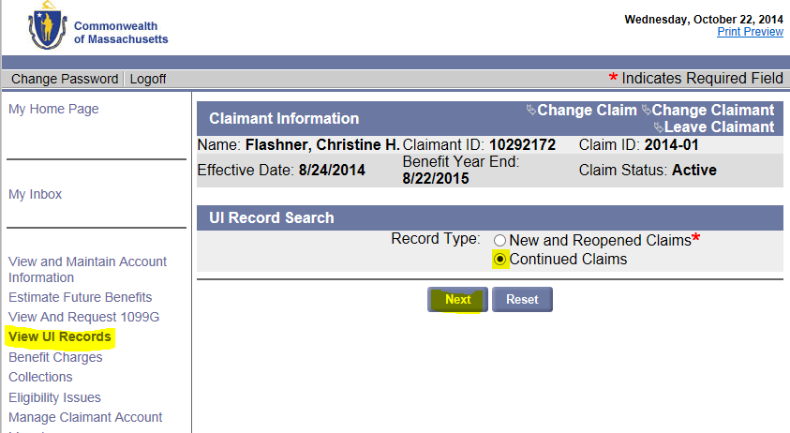

**3. Click:** Next

**1. Click:** View UI Records

**2. Select**: Continued Claims

**7. View as PDF**

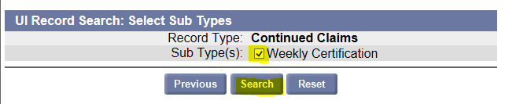

**4. Check box**: Weekly Certification

**5. Click:** Search

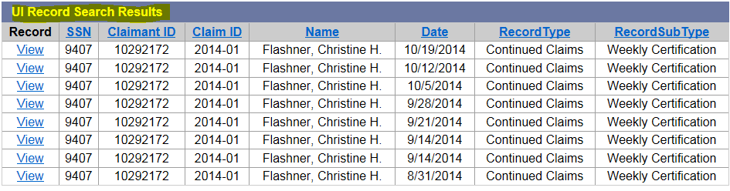

**6. Click: View**

|  |  |  |  |  |  |  |  |
| --- | --- | --- | --- | --- | --- | --- | --- |
| **Date**  **7. View as PDF**  **7. View as PDF**  **7. View as PDF**  **7. View as PDF**  **7. View as PDF**  **7. View as PDF**  **7. View as PDF** | **Type** | **Name** | **Person Contacted** | **Contract Type** | **Contract Info** | **Type of Work** | **Results** |
| 9/15/2014  12:00:00 | Employer | ABC Company | Web site email | Website | Abc.com | development | No response |
| 9/16/2014  **7. View as PDF**  12:00:00 | Employer | Metro Hospital | HR | Phone Number | 781-111-2139 | development | Follow-up requested |
| 9/17/2014  12:00:00 | Employer | Union University | Administrator | In person | Front Desk | development | Follow-up requested |

## How to Obtain Work Search Log Submitted via UI Online

 

**4**

**6**

**5**

**3**

**2**

**1**



|  |  |  |  |  |  |  |  |
| --- | --- | --- | --- | --- | --- | --- | --- |
| **Date**  **7. View as PDF** | **Type** | **Name** | **Person Contacted** | **Contract Type** | **Contract Info** | **Type of Work** | **Results** |
| 9/15/2014  12:00:00 | Employer | ABC Company | Web site email | Website | Abc.com | development | No response |
| 9/16/2014  **7**  12:00:00 | Employer | Metro Hospital | HR | Phone Number | 781-111-2139 | development | Follow-up requested |
| 9/17/2014  12:00:00 | Employer | Union University | Administrator | In person | Front Desk | development | Follow-up requested |

|  |  |
| --- | --- |
| Step | Action |
| 1 | Click on *View UI Records*. |
| 2 | Select *Continued Claims*. |
| 3 | Click **Next** button. |
| 4 | From the Sub Types(s), Check *Weekly Certification* box. |
| 5 | Click **Search** button. |
| 6 | From the UI Record Search Results box, Click **View** for week you want to print. |
| 7 | An image of the selected weeks *Work Search Log* appears. **View as a PDF** document. |