HOW TO POPULATE REFERRING PROVIDER NAME DIRECT DATA ENTRY (DDE) on THE POSC HEADER LEVEL PHYSICIAN CLAIMS

1. For 837P/Physician claims, the REFERRING NPI (aka Referring Provider Name), is populated on the Billing Information Tab
2. On the Billing Information Tab, navigate to the REFERRING PROVIDER NAME field
3. Click the Magnifying Icon on the right hand side of the field. This will open up a Search panel to search for a provider by Business Name, Last Name, First Name, Gender, City, Zip Code, Provider ID/NPI, Specialty, Provider Type
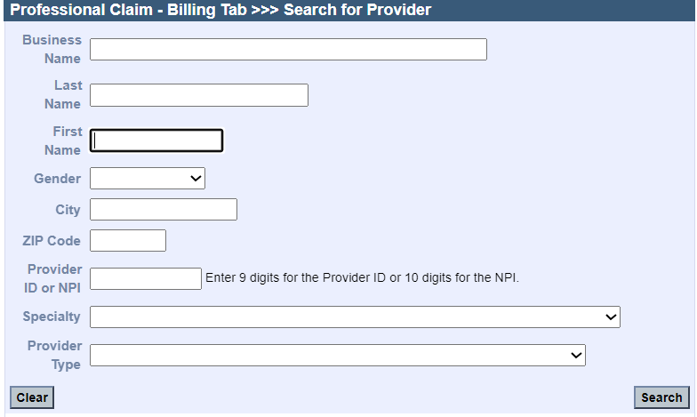

4. Enter the data to perform/conduct the search. For example, Dr. Dan Smith and click the Search button to invoke the Search
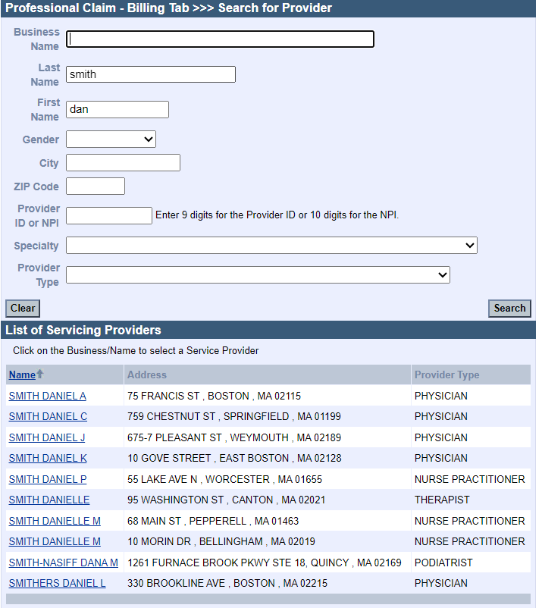

5. Select the Provider Name from the Search Results list (Example Smith, Daniel A 75 Francis St. Boston MA/Physician). Selection of the Provider will populate the REFERRING PROVIDER NAME field.
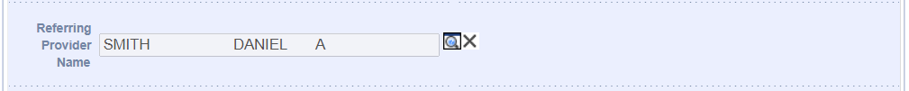

HOW TO POPULATE ORDERING PROVIDER NAME DIRECT DATA ENTRY (DDE) on THE POSC DETAIL LEVEL

1. For 837P/Physician claims, the ORDERING NPI (aka Ordering Provider Name), is populated on the Procedures Tab, for DDE on the POSC
2. On the Procedures Tab, navigate to the ORDERING PROVIDER NAME field
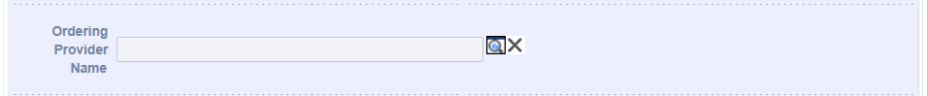

3. Click the Magnifying Icon on the right hand side of the field. This will open up a Search panel to search for a provider by Business Name, Last Name, First Name, Gender, City, Zip Code, Provider ID/NPI, Specialty, Provider Type
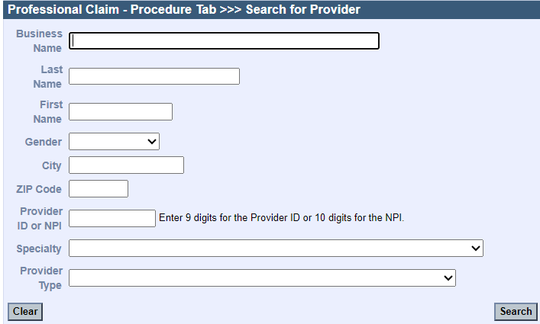

4. Enter the data to perform/conduct the search. For example, Dr. Dan Smith and click the Search button to invoke the Search
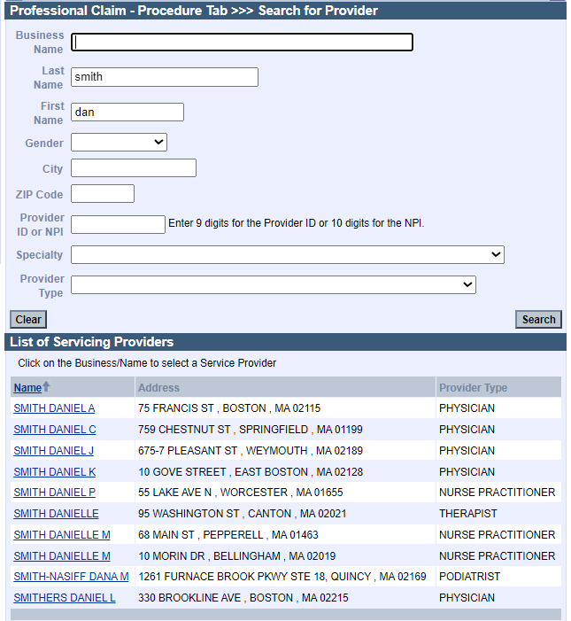

5. Select the Provider Name from the Search results list (Example Smith, Daniel A 75 Francis St. Boston MA/Physician). Selection of the Provider will populate the ORDERING PROVIDER NAME field.
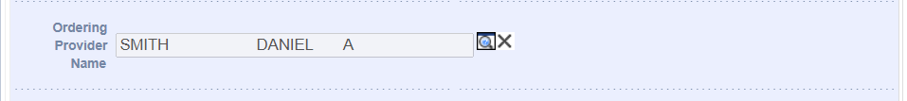

HOW TO POPULATE REFERRING PROVIDER NAME DIRECT DATA ENTRY (DDE) on THE POSC HEADER LEVEL INSTITUTIONAL CLAIMS

1. For 837I/Institutional claims, the REFERRING NPI (aka Referring Provider Name), is populated on the Billing Information Tab
2. On the Billing Information Tab, navigate to the REFERRING PROVIDER NAME field
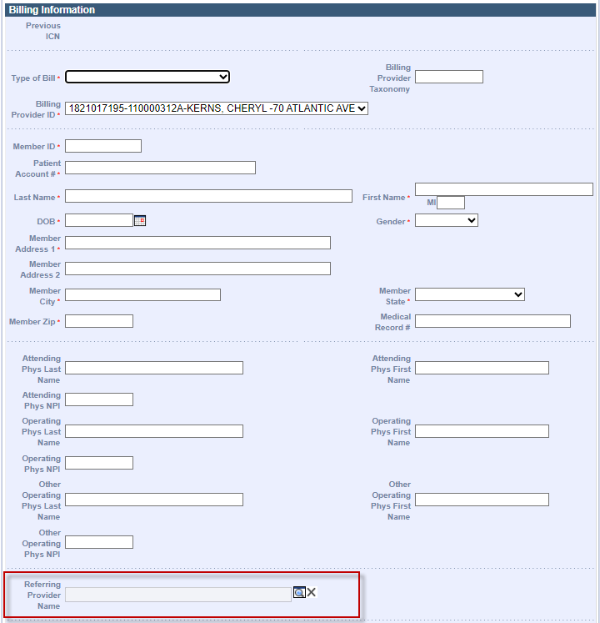

3. Click the Magnifying Icon on the right hand side of the field. This will open up a Search panel to search for a provider by Business Name, Last Name, First Name, Gender, City, Zip Code, Provider ID/NPI, Specialty, Provider Type
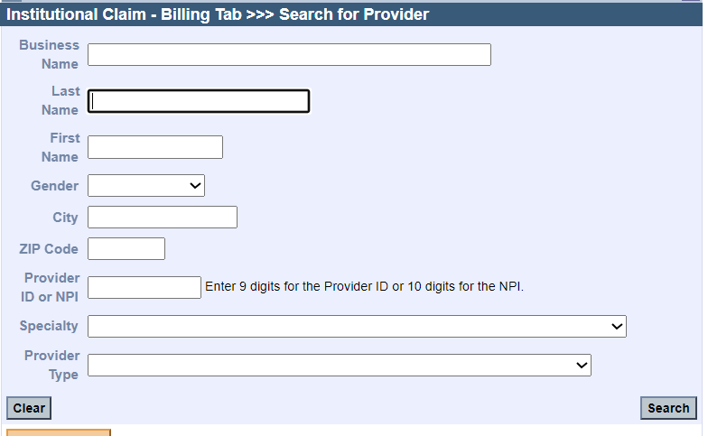

4. Enter the data to perform/conduct the search. For example Dr. Steve Smith and click the Search button to invoke the Search
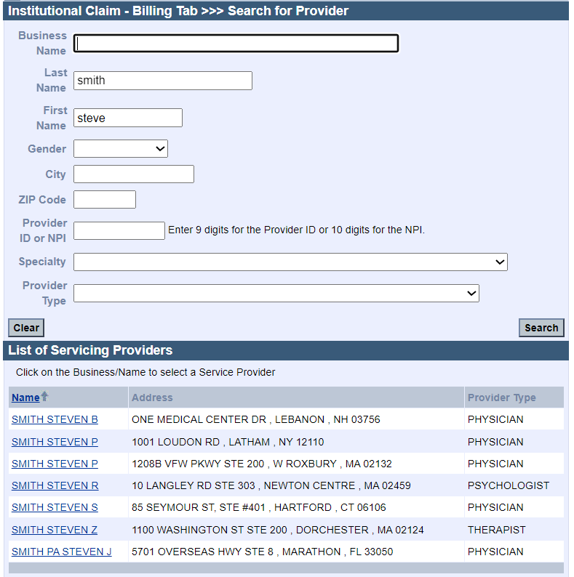

5. Select the Provider Name from the Search results list (Example Smith, Steven P 1208B VFW PKWY STE 200 , W ROXBURY , MA 02132/Physician). Selection of the Provider will populate the REFERRING PROVIDER NAME
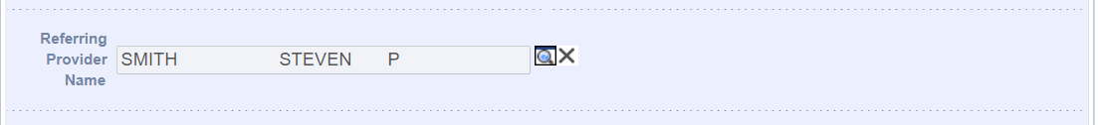

HOW TO POPULATE REFERRING PROVIDER NAME AND NPI EELECTRONIC 837P CLAIMS SUBMISSIONS

Most providers will have billing systems that will auto-populate the REFERRING PROVIDER NAME and NPI Loop/Segment. Providers should follow all rules according to the 837P Implementation Guide or Companion Guide for Electronic Claims submissions.

For 837P REFERRING PROVIDER NAME AND NPI is populated Loop/Segment 2310A. Or Loop/Segment 2420F (when different than Referring Provider in 2310A)
Loop/Segment 2310A refers to Header Level entry
Loop/Segment 2420F refers to Detail Level entry

EXAMPLE-
The digits following the ‘XX’ qualifier is the REFERRING PROVIDER NPI
In this example 1821017195 is the REFERRING PROVIDERS NPI
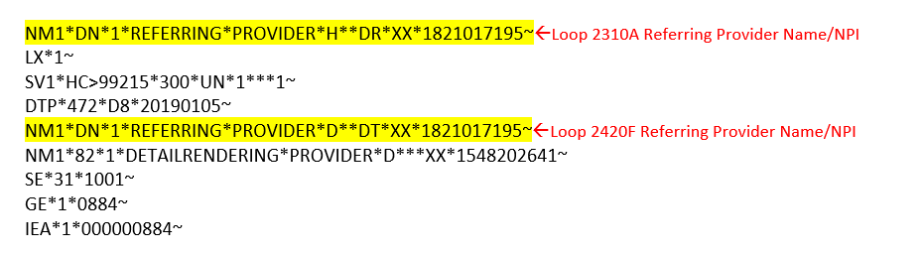

HOW TO POPULATE ORDERING PROVIDER NAME AND NPI EELECTRONIC 837P CLAIMS SUBMISSIONS

Most providers will have billing systems that will auto-populate the ORDERING PROVIDER NAME and NPI Loop/Segments. Providers should follow all rules according to the 837P Implementation Guide or Companion Guide for Electronic Claims submissions.

For 837P ORDERING PROVIDER NAME AND NPI is populated Loop/Segment 2420E. Or Loop/Segment
Loop/Segment 2420E refers to Detail Level entry

EXAMPLE-
The digits following the ‘XX’ qualifier is the ORDERING PROVIDER NPI
In this example 1922020882 is the ORDERING PROVIDERS NPI

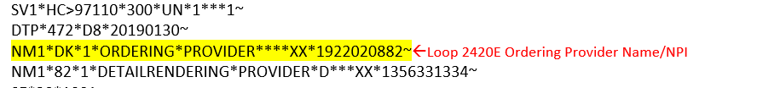

HOW TO POPULATE REFERRING PROVIDER NAME AND NPI EELECTRONIC 837I CLAIMS SUBMISSIONS

Most providers will have billing systems that will auto-populate the REFERRING PROVIDER NAME and NPI Loop/Segments. Providers should follow all rules according to the 837I Implementation Guide or Companion Guide for Electronic Claims submissions.

For 837I REFERRING PROVIDER NAME AND NPI is populated Loop/Segment 2310F. Or Loop/Segment 2420D (when different than Referring Provider in 2310F)
Loop/Segment 2310F refers to Header Level entry
Loop/Segment 2420D refers to Detail Level entry

EXAMPLE-
The digits following the ‘XX’ qualifier is the REFERRING PROVIDER NPI
In this example 1821017195 is the REFERRING PROVIDERS NPI
