How to Pull Massachusetts Compliance Report for Auto-Verification
This job aid will help guide providers in scope for MA Electronic Visit Verification (EVV) on how to pull their EVV compliance data via the Auto Verification Summary – All Visits Report.
1. Navigate to the Reports screen. (Reports > Reports)
2. Select the Data Range Reports for REPORT TYPE and the Auto Verification Summary – All Visits for REPORT NAME.
- Note: Some providers may have more than one corporation listed in the CORPORATION dropdown. Please ensure you are selecting the correct corporation for compliance.
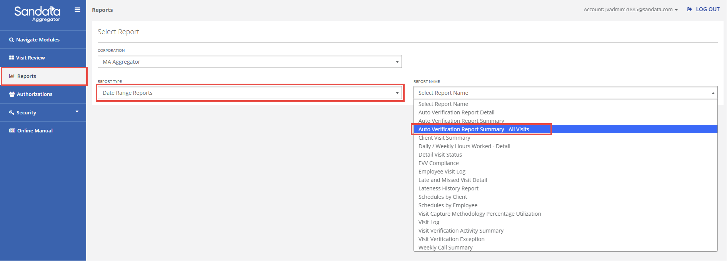
3. Enter/Select the applicable fields in the Timeframe section.
- Note: You will only be able to run it for a max of 31 days and may need to run the report multiple times to see data across a quarter or across a year.
4. Enter/Select the applicable fields in the Select Parameters section based on your corresponding program.
Home Health (HH) Providers:
- For HH Fee-For-Service (FFS), select MAHEA from the CONTRACT dropdown
- For HH Health Plans, select the appropriate Managed Care Entity from the CONTRACT
- For HH, select HH from the PROGRAM dropdown
Group Adult Foster Care (GAFC) Providers:
- For GAFC Fee-For-Service (FFS), select MAHEA from the CONTRACT dropdown
- For GAFC Health Plans, select the appropriate Managed Care Entity from the CONTRACT
- For GAFC, select HH from the PROGRAM dropdown
Acquired Brain Injury (ABI) and Moving Forward Plan (MFP) Waiver Providers:
- For ABI/MFP Waiver Fee-For-Service (FFS), select MAHEA from the CONTRACT dropdown
- For ABI/MFP Waiver Health Plans, select the appropriate Managed Care Entity from the CONTRACT
- For ABI/MFP Waiver, select ABI/MFP from the PROGRAM dropdown
Aging & Independence (AGE) Providers:
- For AGE, select the associated Aging Services Access Points (ASAPs) contract from the CONTRACT dropdown
- For providers that contract with an ASAP, select the associated program from the PROGRAM dropdown
Managed Care Entity (MCE) Providers:
- For providers that contract with a MCE, select the associated Managed Care Entity from the CONTRACT
- For providers that contract with a MCE, select the associated program from the PROGRAM dropdown (see above for HH, GAFC, and Waivers programs)
For SERVICE, leave All selected
5. Click RUN REPORT to review the data pulled on the selected parameters.
- If you use Sandata EVV, reference this support article to learn more about the report fields: Auto Verification Summary Report – All Visits – Sandata Technologies
- If you use an Alt EVV vendor, reference this support article to learn more about the report fields: Auto Verification Summary Report – All Visits – Sandata Technologies

