**Bureau of Climate and Environmental Health (BCEH) eLicensing System**

**How to Renew a Diagnostic Radiography Facility Registration (DRAD) Registration**

*This resource provides instructions for how to Link and Renew a Diagnostic Radiography Facility license in the BCEH eLicensing system.*

**Step 1:** Prior to starting a renewal application, the existing license will need to be linked to your account. To start, click **Link an Existing License or Registration.**

Home Screen

**Note:** If you have already linked your licenses, please skip to **Step 7**.

**Step 2:** Select **Radiation Control Program** for the Board/Program, **Diagnostic Radiography Facility Registration** for the License or Registration Type, and enter the **License or Registration Number**. Click **Proceed**.

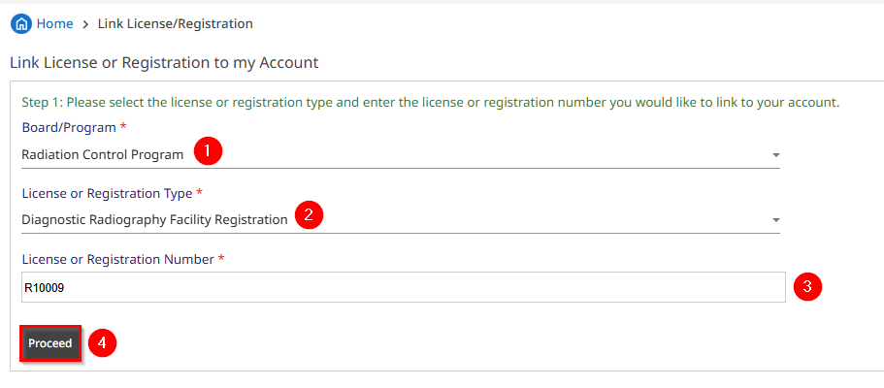

Link License/Registration Screen

**Step 3:** The Radiation Control Program will provide a unique **Registration Pin Code** to contacts associated with the license. Enter the code, check the **reCAPTCHA checkbox,** and click **Proceed**.

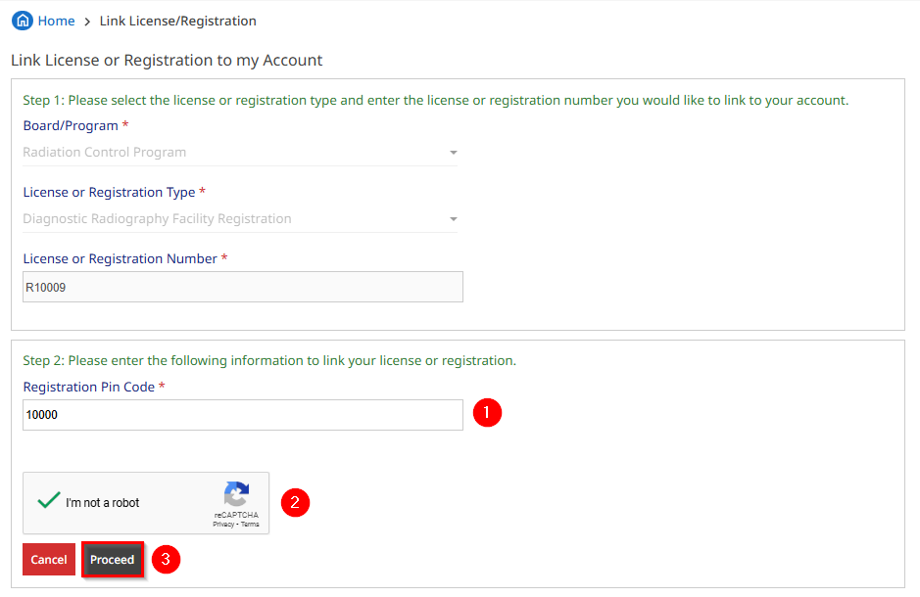

Link License/Registration Screen

**Step 4:** Review the license(s) information, check the **reCAPTCHA checkbox** followed by clicking **Yes, Link**.

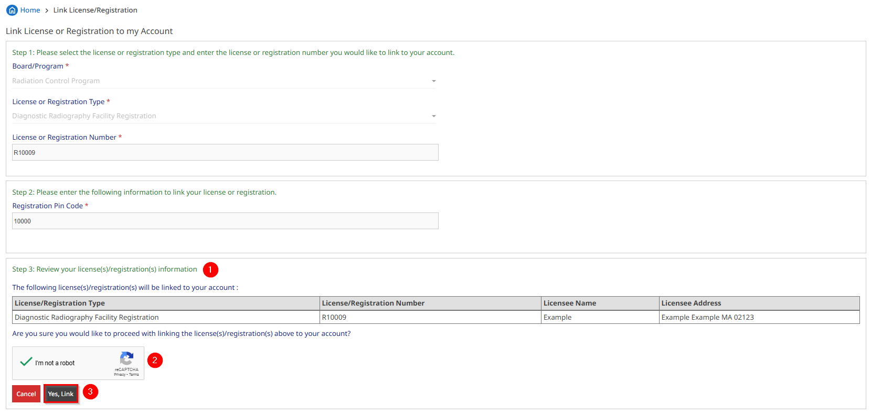

Link License/Registration Screen

**Note:** If your pin code is associated with more than one license, the additional license(s) will appear in the list to be linked to the account.

**Step 5:** The license(s) are now linked successfully. Click **OK** to proceed to the **My Licenses/Registrations** page.

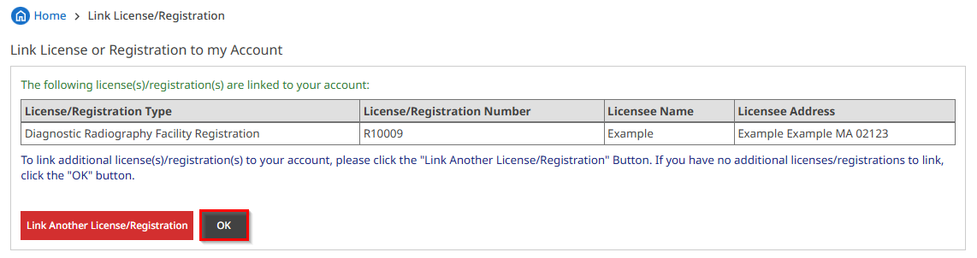

Link License/Registration Screen

**Note:** To link additional licenses, click **Link Another License/Registration** and complete the same steps as outlined above using the unique pin code(s) provided by the Radiation Control Program.

**Step 6:** The **My Licenses/Registrations** page is the homepage for licenses activities. To start an application to renew your license, click **Start a Renewal Application.**

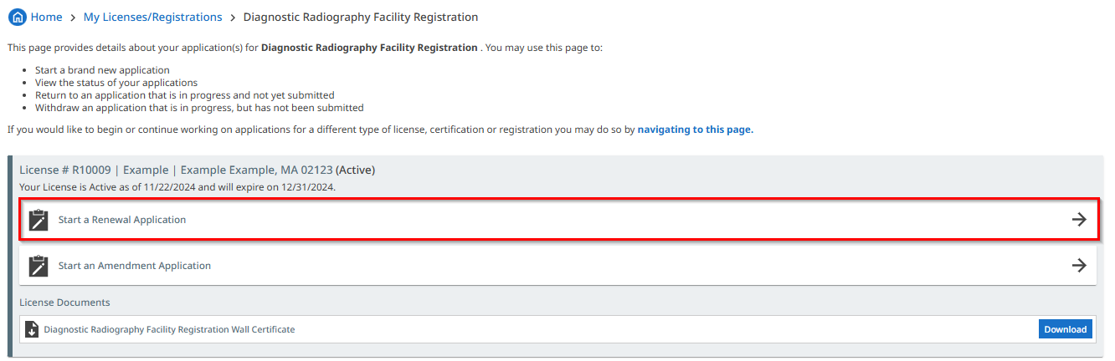

My Licenses/Registrations Screen

**Step 7:** Click **Start Application**.

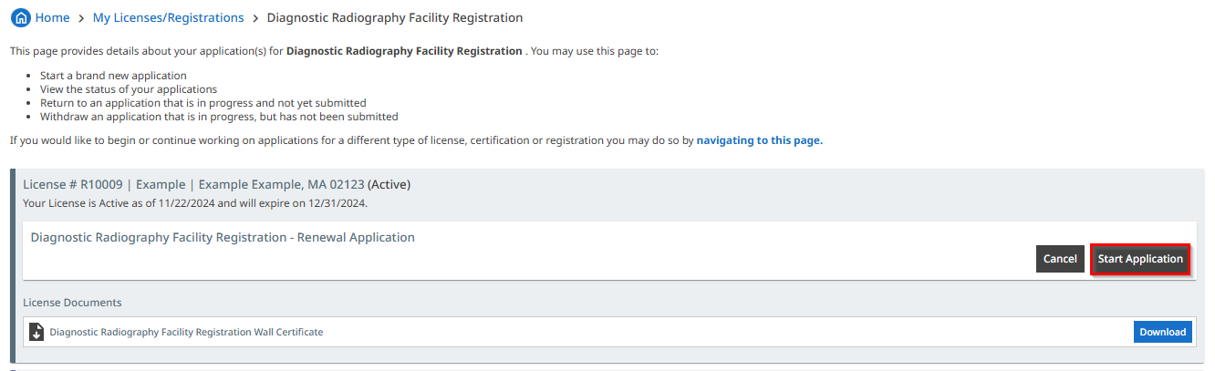

My Licenses/Registrations Screen

**Step 8:** The header of the application provides a numbered list of the steps required in the application. The first step is **Organization Information**. Start reviewing the information in the fields below. All required fields are denoted by a red . Make any needed updates.

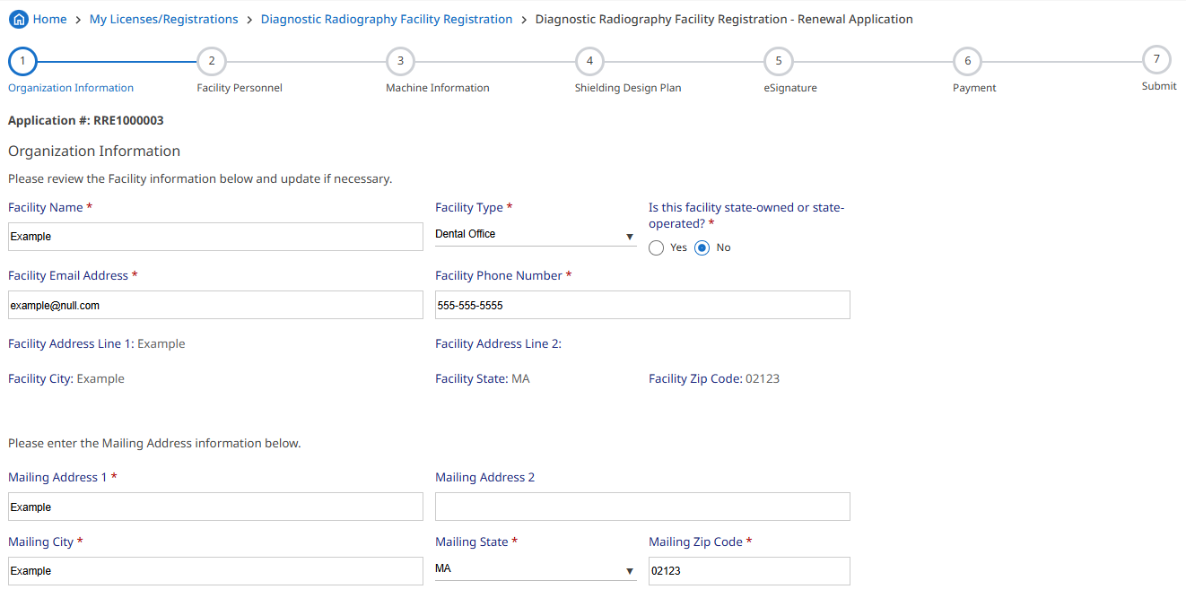

Organization Information Screen

**Note:** Changing the **Facility Address** is **not allowed** on renewal applications. As a result, these fields are non-editable.

**Continue** to review the **Responsible Person, Billing Contact, Facility Inspection Contact, and Inspection Report Contact** information followed by clicking **Save & Go To Next Page**.

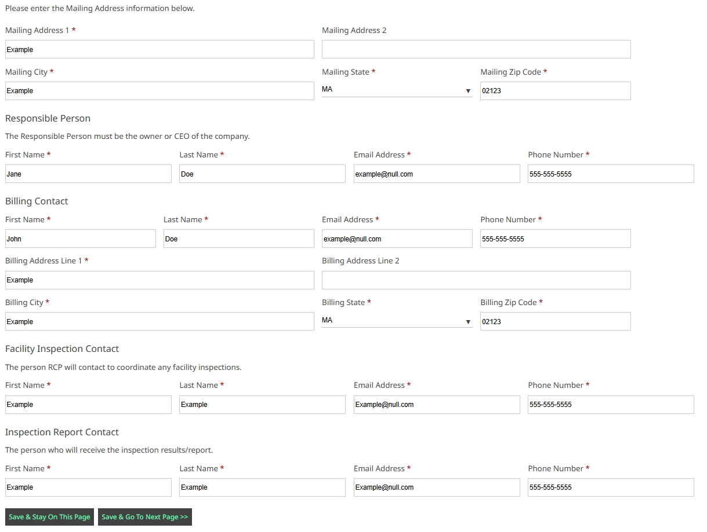

Organization Information Screen, Continued

**Good To Know:** If a required field is empty, the system prevents users from advancing to the next page. The system provides a prompt for the required field to be completed

Organization Information Screen, Missing Information Example

**Step 9:** For the **Facility Personnel** page, review information for **Responsible Physician**, **Interpreting Physician**, and **Radiation Machine Operators.**

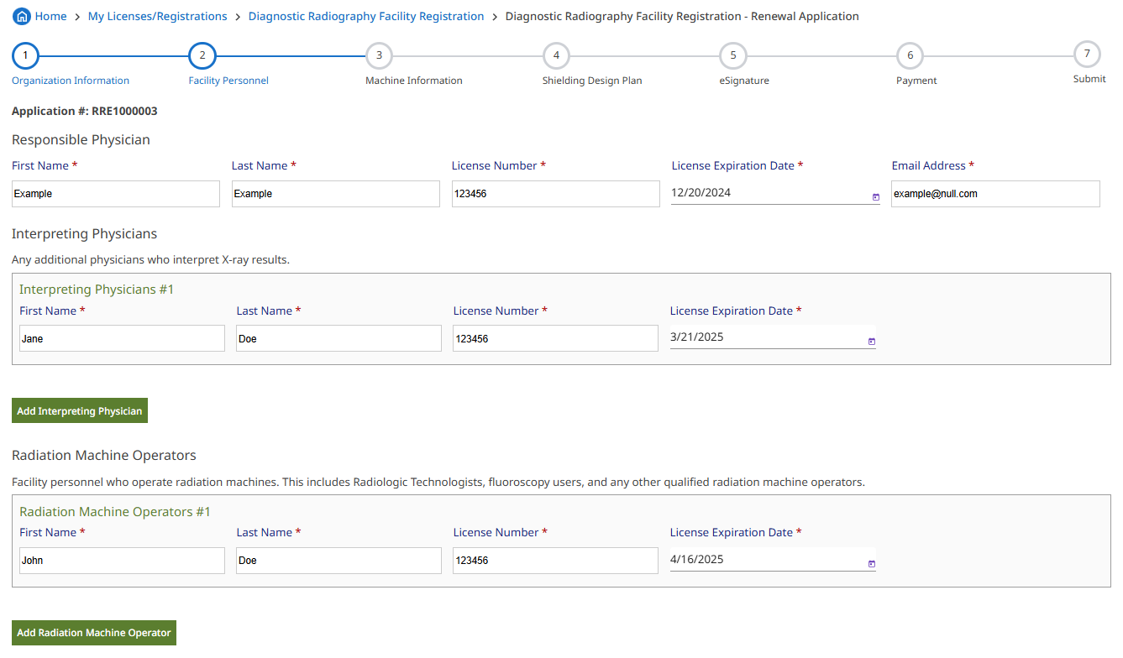

Facility Personnel Screen

**Note:** Click **Add Interpreting Physician/Add Radiation Machine Operator** to add a new record.

Continue to review personnel information for **Medical Physicists** and **Consultants**, followed by **Clicking Save & Go To Next Page**.

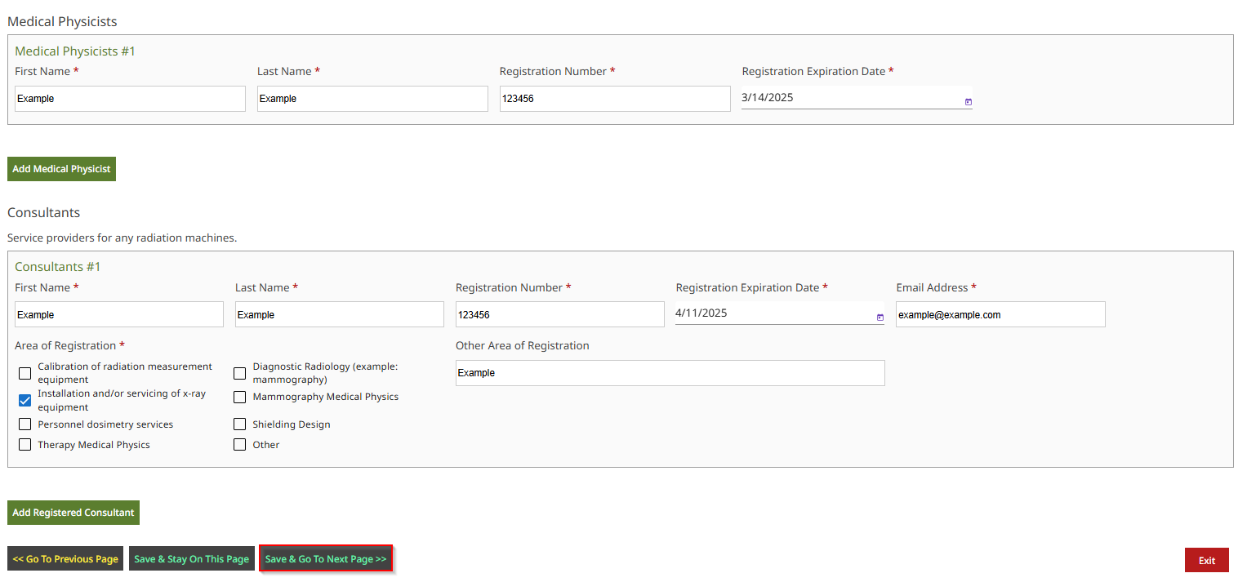

Facility Personnel Screen

**Step 10:** Review the machine details. Click **Add Machine** to enter additional record(s). Click **Save & Go To Next Page** after entering all the facility’s machine(s) used for diagnostic radiography.

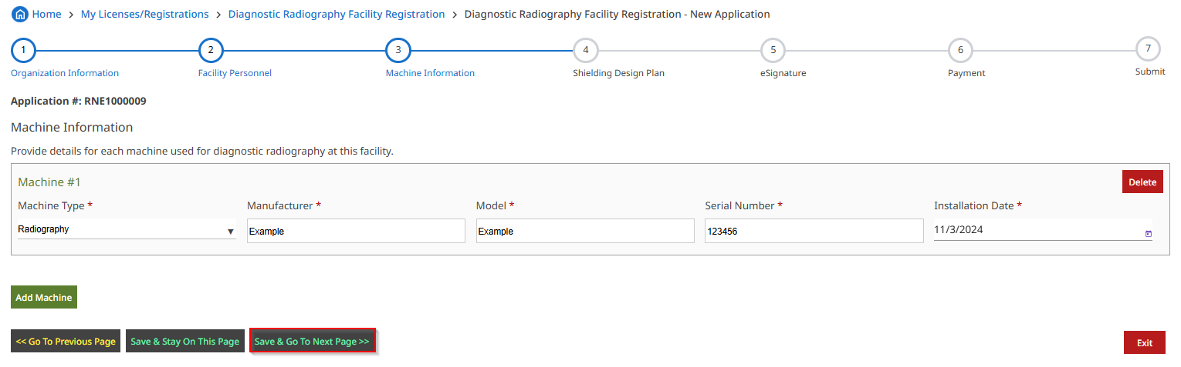

Machine Information Screen

**Step 11:** To report the removal of a machine, select ‘Terminated’, followed by entering the **Removal Date**, **Method of Disposal**, and providing any supporting documentation.

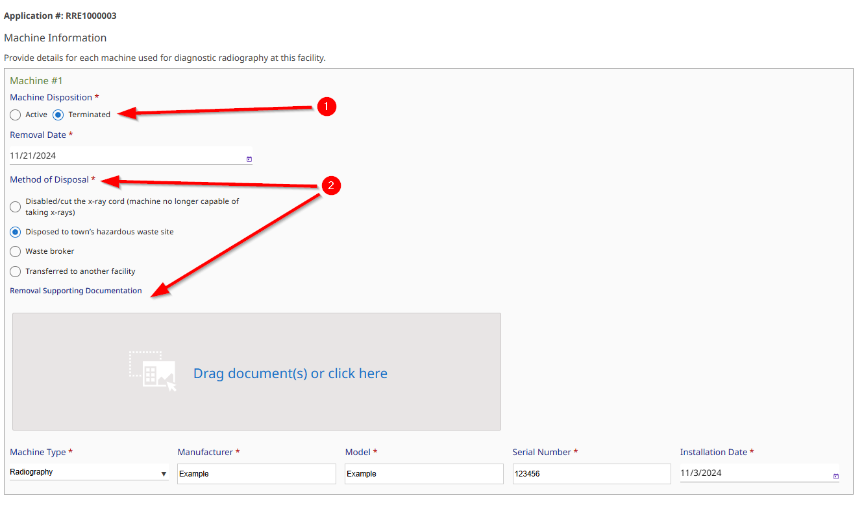

Machine Information Screen

**Step 12:** Select **Yes or No** for the following question in the **Shielding Design Plan** section.

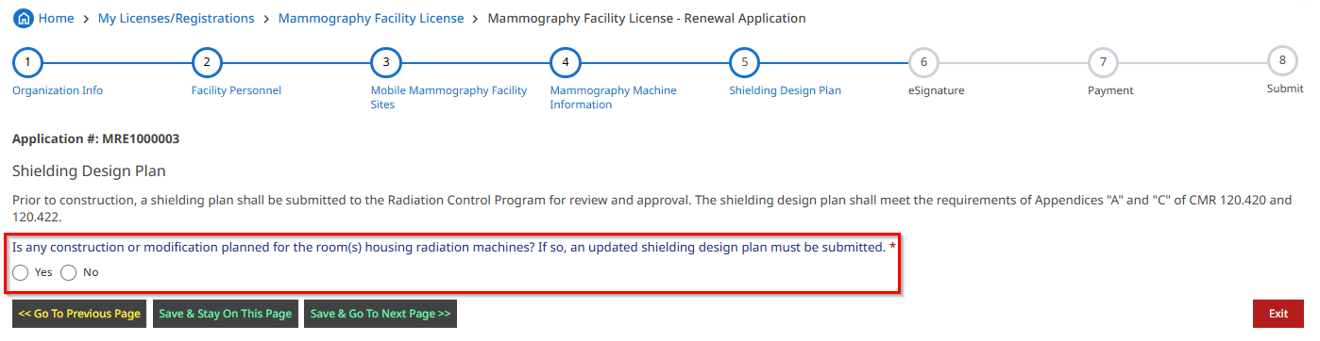

Shielding Design Plan Screen

If **No**, click **Save & Go To Next Page**.

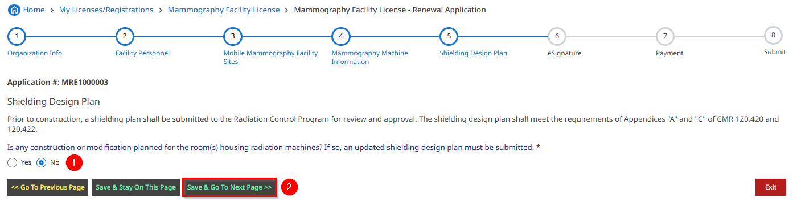

Shielding Design Plan Screen

If **Yes**, a **Shielding Design Plan** is required. Upload the shielding deign and supporting documents. Confirm the plan meets **Radiation Shielding and Safety Requirements**. To upload document(s), click within the document upload section.

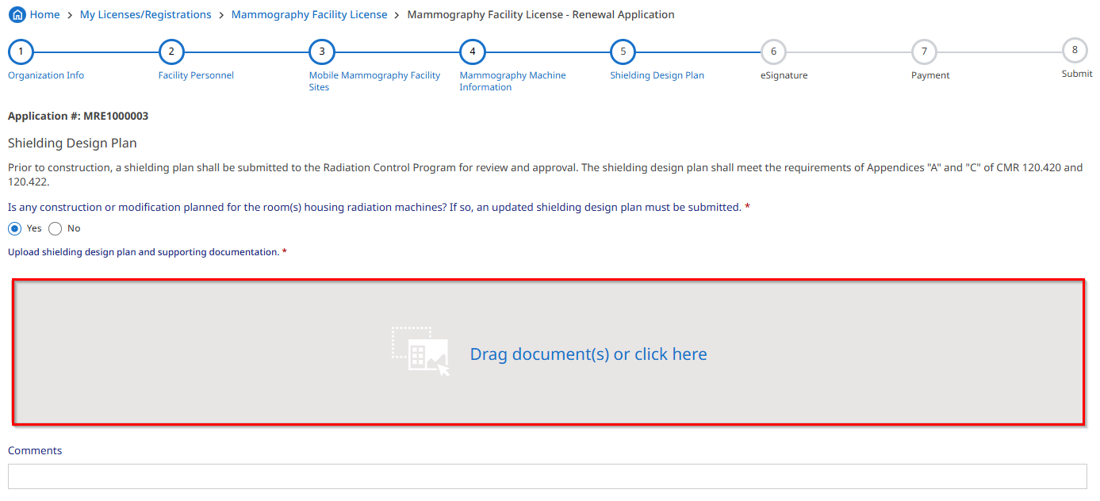

Shielding Design Plan Screen

**Note:** There is also an option to drag and drop a file into this document section.

Locate the document to upload (exact steps may vary e.g., Mac v. PC, etc.)

Shielding Design Plan Screen, Document Upload

Select a **Category** from the dropdown menu and click **Upload**.

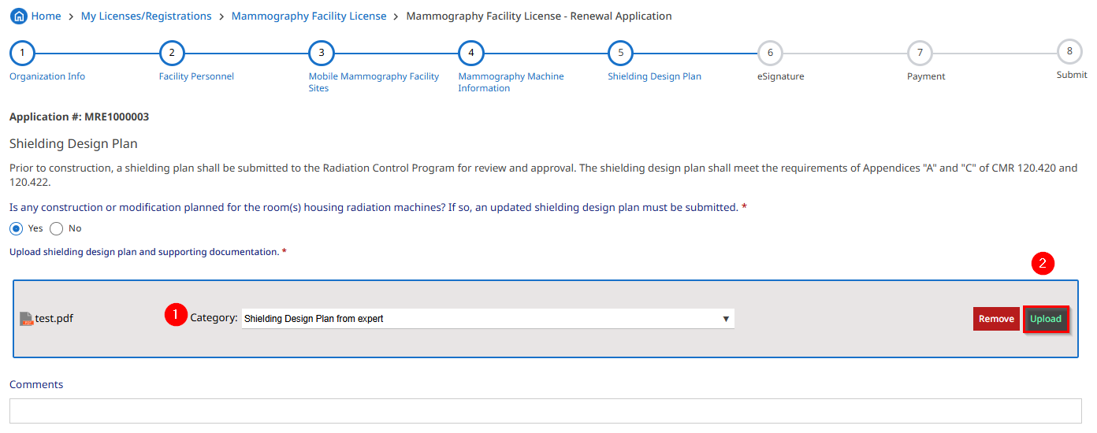

Shielding Design Plan Screen, Document Upload

Review the **Document Name**, **Category** and **Upload Date** to ensure the document is uploaded successfully. Repeat the same process to upload additional documentation, if necessary.

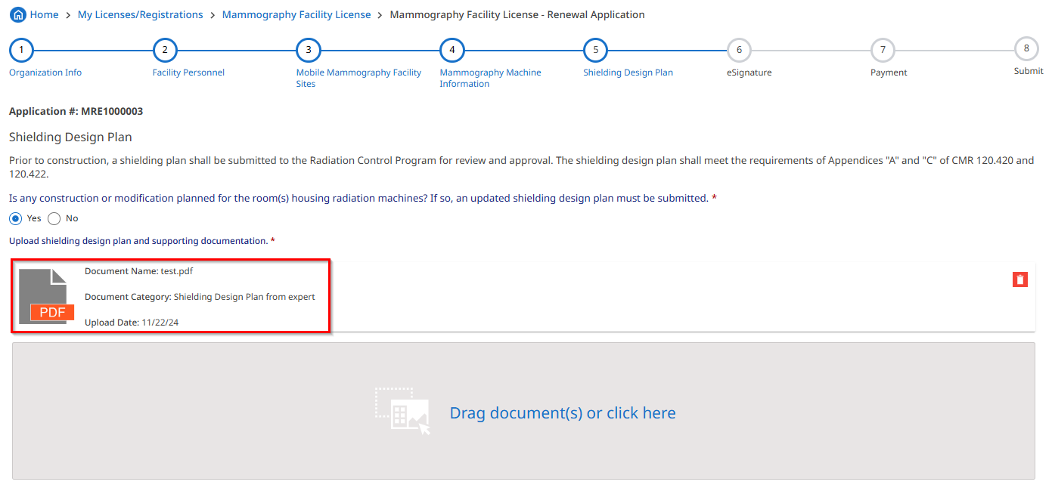

Shielding Design Plan Screen, Document Upload

**Note:** Click the icon to remove a document e.g., if the wrong document was uploaded, etc.

**Step 13:** Review the **Radiation Shielding and Safety Requirements**. Indicate if the plan meets each requirement. Enter comments as necessary.

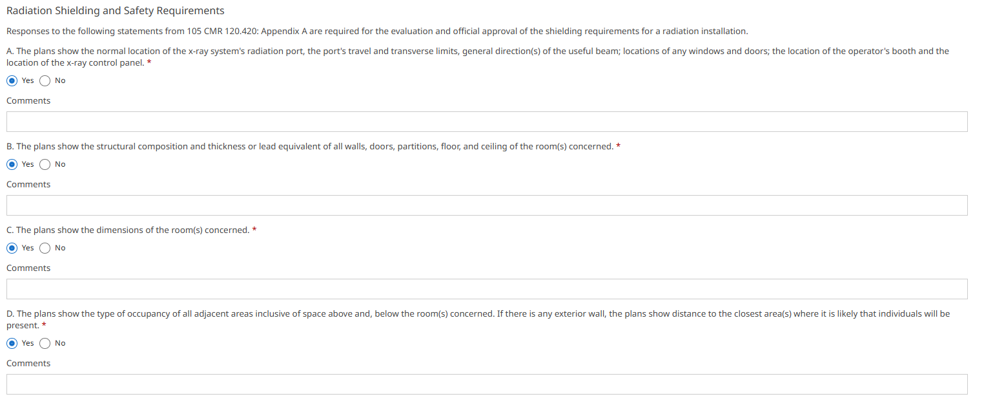

Shielding Design Plan Screen

**Step 14:** Click **Save & Go To Next Page** after completing the section.

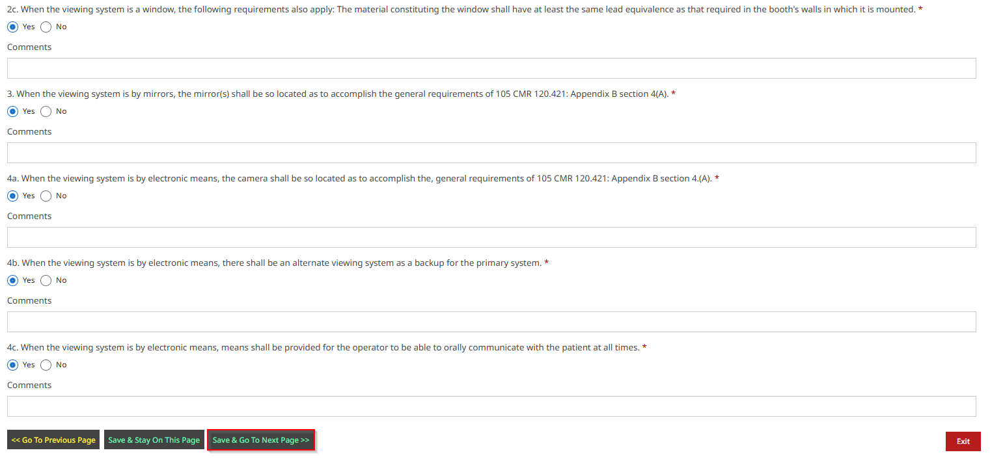

Shielding Design Plan Screen

**Step 15:** Read the eSignature statement, **check the box for I agree**, enter **Full name** followed by clicking **Save & Go To Next Page**

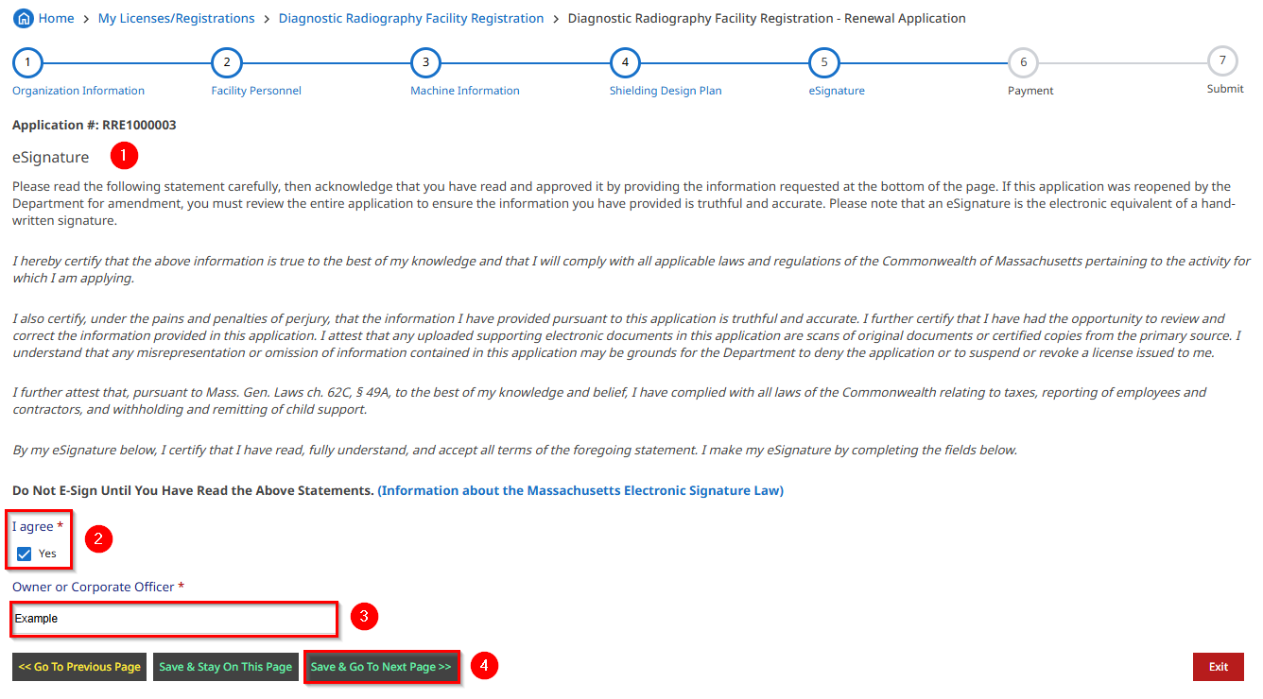

eSignature Screen

**Step 16:** The **Payment** section provides an overview of the payment process. Review the **Important Note** and **Amount Due** based on the number of DRAD machines specified in the application. Click **Pay Fee** to advance to the page where payment info will be collected

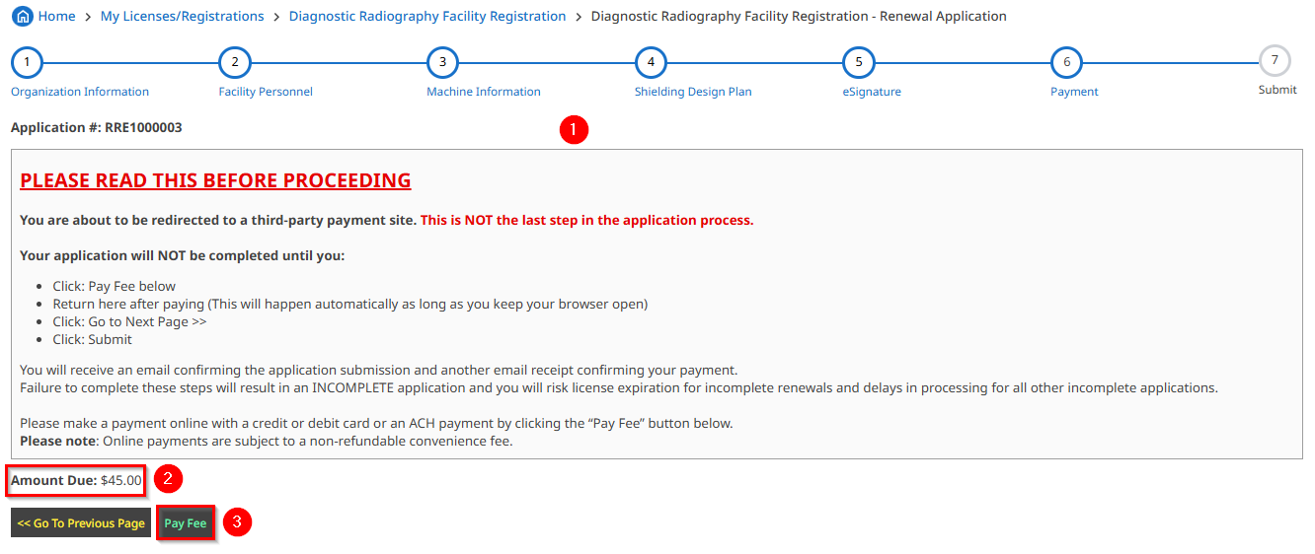

Payment Screen

**Step 17:** Applicants are directed to the secure payment page. Note the Description, ID, and Amount in the Payment section.

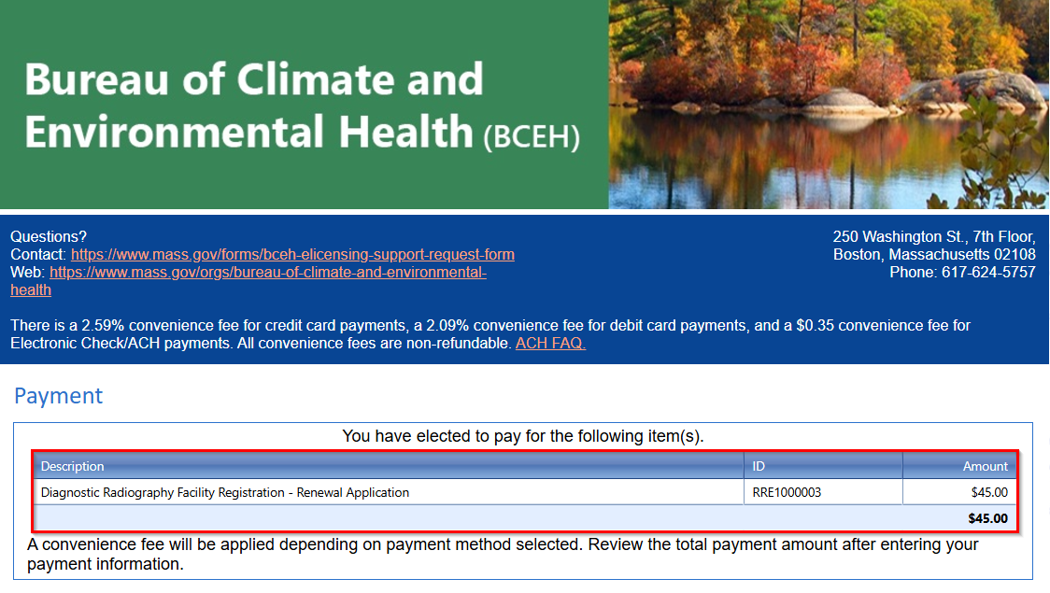

Payment Details Screen

**Step 18:** Complete the **Billing Information** and **Payment Information** fields, followed by clicking **Submit Payment** at the bottom of the page

Enter Payment Information Screen

**Step 19:** Following payment, applicants are directed back to the system. A receipt will also be sent to the email address provided. Please review the payment details followed by clicking **Go To Next Page**.

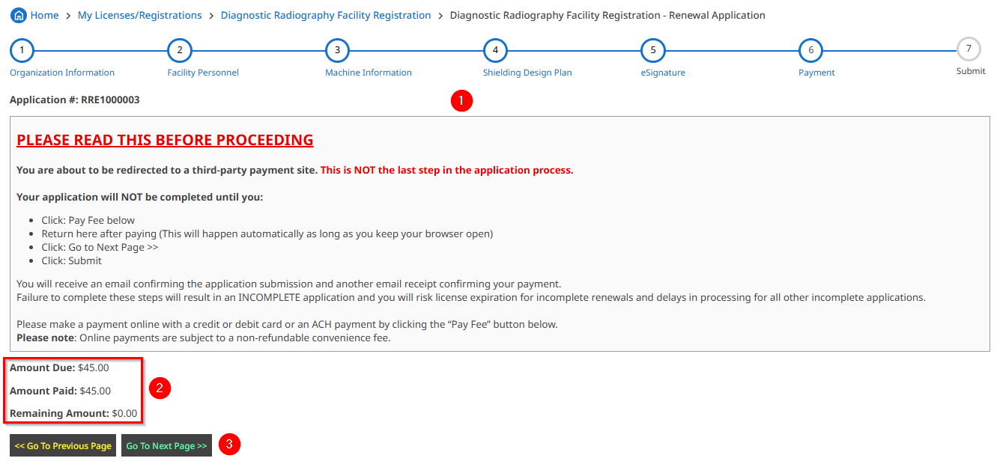

Payment Screen

**Step 20:** The Submit screen provides a chance to application prior to submitting. Review the instructions and check the application for accuracy. Click **Submit Application**.

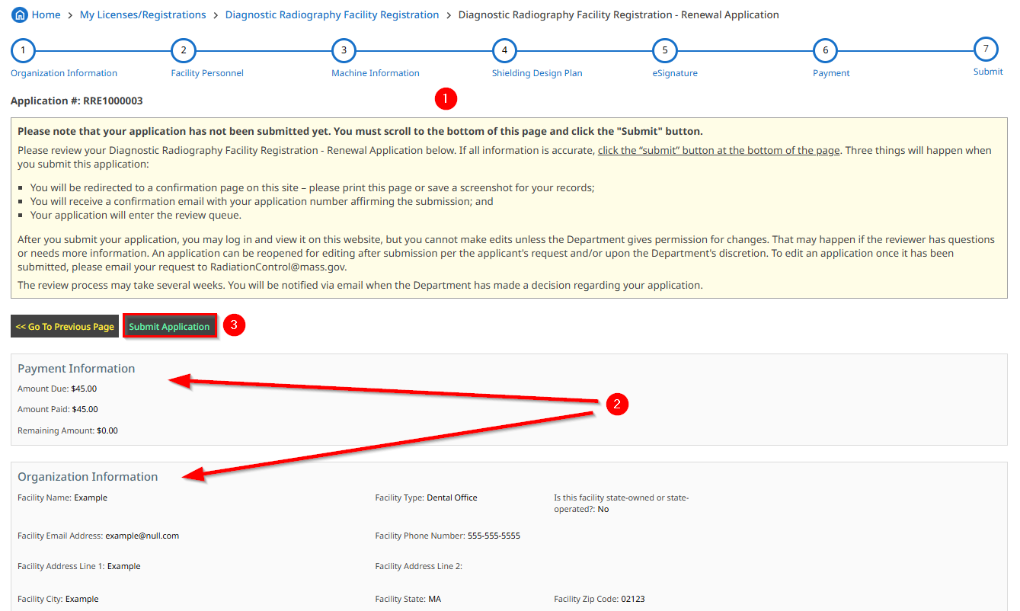

Submit Screen

**Note:** Click **Go to Previous Page** to make any corrections, if necessary

**Step 21:** Applicants are returned to their **My Licenses/Registrations** page after submitting the application. This page provides an opportunity to view your License(s) and complete any further actions including **starting a new application**, **viewing the status of an application**, **viewing/printing an application**, **downloading Wall Certificate(s)** and more.

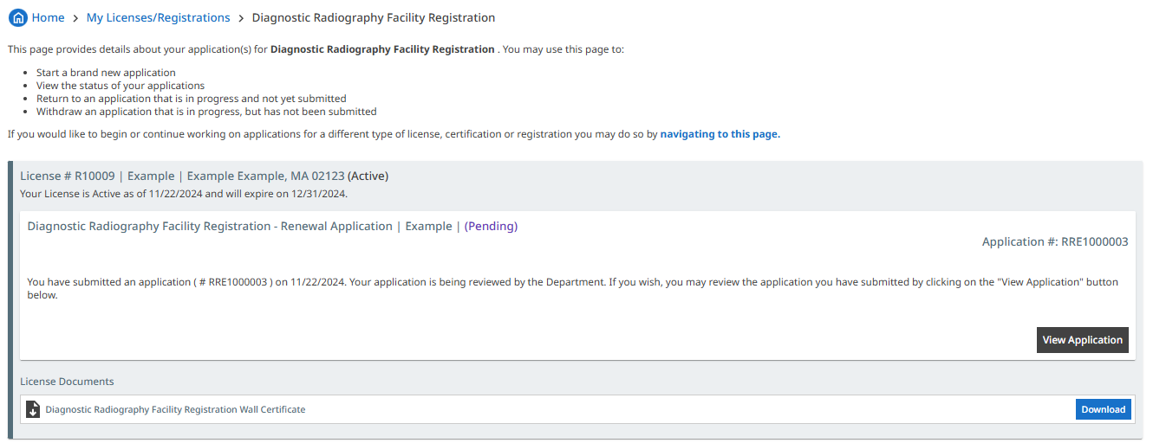

My Licenses/Registrations Screen

Created by the Digital Transformation Office (DTO) v.1.0

For additional resources, please visit the BCEH e-Licensing User Guide link: [Bureau of Climate and Environmental Health eLicensing System User Guide | Mass.gov](https://www.mass.gov/info-details/bureau-of-climate-and-environmental-health-elicensing-system-user-guide)