

How to Request a Hard Copy of Your License in ELAR:
A Step by Step Guide
October 2015

Access ELAR System
- Go to www.mass.gov/ese/licensure | 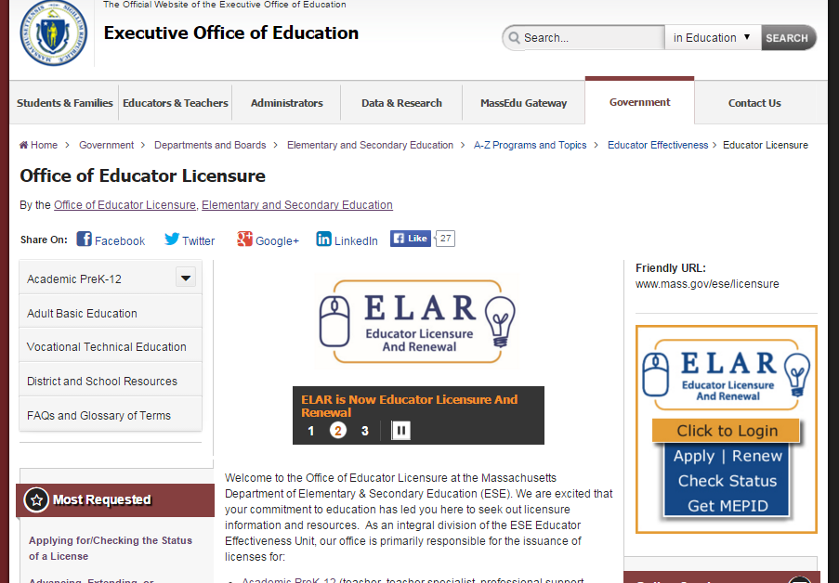
- Click on ELAR Login Image | 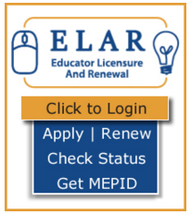

Log-in to ELAR Portal
- Input your User Name and Password (please note: these are case sensitive)  Note:  - If you do not have an ELAR account yet, or are not sure, click on the Create ELAR Profile link and create a new profile/account. If you do have a profile the system will locate it and notify you.  - If you do not know if you have an account, or have forgotten your ELAR User Name or Password, click on the Forgot User Name/Password link and follow prompts. Again, if you already have a profile, you will be alerted.  - You will be required to provide an email address in your ELAR account. It is important that you keep your contact information in ELAR up to date. Most especially your email and mailing addresses. | 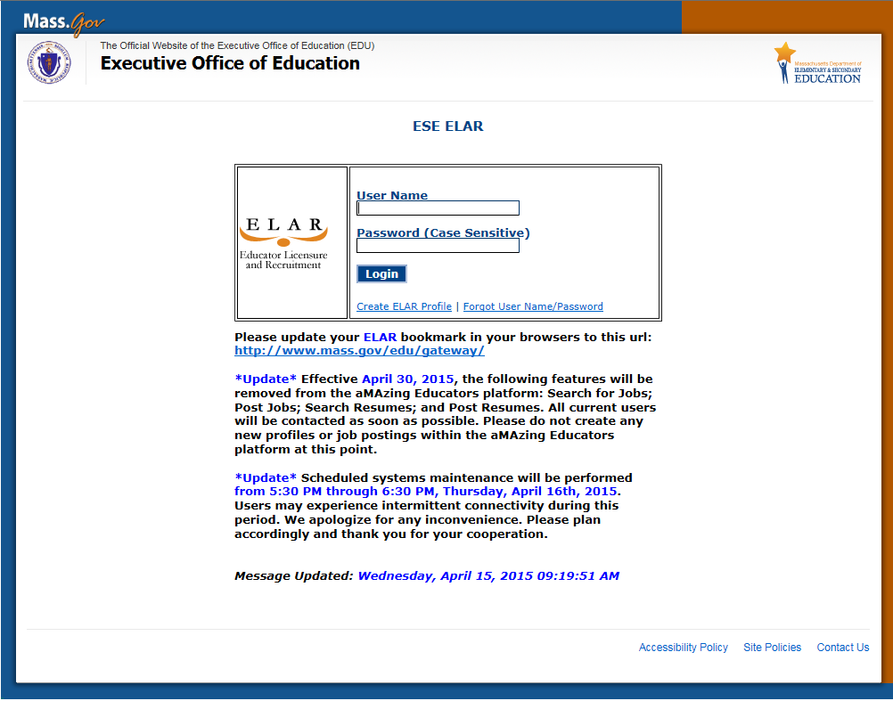

ELAR Welcome Page
- On your ELAR Welcome page click on Request a duplicate license link | 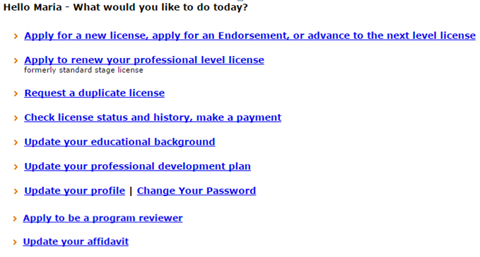
Request a Duplicate of Your License
- Select appropriate radial button (yes or no) next to: Does your request involve a name change?  - Click on Next button | 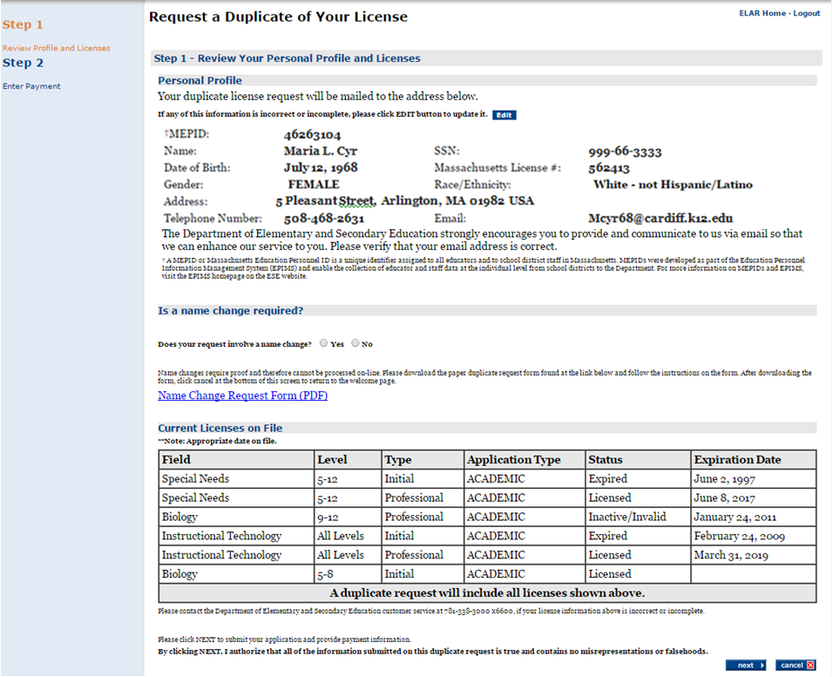

- Make payment | 