View Assignments
(For Pilot and Enterprise Launch, assignments will only include Mandatory training)

Users can see courses and curriculum to which they are assigned by following the following these steps:

Steps 1 and 2. View assigned training and status, take course, open curriculum.
Step 1. On the MassAchieve Learner home page in the left panel you can view and open courses and curriculum that are assigned to you that are Past Due, Due Soon or Have no due date. Step 2. Take courses or open the curriculum by clicking applicable link.
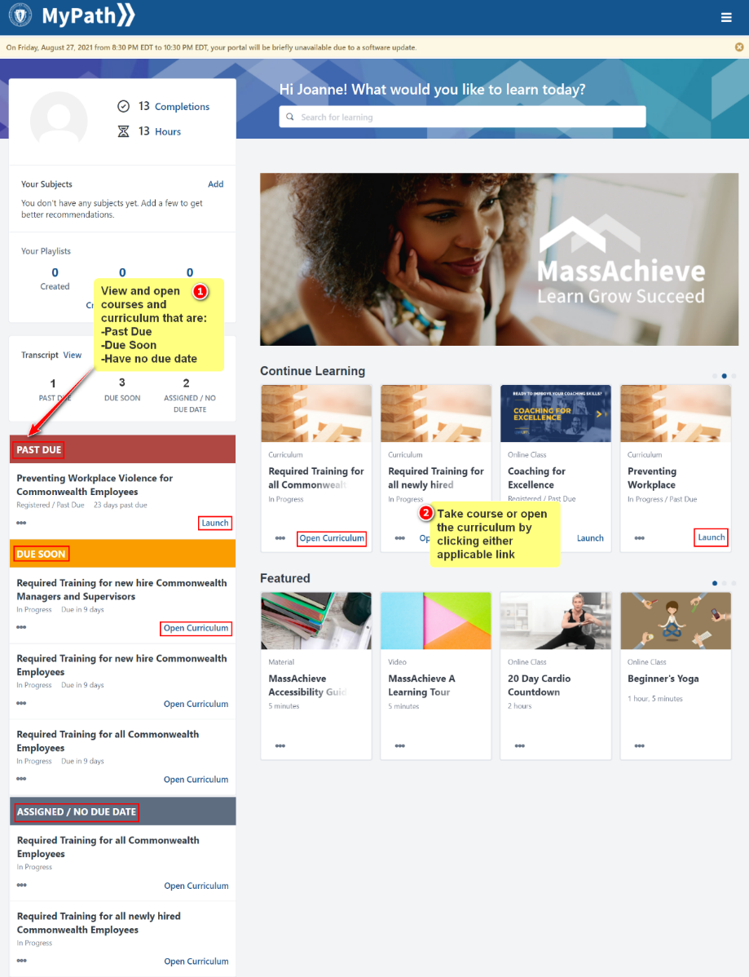

Assignment Statuses and Definitions
- Past Due: Assigned training that has a due date in the past
- Due Soon: Assigned training that has due date approaching
- Assigned/No Due Date: Assigned training that does not have a due date

Links and Actions
- Launch: Starts the course
- Open Curriculum: Opens a curriculum of grouped courses

