INDOOR AIR QUALITY ASSESSMENT

Howard School
70 Howard Street
West Bridgewater, Massachusetts

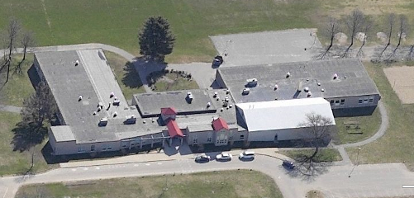

Prepared by:
Massachusetts Department of Public Health
Bureau of Environmental Health
Indoor Air Quality Program
August 2011

Background/Introduction
In response to concerns regarding water damage and possible mold growth, the Massachusetts Department of Public Health’s (MDPH) Bureau of Environmental Health (BEH) conducted an indoor air quality assessment at the Howard School (HS), 70 Howard Street, West Bridgewater, Massachusetts. On March 1, 2011, a visit to conduct an indoor air quality assessment (IAQ) was made to the HS by Sharon Lee, an Environmental Analyst/Inspector and Ruth Alfasso, an Environmental Engineer/Inspector in BEH’s IAQ Program. During the assessment, MDPH/BEH staff were accompanied by Interim Principal John Carroll and Julie Hamblin, Director of Buildings and Grounds, West Bridgewater Public Schools (WBPS).
The HS is a single-story building on slab constructed in 1970. The building interior was remodeled in the mid-1990s. The roofs of the building have been replaced over time since the mid-2000s. The school consists of classrooms, a gymnasium, cafeteria, library and offices. Windows throughout the school are openable.

Methods
Air tests for carbon dioxide, carbon monoxide, temperature and relative humidity were conducted with the TSI, Q-Trak, IAQ Monitor, Model 7565. Air tests for airborne particle matter with a diameter less than 2.5 micrometers were taken with the TSI, DUSTTRAK™ Aerosol Monitor Model 8520. BEH staff also performed a visual inspection of building materials for water damage and/or microbial growth.

Results
The school houses approximately 320 students in grades 4 through 6 and approximately 22 staff members. Tests were taken during normal operations, and results appear in Table 1.

Discussion

Ventilation
It can be seen from Table 1 that carbon dioxide levels were above 800 parts per million (ppm) in 19 of 33 areas tested, indicating less than optimal air exchange in over half of the areas tested within the building at the time of the assessment. It is also important to note that several areas were empty/sparsely populated, which can greatly reduce carbon dioxide levels. Carbon dioxide levels would be expected to increase with higher occupancy.
Fresh air to classrooms is supplied by unit ventilator (univent) systems (Picture 1). A univent draws air from the outdoors through a fresh air intake located on the exterior wall of the building (Picture 2). Return air from the classroom is drawn through an air intake located at the base of the unit (Figure 1). Fresh and return air are mixed, filtered, heated and provided to classrooms through an air diffuser located in the top of the unit. In some areas, univents were operating with fans on low speed (Table 1), reducing the mechanical ventilation provided to these areas. In addition, several univents were obstructed by items on top of air diffusers and/or in front of return vents along the bottom of the units (Pictures 1 and 3). In order for univents to provide fresh air as designed, they must remain “on” and operating while rooms are occupied. Furthermore, units must remain free of obstructions.
The fresh air intake for the univent in classroom 16 is not in a location typical for these units (i.e., directly outside from the unit as shown in Picture 2). Instead, the fresh air intake is ducted to a location above the unit. While observing the intake from the building exterior, the fresh air intake vent was found to be blocked with insulation (Picture 4) to prevent pipes freezing, which previously resulted in flooding (See Microbial/Moisture Concerns discussion). A blocked vent cannot supply fresh air as designed. Insulation should be removed from the fresh air intake and the duct interior should be cleaned. Measures should be made to properly insulate pipes, and the system should be examined to ensure proper function.
Exhaust ventilation in classrooms is provided by rooftop exhaust fans ducted to wall or ceiling-mounted exhaust vents. In several classrooms, exhaust vents are located near hallway doors (Picture 5). When these classroom doors are open, exhaust vents will tend to draw air from both the hallway and the classroom, reducing the effectiveness of the exhaust vents to remove common environmental pollutants. As with univents, in order to function properly, exhaust vents must be activated and allowed to operate while rooms are occupied. Without adequate supply and exhaust ventilation, excess heat and environmental pollutants can accumulate, leading to indoor air/comfort complaints.
In central areas of the building including the cafeteria, gymnasium and office areas, mechanical supply and exhaust ventilation is provided by rooftop air-handling units (AHUs; Picture 6). Fresh air is distributed via ceiling-mounted air diffusers (Picture 7) and ducted back to AHUs via ceiling or wall-mounted return vents (Pictures 8 and 9). AHUs for these areas are controlled by thermostats, which have fan settings of “on” and “auto”. The automatic setting on the thermostat activates the HVAC system at a preset temperature. Once a preset temperature is measured by the thermostat, the HVAC system is deactivated. Therefore, no mechanical ventilation is provided until the thermostat re-activates the system.
The location of some thermostats may not allow for adequate heating/cooling in the building. The thermostat that controls temperature and ventilation in the main office area (including the conference room and principal’s, nurse’s and guidance offices) is reportedly located in front foyer of the building. The current location of the thermostat does not regulate temperature/fresh air provision optimally in the main office area. Relocating the thermostat to an interior wall within the office suite will likely improve the comfort of occupants in these areas.
To maximize air exchange, the MDPH recommends that both supply and exhaust ventilation operate continuously during periods of occupancy. In order to have proper ventilation with a mechanical supply and exhaust system, the systems must be balanced to provide an adequate amount of fresh air to the interior of a room while removing stale air from the room. It is recommended that heating, ventilation and air conditioning (HVAC) systems be re-balanced every five years to ensure adequate air systems function (SMACNA, 1994). The date of the last balancing of these systems was not available at the time of the assessment.
The Massachusetts Building Code requires that each room have a minimum ventilation rate of 15 cubic feet per minute (cfm) per occupant of fresh outside air or openable windows (SBBRS, 1997; BOCA, 1993). The ventilation must be on at all times that the room is occupied. Providing adequate fresh air ventilation with open windows and maintaining the temperature in the comfort range during the cold weather season is impractical. Mechanical ventilation is usually required to provide adequate fresh air ventilation.
Carbon dioxide is not a problem in and of itself. It is used as an indicator of the adequacy of the fresh air ventilation. As carbon dioxide levels rise, it indicates that the ventilating system is malfunctioning or the design occupancy of the room is being exceeded. When this happens, a buildup of common indoor air pollutants can occur, leading to discomfort or health complaints. The Occupational Safety and Health Administration (OSHA) standard for carbon dioxide is 5,000 parts per million parts of air (ppm). Workers may be exposed to this level for 40 hours/week, based on a time-weighted average (OSHA, 1997).
The MDPH uses a guideline of 800 ppm for publicly occupied buildings. A guideline of 600 ppm or less is preferred in schools due to the fact that the majority of occupants are young and considered to be a more sensitive population in the evaluation of environmental health status. Inadequate ventilation and/or elevated temperatures are major causes of complaints such as respiratory, eye, nose and throat irritation, lethargy and headaches. For more information concerning carbon dioxide, consult Appendix A.
Temperatures ranged from 67° F to 75° F, which were within or close to the MDPH recommended range in all areas surveyed (Table 1). The MDPH recommends that indoor air temperatures be maintained in a range of 70° F to 78° F in order to provide for the comfort of building occupants. In many cases concerning indoor air quality, fluctuations of temperature in occupied spaces are typically experienced, even in a building with an adequate fresh air supply. Some occupants reported that they turn off their univents in an attempt to reduce heat. Solar gain, resulting from the sun heating window systems in some areas, increased the temperature discomfort on the day of assessment. Proper use of blinds in classrooms may help in maintaining a comfortable temperature. “Outdoor awnings and louvers can reduce heat that enters a…[building]…by up to 80 percent” (MEMA, 2011). Opening windows, especially those not directly in contact with univents, can also help to improve classroom temperatures. As discussed previously, temperature concerns were also expressed by main office staff. Occupants experiencing temperature issues should work with the school administration and custodial staff to resolve such issues.
Relative humidity measurements in the building ranged from 15 to 26 percent at the time of the assessment, which were below the MDPH recommended comfort range (Table 1). The MDPH recommends a comfort range of 40 to 60 percent for indoor air relative humidity. Relative humidity levels in the building would be expected to be lower during the winter months due to heating. The sensation of dryness and irritation is common in a low relative humidity environment. Low relative humidity is a very common problem during the heating season in the northeast part of the United States.

Microbial/Moisture Concerns
As mentioned, water damage and mold growth concerns in the building prompted the assessment. In order for building materials to support mold growth, a source of water exposure is necessary. Identification and elimination of the source of water to building materials is necessary to control mold growth.
WBPS staff reported water leaks related to HVAC equipment in two separate rooms (the Art Room and room 16). Extreme cold experienced during the winter of 2011 reportedly caused univent pipes to freeze and burst, causing water to leak into the aforementioned classrooms. According to the maintenance staff, damaged materials were reportedly removed and repaired/replaced and cleaned up promptly after the leak occurred. No current signs of active leaks or water damage were noted in these areas at the time of the assessment.
Water-damaged ceiling tiles were observed in a number of areas (Table 1; Pictures 10 and 11), possibly resulting from leaks through roof joints during periods of rain with heavy winds. In the main lobby, the plenum above the drop ceiling was examined in the area of a stained tile and evidence of leaking was noted by staining on a support column where water appeared to have followed the structure. To facilitate drying of this area in case this leak reoccurs, it is recommended that the wallboard be trimmed around the structural column.
Pooling water/ice was observed in a number of areas (Picture 12). WBPS staff indicated that the building periodically experiences leaks where two different sections of the building are joined (Picture 13). Leaks from this area likely contribute to water-damaged ceiling tiles observed in the building, including those in the main lobby. Roof leaks should be repaired promptly and regular inspections of the roof should be carried out to detect and repair future leaks. Measures should also be taken to pitch the roof in a manor that improves drainage.
Sinks were observed in many classrooms. In some cases open or weakly-sealed seams were observed between backsplashes and countertops (Picture 14). If these areas are not made watertight, water can penetrate through the seam, causing water damage to the material under or behind the sink. Improper drainage or sink overflow can lead to water penetration into the countertop, cabinet interior and areas behind cabinets. Water penetration and chronic exposure of porous and wood-based materials can cause these materials to swell and show signs of water damage.
Many classrooms were also found to have porous materials (e.g., paper towels, cloth) stored beneath sinks, which is a humid environment (Picture 15). Repeated moistening of porous materials can result in mold growth. Storage of large amounts of material under the sinks can also prevent rapid detection of leaks.
A portable air-conditioner was observed in the server room (Picture 16). At the time of assessment, the drainage system for the air-conditioner was not connected properly, allowing water to leak/empty onto the floor. Measures should be taken to ensure that these pipes are properly connected to prevent moistening of building materials, which can result in mold growth.
The US Environmental Protection Agency (US EPA) and the American Conference of Governmental Industrial Hygienists (ACGIH) recommend that porous materials be dried with fans and heating within 24 to 48 hours of becoming wet (US EPA, 2001; ACGIH, 1989). If not dried within this time frame, mold growth may occur. Once mold has colonized porous materials, they are difficult to clean and should be removed/discarded.
Plants were observed in several areas (Table 1; Picture 17). Plants should be properly maintained and equipped with washable drip pans. Some of the plants were located on or directly adjacent to univents (Picture 18). Plants should be located away from ventilation sources to prevent aerosolization and distribution of dirt, pollen or mold. Finally, they should not be placed on porous materials, since water damage to porous materials may lead to microbial growth.
BEH staff examined the outside perimeter of the building to identify breaches in the building envelope and/or other conditions that could provide a source of moisture. Efflorescence was noted on the exterior masonry of the building (Picture 19). Efflorescence is a characteristic sign of water infiltration but it is not mold growth. As moisture penetrates and works its way through mortar, brick or plaster, water-soluble compounds dissolve, creating a solution. As the solution moves to the surface of the material, the water evaporates, leaving behind white, powdery mineral deposits. It was also noted that in some areas, exterior masonry did not appear to have the expected weep holes, which would let moisture penetrating through the masonry drain from the base of the wall; lack of these holes may have contributed to the efflorescence. See Figures 2 and 3 for illustration of the function of weep holes.
Plants were also observed growing in close proximity to the building’s exterior (Picture 20), in some instances near univent fresh air intakes. Univents can draw in pollen and mold from these plants and distribute them throughout the classroom. Furthermore, the growth of roots against exterior walls can bring moisture in contact with the foundation. Plant roots can eventually penetrate the wall, leading to cracks and/or fissures in the sublevel foundation. Over time, these conditions can undermine the integrity of the building envelope and provide a means of water entry into the building via capillary action through exterior walls, foundation concrete and masonry (Lstiburek & Brennan, 2001). At the base of exterior walls, some of the masonry had deteriorated (Picture 21), which can provide a means of drafts, moisture and pest entry into the building.

Other IAQ Evaluations
Indoor air quality can be negatively influenced by the presence of respiratory irritants, such as products of combustion. The process of combustion produces a number of pollutants. Common combustion emissions include carbon monoxide, carbon dioxide, water vapor and smoke (fine airborne particle material). Of these materials, exposure to carbon monoxide and particulate matter with a diameter of 2.5 micrometers (μm) or less (PM2.5) can produce immediate, acute health effects upon exposure. To determine whether combustion products were present in the indoor environment, BEH staff obtained measurements for carbon monoxide and PM2.5.

Carbon Monoxide
Carbon monoxide is a by-product of incomplete combustion of organic matter (e.g., gasoline, wood and tobacco). Exposure to carbon monoxide can produce immediate and acute health affects. Several air quality standards have been established to address carbon monoxide and prevent symptoms from exposure to these substances. The MDPH established a corrective action level concerning carbon monoxide in ice skating rinks that use fossil-fueled ice resurfacing equipment. If an operator of an indoor ice rink measures a carbon monoxide level over 30 ppm, taken 20 minutes after resurfacing within a rink, that operator must take actions to reduce carbon monoxide levels (MDPH, 1997).
The American Society of Heating Refrigeration and Air-Conditioning Engineers (ASHRAE) has adopted the National Ambient Air Quality Standards (NAAQS) as one set of criteria for assessing indoor air quality and monitoring of fresh air introduced by HVAC systems (ASHRAE, 1989). The NAAQS are standards established by the US EPA to protect the public health from six criteria pollutants, including carbon monoxide and particulate matter (US EPA, 2006). As recommended by ASHRAE, pollutant levels of fresh air introduced to a building should not exceed the NAAQS levels (ASHRAE, 1989). The NAAQS were adopted by reference in the Building Officials & Code Administrators (BOCA) National Mechanical Code of 1993 (BOCA, 1993), which is now an HVAC standard included in the Massachusetts State Building Code (SBBRS, 1997). According to the NAAQS, carbon monoxide levels in outdoor air should not exceed 9 ppm in an eight-hour average (US EPA, 2006).
Carbon monoxide should not be present in a typical, indoor environment. If it is present, indoor carbon monoxide levels should be less than or equal to outdoor levels. Outdoor carbon monoxide concentrations were non-detect (ND) at the time of the assessment (Table 1). No measureable levels of carbon monoxide were detected inside the building during the assessment (Table 1).

Particulate Matter
The US EPA has established NAAQS limits for exposure to particulate matter. Particulate matter is airborne solids that can be irritating to the eyes, nose and throat. The NAAQS originally established exposure limits to particulate matter with a diameter of 10 μm or less (PM10). According to the NAAQS, PM10 levels should not exceed 150 micrograms per cubic meter (μg/m³) in a 24-hour average (US EPA, 2006). These standards were adopted by both ASHRAE and BOCA. Since the issuance of the ASHRAE standard and BOCA Code, US EPA established a more protective standard for fine airborne particles. This more stringent PM2.5 standard requires outdoor air particle levels be maintained below 35 μg/m³ over a 24-hour average (US EPA, 2006). Although both the ASHRAE standard and BOCA Code adopted the PM10 standard for evaluating air quality, MDPH uses the more protective PM2.5 standard for evaluating airborne particulate matter concentrations in the indoor environment.
Outdoor PM2.5 concentrations the day of the assessment were measured at 6 μg/m³. PM2.5 levels measured inside the building ranged from 3 to 13 μg/m³ (Table 1), which were below the NAAQS PM2.5 level of 35 μg/m³. Frequently, indoor air levels of particulates (including PM2.5) can be at higher levels than those measured outdoors. A number of activities that occur indoors and/or mechanical devices can generate particulate during normal operations. Sources of indoor airborne particulates may include but are not limited to particles generated during the operation of fan belts in the HVAC system, use of stoves and/or microwave ovens in kitchen areas; use of photocopiers, fax machines and computer printing devices; operation of an ordinary vacuum cleaner and heavy foot traffic indoors.
While examining univents at the school, BEH staff observed accumulated dust and debris within the cabinet of the units. Spaces between the cabinets and main compartment can allow dust, debris and odors to be drawn from the cabinet into the main compartment where these materials can bypass filtration. Measures should be taken to seal breaches between compartments as well as any spaces around utility pipes to prevent aerosolization of dust, debris and odors.

Volatile Organic Compounds
Indoor air concentrations can be greatly impacted by the use of products containing volatile organic compounds (VOCs). VOCs are carbon-containing substances that have the ability to evaporate at room temperature. Frequently, exposure to low levels of total VOCs (TVOCs) may produce eye, nose, throat and/or respiratory irritation in some sensitive individuals. For example, chemicals evaporating from a paint can stored at room temperature would most likely contain VOCs. In an effort to identify materials that can potentially increase indoor VOC concentrations, BEH staff examined rooms for products containing these respiratory irritants.
Cleaning products were found in a number of rooms throughout the building (Picture 22; Table 1). Cleaning products contain chemicals that can be irritating to the eyes, nose and throat of sensitive individuals. These products should be properly labeled and stored in an area inaccessible to children. In addition, a Material Safety Data Sheets (MSDS) should be available at a central location for each product in the event of an emergency. Consideration should be given to providing teaching staff with school issued cleaning products and supplies to prevent any potential for adverse chemical interactions between residues left from cleaners used by the facilities staff and those left by cleaners brought in by others.
The majority of classrooms contained dry erase boards and related materials. Materials such as dry erase markers and dry erase board cleaners may contain VOCs, such as methyl isobutyl ketone, n-butyl acetate and butyl-cellusolve (Sanford, 1999), which can be irritating to the eyes, nose and throat.
In an effort to reduce noise, tennis balls had been sliced open and placed on the base of desk/chair legs in some classrooms (Picture 23). Tennis balls are made of a number of materials that are a source of respiratory irritants. Constant wearing of tennis balls can produce fibers and cause VOCs to off-gas. Tennis balls are made with a natural rubber latex bladder, which becomes abraded when used as a chair leg pad. Use of tennis balls in this manner may introduce latex dust into the school environment. Some individuals are highly allergic to latex (e.g., spina bifida patients) (SBAA, 2001). It is recommended that the use of materials containing latex be limited in buildings to reduce the likelihood of symptoms in sensitive individuals (NIOSH, 1997).

Other Conditions
Other conditions that can affect indoor air quality were observed during the assessment. In several classrooms, items were observed on windowsills, tabletops, counters, bookcases and desks (Pictures 3 and 24). The large number of items stored in classrooms provides a source for dusts to accumulate. These items (e.g., papers, folders, boxes) make it difficult for custodial staff to clean. Items should be relocated and/or be cleaned periodically to avoid excessive dust build up. In addition, these materials can accumulate on flat surfaces (e.g., desktops, shelving and carpets) in occupied areas and subsequently be re-aerosolized causing further irritation.
BEH staff observed pencil sharpeners with catch trays underneath them containing a large amount of pencil shavings (Picture 25). Chalk and dry erase board trays were also observed with a build up of chalk dust and whiteboard marker debris. These materials can be aerosolized by air movement from the ventilation system, doors opening and closing, or foot traffic and may present an eye or respiratory irritant.
BEH staff noted that the teachers’ copy room, which contained several copy machines, a laminator, a refrigerator and other food-preparation appliances, did not have any exhaust ventilation. Materials from this equipment can build up and lead to IAQ complaints. A number of exhaust vents were observed in the adjacent lounge. Consideration should be made to duct one of these exhaust vents to serve the copy room.
A number of air diffusers, exhaust vents and univent components in classrooms were observed to have accumulated dust/debris. Re-activated supply vents/fans can aerosolize dust accumulated on fan blades/housing. If exhaust vents are not functioning, backdrafting can occur, which can re-aerosolize dust particles.
A number of breaches were observed in walls around pipes serving the boiler room. These breaches can serve as pathways for odors and particulates in the boiler room to migrate to other areas of the building, or can be a source for air pressurization which might force air from the boiler room into adjacent areas.
Finally, in the custodial room, abandoned pipes from equipment that was no longer present were noted. Any unused pipes should be cut and capped in place or removed completely to prevent them from becoming pathways for odors and/or water leakage.

Conclusions/Recommendations
In view of the findings at the time of the visit, the following recommendations are made:
- Operate all ventilation systems (e.g., AHUs, exhaust vents and univents) throughout the building continuously during occupied periods.
- To increase airflow in classrooms, set univent controls to “high”. Operate thermostats for AHUs in the fan “on” position to increase fresh air supplied to these areas.
- Ensure classroom exhaust vents are turned on at the start of school and are allowed to operate during occupancy. Consider contacting an electrician or HVAC firm to install timer for exhaust vents.
- Remove all blockages from univents and exhaust vents to ensure adequate airflow.
- During periods of mild weather, use openable windows in conjunction with mechanical ventilation to facilitate air exchange. Care should be taken to ensure windows are properly closed at night and weekends to avoid the freezing of pipes and potential flooding.
- In order to reduce temperatures and heat in affected classrooms several actions should be taken and/or considered:
  - Lower/adjust window blinds as needed. If not working properly, make repairs as needed.
  - Operate classroom univents continuously during occupied hours to draw in cool outside air (by lowering thermostat).
  - Ensure exhaust ventilation is operating to remove excess heat.
  - Consider mounting portable fans to facilitate air circulation.
  - Consider applying solar (tinted) film to windows as needed to reduce solar gain/excess heat.
- Consider relocating the thermostat for the area encompassing the nurse’s office, principal’s office and guidance office to better control temperature in these areas.
- Consider adopting a balancing schedule of every 5 years for all mechanical ventilation systems, as recommended by ventilation industrial standards (SMACNA, 1994).
- Work with town officials to develop a preventative maintenance program for all mechanical ventilation equipment. Change filters for air-handling equipment (e.g., univents, AHUs and ACs) as per the manufacturer’s instructions or more frequently if needed. Ensure filters fit flush in racks with no spaces between to allow bypass of unfiltered air into the unit. Vacuum interior of units prior to activation to prevent the aerosolization of dirt, dust and particulates.
- Seal spaces between compartments and around pipes in univent cabinets with a fire-rated sealant.
- Remove insulation from the univent to the special education classroom and restore proper function of the unit. Consider alternate means for insulating/preventing freezing.
- For buildings in New England, periods of low relative humidity during the winter are often unavoidable. Therefore, scrupulous cleaning practices should be adopted to minimize common indoor air contaminants whose irritant effects can be enhanced when the relative humidity is low. To control for dusts, a high efficiency particulate arrestance (HEPA) filter equipped vacuum cleaner in conjunction with wet wiping of all surfaces is recommended. Avoid the use of feather dusters. Drinking water during the day can help ease some symptoms associated with a dry environment (throat and sinus irritations).
- Ensure roof leaks are repaired, particular attention should be made to examine/repair the area between roof surfaces shown in Picture 13.
- Until leak is repaired in main lobby, trim and remove water-damaged wallboard around structural column above ceiling plenum to prevent future water damage and potential mold growth.
- Examine methods to reduce/prevent water pooling on the roof (e.g., re-pitch roof, improve drainage).
- Replace water-damaged ceiling tiles. Examine the area above these tiles for mold growth. Disinfect areas of water leaks with an appropriate antimicrobial, as needed.
- Provide proper drainage for portable air-conditioner in the server room (Picture 16).
- Ensure plants have drip pans and avoid over-watering. Examine drip pans periodically for mold growth. Disinfect with an appropriate antimicrobial where necessary. Remove plants from near air diffusers.
- Remove plants growing in close proximity of the building.
- Repair damage to the building’s foundation to prevent water/pest intrusion (Picture 21).
- Seal areas around sinks to prevent water damage to the interior of cabinets and adjacent wallboard. Repair/replace countertop as necessary. Consider replacing these with a one piece/seamless molded countertop.
- Refrain from storing porous items (e.g., cardboard, paper) or large amounts of material beneath sinks.
- Store cleaning products properly and out of reach of students. Ensure spray bottles are properly labeled. Consider providing standard school-issued cleaning products to staff.
- Relocate or consider reducing the amount of materials stored in classrooms to allow for more thorough cleaning of classrooms. Clean items, including chalk trays, pencil shaving trays and dry erase marker trays regularly with a wet cloth or sponge to prevent excessive dust build-up.
- Clean personal fans, univent air diffusers, return vents and exhaust vents periodically of accumulated dust.
- Refrain from using air fresheners and deodorizers to prevent exposure to VOCs.
- Consider replacing latex-based tennis balls with latex-free tennis balls or glides.
- Consider adding local exhaust ventilation to the teacher’s copy area if possible.
- Ensure that breaches in walls/around pipes in the boiler room are sealed and that unused pipes in the custodial room are appropriately removed or cut and capped.
- Consider adopting the US EPA (2000) document, “Tools for Schools”, as an instrument for maintaining a good indoor air quality environment in the building. This document is available at: http://www.epa.gov/iaq/schools/index.html.
- Refer to resource manual and other related indoor air quality documents located on the MDPH’s website for further building-wide evaluations and advice on maintaining public buildings. These documents are available at: http://mass.gov/dph/iaq.

References
ACGIH. 1989. Guidelines for the Assessment of Bioaerosols in the Indoor Environment. American Conference of Governmental Industrial Hygienists, Cincinnati, OH.
ASHRAE. 1989. Ventilation for Acceptable Indoor Air Quality. American Society of Heating, Refrigeration and Air Conditioning Engineers. ANSI/ASHRAE 62-1989.
BOCA. 1993. The BOCA National Mechanical Code/1993. 8th ed. Building Officials and Code Administrators International, Inc., Country Club Hill, IL.
Lstiburek, J. & Brennan, T. 2001. Read This Before You Design, Build or Renovate. Building Science Corporation, Westford, MA. U.S. Department of Housing and Urban Development, Region I, Boston, MA
MEMA, 2011. “MEMA Advises Caution During Extremely Hot Weather.” http://www.mass.gov/?pageID=eopsterminal&L=3&L0=Home&L1=Public+Safety+Agencies&L2=Massachusetts+Emergency+Management+Agency&sid=Eeops&b=terminalcontent&f=mema_feature_story_2011_feature_stories_2011_06_07_extremely_hot_weather&csid=Eeops [Accessed: 27 July 2011]
MDPH. 1997. Requirements to Maintain Air Quality in Indoor Skating Rinks (State Sanitary Code, Chapter XI). 105 CMR 675.000. Massachusetts Department of Public Health, Boston, MA.
NIOSH. 1997. NIOSH Alert Preventing Allergic Reactions to Natural Rubber latex in the Workplace. National Institute for Occupational Safety and Health, Atlanta, GA.
OSHA. 1997. Limits for Air Contaminants. Occupational Safety and Health Administration. Code of Federal Regulations. 29 C.F.R 1910.1000 Table Z-1-A.
Sanford. 1999. Material Safety Data Sheet (MSDS No: 198-17). Expo® Dry Erase Markers Bullet, Chisel, and Ultra Fine Tip. Sanford Corporation. Bellwood, IL.
SBAA. 2001. Latex In the Home And Community Updated Spring 2001. Spina Bifida Association of America, Washington, DC.
SBBRS. 1997. Mechanical Ventilation. State Board of Building Regulations and Standards. Code of Massachusetts Regulations. 780 CMR 1209.0
SMACNA. 1994. HVAC Systems Commissioning Manual. 1st ed. Sheet Metal and Air Conditioning Contractors’ National Association, Inc., Chantilly, VA.
US EPA. 2000. Tools for Schools. Office of Air and Radiation, Office of Radiation and Indoor Air, Indoor Environments Division (6609J). EPA 402-K-95-001, Second Edition. http://www.epa.gov/iaq/schools/tools4s2.html
US EPA. 2001. “Mold Remediation in Schools and Commercial Buildings”. Office of Air and Radiation, Indoor Environments Division, Washington, DC. EPA 402-K-01-001. March 2001. Available at: http://www.epa.gov/iaq/molds/mold_remediation.html
US EPA. 2006. National Ambient Air Quality Standards (NAAQS). US Environmental Protection Agency, Office of Air Quality Planning and Standards, Washington, DC. http://www.epa.gov/air/criteria.html.
Picture 1

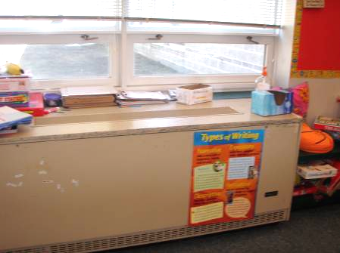

Typical Classroom Univent

Picture 2

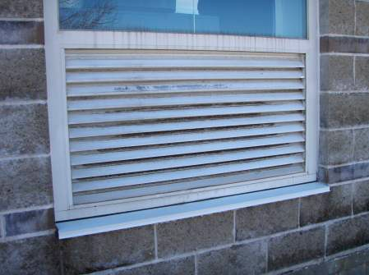

Typical Univent Fresh Air Intake

Picture 3

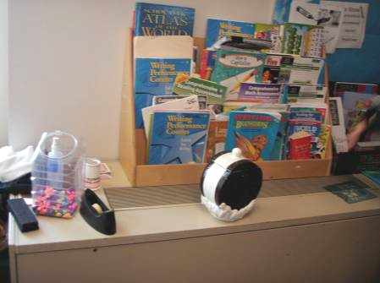

Univent with Obstructions

Picture 4

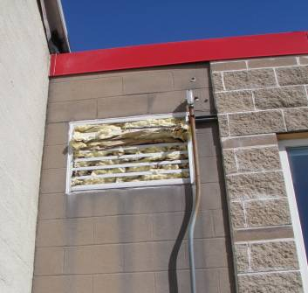

Outside Vent Blocked with Insulation

Picture 5

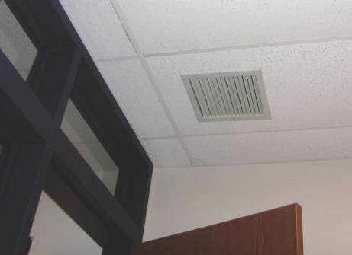

Exhaust Vent Close to Classroom Door (note door is also open)

Picture 6
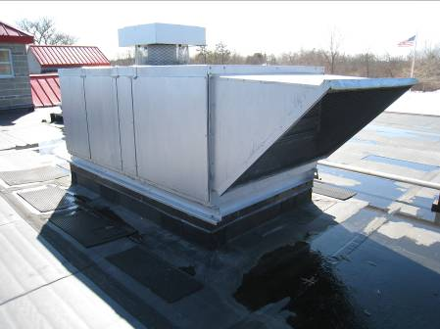

Rooftop Air Handling Unit (AHU)

Picture 7

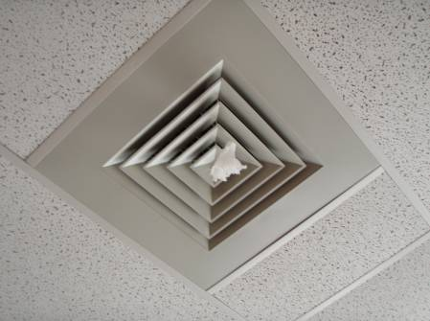

Example Supply Air Diffuser

Picture 8

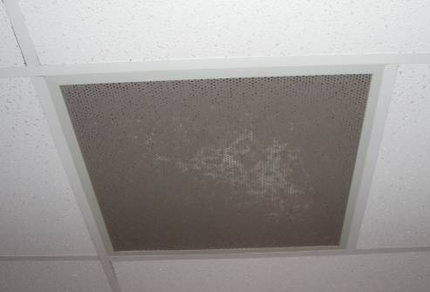

Ceiling-Mounted Return Vent, Note Presence of Occluding Dust

Picture 9

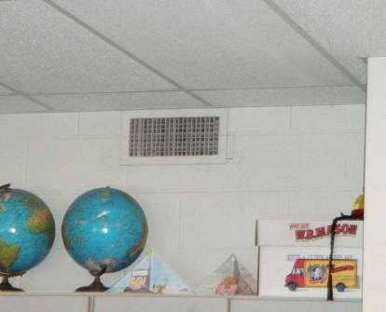

Wall-Mounted Return Vent

Picture 10

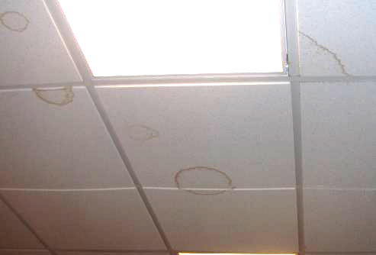

Water-Damaged Ceiling Tiles

Picture 11

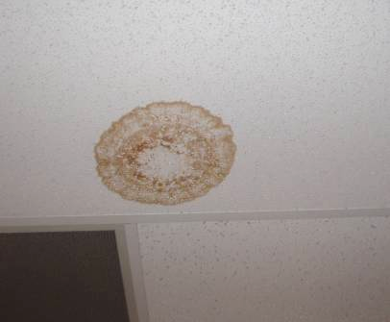

Water-Damaged Ceiling Tile
Picture 12

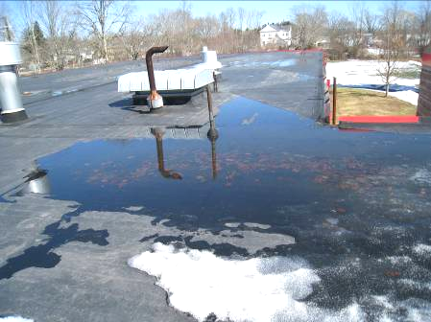

Pooled Water and Ice on the Roof

Picture 13

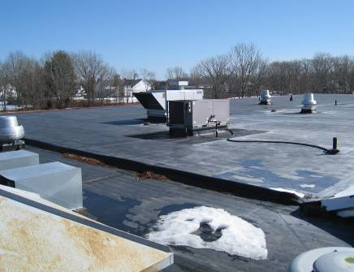

Joint in Roofs where Leaks are Believed to Occur

Picture 14

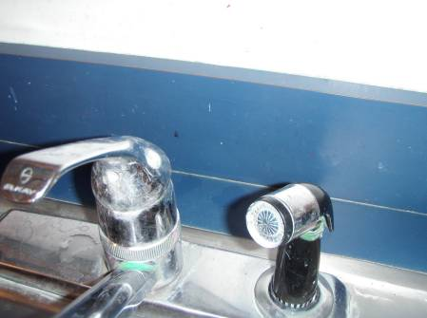

Example Backsplash/Countertop Seam

Picture 15

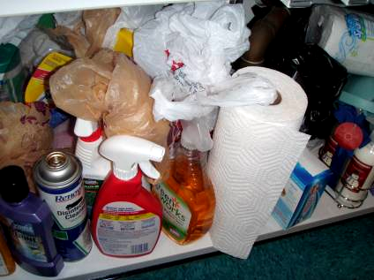

Storage of Materials, Including Porous (Paper Towels) and Cleaning Products under Classroom Sink

Picture 16

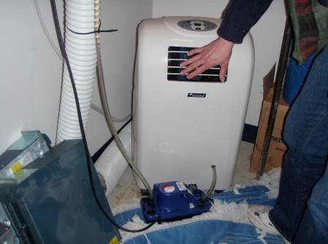

Portable Air Conditioner in Server Room

Picture 17

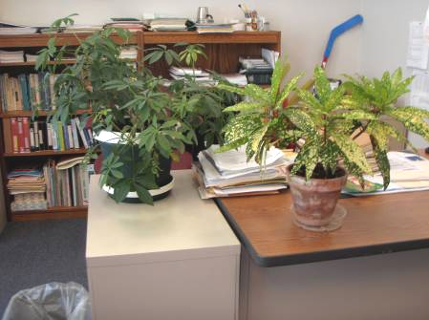

Example of Plants in Building

Picture 18

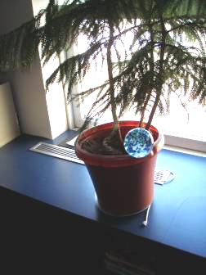

Plant Adjacent to Air Vent

Picture 19

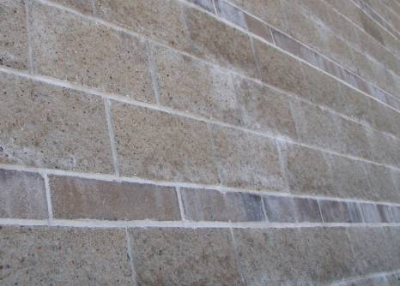

Masonry Wall Showing Efflorescence (white material)

Picture 20

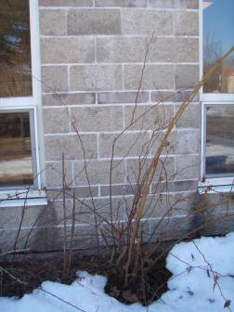

Plants Close to Building Foundation

Picture 21

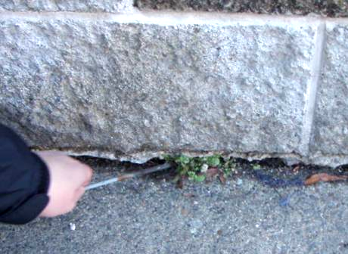

Deteriorating Masonry at Base of Exterior Wall

Picture 22

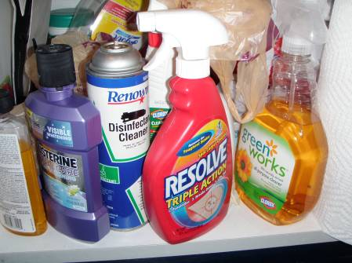

Example of Cleaning Products Found in Classroom

Picture 23

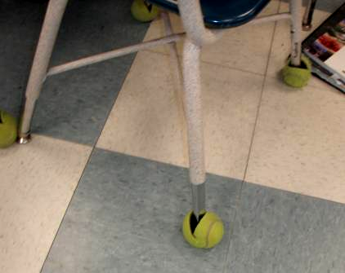

Tennis Balls Used as Chair Glides

Picture 24

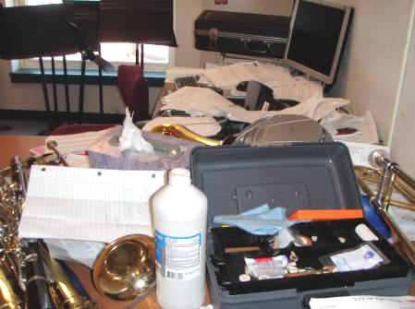

Items (Clutter) in the Band Room

Picture 25

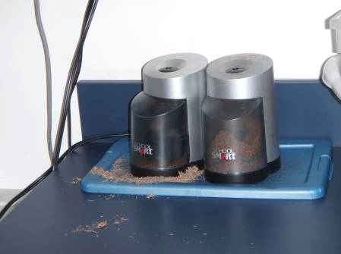

Pencil Shavings
Location | Carbon  Dioxide  (ppm) | Carbon Monoxide  (ppm) | Temp  (°F) | Relative  Humidity  (%) | PM2.5  (µg/m3) | Occupants  in Room | Windows  Openable | Ventilation |  | Remarks
 |  |  |  |  |  |  |  | Supply | Exhaust | Remarks
Background (parking area) | 401 | ND | 43 | 18 | 6 | NA |  |  |  | Sunny, breezy
Art room | 647 | ND | 71 | 20 | 6 | 0 | Y | Y | Y | Breach between sink countertop/ backsplash, dusty UV, WD-CT
Band room | 1140 | ND | 68 | 26 | 4 | 0 | Y | Y | Y | DEM, clutter
Cafeteria | 1239 | ND | 71 | 26 | 13 | ~100 | Y | Y | Y | DOs, Ceiling fans (operating), 3 WD-CTs, dusty exhaust vent
Computer room | 652 | ND | 70 | 17 | 3 | 1 | N | Y | Y  Dusty | AT, DEM, 23 computers, WD-CTs, loud air handling unit
Conference room | 795 | ND | 73 | 17 | 8 | 0 | N | Y | Y | DEM, DO
Custodial room |  | ND |  |  | 7 |  | N | N | N | Open pipes
Electrical/  maintenance room |  | ND | 70 | 20 | 6 |  |  |  |  | Dehumidifier
Girls’ bathroom |  |  |  |  |  |  | N | Y | Y | Passive door vent
Guidance office | 658 | ND | 73 | 15 | 7 | 0 | Y | Y | Y  VL | DO, AT, plants, WD-CTs
Gym/stage area | 970 | ND | 68 | 25 | 5 | 0 | N | Y | Y | Insulated unfinished ceiling
Library | 542 | ND | 69 | 20 | 3 | 2 | Y | Y | Y  dusty | CD, 13 WD-CTs, clutter
Main office | 972 | ND | 72 | 18 |  | 3 | Y | Y | Y | Air conditioner, carpeted
Music room (now a large classroom) | 1068 | ND | 72 | 18 | 7 | 3 | Y | Y | Y | Carpeted
Nurse’s office | 864 | ND | 73 | 18 | 11 | 0 | N | Y | Y  VL
Principal’s Office | 642 | ND | 74 | 16 | 8 | 0 | Y | Y | Y  VL | DO
Science room | 1442 | ND | 73 | 25 | 7 | 0 | Y | N | Y | WD-CT, breaches around pipes
Special education classroom | 678 | ND | 72 | 15 | 6 | 0 | Y | Y | Y  VL | WD-CT
Staff lunch lounge | 686 | ND | 73 | 17 | 7 | 4 | Y | Y | Y
Teachers’ copy room | 656 | ND | 72 | 18 | 8 | 2 | N | Y | N | PC, laminator, refrigerator, no exhaust vent
Room 1 | 1278 | ND | 74 | 23 | 11 | 26 | Y | Y | Y | Breach between sink countertop/ backsplash, DEM, PF, items in UV
Title 1 office | 808 | ND | 72 | 18 | 6 | 0 | N | Y | Y  VL | Carpeted
Room 2 | 980 | ND | 74 | 17 | 8 | 10 | Y | Y | Y | DEM, DO, low flow from univent
Room 3 | 971 | ND | 75 | 19 | 7 | 2 | Y | Y | Y | Breach between sink countertop/backsplash, DEM, CD, PF, DO, low flow from univent, strong solar gain
Room 4 | 710 | ND | 73 | 15 | 7 | 7 | Y | Y | Y | Fan in UV is loud, DEM, reported univent damage from freezing, items on UV
Room 5 | 690 | ND | 71 | 16 | 6 | 3 | Y | Y | Y | DO, DEM, CD, CPs
Room 6 | 763 | ND | 67 | 20 | 6 | 0 | Y | Y | Y | DEM, CPs, items hanging from CTs, breach between sink countertop/ backsplash, items on UV
Room 7 | 891 | ND | 71 | 22 | 5 | 6 | Y | Y | Y  VL | PC, items hanging from CT, breach between sink countertop/backsplash
Room 8 | 792 | ND | 71 | 21 | 4 | 0 | Y | Y | Y  VL | CPs, wipes
Room 9 | 849 | ND | 71 | 21 | 5 | 2 | N | Y | Y  VL | DEM, PF
Room 10 | 1200 | ND | 71 | 23 | 7 | 23 | Y | Y | Y  VL | TB, DEM, PF, CPs, plants, DO
Room 11 | 1251 | ND | 72 | 23 | 5 | 24 | Y | Y  Off | Y | TB, WD-CTs, DEM, plants and items on UV
Room 12 | 1445 | ND | 75 | 24 | 5 | 28 | Y | Y | Y | Plants, DEM, CP, PF
Room 13 | 1263 | ND | 73 | 21 | 6 | 24 | Y | Y |  | Items and plants on UV, PF, CPs, DEM
Room 14 | 1241 | ND | 72 | 22 | 7 | 25 | Y | Y | Y | Breach between sink countertop/ backsplash, CPs, DEM, plants, PF -dusty, items on UV
Room 15 | 1192 | ND | 73 | 22 | 6 | 24 | Y | Y | Y | CPs, PF, DEM, CD, plants, fresh air blocked
Room 16 | 780 | ND | 73 | 20 | 6 | 0 | Y | Y | Y | Plants, DEM, CP, PF, items

