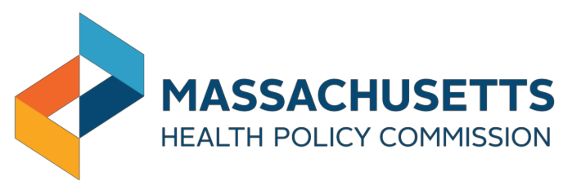

**Health Policy Commission**

**Investments in NAS**

## December 19, 2016

## Overview of HPC’s Mother and Infant-Focused NAS Interventions

**6 initiatives**

Funded by the HPC

# $3,000,000

HPC funding

## 59 Organizations

(e.g. hospitals, primary care practices, behavioral health providers) collaborating

# >450 infants with NAS

Collectively treated by HPC’s

proposed awardees in 2015

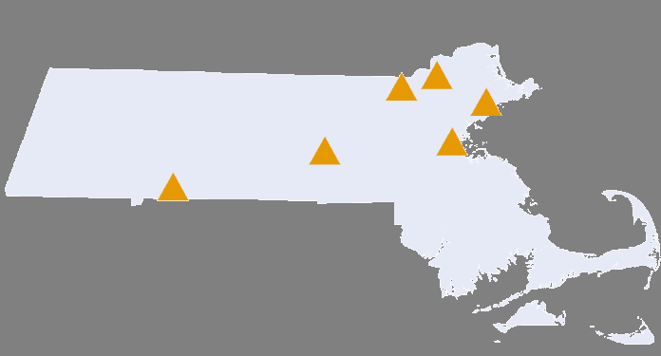

**Initiatives span the Commonwealth:** From the Springfield to Middlesex County

# >$5,000,000

combined investment with 30% of initiative costs being contributed by the applicants

During pregnancy (Pre-Natal) Care

Post delivery and

during in-patient care After hospital discharge

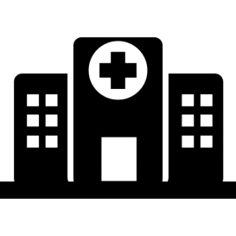

**HPC Pilot Program**

$1,000,000

**DPH “Moms Do Care”**

$3,000,000

**HPC Extension and Expansion of DPH Intervention**

$3,000,000

During pregnancy (Pre-Natal) Care

Post delivery and

during in-patient care After hospital discharge



#### HPC Pilot Program

**Funds**: $1,000,000

**DPH “Moms Do Care”** Program Funded through a federal grant

$3,000,000

**Proposed HPC Funding** through CHART Investment Program to expand on DPH work

$3,000,000

**Awardees**: Baystate, UMass Memorial, Boston Medical Center, Lawrence General

**Application**: competitive process

During pregnancy (Pre-Natal) Care

Post delivery and

during in-patient care After hospital discharge



**DPH “Moms Do Care”** Program

**HPC Pilot Program** Funded through FY16 State Budget

$500,000

**Proposed HPC Funding** through CHART Investment Program to expand on DPH work

$3,000,000

**Funds**: $3,000,000

**Source**: Federal SAMHSA Grant **Awardees**: Cape Cod and UMass Memorial Health Systems

During pregnancy (Pre-Natal) Care

Post delivery and

during in-patient care After hospital discharge



**Funds**: $3,000,000 **Awardees**: Beverly, Lowell General

**Application**: competitive process

**HPC Pilot Program** Funded through FY16 State Budget

$500,000

**DPH “Moms Do Care”** Program Funded through a federal grant

$3,000,000

#### HPC

**Expansion & Extension of DPH Intervention**

HPC is investing in both inpatient quality improvement initiatives to address treatment of infant with NAS, and outpatient efforts to increase adherence to pharmacologic treatment among pregnant and post-partum women with opioid use disorder (OUD). HPC’s 6 hospital grantees will begin work on the following aims in early 2017.

#### Inpatient activity:

* Facilitate “rooming-in” for eligible women

& infants

* Increase breastfeeding rates
* Facilitate early initiation of skin-to-skin contact after birth
* Provide bedside psychotherapy to women after birth
* Increase # of infants discharged to biological family
* Make EI referral prior to discharge
* Treat infants in need of pharmacologic intervention with methadone instead of morphine

#### Outpatient activity:

* Screen for OUD at first prenatal appointment
* Increase engagement in and adherence to pharmacologic treatment during pregnancy among women with OUD
* Provide same-day co-located BH and prenatal care
* Provide social supports to facilitate access to treatment (e.g., childcare, transportation)
* Improve post-discharge follow up with EI, pediatrics, and addiction treatment provider

2 HPC grantees are also implementing interventions that target pregnant and post-partum women with OUD to increase engagement in, and adherence to, pharmacologic treatment. This replicates a grant being operated by DPH. DPH’s *Moms Do Care* initiative is currently operating at UMass and Cape Cod Health Systems.

|  |  |  |  |  |  |
| --- | --- | --- | --- | --- | --- |
| **Grantee** | **Award** | **Total initiative**  **cost** | **Expanding DPH’s MDC**  **initiative** | **2015 NAS**  **volume** | **Primary aim** |
| **Baystate Medical Center** | $249,778 | $400,480 | No | 119 | Increase rate of rooming-in by 30% |
| **Boston Medical Center** | 248,976 | 349,879 | No | 110 | Decrease LOS by 40% |
| **UMass Memorial Medical Center** | 249,992 | 354,204 | No | 81 | Reduce LOS by 30% |
| **Lawrence**  **General Hospital** | 250,000 | 373,766 | No | 28 | Reduce TCOC by  10% |
| **Beverly Hospital** | 1,000,000 | 1,323,042 | Yes | 35 | Reduce LOS by 30% |
| **Lowell General Hospital** | 999,032 | 1,425,693 | Yes | 46 | Increase pharmacologic treatment of pregnant women with OUD by 20% |

See appendix for hospital specific detail 8



#### TECHNICAL ASSISTANCE (EXAMPLES)

* + Training providers and support staff on trauma informed care and stigmatizing

attitudes and speech

* + Training for PCPs, family practice, and OB/GYNs on buprenorphine prescribing to increase number of providers waivered to prescribe
  + Training OB/GYNs and affiliated support staff on best practices around treatment of pregnant women with OUD
  + Development of web-based toolkit for OB/GYNs addressing OUD
  + Training peer moms (e.g., ethics, compassion fatigue, privacy)
  + Parenting classes for women with OUD
  + Providing care management support for providers

#### EVALUATION (EXAMPLES)

**Individual level:**

* + Rates of illicit drug use
  + Rates of program retention
  + Changes in functional status level
  + Changes in housing stability
  + Rates of PTSD symptoms

#### System level:

* + Number of waivered providers
  + Rates of identifying and engaging pregnant women with OUD
  + Expressed stigmatizing beliefs and attitudes among providers
  + Level of behavioral health integration

#### TECHNICAL ASSISTANCE (EXAMPLES)

* + Training nurses on scoring severity of NAS symptoms
  + Training providers on emerging best practices in clinical protocols, including targeted training on hospital specific quality improvement initiative elements
  + Quality improvement implementation support (e.g., rapid cycle adjustments to account for successes and failures)
  + Data reporting support and feedback with hospital “scorecards”
  + Annual practice surveys
  + Dissemination of learnings from support provided to HPC funded hospitals to all birthing hospitals in the Commonwealth

#### EVALUATION (EXAMPLES)

* + Rates of breastfeeding (initiation and at time of discharge)
  + Rates of early skin to skin contact (between infant and birth mother)
  + Rates and type of pharmacologic intervention, and weaning time
  + Changes in LOS in various settings of care (NICU, special care nursery, total hospital stay)
  + Reliability of scoring of NAS symptoms
  + Known prenatal exposure to opioids (for treatment of OUD or otherwise)
  + Rates of referral to early intervention services prior to discharge



* + - Appendix



**Primary Aim**

|  |  |
| --- | --- |
| **Proposed Award** | **Total Initiative Cost** |
| $249,778 | $400,480 |

Increase rooming in-care among eligible maternal-infant dyads with NAS by 30%

**Target Population**

All infants scored for NAS

**Secondary Aims**

1. Increase adherence to MAT by pregnant

women with opioid abuse disorder by 30%

1. Increase breastfeeding and skin to skin care rates by 30% for opioid exposed infants.
2. Increase the number of infants being discharged home to biological families by 30% with continued breastfeeding after hospital discharge through 6 months post-partum along with monitoring long term neurocognitive outcomes.

**Innovative Model**

* Allocating and utilizing rooms on the postpartum floor to provide care to the mother-infant dyad during observation as well as treatment phases of NAS.
* Will dedicate 4 rooms on the postpartum floor for eligible parents to stay with their infant 24 hours per day x 7 days per week until discharge.
* A dedicated trained nurse will provide the medical care including monitoring of the Finnegan scores and administering medications as prescribed, and providing daily infant care in cooperation with the parents.
* Nurses caring for infants with NAS are certified in the Finnegan scoring system or FNAST (Finnegan Neonatal Abstinence Scoring Tool)
* Quarterly NAS and opiate treatment updates into regularly scheduled nursing “Brown Bag” conferences

**Operational Approach**

.

Increasing focus on non-pharmacologic care,

improving pharmacologic care, and initiating new hospital care models



12

|  |  |  |
| --- | --- | --- |
| **Proposed Award** |  | **Total Initiative Cost** |
| **$248,976** |  | **$349,879** |



**Primary Aim**

Decrease length of inpatient stay for infants with

NAS by 40%

**Target Population**



All infants scored for NAS and birth mothers

**Secondary Aims**

1. Reduce pharmacotherapy by 30%
2. Improve breastfeeding initiation rates by 15%
3. Improve maternal presence at the bedside by 20%
4. Institute bedside psychotherapy for mothers

**Operational Approach**

Increasing focus on non-pharmacologic care, improving pharmacologic care, and initiating new hospital care models

**Innovative Model**

* Increasing parental presence at bedside
* Implementing peer support to introduce the benefits of breastfeeding and rooming-in
* Optimizing NAS pharmacologic treatment with methadone as a first-line therapy instead of morphine
* Improved approaches to NAS symptom scoring
* Ensuring timely access to wrap-around outpatient services for woman and infant
* Implementation of prenatal care curriculum that includes brief individual obstetric evaluation, group discussion, education, peer support, and relapse prevention.

#### Proposed Award



**$249,992**

**Total Initiative Cost**

**$354,204**

**Primary Aim Operational Approach**

Reduce inpatient length of stay for infants with NAS by 30%



**Target Population**

All infants scored for NAS

**Secondary Aims**

Reduce readmission rates for NAS within 30 days of discharge by 25%.

* Multidisciplinary, coordinated approach that integrates prenatal and postnatal management.
* Organizational Commitment - The Divisions of OB/GYN and Neonatology at UMass have made NAS care a priority (involved in NeoQIC & DPH grant).
* The UMass Memorial NICU has developed a standing NAS QI committee to maintain and further improve outcomes for infants with NAS.



**Primary Aim Operational Approach**

|  |  |  |
| --- | --- | --- |
| **Proposed Award** |  | **Total Initiative Cost** |
| **$250,000** |  | **$373,766** |

Reduce the cost per NAS episode by 10%

**Secondary Aim**

* + Implement an evidence-based, integrated

treatment plan

* + Facilitate more rooming-in
  + Faster transfer out of special care nursery
  + Higher rates of breast feeding
* Reduce LOS for infants receiving

pharmacologic treatment by 20%

* Increase rate of infants that are primarily breastfed or breastfed to any extent to at least 50%
* Increase skin-to-skin contact

**Target Population**

All infants scored for NAS

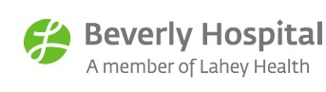

**Operational Approach**

|  |  |  |
| --- | --- | --- |
| **Proposed Award** |  | **Total Initiative Cost** |
| **$1,000,000** |  | **$1,323,042** |

* + DCF

**Partners**

* Screening and referral for substance abuse at the first obstetrical appointment
* Northeast Regional Office
* Northeast ARC EI
* Cape Ann EI
* North Shore YMCA
* Catholic Charities

**Primary Aim**

30% reduction in length of stay by 27

months for infants admitted with NAS

* Screening for substance use in pregnancy and comorbid

psychiatric conditions such as depression, anxiety, bipolar disorder, obsessive compulsive disorder, and abuse within one week of referral

* Women with OUD will be referred for maintenance dosing with buprenorphine or methadone
* Consolidated services will be provided in one location and one day weekly (counseling, trauma-based, prenatal care)
* NAS Infant follow-up clinic

**Target Population**

70 pregnant women with opioid use disorder and all infants scored for NAS



**Partners**

|  |  |  |
| --- | --- | --- |
| **Proposed Award** |  | **Total Initiative Cost** |
| **$999,032** |  | **$1,425,693** |

* WomanHealth (OB/GYN practice)
* Lowell Community Health Center
* OB/GYN Associates of Merrimack Valley
* Clean Slate (buprenorphine provider)
* Habit Opco (methadone provider)
* South Bay Lowell Mental Health Clinic (Behavioral Health services)
* South Bay Lowell Early Childhood Services (Early Intervention provider)
* Thom Anne Sullivan Center (Early

Intervention provider)

* MA WIC Nutrition Program

**Operational Approach**

* Identify pregnant women with opioid use disorder early in their pregnancies, guide them in accessing pharmacotherapy, and support families through pregnancy, delivery, and six months postpartum
* Participate in DPH’s “Moms Do Care” program, including technical assistance and evaluation

**Primary Aim**

**Target Population**



* 20% increase in MAT for pregnant women

with opioid use disorder. ▪ 50 pregnant women with opioid use disorder

and all infants scored for NAS

### For more information about the Health Policy Commission: Visit us: <http://www.mass.gov/hpc>

Follow us: @Mass_HPC

E-mail us: [HPC-Info@state.ma.us](mailto:HPC-Info@state.ma.us)