Home Page Overview

Quick Links
Quick Links provides one click access to commonly used functions including timesheet and paycheck
Announcements
The Announcements feed contains topical HR/CMS information, as well as system information.
Employee Expiring Memberships and Licenses
Displays employee licensure and membership expirations
My Delegation
Pending delegation requests assigned to the employee or assigned by the employee

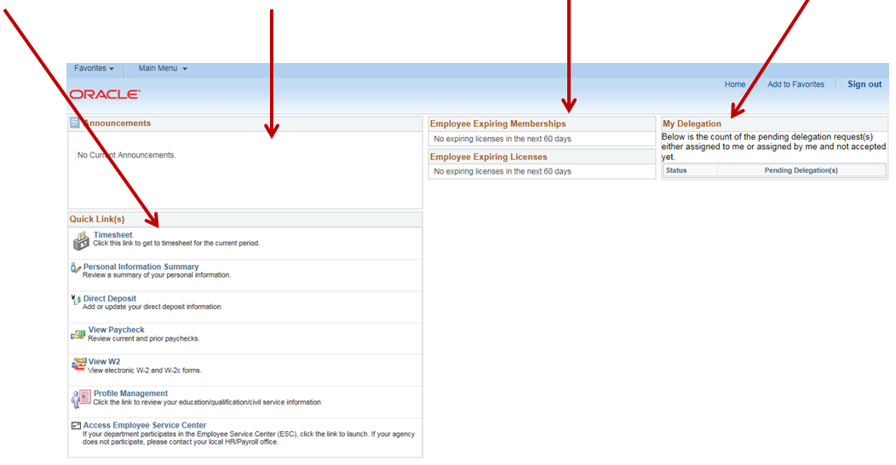

Punch Timesheet Overview
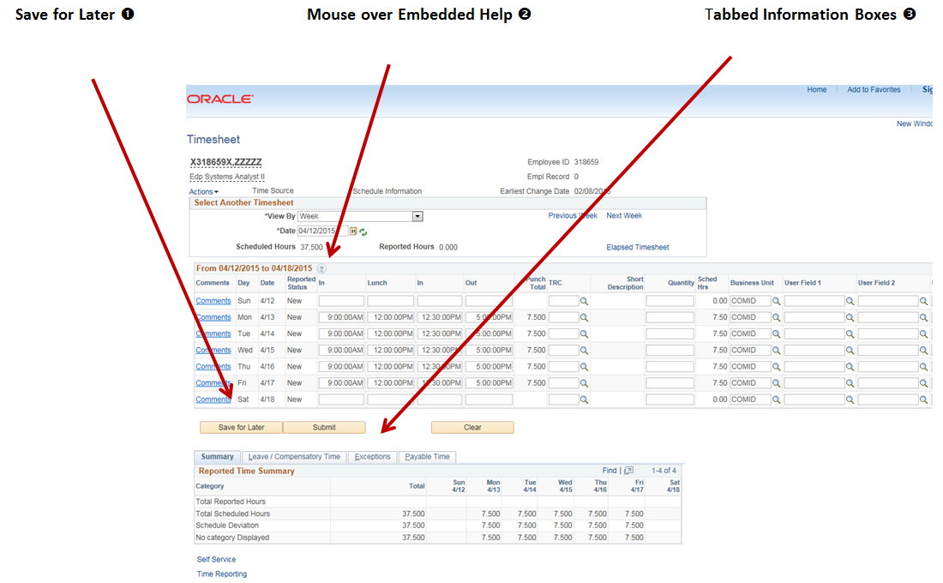

ElapsedTimesheet Overview
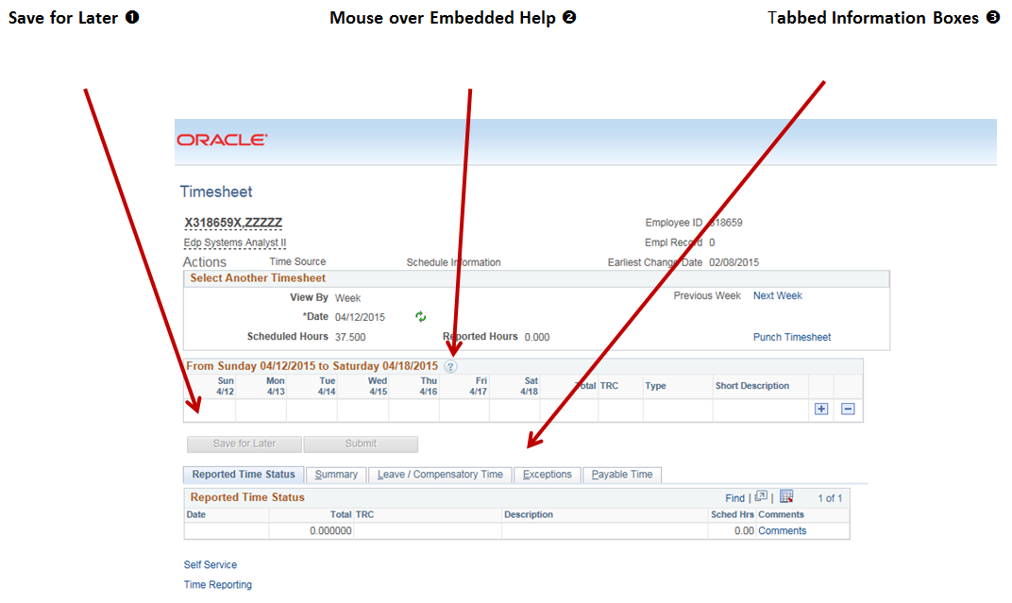

Save for Later ❶
The Save for Later button allows you to enter time without submitting it. Time can be entered daily and submitted once at the end of the week.
Enter your time and click Save for later. Return to your timesheet, complete your time entries and then click Submit for approval.
Mouse over Embedded Help ❷
The embedded help features are enabled on the Timesheet page. Click on the button with the question mark to display embedded help.
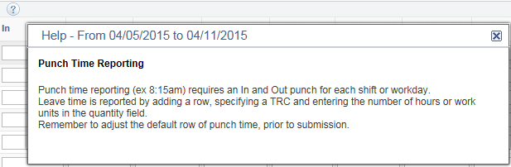
Tabbed Information Boxes ❸
Tabbed summaries at the bottom of the page keep the information you need at your fingertips. This results in less scrolling to find information; instead it fits all in one page and can be easily accessed in a singel click.
The Timesheet Tabs provide information on Reported Time Status, Summary, Leave/Compensatory Time, Exceptions and Payable Time.
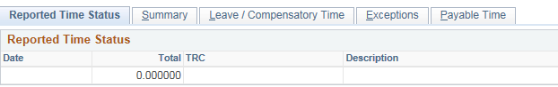

For More Information
For more information contact:
Employee Service Center (ESC): 617-979-8500
Non-ESC supported agencies, please contact your HR department.

