

HR/CMS v9.2 Navigation - Quick Reference for Employee

Home Page Overview
The HR/CMS home page provides quick access to frequently used employee functions and status information.
Feature | Description
Quick Links | Provides one-click access to commonly used functions, including timesheet and paycheck.
Announcements | Contains topical HR/CMS information, as well as system information.
Employee Expiring Memberships and Licenses | Displays employee licensure and membership expirations.
My Delegation | Displays pending delegation requests assigned to the employee or assigned by the employee.

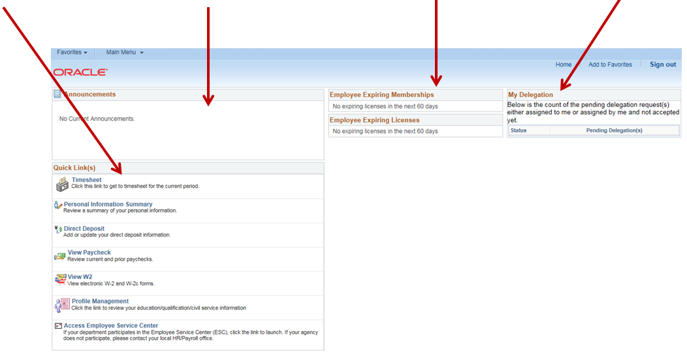
Figure 1. Home page overview with four highlighted areas.

Punch Timesheet Overview
The punch timesheet overview highlights three main features employees may use while entering time:
1. Save for Later: enter time without submitting it immediately.
2. Mouse over Embedded Help: open help by selecting the question mark icon.
3. Tabbed Information Boxes: use the tabs at the bottom of the page to review related timesheet information.
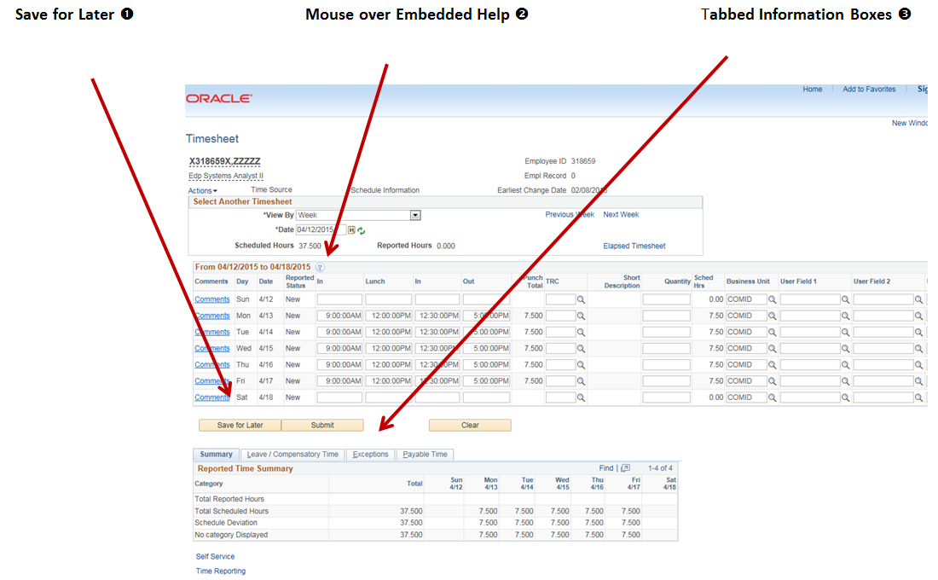
Figure 2. Punch timesheet overview with three callouts.

Elapsed Timesheet Overview
The elapsed timesheet overview shows the same three features in an elapsed-time layout: Save for Later, embedded help, and tabbed information boxes.
1. Save for Later appears below the time-entry grid.
2. The embedded help icon appears near the timesheet date and reported-hours information.
3. Tabbed Information Boxes appear below the time-entry grid for quick access to summaries and exceptions.
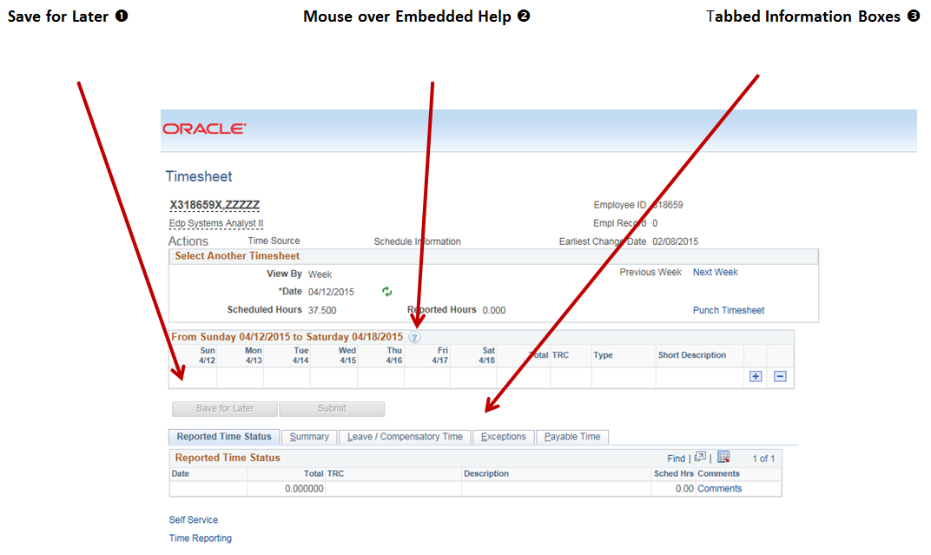
Figure 3. Elapsed timesheet overview with three callouts.

Timesheet Features

Save for Later
The Save for Later button allows you to enter time without submitting it. Time can be entered daily and submitted once at the end of the week.
Enter your time and select Save for Later. Return to your timesheet, complete your time entries, and then select Submit for approval.
Figure 4. Timesheet action buttons.

Mouse over Embedded Help
Embedded help features are enabled on the Timesheet page. Select the question mark icon to display embedded help.
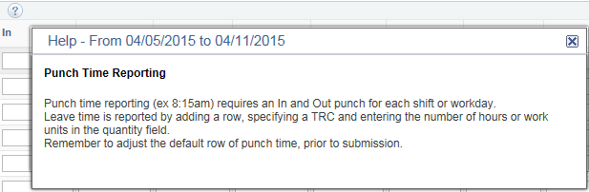
Figure 5. Embedded help example for punch time reporting.

Tabbed Information Boxes
Tabbed summaries at the bottom of the page keep the information you need at your fingertips. This results in less scrolling; instead, the information fits on one page and can be accessed in a single click.
The Timesheet tabs provide information on Reported Time Status, Summary, Leave/Compensatory Time, Exceptions, and Payable Time.
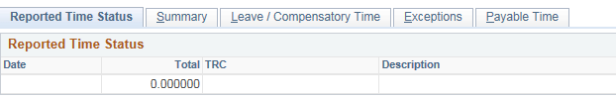
Figure 6. Timesheet tabbed information boxes.

For More Information
For more information, contact:
- Employee Service Center (ESC): 617-979-8500
- Non-ESC supported agencies: contact your HR department.

