Office of Grants and Research

FFY2026 Homeland Security Grant Program – State Share

Budget Instructions

Excel Budget Worksheet Quick Tips
- Read the Availability of Grant Funds (AGF)
- Navigate to “Budget Detail” tab. Read the instructions at top of this tab for guidance specific to completing that budget.
- The Excel budgets use macro functionality. Please follow the steps outlined in the “Opening Document” tab to make sure macros are enabled. If there are any issues with functionality, please contact the assigned program manager from the AGF immediately.
- Complete “Budget Detail” tab and verify subtotals carried over correctly on the “Budget Summary” and “Object Classes” tabs. Please fill out identifying fields at the bottom of the “Budget Summary” tab.
- The HSGP State Share allows for a maximum 5% allocation of total budget for Management and Administration (M&A).

How to Use Excel Budget
- Go to “Opening Document” tab for instructions on how to enable macros.
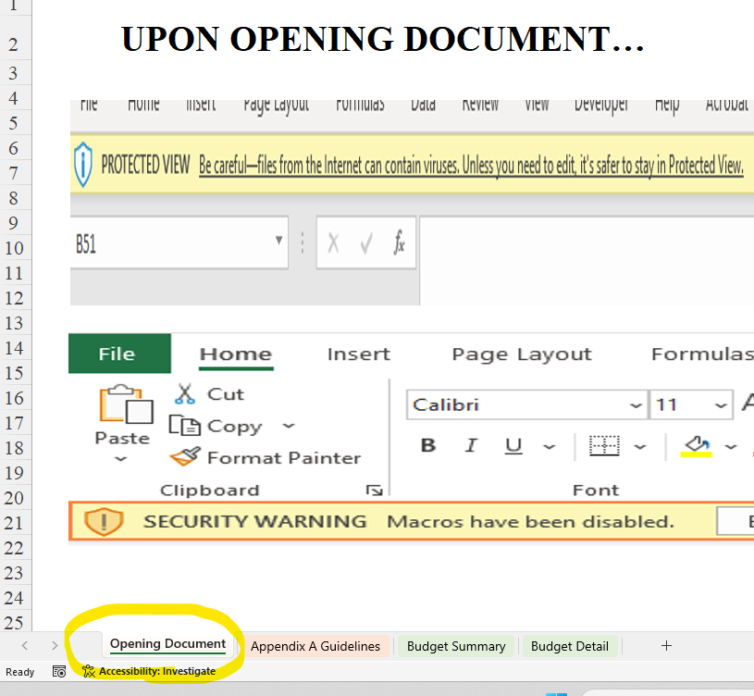
- Go to “Budget Detail” tab and read instructions at the top of page.
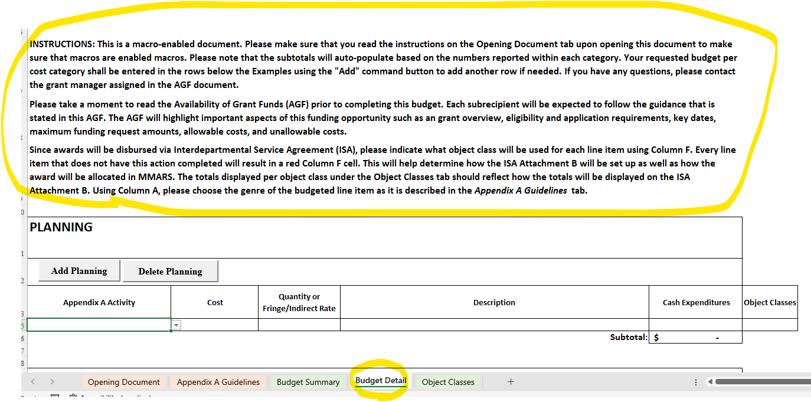
- Based on the applicant’s desired budget, please start entering the line-by-line budget using the “Budget Detail” tab. Every line item must have Column A (Appendix A Activity), Column B (Cost), Column C (Quantity or Fringe/Indirect Rate), Column D (Description), and Column F (Object Classes) completed.
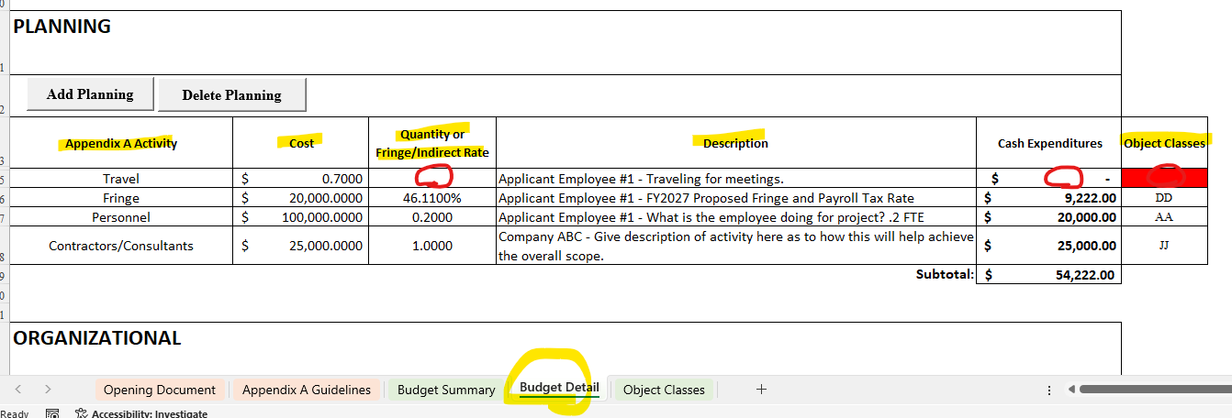
Each line item must have “Cash Expenditures” calculated in Column E. This is the product of Column B (Cost) and Column C (Quantity or Fringe/Indirect Rate). If a fringe rate or indirect rate is to be entered in Column C, make sure to indicate which type of rate it is using Column A (Appendix A Activity). Both input variables must be entered for “Cash Expenditures” to populate. If one of the input variables is missing, like in the example above, “Cash Expenditures” will not calculate.
Since awards will be disbursed via Interdepartmental Service Agreement (ISA), please indicate what object class will be used for each line item using Column F. Every line item that does not have this action complete will result in a red Column F cell. This will help determine how the ISA Attachment B will be set up. The totals displayed per object class under the Object Classes tab should reflect how the totals will be displayed on the ISA Attachment B.
- Click the command macro to enter new rows in a cost category.
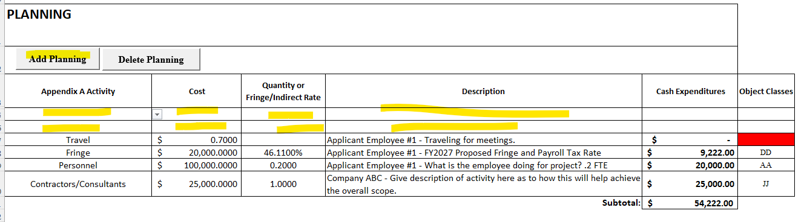
- Please repeat this process for all cost categories being budgeted.

- Every direct expense, not in cost category, Management and Administration (M&A), will determine the maximum amount of M&A that can be budgeted. There is a calculator next to the M&A cost category which will tell the applicant the amount of M&A that cannot be exceeded. In the example below, if line items totaling an amount greater than $2,853.80 are entered into the M&A cost category, the subtotal will turn red and will require the applicant to revise.
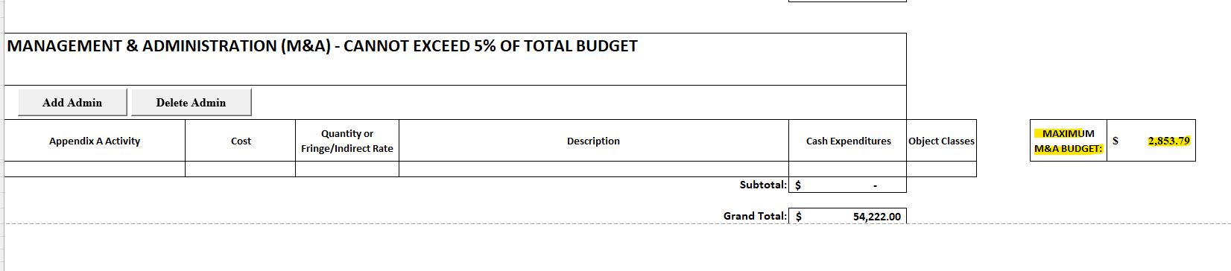

- After completing the line-by-line budget, go to the “Object Classes” tab and confirm that all amounts per object class are correct and what are expected to be reflected on the ISA Attachment B if awarded.
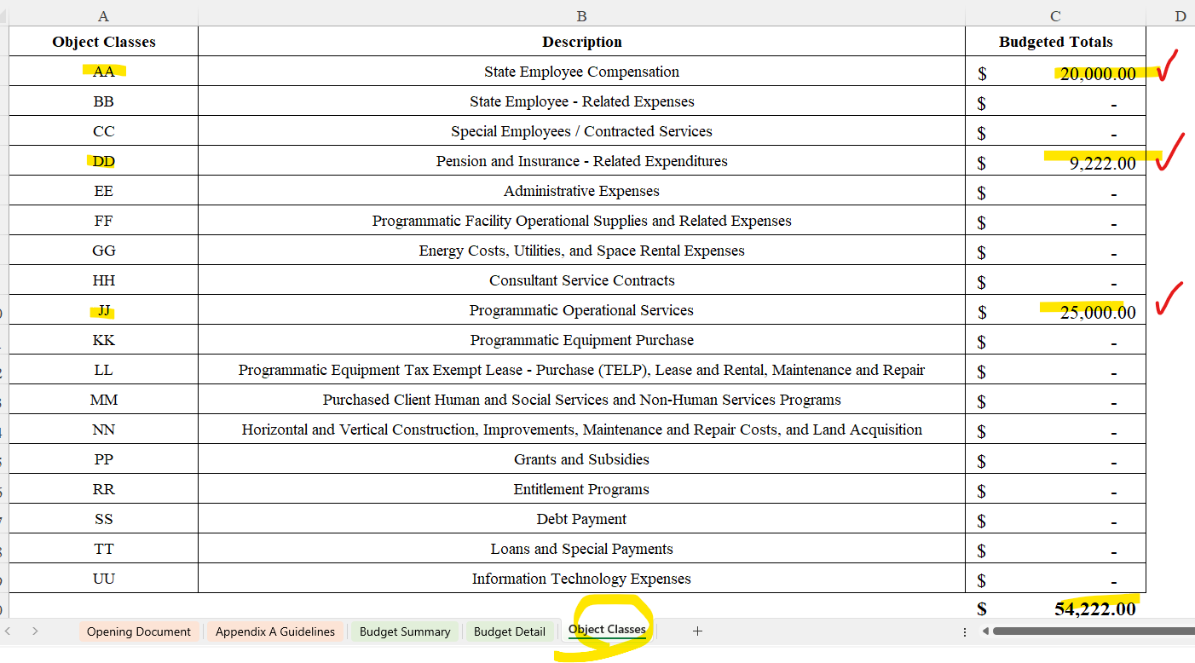
- Upon review of the “Object Classes” tab, go to “Budget Summary” tab and confirm that all subtotals/grand total are carried over properly from the “Budget Detail” tab and enter the Name of Applicant.
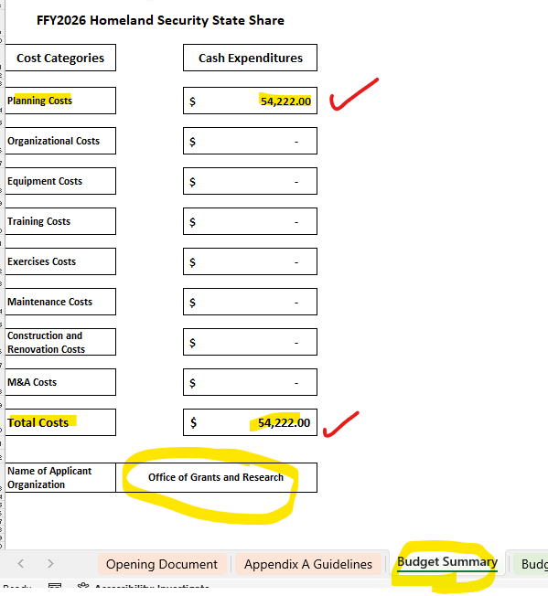
- Save the document.
- Go to “Budget Detail” tab. Click the “Print PDF” option at the top of the page. This will create a consolidated PDF of the “Budget Summary,” “Budget Detail,” and “Object Classes” tabs. A copy of the PDF will be saved to your Desktop.
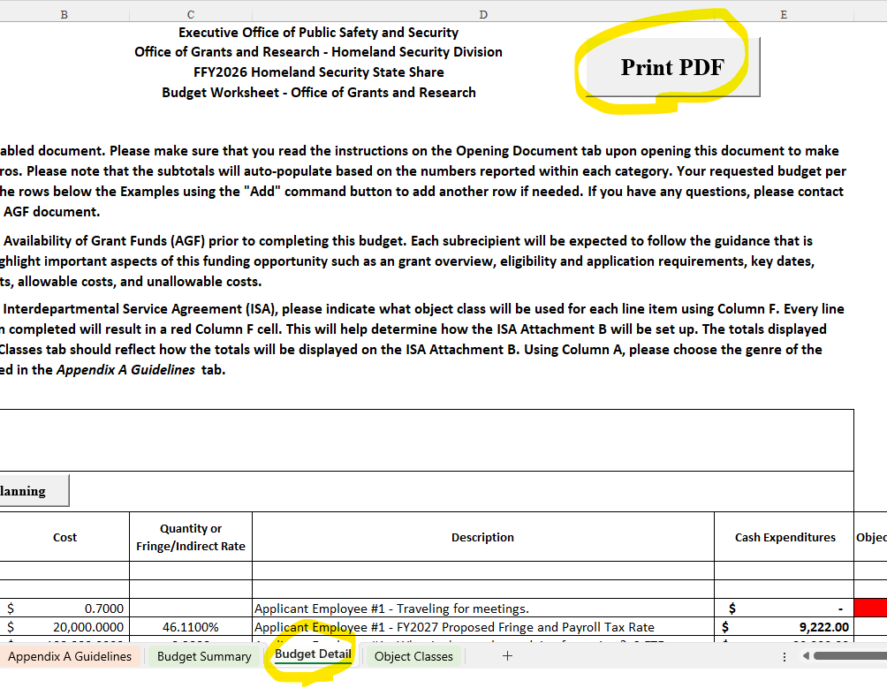
- Submit both the consolidated PDF and Excel Budget along with the application in Cognito.

