

Health Safety Net
2011 Annual Report

September 2012

Deval Patrick, Governor
Commonwealth of Massachusetts

Timothy P. Murray
Lieutenant Governor
JudyAnn Bigby, M.D., Secretary
Executive Office of Health and Human Services


Áron Boros, Commissioner
Division of Health Care Finance and Policy

Table of Contents

Introduction | 2
Payments and Volume | 4
Service Patterns | 12
User Demographics | 22
Financing | 26
Demonstration Projects | 33
Health Safety Net Eligibility Processes | 40

Massachusetts Division of Health Care Finance and Policy 1

About the Health Safety Net
Introduction

HSN Overview

• The Division of Health Care Finance and Policy (DHCFP) administers the Health Safety Net (HSN), created by Chapter 58 of the Acts of 2006. The HSN makes payments to hospitals and community health centers for health care services provided to low-income Massachusetts residents who are uninsured or underinsured.

• This report reflects HSN utilization and payments for twelve months (October 1, 2010 through September 30, 2011) of Health Safety Net fiscal year 2011 (HSN11). In HSN11, payments and volume were reported by the month in which the claim was paid by the HSN.

HSN Payments

• As mandated by Chapter 58, the HSN pays hospitals based on claims, which are adjudicated to verify that the patient is eligib le and the services are covered. HSN payment rates are based on Medicare payment principles. Inpatient medical services are paid using diagnosis-related group (DRG) specific rates, which incorporate adjustments for variations in patient acuity, teaching status, and percent of low-income patients. Inpatient psychiatric and rehabilitation cases are paid using per diem rates. Outpatient services are paid using a per-visit rate developed by estimating the amount Medicare would have paid for comparable services. Additional outpatient adjustments a re made for disproportionate share and community hospitals. HSN payments cannot exceed available funding for a given year. If a projected shortfall in payments is anticipated , hospital payments are subject to reduction using the greater proportional need method of shortfall distribution.

• Community health centers (CHCs) are paid by the HSN using the federally qualified health center (FQHC) medical visit rate. An cillary services provided by CHCs are paid at
MassHealth payment rates and include all applicable rate enhancements.

• Outpatient prescription drugs for eligible providers are priced using the pharmacy online payment system (POPS) employed by t he MassHealth program.

HSN Eligibility

• Massachusetts residents who are uninsured or underinsured and have income up to 200% of the Federal Poverty Level (FPL) are eligible for full HSN primary or HSN secondary coverage. If residents have income between 201% and 400% of the FPL, they are eligible for partial HSN or partial HSN seconda ry coverage, which includes a sliding scale deductible.

• Residents who are enrolled in private health insurance, MassHealth, or Commonwealth Care may be eligible for HSN secondary coverage for certain services not covered by their primary insurance. In order to support enrollment in Commonwealth Care, individuals are eligible for the HSN during the Commo nwealth Care enrollment process. Individuals who have been determined eligible for Commonwealth Care but do not complete the enrollment process lose their HSN eligibility.

• Chapter 65 of the Acts of 2009 eliminated Commonwealth Care eligibility for Aliens with Special Status (AWSS). AWSS are gener ally legal immigrants who have resided in the United States for fewer than five years. This change resulted in the transition of approximately 30,000 individuals from Commonwealt h Care to a new program called Commonwealth Care Bridge. During the transition process, these individuals were eligible for the HSN. Additionally, any new AWSS applying for b enefits were determined eligible only for the HSN or MassHealth Limited instead of Commonwealth Care or Commonwealth Care Bridge through March 2012.

• In July 2010, MassHealth and Commonwealth Care dental benefits were restructured. In certain instances, the HSN pays for cert ain dental services for individuals enrolled in
MassHealth and Commonwealth Care who are not otherwise eligible for HSN services.

• As of December 2010, MassHealth only pays for the first 20 days of an inpatient stay for adult members. The HSN pays for the portion of the stay exceeding 20 days for these individuals. These changes to MassHealth dental policy and inpatient payment policy and to have resulted in an overall increa se in the number of individuals eligible for HSN funded services.

HSN Funding

• HSN11 funding included the following sources: an assessment on acute hospitals’ private sector charges; a surcharge on paymen ts made to hospitals and ambulatory surgical centers by HMOs, insurers, third party administrators, and individuals; an annual appropriation from the Commonwealth’s General Fund; and offset funding for uncompensated care from the Medical Assistance Trust Fund.

Notes: Diagnosis-related groups (DRGs) are a classification system that groups patients according to diagnosis, type of treatment, age , and other relevant criteria. Providers are paid a set fee for treating patients in a single DRG category.
Source: Centers for Medicare and Medicaid Services Online Glossary Tool as of 8/30/11.

Massachusetts Division of Health Care Finance and Policy 2

Major Findings
Introduction

The major findings for Health Safety Net Fiscal Year 2011 (HSN11) include:

• Demand for Health Safety Net (HSN) payment exceeded the amount of HSN funding available in HSN11. Demand represents the amount that providers would have been paid in the absence of a funding shortfall. During HSN11, hospital providers experienced an $84 million shortfall. If hospital providers had been paid in full, hospital payments would have increased 4% when compared to the prior fiscal year.

• Total HSN volume in HSN11 increased by 8% compared to the prior fiscal year. Hospital volume in HSN11 increased by 3% compared to the prior fiscal year.

• Inpatient hospital volume for HSN11 increased by 6% compared to the prior fiscal year. Outpatient hospital volume in HSN11 increased by
3% compared to the prior fiscal year.

• HSN community health center (CHC) volume and payments both increased by 20% in HSN11 when compared to the prior fiscal year.

• Total unique HSN users increased by 3% in HSN11 compared to the prior fiscal year.

HSN11 Compared to HSN10

Hospital CHC Total

Oct 2010–Sep 2011 compared to Oct 2009–Sep 2010  4%  20%  5% Oct 2010–Sep 2011 compared to Oct 2009–Sep 2010 0%  20%  2% Oct 2010–Sep 2011 compared to Oct 2009–Sep 2010  3%  20%  8%
Oct 2010–Sep 2011 compared to Oct 2009–Sep 2010 N/A N/A  3%

Notes: The Health Safety Net fiscal year runs from October 1 through September 30 of the following year. HSN10 is Health Safety Net fiscal year 2010. HSN11 is Health Safety Net fiscal year 2011. HSN10 and HSN11 data reflect updated claims activity and may differ from previously published reports. Users who receive a service in more than one setting (hospital, community health ce nter or emergency room bad debt) are counted only once.

Massachusetts Division of Health Care Finance and Policy 3

HSN Total Demand and Payment Trends
Payments and Volume

+14%
(Demand)

-3%
(Payments)

$69M

+5%
(Demand)

+2%
(Payments)

$403M (Payments)

$412M (Payments)
Total Health Safety Net (HSN) payments increased by 2% in Health Safety Net fiscal year
2011 (HSN11) compared to the prior fiscal year, while demand increased by 5%.

Demand represents the amount that providers would have been paid in the absence of a funding shortfall. Because HSN11 demand exceeded HSN11 funding, hospital providers experienced a $84 million shortfall during HSN11.

Notes: The Health Safety Net fiscal year runs from October 1 through September 30 of the following year. Hospital and community heal th center payments are reported in the month in which payment was made. Shortfall amount is based on spending assumptions in place during HSN11 and may differ from year-end shortfall estimates reported elsewhere. Numbers are rounded to the nearest mi llion and may not sum due to rounding; percent changes are calculated prior to rounding.
Source: DHCFP Health Safety Net Data Warehouse as of 11/02/11.

Massachusetts Division of Health Care Finance and Policy 4

HSN Shortfall Overview
Payments and Volume

The Health Safety Net (HSN) has a limited amount of funding available to pay providers. When the anticipated payment for services provided is greater than the funding available, the amount of the difference is known as the shortfall. As required by M.G.L. Chapter 118G, Section 39(6)(b), the shortfall is distributed solely among hospital providers. The statute also requires that the shortfall be distributed “in a manner that reflects each hospital's proportional financial requirement for reimbursements from the fund.” The distribution methodology is further defined by regulation in 114.6 CMR 14.03(2)(b)(2) to be based on each hospital’s share of statewide patient care costs (PCC), including the cost of caring for Medicare and Medicaid patients. Thus, larger hospitals are responsible for a greater share of the shortfall than smaller facilities.

This method of allocating the shortfall is known as the “Greater Proportional Need” (GPN) method. It is intended to distribute the financial burden in a way that does not disadvantage those hospitals providing a larger amount of HSN services.* The effects of the GPN method are illustrated in the chart below, which shows hypothetical hospitals of equal overall size (measured in terms of a hospital’s PCC) that provide different levels of services to HSN patients and receive different levels of HSN payment. In this example, facilities A and B experience the same dollar amount of the shortfall. However, because hospital B provides more HSN services, its shortfall allocation is less as a proportion of its HSN payments than is hospital A’s shortfall allocation as a proportion of its HSN payments.

Additionally, disproportionate share hospitals (DSH) receive additional protection from the shortfall. DSH hospitals are always paid for at least 85% of their HSN demand in a shortfall situation. In this example, hospital C, a DSH hospital, experiences less of the shortfall than hospitals A or B, despite having the same patient care costs.

PCC

$300 K

$200 K HSN
Demand

(60%)

PCC

$300 K

$500 K HSN
Demand

(38%)

PCC
$150 K
$850 K HSN
Demand
(15%)

Shortfall Allocation

Hospital A (Non-DSH)

Hospital B (Non-DSH)

Hospital C (DSH)

*The GPN method avoids distributing the shortfall proportionally to a hospital's HSN demand, which would cause hospitals that provide more HSN services to experience more shortfall dollars. In this example, Hospital C would experience the most shortfall dollars
if the distribution were proportional to a provider’s HSN demand, because Hospital C has the most HSN demand. The GPN method allocates the shortfall based primarily on the hospital’s size, which is more indicative of the provider’s ability to experience a shortfall in funding.

Massachusetts Division of Health Care Finance and Policy 5

HSN Total Service Volume Trends
Payments and Volume

+11%

+8%
Health Safety Net (HSN) total volume for hospitals and community health centers increased 8% in Health Safety Net fiscal year 2011 (HSN11) compared to the prior fiscal year.

Hospital volume is the sum of inpatient discharges and outpatient visits for which payments were made to hospital providers in the years shown. Community health center volume is the sum of visits for which payments were made to community health center providers in the years shown.

Notes: The Health Safety Net fiscal year runs from October 1 through September 30 of the following year. Hospital and community heal th center volume exclude pharmacy claims. HSN09 and HSN10 hospital and CHC volume reflects updated hospital and CHC
claims activity and may differ from data previously published. Numbers are rounded to the nearest thousand and may not sum due to rounding; percent changes are calculated prior to rounding .
Source: DHCFP Health Safety Net Data Warehouse as of 10/04/11.

Massachusetts Division of Health Care Finance and Policy 6

HSN Hospital Demand and Payment Trends
Payments and Volume

+14%
(Demand)

-4%
(Payments)

+4%
(Demand)

0%
(Payments)

$356 M (Payments)

$356 M
(Payments)
Hospital payments remained stable between Health Safety Net fiscal year 2010 (HSN10) and between Health Safety Net fiscal year 2011 (HSN11), while hospital demand increased by 4%.

Demand represents the amount that providers would have been paid in the absence of a funding shortfall.

Notes: The Health Safety Net fiscal year runs from October 1 through September 30 of the following year. Other HSN Payments include payment adjustments that are not attributable to a service category. Hospital payments are reported in the month in which payment was made. The HSN10 and HSN11 shortfall allocations are distributed proportionally by service type. Shortfall amount is based on spending assumptions in place during HSN11 and may differ from year-end shortfall estimates reported elsewhere. Numbers are rounded to the nearest million and may not sum due to rounding; percent changes are calculated prior to rounding.
Source: DHCFP Health Safety Net Data Warehouse as of 11/02/11.

Massachusetts Division of Health Care Finance and Policy 7

HSN Hospital Service Volume Trends
Payments and Volume

12%

+3%
Hospital volume increased by
3% in Health Safety Net fiscal year 2011 (HSN11) compared to the prior fiscal year.

During HSN11, total inpatient volume increased 6% and total outpatient volume increased
3% compared to the prior fiscal year.

Notes: The Health Safety Net fiscal year runs from October 1 through September 30 of the following year. Hospital volume is the sum of inpatient discharges and outpatient visits for which payments were made to hospital providers in the months shown. HSN09 and HSN10 volume reflects updated hospital claims activity and may differ from data previously published. Numbers are rounded to the nearest thousand and may not sum due to rounding; percent changes are calculated prior to rounding.
Source: DHCFP Health Safety Net Data Warehouse as of 10/04/11.

Massachusetts Division of Health Care Finance and Policy 8

HSN Community Health Center Payment
Trends
Payments and Volume

Community health center
(CHC) payments increased by
20% in Health Safety Net fiscal year 2011 (HSN11) compared to the prior fiscal year.

+12%

Notes: The Health Safety Net fiscal year runs from October 1 through September 30 of the following year. Community health center pay ments are reported in the month in which payment was made. Numbers are rounded to the nearest million and may not sum due to rounding; percent changes are calculated prior to rounding.
Source: DHCFP Health Safety Net Data Warehouse as of 10/25/11.

Massachusetts Division of Health Care Finance and Policy 9

HSN Community Health Center Volume
Trends
Payments and Volume

Community health center (CHC) volume increased 20% in Health Safety Net fiscal year
2011 (HSN11) compared to the prior fiscal year.

+20%

+7%

Notes: The Health Safety Net fiscal year runs from October 1 through September 30 of the following year. Community health center vol ume is the sum of visits for which payments were made to community health center providers in the months shown. Community health center volume excludes pharmacy claims. CHCs have been moving from a voucher-based to a claims-based adjudication and payment system since April 2009; this transition may result in shifts in volume that is expected to stabilize once all CHCs have transitioned to the new system. HSN09 and HSN10 volume reflect updated CHC claims activity and may differ from data previousl y published. Numbers are rounded to the nearest thousand and may not sum due to rounding; percent changes are calculated prior to rounding.
Source: DHCFP Health Safety Net Data Warehouse as of 10/04/11.

Massachusetts Division of Health Care Finance and Policy 10

HSN Total User Trends
Payments and Volume

+15%

+3%
Medical expenses for an estimated 325,848 individuals were billed to the Health Safety Net (HSN) in Health Safety Net fiscal year 2011 (HSN11).

The number of users increased by 3% in HSN11 compared to the prior fiscal year.

Notes: The Health Safety Net fiscal year runs from October 1 through September 30 of the following year. Users who receive a service in more than one setting (hospital, community health center or emergency room bad debt) are counted only once. Users are reported on claims for which payments were made to hospital and community health center providers in the months shown. Total users in HSN09 and HSN10 reflect updated claims activity and may differ from data previously reported..
Numbers are rounded to the nearest thousand; percent changes are calculated prior to rounding.
Source: DHCFP Health Safety Net Data Warehouse as of 10/04/11

Massachusetts Division of Health Care Finance and Policy 11

Hospital Utilization and Payments by Service Type and Age

Inpatient Outpatient
Service Patterns

Seventy-seven percent of inpatient payments in Health Safety Net fiscal year 2011

Age Groups for
HSN11

Inpatient
Discharges

Inpatient
Payments

Outpatient
Visits

Outpatient
Payments
(HSN11) were for services provided to adults ages 27 to
64.

Ages 0 to 18 1% 2% 3% 3% Ages 19 to 26 11% 14% 16% 18% Ages 27 to 44 25% 33% 35% 39% Ages 45 to 64 35% 44% 32% 32% Ages 65 and Older 27% 7% 14% 8% All Ages 100% 100% 100% 100%

Inpatient volume for this same population accounted for 60% of discharges in HSN11.

Because the Health Safety Net
(HSN) is a secondary payer for low-income Medicare patients, adults ages 65 and older accounted for 27% of inpatient discharges but only
7% of inpatient payments during HSN11.

Notes: The Health Safety Net fiscal year runs from October 1 through September 30 of the following year. Hospital volume is the sum of inpatient discharges and outpatient visits for which payments were made to hospital providers in the months shown. Hospital volume excludes pharmacy claims. Hospital payments are reported in the month in which payment was made. Hospital payments exclude pharmacy payments. Numbers are rounded to the nearest percent and may not sum to 100% due to rounding.
Source: DHCFP Health Safety Net Data Warehouse as of 10/11/11.

Massachusetts Division of Health Care Finance and Policy 12

Hospital Utilization and Payments by Eligibility Group

100% 100%
Service Patterns

During Health Safety Net fiscal year 2011 (HSN11), approximately half of both hospital volume and payments

2%
9%

10%
2%

20%

4%

53%
Eligibility Not Reported

Emergency Room Bad Debt

Temporary Coverage

HSN Secondary: Other

HSN Secondary: MassHealth

HSN Partial (200.1% to 400% FPL)

HSN Primary (0% to 200% FPL)
2%

10%

22%

1%

14%

4%

47%
were for individuals who were eligible only for the Health Safety Net (HSN) and had no other coverage.

HSN temporary users were
the most costly, accounting for only 10% of volume, but 22% of payments.

HSN temporary coverage includes patients awaiting enrollment in Commonwealth Care, MassHealth Basic, and MassHealth Essential.

Temporary users were the most costly due to higher use of inpatient services, which are more costly than outpatient services.

Hospital Volume
HSN11
Hospital Payments
HSN11

Notes: The Health Safety Net fiscal year runs from October 1 through September 30 of the following year. Hospital volume is the sum of inpatient discharges and outpatient visits for which payments were made to hospital providers in the months shown. Hospital volume excludes pharmacy claims. Hospital payments are reported in the month in which payment was made. Hospital payments exclude pharmacy payments. HSN Secondary: Other includes coverage for both Medicare and private insurance patients. Numbers are rounded to the nearest percent and may not sum to 100% due to rounding. Numbers less than 1% are not displayed.
Source: DHCFP Health Safety Net Data Warehouse as of 11/04/11.

Massachusetts Division of Health Care Finance and Policy 13

Hospital Inpatient Utilization and Payments by Admission Type

Scheduled

Urgent

Emergency
Service Patterns

Ninety-one percent of inpatient discharges and 89% of inpatient payments were for emergency and urgent care during Health Safety Net fiscal year 2011 (HSN11).

Nine percent of inpatient discharges and 12% of inpatient payments in HSN11 were for scheduled or elective procedures.

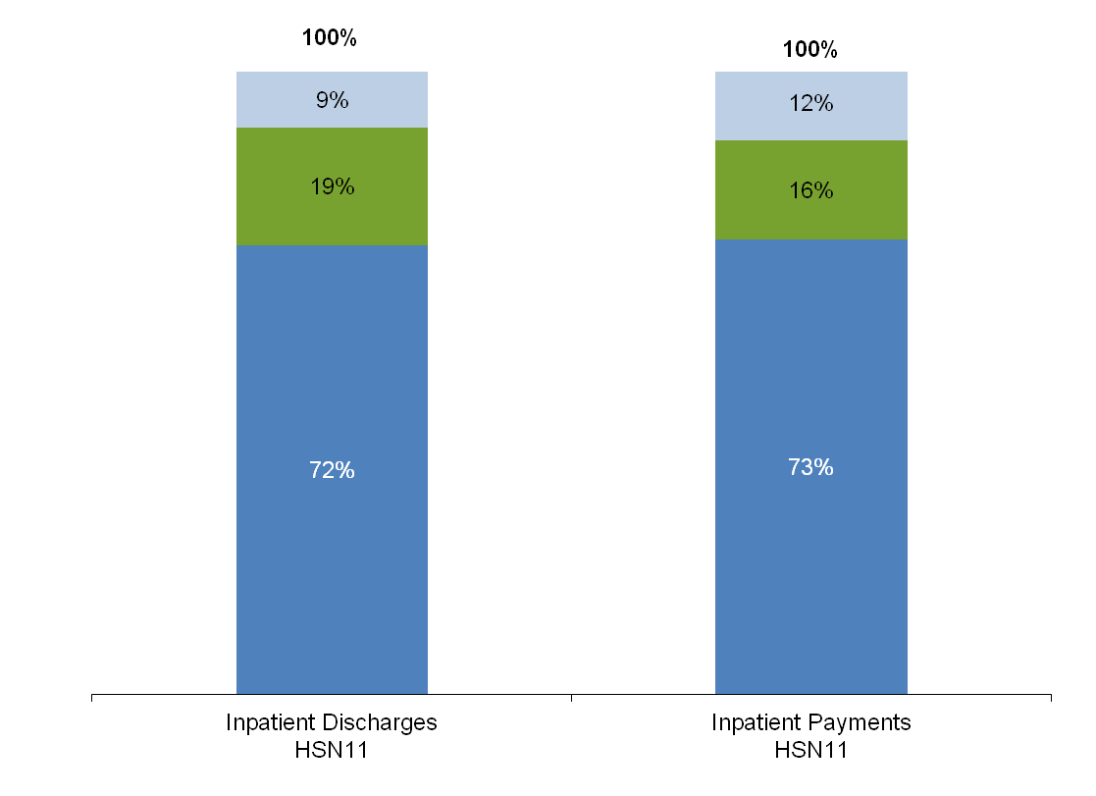

Notes: The Health Safety Net fiscal year runs from October 1 through September 30 of the following year. Hospital inpatient volume i s inpatient discharges for which payments were made to hospital providers in the months shown. Hospital inpatient volume excludes pharmacy claims. Hospital inpatient payments are reported in the month in which payment was made. Hospital inpatient payments exclude pharmacy payments. Numbers are rounded to the nearest percent and may not sum to 100% due to rounding. Numbers less than 1% are not displayed.
Source: DHCFP Health Safety Net Data Warehouse as of 10/0711.

Massachusetts Division of Health Care Finance and Policy 14

HSN Hospital and Community Health
Center Locations

Geographic Distribution

Low-income individuals who are eligible for Health Safety Net (HSN) services can seek care at any of the 65 acute hospitals and 36 community health centers (CHCs) located throughout Massachusetts.

This map shows only the main locations for each hospital and CHC provider. Some HSN providers also offer services at health centers separate from their main location.

Source: DHCFP Health Safety Net Data Warehouse as of 12/20/10.

Massachusetts Division of Health Care Finance and Policy 15

HSN Hospital Payment Level by Provider
Geographic Distribution

Seventeen Health Safety Net (HSN) hospital providers received less than $1 million in HSN payments in Health Safety Net fiscal year 2011 (HSN11).

Thirty-five HSN hospital providers received between $1 million and
$5 million in HSN payments in
HSN11.

Five HSN hospital providers received between $5 million and
$10 million in HSN payments in
HSN11.

Six HSN hospital providers received between $10 million and
$30 million in HSN payments in
HSN11.

Boston Medical Center and Cambridge Health Alliance received over $30 million in HSN payments in HSN11.

Notes: The Health Safety Net fiscal year runs from October 1 through September 30 of the following year. Hospital payments are repor ted in the month in which payment was made.
Source: DHCFP Health Safety Net Data Warehouse as of 7/7/11.

Massachusetts Division of Health Care Finance and Policy 16

HSN Hospital Service Volume by Provider
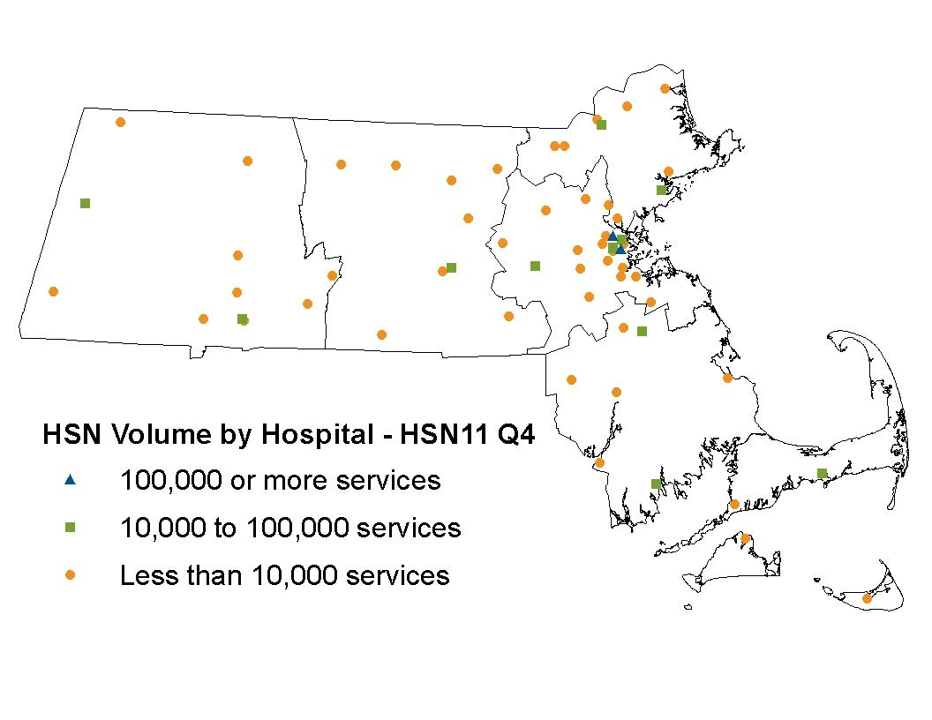

Geographic Distribution

Five Health Safety Net (HSN) hospital providers experienced less than 1,000 discharges and visits in Health Safety Net fiscal year 2011 (HSN11).

Forty-six HSN hospital providers experienced between 1,000 and
10,000 discharges and visits in
HSN11.

Eleven HSN hospital providers experienced between 10,000 and
50,000 discharges and visits in
HSN11.

One HSN hospital provider experienced between 50,000 and
100,000 discharges and visits in
HSN11.

Boston Medical Center and Cambridge Health Alliance experienced over 100,000 discharges and visits in HSN11.

Notes: The Health Safety Net fiscal year runs from October 1 through September 30 of the following year. Hospital volume is the sum of inpatient discharges and outpatient visits for which payments were made to hospital providers in the months shown.
Source: DHCFP Health Safety Net Data Warehouse as of 7/22/11.

Massachusetts Division of Health Care Finance and Policy 17

HSN Users by Hospital
Geographic Distribution

Eleven Health Safety Net (HSN) hospital providers saw less than 1,000 HSN users in Health Safety Net fiscal year
2011 (HSN11).

Thirty-nine HSN hospital providers saw between 1,000 and 5,000 HSN users in HSN11.

Nine HSN hospital providers saw between 5,000 and
10,000 HSN users in HSN11.

Four HSN hospital providers
saw between 10,000 and
20,000 HSN users in HSN11.

Boston Medical Center and Cambridge Health Alliance saw over 20,000 users in HSN11.

Notes: The Health Safety Net fiscal year runs from October 1 through September 30 of the following year. Users who receive a service in more than one setting (hospital, community health center, or emergency room bad debt) are counted only once. Hospital providers for each user is based on data from their most recent claim. Users are reported on claims for which payments were made to hospital and community health center providers in the months shown.
Source: DHCFP Health Safety Net Data Warehouse as of 7/7/11.

Massachusetts Division of Health Care Finance and Policy 18

Top Ten Inpatient Major Diagnostic Categories
Service Patterns

Inpatient Major Diagnostic Categories (MDC)
for HSN11

Percent Inpatient Discharges

Percent Inpatient Payments
In Health Safety Net fiscal year 2011 (HSN11), the top ten diagnostic categories
accounted for 75% of inpatient discharges and 72% of
inpatient payments.

Circulatory Diseases and Disorders 14% 14%

Digestive Diseases and Disorders 11% 11% Respiratory System Diseases and Disorders 10% 8% Mental Diseases and Disorders 10% 8% Musculoskeletal Diseases and Disorders 7% 8% Nervous System Diseases and Disorders 6% 8% Hepatobiliary and Pancreatic Diseases and Disorders 5% 6%

Kidney and Urinary Tract Diseases and Disorders 4% 3%

Alcohol/Drug Use and Induced Organic Mental
Disorders 4% 3%

Skin, Subcutaneous Tissue, and Breast Diseases and
Disorders 4% 3%

Total for Top Ten 75% 72%

Circulatory, digestive, and respiratory system diseases and disorders were the top three diagnostic categories among inpatient claims.

These three diagnostic categories comprised 35% of inpatient discharges and 33% of inpatient payments.

Notes: The Health Safety Net fiscal year runs from October 1 through September 30 of the following year. Inpatient claims are groupe d into major diagnostic categories (MDC) using versions 24, 25, 26, 27, or 28 of the MS-DRG grouper, depending on the date of service on the claim. Hospital inpatient volume is inpatient discharges for which payments were made to hospital providers in the months shown. Hospital inpatient volume excludes pharmacy claims. Hospital inpatient payments are reported in the month in which payment was made. Hospital inpatient payments exclude pharmacy payments. Numbers are rounded to the nearest percent.
Source: DHCFP Health Safety Net Data Warehouse as of 10/21/11.

Massachusetts Division of Health Care Finance and Policy 19

Top Ten Outpatient Clinical Classification
Diagnosis Categories
Service Patterns

In Health Safety Net fiscal year 2011 (HSN11), the top

Outpatient CCS Diagnosis Categories for HSN11

Symptoms, signs, and ill-defined conditions and factors
Percent Outpatient Claims
Percent Outpatient Payments
ten clinical classification (CCS)
diagnosis categories accounted for 83% of outpatient claims and 83% of
outpatient payments.

influencing health status 15% 15%

Diseases of the musculoskeletal system and connective
tissue 10% 10%

Injury and poisoning 8% 9%
Diseases of the circulatory system | 8% | 8%
Diseases of the genitourinary system | 8% | 8%
Diseases of the nervous system and sense organs 8% 8% Endocrine, nutritional, and metabolic diseases and immunity
disorders 7% |  | 6%
Diseases of the digestive system 7% |  | 6%
Mental Illness 7% |  | 6%
Diseases of the respiratory system 6% |  | 6%
Total for Top Ten 83% |  | 83%

Symptoms, signs, and ill- defined conditions and factors influencing health status; musculoskeletal system and connective tissue diseases; and injuries and poisonings were the top three CCS diagnosis categories among outpatient claims.

These three CCS diagnosis categories comprised 33% of outpatient claims and 34% of outpatient payments.

Notes: The Health Safety Net fiscal year runs from October 1 through September 30 of the following year. Outpatient 837I claims are grouped using the Clinical Classification Software (CCS) from the Agency for Healthcare Research and Quality (AHRQ). Hospital outpatient claims are claims for which payments were made to hospital providers in the months shown. Hospital outpatient clai ms excludes UB92 and pharmacy claims. Hospital outpatient payments are reported in the month in which payment was made. Hospital outpatient payments exclude pharmacy payments. Numbers are rounded to the nearest percent .
Source: DHCFP Health Safety Net Data Warehouse as of 10/21/11.

Massachusetts Division of Health Care Finance and Policy 20

Case Mix of the
Inpatient HSN Population

HSN10 HSN11

Case Mix Index 1.191 1.241

Average Length of Stay (days) 4.151 3.995

The case mix index represents the relative complexity, severity of illness, and amount of resources required to treat a given patient population.
The case mix index increased from Health Safety Net fiscal year 2010 (HSN10) to Health Safety Net fiscal year 2011 (HSN11).
The average length of stay for
HSN users has decreased
0.156 days compared to the prior fiscal year.

Notes: The Health Safety Net fiscal year (HSN) runs from October 1 through September 30 of the following year. Case mix data based on Medicare severity diagnostic related groups (MS-DRGs), version 27 for HSN10 and version 28 for HSN11. The analysis includes all primary inpatient claims paid during HSN09 and HSN10.
Source: DHCFP Health Safety Net Data Warehouse as of 10/04/2011.

Massachusetts Division of Health Care Finance and Policy 21

Hospital Utilization and Payments by Gender
User Demographics

In Health Safety Net fiscal
year 2011 (HSN11), men used fewer services than women, but had higher payments for their care.

During this period, men accounted for 43% of volume and 53% of payments.

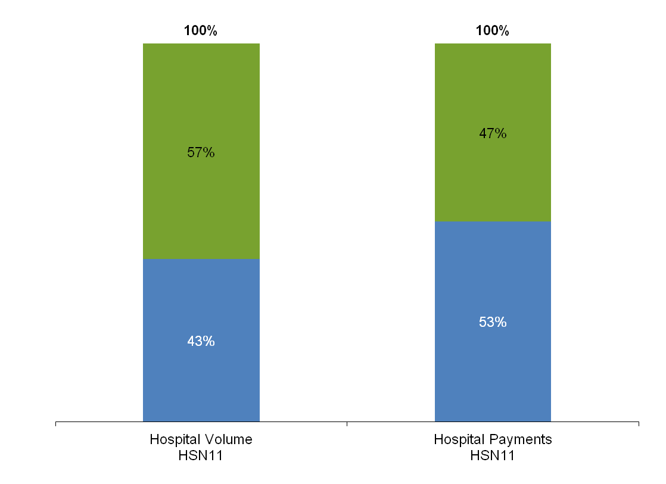

Female

Male

Notes: The Health Safety Net fiscal year runs from October 1 through September 30 of the following year. Hospital volume is the sum of inpatient discharges and outpatient visits for which payments were made to hospital providers in the months shown. Hospital volume excludes pharmacy claims. Hospital payments are reported in the month in which payment was made. Hospital payments exclude pharmacy payments. Numbers are rounded to the nearest percent and may not sum to 100% due to rounding. Numbers less than 1% are not displayed.
Source: DHCFP Health Safety Net Data Warehouse as of 10/11/11.

Massachusetts Division of Health Care Finance and Policy 22

Hospital Utilization and Payments by Age

Ages 65 and Older

Ages 45-64

Ages 27-44

Ages 19-26

Ages 0-18
User Demographics

In Health Safety Net fiscal year 2011 (HSN11), the non- elderly adult population (ages
19 to 64) accounted for 82% of hospital volume and 90% of hospital payments.

Because the Health Safety Net
(HSN) is a secondary payer for low-income Medicare patients, adults ages 65 and older accounted for 15% of hospital volume but only 8% of hospital payments.

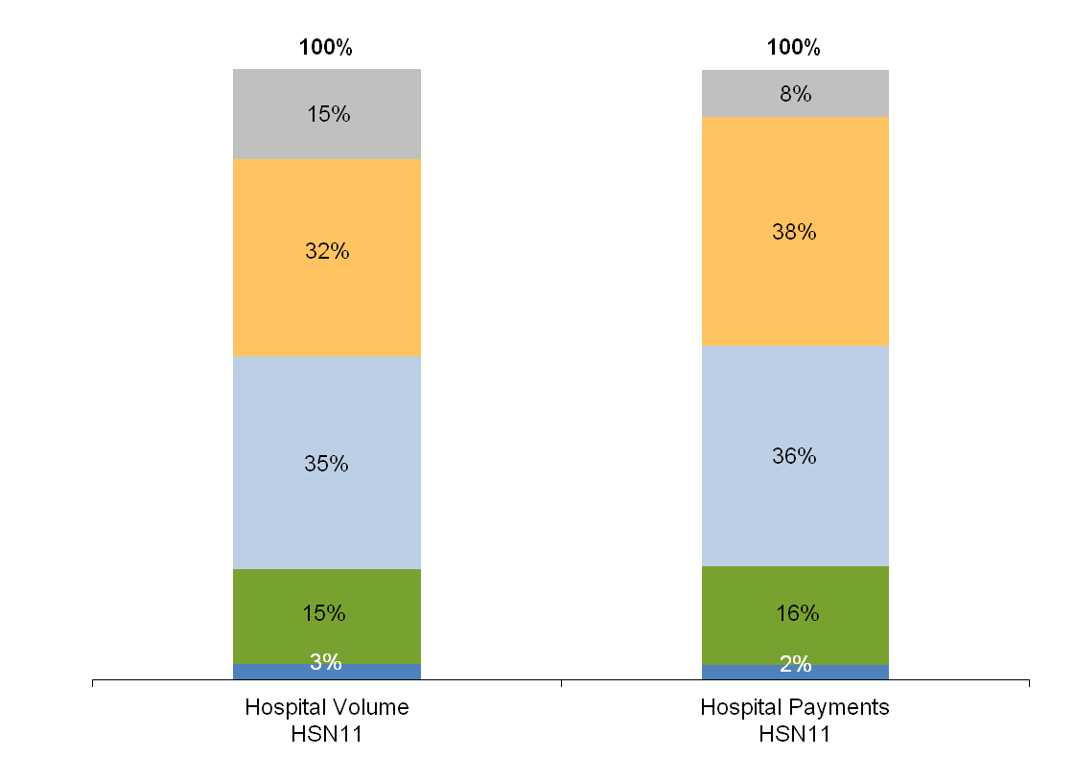

Notes: The Health Safety Net fiscal year runs from October 1 through September 30 of the following year. Hospital volume is the sum of inpatient discharges and outpatient visits for which payments were made to hospital providers in the months shown. Hospital volume excludes pharmacy claims. Hospital payments are reported in the month in which payment was made. Hospital payments exclude pharmacy payments. Numbers are rounded to the nearest percent and may not sum to 100% due to rounding. Numbers less than 1% are not displayed.
Source: DHCFP Health Safety Net Data Warehouse as of 10/11/11.

Massachusetts Division of Health Care Finance and Policy 23

Hospital Utilization and Payments by Family Income

Income Not Reported

Emergency Room Bad Debt

200.1% to 400% FPL

100.1% to 200% FPL

Up to 100% FPL

No Income
User Demographics

In Health Safety Net fiscal
year 2011 (HSN11), users with no income received the most costly services, comprising
37% of service volume that
generated 45% of payments.

Users with income between
100.1% and 200% of the federal poverty level (FPL) used the least costly service mix, accounting for 35% of volume and 26% of payments.

Individuals with income less than 200% of the FPL received services accounting
for 84% of volume and 81% of payments.

Income data is reported on the patient’s Medical Benefit Request (MBR) application. There is no MBR information for emergency room bad debt (ERBD) claims.

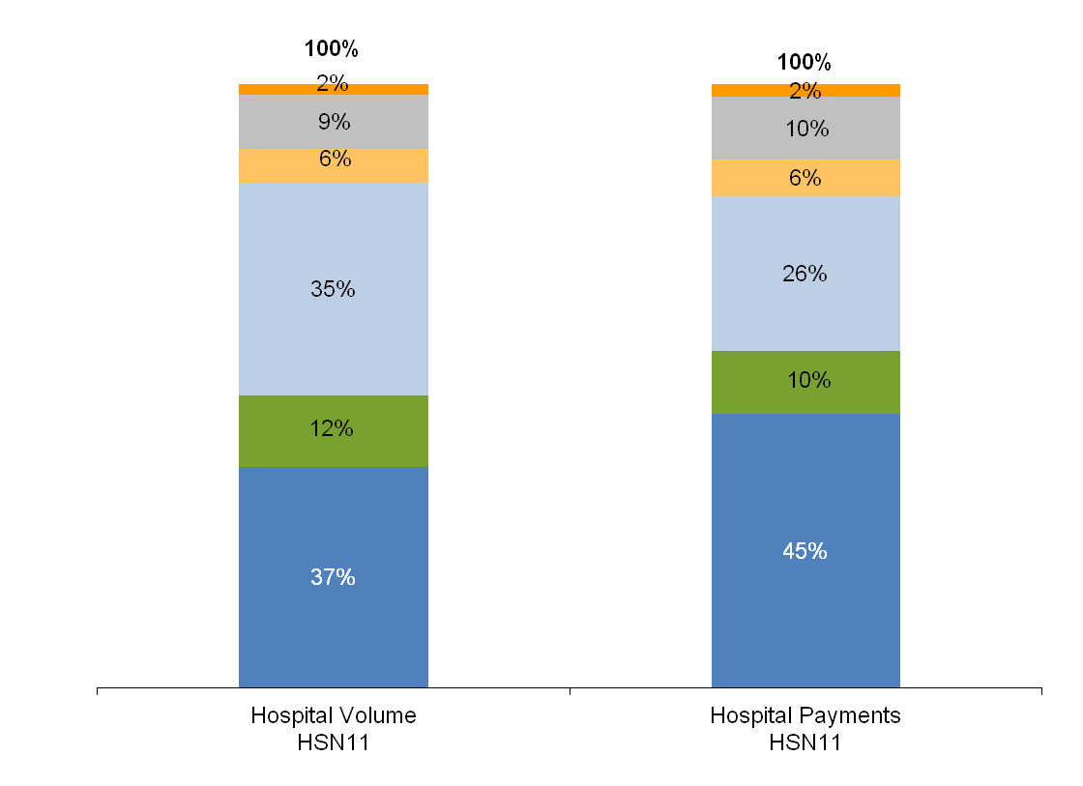

Notes: The Health Safety Net fiscal year runs from October 1 through September 30 of the following year. Hospital volume is the sum of inpatient discharges and outpatient visits for which payments were made to hospital providers in the months shown. Hospital volume excludes pharmacy claims. Hospital payments are reported in the month in which payment was made. Hospital payments exclude pharmacy payments. Numbers are rounded to the nearest percent and may not sum to 100% due to rounding. Numbers less than 1% are not displayed.
Source: DHCFP Health Safety Net Data Warehouse as of 10/11/11.

Massachusetts Division of Health Care Finance and Policy 24

Hospital Utilization and Payments by Family Size

Family Size Not Reported

Emergency Room Bad Debt

Family Size of 4 or More

Family Size of 3

Family Size of 2
User Demographics

Single adults accounted for
57% of hospital volume and
62% of hospital payments during Health Safety Net fiscal year 2011 (HSN11).

Family size data are reported on the patient’s Medical Benefit Request (MBR) application. There is no MBR information for emergency
room bad debt (ERBD) claims.

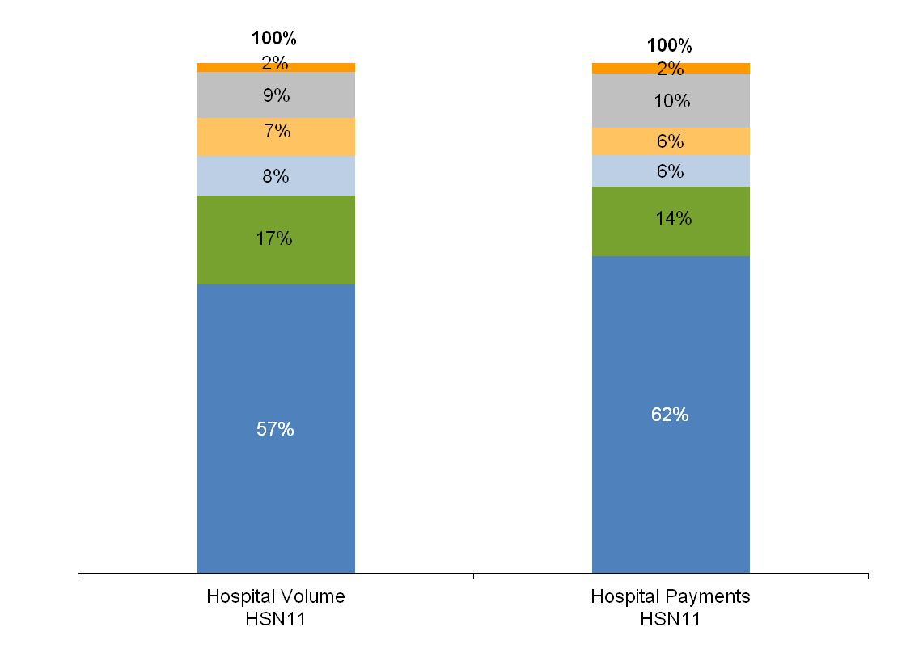

Family Size of 1

Notes: The Health Safety Net fiscal year runs from October 1 through September 30 of the following year. Hospital volume is the sum of inpatient discharges and outpatient visits for which payments were made to hospital providers in the months shown. Hospital volume excludes pharmacy claims. Hospital payments are reported in the month in which payment was made. Hospital payments exclude pharmacy payments. Numbers are rounded to the nearest percent and may not sum to 100% due to rounding. Numbers less than 1% are not displayed.
Source: DHCFP Health Safety Net Data Warehouse as of 10/11/11.

Massachusetts Division of Health Care Finance and Policy 25

HSN11 Hospital Payment Rates

Payment Category Median Payment
Rate

Services for HSN Eligible Individuals
Mean Payment
Rate

Payments are based on Medicare payment principles.

Payment rates range according to the variation in

Inpatient Medical Primary (per discharge) $7,530.97 $10,812.83

Inpatient Psychiatric Primary (per discharge) $5,017.05 $6,182.57

Inpatient Rehabilitation Primary (per day) $1,937.96 $1,849.98

Outpatient Primary (per visit) $285.47 $302.24

Payment on Account Factor
(percentage used for secondary claims) 28.50% 28.04%

Services for Emergency Room Bad Debt
Inpatient Medical Emergency Room Bad Debt (per
discharge)
Inpatient Psychiatric Emergency Room Bad Debt (per discharge)
case mix among hospitals. Hospitals that treat a greater number of complex cases are paid higher rates reflective of this complexity.

The table shows the median and mean payment rates during Health Safety Net fiscal year 2011 (HSN11) for each payment category across all hospitals that provide services in each
$7,261.20 | $8,989.00 | payment category.
$8,928.23 | $8,759.29
$349.17 | $364.56

Outpatient Emergency Room Bad Debt (per visit)

Notes: The Health Safety Net fiscal year runs from October 1 through September 30 of the following year. Payment rates are effective October 1, 2010 for Health Safety Net fiscal year 2011 (HSN11). Payment on Account factor is used for secondary claims and inpatient physician services provided by hospital -based physicians. Hospital payment rates are the median or mean payment amount for all claims paid in HSN11. Rates for these cases vary by diagnosis. Dental services are paid according to t he fees established in 114.3 CMR 14.00: Dental Services.
Source: DHCFP Health Safety Net Data Warehouse as of 11/28/11

Massachusetts Division of Health Care Finance and Policy 26

HSN11 Hospital Payment to Cost Ratios (PCRs)
Financing

Hospitals by Group Pre-Shortfall PCR Actual Payment PCR
Fairview Hospital | 93% | 79%
Faulkner Hospital | 89% | 50%
Hallmark Health | 107% | 62%
Harrington Memorial Hospital | 90% | 74%
Health Alliance Hospitals, Inc. | 90% | 65%
Heywood Hospital | 103% | 71%
Jordan Hospital | 104% | 58%
Lowell General Hospital | 0% | 0%
Marlborough Hospital | 93% | 79%
Martha's Vineyard Hospital | 0% | 0%
MetroWest Medical Center | 91% | 71%
Milford Regional Medical Center | 96% | 57%
Milton Hospital | 93% | 26%
Nantucket Cottage Hospital | 42% | 28%
Nashoba Valley Medical Center | 113% | 51%
New England Baptist Hospital | 53% | 0%
Newton-Wellesley Hospital | 78% | 2%
Northeast Health System | 94% | 52%
South Shore Hospital | 74% | 36%
Steward Holy Family Hospital | 101% | 81%
Steward Norwood Hospital | 97% | 71%
Sturdy Memorial Hospital | 77% | 55%
Winchester Hospital  Teaching Only | 90% | 0%
Beth Israel Deaconess Medical Center | 99% | 68%
Brigham and Women's Hospital | 76% | 40%
Children's Hospital Boston | 205% | 116%
Dana-Farber Cancer Institute | 111% | 27%
Lahey Clinic | 109% | 9%
Massachusetts Eye and Ear Infirmary | 0% | 0%
Massachusetts General Hospital | 71% | 47%
Mount Auburn Hospital | 68% | 36%
Tufts-New England Medical Center | 108% | 60%
UMass Memorial Medical Center | 79% | 62%

Hospitals by Group Pre-Shortfall PCR Actual Payment PCR

Disproportionate Share Hospitals  Athol Memorial Hospital | 140% | 119%
Baystate Medical Center | 105% | 89%
BerkshireMedical Center and Hillcrest Campus | 80% | 68%
Boston Medical Center (Hospitals and CHCs) | 88% | 81%
Cambridge Health Alliance | 94% | 94%
Cape Cod Hospital | 93% | 79%
Clinton Hospital | 63% | 54%
Falmouth Hospital | 91% | 78%
Holyoke Medical Center | 90% | 77%
Lawrence General Hospital | 94% | 85%
Mercy Medical Center | 95% | 80%
Merrimack Valley Hospital | 100% | 85%
Morton Hospital and Medical Center | 106% | 90%
Noble Hospital | 94% | 80%
North Adams Regional Hospital | 101% | 85%
North Shore Medical Center, Inc. | 76% | 65%
Quincy Medical Center | 105% | 89%
Saint Vincent Hospital | 125% | 106%
Saints Medical Center | 101% | 86%
Signature Healthcare Brockton Hospital | 108% | 97%
Southcoast Hospitals Group | 97% | 82%
Steward Carney Hospital, Inc. | 106% | 90%
Steward Good Samaritan Medical Center | 89% | 75%
Steward Saint Anne's Hospital | 99% | 84%
Steward St. Elizabeth's Medical Center | 82% | 70%
Wing Memorial Hospital and Medical Centers | 95% | 81%
All Others
Anna Jaques Hospital | 104% | 70%
Baystate Franklin Medical Center | 89% | 62%
Baystate Mary Lane Hospital | 82% | 44%
Beth Israel Deaconess MedlCtr Hospital - Needham | 89% | 0%
Cooley Dickinson Hospital | 84% | 33%
Emerson Hospital | 83% | 0%

Notes: Health Safety Net fiscal year 2011 (HSN11) measures payments made in the months of October 2010 through September 2011. Hospital payments exclude pharmacy payments. Costs are determined using a total cost-to-charge ratio derived from the fiscal year 2010HCF-403 data.
Source: DHCFP Health Safety Net Data Warehouse as of 11//7/11

Massachusetts Division of Health Care Finance and Policy 27

Sources and Uses
Financing

Sources

• The Health Safety Net (HSN) is primarily funded from three sources: an assessment on acute hospitals’ private sector charges; a surcharge on payments made to hospitals and ambulatory surgical centers by HMOs, insurers, third party administrators, and individuals; and an annual appropriation from the Commonwealth’s General Fund.

Hospital Assessments

• The total amount paid by hospitals into the HSN is established by the Legislature. The fiscal year 2011 (FY11) state budget established a total hospital assessment of $160.0 million. Each hospital’s assessment is calculated by multiplying its private sector charges by the uniform percentage, which is calculated by dividing the total assessment ($160.0 million) by the total private sector charges from all hospitals statewide. Since each hospital’s liability is based on its private sector charges, hospitals that treat more private patients make larger payments to the
HSN.

Surcharge Collections

• The total amount collected through the surcharge is established by the Massachusetts Legislature. The Division of Health Care Finance and Policy sets the surcharge percentage at a level to produce the total amount specified by the Legislature. For Health Safety Net fiscal year 2011 (HSN11), that amount totaled $160.0 million.

General Fund

• The Commonwealth also makes a General Fund contribution to the HSN. In HSN11, the total General Fund contribution was $30 million.

Offsets for Uncompensated Care

• In HSN11, $70.0 million from the Medical Assistance Trust Fund was used to offset uncompensated care costs for allowable HSN services to
Boston Medical Center ($20.0 million) and Cambridge Health Alliance ($50.0 million).

Uses

• Projected uses of HSN funds include estimated hospital demand, estimated community health center payments, and $6 million for demonstration projects.

Massachusetts Division of Health Care Finance and Policy 28

HSN11 Sources and Projected Uses
Financing

Projected Uses
Estimated Hospital Demand ($440.5) Estimated Community Health Center
Payments ($56.4)

Demonstration Projects ($6.0)

Projected Uses ($502.9)
Funding Sources
Hospital Assessment | $160.0
Surcharge Payers | $160.0
General Fund Contribution | $30.0
MATF Offset to Hospital Demand* | $70.0
Total Sources | $420.0

Projected Shortfall ($82.9)

Notes: Dollars in millions. Estimated hospital payments include allowance of $18.0 million for denied claims that may remedia te. Based on hospital and CHC data submitted through September 2011.
*Up to $70.0 million is available from the Medical Assistance Trust Fund to offset uncompensated care costs for allowable HSN services to Boston Medical Center ($20.0 million) and Cambridge Health Alliance ($50.0 million).

Massachusetts Division of Health Care Finance and Policy 29

HSN11 Surcharge Collections
Financing

Surcharge Payer

Collections
HSN11

Percent of Total
HSN11
The total surcharge amount for
Health Safety Net fiscal year
2011 (HSN11) was set by the
Massachusetts Legislature at
$160 million.

Blue Cross Blue Shield of Massachusetts $63,120,676 43% Harvard Pilgrim Health Care $23,357,752 16% Tufts Health Plan $6,702,296 5% UnitedHealth Care Insurance Company $9,614,375 7% Aetna Health, Inc. $6,801,100 5% Connecticut General Life Insurance Company $5,751,672 4% UniCare Life and Health Insurance Company $3,753,777 3% Tufts Total Health Plan $3,647,551 2% Fallon Community Health Plan $3,341,767 2% Health New England $2,520,673 2% All Others $17,681,891 12%
Total HSN11 Collections $146,293,530 100%

Notes: Payment rates effective 10/1/10 for Health Safety Net fiscal year 2011. Totals may not add to 100% due to rounding.
In order to produce the total amount specified by the Legislature, DHCFP set the surcharge percentage at
1.55% for HSN11.

Approximately 787 registered surcharge payers made payments in HSN11. The table lists the top ten surcharge payers and their contributions.

Massachusetts Division of Health Care Finance and Policy 30

HSN11 Hospital Assessments and Payments
Financing

Hospitals
Assessment
To HSN A
Payment From HSN B
Net Payment To/ (From) HSN C = A – B

Hospitals
Assessment
To HSN A
Payment From HSN B
Net Payment To/ (From) HSN C = A – B

Massachusetts Eye and Ear Infirmary $1,317,641 $757,833 $559,809
Massachusetts General Hospital $20,684,039 $23,747,872 ($3,063,833) Mercy Medical Center $1,089,927 $3,226,212 ($2,136,285) Merrimack Valley Hospital $299,384 $1,004,229 ($704,845) MetroWest Medical Center $2,101,011 $4,841,189 ($2,740,178) Milford Regional Medical Center $1,715,312 $1,319,217 $396,095
Milton Hospital $536,119 $132,869 $403,250
Morton Hospital and Medical Center $724,958 $2,139,217 ($1,414,259) Mount Auburn Hospital $2,168,874 $1,598,138 $570,736
Nantucket Cottage Hospital $251,457 $325,656 ($74,199) Nashoba Valley Medical Center $495,952 $188,137 $307,814
New England Baptist Hospital $1,624,509 $0 $1,624,509
Newton-Wellesley Hospital $5,604,153 $57,814 $5,546,339
Noble Hospital $344,419 $400,328 ($55,908) North Adams Regional Hospital $405,843 $287,731 $118,112
North Shore Medical Center $3,297,117 $7,337,047 ($4,039,929) Northeast Hospital Corporation $2,337,967 $2,006,469 $331,498
Quincy Medical Center $557,977 $1,536,692 ($978,715) Saint Vincent Hospital $1,967,870 $4,810,492 ($2,842,622) Saints Medical Center $858,983 $1,973,510 ($1,114,527) Signature Healthcare Brockton Hospital $1,438,738 $8,886,235 ($7,447,497) South Shore Hospital $2,911,037 $1,931,532 $979,506
Southcoast Hospitals Group $3,296,188 $11,505,870 ($8,209,682) Steward Carney Hospital $418,468 $3,232,777 ($2,814,309) Steward Good Samaritan Medical Center $941,811 $3,454,110 ($2,512,300) Steward Holy Family Hospital $1,048,597 $3,010,327 ($1,961,729) Steward Norwood Hospital $1,126,601 $2,276,951 ($1,150,349) Steward Saint Anne's Hospital $793,231 $2,592,152 ($1,798,921) Steward St. Elizabeth's Hospital $1,538,365 $5,273,813 ($3,735,448) Sturdy Memorial Hospital $848,396 $1,785,399 ($937,003) Tufts Medical Center $4,723,790 $3,725,413 $998,377
UMass Memorial Medical Center $9,507,567 $23,495,383 ($13,987,816) Winchester Hospital $2,209,799 ($0) $2,209,799
Wing Memorial Hospital and Medical Centers $477,419 $1,569,692 ($1,092,273)
All Hospitals $160,000,000 $337,999,999 ($177,999,999)
Anna Jaques Hospital | $698,394 | $1,085,066 | ($386,671)
Athol Memorial Hospital | $194,211 | $235,679 | ($41,468)
Baystate Franklin Medical Center | $566,068 | $996,392 | ($430,324)
Baystate Mary Lane Hospital | $208,703 | $212,880 | ($4,176)
Baystate Medical Center | $4,422,856 | $10,513,757 | ($6,090,901)
Berkshire Medical Center and Hillcrest Campus | $1,477,205 | $4,071,924 | ($2,594,719)
Beth Israel Deaconess Medical Center | $532,596 | $12,373,418 | ($11,840,822)
Beth Israel Deaconess Hospital - Needham | $8,948,640 | $0 | $8,948,640
Boston Medical Center | $4,507,862 | $78,011,911 | ($73,504,049)
Brigham and Women's Hospital | $17,907,942 | $10,430,923 | $7,477,019
Cambridge Health Alliance | $1,640,407 | $50,000,000 | ($48,359,593)
Cape Cod Hospital | $1,795,497 | $6,050,500 | ($4,255,003)
Children's Hospital Boston | $8,609,846 | $3,849,996 | $4,759,850
Clinton Hospital | $233,855 | $311,801 | ($77,946)
Cooley Dickinson Hospital | $1,256,705 | $562,569 | $694,136
Dana-Farber Cancer Institute | $6,772,298 | $1,265,712 | $5,506,586
Emerson Hospital | $2,263,901 | ($0) | $2,263,901
Fairview Hospital | $183,227 | $1,104,813 | ($921,586)
Falmouth Hospital | $711,105 | $1,562,783 | ($851,678)
Faulkner Hospital | $2,159,935 | $1,172,731 | $987,204
Hallmark Health | $2,011,622 | $1,810,416 | $201,206
Harrington Memorial Hospital | $591,636 | $1,991,226 | ($1,399,590)
Health Alliance Hospital | $1,117,277 | $1,966,356 | ($849,079)
Heywood Hospital | $673,102 | $1,014,439 | ($341,337)
Holyoke Medical Center | $430,399 | $2,014,553 | ($1,584,154)
Jordan Hospital | $1,518,778 | $1,244,744 | $274,034
Kindred Hospital Boston | $112,042 | $0 | $112,042
Kindred Hospital Boston North Shore | $115,106 | $0 | $115,106
Lahey clinic | $4,979,256 | $301,902 | $4,677,354
Lawrence General Hospital | $908,419 | $7,495,111 | ($6,586,692)
Lowell General Hospital | $1,827,652 | $2,734,220 | ($906,568)
Marlborough Hospital | $589,864 | $1,981,107 | ($1,391,243)
Martha's Vineyard Hospital | $370,075 | $1,202,767 | ($832,691)

Notes: Payment amounts do not include offset payments from the Medical Assistance Trust Fund, or reserves for remediated claims of a pproximately $18 million. Payment amounts reflect the shortfall amount withheld as of September 2010, which differs from the projected year-end calculated shortfall. The annual hospital assessment is calculated by multiplying each hospital’s private sec tor charges (PSC) by the uniform assessment rate of 0.82%. Private sector charges are derived from the fiscal year 2010 HCF -403 Cost Reports filed by hospitals for the period from October 2008 through September 2009. All hospital reported data are unaudited and subject to change with future updates and calculations. Based on data as of 11/2/11.

Massachusetts Division of Health Care Finance and Policy 31

HSN10 and HSN11 Community Health Center Payments
Financing

Community Health Centers HSN10 HSN11 Difference Percent
Change
Community Health Centers HSN10 HSN11 Difference Percent
Change

Boston Health Care for the Homeless Program | $1,027,477 | $1,339,021 | $311,544 | 30.3% |  | Island Health Care | $160,847 | $157,917 | ($2,930) | -1.8%
Brockton Neighborhood Health Center | $5,069,735 | $5,446,891 | $377,156 | 7.4% |  | Joseph M. Smith Community Health Center | $3,352,608 | $3,515,036 | $162,428 | 4.8%
Caring Health Center | $719,025 | $1,105,354 | $386,329 | 53.7% |  | Lowell Community Health Center | $613,450 | $738,401 | $124,951 | 20.4%
CHP Health Center | $354,325 | $474,448 | $120,123 | 33.9% |  | Lynn Community Health Center | $4,602,186 | $4,695,017 | $92,831 | 2.0%
Community Health Center of Cape Cod | $514,607 | $833,088 | $318,481 | 61.9% |  | Manet Community Health Center | $289,796 | $130,857 | ($158,939) | -54.8%
Community Health Center of Franklin County | $619,934 | $1,152,752 | $532,818 | 85.9% |  | Mattapan Community Health Center | $520,295 | $788,876 | $268,581 | 51.6%
Community Health Connections | $3,339,831 | $3,438,569 | $98,738 | 3.0% |  | Mid-Upper Cape Community Health Center | $830,913 | $1,284,986 | $454,073 | 54.6%
Dimock Community Health Center | $657,877 | $627,856 | ($30,021) | -4.6% |  | Neponset Health Center | $208,688 | $408,851 | $200,163 | 95.9%
Duffy Health Center | $57,535 | $183,513 | $125,978 | 219.0% |  | North End Community Health Center | $173,486 | $302,139 | $128,653 | 74.2%
Edward M. Kennedy Community Health Center | $5,291,700 | $6,063,446 | $771,746 | 14.6% |  | North Shore Community Health | $1,704,270 | $1,723,703 | $19,433 | 1.1%
Family Health Center of Worcester | $1,799,480 | $2,385,359 | $585,879 | 32.6% |  | Outer Cape Health Services | $184,264 | $330,252 | $145,988 | 79.2%
Fenway Community Health Center | $222,315 | $411,169 | $188,854 | 84.9% |  | Roxbury Comprehensive Community Health | $131,435 | $200,994 | $69,559 | 52.9%
Geiger-Gibson Community Health Center | $586,485 | $909,180 | $322,695 | 55.0% |  | Sidney Borum, Jr. Health Center | $19,910 | $0 | ($19,910) | -100.0%
Greater Lawrence Family Health Center | $3,150,645 | $3,854,003 | $703,358 | 22.3% |  | South Cove Community Health Center | $2,836,073 | $4,018,179 | $1,182,106 | 41.7%
Greater New Bedford Community Health | $1,883,300 | $2,188,813 | $305,513 | 16.2% |  | South End Community Health Center | $576,328 | $740,272 | $163,944 | 28.4%
Harvard Street Neighborhood Health Center | $713,372 | $779,704 | $66,332 | 9.3% |  | Stanley Street Treatment and Resources | $157,926 | $157,420 | ($506) | -0.3%
HealthFirst Family Care Center | $409,212 | $742,136 | $332,924 | 81.4% |  | Upham's Corner Health Center | $914,158 | $1,038,673 | $124,515 | 13.6%
Hilltown Community Health Centers $301,699 $481,691 $179,992 59.7% Whittier Street Neighborhood Health Center $1,228,194 $1,562,652 $334,458 27.2%
Holyoke Health Center $1,862,321 |  | $2,210,356 | $348,035 | 18.7% |  | All Community Health Centers | $47,085,702 | $56,421,574 | $9,335,872 | 19.8%

Notes: HSN10 payments reflect updated CHC claims activity and may differ from data previously published. Based on data as of 10/25/11.

Massachusetts Division of Health Care Finance and Policy 32

HSN11 Demonstration Projects

October 2010 – September 2011

Massachusetts Division of Health Care Finance and Policy 33

Table of Contents
Demonstration Projects

Demonstration Project Background | 35
Massachusetts Fisherman’s Partnership | 36
The Patient-Centered Medical Homes Initiative | 37

Massachusetts Division of Health Care Finance and Policy 34

Background
Demonstration Projects

• M.G.L. c.118G s.36 authorizes the Division of Health Care Finance and Policy (Division) to allocate up to $6 million per fiscal year from the Health Safety Net Trust Fund for Health Safety Net (HSN) demonstration projects that use case management and other methods to reduce the liability of the fund to acute hospitals. Each project should demonstrate the potential to save the HSN at least $1 for every dollar received in funding.

• This report presents the two demonstration projects that were active during HSN fiscal years 2010 (HSN10) and 2011 (HSN11) from October 1, 2009 to September 30, 2011, providing a full description of each grant program. Additionally, the report provides the history for each program where appropriate.

Massachusetts Division of Health Care Finance and Policy 35

Massachusetts Fisherman’s Partnership
Demonstration Projects

• Through June 2011, the Fishing Partnership Health Plan (FPHP) offered fishermen and their families the opportunity to purchase health insurance at a reduced rate, made possible through subsidized premiums provided by the Health Safety Net (HSN). The FPHP is a freestanding trust fund that operates separately from its primary sponsoring organization, the Massachusetts Fishermen’s Partnership. In state fiscal year 2002 (FY02), the Legislature allocated increased funding from $2 million to $3 million per year, effective state FY03 through state FY07. In state FY08, funding was increased to $4 million.

• The FPHP contracted with Harvard Pilgrim Health Plan to offer fishermen and their families a comprehensive benefit package that included access to Harvard Pilgrim’s network of providers, mental health services, and pharmacy coverage. All fishermen, regardless of health status or current insurance coverage, could enroll in the plan. FPHP offered four tiers of membership depending on the income of the fishermen; as of June 2011, 1,545 fishermen and their family members were enrolled.

• Due to the availability of other subsidized health insurance programs in Massachusetts as a result of the 2006 Health Care Reform, the FPHP transitioned their members to other lower cost options as of July 1, 2011. The Partnership notified their members of the transition in February 2011 and assisted the members in transitioning to MassHealth, CommCare, and CommChoice. FPHP both doubled representatives staffing local offices throughout the Commonwealth and assigned each FPHP member to a designated coordinator. These measures helped ensure that every member received individual attention during this transition.

• Going forward, the FPHP corporation will continue to perform outreach services to Massachusetts fishermen to assist them in accessing health insurance coverage. It will also provide services such as health screenings, wellness programs, and safety trainings to the fishing community.

Massachusetts Division of Health Care Finance and Policy 36

The Patient-Centered Medical Homes Initiative
Demonstration Projects

In August 2008, the Legislature directed the Medicaid program (MassHealth) to carry out a medical home demonstration. Secretary JudyAnn Bigby, M.D. of the Executive Office of Health and Human Services (EHS) further directed the use of the Patient-Centered Medical Home (PCMH) model as the centerpiece in a statewide strategy to improve quality of care for chronically ill patients, reduce costs, and reform primary care.

• EHS has developed a PCMH design to test a new model to transform the quality of and payment for certain primary care practices in the Commonwealth. The design involves implementing a demonstration at primary care practices across Massachusetts, with the intent to roll out the model more broadly in the future based on evaluation results. Other payers also support this initiative in order to maximize the potential for practice-wide change at the sites. In addition, this design reflects the shared responsibility of supporting and redesigning primary care practices in the Commonwealth with financial and infrastructure support provided by payers, and with commitment of resources and dedication to the guiding principles of the PCMH Initiative from primary care practices.

• Other participating payers include Blue Cross Blue Shield of Massachusetts, Boston Medical Center HealthNet Plan, CeltiCare, Fallon Community Health Plan, Harvard Pilgrim Health Care, Health New England, the MassHealth Primary Care Clinician Plan, Neighborhood Health Plan, Network Health, Senior Whole Health, Tufts Health Plan, and UniCare.

• Thirty-two practices were selected to receive funding to participate in the demonstration. Twenty-four of these practices are Health Safety Net (HSN) provider sites. An additional 14 practices were selected to receive unpaid technical assistance as part of the PCMH Initiative. Twelve of these practices are HSN provider sites.

• As one of many payers participating in this initiative, the HSN designated $2 million in HSN09 demonstration funding to support HSN eligible providers in this initiative. HSN staff participated in creating the evaluation criteria used for choosing demonstration sites, and will participate in creating the criteria for evaluation of demonstration goals and benchmarks.

• Approximately 32,000 HSN patients are patients of one of the 35 participating practices that are HSN provider sites. In
HSN11, the HSN paid $562,000 to practices for their participation in the demonstration.

Massachusetts Division of Health Care Finance and Policy 37

Patient-Centered Medical Homes Sites
Demonstration Projects

The Executive Office of Health and Human Services (EHS) selected a total of 46 sites to participate in the Patient-Centered Medical Home Initiative (PCMHI). Of those selected, 32 practices were selected to participate as Technical Assistance Plus (TAP) sites and 14 practices were selected t o participate as Technical Assistance Only (TAO) sites. Both TAP and TAO practices receive technical assistance provided by EHS and its partners to support the transfor mation to a medical home. TAP practices also receive special PCMHI payments for performing certain start-up activities, various medical home activities, and Clinical Care Management services.

The 32 TAP sites, of which 24 are HSN providers:
• Barre Family Health Center*
• Baystate Mason Square Neighborhood Health Center*
• Boston Health Care for the Homeless*
• Boston Medical Center – Family Medicine Center*
• Brockton Neighborhood Health Center*
• Codman Square Health Center*
• Dorchester House*
• Drum Hill Primary, LLC
• East Boston Neighborhood Health Center*
• Fairview Pediatrics
• Family Health Center of Worcester*
• Family Practice Group, P.C.
• Fitchburg Community Health Center*
• Foley Family Practice, P.C.
• Geiger Gibson Community Health Center*
• Greater Lawrence Family Health Center - Haverhill St.*
• Grove Medical Associates, P.C.
• Harvard Vanguard Medical Associates, Medford
• Hilltown Community Health Center – Worthington*
• Holyoke Health Center*
• Joseph Smith Community Health Center – Allston*
• Joseph Smith Community Health Center – Waltham*
• Lee Family Practice, P.C.
• Lynn Community Health Center*
• Mid Upper Cape Community Health Center*
• Neponset Health Center*
• Pediatric Associates of Hampden County – Westfield
• Revere Family Health Center*
• South End Associates (of Fenway CHC)*
• UMass Memorial Pediatric Primary Care Associates*
• Union Square Family Health Center*
• Whittier Street Health Center*
The 14 TAO sites, of which 12 are HSN providers, are:
• Baystate High Street Health Center, Adult Medicine
• Baystate High Street Health Center, Pediatric Medicine
• Bowdoin Street Health Center*
• Broadway Health Center*
• Cambridge Family Health*
• Edward M. Kennedy Community Health Center*
• Greater Gardner Community Health Center*
• Greater New Bedford Community Health Center*
• Malden Family Medicine Center*
• Manet Community Health Center*
• South Boston Community Health Center*
• South End Community Health Center*
• Southern Jamaica Plain Health Center*
• Tufts Medical Center*

Notes: * indicates Health Safety Net providers

Massachusetts Division of Health Care Finance and Policy 38

Demonstration Projects
Demonstration Projects

Demonstration Projects HSN10 HSN11

Fishing Partnership Health Plan $4,000,000 $4,000,000

Unallocated Health Safety Net Demonstration
Funding $2,000,000 $2,000,000

Total $6,000,000 $6,000,000

M.G.L. c.118G s.36 authorizes the Division to allocate up to
$6 million per fiscal year for projects designed to demonstrate alternative approaches to improve health care and reduce costs for the uninsured and underinsured.

Each project should demonstrate the potential to save the Health Safety Net at least $1 for every dollar received in funding.

Notes: Fishing Partnership Health Plan demonstrations was statutorily required per Chapter 47 of the Acts of 1997. Funding fo r other demonstrations was awarded based on criteria determined by the Division. Based on data from 10/04/11.

Massachusetts Division of Health Care Finance and Policy 39

Health Safety Net Eligibility Processes

December 2011

Massachusetts Division of Health Care Finance and Policy 40

Introduction
Eligibility Processes

The Division of Health Care Finance and Policy (Division) hereby submits this report to the Massachusetts Legislature in compliance with Section 35 of M.G.L. Chapter 118G. Section 35 requires the Division to provide an annual report evaluating the processes used to determine eligibility for reimbursable health services. Specifically, Section 35 calls for:

• An analysis of the effectiveness of these processes in enforcing eligibility requirements for publicly-funded health programs and in enrolling uninsured residents into programs of health insurance offered by public and private sources;

• An assessment of the impact of these processes on the level of reimbursable health services by providers; and

• Recommendations for ongoing improvements that will enhance the performance of eligibility determination systems and reduce hospital administrative costs.

This report provides the required evaluation and illustrates that service utilization has declined since the implementation of health care reform. Through continued coordination and collaboration with MassHealth, the Division will continue to realize improvements to the eligibility determination system that supports the Health Safety Net.

Massachusetts Division of Health Care Finance and Policy 41

Health Safety Net Eligibility Background
Eligibility Processes

The Health Safety Net (HSN) was created by Chapter 58 of the Acts of 2006 as the successor to the Uncompensated Care
Pool (UCP). The HSN, like its predecessor, serves as a safety net for uninsured and underinsured Massachusetts residents by reimbursing acute care hospitals and community health centers (CHCs) for allowable services. Some of the HSN’s key eligibility policies include:

• Individuals may be eligible for the HSN if they are uninsured or underinsured and document family income between
0% and 400% of the federal poverty level (FPL).

• Uninsured and underinsured individuals with family income up to 200% of the FPL may be eligible for full HSN.

• Uninsured and underinsured individuals with family income between 201% and 400% of the FPL may be eligible for
partial HSN, which includes a deductible based on the patient’s income.

• Individuals with incomes between 0% and 400% of the FPL who are enrolled in insurance programs with limited benefits (such as MassHealth Limited) may be eligible for HSN secondary.

• HSN secondary eligibility is available for dental services for Commonwealth Care patients whose plans do not cover dental services, and for vision and dental services for Commonwealth Care Bridge patients.

• The HSN provides temporary eligibility to individuals during enrollment “gap” periods, which include the 10 days prior to a patient’s application for certain MassHealth programs or Commonwealth Care, and a period of time after the application, in order to allow sufficient time to complete the enrollment process.

• The HSN may pay for emergency room bad debt (ERBD) at acute hospitals or urgent care bad debt (UCBD) at CHCs in cases where a provider is unable to collect payment from a patient after pursuing collection activity for a specified time period. ERBD and UCBD payments are only made for individuals who are uninsured and not eligible for MassHealth or Commonwealth Care.

• Individuals enrolled in MassHealth programs that provide comprehensive benefits, such as MassHealth Standard, Basic, or Essential, are eligible only for certain dental services not covered by MassHealth, and for the portion of an inpatient stay exceeding 20 days, which MassHealth does not cover.

Massachusetts Division of Health Care Finance and Policy 42

Eligibility Processes Enforcement of Eligibility Requirements – Eligibility Determination and Claims Processing

The eligibility determination process for publicly funded health programs in Massachusetts relies on a single integrated eligibility system. The process begins when an individual fills out a form called a Medical Benefit Request (MBR). The
MBR is a consolidated application used to determine patient eligibility for MassHealth, Commonwealth Care, and the HSN. Patients may either complete a paper MBR or an electronic MBR through the Virtual Gateway with the assistance of a provider or outreach worker.

MassHealth processes the MBR and confirms patient eligibility using the MA-21 eligibility determination system. The system first assesses whether the applicant is eligible for MassHealth. If the applicant is not eligible for MassHealth, eligibility for Commonwealth Care is evaluated, followed by the HSN. As part of the eligibility determination process, MassHealth may initiate data matches with other agencies in order to verify income and determine program eligibility. These sources include, but are not limited to, the HSN, the Commonwealth Health Insurance Connector Authority (the Connector), the Department of Unemployment Assistance, and the Department of Revenue.

Once an eligibility determination is made, the information in the MA-21 system is transferred to the New Medicaid Management Information System (NewMMIS). NewMMIS contains the Eligibility Verification System (EVS), the subsystem that providers use to obtain MassHealth, Commonwealth Care, and HSN eligibility information.

Individuals found eligible for the HSN undergo an annual redetermination process to maintain their eligibility. The redetermination process requires HSN households to complete and return an Eligibility Review Verification form within 45 days of receipt. If a household does not return the form within the specified timeframe, MassHealth will terminate the household’s HSN eligibility.

With the exception of ERBD claims, all HSN claims must be for services provided to patients with HSN eligibility. Beginning in Health Safety Net fiscal year 2008 (HSN08), the claims adjudication system matches all non-ERBD HSN claims to an HSN-eligible patient prior to payment, leaving no paid claims unmatched. The HSN claims adjudication system receives a daily feed of eligibility data from NewMMIS, allowing it to immediately reject claims which cannot be matched to an HSN-eligible patient. The eligibility feed also allows the claims system to properly adjudicate ERBD, as claims for insured or HSN-eligible patients do not qualify for ERBD reimbursement.

Massachusetts Division of Health Care Finance and Policy 43

Eligibility Processes Enforcement of Eligibility Requirements – Identifying Other Available Insurers

The HSN serves as a payer of last resort for patients who are unable to obtain affordable health coverage through other sources. As such, the HSN does not make payments to providers if another payment source is available or if the individual is determined to have access to affordable insurance. To ensure compliance with these principles, the Division:

• Utilizes a common application and maintains the MA-21 system to ensure that eligibility policies are coordinated and applied consistently between the HSN, MassHealth, and Commonwealth Care;

• Utilizes provider messaging that communicates HSN eligibility and cost sharing policies;

• Provides incentives for patients to enroll in affordable and comprehensive insurance plans by precluding HSN primary eligibility if the patient is eligible for affordable insurance coverage through an alternative source such as MassHealth, Commonwealth Care, or an employer;

• Contracts with a vendor to identify paid HSN claims for which an insurance payment or payment from a legal
settlement is available and to recover HSN funds prior to the insurance or settlement payment; and

• Has contracted with a vendor that will review paid inpatient primary claims to determine whether another payer was available on the date of service, and retract HSN payments in cases where the provider did not appropriately bill the primary payer prior to billing the HSN.

Massachusetts Division of Health Care Finance and Policy 44

Eligibility Processes Enforcement of Eligibility Requirements – Encouraging Enrollment in Other Available Insurance Programs
Chapter 58 of the Acts of 2006 requires the Division to “develop programs and guidelines to encourage maximum enrollment of uninsured individuals who receive health services reimbursed by the fund into health care plans and programs of health insurance offered by public and private sources.” Since 2006, the Division has undertaken several initiatives to encourage patients to enroll in available affordable insurance plans.

In October 2007, when the HSN replaced the UCP, approximately 48,000 Commonwealth Care-eligible individuals had not yet enrolled in Commonwealth Care. Between October and December of 2007, these individuals were informed that their HSN eligibility would end after a period of time sufficient to complete the Commonwealth Care enrollment process. All Commonwealth Care-eligible individuals were subsequently removed from the HSN between December 2007 and February 2008.

The current HSN eligibility regulation allows Commonwealth Care-eligible individuals to receive time-limited HSN eligibility in order to allow them time to enroll in Commonwealth Care. Individuals applying for a Commonwealth Care determination may receive up to 90 days of HSN eligibility from their date of application. Commonwealth Care-eligible individuals may also receive HSN eligibility between the time they enroll and the time that plan coverage begins if this period falls outside of the initial 90 days. These eligibility requirements are programmed into the HSN claims system and communicated to providers through EVS.

During HSN09, approximately 26,000 Aliens with Special Status (AWSS) were transitioned from the Commonwealth Care program to the Commonwealth Care Bridge (Bridge) program as the result of Chapter 65 of the Acts of 2009. MassHealth, the Connector, and the HSN coordinated during this time to ensure a smooth transition and that patients remained eligible for the HSN as they were moved from one program to the other. EVS provider messaging was updated in response to Bridge program implementation to allow providers to distinguish Commonwealth Care and Bridge patients. The Health Safety Net Office collaborated with the Connector and with MassHealth to develop and implement these provider messages.

Currently, the HSN is working to expand the eligibility determination system capabilities to screen for access to affordable employer- sponsored insurance, and to encourage individuals to enroll in alternative, affordable insurance. The current regulation allows individuals with access to affordable insurance who enroll in a private plan to retain HSN secondary eligibility, in which the HSN acts as a secondary payer to their primary insurance plan for eligible services. On the other hand, individuals who fail to enroll in affordable insurance available to them may lose HSN eligibility.

Massachusetts Division of Health Care Finance and Policy 45

The Impact of HSN Eligibility Policies on the Level of Reimbursable Health Services by Providers
Eligibility Processes

The effects of HSN eligibility requirements and other changes related to health care reform are reflected in UCP/HSN visit and discharge volume statistics.

UCP/HSN volume declined by
36 percent between Uncompensated Care Pool Fiscal Year 2007 (UCP07), the last year of the UCP, and Health Safety Net Fiscal Year
2008 (HSN08), the first year of the HSN.

HSN volume has begun to gradually increase in HSN09 and HSN10. This increase may be due to economic
factors and coverage changes in other programs.

Notes: The Health Safety Net fiscal year runs from October 1 through September 30 of the following year. Hospital and community health center volume exclude pharmacy claims. HSN08 CHC volume differs from data previously published due to a technical change made to the methodology used to calculate CHC visits. HSN09 and HSN10 hospital and CHC volume reflect updated claims activity and may differ from data previously published. Numbers are rounded to the nearest thousand and may not sum due to rounding; percent changes are calculated prior to rounding.
Source: DHCFP Health Safety Net Data Warehouse as of 10/04/11.

Massachusetts Division of Health Care Finance and Policy 46

Recommendations for Ongoing Improvements
Eligibility Processes

The Division is currently working collaboratively with MassHealth and the Connector to plan for the implementation of the Affordable Care Act (national health reform). The Commonwealth has received a grant to develop and implement a new system for eligibility determination and plan enrollment, and has begun the planning process for this new system. The new system provides an opportunity to improve various aspects of the eligibility determination and tracking process, including member noticing, provider messaging, and data matching to verify member eligibility. The Division will continue to collaborate with other state agencies on the development of this system.

As required by Chapter 68 of the Acts of 2011, the Division is in the process of migrating HSN claims processing from the Division’s in-house claims adjudication system to MassHealth’s NewMMIS adjudication system. Going forward, HSN claims processing will include a full range of claims edits and audits that will improve the Division’s ability to ensure that the HSN only pays for appropriate services for eligible members.

The Division will continue to monitor processes related to the MBR application to ensure continued coordination between MassHealth, the Connector, and the HSN in the eligibility determination process. Through ongoing review of messaging in systems such as EVS, the Division will identify any issues and work with MassHealth to implement updates as needed to improve the quality and accuracy of patient eligibility information available to providers.

Massachusetts Division of Health Care Finance and Policy 47

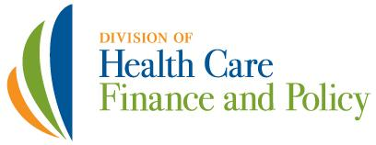

Massachusetts Division of Health Care Finance and Policy

Division of Health Care Finance and Policy
Two Boylston Street
Boston, MA 02116
Phone: (617) 988-3100
Fax: (617) 727-7662
Website: www.mass.gov/dhcfp .

Publication Number: 12-283-HCF-02
Authorized by Gary Lambert, , State Purchasing Agent

This publication is available online at http://www.mass.gov/dhcfp .
When printed by the Commonwealth of Massachusetts, copies are printed on recycled paper.

