Health Safety Net (HSN) Bad Debt User Guide
January 25, 2019

Revision History
January 25th, 2019 | Break-out Bad Debt User Guide from combined Special Circumstances and Bad Debt user Guide.
January 25, 2019 | Added MMIS Id and MMIS ID Checked fields to: 1) web form, and 2) Batch Upload File.
March 22, 2019 | Review and edit.

Health Safety Net (HSN) Bad Debt User Guide January 25, 2019 1
Revision History 1
Overview 4
IE 8 4
How to Prepare for Application Submission 4
Determine Residency and Availability of Patient Information 4
Screenshot of Options 5
Collect Required Information 5
Determine Whether Patient has an MMIS ID 6
Collection Period Verification 6
Example 6
How to Access the Bad Debt Application 7
How to Manually Submit an Application 7
How to Enter Applications for Non-U.S. Residents 10
How to Enter Applications with Insufficient Information 11
Validation 12
Form Level Validation 13
MMIS Id Validation 13
“I could not find an MMIS ID for the patient” checkbox 13
Validation Action 13
Duplicate Validation 14
How to Batch Upload Applications 14
How to Export Applications 15
How to View Applications 16
How to Search for Applications 17
Search by Application Ids 17
Search by Name 17
Search by SSN 17
Display All Applications 17
Batch Upload File CSV Format 18
Batch File Upload Columns 18
Example Batch Upload CSV File 20
20
Races 20
States 20

Overview
This User Guide describes how to:
- IE 8
- Prepare for submitting applications.
- Access the Bad Debt web application.
- Submit bad debt applications.
- Batch upload multiple applications.
- Export existing applications to a CSV file.
- View existing applications.

IE 8
The Bad Debt application has been designed to work exclusively with IE 8. If you use another browser and experience problems you may want to consider switching to IE 8.

How to Prepare for Application Submission
- Determine residency and availability of patient information.
- Collect required information.
- Determine whether patient has an assigned MMIS ID.

Determine Residency and Availability of Patient Information
When you enter a Bad Debt application you must indicate whether you have all patient information and whether the patient resides in the US.
Bad Debt displays three options:
- “By selecting this option, provider affirms that they have exhausted all efforts and have been unable to capture patient information.”
This option should be selected when a provider does not have patient information as noted in No Patient Information below.
- “By selecting this option, provider affirms that patient is not a resident of the United States.”
This option should be selected when a provider is submitting a bad debt application for a patient who is not a resident of the United States (please refer to Non-US Residents below).
- “None of the above”
This button should be selected when a provider has all required information (as noted in Collect Required Information) for an individual residing in the United States.

Screenshot of Options
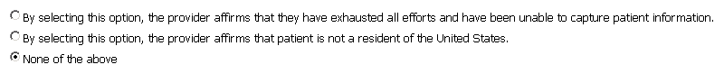

Collect Required Information
Based on the option you selected in the previous section you must collect the following information about the patient:
Information | Required for Option 1?  No Patient Information | Required for Option 2?  Non-US Resident | Required for Option 3?  US Resident
First Name | Auto-Filled | Yes | Yes
Middle Initial | Optional | Optional | Optional
Last Name | Auto-Filled | Yes | Yes
SSN | Auto-Filled | Yes, or 000000000 | Yes
Birth Date | Yes, estimated | Yes | Yes
Gender | Yes | Yes | Yes
MMIS Id | See MMIS ID Verification | See MMIS ID Verification | See MMIS ID Verification
MMIS ID Checked | See MMIS ID Verification | See MMIS ID Verification | See MMIS ID Verification
Street Address | Auto-Filled | Auto-Filled | Yes
City | Auto-Filled | Auto-Filled | Yes
State | Auto-Filled | Auto-Filled | Yes
Zip | Auto-Filled | Auto-Filled | Yes
Race | Yes | Yes | Yes

Check for MMIS ID
You must check whether a patient has an MMIS ID by searching the Eligibility Verification System (EVS) before you enter an application for the patient.

You must perform this check when you have full information about the patient.

When you enter a new application for a patient you will need to:
- Enter the patient’s MMIS Id;
- Or; specify you have checked for an MMIS ID for this patient.

To prepare for application submission:
- Obtain the patient’s first name, last name, and DOB.
- Search EVS by the patient’s first name, last name, and DOB.
- When you find a patient in EVS note the exact spelling of the first and last name and record the MMIS ID.

Collection Period Verification
Bad Debt now checks whether the new application you are entering is within or beyond the collection period since the last application was entered for the same patient.
The current collection period is 120 days.
You may enter additional applications for the same patient after 120 days of the previous application.

Example
Suppose you enter an application for Mary Test on January 1, 2019. Then you attempt to enter a second application for Mary on the dates in the table below:
App Entry Date | Description
February 1st, 2019 | Bad Debt detects the second application is within the 120 day collection period.  Bad Debt prevents you from entering the second application.
May 1st, 2019 | Bad Debt detects the second application is beyond the 120 day collection period.  Bad Debt saves the new second application (assuming all other patient information is valid).

How to Access the Bad Debt Application
You must register with the INET system to enter Bad Debt applications. To register with INET, go to the Special Circumstances User Guide, INET User Registration section and follow the steps in that section to register. Once registered, follow these steps to log in to INET and navigate to the Bad Debt application.
- Log into INET as described in 2.1 Login to INET.
- Click on Special Circumstances Application menu item. See 2.2 INET Main Menu.
- INET System displays the Special Circumstances Welcome page.
- Click on Filing Application in the left menu.
- Click on Create\View Bad Debt Applications.
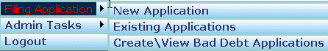
- The INET system displays the Bad Debt Welcome web form.

Once you are on the Bad Debt Welcome web form you can:
- Submit a new application.
- View existing applications.
- Batch upload applications.
- Export applications to a CSV file.

- Return to the INET Main menu.

How to Manually Submit an Application
This section describes how to enter bad debt applications manually.
This submission process is for patients for which you have all patient information. For patients who reside outside the U.S. or patients for whom you don’t have all information see the later sections.
You should prepare to enter an application by following the instructions provided in “How to Prepare for Submitting Applications.
Once you have collected all required patient information, providers can enter the application following these steps:
- Log into INET and navigate to the Bad Debt application as described in How to Access the Bad Debt Application.
- Click on New Application menu item.
- Bad Debt displays the initial page of the application.
- Select the provider you want to use for this application.
- Bad Debt automatically fills in the current date for the application date.
- Click on Submit.
- Bad Debt displays web form 2 of the application.
Since you have all patient information leave the option “None of the above” selected.
When you don’t have all patient information go to “How to Enter Applications When You’re Lacking Information”.
When the patient is a non-U.S. resident go to “How to Enter Applications for Non-U.S. Residents”.
- Enter the patient’s information into the form.
Enter birth date in the format mm/dd/yyyy.
Enter SSN in the format 000000000.
- When you determined the patient has an MMIS ID:
  - Enter the patient’s MMIS Id;
  - and; leave the “I could not find an MMIS ID for this patient.” checkbox unchecked.
- When you determined the patient does not have an MMIS ID:
  - Leave the MMIS Id field blank;
  - and; check the “I could not find an MMIS ID for this patient.” checkbox.
- Enter the patient’s street address, city, state, and 5-digit zip code.
- Click on the Submit button.
- Bad Debt validates patient information. If errors are detected, Bad Debt displays error messages below each field with an error. Correct these errors and then click on the Submit button again.
- Bad Debt matches the patient data you entered to the EVS patient data when you key in an MMIS ID. Bad Debt matches these fields:
  - First name
  - Last name
  - DOB
  - Gender
- When the items you entered does not match the EVS patient data, Bad Debt displays errors indicating which things don’t match.
- Bad Debt checks for duplicate applications by comparing application you entered to existing applications in Bad Debt. When a duplicate application is detected Bad Debt displays an error message. Update the application and attempt to submit it again. See Duplicate Applications below for more information.
- When the patient information is valid, Bad Debt saves the patient information and displays a confirmation page indicating the information was successfully saved and displays the application id.
You may want to save the Bad Debt application id for future reference.
- Providers needing to enter more applications should click on New Application and repeat the process.

How to Enter Applications for Non-U.S. Residents
There may be cases where a patient has a non-U.S. (foreign) address. For these cases only, providers should perform the following steps.
- Log into INET and navigate to the Bad Debt application as described in How to Access the Bad Debt Application.
- Click on New Application.
- Bad Debt displays page 1 of the application.
- Bad Debt automatically fills in the application date with the current date.
- Select the provider you want to use for this application.
- Bad Debt displays web form 2 of the application.
  - Select option 2: “By selecting this option, provider affirms that patient is not a resident of the United States.”
  - The system populates the address, city, state and zip code fields with the provider’s address information.
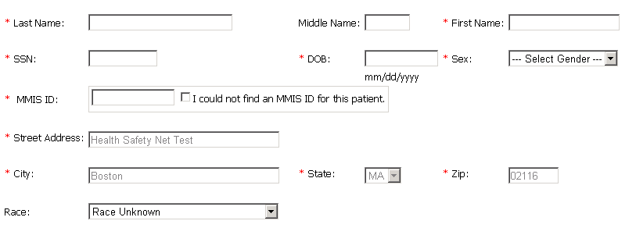
NOTE: HSN staff may, at any time, request written proof from a provider verifying that a patient is not a resident of the United States.
- Enter the patient’s name, SSN and birth date. When the patient doesn’t have an SSN enter 000000000.
- Select the gender of the patient.
- Select the race of the patient.
- Click Submit.
- Bad Debt validates the patient information.
See Validation below for more information.
- When all patient information is valid, Bad Debt saves the patient information and displays a confirmation page indicating the information was successfully saved and displays an application id. You may want to keep the application id for future reference.

How to Enter Applications with Insufficient Information
There may be cases where you do not have full patient information to submit a Bad Debt application. These cases should be rare and occur after you have performed due diligence and exhausted all available means of trying to collect patient information. For these cases only, providers should complete the following steps.

- Log into INET and navigate to the Bad Debt application as described in How to Access the Bad Debt Application.
- Click on New Application.
- Bad Debt displays page 1 of the application.
- Bad Debt automatically fills in the application date with the current date.
- Select the provider you want to use for this application.
- Bad Debt displays page 2 of the application.
- Check option one at the top of the web form labeled: “By selecting this option, provider affirms that they have exhausted all efforts and have been unable to capture patient information.”

- Bad Debt fills in the first name, last name, street address, city, state, and zip code with the name and address of the provider you selected on page 1 of the application.
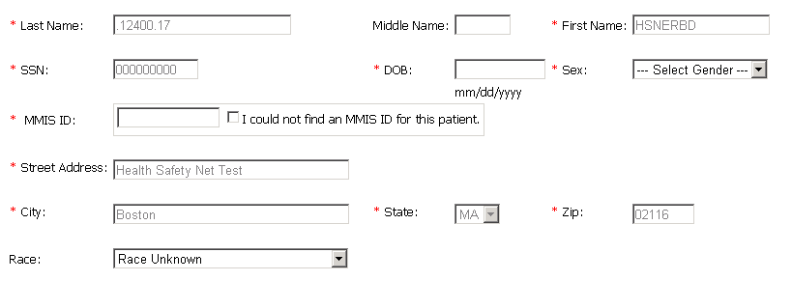
- Bad Debt fills in 000000000 for the SSN.
- Enter the estimated birth date of the patient.
- Select the gender of the patient.
- Select the race of the patient.
- Click Submit.

- Bad Debt validates the information you entered. If any patient information is invalid, Bad Debt displays error messages below the fields with errors.
- When all patient information is valid, Bad Debt saves the patient information and displays a confirmation page. The confirmation page informs the user of the successfully saved information.
- HSN BAD DEBT CLAIMS FOR THE CASES ABOVE (WHERE PATIENT INFORMATION IS NOT AVAILABLE) SHOULD NEVER BE SUBMITTED UNLESS A PROVIDER HAS SUBMITTED A BAD DEBT APPLICATION AS NOTED ABOVE.

Validation
When you click on the Submit button to submit an application Bad Debt validates the patient information as follows:
- Form Level Validation
- MMIS ID Validation
- Duplicate Validation

Form Level Validation
Bad Debt validates the individual fields first as follows:
Field | Validation Description
First name  Last name  Street Address  City | Bad Debt validates that these fields contain a value.
SSN | The SSN is nine digit value
Birth Date | The birth date is a valid date and is not in the future.
MMIS Id | The MMIS Id is a 12-digit value.
Zip | The Zip is a five digit value.
Bad Debt displays errors when any of the above validations fail.
Correct the problems and click Submit again.

MMIS Id Validation
Bad Debt performs the next level of validation once the first level validation succeeds.
“I could not find an MMIS ID for the patient” checkbox | Validation Action
Checked | Bad Debt performs Duplicate Validation.
Unchecked | Bad Debt matches the patient’s first name, last name, and DOB with the patient information available in our systems.  When this validation fails Bad Debt displays a list of patient data items which do not match our patient information.

Duplicate Validation
Bad Debt checks for duplicate applications by comparing the application you entered to existing applications. When a duplicate application is detected Bad Debt displays an error message.
Update the application and attempt to submit it again.

How to Batch Upload Applications
This section describes how to batch upload multiple applications.
- Prepare a CSV file containing the Bad Debt applications to be uploaded based on the table titled Batch File CSV File Format below.
- Log into INET and navigate to the Bad Debt application as described in How to Access the Bad Debt Application.
- Click on Batch File Upload menu item.
- Select the provider for these applications.
- Click on the Browse button and browse to the Bad Debt CSV file on your system that you created in step 1.
- Click on the Upload button.
- Bad Debt reads and validates the CSV file. When errors are detected Bad Debt displays those errors at the bottom of the page. Correct the problems and attempt to upload the CSV file again.
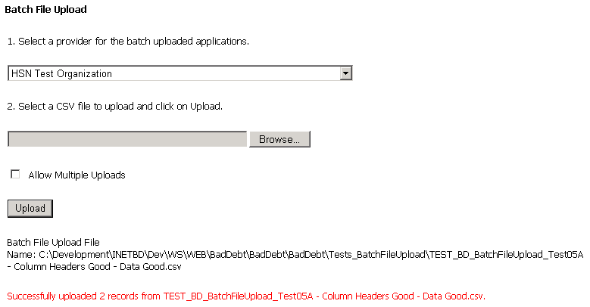
- Bad Debt validates the patient information per the Validation section above.
- When no errors are detected Bad Debt saves the Bad Debt applications and displays a message indicating the number of applications read from the CSV file and saved successfully.
- NOTE: Batch upload applications cannot be submitted for cases where no patient information is available or for patients with a foreign address.

How to Export Applications
This section describes how to export the applications submitted to HSN to a CSV file.
- Log into INET and navigate to the Bad Debt application as described in How to Access the Bad Debt Application.
- Click on Export Applications menu item.
- Click on Export button.
- Bad Debt retrieves all applications you submitted to HSN, generates a CSV file, and sends the CSV file to your browser.
- Your browser should display a dialog box at the bottom of your browser with the question: “Do you want to open or save BadDebtApplications.csv from <Computer-Name>?” where <Computer-Name> is the name of your computer.
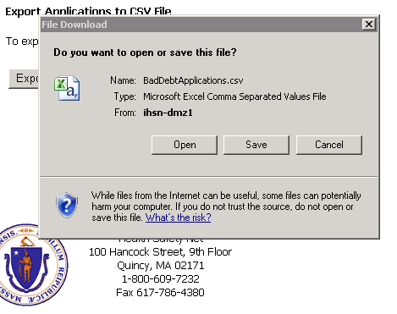
- If you want to save the CSV file to your download folder click on Save.
- If you’re going to keep the CSV file to a folder other than your download folder click on the down arrow in the Save button and select Save As.
- Internet Explorer displays a Save As file dialog box.
- Select the folder where you want to save the CSV file.
- Change the file name if you desire to rename it.
- Click on the “save” button to complete the download and save the CSV file to your computer.

How to View Applications
This section describes how to view applications submitted to HSN.
- Log into INET and navigate to the Bad Debt application as described in How to Access the Bad Debt Application.
- Click on Existing Applications.
- Bad Debt displays all applications you entered into the system.
- You can search for applications by Application ID, First Name, Last Name, or SSN.
- You can page through the applications by clicking on the Previous or Next clicks at the top or bottom of the applications data grid.
- Click on View button on the row of the application you want to view. Bad Debt will display the application information. You will not be able to edit the application information.

How to Search for Applications

Search by Application Ids
- Select Application ID in the Field drop down list.
- Select the appropriate matching operation in the Operation drop down list.
- Enter the application id into the criteria text box.
- Click on Search.
- Bad Debt searches for and displays the specified application.

Search by Name
- Select First Name or Last Name in the Field drop down list.
- Select how you want Bad Debt to match on the name in the Operation drop down list.
- Enter the patient’s first name or last name into the criteria text box.
- Click on Search.
- Bad Debt locates the desired applications by matching on the first or last name and displays the records it finds.

Search by SSN
- Select SSN in the Field drop down list.
- Select the desired matching operation in the Operation drop down list.
- Enter the SSN with or without hyphens: 000000000 or 000-00-0000 into the criteria text box.
- Click on the Search button.
- Bad Debt locates the desired applications by looking for matching SSNs and displays the records it finds.

Display All Applications
To display all applications you entered into the system:
- Click on Display All button.

Batch Upload File CSV Format
You must follow these rules when creating a CSV Batch Upload File:
- Create the CSV file using a text editor like notepad, or you may generate the CSV by a software program.
- The first record in the CSV must contain the column headers as shown in the table below.
- Separate the column header names with a comma.
- Spell the column header names precisely as shown in the table below.
- Write the column header names in the case exactly as shown in the table below. For example, for “last name” the name must be “Last Name”.
- List the column headers in the order shown in the table below.
- The 2nd and subsequent records must contain the patient records you want to submit to HSN as Bad Debt applications.
- You must create separate CSV batch files for each provider for which you desire to submit Bad Debt applications.
- The number of characters in each data item must be less than or equal to the maximum length of the field as listed in the Length column in the table below.
- You must separate data items with a comma.
- You must surround each data item with double quotes.
- You can put as many records into the CSV file as you desire as long as they are for one provider.
- Name the file as you desire.
- The file extension must be “csv”. Example: BadDebts.csv.

Batch File Upload Columns
This table describes the Batch File Upload columns:
Column | Column Header | Length | Required? | Description
A | Last Name | 20 | Yes | The patient’s last name.
B | First Name | 15 | Yes | The patient’s first name.
C | Middle Initial | 1 | No | The patient’s middle initial.
D | Street Address | 30 | Yes | The patient’s street address.
E | City | 30 | Yes | The patient’s city.
F | State | 2 | Yes | Two-letter state abbreviation. Use Code from States table below.
G | Zip | 5 | Yes | 5-digit zip code.
H | Birth Date | 8 | Yes | Format YYYY-MM-DD.  Example: If the person was born on May 12, 1956, the birth date is formatted like 1956-05-12.  The birth date must be equal to or greater than January 1, 1912.
I | Gender | 1 | Yes | M or F.
J | SSN | 9 | Yes | You may leave out hyphens between the number groups, or you may use hyphens:  Examples:  000000000  000-00-0000
K | Race | 6 | Yes | Use the Code from the Races table below. Example: When the patient is Caucasian put WHITE into this column.
L | MMIS Id | 12 | Maybe | The 12-digit MMIS Id.  See MMIS ID Verification for detailed instructions on how to fill in this column.
M | MMISID_Checked | 1 | Maybe | T or F.  See MMIS ID Verification for detailed instructions on how to fill in this column.

Example Batch Upload CSV File
Your Batch Upload File should like something like this:

Races
Use these codes for the Races column in the Batch Upload CSV File.
Description | Code
Race Unknown | UNKNOW
Asian or Pacific Islander | ASIAN
Black-Not of Hispanic Origin | BLACK
Hispanic | HISPAN
American Indian or Alaskan American | INDIAN
Interracial | INTER
Caucasian | WHITE

States
Use these codes for the State column in the Batch Upload CSV file.
Full State Name | Code
Alaska | AK
Alabama | AL
Arkansas | AR
Arizona | AR
California | CA
Colorado | CO
Connecticut | CT
District of Columbia | DC
Delaware | DE
Florida | FL
Georgia | GA
Guam | GU
Hawaii | HI
Iowa | IA
Illinois | IL
Indiana | IN
Kansas | KS
Kentucky | KY
Louisiana | LA
Massachusetts | MA
Maryland | MD
Maine | ME
Michigan | MI
Minnesota | MN
Missouri | MO
Mississippi | MS
Montana | MT
North Carolina | NC
North Dakota | ND
Nebraska | NB
New Hampshire | NH
New Jersey | NJ
New Mexico | NM
Nevada | NV
New York | NY
Ohio | OH
Oklahoma | OK
Oregon | OR
Pennsylvania | PA
Puerto Rico | PR
Rhode Island | RI
South Carolina | SC
South Dakota | SD
Tennessee | TN
Texas | TX
Utah | UT
Virginia | VA
Virgin Islands | VI
Vermont | VT
Washington | WA
Wisconsin | WI
West Virginia | WV
Wyoming | WY

