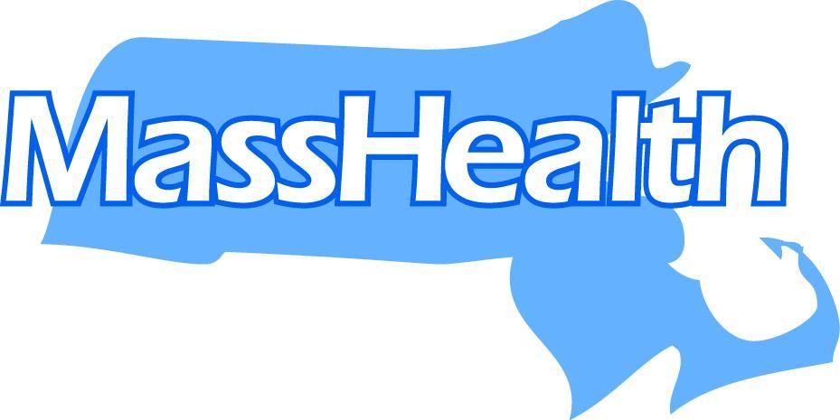
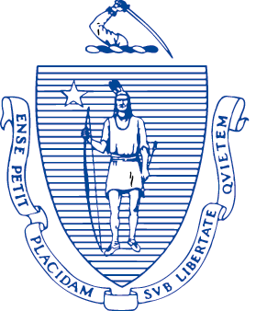
The Commonwealth of Massachusetts
Executive Office of Health and Human Services

Office of Medicaid, Health Safety Net

100 Hancock Street, 9th Floor

Quincy, Massachusetts 02171

Dr KIAME MAHANIAH, MD, MBA
Secretary for MassHealth

MIKE LEVINE
Undersecretary for MassHealth

www.mass.gov/eohhs

MAURA HEALEY
Governor

KIM DRISCOLL
Lieutenant Governor

Secretary

Health Safety Net Active Dental Facility October 2025

HSN Massachusetts Dental Locations (2025)
City/Town | Organization Name | Street Address | Zip Code | Phone Number
Boston | Boston Health Care for the Homeless Program | 780 Albany St | 02118 | 857-654-1609
Brockton | Brockton Neighborhood Health Center | 63 Main St. | 02301 | 508-559-6699
Boston (Jamaica Plain) | Brookside Community Health Center | 3297 Washington St | 02130 | 617-983-6070
Cambridge | Cambridge Health Alliance Dental Clinic | 119 Windsor St. | 02139 | 617-665-3990
Springfield | Caring Health Center - Adult Medicine | 1049 Main St. | 01103 | 413-739-1100
Springfield | Caring Health Center - Forest Park at the "X" | 473 Sumner Ave. | 01108 | 413-739-1101
Boston (Brighton) | Charles River Community Health - Allston/Brighton | 495 Western Ave | 02135 | 617-783-0500
Waltham | Charles River Community Health - Waltham | 43 Foundry St. | 02452 | 781-693-3800
Boston (Dorchester) | Codman Square Health Center | 637 Washington St. | 02124 | 617-822-8142
Mashpee | Community Health Center of Cape Cod Dental Clinic | 107 Commercial St | 02649 | 508-539-6050
Greenfield | Community Health Center of Franklin County Greenfield Dental Clinic | 102 Main Street | 01301 | 413-325-8500
Orange | Community Health Center of Franklin County Orange Dental Clinic | 119 New Athol Road | 01364 | 978-544-1576
Great Barrington | Community Health Programs (CHP) Dental Center | 343 Main St. | 01230 | 418-528-5565
Boston (Dorchester) | DotHouse Health | 1353 Dorchester Ave | 02122 | 617-740-2320
Framingham | Edward M. Kennedy Community Health Center - Waverly Street | 354 Waverly Street | 01702 | 800-853-2288
Worcester | Edward M. Kennedy Community Health Center - Lincoln St. | 605 Lincoln Street | 01605 | 508-595-1115
Worcester | Edward M. Kennedy Community Health Center - Tacoma St. | 19 Tacoma St. | 01605 | 508-595-1115
South Dennis | Ellen Jones Community Dental Center (affiliated with Harbor Health Services) | 516 Route 134 Ste 12 | 02660 | 508-778-5400
Worcester | Family Health Center of Worcester | 26 Queen St., 3rd Floor | 01610 | 508-860-7910
Boston | Fenway Health Ansin Building | 1340 Boylston St. 6th Floor | 02215 | 617-927-6127
Fitchburg | Fitchburg Community Health Center (affiliated with Community Health Connections) | 326 Nichols Rd. | 01420 | 978-878-8420
Boston (Dorchester) | Geiger Gibson Community Health Center | 250 Mount Vernon St | 02125 | 617-288-1140
Gloucester | Gloucester Family Health Center (affiliated with North Shore Community Health) | 302 Washington St. | 01930 | 978-282-8899
Gardner | Greater Gardner Community Health Center (affiliated with Community Health Connections) | 175 Connors St. | 01440 | 978-410-6100
New Bedford | Greater New Bedford Community Health Center | 874 Purchase St. | 02740 | 508-984-7031
Boston (Roslindale) | Greater Roslindale Medical and Dental Center | 4199 Washington St. | 02131 | 617-323-4440
Hyannis | Harbor Community Health Center - Hyannis | 735 Attucks Ln. | 02601 | 508-778-5440
Plymouth | Harbor Community Health Center - Plymouth | 10 Cordage Park | 02360 | 508-778-5470 (TTY 508-778-5472)
Boston (Dorchester) | Harvard Street Neighborhood Health Center | 632 Blue Hill Ave | 02121 | 617-825-3400
Fall River | Health First Family Care Center | 387 Quarry St. | 02723 | 774-627-1262
Holyoke | Holyoke Health Center | 230 Maple St. | 01040 | 413-420-2200
Huntington | Hilltown Community Health Center at Huntington | 73 Russell Road | 01050 | 413-667-3009
Edgartown | Island Health Care Dental Center | 1 Mariners Landing, Unit D | 02539 | 508-939-8597
Leominster | Leominster Community Health Center (affiliated with Community Health Connections) | 165 Mill Street | 01453 | 978-878-8100
Lynn | Lynn Community Health Center | 269 Union St. | 01901 | 781-581-9832
Boston (Mattapan) | Mattapan Community Health Center | 1575 Blue Hill Ave | 02126 | 617-296-0061
Boston | NeighborHealth East Boston | 20 Maverick Sq | 02128 | 617-568-4515
Boston | NeighborHealth South End | 1601 Washinton Street | 02118 | 617-425-2000
Boston | North End Waterfront Health | 332 Hanover St. | 02113 | 617-643-8070
Provincetown | Provincetown Health Center (affiliated with Outer Cape Community Health Center) | 49 Harry Kemp Way | 02657 | 508-487-9395
Salem | Salem Family Health Center (affiliated with North Shore Community Health Center) | 47 Congress St. | 01970 | 978-744-8388
Boston | South Boston Community Health Center | 409 West Broadway | 02127 | 617-464-5825
Quincy | South Cove North Quincy Clinic | 88 Holmes St. | 02171 | 617-318-3200
Boston | South Cove South Street Clinic | 145 South St. | 02111 | 617-521-6730
Boston | South End Community Health Center | 1601 Washington St. | 02118 | 617-425-2050
Roxbury | The Dimock Center | 45 Dimock St. | 02119 | 617-442-8800 x2005
Dorchester | Upham's Corner Health Center Dental Clinic | 636 Columbia Rd. | 02125 | 617-825-9839
Boston | Whittier Street Health Center | 1290 Tremont St. | 02120 | 617-989-3240
Worthington | Worthington Health Center (affiliated with Hilltown Community Health Center) | 58 Old North Road | 01098 | 413-238-5511

