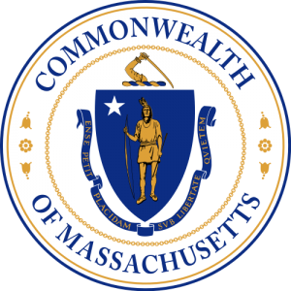

Commonwealth of Massachusetts
Harbormaster Training Council

OPEN MEETING NOTICE

Under the provisions of M.G.L. c. 30A, the Harbormaster Training Council
will conduct an Open Meeting, to wit:

DATE: November 19, 2020

DAY: Thursday

PLACE: Virtual meeting – Zoom
Join Zoom Meeting
https://zoom.us/j/94946159908?pwd=YmZiYkdNNzZJeWI5cmtZL2RLUWc1Zz09
. Meeting ID: 949 4615 9908
. Passcode: 625675
. One tap mobile
. +19292056099,,94946159908# US (New York)
. +13017158592,,94946159908# US (Washington D.C)

TIME: 1:00 p.m. – 2:30 p.m.

AGENDA

- Call to Order
- Review and approve minutes September
- Waiver/Exemption Applications
- MPTC Acadis online system
- New Business -Member Comments
- Public Comments
- Next meeting - December
- Adjournment

Chad Hunter - Chairman

