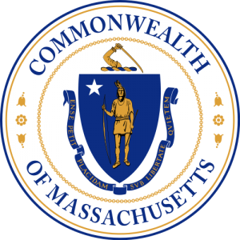
Chairman
Chad Hunter
South Shore

Vice Chairman/Clerk
Rosemary Lesch
North Shore

Members
William McHugh
North Shore

Robert Gillan
South Shore

Jason Holm
Cape & Islands

Charles Blair
Cape & Islands

Joseph Cheevers
Boston

James Concannon
State Police

Robert Akin
Environmental Police

Daniel Zivkovich
EOPSS

US Coast Guard

Commonwealth of Massachusetts
Harbormaster Training Council

OPEN MEETING NOTICE

Under the provisions of M.G.L. c. 30A, the Harbormaster Training Council
will conduct an Open Meeting, to wit:

DATE: October 10, 2019

DAY: Thursday

PLACE: Weymouth Police Station
140 Winter St
Weymouth, MA

TIME: 11:00 a.m. – 1:00 p.m.

AGENDA

- Call to Order
- Review and approve minutes June 5, 2019
- Waiver/Exemption Applications
- Learning Management System (LMS) update
- Establish goals for 2019-2020
- Council Appointment terms
- New Business -Member Comments
- Public Comments
- Next meeting- November
- Adjournment

Chad Hunter - Chairman

