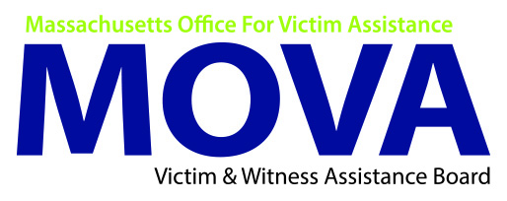

FY2021 Human Trafficking Trust Fund (HTTF)
Intent to Apply

Agency Information
Legal Name:
Program:
Approx. Funding Request:
Program Contact Information
Name:
Title:
Phone:
E-mail:
Executive Director/Agency Leadership
Name:
Date:
Signature:

The intent to apply form is non-binding. The actual funding request may increase or decrease as a budget is prepared, and final application is submitted. All applicants are strongly encouraged to submit a letter of intent by March 16, 2020. Failure to do so may impact the review process.

Submit to:
Kristen Tavano, Senior Grants Procurement Manager
E-mail: kristen.tavano@mass.gov

It is not necessary to submit an original copy. Confirmation of receipt will be e-mailed to the program contact identified above.

** Applications are due no later than 5:00 p.m. on Monday March 30, 2020**

