**INDOOR AIR QUALITY ASSESSMENT**

**Hudson Town Hall**

**78 Main Street**

**Hudson, MA**

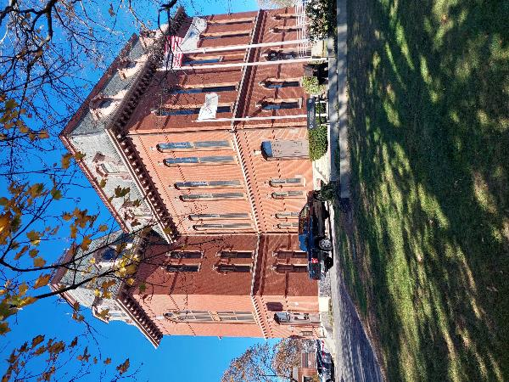

Prepared by:

Massachusetts Department of Public Health

Bureau of Climate and Environmental Health

Division of Environmental Health Regulations and Standards

February 2025

**BACKGROUND**

|  |  |
| --- | --- |
| **Building:** | Hudson Town Hall (HTH) |
| **Address:** | 78 Main Street, Hudson, MA |
| **Assessment Coordinated Via:** | Hudson Health Department |
| **Reason for Request:** | Water damage and general indoor air quality (IAQ) concerns |
| **Date of Assessment:** | November 8, 2024 |
| **Massachusetts Department of Public Heath/Bureau of Climate and Environmental Health (MDPH/BCEH) Staff Conducting Assessment:** | Michael Feeney, Special Advisor to the Bureau, BCEH |
| **Building/Site Description:** | The HTH is a three-story brick building with basement. It was originally constructed in 1872. Later renovations in 1999 included wall-to-wall carpeting over maple tongue-in-groove floors. The basement contains records that are located in an area with wall-to-wall carpeting that had been used as office space. An underground indoor space (subbasement) is located below the rear parking lot and is connected to the basement by a short hallway and is used for storage. |
| **Windows:** | Openable |

# METHODS

IAQ staff conducted a visual inspection of rooms with reported mold odors to identify sources of moisture that would moisten materials in the building to cause mold growth. Please refer to the IAQ Manual and appendices for methods, sampling procedures, and interpretation of results (MDPH, 2015).

**RESULTS AND DISCUSSION**

## Ventilation

It is important to note that the HTH was originally designed to use cross-ventilation to provide comfort for building occupants. The HTH is equipped with windows on opposing exterior walls. This design allows airflow to enter an open window, pass through a room, and exit the building through a window on the opposite side. With all windows and hallway doors or transoms (windows from rooms into hallways typically above room doors) open, airflow can be maintained in a building regardless of the direction of the wind. The system fails if the windows or hallway doors are closed. Rooms have radiators beneath windows which provide heat.

One area of the basement has both a supply diffuser and a return vent (Pictures 1 and 2) connected to a basement air handling unit (AHU). This system was not activated during the assessment, potentially indicating that it was used for air chilling during hot weather. Note that if this system is operating such that the exhaust vent is drawing more air than fresh air is being supplied, it can *depressurize* the space and draw air and water vapor though exterior wall openings.

## Microbial/Moisture Concerns

### Basement conditions

HTH has a basement with a connected subbasement. The lowest levels of buildings constructed with field stone and brick foundations like HTH have a tendency to become moistened with condensation during hot, humid weather. For this reason, building materials used when the HTH was constructed are typically materials that are resistant to mold growth such as stone, hardwood (e.g., maple), brick with mortar joints, plaster, and/or cement. However, the basement was later renovated to install building materials that may serve as mold growth media if moistened, including: wall-to-wall carpeting, wood paneling, and cellulose ceiling tiles.

The subbasement contains a substantial amount of materials that can support mold growth including: books, carboard and paper. A number of cardboard boxes containing paper were found stored on cement floors. Each of these materials may become mold colonized if moistened for over 24 hours.

Note that a dehumidifier is installed in the subbasement to reduce relative humidity. The dehumidifier has a drainage hose that empties into a floor drain (Picture 3). Dehumidifiers need to be kept clean to avoid stagnant water and associated odors.

No means of mechanical fresh air or natural ventilation from openable windows exists in the subbasement. In addition, basements can be subject to significant water vapor sources that can moisten materials from the following:

* The basement has a bulkhead covered with plywood (Picture 4). Rainwater dripping from the overhead fire escape likely passes through the bulkhead to enter the basement.
* A number of electrical services enter the basement though a former basement window (Picture 5). Spaces around conduit and widow frame are likely repeatedly moistened from rain dripping from the fire escape. A significant amount of accumulated debris likely prevents the window frame wood from drying which increases the likelihood of wood frame mold growth as possible water penetration into the basement.
* Water service enters the basement through fieldstone with spaces that can allow for water vapor to enter the basement (Picture 6). The fieldstone is missing mortar and is not parged walls (the application of a cement coating, which is applied over a wall surface, such as over a foundation, or exterior wall). In this condition rainwater and soil water vapor can readily enter the basement to wet building materials.
* The subbasement ceiling has signs of chronic water leaks (Picture 7). The ceiling is underneath the tarmac of the rear parking lot (Picture 8). Cracks in the tarmac correspond to water damage in the subbasement ceiling.
* Plants were noted growing between the exterior wall and tarmac seam. Plant growth indicates water accumulation in this seam which then can migrate indoors through the fieldstone foundation.

Where possible, rainwater should be prevented from direct contact with building walls. Shifting roof rainwater drainage away from the foundation wall reduces water penetration. Water should drain at least five feet from the foundation walls.

In addition, if a building lacks adequate exhaust ventilation and air chilling capacity to reduce relative humidity from outside air, then hot, moist air can be introduced into a building and linger to increase occupant discomfort. Excess humidity can also moisten materials that may lead to mold growth, particularly in areas that are in direct contact with soil (e.g., basement floor and walls).

### Mold Testing Recommendations

The presence of mold does not necessarily indicate a problem. Visual evidence of mold growth and/or the presence of musty odors are reliable indicators of mold problems that are correlated with health risks in buildings where indoor environmental complaints have been made. Mold spores waft through the indoor and outdoor air continually. There is no practical way to eliminate all mold and mold spores in the indoor environment; the way to control indoor mold growth is to control moisture (U.S. EPA, 2024).

There is no means by which to determine whether an individual’s symptoms or reactions were caused by mold by conducting environmental air testing for mold. While mold, spores, and other associated materials can make allergies and asthma symptoms worse, different people react differently to mold and mold spores. In addition to mold, reactions experienced by individuals could be caused by bacteria, other compounds in the air caused by the breakdown of wet building materials, or something different altogether (NIOSH, 2024; California DPH, unknown; Mendell, M. J., Mirer, A. G., Cheung, K., & Douwes, J. 2011; WHO, 2009).

The U.S. Environmental Protection Agency (EPA) does not recommend testing. DPH follows the guidelines contained in the U.S. EPA Mold Remediation in Schools and Commercial Buildings report for cleaning and removing water-damaged materials. US EPA’s guidelines recommend, in most cases, that if visible mold growth is present, mold sampling is not necessary. A number of international, US federal, and state agencies either do not have or recommend against conducting mold testing as part of mold remediation (see References with headings of: Agencies with guidelines recommending against mold testing and References from government agencies, industrial hygiene groups and/or other environmental professional guidelines that denote that no mold exposure limits have been established for mold in workplaces, government buildings, or residences). For example, the U.S. Department of Housing and Urban Development (HUD) does not recommend conducting environmental mold testing.

*“No matter what kind of mold you have, you need to get rid of it and fix the moisture problems that made it grow. Most experts think it’s better to spend your time and money on cleaning up the problem than testing”* (HUD, 2024).

In addition, multiple worker safety agencies and organizations have no worker safety air levels established for exposure to species of mold. The following agencies and professional industrial hygiene agencies have not established mold exposure levels in the workplace that would justify air testing. The following industrial safety guidelines do not list any mold species and air level concentrations:

* US Occupational Safety and Health Administration (OSHA) has not established any mold Permissible Exposure Limits (PELs) for mold air levels.
* American Conference of Governmental Industrial Hygienists (ACGIH) has no established Threshold Limit Values (TLVs) for mold air levels.
* National Institute of Occupational Safety and Health (NIOSH) has no established Recommended Exposure Limits (RELs) for mold air levels.
* American Industrial Hygiene Association (AIHA) has no established Workplace Environmental Exposure Levels (WEELs) for mold air levels.

In addition, even if worker safety exposure limits existed for mold, such guidelines **would not apply** to non-employees in a building. These individuals include students in primary education schools; students in secondary education facilities; adults outside worker ages as defined by OSHA; individuals with chronic health conditions; patients in any medical facility; adults who are invitees, customers, or visitors to the workplace and other members of the general public.

For non-employees, there are **no established mold exposure limits** (international, federal, or state regulations, building standards or guidelines) on how much mold can exist in air before health impacts are expected for the general population. In addition, no international, federal, state, or building standards agency have established mold remediation clean-up levels that must be achieved after mold remediation efforts are completed.

This means that even if tests are conducted, there is no way to compare results or determine whether the measured level could cause health effects or meet clean-up levels. Multiple federal agencies, including the US EPA, US Department of Housing and Urban Development and the US Federal Emergency Management Agency (FEMA) have not established mold exposure standards or recommend environmental mold testing in any water damage/flood recovery guidelines. With no established worker or general public safety exposure limits, air testing will not influence how mold remediation efforts would be conducted.

In order to remove mold from buildings, of primary importance is to identify, repair and/ or limit the moisture source causing damage in the building. Once the moisture source is remediated, then discarding and/or cleaning of mold contaminated materials can be completed.

## Other Concerns

Basement areas had carpeting that appeared to be several decades old. In many areas, this carpeting was visibly very worn, frayed, wrinkled, and stained. The service life of carpeting in schools is approximately 10-11 years (IICRC, 2002) and will be similar in an environment such as a town hall. Aging carpet can produce fibers that can be irritating to the respiratory system. In addition, torn or lifting carpet can create tripping hazards. Carpeting should be cleaned annually or semi-annually in soiled high traffic areas as per the recommendations of the Institute of Inspection, Cleaning and Restoration Certification (IICRC, 2012).

# CONCLUSIONS/RECOMMENDATIONS

HTH has a number of issues related to moisture in the building. Management of buildings in such weather without a centralized HVAC system equipped with cooling capacity/air conditioning can be challenging during periods of extended hot, humid weather. With regard to possible mold issues, the following documents can provide guidance that can be used to reduce the impact of hot, humid weather in buildings.

* Mold Growth Prevention During Hot, Humid Weather <https://www.mass.gov/service-details/preventing-mold-growth-in-massachusetts-schools-during-hot-humid-weather>
* Remediation and Prevention of Mold Growth and Water Damage in Public Schools <https://www.mass.gov/service-details/remediation-and-prevention-of-mold-growth-and-water-damage-in-public-schools-and>
* Methods for Increasing Comfort in Non-air-conditioned Schools <https://www.mass.gov/doc/methods-for-increasing-comfort-in-non-air-conditioned-schools/download>

To remedy building problems, two sets of recommendations are made: **short-term** measures that may be implemented as soon as practicable and **long-term** measures that will require planning and resources to address overall IAQ concerns:

## Short Term Recommendations

### Ventilation recommendations

1. Consider having the HVAC system in the basement balanced to ensure that air removed from the space during operation is not more than air supplied to the space.
2. Use openable windows for fresh air during temperate weather. Ensure windows are closed tightly at the end of each day. Avoid opening windows during extreme cold, heavy rain, hot humid weather, or on days with poor outdoor air quality.
3. Avoid opening windows in areas where air conditioning is operating.

### Water damage recommendations

1. Use dehumidifiers with an appropriate capacity for volume for the basement as well as the sub-basement. Ensure that dehumidifiers properly drain accumulated water to prevent spillage/water accumulation in the floor. Monitor and clean dehumidifiers regularly to prevent spills and stagnant water/odors.
2. Do not store porous materials in the airflow of ceiling-mounted fresh air vents to prevent aerosolization of mold and possible moistening of paper and cardboard.
3. Refrain from storing materials on the basement or subbasement floor that can support mold growth, such as cardboard, paper, cloth, and other porous materials.
4. Consider installing weatherstripping and door sweeps on all basement access doors to prevent basement odors entering first floor areas.
5. Ensure that all basement area windows are intact with sealant to prevent water penetration. Ensure that all holes for building equipment such as conduits are sealed to prevent hot, humid air penetration into the basement. A fire-rated spray foam insulation may be used to seal such openings.
6. It is recommended that porous material be dried with fans and heating within 24 to 48 hours of becoming wet (US EPA, 2008, ACGIH, 1989). If porous materials are not dried within this time frame, mold growth may occur. Water-damaged porous materials cannot be adequately cleaned to remove mold growth. If porous materials are not dried within this time frame, they should be removed and discarded. Follow the guidance in “Mold Remediation in Schools and Commercial Buildings” published by the US EPA (2008) when performing mold remediation (<https://www.epa.gov/mold/mold-remediation-schools-and-commercial-buildings-guide>).
7. Considerations should be given to reducing the amount of stored records to prevent possible mold growth on cardboard and paper stored in the cellar of the building. In order to accomplish this goal, consult the MA Secretary of States webpage for a schedule of records retention: <https://www.sec.state.ma.us/divisions/archives/records-management/municipal-records.htm>.
8. Ensure that any sink and floor drains in the basement and elsewhere in the building have sufficiently wetted traps. Pour water into each drain a minimum of once a week to maintain trap integrity. Consider sealing or properly abandoning any sinks and drains that are no longer needed.
9. To prevent moisture penetration into the basement, the following actions should be considered:
   1. Seal all cracks in cement and asphalt in the parking lot above the subbasement.
   2. Seal all cracks in the foundation and the foundation/cement/tarmac junctions with an appropriate sealing compound.
   3. Remove foliage to at least five feet from the foundation.
   4. Improve the grading of the ground away from the foundation at a slope of 6 inches per every 10 feet (Lstiburek, J. & Brennan, T.; 2001).
   5. Install a water-impermeable layer on ground surface (clay cap) to prevent water saturation of ground near foundation (Lstiburek, J. & Brennan, T.; 2001).
10. Seal open holes in that exist in floors and walls between the basement and upper floors. This includes any utility holes. Ensure that the door to the basement remains closed at all times and use weatherstripping to increase airtightness.

### Other recommendations

1. Consider replacing any carpeting that is installed in the basement that is beyond its service life (i.e., > 11yrs.). If carpet is to be removed, confirm that no asbestos-containing floor tiles exist in underflooring. If asbestos tile exists, compliance with all applicable asbestos removal and disposal laws is recommended.
2. If carpet is retained, clean carpeting annually (or semi-annually in soiled high traffic areas) per the recommendations of the Institute of Inspection, Cleaning and Restoration Certification (IICRC, 2012).
3. In the winter in New England, periods of low relative humidity indoors are often unavoidable. Therefore, scrupulous cleaning practices should be adopted to minimize common indoor air contaminants whose irritant effects can be enhanced when the relative humidity is low. To control for dusts, a high efficiency particulate arrestance (HEPA) filter equipped vacuum cleaner in conjunction with wet wiping of all surfaces is recommended. Avoid the use of feather dusters. Drinking water during the day can help ease some symptoms associated with a dry environment (throat and sinus irritation).
4. Refer to resource manuals and other related indoor air quality documents for further building-wide evaluations and advice on maintaining public buildings. These materials are located on the MDPH’s website at <http://www.mass.gov/dph/iaq>.

## Long-Term Recommendations

1. Consult a building engineer on the appropriate method to regrade the HTH exterior to reduce rainwater penetration through the foundation.
2. Consult with a building engineer on further methods to permanently render the basement as watertight as feasible.
3. Consider a plan to replace aging carpeting in the building.

# REFERENCES

**General References**

Bishop. 2002. Bishop, J. & Institute of Inspection, Cleaning and Restoration Certification. A Life Cycle Cost Analysis for Floor Coverings in School Facilities.

IICRC. 2002. Institute of Inspection, Cleaning and Restoration Certification. A Life-Cycle Cost Analysis for Floor Coverings in School Facilities.

IICRC. 2012. Carpet Cleaning: FAQ. Institute of Inspection, Cleaning and Restoration Certification, Las Vegas, NV.

Lstiburek, J. & Brennan, T. 2001. Read This Before You Design, Build or Renovate. Building Science Corporation, Westford, MA. U.S. Department of Housing and Urban Development, Region I, Boston, MA. [Read This Before You Design, Build or Renovate](https://www1.eere.energy.gov/buildings/publications/pdfs/building_america/32114.pdf)

Massachusetts Department of Public Health (MDPH). 2015. Indoor Air Quality Manual: Chapters I-III. Available at: <https://www.mass.gov/lists/indoor-air-quality-manual-and-appendices>.

**Mold Testing References**

ACGIH, 1989. Guidelines for the Assessment of Bioaerosols in the Indoor Environment. American Conference of Governmental Industrial Hygienists, Cincinnati, OH

ASHRAE, 1985. ASHRAE Transactions. Optimum Relative Humidity Ranges for Health. American Society of Heating, Refrigeration and Air Conditioning Engineers. Vol. 91, Part 1B.

CA DPH, unknown. California Department of Public Health Statement on Building Dampness, Mold, and Health. [California Department of Public Health Statement on Building Dampness Mold and Health](https://www.cdph.ca.gov/Programs/cls/dehl/ehl/CDPH%20Document%20Library/MoldDampStatement2017_ENG.pdf)

HUD. 2024. Help Yourself to a Healthy Home. US Department of Housing and Urban Development. Washington, DC. PAGES and Cover002.indd (hud.gov).

IICRC, 1997. IICRC S001 Standards Reference Guide for Professional On-location Cleaning of Installed Textile Floor Covering Materials. 3rd ed. The Institute of Inspection, Cleaning and Restoration Certification, Vancouver, WA.

Mendell, M. J., Mirer, A. G., Cheung, K., & Douwes, J. 2011. Respiratory and allergic health effects of dampness, mold, and dampness-related agents: a review of the epidemiologic evidence. Environmental Health Perspectives 119(6):748. <https://pubmed.ncbi.nlm.nih.gov/21269928/>

NIOSH, 2024. [Mold, Testing, and Remediation | Workplace Mold | CDC](https://www.cdc.gov/niosh/mold/testing-remediation/index.html)

US EPA, 2008. “Mold Remediation in Schools and Commercial Buildings”. Office of Air and Radiation, Indoor Environments Division, Washington, DC. EPA 402-K-01-001. September 2008. Available at: <http://www.epa.gov/mold/mold-remediation-schools-and-commercial-buildings-guide>

U.S. EPA, 2024, Frequent Questions on Mold and Moisture, Updated: October 14, 2024. [Mold Frequently Asked Questions | US EPA](https://www.epa.gov/mold/mold-frequently-asked-questions)

WHO, 2009. WHO Guidelines for Indoor Air Quality: Dampness and Mould. World Health Organization Copenhagen: WHO Europe. WHO guidelines for indoor air quality: dampness and mould <https://www.who.int/publications/i/item/9789289041683>

**Agencies with guidelines recommending against mold testing**

APHC. Residential Indoor Mold and Residential Mold Air Sample Results What Do They Mean? FACT SHEET 55-026-0319. U.S. Army Public Health Center, Industrial Hygiene Field Services Program, Aberdeen Proving Ground, Maryland. [Microsoft Word - IAQ and Mold Sample Result Fact Sheet_Version 4 HRCD 28 Mar](https://ph.health.mil/PHC%20Resource%20Library/IAQandMoldSampleResultFactSheet.pdf)

CA HESIS. 2005. Molds in Indoor Workplaces. California Hazard Evaluation System and Information Service. P.2 Molds in Indoor Workplaces: Fact Sheet for Workers and Employers (ca.gov) Nov. 2005 <https://www.cdph.ca.gov/Programs/CCDPHP/DEODC/OHB/HESIS/CDPH%20Document%20Library/molds.pdf>

CDC. 2024. Mold. Centers for Disease Control. Atlanta, GA. [Mold | Mold | CDC](https://www.cdc.gov/mold-health/about/index.html).

CTDPH. 2012. Get the Mold Out: Mold Clean-Up Guidance for Residences Fact Sheet. Connecticut Department of Public Health Environmental & Occupational Health Assessment Program Environmental Health Secon 410 Capitol Avenue, MS # 11EOH. [Get The Mold Out_ fact sheet082012](https://portal.ct.gov/-/media/departments-and-agencies/dph/dph/environmental_health/eoha/pdf/getthemoldoutpdf.pdf)

FEMA, 2015. Homeowner’s and Renter’s Guilder to Mold Cleanup after Disasters. <https://www.fema.gov/sites/default/files/documents/fema_hm-cdc-homeowners-and-renters-mold-guide_english.pdf>

Health Canada. Guide to addressing moisture and mould indoors. <https://www.canada.ca/en/health-canada/services/publications/healthy-living/addressing-moisture-mould-your-home.html>

MDHHS. 2010. Mold Fact Sheet. Maine Department of Health and Human Services, Bangor, ME. <https://www.maine.gov/dhhs/mecdc/infectious-disease/epi/disease/documents/pdf/mold.pdf>

MNDPH. 2024. Testing for Mold. [Testing For Mold - MN Dept. of Health (state.mn.us)](https://www.health.state.mn.us/communities/environment/air/mold/moldtest.html)

NHDHHS. 2013. Mold and moisture. New Hampshire Department of Health and Human Services, Concord, NH. <https://www.dhhs.nh.gov/sites/g/files/ehbemt476/files/documents/2021-11/holu-dphs-mold-policy-letter.pdf>

NIOSH. 2024. Mold, Testing, and Remediation. National Institute of Occupational Safety and Health, Cincinnati, OH.

NYDOL. Mold Assessment and Remediation in New York State. Mold Assessment and Remediation in New York State. New York Department of Labor. [p227.pdf (ny.gov)](https://dol.ny.gov/system/files/documents/2021/03/p227.pdf)

ODHS. Unknown. FAST FACTs: Household Mold. Oregon Department of Human Services, Public Health Division, Office of Environmental Public Health: Toxicology Consulting Services. [Moldfactsheet.pdf (oregon.gov)](https://www.oregon.gov/oha/ph/HealthyEnvironments/TrackingAssessment/EnvironmentalHealthAssessment/Documents/Moldfactsheet.pdf)

OSHA. Mold. US Occupational Safety and Health Administration. [Mold - Recognize Mold Hazards | Occupational Safety and Health Administration (osha.gov)](https://www.osha.gov/mold/hazards)

USAPHC. 2018. Technical Guide 278 Industrial Hygiene Public Health Mold Assessment Guide. US Army Public Health Center, Public Health 6582 Magrath Ave BLDG 2059 Fort Carson, Colorado. <https://ph.health.mil/PHC%20Resource%20Library/TG278.pdf>.

VTDH. 2024. Mold Inside Home and Other Buildings. <https://www.healthvermont.gov/sites/default/files/document/env-hh-mold-indoors.pdf>

WSDH. Unknown. Mold. Washington State Department of Health, [Mold | Washington State Department of Health](https://doh.wa.gov/community-and-environment/contaminants/mold)

**References from government agencies, industrial hygiene groups and/or other environmental professional guidelines that denote that no mold exposure limits have been established for mold in workplace, government buildings or residences.**

AIHA. 2019. FAQs About Spore Trap Air Sampling for Mold for Direct Microscopical Examination Mold Analysis Document. American Industrial Hygiene Association, Falls Church, VA. <https://aiha-assets.sfo2.digitaloceanspaces.com/AIHA/resources/FAQs-About-Spore-Trap-Air-Sampling-for-Mold-for-Direct-Examination-Guidance-Document.pdf>

APHC. Residential Indoor Mold and Residential Mold Air Sample Results What Do They Mean? FACT SHEET 55-026-0319. U.S. Army Public Health Center, Industrial Hygiene Field Services Program, Aberdeen Proving Ground, Maryland. [Microsoft Word - IAQ and Mold Sample Result Fact Sheet_Version 4 HRCD 28 Mar](https://ph.health.mil/PHC%20Resource%20Library/IAQandMoldSampleResultFactSheet.pdf)

FEMA, 2015. Homeowner’s and Renter’s Guilder to Mold Cleanup after Disasters. <https://www.fema.gov/sites/default/files/documents/fema_hm-cdc-homeowners-and-renters-mold-guide_english.pdf>

MDHHS. 2010. Mold Fact Sheet. Maine Department of Health and Human Services, Bangor, ME. <https://www.maine.gov/dhhs/mecdc/infectious-disease/epi/disease/documents/pdf/mold.pdf>

OHHN. 2023. Mold Basics. Ohio Healthy Homes Network, Columbus, Ohio. [Mold Basics | Ohio Healthy Homes Network (ohhn.org)](https://www.ohhn.org/mold-basics/)

WDHS. 2021. Controlling Mold and Moisture Household Mold Guidance for Local Health Professionals Wisconsin Department of Health Services, Indoor Air and Radon Program Division of Public Health, Bureau of Environmental and Occupational Health. <https://www.dhs.wisconsin.gov/publications/p02069.pdf>

WHO, 2009. WHO Guidelines for Indoor Air Quality: Dampness and Mould. World Health Organization Copenhagen: WHO Europe. WHO guidelines for indoor air quality: dampness and mould <https://www.who.int/publications/i/item/9789289041683>

**Picture 1**

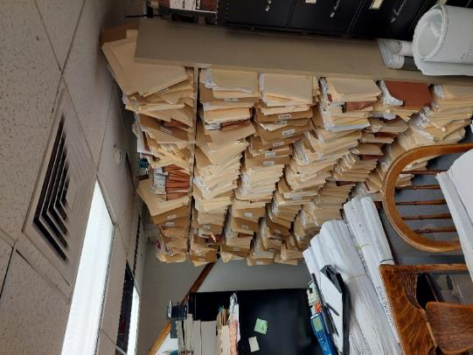

**Basement supply diffuser in suspended ceiling in basement, note stored paper/cardboard**

**Picture 2**

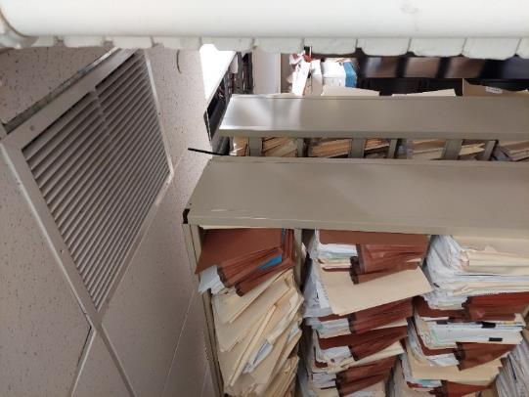

**Basement return vent**

**Picture 3**

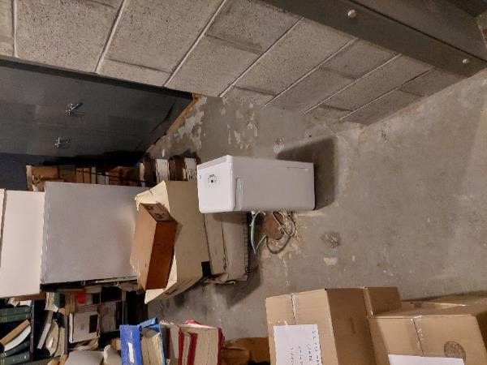

**Dehumidifier in subbasement, note hose emptying into floor drain**

**Picture 4**

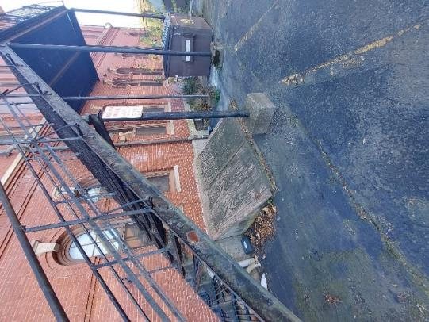

**Plywood-covered bulkhead beneath fire escape**

**Picture 5**

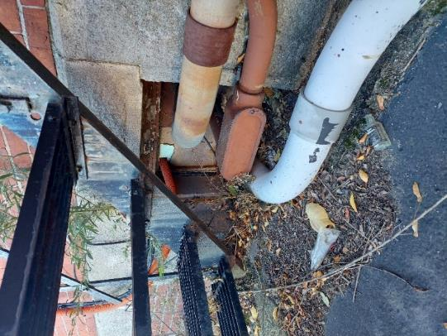

**Electrical conduit in former window with spaces around it**

**Picture 6**

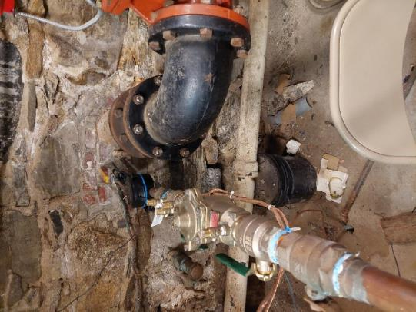

**Fieldstone foundation space that allows water vapor into the basement**

**Picture 7**

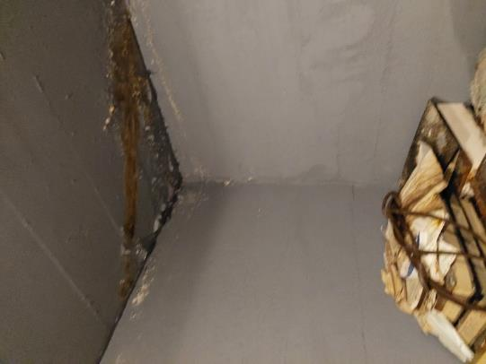

**Water leaks in the subbasement ceiling**

**Picture 8**

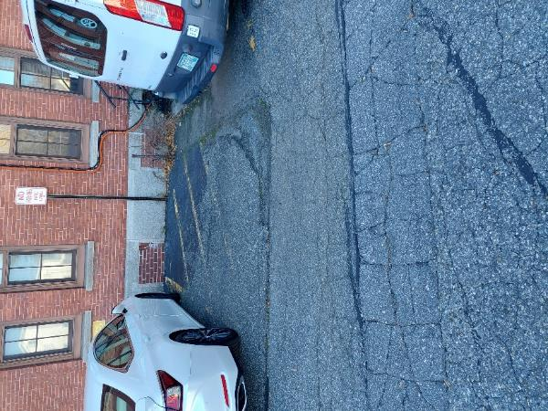

**Parking lot with cracks possibly above subbasement ceiling**