INDOOR AIR QUALITY ASSESSMENT

Hull High School
180 Main Street
Hull, MA 02045

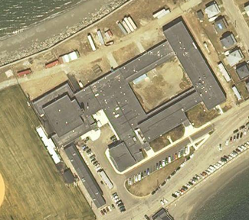

Prepared by:
Massachusetts Department of Public Health
Center for Environmental Health
Emergency Response/Indoor Air Quality Program
March 2007

Background/Introduction
At the request of the Town of Hull’s School Committee and School Department, the Massachusetts Department of Public Health (MDPH), Center for Environmental Health (CEH) provided assistance and consultation regarding indoor air quality at each of Hull’s public schools. These assessments were coordinated through David Twombly, Director of Operations, Hull Public Schools (HPS) and Kevin O’Brien, Director, Hull Board of Health.
On January 29, 2007, Cory Holmes and Sharon Lee, Environmental Analysts in CEH’s Emergency Response/Indoor Air Quality (ER/IAQ) Program conducted an assessment at the Hull High School. The building was previously visited by CEH staff in March 2001 and December 2002. Reports were issued detailing conditions observed at the time of each visit (MDPH, 2001; MDPH, 2002). Subsequent to the 2002 assessment, a comprehensive addition and renovations project was completed at the building.

Methods
Air tests for carbon dioxide, temperature and relative humidity were taken with the TSI, Q-Trak, IAQ Monitor, Model 8551. CEH staff also performed a visual inspection of building materials for water damage and/or microbial growth.

Results
The school houses approximately 420 students in grades 9 through 12 and approximately 60 staff members. Tests were taken under normal operating conditions. Test results appear in Table 1.
Discussion
Ventilation
It can be seen from the Table 1 that carbon dioxide levels were above 800 parts per million (ppm) in twenty of fifty-four areas surveyed, indicating less than optimal air exchange in slightly less than half of the areas surveyed. It is important to note that a number of areas with carbon dioxide levels below 800 ppm were sparsely populated or unoccupied during the assessment. Low occupancy can greatly reduce carbon dioxide levels. Carbon dioxide levels would be expected to be higher with full occupancy.
Fresh air in classrooms is supplied by unit ventilator (univent) systems (Picture 1). A univent draws air from the outdoors through a fresh air intake located on the exterior wall of the building (Picture 2) and returns air through an air intake located at the base of the unit. Fresh and return air are mixed, filtered, heated and provided to classrooms through an air diffuser located in the top of the unit. Adjustable louvers control the ratio of outside to recirculated air (Figure 1). Univents were found deactivated in a few areas (Table 1). Obstructions to airflow, such as items stored on or in front of univents were also observed in some areas (Table 1). In order for univents to provide fresh air as designed, units must be activated while rooms are occupied and air diffusers should remain free of obstructions.
Exhaust ventilation in classrooms is provided by wall-mounted vents (Picture 3) ducted to rooftop motors (Picture 4). These exhausts were operating during the assessment. It is important to note that the location of some exhaust vents can limit exhaust efficiency. In some classrooms, exhaust vents are located above hallway doors (Picture 3). When classroom doors are open, exhaust vents tend to draw air from the hallway, thereby reducing the effectiveness of the vents to remove common environmental pollutants from classrooms.
Mechanical ventilation in common areas and interior rooms (e.g., gym, cafeteria, media center) is provided by air handling units (AHUs) located on the roof (Picture 4). Outside air is heated or cooled and distributed to occupied areas via ceiling-mounted air diffusers (Picture 5) and ducted back to AHUs via ceiling-mounted return grates (Picture 6). Practice rooms in the music suite had neither mechanical ventilation nor openable windows to introduce fresh air. Carbon dioxide measurements were 1140 ppm and 1158 ppm in the practice rooms, which were each occupied by a student. Consideration should be given to providing a source of mechanical ventilation to these rooms.
To maximize air exchange, the MDPH recommends that both supply and exhaust ventilation operate continuously during periods of school occupancy. In order to have proper ventilation with a mechanical supply and exhaust system, the systems must be balanced to provide an adequate amount of fresh air to the interior of a room while removing stale air from the room. It is recommended that existing ventilation systems be re-balanced every five years to ensure adequate air systems function (SMACNA, 1994). The date of the last balancing of these systems was not available at the time of the assessment, but should have occurred at some point after construction/renovation in 2002.
The Massachusetts Building Code requires a minimum ventilation rate of 15 cubic feet per minute (cfm) per occupant of fresh outside air or have openable windows in each room (SBBRS, 1997; BOCA, 1993). The ventilation must be on at all times that the room is occupied. Providing adequate fresh air ventilation with open windows and maintaining the temperature in the comfort range during the cold weather season is impractical. Mechanical ventilation is usually required to provide adequate fresh air ventilation.
Carbon dioxide is not a problem in and of itself. It is used as an indicator of the adequacy of the fresh air ventilation. As carbon dioxide levels rise, it indicates that the ventilating system is malfunctioning or the design occupancy of the room is being exceeded. When this happens a buildup of common indoor air pollutants can occur, leading to discomfort or health complaints. The Occupational Safety and Health Administration (OSHA) standard for carbon dioxide is 5,000 parts per million parts of air (ppm). Workers may be exposed to this level for 40 hours/week based on a time weighted average (OSHA, 1997).
The MDPH uses a guideline of 800 ppm for publicly occupied buildings. A guideline of 600 ppm or less is preferred in schools due to the fact that the majority of occupants are young and considered to be a more sensitive population in the evaluation of environmental health status. Inadequate ventilation and/or elevated temperatures are major causes of complaints such as respiratory, eye, nose and throat irritation, lethargy and headaches. For more information concerning carbon dioxide, please see Appendix A.
Temperature measurements ranged from 67º F to 76º F, which were within or close to the lower end of the MDPH recommended comfort guidelines the day of the assessment. The MDPH recommends that indoor air temperatures be maintained in a range of 70 º F to 78 º F in order to provide for the comfort of building occupants. In many cases concerning indoor air quality, fluctuations of temperature in occupied spaces are typically experienced, even in a building with an adequate fresh air supply. Temperature control issues were reported in the music room. A large, ceiling-mounted air conditioning unit was retro-fitted in the music room (Picture 7). This air conditioner reportedly provides uneven cooling. CEH staff activated the unit during the assessment and observed that cooling across the coils appeared uneven, which may indicate a malfunction.
The relative humidity ranged from 10 to 37 percent, which were below the MDPH recommended comfort range in all areas surveyed during the assessment. The MDPH recommends that indoor air relative humidity is comfortable in a range of 40 to 60 percent. During the heating season, relative humidity levels would be expected to drop below the recommended comfort range. The sensation of dryness and irritation is common in a low relative humidity environment. For buildings in New England, periods of low relative humidity during the winter are often unavoidable.

Microbial/Moisture Concerns
Water-damaged ceiling tiles were observed in several areas (Picture 8/Table 1), which can indicate leaks from the roof or plumbing system. Occupants in room B-212 reported active leaks during heavy wind-driven rain. Water-damaged ceiling tiles can provide a source for mold growth and should be replaced after a water leak is discovered and repaired. Water-damaged ceiling materials, which appeared to be constructed of gypsum wallboard, were observed in the hallway near the gymnasium (Picture 9).
In order for building materials to support mold growth, a source of moisture is necessary. Identification and elimination of water moistening building materials is necessary to control mold growth. Building materials with increased moisture content over normal concentrations may indicate the possible presence of mold growth. Identification of the location of materials with increased moisture levels can also provide clues concerning the source of water supporting mold growth.
In an effort to ascertain moisture content of the water-damaged ceiling materials near the gymnasium, moisture content was measured with a Delmhorst Moisture Detector equipped with a Delmhorst Standard Probe. The Delmhorst probe is equipped with three lights that function as visual aids that indicate moisture level. Readings that activate the green light indicate a sufficiently dry or low moisture level, those that activate the yellow light indicate borderline conditions and those that activate the red light indicate elevated moisture content. No elevated moisture readings were measured during the assessment (Table 1).
Plants were noted in several classrooms. Plants can be a source of pollen and mold, which can be respiratory irritants for some individuals. Plants should be properly maintained and equipped with drip pans. Plants should also be located away from ventilation sources (e.g., air intakes, univent diffusers) to prevent the entrainment and/or aerosolization of dirt, pollen or mold. Aquariums were observed in a few classrooms. Aquariums should be properly maintained to prevent microbial/algae growth, which can emit unpleasant odors.

Other Concerns
Several other conditions that can affect indoor air quality were noted during the assessment, including those observed in the chemical storeroom and science areas:
- Some items were labeled with chemical formula rather than by chemical name (Picture 10).
- Chemicals containers were sealed with rubber stoppers, some of which had become damaged, thereby allowing chemicals to freely off-gas (Picture 10).
- Crystallization of chemicals had occurred on the surface of some containers.
- The chemical exhaust hood in room C-115 is reportedly not operating.

It is highly recommended that a thorough inventory of chemicals in the chemical storeroom and science department be conducted to determine whether chemical storage and disposal is conducted in an appropriate manner, consistent with Massachusetts hazardous waste laws.
In some classrooms items were observed on windowsills, tabletops, counters, bookcases and desks. The large number of items stored in classrooms provides a source for dusts to accumulate. These items, (e.g., papers, folders, boxes) make it difficult for custodial staff to clean. Items should be relocated and/or be cleaned periodically to avoid excessive dust build up. A number of exhaust/return vents and personal fans were observed to have accumulated dust. If exhaust vents are not functioning, backdrafting can occur, which can re-aerosolize accumulated dust particles.
Plug-in air fresheners were seen in a few areas. Air fresheners contain chemicals that can be irritating to the eyes, nose and throat of sensitive individuals. Furthermore, air fresheners do not remove materials causing odors, but rather mask odors that may be present in the area. Dry erase markers were seen in several classrooms. Materials such as dry erase markers and dry erase board cleaners may contain VOCs, (e.g. methyl isobutyl ketone, n-butyl acetate and butyl-cellusolve) (Sanford, 1999).
Finally, concerns regarding proper mechanical ventilation were expressed by occupants in the wood shop. According to the occupant, the mechanical exhaust system for the wood shop equipment is not configured in a manner that draws wood dust and related materials into the dust collection system. It was reported to CEH staff that a feasibility study to evaluate the system was conducted by an HVAC engineering firm. The report is said to include recommendations for improvement. Consideration should be given to assessing and improving the mechanical ventilation in the shops to prevent accumulation of dust and particles.

Conclusions/Recommendations
In view of the findings at the time of the assessment, the following recommendations are made:
- Operate all ventilation systems throughout the building (e.g., gym/locker rooms, auditorium, classrooms) continuously during periods of school occupancy independent of thermostat control to maximize air exchange. To increase airflow in classrooms, set univent controls to “high”.
- Remove all blockages from univents to ensure adequate airflow.
- Ensure classroom doors are closed to maximize air exchange.
- Supplement airflow by using openable windows to control for comfort. Care should be taken to ensure windows are properly closed at night and weekends to avoid the freezing of pipes and potential flooding (during winter months).
- Examine the feasibility of providing mechanical (or natural) ventilation to practice rooms in the music suite.
- Examine ceiling-mounted AC unit in music room for proper operation. Perform repairs as needed.
- Consider adopting a balancing schedule of every 5 years for all mechanical ventilation systems, as recommended by ventilation industrial standards (SMACNA, 1994).
- For buildings in New England, periods of low relative humidity during the winter are often unavoidable. Therefore, scrupulous cleaning practices should be adopted to minimize common indoor air contaminants whose irritant effects can be enhanced when the relative humidity is low. To control for dusts, a high efficiency particulate arrestance (HEPA) filter equipped vacuum cleaner in conjunction with wet wiping of all surfaces is recommended. Drinking water during the day can help ease some symptoms associated with a dry environment (e.g., throat and sinus irritations).
- Isolate and repair water leaks. Repair/replace any water-damaged ceiling tiles, plaster and/or other damaged building materials. Examine above and around these areas for mold growth. Disinfect areas of water leaks with an appropriate antimicrobial. Building occupants should report any roof leaks or other signs of water penetration to school maintenance staff for remediation.
- Ensure all plants are equipped with drip pans. Examine drip pans for mold growth and disinfect areas of water leaks with an appropriate antimicrobial where necessary. Move plants away from air intakes and univent air diffusers in classrooms.
- Ensure chemical exhaust hoods in science areas are operating properly. Science staff should work with school administration and their HVAC vendor to develop a preventative maintenance program for all local exhaust equipment (e.g., lab hoods, prep rooms).
- Conduct a chemical inventory in the chemical storage room and science labs. Properly store flammable materials in a manner consistent with the local fire code. Discard hazardous materials or empty containers of hazardous materials in a manner consistent with environmental statutes and regulations. Label chemical containers with the chemical name of its contents. Follow proper procedures for storing and securing hazardous materials.
- Ensure wood shop staff, school administration and the school’s HVAC vendor meet and collaborate to make adjustments for maximizing wood dust collection/removal capabilities of the local exhaust system.
- Refrain from using strongly scented materials (e.g., air fresheners).
- Relocate or consider reducing the amount of materials stored in classrooms to allow for more thorough cleaning. Clean items regularly with a wet cloth or sponge to prevent excessive dust build-up.
- Clean fan blades and exhaust/return vents periodically of accumulated dust.
- Consider adopting the US EPA (2000) document, “Tools for Schools”, to maintain a good indoor air quality environment on the building. This document can be downloaded from the Internet at: http://www.epa.gov/iaq/schools/index.html.
- Refer to resource manuals and other related indoor air quality documents for further building-wide evaluations and advice on maintaining public buildings. These materials are located on the MDPH’s website: http://mass.gov/dph/indoor_air.
References
ACGIH. 1989. Guidelines for the Assessment of Bioaerosols in the Indoor Environment. American Conference of Governmental Industrial Hygienists, Cincinnati, OH.
BOCA. 1993. The BOCA National Mechanical Code-1993. 8th ed. Building Officials & Code Administrators International, Inc., Country Club Hills, IL.
MDPH. 2001. Indoor Air Quality Report for Hull High School Dated June 2001. Massachusetts Department of Public Health, Bureau of Environmental Health Assessment, Boston, MA.

MDPH. 2002. Letter to Kevin O’Brien, Director, Hull Board of Health Regarding Indoor Air Quality/Renovations at Hull High School, Dated December 30, 2002. Massachusetts Department of Public Health, Bureau of Environmental Health Assessment, Boston, MA.

OSHA. 1997. Limits for Air Contaminants. Occupational Safety and Health Administration. Code of Federal Regulations. 29 C.F.R 1910.1000 Table Z-1-A.

Sanford. 1999. Material Safety Data Sheet (MSDS No: 198-17). Expo® Dry Erase Markers Bullet, Chisel, and Ultra Fine Tip. Sanford Corporation. Bellwood, IL.
SBBRS. 1997. Mechanical Ventilation. State Board of Building Regulations and Standards. Code of Massachusetts Regulations. 780 CMR 1209.0
SMACNA. 1994. HVAC Systems Commissioning Manual. 1st ed. Sheet Metal and Air Conditioning Contractors’ National Association, Inc., Chantilly, VA.
US EPA. 2000. Tools for Schools. Office of Air and Radiation, Office of Radiation and Indoor Air, Indoor Environments Division (6609J). EPA 402-K-95-001, Second Edition. http://www.epa.gov/iaq/schools/tools4s2.html

US EPA. 2001. Mold Remediation in Schools and Commercial Buildings. US Environmental Protection Agency, Office of Air and Radiation, Indoor Environments Division, Washington, DC. EPA 402-K-01-001. March 2001.

Picture 1

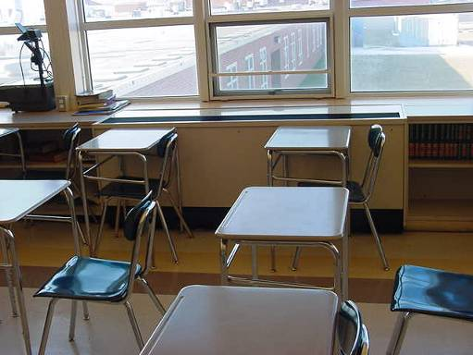

Classroom Univent

Picture 2

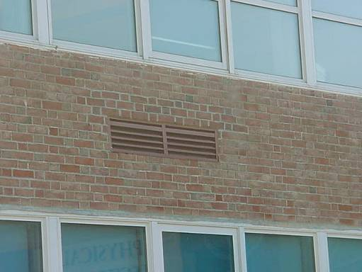

Univent Fresh Air Intake
Picture 3

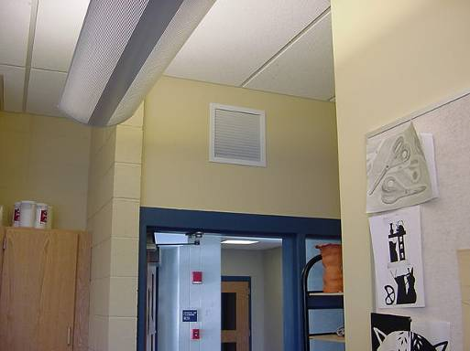

Wall-Mounted Classroom Exhaust Vent over Door

Picture 4

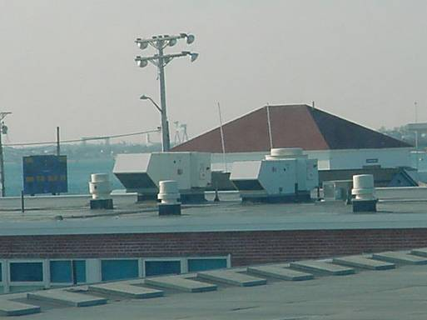

Rooftop Air Handling Units and Exhaust Fans
Picture 5

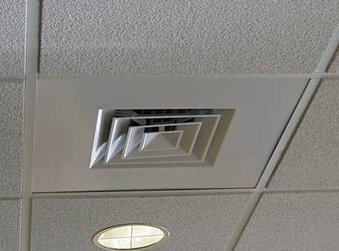

Ceiling-Mounted Supply Diffuser

Picture 6

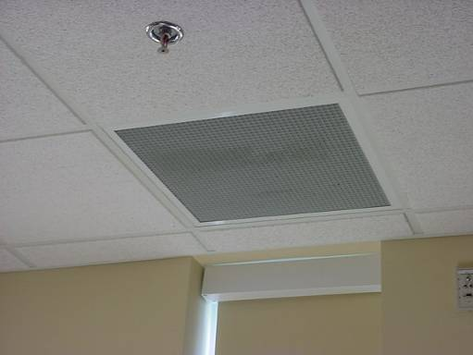

Ceiling-Mounted Return Vent
Picture 7

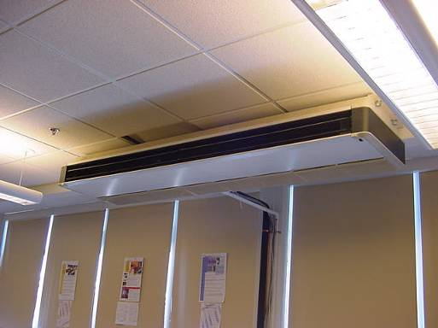

Ceiling-Mounted AC Unit in Music Room

Picture 8

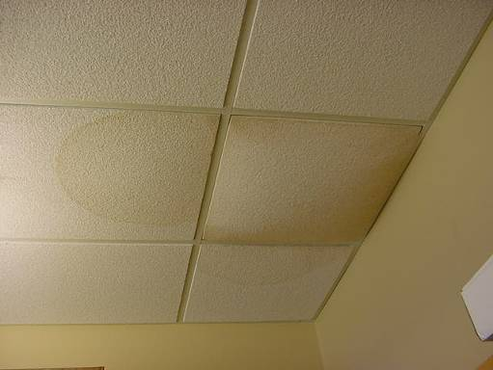

Water Damaged Ceiling Tiles in Room B-212
Picture 9

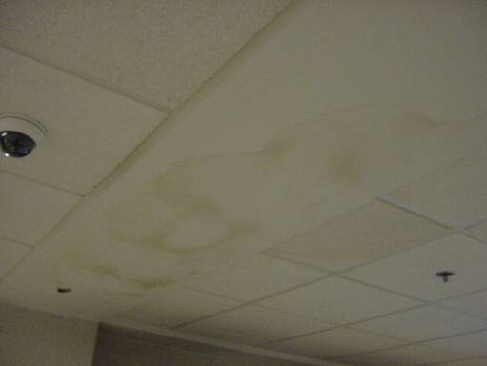

Water Damaged Ceiling in Hallway near Gymnasium

Picture 10

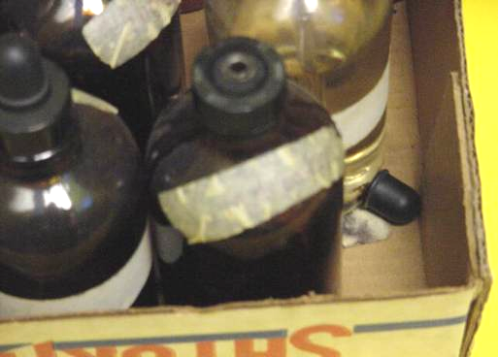

Chemical Storage Containers Labeled with Chemical Formula, Also Note Damaged Rubber Stopper, Allowing the Container to Freely Off-Gas into the Chemical Storeroom
Location | Carbon  Dioxide  (*ppm) | Temp  (°F) | Relative  Humidity  (%) | Occupants  in Room | Windows  Openable | Ventilation |  | Remarks
 |  |  |  |  |  | Supply | Exhaust | Remarks
Background | 309 | 22 | 41 |  |  |  |  | Clear, cold, NW winds 15 mph
B 212 art | 1067 | 70 | 37 | 25 | Y | Y | Y | 2 CT corner-periodic leak: wind driven rain, DEM
B 213 | 654 | 71 | 22 | 0 | Y | Y | N | Risograph, DEM
B 218 | 1188 | 71 | 26 | 23 | Y | Y | Y | Plants, DO, DEM
C 201 | 1378 | 72 | 23 | 21 | Y | Y | Y
C 203 | 1439 | 74 | 24 | 17 | Y | Y | Y | DEM-particulate
C 207 | 1080 | 74 | 22 | 19 | Y | Y | Y | DO
C 209 | 1816 | 72 | 26 | 21 | Y | Y | Y | Univent-off
C 109 | 673 | 70 | 19 | 1 | Y | Y | Y | 12 occupants gone 40 mins, aquarium
Science Prep Room | 666 | 72 | 20 | 0 | Y | Y | Y | Chemical formula-not name, labels falling off, crystallization, rubber stopper damage
C 103 | 752 | 73 | 18 | 2 | Y | Y | Y | DEM, no local exhaust, 1 CT
C 100 | 773 | 71 | 16 | 2 | Y | Y | N | DEM
B 211 | 1194 | 69 | 35 | 18 | Y | Y | Y | 1 MT, plants, DO, PF
B 200 | 512 | 69 | 17 | 0 | Y | Y | Y
B 220 | 571 | 70 | 20 | 0 | Y | N | N | DO, PF
B 217 | 729 | 70 | 20 | 2 | Y | Y | N | DEM odors, DO
C 202 | 644 | 72 | 17 | 1 | Y | Y | Y | Plants, PS, DEM
C 206 | 1386 | 72 | 23 | 18 | Y | Y | Y | DEM, PF, plants
C 208 | 792 | 72 | 20 | 1 | Y | Y | Y | DO, DEM, PF
C 211 | 676 | 71 | 16 | 7 | Y | Y | Y | DEM, soda bottles
C 108 | 1270 | 74 | 20 | 15 | Y | Y | Y
C 104 | 1274 | 74 | 19 | 21 | Y | Y | Y | DEM, PF, clutter
C 102 | 897 | 74 | 18 | 16 | Y | Y | Y | DO, DEM
B 152 | 1012 | 72 | 17 | 18 | Y | Y | Y | DEM, cleaners, air freshener-lemon scented
B 128 | 783 | 72 | 16 | 11 | Y | Y | Y | DEM, 2 CT-plumbing leaks?
B 122 | 517 | 72 | 14 | 0 | Y | Y | Y | DEM
B 121 | 625 | 71 | 16 | 4 | Y | Y | Y | Univent-off, teacher’s desk in front of univent, DEM
Auditorium | 431 | 67 | 13 | 0 | N | Y | Y
Library Office | 439 | 70 | 15 | 2 | N | Y | Y | DO
Library Work Room | 460 | 72 | 15 | 0 | N | Y | Y | DO, Risograph
Library | 526 | 72 | 16 | 5 | N | Y | Y
C 117 | 1170 | 74 | 20 | 16 | Y | Y | N | DEM
C 115 | 831 | 74 | 12 | 15 | Y | Y | N | DEM, PS, WD-GW/plaster, chemical hood-non functional
C 113 | 617 | 75 | 13 | 2 | Y | Y | N | Plants
D 127 | 499 | 73 | 10 | 1 | Y | Y | Y
D 126 | 438 | 70 | 10 | 2 | N | N | Y | Lingering odors, lack of exhaust
D 131 | 542 | 70 | 10 | 8 | Y | Y | N
B 131 | 1072 | 72 | 19 | 24 | Y | Y | Y | Plants, DEM
B 129 | 1139 | 70 | 20 | 15 | Y | Y | Y | DEM, univent-off, DO
B 118 | 538 | 72 | 20 | 0 | N | Y | Y
B 114 | 603 | 71 | 18 | 1 | N | Y | Y
B 113 | 521 | 71 | 18 | 0 | N | Y | Y | Plug-in air freshener
Nurse Suite | 518 | 73 | 18 | 1 | Y | Y | Y
B 119 | 539 | 73 | 17 | 4 | Y | Y | Y
Main Office | 634 | 72 | 19 | 2 | N | Y | Y | Photocopier, plants, DEM
D 100 | 892 | 75 | 19 | 8 | Y | Y | Y | In office-door undercut , items on/near univent: temperature control issues, AC-uneven
D 103 practice room | 1158 | 75 | 21 | 1 | N | N | Y | Exhaust dusty, recommend supply ventilation
D 102 practice room | 1140 | 76 | 22 | 1 | N | N | Y | Exhaust dusty, recommend supply ventilation
Girls Locker Room | 501 | 71 | 15 | 0 | N | Y | Y
Boy’s Locker Room | 525 | 72 | 16 | 0 | Y | Y | Y
Gym | 586 | 72 | 17 | 25 | N | Y | Y
D 128 Shop | 425 | 73 | 13 | 0 | Y | Y | Y
D 119 | 754 | 74 | 18 | 1 | Y | Y | Y | 20 occupants gone 5 mins, DEM
Gym Hallway |  |  |  |  |  |  |  | Water damaged gypsum ceiling, CTs, peeling paint-low moisture
Cafeteria | 1002 | 75 | 22 | 150-200 | Y | Y | Y | 2 ajar CTs
D 126 | 491 | 72 | 17 | 7 | Y | Y | Y | PM2.5 (occupied) = 17

