WATER DAMAGE/REMEDIATION ASSESSMENT

Hull High School
180 Main Street
Hull, Massachusetts

Prepared by:
Massachusetts Department of Public Health
Bureau of Environmental Health
Indoor Air Quality Program
February 2018

BACKGROUND
Building: | Hull High School
Address: | 180 Main Street, Hull, MA
Assessment Coordinated via: | Hull Health Department and Hull School Department
Reason for Request: | Water damage/mold growth concerns
Date of Assessment: | February 5, 2018
Massachusetts Department of Public Health/Bureau of Environmental Health (MDPH/BEH) Staff Conducting Assessment: | Cory Holmes, Environmental Analyst/Inspector, Indoor Air Quality (IAQ) Program
Date of Building Construction: | 1957
Building Description: | A multi-story, brick-faced building originally constructed in the late 1950s. The building underwent complete renovations in 2002.

METHODS
Please refer to the IAQ Manual and appendices for methods, sampling procedures, and interpretation of results (MDPH, 2015).

RESULTS and DISCUSSION

Microbial/Moisture Concerns
Areas of concern focused on water penetration issues from the central courtyard and in the gym foyer. As reported by school officials, periodic rain water enters the main hallway around exterior doors periodically during heavy wind/weather events (Pictures 1 through 3). BEH/IAQ staff examined doors in the courtyard and noted that weather-stripping was dry/brittle and damaged (Pictures 4 and 5). Although, this source of leaks should be addressed, there were no porous building materials that can harbor mold growth (e.g., carpet, drywall) in the affected area. The areas impacted consist of floor tile, metal and masonry (Picture 2).
According to school officials the foyer/entrance to the gym area has been a point of chronic leakage (Picture 6), however over the summer/fall of 2017, many areas along the exterior were repointed/weather-proofed. At the time of assessment, gypsum wallboard and damaged ceiling tiles had since been repaired/replaced. The assessment occurred after a steady rain (reportedly heavy at times). All building materials were dry and no evidence of water damage/further leaks were observed in the gym/foyer area (Pictures 7 and 8).
In order for building materials to support mold growth, a source of water exposure is necessary. The US Environmental Protection Agency (US EPA) and the American Conference of Governmental Industrial Hygienists (ACGIH) recommends that porous materials (e.g., wallboard, carpeting) be dried with fans and heating within 24 to 48 hours of becoming wet (US EPA, 2008; ACGIH, 1989). If porous materials are not dried within this time frame, mold growth may occur.

CONCLUSIONS and RECOMMENDATIONS
In view of the findings at the time of the visit, the following recommendations are made:
- Make repairs to exterior doors in courtyard, replace weather-stripping as needed. Monitor for continued leaks and make further repairs as needed.
- Continue to monitor gym/foyer areas for leaks to ensure repairs are adequate, make further repairs if necessary.
- For more information about mold consult the US EPA’s “Mold Remediation in Schools and Commercial Buildings” published by the US Environmental Protection Agency (US EPA, 2008) (http://www.epa.gov/mold/mold_remediation.html).
- Refer to resource manual and other related IAQ documents located on the MDPH’s website for further building-wide evaluations and advice on maintaining public buildings. These documents are available at: http://mass.gov/dph/iaq.

REFERENCES
ACGIH. 1989. Guidelines for the Assessment of Bioaerosols in the Indoor Environment. American Conference of Governmental Industrial Hygienists, Cincinnati, OH.
MDPH. 2015. Massachusetts Department of Public Health. Indoor Air Quality Manual: Chapters I-III. Available at: http://www.mass.gov/eohhs/gov/departments/dph/programs/environmental-health/exposure-topics/iaq/iaq-manual/.
US EPA. 2008. Mold Remediation in Schools and Commercial Buildings. US Environmental Protection Agency, Office of Air and Radiation, Indoor Environments Division, Washington, D.C. EPA 402-K-01-001. http://www.epa.gov/mold/mold-remediation-schools-and-commercial-buildings-guide.
Picture 1
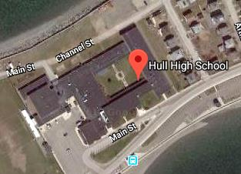
Hull High School, arrow indicates wind-driven rain from Northerly direction impacting courtyard doors shown in Picture 2
Picture 2
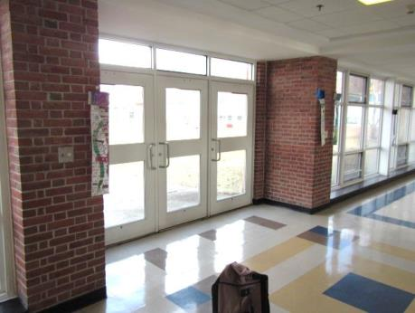
Interior view of courtyard access doors
Picture 3
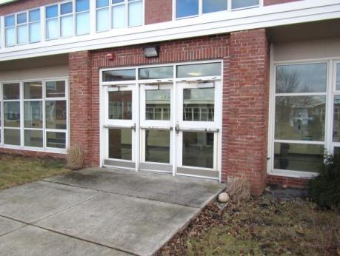
Exterior view of courtyard access doors
Picture 4
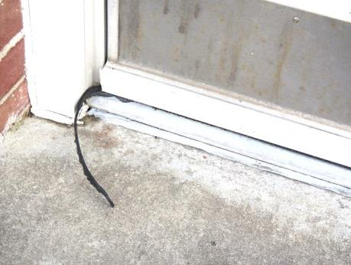
Loose/damaged weather-stripping on exterior courtyard access doors
Picture 5
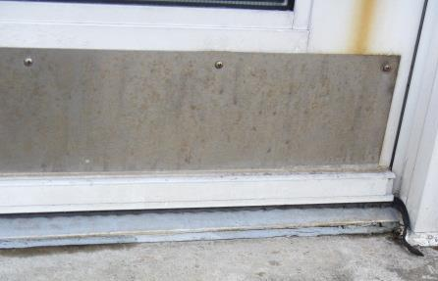
Loose/damaged weather-stripping on exterior courtyard access doors
Picture 6
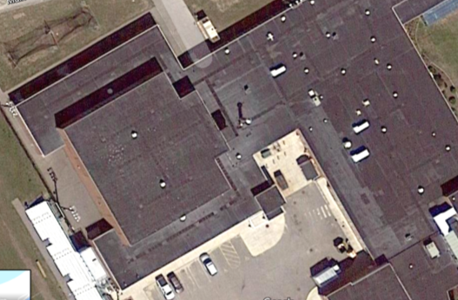
Bracket indicates approximate area of gym foyer where water penetration has occurred
Picture 7
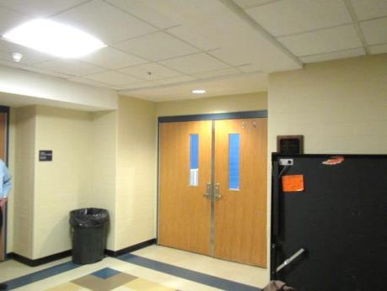
Gym foyer area of previous leaks, no further signs of water damage on building materials
Picture 8
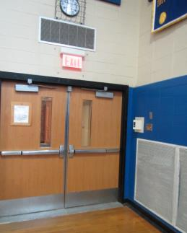
Gym area directly inside area of leaks, no evidence of water damage on building materials

