**INDOOR AIR QUALITY**

**ASSESSMENT**

**Hull Police Department**

**1 School Street**

**Hull, Massachusetts**

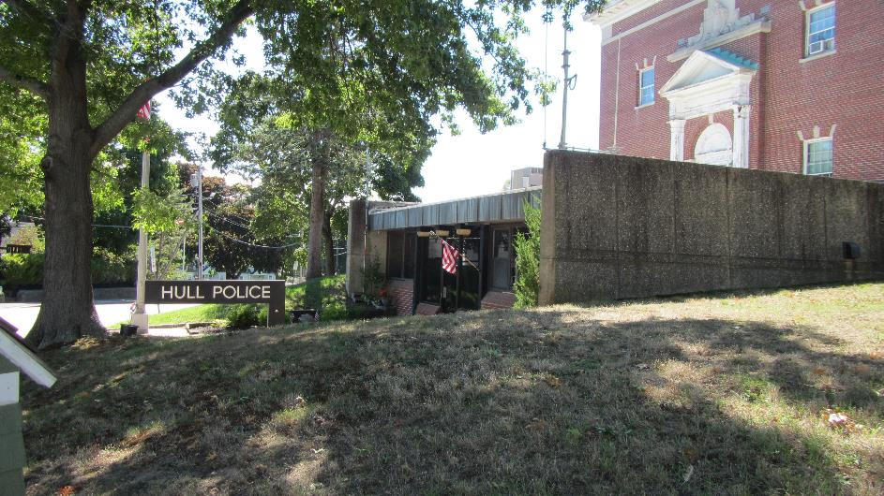

Prepared by:

Massachusetts Department of Public Health

Bureau of Environmental Health

Indoor Air Quality Program

October 2022

# BACKGROUND

|  |  |
| --- | --- |
| Building: | Hull Police Department (HPD) |
| Address: | 1 School Street, Hull, MA |
| Assessment Requested by: | Philip E. Lemnios, Town Manager, Town of Hull, and Chief John Dunn, Hull Police Department |
| Reason for Request: | General indoor air quality (IAQ) and mold concerns |
| Date of Assessment: | September 16, 2022 |
| Massachusetts Department of Public Health/Bureau of Environmental Health (MDPH/BEH) Staff Conducting Assessment: | Michael Feeney, Director,  Indoor Air Quality Program |
| Building Description: | The HPD occupies a one-story  building constructed in the 2000s. |
| Windows: | Windows are openable |

# Methods

Please refer to the IAQ Manual for methods, sampling procedures, and interpretation of results (MDPH, 2015).

# IAQ Testing Results

The following is a summary of indoor air testing results (Table 1).

* ***Carbon dioxide levels*** were below the MDPH guideline of 800 parts per million (ppm) in all areas assessed. Note that most areas were lightly occupied or unoccupied at the time of the assessment; carbon dioxide levels would be expected to be higher with increased occupancy.
* ***Temperature*** was within or close the recommended range of 70°F to 78°F in areas assessed.
* ***Relative humidity*** was the within or close to the lower end of the recommended range of 40% to 60% in the areas assessed.
* ***Carbon monoxide*** levels were non-detectable (ND) in all areas assessed.
* ***Fine particulate matter (PM2.5)*** concentrations measured were below the National Ambient Air Quality Standard (NAAQS) level of 35 μg/m3 in all areas assessed.

## Ventilation

The HPD has a mechanical heating, ventilating, and air-conditioning (HVAC) system. One air handling unit (AHU) is located on the roof of the HPD (Picture 1). The rooftop AHU has a fresh air intake but does not appear to have the capacity to exhaust air. Some areas in reception and dispatch have return vents that are connected to the rooftop AHU via ductwork.

A second AHU is installed on the ceiling of the hallway between offices and the lock up (Picture 2). The hallway AHU has no means to introduce fresh air or provide exhaust, so only recirculates air and provides heating or cooling. It appears that the HPD is designed to use its main hallways as an air duct to draw air from the front office to the booking area.

Rooms along the exterior have exhaust vents installed in exterior walls (Pictures 3 and 4). It appears the purpose of these vents is to exhaust stale air from rooms and thus draw air from the main hallway into each room. However, none of these exhaust vents were operating during this assessment.

In addition to general HVAC equipment, wall-mounted air-conditioning units were installed (mini-splits, Picture 5). Mini-splits heat and/or cool recirculated air only.

Apart from the Squad Room, basement areas of the HPD are not connected to either of the AHUs. Each of these maintenance/storage areas has openable windows located in window wells which are discussed further under **Microbial/Moisture Concerns** below. The garage is also not connected to the HVAC system and has no openable windows. The garage has industrial heaters that recirculate air.

It is important to note that HVAC systems are designed to heat and cool a predetermined volume of air drawn from outdoors via fresh air intakes installed in AHUs. If insufficient air is added to the interior of a building through the HVAC system, the ability of the HVAC system to maintain heating or cooling will be impaired.

Various doors between conditioned and unconditioned spaces exist in the building, particularly a door leading to the garage, an unconditioned space which can open to the outdoors. During this visit, the interior door to the garage was pegged open. In this configuration, a significant amount of unconditioned air is likely captured by the HVAC system and then redistributed throughout the building, making temperature and humidity control difficult during hot, humid weather. If the garage door is held open during cold weather months, heat control would also become difficult due to the introduction of a large volume of cold, unconditioned air.

It is recommended that HVAC systems be re-balanced every five years to ensure adequate air systems function (SMACNA, 1994). It is unknown when the last time these systems were balanced.

## Microbial/Moisture Concerns

Concerns regarding moisture and microbial growth were one of the reasons for this assessment. IAQ staff noted mold growth on the exterior of ductwork of the hallway AHU (Picture 6). Mini-splits also show signs of mold growth (Picture 7). Since the ductwork and mini-split units are composed of non-porous materials, it is likely mold is growing on a layer of dust and debris adhered to the units, which can be cleaned. Regular cleaning of surfaces such as AHU ducts and mini-splits to remove debris will prevent future mold growth.

Water-damaged ceiling tiles and plaster were observed in several areas. Water-damaged ceiling tiles can be a source of odors and may become a mold growth medium. No dark staining indicating mold was observed at the time of the visit.

### Humidity control in the HPD

Relative humidity indoors ranged from 39 to 47%. In general, with a functional HVAC system where operational fresh air intake and exhaust ventilation equipment operate in chiller mode, indoor relative humidity measurement would be expected to be equal to or less than outdoor relative humidity. The relative humidity measured in occupied areas was higher than outdoor measurements in some areas. This condition may be attributed to several factors:

* The introduction of large amounts of unconditioned outdoor air into a building through the open garage via the open interior door.
* Introduction of unconditioned outdoor air when exterior door near booking is opened.
* Having the chilling set point too low.
* Lack of exhaust ventilation, including for areas where water vapor may be generated such as the locker room.
* Outdoor air infiltration through HPD basement windows.

Given these conditions, IAQ staff would expect that relative humidity in the building would be much higher (>60%) during periods of persistent hot, humid weather. Relative humidity above the MDPH IAQ comfort level of 60%, reduces the ability of the human body to regulate temperature through perspiration and can lead to increased discomfort even if the temperature is in a comfortable range. Excess humidity can also be a source of water vapor to moisten building materials and stored materials. One sign that indoor air has had high relative humidity for long periods of time is the presence of bowing ceiling tiles. These often result from a gradual degradation of the ceiling tile with exposure to chronic high humidity. Bowing ceiling tiles were noted in the HPD.

It is important to note that Massachusetts experienced extended periods of high relative humidity during the summers of 2018 and 2021 (WP, 2018; NOAA, 2021). July 2021 was the wettest ever recorded in Massachusetts, and the three-month period from June through August 2021, known as the meteorological summer, was tied for the warmest on record across the United States, according to the National Oceanic and Atmospheric Administration’s Centers for Environmental Information (NOAA, 2021).

This weather resulted in condensation problems in many publicly-owned or operated buildings (HG, 2021), particularly those with below-grade spaces with wall or floors in direct contact with soil or cement slab. In these instances, the floors in direct contact with soil may have temperatures that would result in condensation wetting floors under conditions of high relative humidity.

In addition to increasing relative humidity indoors, an excessively low temperature set point for the HVAC system can also result in chilling of building components below the dew point and generating condensation; this may explain why mold growth was observed on ductwork and mini-split vents.

### Window Wells

As noted, the lower level of the HPD has windows that open into window wells (Pictures 8 and 9). Some window wells were covered with wooden planks (Picture 8). Others were filled with plant debris (Picture 9). The floors of window wells are usually equipped with drains to prevent rainwater pooling. Plants and other debris can block drainage, allowing the wells to fill with water and leak into the basement through spaces in window frames. While the wooden planks such as shown in Picture 8 are likely designed to prevent access to the building, the planks restrict airflow and water evaporation for the window well, which can increase water vapor penetration through sash windows and cause rot damage to window wood.

### Roof Conditions

Of note was the condition of the roof over the 1970s’ section of the HPD. This roof does not appear to be made of a rubberized membrane, asphalt or ballasted. The roof appears to have an underlying layer topped with a coating. Water has penetrated through the coating to be absorbed by the underlying materials, giving the roof a “lumpy” appearance (Pictures 10 and 11). Given this condition, water can readily accumulate on the roof and then penetrate through the covering and into the building to wet ceiling tiles and other building materials. Additional damage to the roof was likely caused by installation of a ramp and railing directly onto the roofing materials (Pictures 12 and 13). The roof beneath the ramp cannot readily dry and there is also a significant amount of plant debris trapped beneath the ramp. Such accumulated materials can hold moisture which can then damage the roof during winter months as water freezes and thaws to open cracks in the roof coating.

The roof does not have a consistent pitch, with the roof directing rainwater to the roof drain. One section of the roof appears to direct rainwater into a window well in the 1970s section (Picture 9). HPD staff reported water penetration through windows in this well.

### Exterior Conditions Impacting the Building

Several trees overhang the HPD roof (Picture 14). Trees pose a number of hazards to the HPD:

* Leaves and seeds accumulate around the roof drain, which inhibits rainwater drainage from the roof. This condition can also lead to ice blocking the drain, leading to water running off the roof to moisten exterior walls.
* The trees prevent sunlight from drying the eastern wall of the HPD.
* A tree is a possible danger to the HPD due to close proximity to its exterior walls. The recommended safe distance from which a tree should be planted is recommended to be greater than its maximum growth height (BI, 2015). Soil subsidence may also be caused by tree roots, which can undermine the structure of a building to cause wall and floor cracking as well as other related damage. Severe weather may result in the tree falling onto the HPD.
* In general, a tree root system will spread out in all directions from its trunk. Any structure disrupting the root structure may make the tree unstable if subjected to high winds from a certain direction. The east side of the tree has its root system disrupted by a sidewalk/roadway. If trees are subjected to strong easterly winds, it is possible that the tree can uproot to fall on the HPD.

The Federal Emergency Management Agency (FEMA) provides a number of recommendations in order to prepare for severe thunderstorms. FEMA specifically recommends “Cut down or trim trees that may be in danger of falling on your [building]” (FEMA, 2018). Given the proximity to the HPD, removal of the tree should be strongly considered.

## Other Conditions

The HPD has carpeting. In general, it is not recommended for police departments and other emergency response agencies to have carpeted floors due to the possible cross-contamination that may occur from footwear contact with automotive products, chemicals, or biological contamination. In addition, the Institute of Inspection, Cleaning and Restoration Certification (IICRC) discusses floor covering in its guideline, “Standard for Professional Cleaning of Textile Floor Coverings” (IICRC, 2015). Based on this standard, the IICRC recommends twice-daily vacuuming and/or pile-lifting cleaning for commercial carpeting in heavy traffic areas. This frequency of cleaning of the building as well as the use of vacuum cleaners equipped with high-efficiency particulate arrestance (HEPA) filters would remove respirable dust from the indoor air.

Office areas were also mostly carpeted. Carpets in these areas should be cleaned annually (or semi-annually in soiled/high traffic areas) in accordance with Institute of Inspection, Cleaning and Restoration Certification (IICRC) recommendations, (IICRC, 2012).

The Squad Room contains a gas stove with no exhaust vent. Cooking on this stove may result in pollutants, including products of natural gas combustion and cooking-related pollutants, lingering in the air. Gas stoves in particular should have a direct means to exhaust cooking pollutants directly outdoors, preferably using a fan-driven kitchen hood. Opening windows is not adequate to vent cooking pollutants from gas stoves.

The garage does not appear to have a direct means to vent outdoors. Active exhaust ventilation for vehicle operations is recommended to prevent motor exhaust from entering occupied space.

Under certain conditions, combustion of gasoline, and heating/cooking gas may produce carbon monoxide (CO). IAQ staff could not identify if CO monitors were installed in the Squad Room or hallway near the garage. CO monitors would be recommended to be installed in locations near the entrance to the garage as well as the Squad Room.

**Conclusions/Recommendations**

The HPD has a number of issues related to moisture in the building. The capacity of mechanical ventilation equipment to provide adequate chilled air and reduce relative humidity indoors is limited. The following documents can provide guidance that can be used to reduce the impact of hot, humid weather in buildings:

* Mold Growth Prevention During Hot, Humid Weather <https://www.mass.gov/service-details/preventing-mold-growth-in-massachusetts-schools-during-hot-humid-weather>
* Remediation and Prevention of Mold Growth and Water Damage in Public Schools <https://www.mass.gov/service-details/remediation-and-prevention-of-mold-growth-and-water-damage-in-public-schools-and>
* Methods for Increasing Comfort in Non-air-conditioned Schools <https://www.mass.gov/doc/methods-for-increasing-comfort-in-non-air-conditioned-schools/download>

To address the building issues, two sets of recommendations are made: **short-term** measures that may be implemented as soon as practicable and **long-term** measures that will require planning and resources to address overall IAQ concerns. In view of the findings at the time of the visit, the following recommendations are provided:

**Short Term Recommendations**

*Ventilation recommendations*

1. Examine whether the set point for chilling should be raised to avoid condensation.
2. Have the HVAC system balanced every 5 years in accordance with SMACNA recommendations (SMACNA, 1994).
3. Examine exhaust vents in rooms (e.g. Picture 3) to determine if functional or if they can be repaired. If possible, use exhaust vent fans to vent water vapor and other pollutants.
4. Routinely clean surfaces such as mini-split vents to remove and prevent mold growth. Follow manufacturer’s instructions to avoid damage to any HVAC equipment.

*Water damage recommendations*

1. Clean mold from ductwork using methods in accordance with the EPA guideline “Mold Remediation in Schools and Commercial Buildings” (US EPA, 2008). Clean non-porous water-stained surfaces, including walls and floors and remove any debris.
2. Once cleaned, consider installing insulation on the exterior of the hallway AHU duct to prevent condensation. Insulation should have a sufficient R Value to keep the exterior from generating condensation. Avoid using paper-backed insulation. Ensure all ends of insulation are properly sealed to prevent water vapor contact in the duct/insulation junction.
3. Ensure the garage access door fits tightly, including weather-stripping, and keep it closed when not in use.
4. Keep all sash windows closed when HVAC equipment is providing chilled air during hot, humid weather.
5. Replace water-damaged ceiling tiles.
6. Remove all shrubbery at least 5 feet from exterior walls.
7. Work with an HVAC contractor to determine if the HVAC system can be operated or modified to provide additional dehumidification while in chilling mode.
8. Use dehumidifiers in the building during hot, humid weather if HVAC system is not capable of reducing relative humidity levels. If used, maintain all dehumidifiers and regularly remove water and clean receptacles to avoid stagnant water, odors, and the potential for leaks.
9. Remove all plants and debris from window wells on a regular basis (e.g., quarterly). Examine if window wells have drains and repair as needed.
10. In order to prevent mold growth/water damage to building materials in basement areas during extended hot, humid weather (e.g., heatwave). The following actions are recommended:
    1. Operate the fresh air supply and exhaust system in the basement continuously when outdoor relative humidity is greater then 70%.
    2. Consider raising the temperature set point for the HVAC system in the basement during periods of hot weather when the building is mostly empty of occupants to limit condensation.
    3. Use dehumidifiers in the basement to supplement humidity reduction during periods of extended heat with high relative humidity (>48 hours).

### Other Recommendations

1. Install carbon monoxide detectors in the hallway leading to the garage and Squad Room.

**Long Term Recommendations**

1. Consult a building engineering firm to conduct a building-wide ventilation systems assessment. Based on historical issues with air exchange/indoor air quality complaints, age, physical deterioration, and availability of parts for ventilation components, such an evaluation is necessary to determine the feasibility of repair or replacement of the equipment.
2. Consideration should be given to replacing carpeting with a different type of floor covering that can be readily cleaned. Until that time, clean high traffic areas frequently in accordance with IICRC recommendations (IICRC, 2012).
3. Consult a roofing contractor regarding whether the existing roof can be repaired. If not, replacement may be necessary. Also discuss reconfiguration of the access ramp to prevent water and plant debris accumulation.
4. Consider installing a kitchen hood vent for stove. Consider replacing gas stove with electric model, particularly if exhaust vent installation is not feasible.
5. It is highly recommended to remove trees overhanging the building to improve roof drainage and prevent potentially catastrophic damage in severe wind conditions/heavy rain.

# REFERENCES

BI. 2015. A List of Trees and the Recommended Safe Distance from Buildings. Bickers Insurance, Littlehampton, West Sussex, UK. <https://www.bickersinsurance.co.uk/about-us/latest-news/property-owners-news/a-list-of-trees-and-the-recommended-safe-distance-from-buildings/>

FEMA. 2018. How to Stay Safe When a Thunderstorm Threatens. Federal Emergency Management Agency, Washington, DC. FEMA V-1009/May 2018.

HG. 2021. Mold keeps South Hadley High School shuttered. Hampshire Gazette. <https://www.gazettenet.com/South-Hadley-High-School-still-closed-amid-mold-remediation-42413519>

IICRC. 2012. Institute of Inspection, Cleaning and Restoration Certification. Carpet Cleaning: FAQ.

IICRC. 2015. Institute of Inspection, Cleaning and Restoration Certification. Commercial Carpet Cleaning: FAQ.

MDPH. 2015. Massachusetts Department of Public Health. Indoor Air Quality Manual: Chapters I-III. Available at: <https://www.mass.gov/lists/indoor-air-quality-manual-and-appendices#indoor-air-quality-manual->

NOAA. 2021. Summer 2021 neck and neck with Dust Bowl summer for hottest on record. National Oceanic and Atmospheric Administration, 1401 Constitution Avenue NW, Room 5128, Washington, DC 20230 https://www.noaa.gov/news/summer-2021-neck-and-neck-with-dust-bowl-summer-for-hottest-on-record

SMACNA. 1994. HVAC Systems Commissioning Manual. 1st ed. Sheet Metal and Air Conditioning Contractors’ National Association, Inc., Chantilly, VA.

US EPA. 2008. “Mold Remediation in Schools and Commercial Buildings”. Office of Air and Radiation, Indoor Environments Division, Washington, DC. EPA 402-K-01-001. September 2008. Available at: <http://www.epa.gov/mold/mold-remediation-schools-and-commercial-buildings-guide>.

WP. 2018. ‘It’s been relentless’: Smothering summer humidity in the Northeast has crushed records. Washington Post, Washington, DC. <https://www.washingtonpost.com/news/capital-weather-gang/wp/2018/08/30/its-been-relentless-smothering-summer-humidity-in-the-northeast-has-crushed-records/>

**Picture 1**

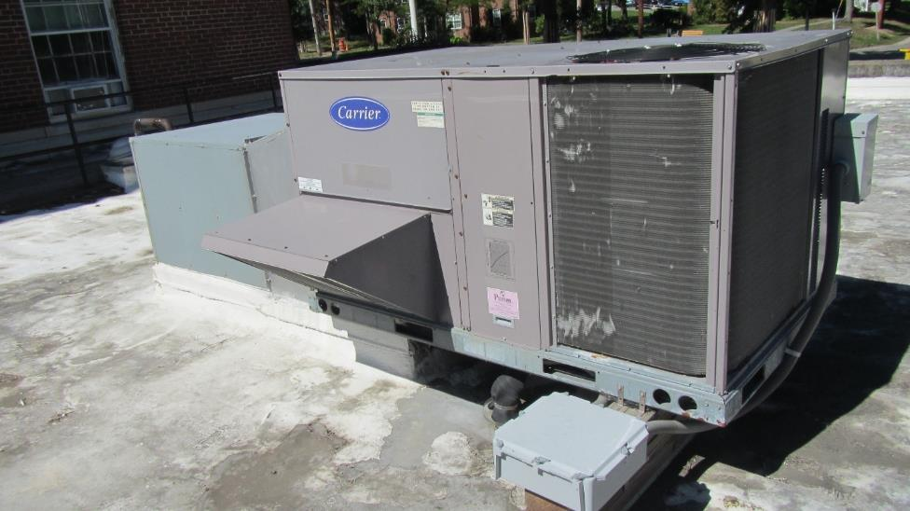

**Rooftop AHU**

**Picture 2**

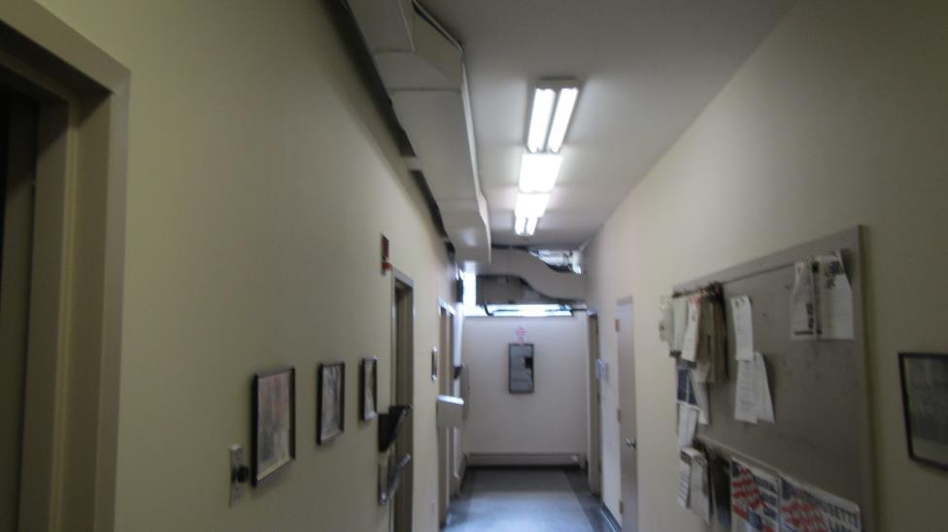**Hallway AHU**

**Picture 3**

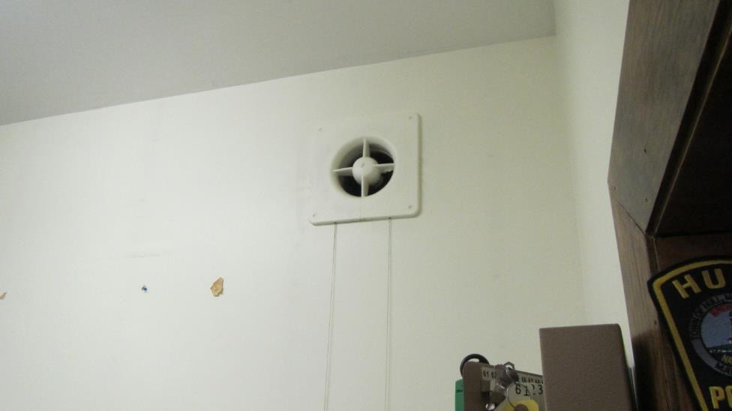

**Deactivated exhaust vent, interior view**

**Picture 4**

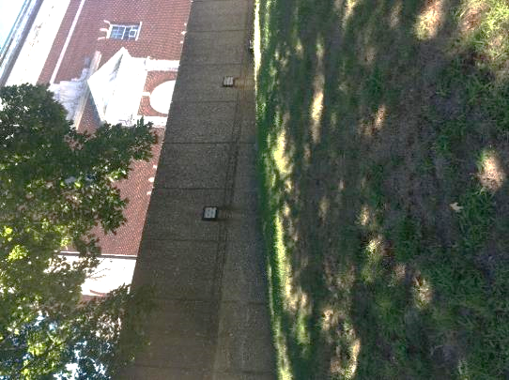

**Deactivated exhaust vent, exterior view**

**Picture 5**

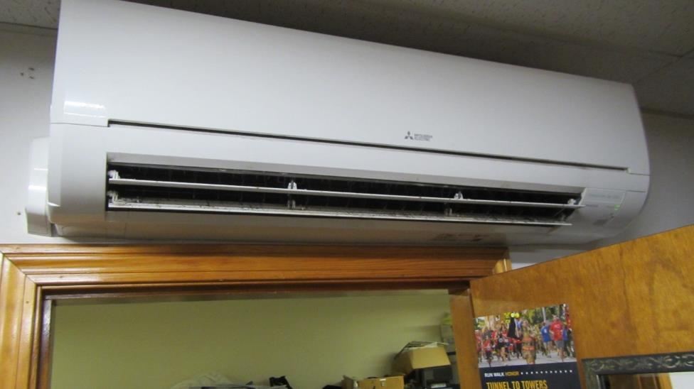

**Mini-split**

**Picture 6**

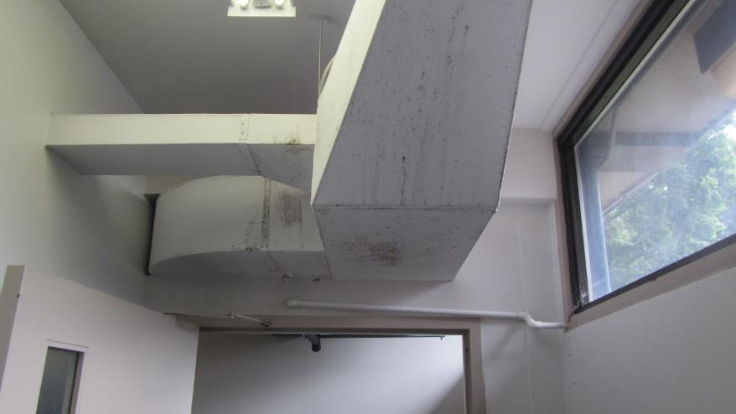

**Mold on Hallway AHU duct, note water stains from condensation dripping**

**Picture 7**

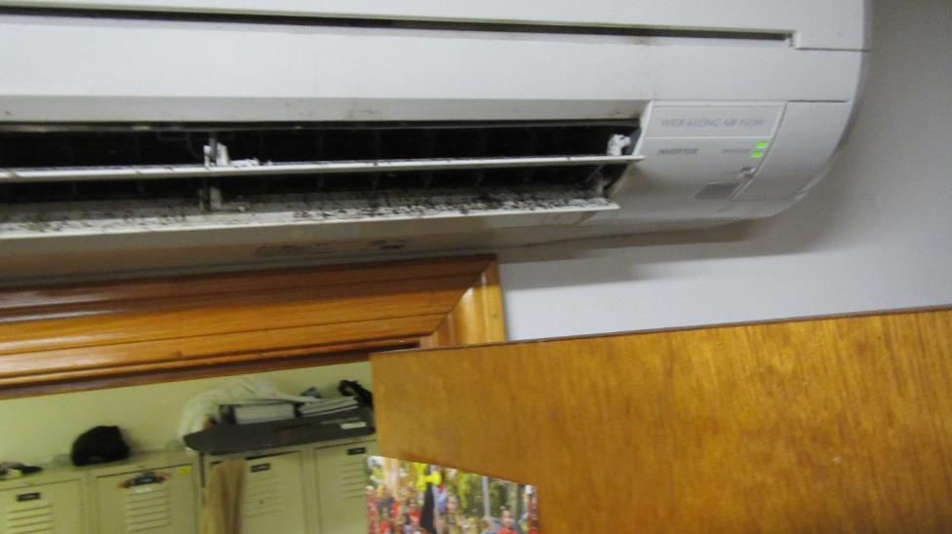

**Possible mold growth in mini-split vent**

**Picture 8**

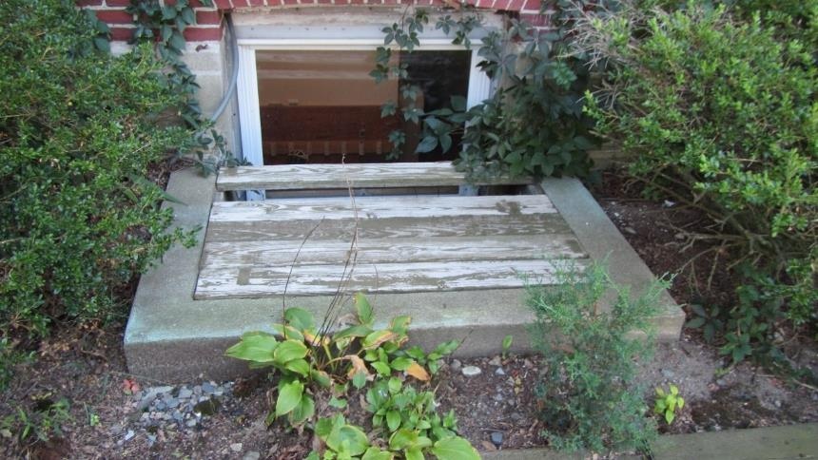

**Window well covered with wood planks**

**Picture 9**

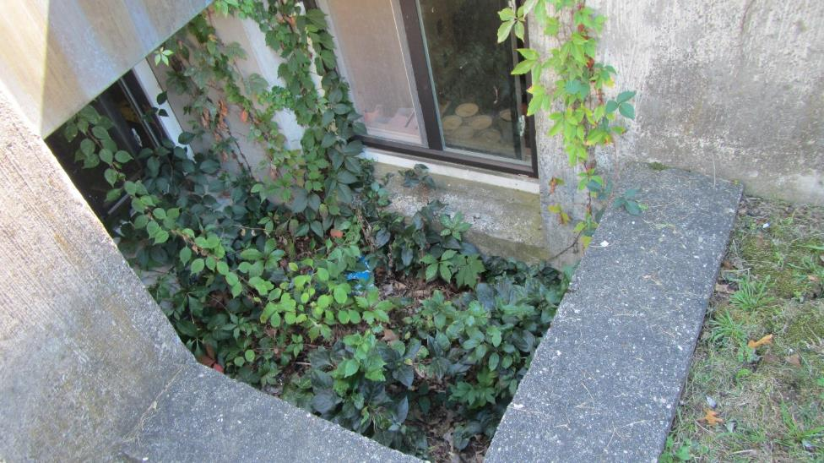

**Window well filled with plants and debris**

**Picture 10**

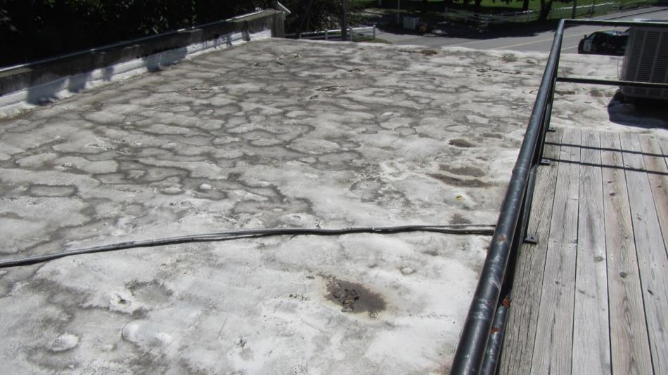**“Lumpy” roof from extended water exposure**

**Picture 11**

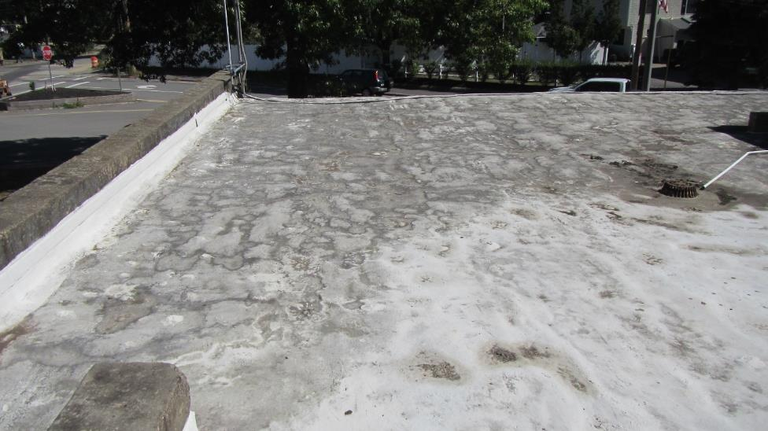**“Lumpy” roof from extended water exposure**

**Picture 12**

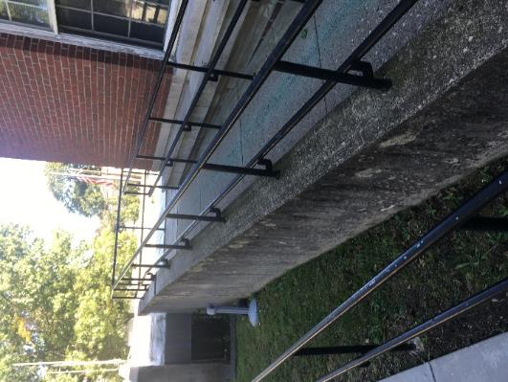

**Access ramp leading to roof top**

**Picture 13**

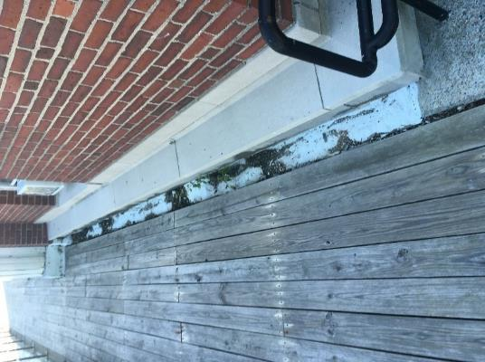

**Wood planks on roof directly placed on roofing material**

**Picture 14**

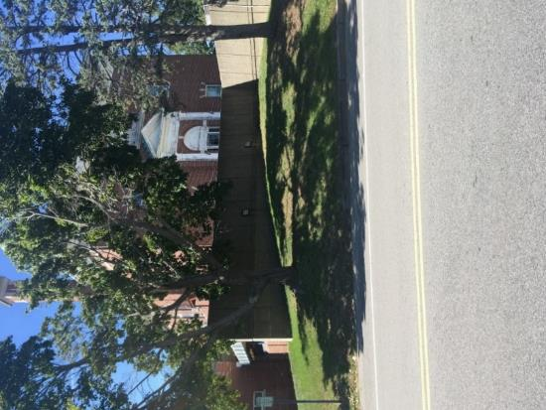

**Trees overhanging HPD roof**

| **Location** | **Carbon**  **Dioxide**  **(ppm)** | **Carbon Monoxide**  **(ppm)** | **Temp**  **(°F)** | **Relative**  **Humidity**  **(%)** | **PM2.5**  **(µg/m3)** | **Occupants**  **in Room** | **Windows**  **Openable** | **Ventilation** | | **Comments** |
| --- | --- | --- | --- | --- | --- | --- | --- | --- | --- | --- |
| **Supply** | **Exhaust** |
| Background (outdoors) | 320 |  | 67 | 43 |  |  |  |  |  |  |
| 1 | 446 | ND | 73 | 41 | 1 | 0 | N | Y | Y | Possible musty carpet odor, exhaust system off |
| 2 | 427 | ND | 73 | 40 | 1 | 0 | N | N | N |  |
| Booking | 378 | ND | 74 | 39 | 1 | 0 | N | Y | Y | Mold/water staining on duct near exterior door |
| Booking office | 394 | ND | 75 | 39 | 1 | 0 | N | Y | N |  |
| 3 | 381 | ND | 74 | 39 | 1 | 0 | N | Y | N |  |
| 4 | 371 | ND | 73 | 41 | 1 | 0 | N | Y | Y |  |
| 5 | 388 | ND | 74 | 42 | 1 | 0 | N | Y | Y |  |
| 6 | 360 | ND | 72 | 39 | 1 | 0 | N | N | N |  |
| 7 | 351 | ND | 71 | 39 | 1 | 0 | N | N | N |  |
| 8 | 339 | ND | 68 | 43 | 1 | 0 | Y | N | N |  |
| Garage | 323 | ND | 73 | 30 | 1 | 0 | N | N | N |  |
| 9 | 330 | ND | 66 | 43 | 1 | 1 | Y | Y | Y |  |
| Dispatch | 438 | ND | 67 | 44 | 1 | 2 | N | Y | Y |  |
| Reception | 365 | ND | 69 | 42 | 1 | 0 | N | Y | Y |  |
| Hall outside evidence | 368 | ND | 69 | 43 | 1 | 0 | N | N | N |  |
| Squad room | 371 | ND | 69 | 45 | 1 | 3 | Y | Y | Y | Water damage below window, mold on mini-split vent, gas stove |
| Locker room | 386 | ND | 68 | 47 | 1 | 0 | N | N | N |  |
| Bike storage | 363 | ND | 67 | 44 | 1 | 0 | Y | N | N | Water-damaged plaster below window |
| Bike tire room | 355 | ND | 68 | 45 | 1 | 0 | Y | N | N | Water-damaged plaster below window |
| Storeroom | 356 | ND | 69 | 45 | 1 | 0 | Y | N | N | Water-damaged plaster below window |