INDOOR AIR QUALITY ASSESSMENT

Hull Town Hall
253 Atlantic Avenue
Hull, Massachusetts

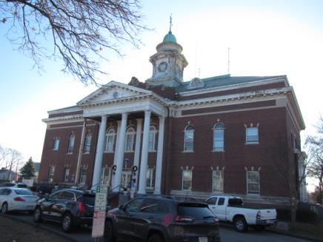

Prepared by:
Massachusetts Department of Public Health
Bureau of Environmental Health
Indoor Air Quality Program
December 2018

BACKGROUND
Building: | Hull Town Hall (HTH)
Address: | 253 Atlantic Avenue, Hull, MA
Assessment coordinated via: | Hull Board of Health
Reason for Request: | Water damage and general indoor air quality (IAQ)
Date of Assessment: | December 11, 2018
Massachusetts Department of Public Health/Bureau of Environmental Health (MDPH/BEH) Staff Conducting Assessment: | Cory Holmes, Environmental Analyst/Inspector, IAQ Program
Date of Building Construction: | Early 1920s, an addition and interior renovations were made in the 1970s.
Building/Site Description: | The HTH is a two-story brick building with attic and basement located near downtown Hull. A number of areas contain wall to wall carpeting and interlocking ceiling tile systems. The roof is slate. The Hull Police Department occupies a portion of the building that was not part of this assessment.
Building Population: | The building is staffed with 15-20 employees and serves the public daily.
Windows: | Openable

METHODS
Please refer to the IAQ Manual for methods, sampling procedures, and interpretation of results (MDPH, 2015).

RESULTS and DISCUSSION
The following is a summary of indoor air testing results (Table 1).
- Carbon dioxide levels were below the MDPH guideline of 800 parts per million (ppm) in all areas.
- Temperature was within or very close to the MDPH recommended range of 70°F to 78°F in all areas.
- Relative humidity was below the MDPH recommended range of 40 to 60% in all occupied areas, which is common during the heating season.
- Carbon monoxide levels were non-detect (ND) throughout the building.
- Particulate matter (PM2.5) concentrations measured were below the National Ambient Air Quality (NAAQS) level of 35 μg/m³ in all areas tested.

Ventilation
The HTH has no mechanical ventilation to bring in outside air for occupied areas. Openable windows provide the sole source of fresh air. However many of the windows are old and in disrepair.

Microbial/Moisture Concerns
The request for this assessment resulted from a flooding event that occurred when water entered the building through an abandoned interior drainage system over the weekend of December 1-2. A flooding restoration specialist (Service Master) was contacted to conduct drying operations with fans and dehumidifiers. On December 11, BEH/IAQ staff conducted moisture measurements and made observations to determine if porous building materials were properly dried. At that time, carpeting beneath file cabinets in the Tax Collectors office was wet (Pictures 1 and 2). It was recommended at the time of assessment that this carpet be removed. However, due to the age of the building it was also recommended to determine if there were any asbestos-containing floor tiles beneath the carpet.
The US Environmental Protection Agency (US EPA) and the American Conference of Governmental Industrial Hygienists (ACGIH) recommends that porous materials (e.g., wallboard, carpeting) be dried with fans and heating within 24 to 48 hours of becoming wet (US EPA, 2008; ACGIH, 1989). If porous materials are not dried within this time frame, mold growth may occur.
Water-damaged ceiling tiles and plaster were noted in a number of areas (Pictures 3 through 8, Table 1), which are evidence of building envelope and/or plumbing leaks. Replacement of ceiling tiles and repair/refinishing of water-damaged materials, including ceiling/wall plaster should be conducted after leaks are identified and repaired. It should be noted however, that ceiling tiles are of the interlocking type that are difficult to replace and likely not manufactured anymore. The majority of water damage to ceiling tiles and plaster appears to be from roof leaks, as shown by the large amount of water-damaged materials in the attic (Pictures 9 through 11), which was originally a balcony area.
The Tax Collectors restroom is used for storage of records. This space is not conducive for storage of porous materials such as paper and cardboard (Picture 12). Elevated humidity, condensation and toilet/sewage overflow can lead to the moistening/contamination of these materials. Materials contaminated by sewage (black water), would need to be discarded.

Other IAQ Evaluations
Several areas were carpeted. Carpets should be cleaned annually (or semi-annually in soiled/high traffic areas) in accordance with Institute of Inspection, Cleaning and Restoration Certification (IICRC) recommendations, (IICRC, 2012). The service life of carpeting is approximately 10-11 years (IICRC, 2002). In many areas, carpeting was observed to be worn and stained. Carpeting of this age and condition becomes increasingly difficult to clean and maintain and may be a source of particulate matter to the indoor environment. Regular cleaning with a high efficiency particulate air (HEPA) filtered vacuum in combination with an annual cleaning will help to reduce accumulation and potential aerosolization of materials from carpeting.
Several areas were missing light covers (Table 1, Pictures 3 and 6). Loosely stored bulbs were also observed in the stairwell (Picture 13). Fluorescent bulbs contain mercury, which can be released if they are accidentally broken.
Also note that the IT office had a number of missing/loose floor tiles (Picture 14). These tiles should be replaced to avoid a falling/tripping hazard.

CONCLUSION AND RECOMMENDATIONS
In order to address the conditions listed in this assessment, the recommendations made to improve IAQ are divided into short-term and long-term corrective measures. The short-term recommendations can be implemented as soon as possible. Long-term solution measures are more complex and will require planning and resources to adequately address overall IAQ concerns. In view of the findings at the time of the visit, the following recommendations are made:

Short-Term Recommendations
- Ensure that wet carpeting beneath file cabinets in the Tax Collectors office is removed. As stated previously, prior to removal, ensure that floor tiles beneath carpeting do not contain asbestos. If floor tiles may contain asbestos, all work should be done in accordance with state and federal regulations.
- Make repairs to the roof.
- Remove/replace any water-damaged insulation material in attic. Once fiberglass insulation becomes wet it loses efficiency (R-rating).
- Continue to use windows to provide fresh air during temperate weather. Close windows tightly during wet and hot, humid weather to prevent moisture accumulation.
- If possible, replace missing/water-damaged ceiling tiles.
- Scrape loose paint and seal/paint water-damaged ceiling and wall plaster.
- Periodically clean dust and debris from floors, flat surfaces, fans and AC units.
- For buildings in New England, periods of low relative humidity during the winter are often unavoidable. Therefore, scrupulous cleaning practices should be adopted to minimize common indoor air contaminants whose irritant effects can be enhanced when the relative humidity is low. To control for dusts, a high efficiency particulate arrestance (HEPA) filter equipped vacuum cleaner in conjunction with wet wiping of all surfaces is recommended. Avoid the use of feather dusters. Drinking water during the day can help ease some symptoms associated with a dry environment (throat and sinus irritation).
- Store porous items (i.e., cardboard and paper) off the floor in sealed boxes, bags or totes to prevent water damage. Discard water-damaged and/or moldy materials.
- Remove cardboard boxes from Tax Collectors restroom and stairwell in maintenance storeroom. Avoid using restroom areas for storage.
- Seal open utility holes/breaches in ceilings, floors and walls with a fire-rated sealant.
- Clean carpeting annually or semi-annually in soiled high traffic areas as per the recommendations of the Institute of Inspection, Cleaning and Restoration Certification (IICRC, 2012).
- Replace old worn carpeting past its useful life (> 10-11 years); consider replacing with carpet squares.
- Replace missing light covers to prevent accidental breakage of mercury-containing florescent bulbs. Store bulbs properly in sturdy containers and dispose of periodically in accordance with regulations for mercury-containing items.
- Replace loose/damaged floor tiles in IT office.
- Refer to resource manual and other related indoor air quality documents located on the MDPH’s website for further building-wide evaluations and advice on maintaining public buildings. These documents are available at http://mass.gov/dph/iaq.

Long Term Recommendations
- Consider replacing roof.
- Consider replacing existing (interlocking) ceiling tile systems building-wide with a more manageable suspended ceiling type.

REFERENCES
ACGIH. 1989. Guidelines for the Assessment of Bioaerosols in the Indoor Environment. American Conference of Governmental Industrial Hygienists, Cincinnati, OH.
IICRC. 2002. Institute of Inspection, Cleaning and Restoration Certification. A Life-Cycle Cost Analysis for Floor Coverings in School Facilities.
IICRC. 2012. Institute of Inspection, Cleaning and Restoration Certification. Carpet Cleaning: FAQ.
MDPH. 2015. Massachusetts Department of Public Health. Indoor Air Quality Manual: Chapters I-III. Available at: http://www.mass.gov/eohhs/gov/departments/dph/programs/environmental-health/exposure-topics/iaq/iaq-manual/.
US EPA. 2008. Mold Remediation in Schools and Commercial Buildings. US Environmental Protection Agency, Office of Air and Radiation, Indoor Environments Division, Washington, D.C. EPA 402-K-01-001. http://www.epa.gov/mold/mold_remediation.html
Picture 1
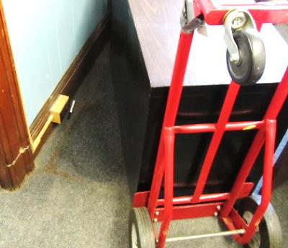
Wet carpeting (circular stain) beneath file cabinet in Tax Collectors office
Picture 2
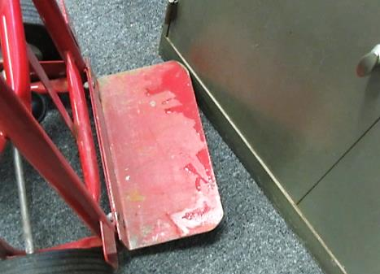
Wet carpeting (circular stain) beneath file cabinet in Tax Collectors office, note moisture on two-wheeler
Picture 3
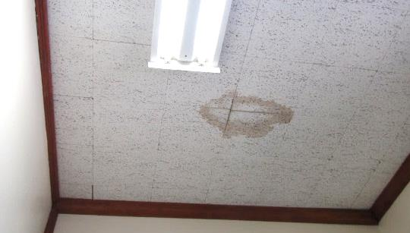
Water-damaged ceiling tiles, also note missing florescent light cover
Picture 4
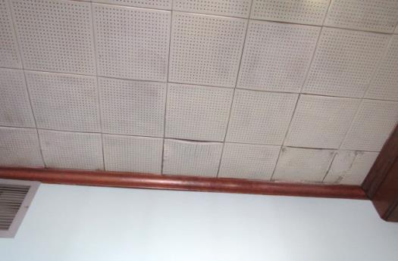
Water-damaged ceiling tiles
Picture 5
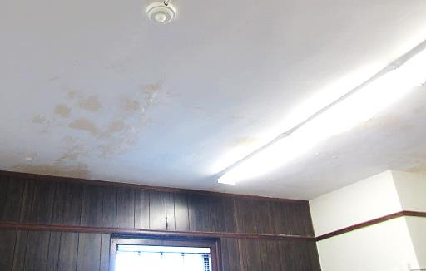
Peeling paint and water-damaged ceiling plaster
Picture 6
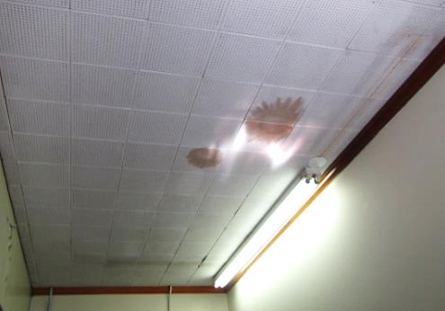
Water-damaged ceiling tiles, also note missing florescent light cover
Picture 7
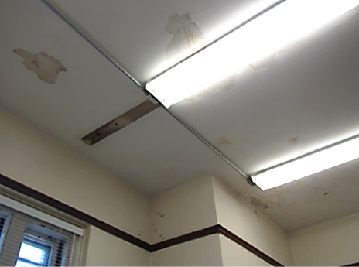
Peeling paint and water-damaged ceiling plaster
Picture 8
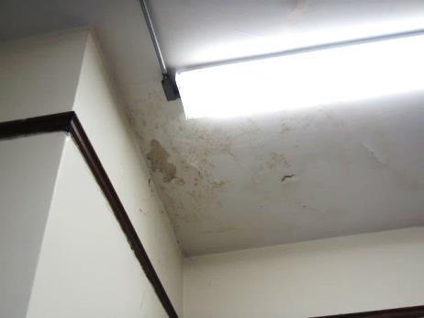
Peeling paint and water-damaged ceiling plaster
Picture 9
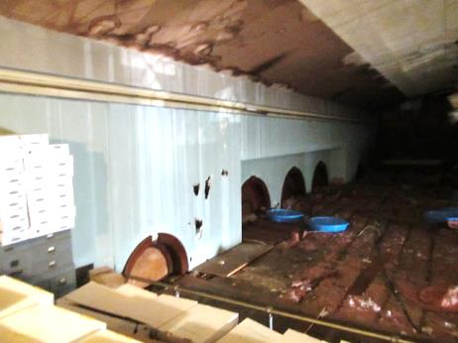
Water-damaged building materials in the attic (former balcony)
Picture 10
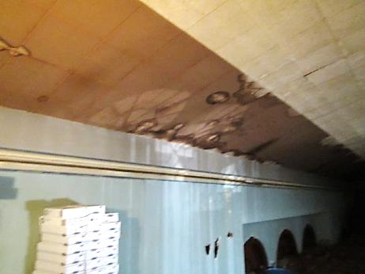
Water-damaged building materials in the attic (former balcony)
Picture 11
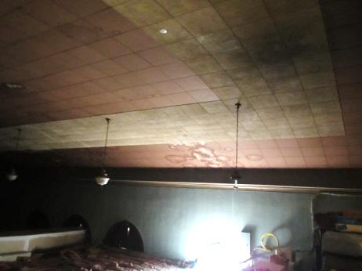
Water-damaged building materials in the attic (former balcony)
Picture 12
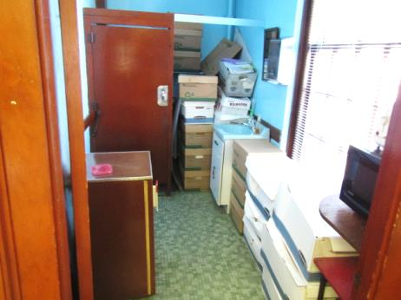
Cardboard/paper storage in Tax Collectors restroom
Picture 13
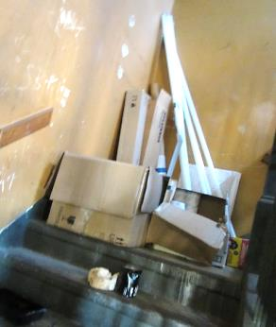
Loosely stored florescent bulbs and cardboard boxes in maintenance storeroom/stairwell
Picture 14
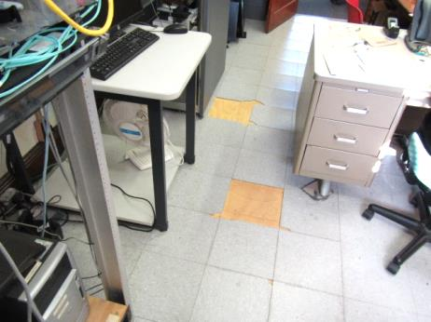
Missing/loose floor tiles in IT office
Location | Carbon  Dioxide  (ppm) | Carbon Monoxide  (ppm) | Temp  (°F) | Relative  Humidity  (%) | PM2.5  (µg/m³) | Occupants  in Room | Windows  Openable | Ventilation |  |  | Remarks
 |  |  |  |  |  |  |  | Intake | Exhaust
Background (outside) | 392 | ND | 36 | 14 | 18 |  |  |  |  |  | Cold, clear
Attic |  |  |  |  |  |  |  |  |  |  | Kiddie pools collecting water, WD ceiling/insulation
2nd Floor
Breakroom | 671 | ND | 69 | 27 | 10 | 0 | Y | N |  | N
Gents Room | 761 | ND | 70 | 26 | 7 | 3 | Y | N |  | N | Anteroom to men’s restroom, photocopier
Conservation | 774 | ND | 71 | 24 | 9 | 2 | Y | N |  | N | Area of WD event, carpet/walls dry, missing light covers, WD CTs
IT Office | 664 | ND | 73 | 19 | 13 | 1 | Y | N |  | N | Loose/missing floor tiles, missing light covers, WD CTs, reports of occasional birds, window AC
Accounting | 710 | ND | 73 | 19 | 5 | 1 | Y | N |  | N
Accounting Office | 740 | ND | 74 | 19 | 5 | 1 | Y | N |  | N | WD CT-leak reported ~12 months ago
Board of Health | 708 | ND | 74 | 30 | 6 | 1 | Y | N |  | N
2nd Floor Hallway |  |  |  |  |  |  |  |  |  |  | Leak around smoke alarm, missing light covers
Assessors | 726 | ND | 74 | 19 | 6 | 2 | Y | N |  | N | WD CT-occasional leaks reported, WD wall/ceiling plaster, missing light covers
Assessor’s Office | 706 | ND | 74 | 19 | 7 | 0 | Y | N |  | N | WD CT
Building Department | 720 | ND | 74 | 20 | 6 | 1 | Y | N |  | N | Missing light covers
Planning Board | 754 | ND | 73 | 20 | 7 | 2 | Y | N |  | N | Missing light covers, WD CTs
Retirement | 766 | ND | 73 | 21 | 7 | 1 | Y | N |  | N | WD CTs
Nurse’s Clinic | 706 | ND | 78 | 14 | 5 | 1 | Y | N |  | N | WD/stained ceiling plaster (rear storeroom)
Maintenance Room/Stairwell |  |  |  |  |  |  |  |  |  |  | Loose florescent bulbs in staircase, boxes on concrete
Tax Collector | 724 | ND | 74 | 23 | 9 | 3 | Y | N |  | N | WD/stained ceiling plaster, missing light covers, carpet wet beneath file cabinets
Restroom (Tax Collector) |  |  |  |  |  |  |  |  |  |  | Storage of cardboard boxes on floor, missing light covers
Treasurer | 563 | ND | 76 | 15 | 8 | 2 | Y | N |  | N
Board of Selectmen | 586 | ND | 77 | 16 | 7 | 2 | Y | N |  | N | WD ceiling plaster/peeling paint, worn/old carpeting
Town Clerk | 646 | ND | 77 | 19 | 7 | 0 | Y | N |  | N | WD ceiling plaster
Town Manager | 662 | ND | 72 | 17 | 7 | 1 | Y | N |  | N
Town Manager Admin | 647 | ND | 77 | 19 | 8 | 1 | N | N |  | N
Meeting Room | 494 | ND | 78 | 15 | 7 | 0 | Y | N |  | N | Peeling ceiling paint
Community Television | 442 | ND | 76 | 11 | 8 | 0 | Y | N |  | N

