Human Granulocytic Anaplasmosis (HGA) Surveillance in Massachusetts, 2014
Massachusetts Department of Public Health (MDPH)

Investigation of suspect cases of HGA, and the collection of clinical and exposure data by local public health enables MDPH to analyze trends and provide this surveillance summary.
2014 Surveillance Highlights

- 604 confirmed and probable cases of HGA were reported in Massachusetts in 2014. This was an 84% increase over the number of cases reported in 2013. Overall 1,369 suspect cases of HGA were investigated.

- Statewide, HGA incidence increased from 5.0 to 9.2 cases per 100,000 residents. The counties with the highest incidence continue to be Barnstable, Berkshire, Dukes, Nantucket and Plymouth where the incidence increased substantially. Nantucket had the greatest change in incidence, from 59.0 to 88.5 cases per 100,000 residents.

- The majority of cases occurred in May, June, and July, with only 37% of cases reporting awareness of a recent tick bite.

- People over the age of 60 years continue to be at greatest risk for clinical disease (48% of patients identified with HGA were over 60) and 49% of all cases were male. Of note in 2014, the incidence in those aged 80-84 increased from 8.0 to 32.5 cases per 100,000.

- One out of three patients with HGA (34%) was hospitalized. The symptoms most commonly reported included fever (94%), malaise (85%), and muscle aches and pain (67%). There were at least two fatalities.

- For more information about HGA and other tick-borne diseases, including things you can do to keep you and your loved ones safe, please visit www.mass.gov/dph/tick.

The map below illustrates HGA incidence rates per 100,000 by city and town of residence in Massachusetts from 2010-2014. Areas of highest incidence include southern Berkshire County, Southeastern Massachusetts, Cape Cod and the Islands. Many locations within Middlesex, Norfolk and Essex Counties also had areas of elevated incidence.

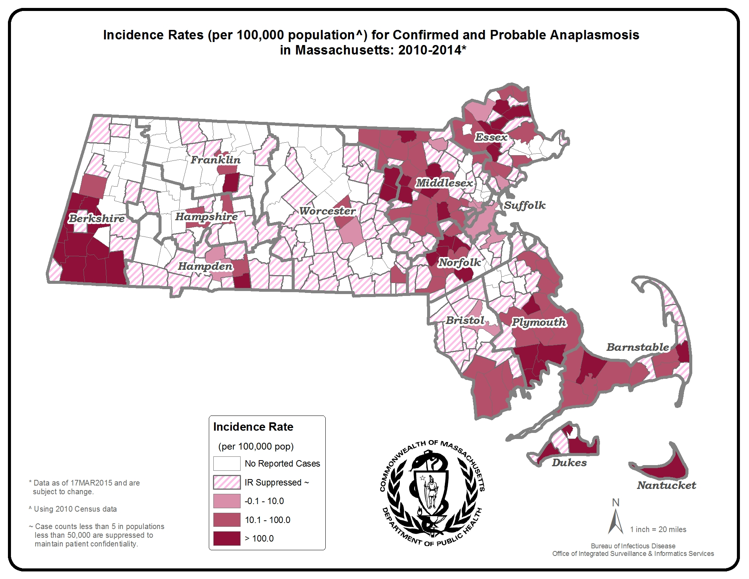
County | 2014 Cases  Confirmed and Probable | 2014  Incidence Rate per 100,000
Barnstable | 65 | 30.1
Berkshire | 79 | 60.2
Bristol | 26 | 4.7
Dukes | 8 | 48.4
Essex | 41 | 5.5
Franklin | 6 | 8.4
Hampden | 11 | 2.4
Hampshire | 10 | 6.3
Middlesex | 131 | 8.7
Nantucket | 9 | 88.5
Norfolk | 44 | 6.6
Plymouth | 117 | 23.6
Suffolk | 10 | 1.4
Worcester | 47 | 6.0
State Total | 604 | 9.2
Figure 1.
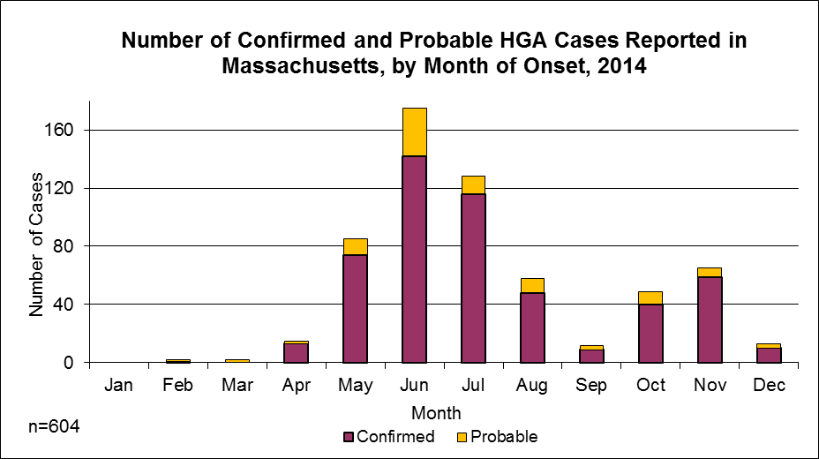

Figure 2.
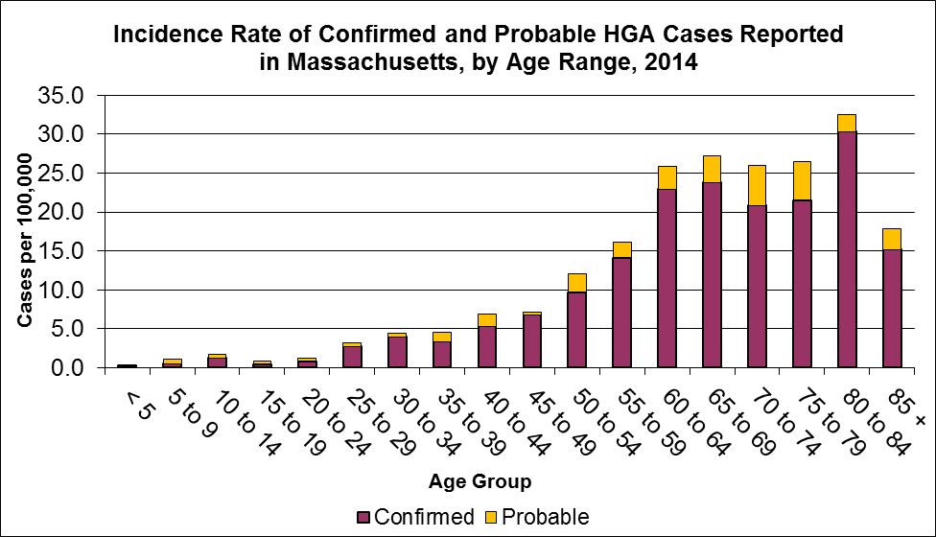

Figure 3.
